

MALAYSIAN JOURNAL OF ANALYTICAL SCIENCES
ISSN 1394 - 2506

Published by The Malaysian Analytical Sciences Society

AN ACOUSTIC STUDY OF Shorea leprosula WOOD FIBER FILLED POLYURETHANE COMPOSITE FOAM

(Kajian Akustik Busa Komposit Poliuretana Terisi Serat Kayu Shorea leprosula)

Muhammad Shafiq Mohd Azahari, Anika Zafiah M. Rus*, Shaharuddin Kormin, M. Taufiq Zaliran

Sustainable Polymer Engineering, Advanced Manufacturing and Material Center (SPEN-AMMC),

Faculty of Mechanical and Manufacturing Engineering,

Universiti Tun Hussein Onn Malaysia, 86400 Parit Raja, Batu Pahat, Johor, Malaysia

*Corresponding author: zafiah@uthm.edu.my

Received: 27 July 2017; Accepted: 28 April 2018

Abstract

Polyurethane foam is an excellent material for sound absorbing materials. This material is produced by mixing crosslinker, and polyol to produce foams with the presence of blowing agent. This study consists of an experimental study on acoustics properties enhancement of polyurethane foam by mixing different weight percentage of Shorea leprosula wood fiber into the polymer matrix. An optimal percent of 5-20% wood fiber was used to obtain a homogeneous mixture. The polymer foam composites acoustic properties were measured by using impedance tube test to obtain the sound absorption coefficient. The polymer foam composites UF₈₀ produced have a better sound absorption coefficient, α of 0.9507. UF₈₀ gives a higher density of 865.5 kg/m³ and smallest pore size of 413.4 µm which is determined by using Mettler Toledo Density kit and Scanning Electron Microscope (SEM) respectively compared to UF. The noise reduction coefficient (NRC) of the polymer foam composites UF₈₀ is twice as high as UF. This studies proved that Shorea Leprosula wood fiber influenced the acoustic properties of polymer foam composites.

Keywords: polyurethane foam, wood fiber, acoustic properties, sound absorption coefficient, noise reduction coefficient

Abstrak

Busa poliuretana adalah bahan yang sangat baik untuk bahan menyerap bunyi. Bahan ini dihasilkan dengan mencampurkan penghubung silang, dan poliol untuk menghasilkan busa dengan kehadiran ejen meniup. Kajian ini terdiri daripada kajian mengenai sifat-sifat akustik penambahbaikan busa poliuretana dengan mencampurkan peratusan berat serat kayu Shorea leprosula berbeza ke dalam matriks polimer. Peratus optimum serat kayu 5-20% digunakan untuk mendapatkan campuran homogen. Sifat akustik polimer komposit diukur dengan menggunakan ujian tiub impedans untuk mendapatkan pekali penyerapan bunyi. Polimer komposit UF₈₀ yang dihasilkan mempunyai pekali penyerapan bunyi, α yang lebih baik dengan 0.9507. UF₈₀ memberikan ketumpatan yang lebih tinggi dengan 865.5 kg/m³ dan saiz liang yang lebih kecil dengan 413.4 µm masing-masing ditentukan menggunakan kit ketumpatan Mettler Toledo dan Mikroskopi Pengimbas Elektron (SEM) berbanding UF. Pekali pengurangan hingar (NRC) daripada polimer komposit UF₈₀ adalah dua kali lebih tinggi daripada UF. Kajian ini membuktikan bahawa serat kayu Meranti Merah mempengaruhi sifat akustik busa poliuretana.

Kata kunci: busa poliuretana, serat kayu, sifat akustik, pekali penyerapan bunyi, pekali pengurangan hingar

Introduction

As the industrial waste gradually expands, it is slowly turned to be a major concern for the surroundings as well as human well-being. Another surroundings issue, which is changing into an undeniably major concern because of its negative effect on human well-being, is noise pollution [1]. Hence, innovative development of effective and environmentally friendly sound absorbing materials is essential [2,3]. Polymer foams are incorporate interconnected cells in a polymer matrix. Polymer foam can have an open, partially open, or a closed cell structure. Closed pores are usually much less efficient than open pores in absorbing sound energy. This is due to the fact that open pores have a continuous channel of communication with the external surface of the frame, and they have a tremendous effect on the absorption of sound [4].

Polymer foam needs less material than a sturdy polymer having a similar volume, consequently material expenses are decreased in several applications [5]. Polyurethane foams are generally used as a part of the industry for their thermal, mechanical, electrical, and acoustic properties [6, 7]. Polyurethane foam is a good sound absorbing material due to its generally low density and high porosity. When acoustic waves propagate within the foams porosity, energy is reduced. The air friction loss within the cores and then converted into heat [8]. This energy absorption is enclosed by the polymer foam morphology, which is an inherent property of the foam and is defined by using the gradual decrease in energy in the dissemination of the acoustic wave propagation [9]. The addition of polyurethane foam with various waste materials produces development composites materials with vital applications [5, 10]. Many researches proved that the feasibility to strengthen polymer foams with waste materials is to improve their mechanical; acoustic properties. Hence, researchers have utilized and considered fibrous waste with several characteristics to get sound absorbing materials: cotton [11], hemp strands [12], coconut coir fiber [11], and tea-leaf strands [13].

In Malaysia, wood plantation industries dispose and burned all the wood waste in the incinerators for each year and caused environmental pollution [14, 15]. Only a few wood wastes materials are reused by farmers and industrials enterprises. The leftover wood waste goes to landfills or to metropolitan waste incinerators [16] and used in several applications. This wood waste may result from the sawdust of furniture manufacturing or may simply come from building construction industries that are no longer used [14, 15, 17]. Wood waste is biodegradable, lightweight, cheaper, nontoxic, and has nonabrasive qualities with environmental and economic advantages

The target of this study is to study the acoustic properties of polymer foam composites which are used to utilize the wood waste materials by making new materials and also reduce the noise. The aims of this studies are to test the acoustic properties of polyurethane foam with various percent of wood fiber (Shorea leprosula) polymer foam composites as sound absorbing materials.

Materials and Methods

Raw materials

Figure 1 show the Shorea leprosula wood fiber which is used to enhance acoustic properties of polyurethane foam, origins from the manufacture of furniture manufacturing. The wood fiber was sun dried for a day to remove the humidity and then being ground and sieved into fine wood by using heavy duty blender to get desired fine particle size (<300 μm). The matrix of composite materials produced in this study is polymer foam composites.

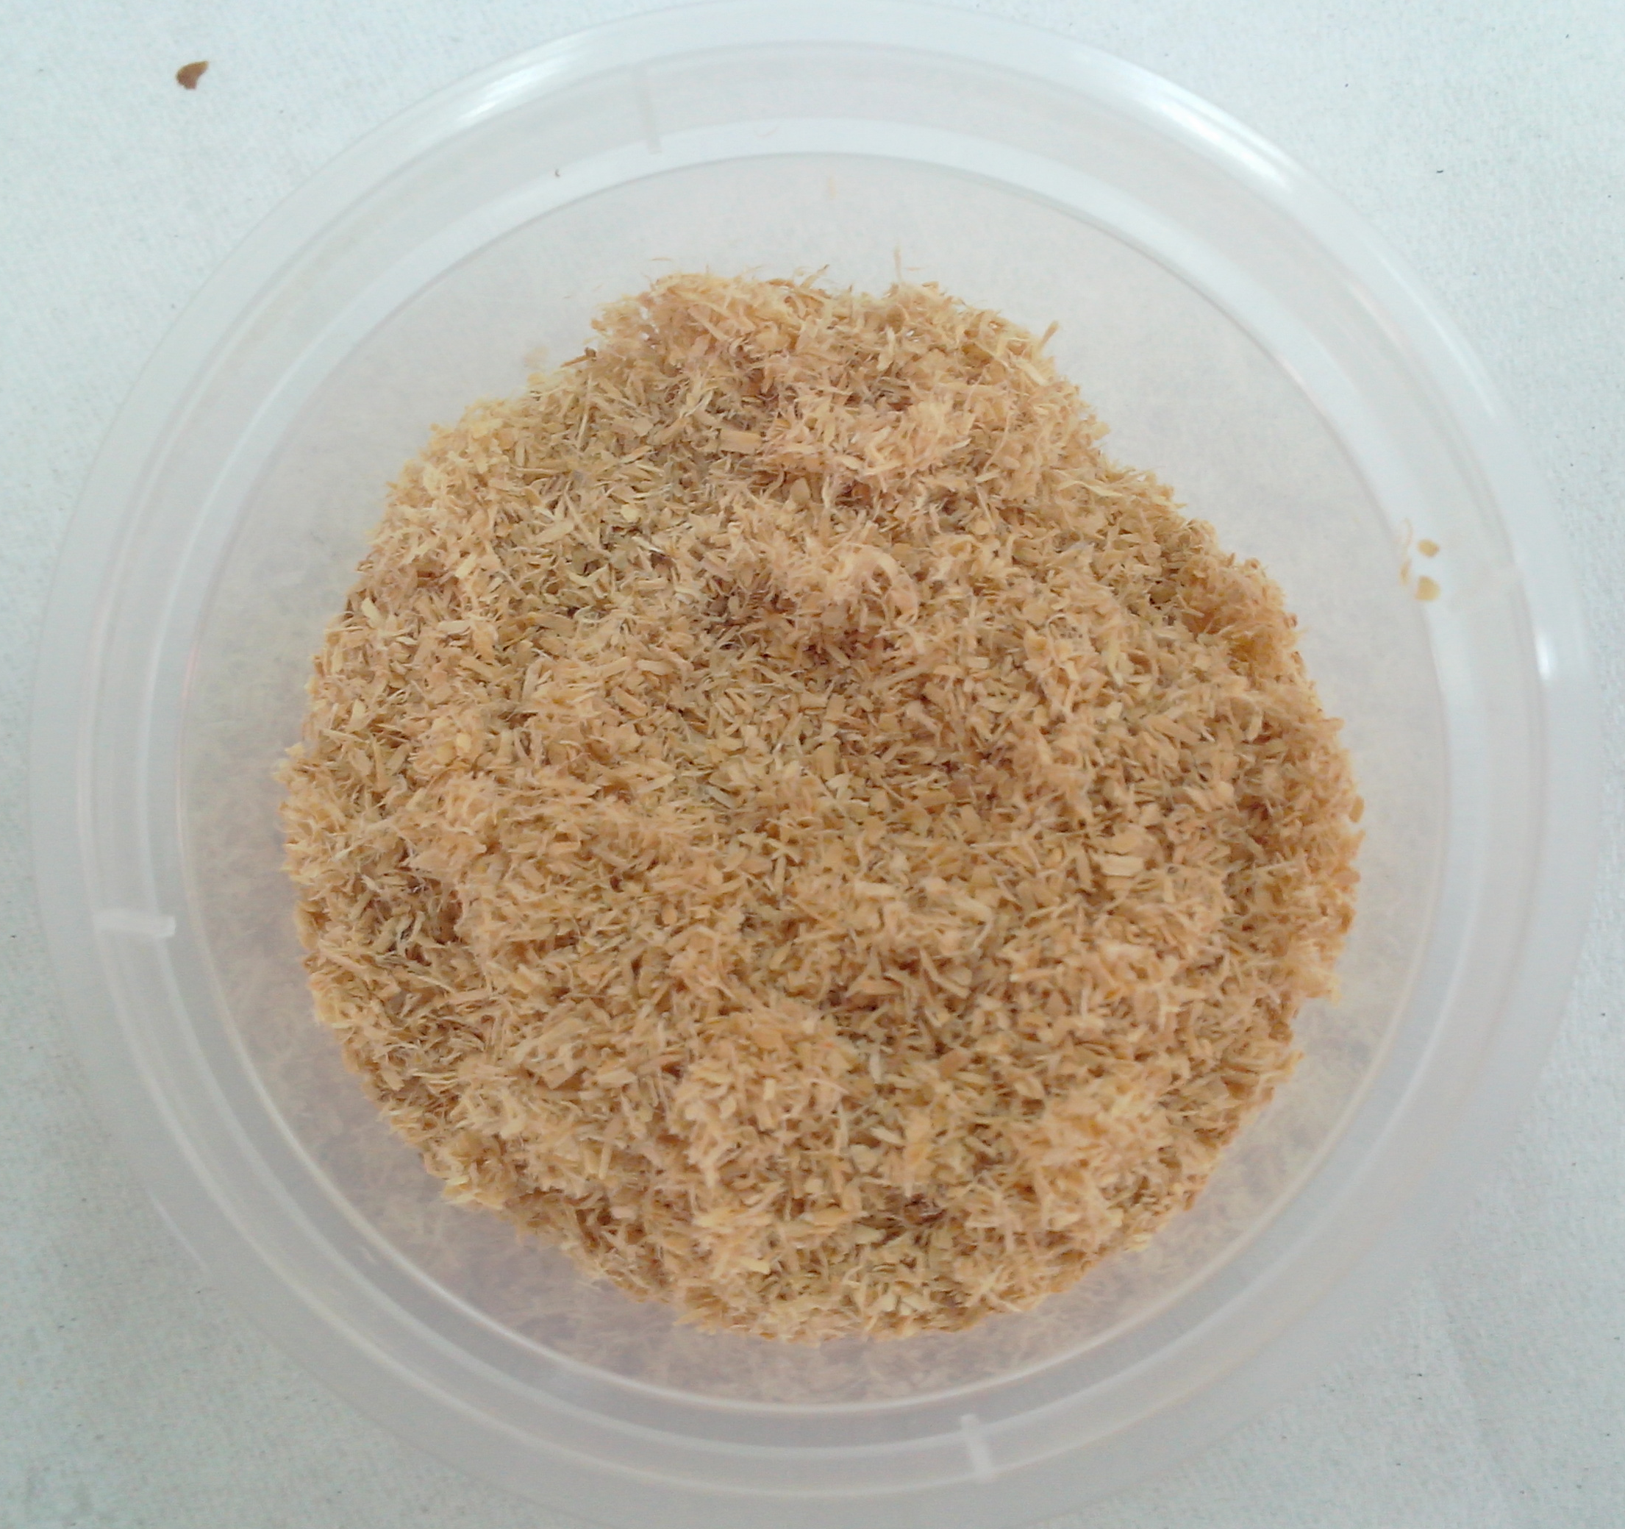

Figure 1. Shorea leprosula wood fiber

Foam preparation

Polymer foam composites samples were prepared by adding wood fiber with a polyurethane formulation consist of polymethane polyphenyl isocyanate (Modified Polymeric-MDI) and polyol. The polyurethane foams were prepared by mixing by the polyol and water (blowing agent) with isocyanate ratio of 1.0:0.1:0.5. This polymerization reaction is exothermic when reactions between alcohols with two or more reactive hydroxyls (-OH) groups per molecule (diols, triols, polyols) and isocyanates that have more than one reactive isocyanate group (-NCO) per molecule (diisocyanates, polyisocyanates). At the beginning of the procedures, different weight percentage (wt.%) of Shorea leprosula wood fiber into polyurethane foam were produced. Table 1 shows the weight percentage range of wood fiber used varies less or equal to 20% wt/wt of polyol.

Polyol and isocyanate were mixed with wood fiber at pre-determined weight ratios. The mixture in the mold is continuously stirred until it reaches homogenous composition and left to cure at room temperature for 24 hours [14, 15, 17]. Upon curing, the sample is cut to get 10 mm in thickness of each sample with 100 mm and 28 mm in diameter for sound absorption coefficient measurement using impedance tube testing as referred to Figure 2.

Table 1. Polymer foam composites composition ratios
Samples | Flexible Polyurethane Foam  (wt.%) | Wood Fiber  (wt.%) | Sample Thickness  (mm)
UF  UF₉₅  UF₉₀  UF₈₅  UF₈₀ | 100  95  90  85  80 | 0  5  10  15  20 | 10  10  10  10  10

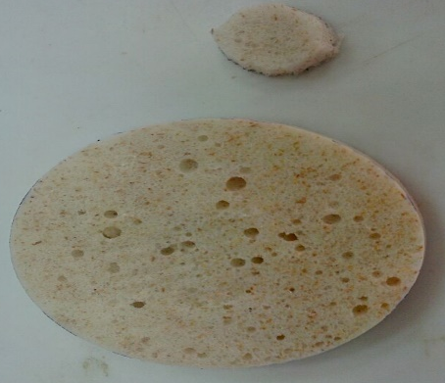

Figure 2. Polymer foam composites prepared for sound absorption coefficient measurement using impedance tube testing

Density of polymer foam composite

The densities of the polymer foam composites were measured by using Buoyancy method according to European Standard EN 993-1 which automatically determined the density by using Mettler Toledo Density Kit. Each sample with 10 × 10 × 10 mm size (length × width × thickness) was cut from the polymer foam composites and average value from five different samples were recorded.

Scanning electron microscope

Scanning electron microscopy (SEM) analyses were performed in a JEOL-JSM6380LA for polymer foam composites after vacuum-coating with gold (Auto Fined Coater of JEOL-JFC1600). This coated procedure for each sample is to avoid electrostatic charging during testing and at accelerating voltage of 10.0 kV [14, 15, 17]. Average pore size was obtained by measuring at least 10 pore size on the surface of each polymer foam composites.

Impedance tube testing

A sound wave incident on a material can be absorbed, reflected as well as transmitted by the material. These three processes are whole feasible relying on the characteristics of the material. The incident sound wave absorption is a practical approach to reduce noise. Sound absorption coefficient examined the acoustic property of the sound absorbing material.

It comprises of an adjustable filter, propagation tube, large sample tube 100 mm diameter (0-1500 Hz), small sample tube 28 mm diameter (1500-6000 Hz) and two-microphone technique and a digital frequency analysis system for the estimation of the normal incidence sound absorption coefficient and normal specific acoustic impedance proportion of materials [14, 15, 17]. The sample is analyzed by using impedance tube test according to ASTM E1050 for evenly mounted orientation materials for the frequency range of 100-6000 Hz.

Results and Discussion

The influences of material density on acoustic properties

Density difference plot of sound absorbing polymer foam composites used in this research, relying on the percentage of added wood fiber as shown in Figure 3. The highest density is 865.5 kg/m³ for UF₈₀ samples, follows by 850.8 kg/m³ for UF₈₅ sample, then, 835.1 kg/m³ for UF₉₀ sample, and 814.7 kg/m³ for UF₉₅ sample. Meanwhile, the smallest density is 807.0 kg/m³ for UF sample. As the wood waste fiber percentage used increases, the density of the material also increases.

UF₉₀
UF₈₀
UF₈₅
UF₉₅

Figure 3. Density of polymer foam composites, kg/m³

The influences of type and pore size of materials on acoustic properties

Type and size of pores are among important factors to be considered in porous sound absorbing material. In Figure 4, the overall polymer foam composites samples show open pores. Open pores with continuous channels give better sound absorption, because of the multiple reactions between the sound wave and the walls of the pores [2, 18]. As a result, more energy will be transformed into heat energy resulting in high sound wave absorption.

From Figure 4, the average pore size was calculated and presented in Figure 5. It can be observed that, as the weight percentage of wood fiber is increased, the average pore size will decreases. In Figure 5, UF gives the largest average pore size with 578.4 µm, follows by UF₉₅ with 574.4 µm, UF₉₀ with 568.2 µm and UF₈₅ with 504.4 µm. The smallest average pore size shows by UF₈₀ with 413.4 µm. The influence of pore size on sound absorption can be understood by the difference in the converted energy from sound energy to thermal energy through friction with the inner wall of air and pores. As cross-referring to Figure 6, the smaller the pore size, the more the collision happens among sound wave and cell wall, the longer the path of reflection and refraction and the more the absorption energy, the greater the sound absorption coefficient [19].

(a)
(b)
(d)
(c)

(e)

Figure 4. SEM image of polymer foam composites for: (a) UF, (b) UF₉₅, (c) UF₉₀, (d) UF₈₅ and (e) UF₈₀

UF₈₀
UF₈₅
UF₉₀
UF₉₅

Figure 5. Average pore size, µm of polymer foam composites for: (a) UF; (b) UF₉₅; (c) UF₉₀; (d) UF₈₅ and; (e) UF₈₀

The influences of wood fiber percentage on acoustic properties

The influences of wood fiber percentage used in producing polymer foam composites on the sound absorption coefficient are shown in Figure 6. Polymer foam composites with wood waste fiber have better sound absorption properties in comparison to the UF that gives sound absorption coefficient, α is 0.1606 and 0.7737 at low (0 – 1500 Hz) and high (1501- 6000 Hz) absorption frequency level in the overall frequency range analyzed. The UF₈₀ gives α, 0.2355 and 0.9507 at the low and high absorption frequency level respectively. The UF₈₅ shows at the low and high absorption frequency level; α is 0.2210 and 0.9211, respectively. At the low and high absorption frequency level, UF₉₀ α is 0.1700 and 0.8994, respectively. The UF₉₅ shows that at the low and high absorption frequency level, α is 0.2355 and 0.9507, respectively. The maximum value of α is achieved by sample material UF₈₀ at high absorption frequency level. Thus, the sound absorption coefficient has a strong connection with the amount of percentage wood fiber added in the polymer foam composites [16, 20].

The increase in sound absorption coefficient due to the large surface area of fillers on the polymer foam composites interface in which the acoustic energy can be dissipated as heat energy [2]. Sound propagation takes place in a network of interconnected pores where viscous and thermal interaction causes the acoustic energy to be dissipated and converted into heat energy. At low frequencies, polymer foam composites absorb sound by energy loss caused by heat exchange. This is an isothermal process. The absorbed energy moves within the cells by friction with air. This friction is converted into heat. Formation of fine morphology by fillers creates more paths for passing of sound waves into foam structure and as a consequence, polymer foam composites absorb more sound [2, 17].

As cross-referring in the previous page, in Figure 3, the density of polymer foam composites influences the sound absorption coefficient. Thus, by referring to Figure 6, as the density of the polymer foam composites increased, the sound absorption value at high frequency absorption level (1501 - 6000 Hz) also increases. When the wood fiber percentage per unit area increases, the apparent density becomes increases. Materials with higher density normally will absorb more sound energy caused by more surface frictional between the sound wave and the fiber elements [4, 21]. Hence, the sound absorption coefficient increases when energy loss increases as the surface friction increases. From Figure 6, less dense and more open structure absorbs sound at low absorption level frequencies (500 Hz) while, denser polymer foam composites absorb better at frequencies above than 2000 Hz.
UF₈₀
UF₈₅
UF₉₀

Figure 6. Sound absorption coefficient of polymer foam composites at low and high frequency absorption level

Further interest in acoustic analysis properties of polymer foam composites of the sound absorption coefficient, α values at different frequency ranges is calculated by using a single value; which is the noise reduction coefficient (NRC). The noise reduction coefficient (NRC) is the average of sound absorption coefficients, α at a specified set of frequencies, typically 250 Hz, 500 Hz, 1000 Hz, and 2000 Hz in accordance with the type of tube and acoustic measuring instrument used for the tests. The NRC can be calculated by using the formula in equation 1:

$NRC = \frac{(∝_{250 }+ ∝_{500 }+∝_{1000 }+∝_{2000 })}{4}$ (1)

Interpretation of acoustic properties of flexible polyurethane foam by adding wood fiber can be gained from the values of noise reduction coefficient in Figure 7, which is higher in the case of polymer foam composites. As the percentage of wood fiber increase, the value of noise reduction coefficient (NRC) also increases [1, 22]. The UF₈₀ has the maximum NRC value of 0.3140, which is twice as UF.

UF₉₅
UF₈₀
UF₈₅
UF₉₀

Figure 7. Noise reduction coefficient of polymer foam composites

Conclusion

Acoustic properties of polymer foam composites show a great influence to improve the current materials properties and producing advanced materials with better sound absorption properties. These sound absorbing materials can lessen the cost as well as beneficial to sound absorbing material by producing materials from reused and natural resources. Polymer foam composites produced by mixing the Shorea leprosula wood fiber in flexible polyurethane foam matrix revealed excellent acoustic properties with better improvement compared to UF foam. The UF₈₀ polymer foam composite was found to be the best composite used in noise reduction application with a maximum sound absorption coefficient of 0.9507 and noise reduction coefficient of 0.3140. Furthermore, the microstructural morphology shows an open pore and smallest pore size with 413.4 µm with a maximum density of 865.5 kg/m³. Consequently, the produced polymer foam composites are best to use both for outdoor and indoor sound absorption applications.

Acknowledgement

The author would like to thank Sustainable Polymer Engineering, Advanced Manufacturing and Materials Center (SPEN-AMMC), Universiti Tun Hussein Onn Malaysia (UTHM), Johor and Malaysian Government for supporting this research under Postgraduate Incentive Research Grant (GIPS U832) and Fundamental Research Grant Scheme (FRGS), vot 1481.

References
- Chathurangani, O. S., Perera, W. J. M. K., Kumari, H. M. N. S., Subashi, G. H. M. J. and De Silva, G. S. Y. (2013). Utilization of sawdust and coconut coir fibre as noise reducing wall surface materials. http://dl.lib.mrt.ac.lk/handle/123/8928. [Access online 27 March 2018].
- Gayathri, R., Vasanthakumari, R. and Padmanabhan, C. (2013). Sound absorption, thermal and mechanical behavior of polyurethane foam modified with nano silica, nano clay and crumb rubber fillers. International Journal of Scientific & Engineering Research, 4(5): 301-308.
- Peng, L., Song, B., Wang, J. and Wang, D. (2015). Mechanic and acoustic properties of the sound-absorbing material made from natural fiber and polyester. Advances in Materials Science and Engineering, 2015: 1-5.
- Zhu, X., Kim, B. J., Wang, Q. and Wu, Q. (2013). Recent advances in the sound insulation properties of bio-based materials. BioResources, 9(1): 1764-1786.
- Maderuelo-Sanz, R., Nadal-Gisbert, A. V., Crespo-Amorós, J. E. and Parres-García, F. (2012). A novel sound absorber with recycled fibers coming from end of life tires (ELTs). Applied Acoustics, 73(4): 402-408.
- Gu, R., Sain, M. M. and Konar, S. K. (2013). A feasibility study of polyurethane composite foam with added hardwood pulp. Industrial Crops and Products, 42: 273-279.
- Luo, X., Mohanty, A. and Misra, M. (2013). Lignin as a reactive reinforcing filler for water-blown rigid biofoam composites from soy oil-based polyurethane. Industrial Crops and Products, 47: 13-19.
- Mamtaz, H., Fouladi, M. H., Al-Atabi, M. and Namasivayam, S. N. (2016). Acoustic absorption of natural fiber composites. Journal of Engineering, 2016: 1-11.
- Chen, S., Jiang, Y., Chen, J. and Wang, D. (2015). The effects of various additive components on the sound absorption performances of polyurethane foams. Advances in Materials Science and Engineering, 2015: 1-9.
- Lacoste, C., Basso, M. C., Pizzi, A., Celzard, A., Ella Ebang, E., Gallon, N. and Charrier, B. (2015). Pine (P. pinaster) and Quebracho (S. lorentzii) tannin-based foams as green acoustic absorbers. Industrial Crops and Products, 67: 70-73.
- Zulkifli, R., Zulkarnain and Nor, M. J. M. (2010). Noise control using coconut coir fiber sound absorber with porous layer backing and perforated panel. American Journal of Applied Sciences, 7(2): 260-264.
- Youneung, L. and Changwhan J. (2003). Sound absorption properties of recycled polyester fibrous assembly absorbers. AUTEX Research Journal, 3(2): 78-84.
- Ekici, B., Kentli, A. and Küçük, H. (2012). Improving sound absorption property of polyurethane foams by adding tea-leaf fibers. Archives of Acoustics, 37(4): 515-520.
- Azahari, M. S. M., Rus, A. Z. M., Kormin, S. and Zaliran, M. T. (2017). Acoustic properties of polymer foam composites blended with different percentage loadings of natural fiber. IOP Conference Series: Materials Science and Engineering, 244(1): 012009.
- Azahari, M. S. M., Rus, A. Z. M., Zaliran, M. T. and Kormin, S. (2017). Improving sound absorption property of polyurethane foams doped with natural fiber. IOP Conference Series: Materials Science and Engineering, 226(1): 012009.
- Rus, A. Z. M. and Shafizah, S. (2015). Acoustic behavior of polymer foam composite of Shorea leprosula after UV-irradiation exposure. International Journal of Mechanical, Aerospace, Industrial and Mechatronics and Manufacturing Engineering, 9(1): 188-192.
- Rus, A. Z. M., Azahari, M. S. M., Kormin, S., Soon, L. B., Zaliran, M. T. and Ahraz Sadrina M. F. L. (2017). Hybrid waste filler filled bio-polymer foam composites for sound absorbent materials. AIP Conference Proceedings, 1877(1): 060004.
- Berardi, U. and Iannace, G. (2015). Acoustic characterization of natural fibers for sound absorption applications. Building and Environment, 94: 840-852.
- Soto, G., Castro, A., Vechiatti, N., Iasi, F., Armas, A., Marcovich, N. E. and Mosiewicki, M. (2017). Biobased porous acoustical absorbers made from polyurethane and waste tire particles. Polymer Testing, 57: 42-51.
- Sa'adon, S. and Rus, A. Z. M. (2013). Utilization of treated red meranti wood dust as polymer foam composite for acoustic study. Key Engineering Materials, 594-595: 760-764.
- Nandanwar, A., Kiran, M. C. and Varadarajulu, K. C. (2017). Influence of density on sound absorption coefficient of fibre board. Open Journal of Acoustics, 7: 1-9.
- Sa'adon, S. and Rus, A. Z. M. (2014). Acoustical behavior of treated wood dust-filler for polymer foam composite. Applied Mechanics and Materials, 465-466: 1039-1043.

