

MALAYSIAN JOURNAL OF ANALYTICAL SCIENCES
ISSN 1394 - 2506

Published by The Malaysian Analytical Sciences Society

THE INFLUENCE OF GROWTH TEMPERATURE ON THE PROPERTIES OF ZINC OXIDE BY THERMAL OXIDATION

(Kesan Suhu Pertumbuhan Ke Atas Sifat-Sifat Zink Oksida Menggunakan Pengoksidaan Haba)

Nuraini Abdullah*, Noor Mazni Ismail, Dewan Muhammad Nuruzzaman

Faculty of Manufacturing Engineering,

Universiti Malaysia Pahang, 26600 Pekan, Pahang, Malaysia

*Corresponding author: nuraini.abdullah89@yahoo.com

Received: 2 April 2018; Accepted: 31 July 2018

Abstract

Zinc thin films were successfully deposited on Si substrate by thermal evaporation method under constant base pressure of 1.604 x10⁻⁴ Pa. Thermal oxidation of the deposited film was carried out at two different growth temperatures of 300 ºC and 500 ºC. The effects of growth temperature on the properties of zinc oxide were investigated. Thermal oxidation was carried out in a horizontal tube furnace in air condition for constant time one hour. After thermal oxidation at temperature 500 ºC, the white-silver zinc thin films were changed to black-brown zinc oxide. FESEM results show that the zinc particles were almost round shape with nanostructures in size. ZnO nanocrystals were successfully obtained at low growth temperature of 300 ºC and the size of nanowires decreased as the growth temperature was increased to 500 ºC. The XRD results confirmed that ZnO started to oxidize at growth temperature of 300 ºC with the sharpest peak obtained indexed to ZnO(101). However, the oxidation of Zn was not fully completed while Zn peaks appeared at this temperature. At growth temperature 500 ºC, all the peaks were indexed to ZnO with the sharpest peak was ZnO(101) meaning that the oxidation was completed. The calculated crystallite sizes were varied from 27.841 nm to 36.788 nm for ZnO at 300 °C and 0.697 nm to 161.18 nm for ZnO at 500 °C.

Keywords: zinc oxide, silicon, thermal evaporation, thermal oxidation

Abstrak

Filem nipis zink telah berjaya didepositkan pada substrak Si oleh kaedah penyejatan haba di bawah tekanan asas tetap 1.604x10⁻⁴ Pa. Pengoksidaan termal telah dijalankan ke atas filem yang telah didepositkan pada dua suhu yang berbeza iaitu 300 ºC dan 500 ºC. Kesan suhu pertumbuhan pengoksidaan telah disiasat terhadap sifat zink oksida. Pengoksidaan termal untuk masa malar 1 jam dalam relau tiub mendatar dalam kehadiran udara telah dijalankan. Filem nipis zink putih diubah menjadi zink oksida hitam coklat selepas pengoksidaan haba pada suhu 500 ºC. Keputusan FESEM menunjukkan bahawa zarah zink hampir membentuk bulat dengan saiz nanostruktur. Nanokristal ZnO telah berjaya diperoleh pada suhu pertumbuhan yang rendah iaitu 300 ºC dan saiz nanowayar menjadi berkurangan apabila suhu pertumbuhan meningkat kepada 500 ºC. Hasil XRD mengesahkan bahawa ZnO mula teroksida pada suhu pertumbuhan 300 ºC dengan puncak paling ketara yang diperoleh diindeks ke ZnO(101). Walau bagaimanapun, pengoksidaan Zn tidak siap sepenuhnya kerana masih terdapat puncak Zn muncul pada suhu ini. Pada suhu pertumbuhan 500 ºC, semua puncak diindeks kepada ZnO dengan puncak paling ketara ialah ZnO(101) yang bermaksud pengoksidaan telah berlaku sepenuhnya. Saiz kristal yang dikira berbeza bermula dari 27.841 nm hingga 36.788 nm untuk ZnO pada 300 °C dan 0.6966 nm hingga 161.18 nm untuk ZnO 500 °C.

Kata kunci: zink oksida, silikon, pengewapan haba, pengoksidaan haba

Introduction

Recently zinc oxide (ZnO) thin film has been listed as one of the most interesting semiconductor oxides due to its special characteristics. Other than its wide band gap of 3.27eV, it also has a large excitation energy bonding of 60 meV [1]. It has attracted much attention in order for many applications such as solar cells, gas sensor, nanolaser and other photoluminescent devices. There are several techniques that can be used to synthesize ZnO thin films for example sputtering, spray pyrolysis, sol-gel, chemical vapor deposition, RF magnetron sputtering, pulsed laser deposition, etc. Besides, one of the simplest methods is thermal oxidation that has been paid less attention. Thermal oxidation method also requires a relatively simple and low-cost procedure that does not need any catalyst or higher temperature growth [2]. By comparing to the catalyst-assisted growth, direct oxidation of metallic zinc can produce ZnO nanostructures with a large-scale growth capabilities and high purity owing to the elimination of intermediaries involved in catalytic chemical synthesis of oxide nanostructures [3]. The oxidation of Zn foils or powders under oxygen gas flow results the variation of ZnO nanostructures morphologies [1]. There have been a few reports of synthesizing zinc oxide by thermal oxidation methods [1-10]. Based on some reports, ZnO nanostructures were formed at growth temperature (420 ºC) and boiling temperature (907 ºC) of Zn while decomposition of ZnO was reported at a temperature up to ~1400 ºC [3]. As prevention, the growth of ZnO nanostructures should stop below the decomposition temperature of Zn.

In this study, we have reported the growth temperature effect on the properties of ZnO by thermal oxidation. The deposited Zn thin films on Si substrates resulted white color of thin films and changed to silver-grey at low oxidation temperature of 300 ºC and was changed to black-brown at temperature 500 ºC. The characterizations of ZnO were conducted by FESEM, EDX and XRD. This research was focused to investigate the difference between the physical characteristics of ZnO at two different conditions i.e. partially oxidized and fully oxidized states that were obtained at 300 and 500 °C, respectively.

Materials and Methods

High purity (99.99%) Zn powders (purchased from Permula Sdn Bhd) were used in thermal evaporation experiments. Silicon (Si) with a dimension of 4inch diameter was used as a substrate. The cleaning process of Si substrate was conducted by using Piranha method. A solution of acid sulphuric (H₂SO₄) 3:1 hydrogen peroxide (H₂S₂) was freshly prepared. The cleaning process was conducted in an ultrasonic bath at temperature 65 ºC for 30 minutes to remove the contaminant on the surface. After that, the Si substrate was rinsed with distilled water and dried by air gun. Next, the thermal evaporation was started with filled Zn powder (0.05g) in the tungsten boat and placed the Si substrate in the thermal evaporator. The base pressure in thermal evaporator was set at 1.60 x 10⁻⁴ Pa with target-substrate distance of 10.5 mm at room temperature, voltage 0.9V and current 20-25A. The deposition time was constant for 30 minutes for each sample.

Then, the deposited Zn thin films were characterized by FESEM JEOL, JSM-7800F with EDX analysis. The oxidation of Zn was performed in a tube furnace in closed air condition at growth temperature of 300 ºC and 500 ºC at constant heating rate of 5 ºC/min for 1h. After oxidation process, the tube furnace was naturally cooled down to room temperature and the samples were unloaded. The ZnO films were then characterized by FESEM JEOL, JSM-7800F with EDX analysis and X-ray Diffraction (XRD) pattern was collected on a XRD Bruker D8 Advance with CuKα radiation ( λ = 0.1546 nm ).

The average crystallite size (D) was determined using the Sherrer’s equation [10]:

D=kλ/β_{2θ}cosθ (1)

where k denotes the Scherrer constant (the shape factor of the average crystallite and can be considered k = 0.9 [10]; λ = 1.54060Å is the wavelength of the incident Cukα radiation; β_{2θ} represents the full-width at half maximum of the respective peak and θ is the Bragg diffraction angle.

Results and Discussion

Figures 1(a-d) show the characterization results using FESEM and EDX. Figure 1(a) shows the average particle size of the Zn thin film using 10000 x magnifications. The measured particle size varies from 101nm to 176nm with the particles almost round shape. The obtained results also showed that the sizes of particles are almost uniform which means that the evaporation process was uniformly distributed over the surface. Figure 1(b) shows the cross section of the Zn thin films. The obtained results showed that measured thickness of the deposited Zn thin film varies from around 0.6µm to 1.1µm. Figures 1(c)-(d) show the EDX results of the Zn film and the elements consist of Si, C, O and Zn meaning that Zn was successfully grown on the Si substrate.

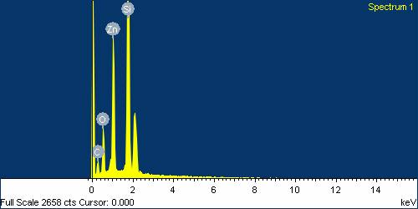
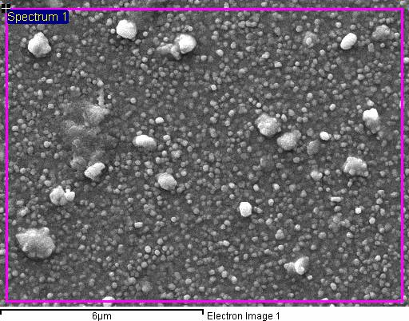
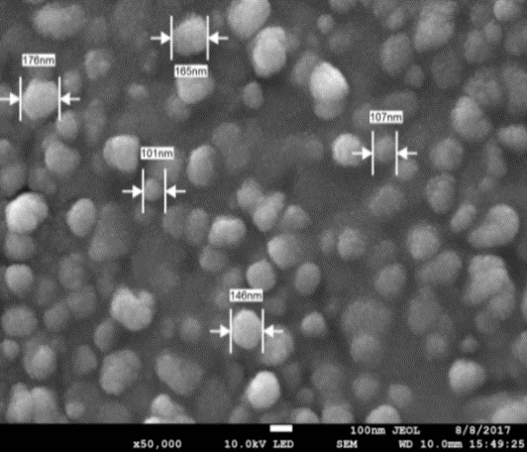
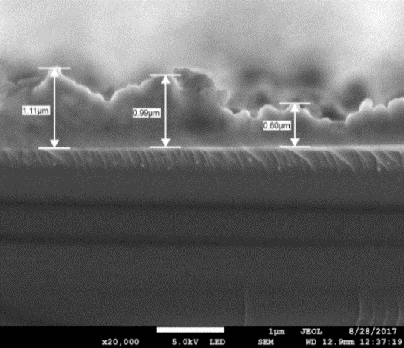
(d)
(c)
176nm
165nm
107nm
101nm
146nm
(a)
1.1µm
0.9µm
0.6µm
(b)

Figure 1. FESEM image of Zn thin film after thermal evaporation and (b)cross section of Zn layer on the Si substrate (c) EDX point surface of Zn layer on Si and (d) EDX spectrum of Zn thin film

Figures 2(a-f) show representative of FESEM images and EDX spectrum of the surfaces of ZnO oxidized at different temperatures. The uniform hexagonal nanocrystals at 300 ºC and nanowires of ZnO at 500 ºC were observed. Figure 2(a) shows the top view of the ZnO films at growth temperature 300 ºC and ZnO nanocrystals are uniformly distributed over the surface. These results of hexagonal nanocrystals of ZnO on Si substrate are the same results using low temperature hydrothermal method [11] and thermal oxidation of Zn films at 600 ºC deposited in Ar+O₂/10mTorr [8].

The ZnO nanocrystals sizes were measured 75 nm, 99.7 nm and 104 nm. The formation of ZnO nanowires strongly depended on the thermal oxidation temperature. The optimal temperature range for the ZnO nanowires are in between 300 ºC and 400 ºC and below the melting points of Zn and ZnO (Zn: 419.58 ºC, ZnO:1975 ºC). However, there are some results claimed that the ZnO nanowires became less and gradually vanished at higher temperature such as 500 ºC and 600 ºC [12]. The results of ZnO nanowires have been studied by the other researcher at oxidation temperature 400 ºC and the formation became much higher surface density, larger diameter and long length at 500 ºC [3]. In this study, we found that the size of nanowires became smaller by increased oxidation temperature at 500 ºC as shown in Figure 2(b) and the image of uniform ZnO nanowires distributed over the surface at 500 ºC. The measured nanowires sizes decreased to 20.6 nm, 21.4 nm and 24.6 nm. Liu et al. [7] also claimed that when the temperature increased over 400 ºC, the density of the nanowires was decreased with few nanowires. Figures 2(c-d) and Figures 2(e-f) show the EDX spectrum of ZnO thin films at growth temperature 300 ºC and 500 ºC, respectively. The results show that at these two different temperatures, the highest element of the sample consists of Zn and the other elements are Si, C and O.

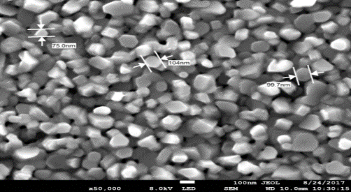
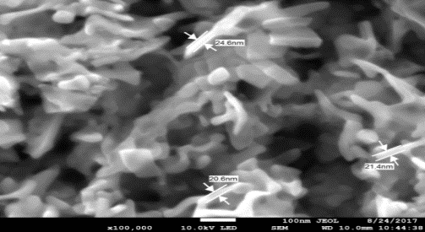
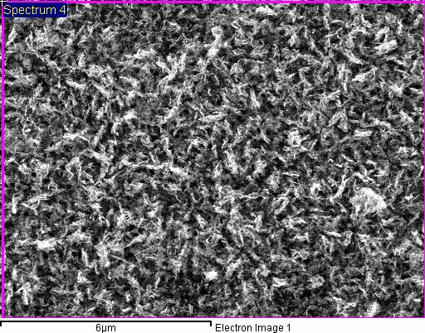
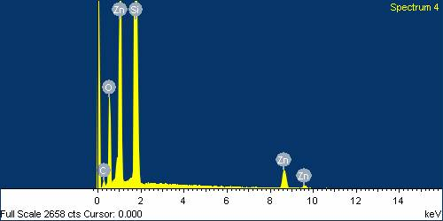
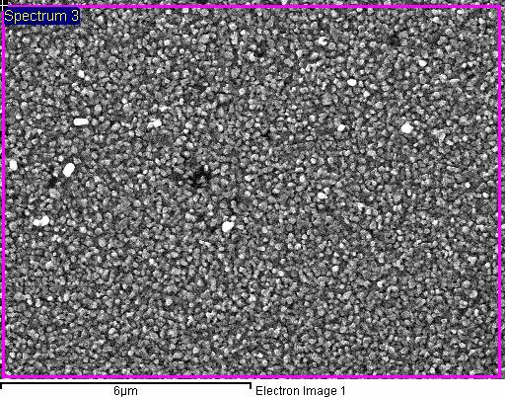
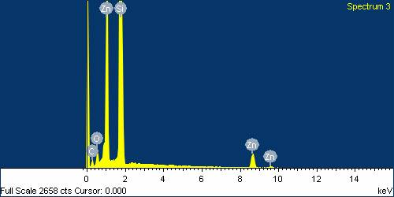
75nm
104nm
99.7nm
(a)
24.6nm
21.4nm
20.6nm
(b)
(e)
(f)
(c)
(d)

Figure 2. FESEM and EDX images of ZnO thin film after thermal oxidation (a) the surface and particle size of ZnO at 300 ºC, (b) the surface and average particle of ZnO at 500 ºC, (c) EDX point surface of ZnO nanocrystals layer on Si at 300 ºC, (d) EDX spectrum of ZnO nanocrystals at 300 ºC (e) EDX point surface of ZnO nanowires layer on Si at 500 ºC and (f) EDX spectrum of ZnO nanowires at 500 ºC

The identification of crystallite phases and microstructural analysis for ZnO thin films was studied by XRD. Figures 3(a) and (b) show the representative XRD patterns of ZnO thin film at growth temperature 300 ºC and 500 ºC, respectively. From Figure 3(a), it can be observed that those ZnO thin films are polycrystalline and have a hexagonal close-packed structure. M.S Aida et al. claimed that the oxidation started at a temperature equal to 250ºC and the total oxidation was achieved at 300ºC leading to stoichiometric ZnO films [1]. Within their research, preparation of ZnO thin films was carried out by direct thermal evaporation of ZnO powder and then followed by annealing in oxygen/air atmosphere using an open horizontal furnace. They also demonstrated that the oxidation mechanism was achieved by diffusion of oxygen ions. But in our work, Zn was not fully oxidized at this temperature because the oxidation method and the mechanism were different as compared to Aida et al. [1]. The XRD pattern was indexed to ZnO (zincite) according to PDF card 01-089-7102 with lattice parameter a=3.250Å and c=5.207Å. The most intense peak was indexed to ZnO(101) at 2θ = 36.2554°. However, there are still have other peaks corresponding to Zn hexagonal structure according to PDF card 01-087-0713 with lattice parameter a = 2.665Å and c = 4.947Å. From the obtained results, we can say that Zn was not fully oxidized at this growth oxidation temperature since the melting point of Zn is 419.58 °C. Further information of studied structural characteristics of ZnO at 300 °C are presented in Table 1. Figure 3(b) shows the XRD pattern of ZnO films at growth temperature 500 °C and the results claimed that all the peaks were indexed to hexagonal ZnO according to PDF card 01-082-3143 with lattice parameter a = 3.245Å and c = 5.220Å. The sharpest peak was indexed to ZnO(101) plane and the other peaks of ZnO were indexed to (100), (002), (102), (110), (103) and (112) plane as reported in Rusu et al. [5] and Li et al. [8] at 600 °C. At this growth temperature, Zn thin film was completely oxidized with increasing the intensity of ZnO peaks compared to ZnO at 300 °C. Yuvaraj et al. [6] also stated that the intensity of the ZnO peaks increased with the increase in the oxidation temperature. The further information of structural characteristics of ZnO films at 500 °C are presented in Table 2. The average crystallite size varied from 27.841 nm to 36.788 nm for ZnO at 300 °C and 0.6966 nm to 161.18 nm for ZnO at 500 °C. These values indicate that a nanocrystalline structure of the ZnO films was obtained. Other researchers reported the improvement of the quality of the ZnO films with increase of the annealing temperature [2].

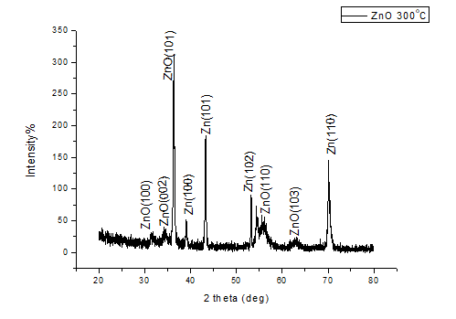
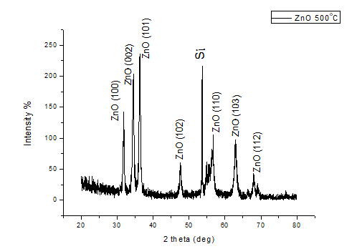
(b)
(a)

Figure 3. XRD pattern for ZnO films on Si substrate prepared by thermal oxidation (a) ZnO films at growth temperature 300 ºC and (b) ZnO films at growth temperature 500 ºC.

Table 1. Structural parameters of the investigated ZnO thin film at 300 ºC
 | ZnO(101) | Zn(101) | ZnO(110) | Zn(110)
D crystallite size (nm) | 36.788 | 35.232 | 35.263 | 27.841
2θ | 36.2554 | 43.2196 | 56.6004 | 70.6300
d (Å) | 2.47570 | 2.09154 | 1.62475 | 1.33250

Table 2. Structural parameters of the investigated ZnO thin film at 500 ºC
 | (100) (002) | (101) (102) | (110) (103) | (112)
D crystallite size (nm) | 23.0 161.1 | 25.83 8.51 | 3.06 16.7 | 0.69
2θ | 31.82 34.33 | 36.27 47.5 | 56.69 62.7 | 67.97
d (Å) | 2.81 2.61 | 2.47 1.91 | 1.62 1.48 | 1.38

Conclusion

The FESEM and EDX spectrum results we can say that Zn was successfully deposited on the Si substrate by using thermal evaporation method. The FESEM of Zn thin film shows that the particles were almost round shape with uniform distribution over the Si surface. Zn particles were in nanoparticles size and the thickness of Zn layer showed by cross section of Zn film was in micrometer. For thermal oxidation process, we obtained ZnO nanocrystals with hexagonal shape from the top view of FESEM image at low growth temperature of 300 ºC. The size of nanowires was decreasing with increasing the growth temperature to 500 ºC. The EDX spectrum of ZnO at 300 ºC and ZnO of 500 ºC confirmed that the highest peaks were Zn and O meaning that oxidation was occurred. The XRD pattern of ZnO at growth temperature 300 ºC obtained that the oxidation of Zn was started at 300 ºC since the sharpest peak was indexed to ZnO(101) plane but the oxidation was not fully completed by considering other peaks of Zn. However, all the peaks of ZnO at 500 ºC were indexed to ZnO (100), (002), (102), (110), (103) and (112) planes meaning that the oxidation was completely occurred. The intensity was increased with the increase in growth temperature from 300 ºC to 500 ºC. The crystallite size, D of ZnO particles was calculated from 27.841 nm to 36.788 nm for ZnO at 300 °C and 0.697 nm to 161.18 nm for ZnO at 500 °C.

Acknowledgement
The authors are grateful to the RAGS grant #RDU 151410 for financial support to carry out this work. The authors also wish to extend their sincere thanks to all the technical staffs of Faculty of Manufacturing Engineering, University Malaysia Pahang involved related to this research work.

References
- Aida, M. S., Tomasella, E., Cellier, J., Jacquet, M., Bouhssira, N., Abed, S. and Mosbah, A. (2006). Annealing and oxidation mechanism of evaporated zinc thin films from zinc oxide powder. Thin Solid Films, 515 1494-99.
- Rusu, G. G., Girtan, M. and Rusu, S. (2007). Preparation and characterization of ZnO thin films prepared by thermal oxidation of evaporated Zn thin films. Superlattices and Microstructures, 42: 116-22.
- Yuan, L., Wang, C., Cai, R., Wang, Y. and Zhou, G. (2014). Temperature-dependent growth mechanism and microstructure of ZnO nanostructures grown from the thermal oxidation of zinc. Journal of Crystal Growth, 390:101-108.
- Girtan, M., Rusu, G.G., Dabos-Seignon, S. and Rusu, M. (2008). Structural and electrical properties of zinc oxides thin films prepared by thermal oxidation. Applied Surface Science, 254: 4179-4185.
- Rusu, G. G., Rusu, M. and Apetroaei, N. (2007). On the structural changes during thermal oxidation of evaporated Zn thin films. Thin Solid Films, 515: 8699-8704.
- Yuvaraj, D. and Rao, K. N. (2009). Selective growth of ZnO nanoneedles by thermal oxidation of Zn microstructures. Materials Science and Engineering B, 164:195-99.
- Liu, Y., Pan, C., Dai, Y. and Chen, W. (2008). Synthesis of one-dimensional ZnO nanoneedles using thermal oxidation process in the air and its application as filed emitters. Materials Letters, 62: 2783-2786.
- Li, Z. W., Gao, W. and Reeves, R. J. (2005). Zinc oxide films by thermal oxidation of zinc thin films. Surface & Coatings Technology, 198: 319-323.
- Dhananjay., Nagaraju, J. and Krupanidhi, S. B. (2007). Investigations on zinc oxide thin films grown on Si(100) by thermal oxidation. Materials Science and Engineering B, 137: 126-130.
- Rusu, D. I., Rusu, G. G. and Luca, D. (2011). Structural characteristics and optical properties of thermally oxidized zinc films. Acta Physica Polonica A, 119: 850-856.
- Pietruska, R., Witkowski, B.S., Gieraltowska, S., Caban, P., Wachnicki, L., Zielony, E., Gwozdz, K., Bieganski, P., Placzek-Popko, E. and Godlewski, M. (2015). New efficient solar cell structures based on zinc oxide nanorods. Solar Energy Materials & Solar Cells, 143: 99-104.
- Yu, W. and Pan, C. (2009). Low temperature thermal oxidation synthesis of ZnO nanoneedles and the growth mechanism. Materials Chemistry and Physics, 115: 74-79.

