

MALAYSIAN JOURNAL OF ANALYTICAL SCIENCES
ISSN 1394 - 2506

Published by The Malaysian Analytical Sciences Society

Modified Leaching of ²³⁸U and ²³²Th from Water Leach Purification (WLP) Residue

(Modifikasi Larut Lesap Bagi ²³⁸U dan ²³²Th dari Residu Pemurnian Larut Lesap Air (WLP))

Nur Shahidah Abdul Rashid¹, Zetty Izzaty Saleh², Nurul Syiffa Mahzan², Siti Nur Ain Sulaiman²,
Khoo Kok Siong², Mohd. Idzat Idris², Syazwani Mohd Fadzil²*

¹Division of Advanced Nuclear Engineering,
Pohang University of Science and Technology, 790784 Pohang, Gyeongsangbuk, South Korea
²School of Applied Physics, Faculty of Science and Technology,
Universiti Kebangsaan Malaysia, 43600 UKM Bangi, Selangor, Malaysia

*Corresponding author: syazwanimf@ukm.edu.my

Received: 29 August 2017; Accepted: 29 October 2018

Abstract
In recent years, the importance of actinide element mobile fractions in risk assessment evaluation of contaminated sites has increased. The knowledge of the sorption kinetics of ²³⁸U and ²³²Th and the thermodynamics behind the sorption process on radioactive waste is important to understand their mobility. In this study, the leaching process of ²³⁸U and ²³²Th from water leach purification (WLP) residue of Lynas Advanced Materials Plant was investigated to obtain the optimum leaching conditions by combining synthetic precipitation leaching procedure and batch method for the simulation of acid rain and heavy flooding, correspondingly. The initial ²³⁸U and ²³²Th concentrations, and the concentration at varies pH and contact time of ²³⁸U and ²³²Th from the WLP residue were studied. Results show that the initial concentrations of ²³⁸U and ²³²Th in the WLP residue are 6.6 and 206.1 mg/kg, respectively. In general, the highest values of the concentration after the leaching process of ²³⁸U and ²³²Th are 0.363 and 8.288 mg/kg, correspondingly. These results show the maximum potential remobilisation of ²³⁸U and ²³²Th at pH 4 with the same contact time of 14 days. At a similar duration, the maximum percentages of leaching are 5.50% and 3.99% for ²³⁸U and ²³²Th, respectively. Moreover, at pH 7, the minimum leaching percentages of ²³⁸U and ²³²Th are 4.7% and 3.61%, correspondingly. Thus, remobilising ²³⁸U and ²³²Th shows that the rate of leaching is influenced by the pH of leachant used. The maximum concentrations of ²³⁸U and ²³²Th are obtained at low pH such as pH 4. At pH 7 and 8, the leached amounts of ²³⁸U and ²³²Th are minimum. Therefore, combining the SPLP and batch method is practical for estimating the leaching and remobilisation of ²³²Th and ²³⁸U from WLP residues. The combined method may be useful for monitoring and risk assessment in environmental studies.

Keywords: leaching, WLP residue, uranium, thorium

Abstrak
Dalam tahun-tahun kebelakangan ini, kepentingan pergerakan unsur aktinida menjadi perhatian semasa penilaian risiko tapak-tapak yang tercemar. Pengetahuan tentang penyerapan kinetik dan termodinamik di sebalik proses penyerapan sisa radioaktif adalah penting untuk memahami pergerakan ²³⁸U dan ²³²Th. Dalam kajian ini, proses kelarut lesapan ²³⁸U dan ²³²Th dari residu pemurniaan larut lesap air (WLP) dari Lynas Advanced Materials Plant telah dikaji untuk mendapatkan keadaan kelarut lesapan yang optimum menggunakan gabungan prosedur larut lesap pemendapan sintetik dan kaedah kelompok, masing-masing sebagai simulasi semasa keadaan hujan asid dan banjir. Kepekatan awal ²³⁸U dan ²³²Th, dan kepekatan ²³⁸U dan ²³²Th terhadap pH dan masa berbeza dari residu WLP turut dilihat. Keputusan menunjukkan kepekatan awal ²³⁸U dan ²³²Th dalam residu WLP masing-masing adalah 6.6 mg/kg dan 206.1 mg/kg. Secara amnya, nilai tertinggi kepekatan selepas proses larut lesap bagi ²³⁸U dan ²³²Th masing-masing adalah 0.363 mg/kg dan 8.288 mg/kg. Kedua-dua hasil menunjukkan bahawa potensi pergerakan maksimum adalah pada pH 4 bagi ²³⁸U dan ²³²Th dalam masa 14 hari. Dalam tempoh masa yang sama, peratusan kelarut lesapan maksimum dicatatkan sebanyak 5.50% dan 3.99% masing-masing bagi ²³⁸U dan ²³²Th. Selain itu, pada pH 7, peratusan larut lesap minimum bagi ²³⁸U dan ²³²Th masing-masing adalah 4.7% dan 3.61%. Oleh itu, pergerakan ²³⁸U dan ²³²Th menunjukkan ia dipengaruhi oleh pH pelarut yang digunakan. Kepekatan maksimum ²³⁸U dan ²³²Th diperoleh pada pH yang lebih rendah seperti pH 4. Pada nilai pH 7 dan 8 mencatatkan kepekatan larut lesap ²³⁸U dan ²³²Th yang minimum. Kesimpulannya, gabungan kaedah SPLP dan kaedah kelompok adalah praktikal untuk menganggar larut lesap dan pergerakan ²³⁸U dan ²³²Th dari residu WLP. Gabungan kaedah ini boleh digunakan sebagai tujuan pemantauan dan penilaian risiko terhadap kajian alam sekitar.

Kata kunci: larut lesap, residu WLP, uranium, torium

Introduction
Demands for rare earth elements (REEs) have been increasing in many new energy technologies and systems that contribute to reduced greenhouse gas (GHG) emission and fossil fuel depletion [1]. However, producing REEs is far from being environmentally sustainable because it requires significant material and energy consumption whilst generating considerable air/water emissions and solid waste. Although many REEs are critically important for sustainable mobility and energy supply, producing REEs incurs serious environmental damages [2].

The Mount Weld mine is operated by Lynas Corporation Ltd. which is involved in mining and concentrating REE ore. On average, the ore contains 0.075% ThO₂ and 0.003% U₃O₈; these contents correspond to the average activity concentrations of 2.7 Bq g⁻¹ of ²³²Th and 0.3 Bq g⁻¹ of ²³⁸U [3]. The mining and processing concentrations of REE ore at Mount Weld is followed by a shipment of the concentrate to an REE processing facility, that is, Lynas Advanced Materials Plant (LAMP) at Gebeng, Pahang State, Malaysia, where further processing is conducted to produce high-purity REE compounds [3]. LAMP processes lanthanide concentrates at an integrated processing site which utilises physical and chemical treatment processes. Water leach purification (WLP) residues resulted from the leaching and purification of water-soluble lanthanide components from the calcined, cracked concentrate. According to the United States Environmental Protection Agency, rare earth concentrate is classified as a Technologically Enhanced Naturally Occurring Radioactive Material (TENORM) [4]. REEs have been considered beneficial and profitable in Malaysia, but occupational, public safety and health risks related to REEs may be addressed at their mining, transportation, processing, waste disposal and decommissioning stages [5]. Thorium is a waste product in REE mining; it is mainly eliminated during the leaching process of the desired metals. Furthermore, thorium which denotes a radioactive impact of REE mining in addition to uranium and their decay products has raised environmental concerns for the last several years [6].
In addition to WLP residues, LAMP produces flue gas desulphurisation (FGD) and neutralised underflow (NUF) residues. Among the residues, the WLP is considered the most toxic given its elevated levels of uranium, thorium, associated radioactivity and heavy metals [7]. The WLP residue process generates the most radioactive and contaminated tailings. The WLP residue contains most of uranium and thorium separated from the REE products during the refining process. The concentrate used as feedstock for the refining process contains uranium (30 ppm) and thorium (approximately 1700 ppm) generated between 3.5 and 8 Bq g⁻¹ of a specific activity. Theoretically, all the radioactive elements are removed during the refining process and are expected to be transferred to waste streams and disposed of in the tailing pond.
Leaching is a process in which contaminants are transferred from a stabilised matrix to liquid media, such as water or other solutions. Chemical reagents, such as acids, bases and chelating agents, are used to create a leaching solution to investigate the mobilisation of heavy metals from the soils [8]. Previous researchers have used leaching test to investigate the leachability of environmental contaminants from oil sludge to assess potential environmental impact [9, 10]. Then, results from leaching have been extrapolated to assess the long-term release of toxic elements from the oil sludge [10, 11]. Similar studies that used modification and combination of leaching tests have also been conducted for ²³⁸U and ²³²Th in WLP samples and have been discussed elsewhere [12, 13]. A leaching test has similar concepts adopted for soil washing.
Soil washing is frequently used in soil remediation because this process (i) completely removes contaminants, thus ensuring the rapid clean-up of a contaminated site, (ii) satisfies specific criteria, (iii) reduces or eliminates long-term liability, (iv) may be the most cost-effective solution and (v) may produce recyclable materials or energies. Chemical reagents must be added to the washing water because washing the soils with water alone will remove the low amount of cations in the leachates [14-17]. Generally, soil washing with acids relies on ion exchange and dissolution of soil components or discrete metal compounds to extract metals [8]. Strong acids attack and degrade the soil crystalline structure at extended contact times [18]. Many research studies have mentioned different types of acids used as leaching agents, thereby resulting in different metal removal efficiencies [19]. The effectiveness of soil washing is closely related to the ability of the extracting solution to dissolve the metal contaminants in soils. However, the strong bonds between the soil and metals complicate the cleaning process [18]. Moreover, efficiency is affected by extraction time with chemical reagents because the rate of metal extraction is a factor of time [8]. Although many studies on soil washing which uses different chemical reagents have been conducted, the number of reports that focused on leaching process kinetically and thermodynamically have remained insufficient in literature.
This study aims to simulate the potential remobilisation of ²³⁸U and ²³²Th that leach from the WLP residue over a range of pH with different contact time. Synthetic precipitation leaching procedure (SPLP) experiments have been performed to provide information on ²³⁸U and ²³²Th release, thus simulating the acid rain condition.

Materials and Methods
Sample preparation
The WLP residue samples were collected from LAMP, Kuantan, Malaysia. The sample was dried and sieved using a mechanical sieve to separate <2 mm particles from a coarse material. Then, the samples were transformed into pellets with a ratio of 1:6, that is, 1.0 g of WLP residue and 6.0 g of boric acid. The initial concentration of ²³⁸U and ²³²Th was determined using X-ray fluorescence spectrometer (XRF) Bruker/S8 Tiger/2009 at the Centre for Research and Instrumentation, Universiti Kebangsaan Malaysia (UKM), Bangi. The leaching test was applied to the sample to eliminate any possibility of redistributing actinides between different phases given air oxidation.

Leaching experiments
The SPLP test (Method 1312) is designed in accordance with the procedure of Solid Waste Manual 846 [20] to determine the mobility of organic and inorganic analytes present in liquids, soils and wastes. The SPLP test is used to simulate the effect of acid rain on land-disposed wastes. However, the leaching experiment is modified from the SPLP by adding pH 7 and 8, thereby simulating groundwater pH. It can also be used to determine the concentration of a contaminant that will leach from the soil. The method uses a diluted sulphuric and nitric acids (with a pH of 4.2) as the leaching solution. This method can simulate weathering for 100 years of exposure to acid rain [21] and has been studied with other leaching tools [10, 11]. This single-batch extraction method is used to assess the leaching potential of a waste exposed to rainfall. The procedure is performed using the same equipment used to perform the toxicity characteristic leaching procedure and requires using one of two leaching fluids depending on the location of the waste disposal site. A 20:1 liquid-to-solid (L/S) ratio and an extraction time of 18 ± 2 hours were used in this test. The leachate fluid consists of slightly acidified deionised water that is formulated to simulate natural precipitation. A mixture of 60:40 (H₂SO₄:HNO₃; by weight) is used to achieve the appropriate pH for the extraction fluid [20].

Combined with the previous procedure, 10 g of WLP residue was equilibrated with 200 mL of leaching solution at a 20:1 ratio with various pH values (4, 5, 7 and 8) as a function of time. Additional information on batch leaching test can be found elsewhere [9-13]. The pH of the solution was adjusted prior to the experiments, thus simulating the potential remobilisation of ²³⁸U and ²³²Th after heavy flooding of the catchment area. The meter was calibrated prior to each set of measurements, and checks were obtained on other buffers between readings to ensure that all buffers are read and recorded at ±0.05 pH units. The pH analysis did not require a sample treatment but the sample solution should be measured immediately. The agitation was held at 200 rpm using a stirrer at a fixed temperature (27 °C) for 18 hours. Then, the samples were left in the room with different contact time. This approach presents the correlation between leachates and contact time. All the samples were then observed on the 1st, 2nd, 7th and 14th day. Then, the solid/liquid slurry is filtered and analysed by using inductively coupled plasma–mass spectrometer (ICP-MS) ELAN 9000 PerkinElmer SCIEX at the Malaysia Nuclear Agency, Bangi. Data were recorded, and each extraction method was prepared in duplicate. Blanks of leaching solutions (pH 4, 5, 7 and 8) without WLP were run as controls.

Percent of contaminant mass in the SPLP leachate also known as percentage uptake was calculated as equation 1:

$\frac{\left(C_{L}×V_{L}\right)}{\left(C_{T}×M_{S}\right)}×100$, (1)

where C_{L} is the leachate concentration (mg/L), V_{L} is the volume of leachate in litres (0.2 L), C_{T} is the total sample concentration (mg/kg) and M_{S} is the mass of the sample in kilograms (0.01 kg) [22].

Results and Discussion
The initial concentration of ²³⁸U and ²³²Th in WLP residue samples was analysed using the XRF. The analysis finding shows that the concentration of ²³⁸U and ²³²Th is 6.6 and 206.1 mg/kg, respectively [12, 13]. According to the Malaysia Nuclear Agency [23], the WLP residue with a production of approximately 32,000 tonnes per year contains 1655 ppm ²³²Th and 22.5 ppm ²³⁸U. The radioactive residue is stored in retention ponds which are built with impermeable soil and are lined with a high-density polyethylene cover to prevent any seepage. WLP residue was also classified as a radioactive residue in accordance with the preview of Act 304 and regulations [24]. The treated effluent was analysed for its thorium radionuclide contents, ²²⁶Ra and ²²⁸Ra, but the concentrations did not reach the detection limit of 0.5 Bq/L during a test run. Thorium is assumed to be completely precipitated as thorium pyrophosphate (ThP₂O₇) during the separation with MgO at pH 3.5 and discharged in the WLP. The WLP residues contain abundant compounds in addition to ThP₂O₇, such as iron, barium, calcium or silica species. The composition of WLP residue affects the elemental solubility in an aqueous phase. ThP₂O₇ is water-insoluble formed by converting the sulphate of thorium, whereas the rare earth sulphates remain stable in sulphate solution [24,25].

The leaching process depends on several physical and chemical factors and occurs whenever a liquid phase percolates or is in contact with a solid material, thereby dissolving inorganic or organic substances [26]. The most important physical factors are size, shape and porosity of the particles, homogeneity of mineral phases, temperature, time frame, flow rate or liquid amount of leachant and degree of saturation and wet/dry cycles. The most important chemical aspects are related to pH and redox conditions, control mechanisms (kinetic or equilibrium), availability for leaching, complexation and sorption processes [27]. The leaching processes may involve precipitation/dissolution, diffusion, sorption, surface coating or wash-off which may be controlled kinetically or by equilibrium conditions [28]. Numerous tests, such as identifying leachable constituents [29], may be used depending on the objectives to evaluate the leaching processes. The present study focuses on ²³⁸U and ²³²Th. The most important variables that must be established for a specific leaching test are the sample preparation, leachant composition (pH, redox conditions), method of contact, L/S ratio, contact time, temperature and leachant separation method [28].

The pH values of leachate used in modified SPLP method are illustrated in Figure 1. The pH is selected to simulate acid rain (pH = 4 ± 0.05 and pH = 5 ± 0.05) because air includes several acidic emissions such as hydrogen fluoride (HF) and sulphuric acid (H₂SO₄) [7]. The modified SPLP was adjusted to pH = 7 ± 0.05 and pH = 8 ± 0.05 to simulate groundwater condition. Soil and water contaminants may be released by natural processes, such as weathering or human mismanagement, when constructing defective impoundment areas which may break or leak. Environmental effects of acid gases are popular and can lead to localised ‘acid rain’ which can damage crops and acidify freshwater bodies such as lakes and streams [30]. LAMP which is situated on the east coast peninsula of Malaysia receives considerable rains during monsoon season. These climates would lead to heavy flash floods and might cause several dams to overflow, thereby dispersing the WLP residue by wind and rain. The leaching of ²³⁸U, ²³²Th and other metals may contribute to increased groundwater contamination.

Figure 1 demonstrates that the average ²³⁸U concentration leached from the WLP residue is in the ranges of 0.271–0.363 mg/kg (pH 4), 0.256–0.349 mg/kg (pH 5), 0.283–0.31 mg/kg (pH 7) and 0.235–0.323 mg/kg (pH 8), whereas that of the ²³²Th concentration is in the ranges of 2.078–8.228 mg/kg (pH 4), 2.054–8.08 mg/kg (pH 5), 2.139–7.44 mg/kg (pH 7) and 1.827–8.026 mg/kg (pH 8). At low pH, the concentration of ²³⁸U and ²³²Th is the maximum. The maximum concentration value is frequently reported as the availability for leaching. For both radionuclides, at pH 7 and 8, the leached amount is minimum. The mixture of two concentrated acid solutions does not have a buffering characteristic. Thus, the solution mixture does not resist changes in the concentrations of hydronium and hydroxide ions, as well as the pH. The resistance of a buffer solution to pH change is based on Le Chatelier’s principle and the common ion effect [31].

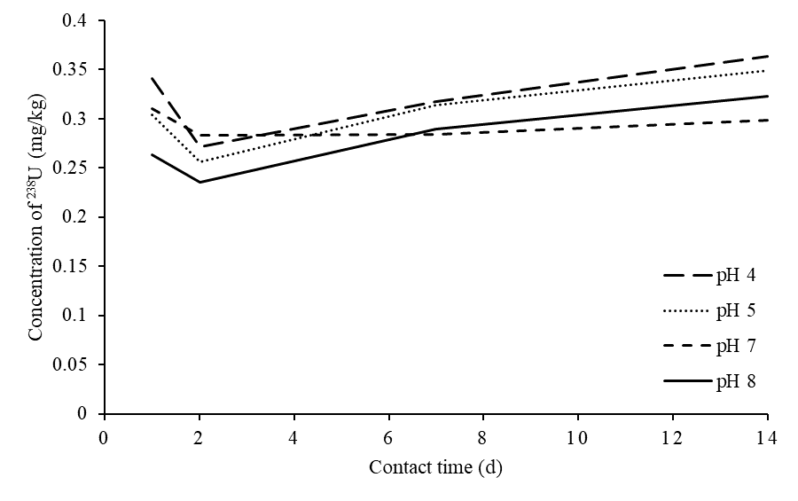
(a)

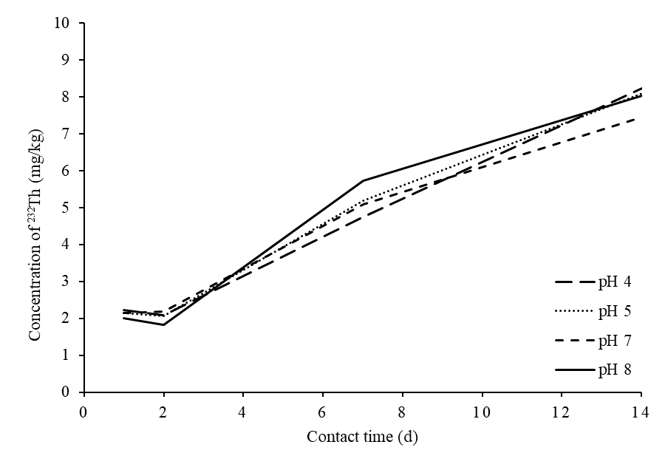
(b)
Figure 1. Effect of contact time and pH on the leaching concentrations of (a) ²³⁸U and (b) ²³²Th.

Figure 1 exhibits that the highest values of the concentration of ²³⁸U and ²³²Th are 0.363 and 8.228 mg/kg, correspondingly [12, 13]. The concentration of ²³²Th is higher than ²³⁸U probably due to the ²³²Th chemical and physical characteristics, namely, strong sorption to solid matrices, thereby resulting in an extremely low bioavailability and mobility. Thorium (Th⁺⁴) is highly insoluble in water. Under acidic conditions below pH 4, the solubility increases, and complexation with carbonates, sulphates or organic substances enhances its solubility [32]. Al-Areqi et al. [24] found that the maximum recovery and concentration of ²³²Th are obtained by HNO₃ and H₂SO₄ in comparison with NaOH. Thorium is mostly available as an insoluble material during the physical beneficiation process, but it is transformed during the chemical processes into extra soluble species, such as Th(NO₃)₄, Th(OH)₄, Th-oxalate and other species [32]. In soils, humic substances are considered particularly important in adsorbing thorium. In most cases, sediment resuspension and mixing may control the transportation of particle-sorbed thorium in water; however, in several cases, the concentration of dissolved thorium in waters may increase due to formation of soluble complexes with carbonate, humic materials or other ligands in the water [33]. The contamination of groundwater by transporting thorium from soil to groundwater does not occur in most soils, except those with low sorption characteristics and the capability to form soluble complexes. Chelating agents produced by certain microorganisms (Pseudomonas aeruginosa) present in soils may enhance the dissolution of thorium in soils [32].

Contact intervals of 1–14 days were applied to evaluate leaching as a function of contact time. This approach is different from previous studies [10, 11] which have extended intervals based on a different standard leaching procedure. This period was selected because it was reported as a period of flooding on the east coast peninsula of Malaysia which receives abundant rain during the monsoon season. In Figure 1(a), the concentration of ²³⁸U slightly increased with contact time, whereas Figure 1(b) displays that the concentration of ²³⁸Th rapidly increased with contact time. Moreover, Figure 2 depicts the average percentage release for ²³⁸U and ²³²Th. The patterned release for ²³⁸U and ²³²Th was presented in a log scale line to represent the release behaviour on the basis of the calculated percentage release using Eq. (1). The maximum percentages of leaching are 5.50% and 3.99% for ²³⁸U and ²³²Th, respectively. These results show the maximum potential remobilisation of ²³⁸U and ²³²Th at low pH (pH=4) during the end of the duration test at 14 days. By contrast, the minimum leaching efficiencies at pH 7 were recorded for ²³⁸U and ²³²Th at 4.7% and 3.61%, correspondingly.

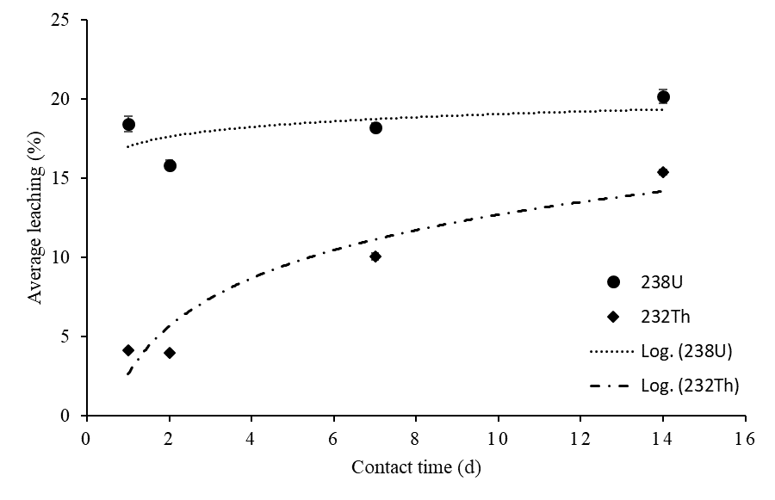
Figure 2. Percentage of average ²³⁸U and ²³²Th release as function of time

Conclusion
In summary, the effect of ²³⁸U and ²³²Th leaching release was moderately influenced by the pH of the solution used. The findings indicate that the maximum potential remobilisation percentages of ²³⁸U and ²³²Th at pH 4 at the final-day testing interval (14 days) are 5.50% and 3.99%, respectively. By contrast, at pH 7, the minimum leaching release was found for both waste products. Potential mobilisation of ²³⁸U and ²³²Th was observed from the WLP in the aqueous medium during the monsoon and flooding seasons.

Acknowledgement
The authors are grateful to the Centre for Research and Instrumentation (CRIM) for the facility and Universiti Kebangsaan Malaysia for the financial support under the project code GGPM-2016-040.

References
- Alonso, E., Sherman, A. M., Wallington, T. J., Everson, M. P., Field, F. R., Roth, R. and Kirchain, R. E. (2012). Evaluating rare earth element availability: A case with revolutionary demand from clean technologies. Environmental Science & Technology, 46(6): 3406-3414.
- Navarro, J. and Zhao, F. (2014). Life-cycle assessment of the production of rare-earth elements for energy applications: A review. Frontiers in Energy Research, 2: 45.
- IAEA (2011). Report of the international review mission on the radiation safety aspects of a proposed rare earths processing facility (the Lynas project). International Atomic Energy Agency (IAEA).
- O'Brien, R. and Cooper, M. (1998). Technologically enhanced naturally occurring radioactive material (NORM): pathway analysis and radiological impact. Applied Radiation and Isotopes, 49(3): 227-239.
- Zhang L. (2014). Towards sustainable rare earth mining: a study of occupational & community health issues. Thesis of Master Degree, University of British Columbia.
- IAEA (2011). Radiation protection and NORM residue management in the production of rare earths from thorium containing minerals. International Atomic Energy Agency (IAEA).
- National Toxics Network (2012). Rare earth and radioactive waste a preliminary waste stream assessment of the Lynas Advanced Materials Plant, Gebeng, Malaysia. National Toxics Network (NTN).
- Alghanmi, S. I., Al Sulami, A. F., El-Zayat, T. A., Alhogbi, B. G. and Salam, M. A. (2015). Acid leaching of heavy metals from contaminated soil collected from Jeddah, Saudi Arabia: kinetic and thermodynamics studies. International Soil and Water Conservation Research, 3(3): 196-208.
- Fadzil, S. M., Sarmani, S., Ab. Majid, A., Khoo, K. S. And Hamzah, A. (2011). k₀-INAA measurement of levels of toxic elements in oil sludge and their leachability. Journal of Radioanalytical and Nuclear Chemistry 287: 41-47.
- Mohd Fadzil, S. (2011). Penentuan kepekatan dan penilaian jangka masa panjang pelepasan unsur As, Co, Cr, dan Zn dari enap cemar minyak. Thesis of Master Degree, Universiti Kebangsaan Malaysia.
- Mohd Fadzil, S., Sarmani, S., Ab. Majid, A., Hamzah A. and Khoo, K.S. (2013). Modeling of cumulative release on long term leaching behaviour of selected oil sludge from crude oil terminal and petroleum refining plant. Journal of Radioanalytical and Nuclear Chemistry 297: 265-270.
- Mahzan, N. S. (2017). Menentukan tahap kelarutlesapan radionuklid ²³⁸U dari sampel residu pemurnian larut lesap air (WLP) terhadap medium akues. Thesis of Bachelor Degree, Universiti Kebangsaan Malaysia.
- Saleh, Z. I. (2017). Penentuan kelarutlesapan radionuklid ²³²Th dalam sampel pemurnian larut lesap air (WLP). Thesis of Bachelor Degree, Universiti Kebangsaan Malaysia.
- Government of Canada (2003). Site remediation technologies: A reference manual. Contaminated Sites Working Group, Government of Canada, Ontario, Canada.
- Fawzy, E. (2008). Soil remediation using in situ immobilisation techniques. Chemistry and Ecology, 24(2): 147-156.
- Nouri, J., Khorasani, N., Lorestani, B., Karami, M., Hassani, A. and Yousefi, N. (2009). Accumulation of heavy metals in soil and uptake by plant species with phytoremediation potential. Environmental Earth Sciences, 59(2): 315-323.
- Kord, B., Mataji, A. and Babaie, S. (2010). Pine (Pinus Eldarica Medw.) needles as indicator for heavy metals pollution. International Journal of Environmental Science & Technology, 7(1): 79-84.
- Wuana, R., Okieimen, F. and Imborvungu, J. (2010). Removal of heavy metals from a contaminated soil using organic chelating acids. International Journal of Environmental Science & Technology, 7(3): 485-496.
- Moutsatsou, A., Gregou, M., Matsas, D. and Protonotarios, V. (2006). Washing as a remediation technology applicable in soils heavily polluted by mining–metallurgical activities. Chemosphere, 63(10): 1632-1640.
- USEPA (1994). Method 1312: Synthetic Precipitation Leaching Procedure, part of test methods for evaluating solid waste, physical/chemical methods. United States Environmental Protection Agency (USEPA).
- Townsend, T., Jang, Y.-C. and Tolaymat, T. (2003). A guide to the use of leaching tests in solid waste management decision making. University of Florida, Florida.
- New Jersey Department of Environmental Protection (2013). Development of Site-Specific Impact to Ground Water Soil Remediation Standards Using the Synthethic Precipitation Leaching Procedure. New Jersey Department of Environmental Protection.
- Malaysia Nuclear Agency (2010). Radiological impact assessment of advanced materials plant Gebeng Industrial Estate, Kuantan, Pahang. Malaysia Nuclear Agency.
- Al-Areqi, W. M., Majid, A. A., Sarmani, S. (2014). Digestion study of water leach purification (WLP) residue for possibility of thorium extraction. Malaysian Journal of Analytical Sciences, 18(1): 221-225.
- IAEA. (2014). Report of international post-review on the radiation safety aspects of the operation of a rare earth processing facility and assessment of the implementation of the 2011 mission recommendations. International Atomic Energy Agency (IAEA).
- Quina, M. J., Bordado, J. C. and Quinta-Ferreira, R. M. (2009). The influence of pH on the leaching behaviour of inorganic components from municipal solid waste APC residues. Waste Management, 29(9): 2483-2493.
- Van der Sloot, H. and Dijkstra, J. (2004). Development of horizontally standardized leaching tests for construction materials: A material based or release based approach? Identical leaching mechanisms for different materials, (ECN-C-04-060). https://www.ecn.nl/publications/PdfFetch.aspx?nr=ECN-C--04-060. [Accessed online 15 February 2017].
- Pendowski, J. (2003). An assessment of laboratory leaching tests for predicting the impacts of fill material on ground water and surface water quality-Report to the legislature. Washington State Department of Ecology. https://fortress.wa.gov/ecy/publications/documents/0309107.pdf. [Accessed online 8 March 2017].
- Guo, P., Duan, T., Song, X., Xu, J. and Chen, H. (2008). Effects of soil pH and organic matter on distribution of thorium fractions in soil contaminated by rare-earth industries. Talanta, 77(2): 624-27.
- Wright, R. and Schindler, D. (1995). Interaction of acid rain and global changes: effects on terrestrial and aquatic ecosystems. Water, Air, and Soil Pollution, 85(1): 89-99.
- Treptow, R. S. (1980). Le Châtelier's principle: A reexamination and method of graphic illustration. Journal of Chemical Education, 57(6): 417.
- Langmuir, D. and Herman, J. S. (1980). The mobility of thorium in natural waters at low temperatures. Geochimica et Cosmochimica Acta, 44(11): 1753-1766.
- Mernagh, T. P. and Miezitis, Y. (2008). A review of the geochemical processes controlling the distribution of thorium in the earth's crust and Australia's thorium resources. Geoscience Australia, Canberra: pp. 48.

