

MALAYSIAN JOURNAL OF ANALYTICAL SCIENCES
ISSN 1394 - 2506

Published by The Malaysian Analytical Sciences Society

POLYURETHANE MEMBRANE AS AN ADSORBENT FOR METHYL ORANGE AND ETHYL VIOLET DYES

(Membran Poliuretana Sebagai Penjerap untuk Pewarna Metil Oren dan Etil Ungu Lembayung)

Khairiah Haji Badri^{1,2}*, Fatem Hamimie Ismail¹, Amira Shakim Abdul Shakir¹, Sharifah Mohamad³,
Hawa Aqilah Hamuzan¹, Nur Syakilla Hassan¹

¹Polymer Research Center, Faculty of Science and Technology
²School of Chemical Sciences and Food Technology, Faculty of Science and Technology
Universiti Kebangsaan Malaysia, 43600 UKM Bangi, Selangor, Malaysia
³Department of Chemistry, Faculty of Science,
Universiti Malaya, 50603 Kuala Lumpur, Malaysia

*Corressponding author: kaybadri@ukm.edu.my

Received: 27 July 2017; Accepted: 28 April 2018

Abstract
Ethyl violet (EV) and methyl orange (MO) are commercial dyes used in a large number of industries. Due to their complex chemical structures and synthetic nature, these dyes are highly stable to light and oxidation, making them non-biodegradable, highly toxic, carcinogenic and mutagenic in nature. Among all techniques, adsorption continues to attract considerable attention due to its simplistic approach and numerous benefits such as greater efficiency, capacity to remove dyes on a large scale, ease of recovery, and recyclability of adsorbents. A palm-based polyurethane (PU) membrane has been synthesised into adsorbent and its ability to adsorb the dye molecules was investigated. The PU membrane was produced via condensation polymerisation between palm-based monoester (PKOp) and 4,4-methylene diphenyl diisocyanate (MDI) with acetone as the solvent. The FTIR spectrum has confirmed the formation of urethane linkage (HN-(C)O) through the presence of N-H, C-NH, C-O-C and C=O urethane peaks which were observed at 3293 cm⁻¹, 1602cm⁻¹, 1221 cm⁻¹ dan 1716 cm⁻¹, respectively. Tensile testing has demonstrated that as the thickness of membrane is increased, the elasticity also increased proportionally with increasing tensile strain ranging from 6.7 MPa to 7.42 MPa. Various adsorption parameters such as initial concentration of dyes, effect of pH, effect of adsorbent dosage and contact time were studied and optimised. The adsorption study revealed that approximately 99% of EV and 25% of MO was adsorbed by the PU membrane within a short duration of 30 minutes. The parameters were determined from Langmuir, Freundlich and Temkin adsorption isotherm models. The isotherm studies specified that the adsorption of PU membrane towards EV and MO dyes is well fitted to the Langmuir model with the value of the maximum adsorption capacities for monolayer adsorption at 9.461 mg/g for EV and 4.340 mg/g for MO.

Keywords: polyurethane membrane, adsorption, ethyl violet, methyl orange, adsorption isotherm

Abstrak
Etil ungu lembayung (EUL) dan metil oren (MO) adalah pewarna komersial yang digunakan dengan banyaknya dalam industri. Pewarna ini adalah sangat stabil di bawah dedahan cahaya dan pengoksidaan disebabkan oleh struktur kimianya yang komplek dan sifat sintetiknya menjadikannya tidak terbiodegradasi, sangat bertoksik, karsinogenik dan mutagenik. Penjerapan adalah kaedah yang semakin mendapat perhatian disebabkan pendekatannya yang ringkas dan kepentingan lain seperti keberkesanan yang tinggi, kemampuan menyingkirkan pewarna pada skala besar, perolehan semula yang mudah dan kitar-semula penjerap. Membran PU telah dihasilkan melalui tindak balas pra-pempolimeran antara monoester berasaskan poliol sawit (PKO-p) dan 4,4-metilena difenil diisosianat (MDI). Pencirian membran PU dijalankan melalui analisis spektroskopi FTIR, FESEM serta ujian regangan. Kehadiran tulang belakang uretana dikenalpasti dalam spektrum FTIR membran PU dengan kehadiran puncak N-H, CNH, C-O-C dan C=O masing-masing dikesan pada nombor gelombang 3293 cm⁻¹, 1602cm⁻¹, 1221 cm⁻¹ dan 1716 cm⁻¹. Ujian regangan menunjukkan pertambahan dalam ketebalan membran meningkatkan terikan regangan dalam julat 6.7 MPa sehingga 7.42 MPa. Beberapa parameter penjerapan seperti kepekatan awal pewarna, kesan pH, kesan dos penjerap dan masa sentuhan telah dikaji dan dioptimumkan. Kajian penjerapan mendapati kira-kira 99% EUL dan 25% MO telah dijerap oleh membran PU dalam tempoh yang singkat iaitu 30 minit. Parameter ini ditentukan melalui model penjerapan isoterma Langmuir, Freundlich dan Temkin. Kajian isoterma ini mendapati penjerapan membran PU terhadap EUL dan MO adalah bertepatan dengan model Langmuir dengan nilai maksima kapasiti penjerapan sebanyak 9.461 mg/g untuk EUL dan 4.340 mg/g untuk MO.

Kata kunci: membran poliuretana, penjerapan, etil ungu lembayung, metil oren, isoterma penjerapan

Introduction
Rapid growth in industrial and manufacturing activities not only led to economic development but it has increased pollution by releasing toxic materials to the environment. An increasing concern on releasing of dye effluents from the textile industry into the aquatic ecosystems has initiated this study. It has become a major problem due to non-biodegradable nature of dyes which permanently pollute the environment [1-4]. Furthermore, bright coloured effluent containing toxic dyes may adversely affect aquatic life by lowering the penetration rate of sunlight entering the water and causing harm to living organisms [5-7]. Ethyl violet (EV) and methyl orange (MO) are commercial dyes used in a large number of industries, not only textile but also the food industry. Due to their complex chemical structures and synthetic nature, these dyes are highly stable to light and oxidation, making them non-biodegradable, highly toxic, carcinogenic and mutagenic in nature.

Thus, effective approaches are necessary to reduce this problem. Solid adsorbent has been increasingly used recently for the removal of chemical substance from industrial waste water. The adsorption method using polymeric membranes is one of the interesting methods that can be studied. Polymeric membrane has the ability to remove dye in a short time and polymer has high resistance to chemical and thermal stability. Polymers such as polyurethane (PU) is one of the polymers that can be used to study membrane adsorption levels based on the elastomer characteristics of PU and its ability to act as membranes. Besides that, PU is elastic and has good adsorption properties [8-10]. In this research, PU membrane was prepared and adsorptions of dyes on PU membrane were examined.

Materials and Methods
Materials
Palm-based polyol (PKO-p) was supplied by UKM Technology Sdn Bhd directly from the pilot plant stationed at UKM/MPOB Station, Pekan Bangi Lama, Selangor, Malaysia. 4,4-diphenylmethane diisocyanate (MDI) was obtained from Behn Meyer Agricare (M) Sdn. Bhd Subang Jaya Selangor, Malaysia. Industrial grade acetone was supplied by Saintifik Gemilang Sdn. Bhd. Polyethylene glycol (PEG; MW 200 Da) and hydrochloric acid (HCl, 98%) were purchased from Merck (M) Sdn Bhd. Selangor, Malaysia. Sodium hydroxide pellet (NaOH, ~98% purity) was supplied by Systerm Sdn Bhd, Shah Alam, Selangor, Malaysia. Ethyl violet (cationic triarylmethane dye) and methyl orange (anionic dye) were purchased from Sigma Aldrich (M) Sdn. Bhd. Both dyes were used without further purification.

Method
Pre-polymerisation method was used to produce the palm-based PU membrane. Polyurethane membrane involved the reaction between PKO-p and MDI in the presence of PEG as the chain extender and acetone as the solvent. Initially, 100 wt.% PKO-p, 40 wt.% PEG and 30 wt.% acetone were mixed together and then reacted with the mixture consisting of 100 wt.% MDI and 30 wt.% acetone at a ratio of 1:1 and stirred for 30 s until a homogeneous mixture was obtained. The mixture was casted on a Teflon plate and left at room temperature for the curing process.

Characterisation
Fourier transform infrared spectroscopy (FTIR) analysis was conducted using a Perkin Elmer Spectrum 400 model spectrophotometer. Each spectrum was recorded in a frequency ranging from 4000 to 650 cm⁻¹ via the ATR-FTIR technique. The tensile test was performed using Instron Universal Testing Machine model 2716 Series in accordance with ASTM D882-10 standard. The PU membrane was cut into dumbbell-shape with the dimension of 180 mm x 25 mm (length x width). The surface morphology of the PU membrane was examined using a Field Emission Scanning Electron Microscope (FESEM) model JEOL JSM-7600F. PU membrane was cut into cube shape with the dimension of 2 mm x 2 mm x 2 mm for the adsorption experiment.

Adsorption experiments
For the effect of contact time study, 250 ml of dye solution was prepared and 0.6 g adsorbent was added and shaken using an electronic shaker at 180 rpm. The temperature was maintained at 30 °C. Initial concentrations of dyes were studied by preparing five different concentrations which were 5, 10, 15, 20, 25 and 30 ppm dye solutions. About 0.6 g of adsorbent was added into 250 ml dye solution and left for 40 min at 30 °C. The solutions were filtered and further examination was carried out using UV-vis spectrometer. In the pH study, a constant amount of adsorbent (0.6 g) was added into a constant volume of dye (250 ml). The initial concentration used was 10 ppm with different pH. The pH of dyes was adjusted to 2.5, 4.5, 5.5, 7.5, 8.5 and 12.5 by adding 0.01 M NaOH and 0.01 M HCl. The flask was shaken at 180 rpm using the electronic shaker at 30 ° C. In order to investigate the effect of adsorbent dose, different amounts of adsorbent (0.2 g, 0.4 g, 0.6 g, 0.8 g, 1.0 g and 1.2 g) were added into the 250 ml dye solution at 30 °C, pH 7 with 30 minutes contact time.

Results and Discussion
Fourier transform infrared spectroscopy
The FTIR spectrum exhibited the presence of several peaks related to the functional group in PU membrane. PU was formed from the reaction between isocyanate group (-N=C=O) with hydroxyl group (OH) from PKO-p to produce urethane linkage. The presence of C-NH, -OH, CNH dan C=O peaks were observed in FTIR spectrum of PU membrane. Table 1 summarises several important peaks observed in the FTIR spectra of the PU membrane, MDI and PKO-p.

Table 1. Data analysis from the FTIR spectrum of the PU membrane, MDI and PKO-p
Functional Group | Wavenumber, cm⁻¹
Functional Group | PU | MDI | PKO-p
N-H | 3293 | - | -
CH₂ | 2923 | 2914 | 2853
CH₃ | 2853 | - | 2922
C=O | 1716 | 1717 | 1737
C-N | 1602 | 1608 | -
N-H | 1534 | - | -
C-O-C | 1221 | - | 1048
N=C=O | - | 2246
-OH | - | - | 3359

The peak at 3293 cm⁻¹ indicated the presence of NH group. The peaks at 2923 and 2853 cm⁻¹ are attributed to the stretching vibration of −CH₂ and CH₃. The absorption peaks at 1716 cm⁻¹, 1602 cm⁻¹ and 1221 cm⁻¹ are assigned to carbonyl urethane group (C=O), carbamate (C-NH) and ether (-C-O-C-) respectively. These peaks showed the presence of the urethane bond which is the main chain in the PU structure. The disappearance of isocyanate group in MDI and hydroxyl group in PKO-p from the PU spectra showed that MDI and PKO-p have completely reacted to form PU [11].

Field emission scanning electron microscope analysis
FESEM analysis provides information about surface morphology and pore distribution of the PU membrane. This information is used to study on the porosity property of the PU membrane and its effect on adsorption of the dyes. Basically, PU membrane has a flat surface and is transparent. However, the clear colour of PU membrane changed to yellowish for a thicker PU membrane. Figure 1 shows the FESEM micrographs obtained at three different magnifications which are (a) 5,000x, (b) 10,000x, (c) 20,000x and (d) 25,000x. The FESEM micrographs show the porosity and the hollow structure on the surface of the PU membrane. Membranes with pores indicate excellent potential in the adsorption study. Presence of pores is important for an adsorbent to effectively work in the adsorption process.
Figure 1. FESEM micrographs at magnifications of (a) 5,000x, (b) 10,000x, (c) 20,000x and (d) 25,000x

Tensile properties
Figure 2 shows the graph of tensile strain at break and tensile stress against thickness of the PU membrane. The percentage of tensile strain at break increased from 418 % to 543% with increasing thickness from 0.8 mm to 2.5 mm (Figure 2a). However, the percentage of tensile strain at break reduced for PU membrane at 2.5 mm thickness. The same trend is observed in Figure 2b where increasing thickness of the PU membrane from 0.8 mm to 2.5 mm increased the tensile stress from 6.70 MPa to 7.42 MPa. Based on the graph, the PU membrane with 2.0 mm thickness has been selected for adsorption studies. This is because it shows the highest tensile strain capability,

Tensile properties
Figure 2 shows the graph of tensile strain at break and tensile stress against thickness of the PU membrane. The percentage of tensile strain at break increased from 418 % to 543% with increasing thickness from 0.8 mm to 2.5 mm (Figure 2a). However, the percentage of tensile strain at break reduced for PU membrane at 2.5 mm thickness. The same trend is observed in Figure 2b where increasing thickness of the PU membrane from 0.8 mm to 2.5 mm increased the tensile stress from 6.70 MPa to 7.42 MPa. Based on the graph, the PU membrane with 2.0 mm thickness has been selected for adsorption studies. This is because it shows the highest tensile strain capability, indicating the highest elasticity and tensile strength.

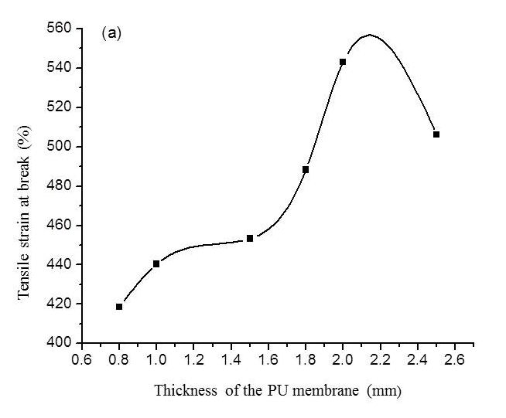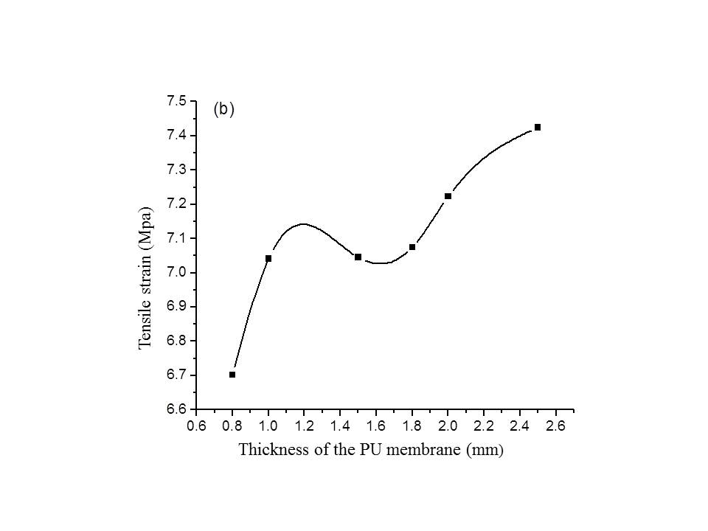
Figure 2. (a) Tensile strain at break and (b) tensile strain trends with increasing thickness of the PU membrane
Adsorption study
The pH of the aqueous medium is an important factor in the adsorption process. In order to investigate the effect of pH on dye removal, studies were carried out at the pH range of 2.5-12.5 at the dye concentration of 10 mg/L, adsorbent dosage of 0.6 g in 250 ml and 60 min contact time at room temperature. As shown in Figure 3(a), the maximum removal percentage of MO was observed at pH 7 (neutral) and at higher than pH 7, the removal percentages reduced. For MO, the percent removal of dyes increased with the increasing pH from acidic condition (more than pH 7) to the maximum state at base condition (pH 8.5). MO has a pKa value of 3.4 [12]. If the pH value is less that the pKa value, MO that exists in anionic state will become protonated.

Effect of absorbent dosage on the absorption of EV and MO was investigated using six different masses of PU membrane as shown in Figure 3(b). As we can see, the removal percentage increased significantly at low dosage of PU membrane up to a point where the removal percentage remained constant. Optimum dosage of PU membrane for removal percentage was 0.6 g for both EV and MO. At 0.6 g dosage, PU membranes had adsorbed 98% of EV and 25% of MO.

In this study, adsorption of dyes on PU membrane at different contact time has been studied for 3 hours with the constant initial concentration of 10 mg/L, temperature of 30 °C, adsorbent dosage of 0.6 g/250 ml and pH 7. The effect of contact time on removal percentages of dyes by PU membrane is presented in Figure 3 (c). For the first 40 min, the removal percentage of EV was rapid but after that it remained constant. Meanwhile, the removal percentage of MO increased slowly up to 50 minutes and then remained constant. Removal percentages for both dyes were constant at certain times due to the fact that absorption equilibrium has been achieved. The removal percentages of dyes were higher at the beginning because the absorbent provided a large surface area for adsorption until it accumulated or formed flux.

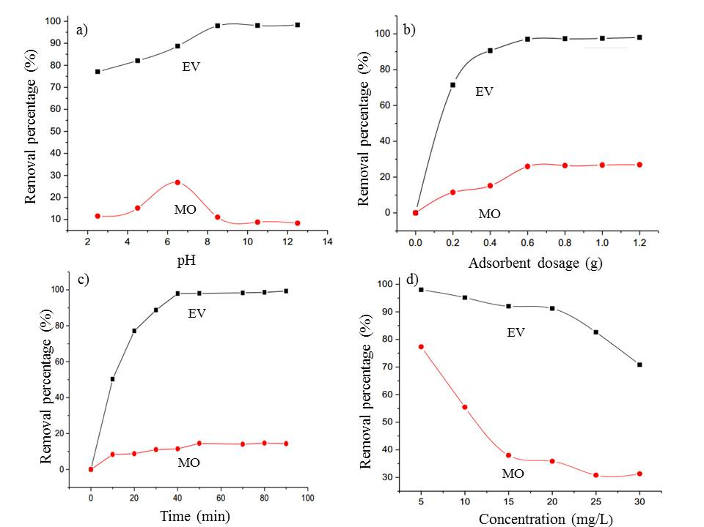
Figure 3. (a) Effect of pH, (b) amount of adsorbent, (c) contact time and (d) initial concentration on removal percentage of dyes
Dye concentrations were varied to 5, 10, 15, 20, 25 dan 30 ppm with constant weight of adsorbent at 0.6 g in 250 ml at pH 7 (Figure 4). The adsorption was monitored at 30 °C with 40 and 50 min contact time for EV and MO respectively. Figure 3(d) shows the effect of initial concentration of dye solution. As can be seen from the figure, both dyes showed higher removal percentage at 5 ppm concentration at about 98% and 78% for EV and MO respectively. At increasing dye concentrations, the removal percentage of both dyes decreased. This can be attributed to the fact that at lower concentrations, the availability of adsorption sites increased; thus, adsorption of dyes occurred immediately.

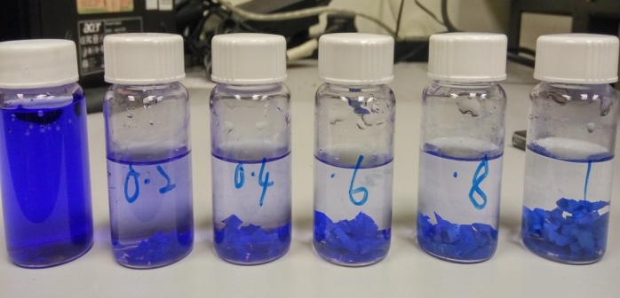

(a)

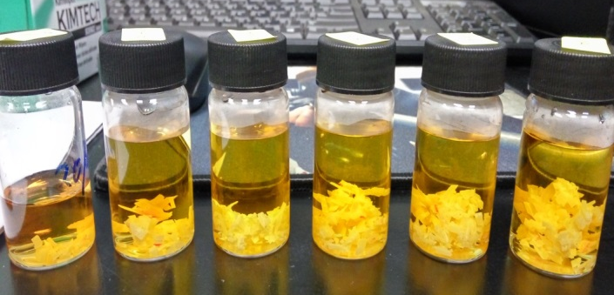

(b)

Figure 4. Physical changes on the dye-containing effluent upon removal of (a) EV and (b) MO dyes using the PU membranes at varying concentrations of the dyes

Adsorption isotherms
The isotherm parameters were explored to study the adsorption process by using Langmuir, Freundlich and Temkin adsorption isotherm models. In this study, Langmuir isotherm was employed to describe the adsorption isotherm. The linear form of Langmuir equation is as follows:

(1)

where C_{e} (mg/L) is the concentration of the dye solution at equilibrium (mg/L), q_{e} is the amount of dye adsorbed per mass of adsorbent (mg/g), Q_{o} and b is the Langmuir constant related to capacity and adsorption rate. The linear plot of C_{e}/q_{e} versus C_{e} (Figure 5) shows that the adsorption followed the Langmuir model with the value of the maximum adsorption capacity for monolayer adsorption at 9.461 mg/g for EV and 4.340 mg/g for MO respectively.

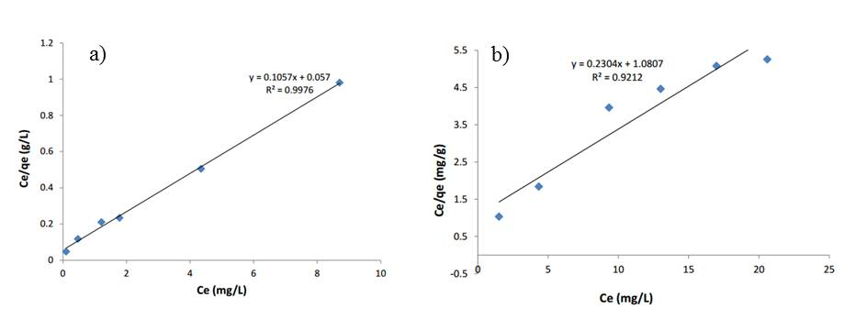
Figure 5. Langmuir adsorption isotherms for adsorption of (a) EV dye and (b) MO dye

Conclusion
Palm-based PU membrane has proven to be a promising adsorbent for the removal of EV and MO from aqueous medium. The removal percentage of dyes was found to be dependent on pH, adsorbent dosage, contact time and initial dye concentration. The adsorption study indicated that EV dye shows excellent absorption percentages on PU membrane compared to MO dye because the molecule size of EV is smaller than MO. Thus, the adsorption of EV dye molecules was more effective and quick. The adsorption data fitted very well in the Langmuir isotherm equation.

Acknowledgements
The authors would like to thank the Polymer Research Centre and School of Chemical Sciences and Food Technology, Faculty of Science and Technology, Universiti Kebangsaan Malaysia for providing the working area, Ministry of Higher Education and Centre for Research Instrumentation Management (CRIM), Universiti Kebangsaan Malaysia for the instruments provided for sample analysis throughout the study. This research has been funded by the Universiti Kebangsaan Malaysia through its Publication Grant Scheme DLP-2014-020.

References
- Beydilli, M., Pavlostathis, S. and Tincher, W. (1998). Decolorization and toxicity screening of
selected reactive azo dyes under methanogenic conditions. Water Science and Technology, 38(4-5): 225-232.
- Bayramoğlu, G. and Arica, M. Y. (2007). Kinetics of mercury ions removal from synthetic aqueous solutions using by novel magnetic p (GMA-MMA-EGDMA) beads. Journal of Hazardous Materials, 144(1): 449-457.
- Bechtold, T., Burtscher, E. and Turcanu, A. (2001). Cathodic decolourisation of textile waste water containing reactive dyes using a multi- cathode electrolyser. Journal of Chemical Technology and Biotechnology, 76(3): 303-311.
- Salleh, M. A. M., Mahmoud, D. K., Karim, W. A. and A. Idris. (2011). Cationic and anionic dye adsorption by agricultural solid wastes: A comprehensive review. Desalination, 280(1): 1-13.
- Culp, S. J. and Beland, F. A. (1996). Malachite green: a toxicological review. International Journal of Toxicology, 15(3): 219-238.
- Srivastava, S., Sinha, R. and Roy, D. (2004). Toxicological effects of malachite green. Aquatic Toxicology, 66(3): 319-329.
- Attia, A. A., Girgis, B. S. and Fathy, N. A. (2008). Removal of methylene blue by carbons derived from peach stones by H₃ PO₄ activation: batch and column studies. Dyes and Pigments, 76(1): 282-289
- Queiroz, D. P. and De Pinho, M. N. (2005). Structural characteristics and gas permeation properties of polydimethylsiloxane/poly (propylene oxide) urethane/urea bi-soft segment membranes. Polymer, 46(7): 2346-2353.
- Sadeghi, M., Semsarzadeh, M. A., Barikani, M. and Ghalei, B. (2010). The effect of urethane and urea content on the gas permeation properties of poly (urethane-urea) membranes. Journal of Membrane Science, 354(1): 40-47.
- Li, H., Freeman, B. D. and Ekiner, O. M. (2011). Gas permeation properties of poly (urethaneurea) s containing different polyethers. Journal of Membrane Science, 369(1): 49-58.
- Clemitson, I. (2011). Polyurethane casting prime edition. CRC Press, New York.
- Shahabuddin, S., Sarih, N. M., Mohamad, S. and Baharin, S. N. A. (2016). Synthesis and characterization of Co₃O₄ nanocube-doped polyaniline nanocomposites with enhanced methyl orange adsorption from aqueous solution. RSC Advances, 6(49): 43388-43400.

