

MALAYSIAN JOURNAL OF ANALYTICAL SCIENCES
ISSN 1394 - 2506

Published by The Malaysian Analytical Sciences Society

ENHANCED CORROSION INHIBITION USING PURIFIED TANNIN IN HCl MEDIUM

(Peningkatan Perencat Kakisan Menggunakan Tanin Tertulen dalam Medium HCl)

Hatika Kaco¹, Nur Atiqah Abu Talib², Sarani Zakaria²*, Sharifah Nabihah Syed Jaafar², Norinsan Kamil Othman³, Chin Hua Chia², Sinyee Gan²

¹Kolej PERMATA Insan,

Universiti Sains Islam Malaysia, PERMATA Insan Complex,Bandar Baru Nilai, 71800 UKM Nilai, Negeri Sembilan, Malaysia

²Bioresources and Biorefinery Laboratory, Faculty of Science and Technology

³School of Applied Physics, Faculty of Science and Technology

Universiti Kebangsaan Malaysia, 43600 UKM Bangi, Selangor, Malaysia

*Corresponding author: szakaria@ukm.edu.my

Received: 4 June 2018; Accepted: 7 November 2018

Abstract

Tannin was successfully extracted from Gelam bark using acetone as the solvent as natural alternatives. The extracted tannin was then used as corrosion inhibitor for mild steel under acidic medium. The gravimetric and electrochemical potentiodynamic corrosion tests were executed at different purified and unpurified tannin concentrations (200-800 ppm) to test the ability to inhibit mild steel corrosion. The results showed that the corrosion rate decreased as tannin concentration increased while the inhibition efficiency increased. The isotherm adsorption found that the Langmuir model was the best model to represent the interaction of tannin inhibitor and the active sites on mild steel surface. The SEM analysis showed that the mild steel morphology changed after the addition of tannin. The presence of blue-black color on the mild steel surface indicated the formation of ferric tannate to protect the surface of mild steel. In conclusion, purified tannin was a better inhibitor compared to unpurified tannin on mild steel in 1 M HCl.

Keywords: corrosion rate, extraction, gelam bark, green inhibitor, Langmuir

Abstrak

Tanin telah berjaya diekstrak daripada kulit Gelam menggunakan aseton sebagai pelarut. Tanin yang diekstrak kemudian digunakan sebagai perencat kakisan untuk keluli lembut dalam medium berasid. Ujian kakisan gravimetrik dan potensiodinamik elektrokimia dikaji pada kepekatan tanin tulen dan tidak tulen yang berbeza (200-800 ppm) ke atas kebolehan untuk merencat kekisan keluli lembut. Ia menunjukkan bahawa kadar kakisan berkurang dengan peningkatan kepekatan tanin manakala kecekapan perencatan meningkat. Lengkung suhu penjerapan mendapati bahawa model Langmuir merupakan model terbaik untuk menjelaskan interaksi perencat tanin dan tapak aktif permukaan keluli lembut. Morfologi keluli lembut berubah selepas penambahan tanin seperti dalam analisis SEM. Kehadiran warna biru hitam pada permukaan keluli lembut menunjukkan pembentukan ferik tanat untuk melindungi permukaan keluli lembut. Sebagai kesimpulan, tanin tertulen menunjukkan perencatan yang lebih baik berbanding tannin tak tulen keatas keluli lembut dalam 1 M HCl.

Kata kunci: kadar kakisan, pengekstrakan, kulit gelam, perencat hijau, Langmuir

Introduction

Corrosion inhibitor is defined as a material or chemical compound used to delay and/or control the corrosion process especially in iron-based material such as steel and alloy [1, 2]. Previous studies have shown that corrosion inhibitor is able to hinder the corrosion attack which damages and degrades mild steel surfaces [3−5]. Particularly, organic compound heteroatom, such as nitrogen, sulphur, oxygen, and heterocyclic compound has the potential to be used as a corrosion inhibitor [2, 3, 6]. The sequence of the heteroatom coordination bond (O < N < S < P) corresponds to its efficiency as the corrosion inhibitor [7,8] due to the compound’s higher electron density acting as the reaction centre [6]. These compounds adsorb onto the surface of metal and prevent corrosion active sites to be attacked by the corrosive environment [3].

However, most of synthetic corrosion inhibitors are toxic, expensive, and non-biodegradable [3, 6]. Consequently, the use of natural inhibitors derived from plants is environmentally friendly, attractive, and important [1, 8, 9]. Natural inhibitors have been derived from plants like mangrove [5, 10−12], Azadirachta indica [4], black wattle [13], Chamaerops humilis [1], Pterocarpus soyaux [3], and Thevetia peruviana [14]. These natural inhibitors mostly contain various types of components such as alkaloids, tannins, flavonoids, saponins, and volatile oil which are analogous with synthetic inhibitor and being proven to work as efficiently as their synthetic counterpart [9].

Tannin can be obtained from plant tissue particularly bark, leaves, and fruits through extraction process using organic solvents such as acetone, ethanol and methanol [15]. Many researchers successfully extracted tannin from mangrove bark, acacia, and black wattle [11−13]. Generally, tannin can be found as hydrolysable and condensed tannin polyphenolic compounds [16, 17]. Condensed tannins are a group of phenolic polymers consisting of ﬂavan-3-ol units linked together through C4–C6 or C4–C8 bonds. These polyﬂavonoids contain (−)-robinetinidol, (+)-catechin, and (+)-gallocatechin units [12]. The hydrolysed tannin is derived from glucose and categorized into two types: gallotannins or gallic acids and ellagitannins or digallic acids which are frequently esterified to polyols [13, 16].

Therefore, owing to the hydroxyl group in the ortho position on the aromatic rings, tannins are capable to chelate iron and other metallic cations such as copper [13]. The highly soluble ferric tannate is a blue-black complex formed during the reaction between Fe⁺³ ion, which comes mostly from the metallic compound, and the hydroxyl group in the ortho position in a oxygenate aqueous solution [13]. Tannin molecules having hydroxyl groups can reach to the metal surface and adsorb onto the surface of corroded metal by electronic interaction. Thus, they form protective layers to repel water molecules and inhibit ingression of destructive species like Cl⁻, SO₄⁻² and CO₂ which are responsible for the de-passivation of metal [5,18].

In this study, we aim to identify the ability and performance of tannin and purified tannin extracted from a local plant, gelam (Melaleuca cajuputi) in 1 M HCl. Different concentrations of tannin were applied on mild steel. We subsequently measured the weight loss of the mild steel and the potentiodynamic test result to obtain the corrosion rate and inhibitor efficiency value of the tannin inhibitor. The mild steel samples before and after undergoing corrosion test were analysed using optical metallurgy microscopy and scanning electron microscopy (SEM).

Materials and Methods

Materials

The bark of 10-year-old gelam plant was obtained from Pulau Duyung Terengganu. For the extraction, purification, and corrosion control processes, the chemicals used were acetone, methanol, ethanol, and hydrochloric acid purchased from Sigma Aldrich without any further purification.

Tannin extraction and purification

Tannin from the gelam bark was extracted using acetone: 20 g of gelam bark was immersed in a mixture of acetone and distilled water at 7:3 ratio (v/v) for 72 h at room temperature. The extracted yield was filtered and evaporated using a rotary evaporator to remove the acetone. The extract was freeze-dried, producing a dark brown powder which was the extracted tannin [19]. Then, the extracted tannin was purified: 40 g of Sephadex LH-20 powder was mixed into 400 ml methanol/water solution at 1:1 ratio. The mixed solvent was stirred and 2 g of the extracted tannin was dissolved. The mixed solvent was removed using rotary evaporator. The purified tannin was freeze-dried and placed in a dry bottle for further use.

Preparation of mild steel

Mild steel was cut into 16 mm × 3 mm specimens in cylinder shape. A 1.5 mm small hole was punched on the top of the mild steel to facilitate the sample suspension during the weight loss test. The sample was then polished and ground using a disc grinding machine with different grade silicon carbide paper (240, 400, 600, 800, 1000 and 1200 mesh). The sample was rinsed using acetone, followed by distilled water, and later kept in a desiccator to prevent oxidation until all the excess grounded materials have been removed.

Preparation of corrosion medium

The mild steel specimens were immersed in HCl medium at different tannin concentrations at room temperature for 6 h. The corrosion test at different tannin concentrations was repeated three times to obtain an average reading. The concentration of tannin was summarized in Table 1.

Corrosion inhibition - gravimetric methods

The mild steel specimens were rinsed using acetone to ensure that the samples were free from chemicals or impurities that can disturb the results on weight loss test. The specimens were weighed before immersing for 6 hours in 25 ml HCl mixed with 5 ml ethanol and tannin at different concentration as shown in Table 1. The specimens were lifted and washed to remove the oxide formed on the surface following the ASTM standard G1-03 and rinsed using distilled water and acetone, and then dried. The dried samples were weighed to calculate the weight after immersing in corrosive medium. The percentage of inhibition efficiency (IE) was calculated using equation 1 [8]:

$IE=1- \frac{ Wi }{Wo}$ × 100 (1)

where W_{o} is the weight loss of mild steel without inhibitor and W_{i} is the weight loss of mild steel with inhibitor.

Table 1. Preparation of corrosion medium for gravimetric test and electrochemical potentiodynamic test
Tannin Concentration (ppm) | Medium
Control medium | Ethanol + HCl
200 | Ethanol + HCl + tannin powder
400 | Ethanol + HCl + tannin powder
600 | Ethanol + HCl + tannin powder
800 | Ethanol + HCl + tannin powder

Potentiodynamic electrochemical test

Polarization test was performed using three electrodes: saturated calomel electrode (SCE) as reference electrode, platinum plate (1 cm × 1 cm) as counter electrode, and the sample as working electrode with 1 cm2 sample surface area. The sample was immersed in the corrosive medium for 30 s to achieve the stability phase before starting the potentiodynamic electrochemical test. A potentiodynamic slope required a scanning capability from −0.25 to +0.25 mV. This electrochemical analysis involved a computer-controlled potentiostat model K47 Gamry at the scanning rate of 1.0 mVs⁻¹. Each experiment was repeated three times.

This analysis yielded constant Tafel anode (βa), cathode (βc), and polarization resistance value (Rp). The polarization slope would give the value of corrosion inhibitor efficiency (% IE) and corrosion rate. The % IE can be calculated using the following equation [20]:

% IE = [(Icorr(0) – Icorr(i))/Icorr(0)] × 100 (2)

where, Icorr(0) = corrosion current density of uninhibited system (mA cm²) and Icorr(i) = corrosion current density of inhibited system (mA cm²).

Morphological analysis

The microstructure and morphology of mild steel before and after the corrosion test were analysed under an optical microscopy metallurgy (model Carl Ziees AXIOLAB A1) and a scanning electron microscope (SEM) (model ZEISS model 55VP).

Results and Discussion

Fourier transform infrared spectroscopy (FTIR) of extracted and purified tannin

Surface functional groups of the extracted tannin (TN) and purified tannin (PTN) were investigated by using FTIR. The FTIR spectrums of the extracted tannin from gelam bark using acetone as solvent is shown in Figure 1. The FTIR spectrum of TN sample was the same as the commercial tannin. The wide range of 3100-3700 cm⁻¹ intensity peak showed that the extracted tannin contained high amount of hydroxyl group due to the moisture in the tannin and hydroxyl group coming from lignin, cellulose, and hemicellulose [21]. These hydroxyl groups are necessary for tannin to inhibit corrosion of mild steel [13, 22]. The peaks at 2938 cm⁻¹ and 2934 cm⁻¹ represented the C-H group; the peak ranging at 1455-1516 cm⁻¹ exhibited the stretch of aromatic ring groups; and 1036 cm⁻¹ was the peak for aliphatic C-O group [22]. The other main peaks for tannin were at wavenumber of 1618, 1619, 1423 and 1420 cm⁻¹ which signaled the presence of aromatic groups [13, 22]. For the purified tannin (PTN), some peaks were reduced while others increased in intensity. The intensity peak at 2930 cm⁻¹ of C-H group for PTN is lower compared to TN, indicating that the PTN contained lower amount of C-H due to the purification process. However, the 1036 cm⁻¹ peak, corresponding to the aliphatic group, has increased for the PTN sample compared to TN. Moreover, the aromatic group intensity of TN at 1400 to 1600 cm⁻¹ range has reduced after the purification process.

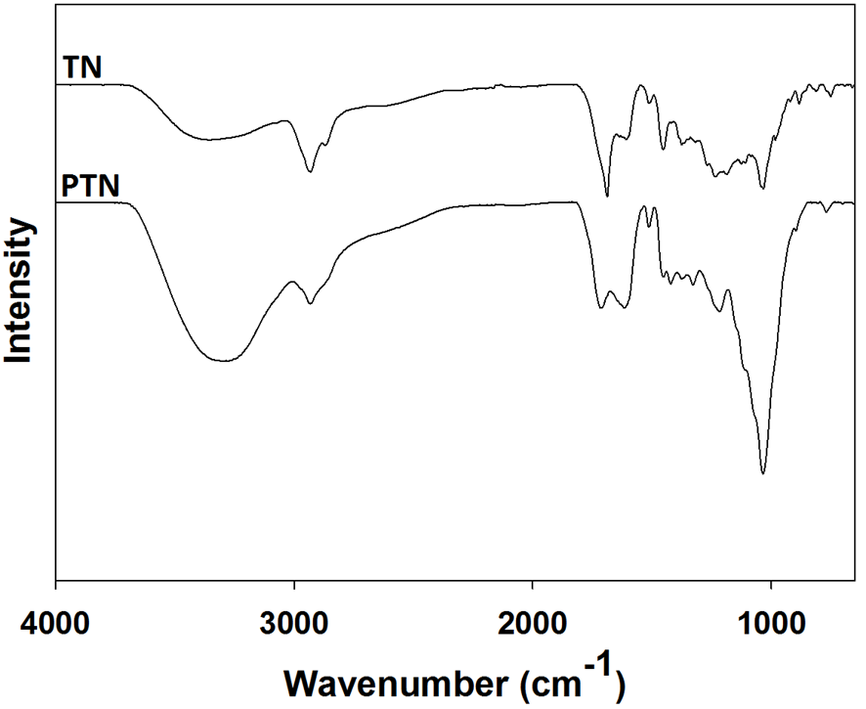

Figure 1. FTIR spectrum of tannin (TN) and purified tannin (PTN)

Corrosion inhibition analysis: Gravimetric test

Figure 2 shows the effect of concentration on the corrosion rate (mpy) of mild steel in 1 M HCl at room temperature. At first (blank sample), the weight loss of mild steel in corrosive medium of 1 M HCl is high but the addition of tannin has decreased its weight loss. Additionally, increasing the concentration of tannin on the mild steel surface has further decreased its weight loss for both tannin (TN) and purified tannin (PTN) samples. The corrosion rate followed the same pattern as weight loss, decreasing at higher concentration of tannin for both TN and PTN under the same medium. The decreasing corrosion rate was due to the increase of chemical reaction as a result of increasing concentration of the corrosive medium [3]. Corrosion rate of mild steel without the inhibitor was 40.49 mpy which was higher compared to corrosion rate of mild steel with TN and PTN as inhibitor which were 13.85 mpy and 6.93 mpy, respectively, showing that TN was more efficient as corrosion inhibitor for mild steel compared to PTN.

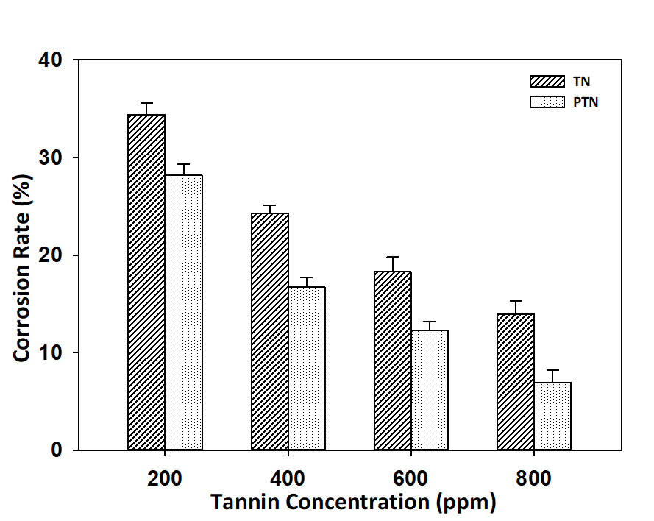

Figure 2. Effect of tannin concentration on corrosion rate of mild steel using TN and PTN as green inhibitor

Figure 3 shows the inhibition efficiency (%IE) for both TN and PTN at tannin concentration of 200, 400, 600 and 800 ppm based on Icorr from the Tafel curves and Rp values. Both TN and PTN showed the highest IE (65.8 % and 83 %) with the inhibitor concentration of 800 ppm at 300 K due to the aromatic group that gave some advantages in corrosion inhibition process [23]. Tannin as inhibitor possesses the ability to inhibit corrosion on mild steel due to the presence of functional groups such as hydroxyl (OH), methoxyl (-OCH) and methyl (-CH3) which act as electron donor groups [10]. In aqueous medium, these functional groups release their electron and bond at the d-orbital which exists on mild steel. Hence, by increasing the concentration of tannin, the adsorption rate increases, thus protecting the mild steel from corrosion agent [10]. However, the PTN samples still had some impurities such as carbohydrates, polysaccharides, and sugars which occurred alongside tannin during the gravimetric test.

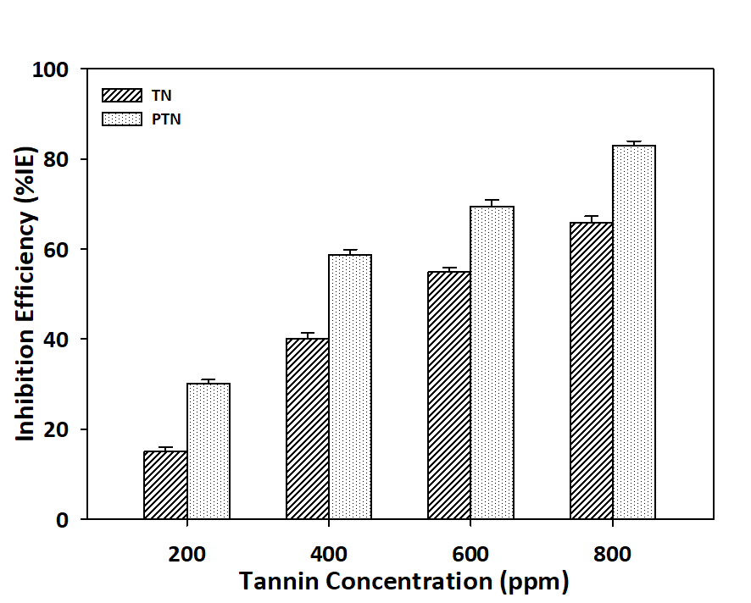

Figure 3. Effect of tannin concentration on inhibition efficiency of mild steel using TN and PTN as green inhibitor

Electrochemical potentiodynamic test

The determination of potentiodynamic polarization on TN and PTN samples was performed to investigate the kinetics of the cathodic and anodic reactions [24]. The polarization profile of mild steel in 1.0 M HCl is shown in Figure 4 and 5. The values of the variation of corrosion current density (Icorr), corrosion potential (Ecorr), anodic Tafel slope (βa), and cathodic Tafel slope (βc) at various concentrations of the TN and PTN inhibitors were obtained from the polarization profiles (Tables 2 and 3).

Figure 4 and 5 show the polarization curve for mild steel at different concentration of TN and PTN in 1 M HCl, displaying the effects of TN and PTN inhibition on cathodic and anodic reactions. Both changes in the slope of cathodic and anodic current-potential lines revealed that both reactions restrained with the presence of inhibitor; further restrictions occurred when the concentration of inhibitor increased [24]. The Tafel plot showed that the gradient of cathodic Tafel slope (βc) value was higher than that of the anodic Tafel slope (βa), demonstrating that the tannin molecules successfully inhibited the corrosive activities on the mild steel. A compound can be categorized as anodic- or cathodic-type inhibitor when the shifted value of Ecorr is more than 85 mV. Therefore, from Table 2 and 3, tannin can be indicated as a mixed corrosion inhibitor; it was able to inhibit via anodic and cathodic reactions [20, 25]. Therefore, the anodic dissolution reactions and the hydrogen evolution reactions on the cathodic sites had been inhibited by both inhibitors [7].

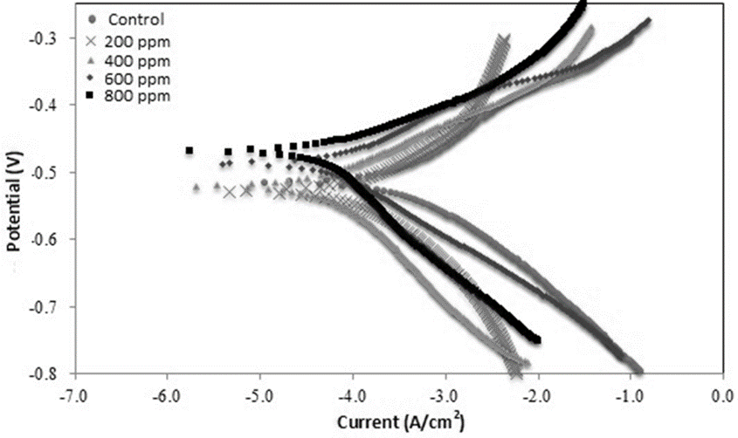

Figure 4. Polarization curve of mild steel at different concentration of TN in 1 M HCl at room temperature

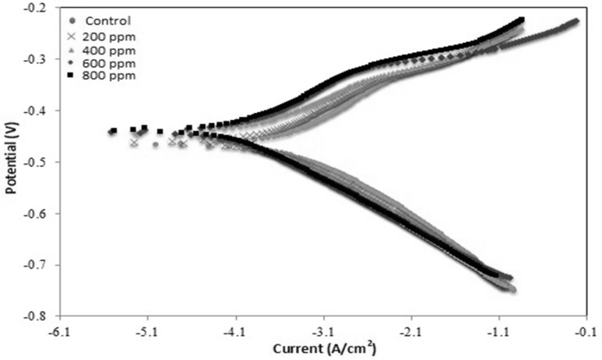

Figure 5. Polarization curve of mild steel at different concentration of PTN in 1 M HCl at room temperature

From Table 2 and 3, the current density value (Icorr) decreased but the inhibition efficiency increased with the increase of the inhibitor concentration from 200 to 800 ppm. This phenomenon can be explained by the increasing adsorption of inhibitor onto the mild steel surface with the increasing inhibitor concentration. Thus, higher mild steel surface area was protected by the acidic medium and the metal dissolution rate decreased, leading to the increased inhibition efficiency which was determined by the Icorr value [7, 24]. The increasing trend in the percentage of inhibition efficiency for PTN was higher compared to TN due to less impurity such as simple sugar, glycoside, polyphenol monomer, and carbohydrate which acted as barriers to the formation of ferric tannate [12].

Table 2. Electrochemical polarization potentiodynamic data for mild steel at different concentration of TN
in 1 M HCl at 300 K
Inhibitor Concentration  (ppm) | Corrosion Potential  E_{corr} (mV) | Corrosion Current Density  I_{corr}  (mA/cm²) | Gradient  Anode  β_{a}  (mV) |  | Gradient  Cathode  β_{c}  (mV) | Corrosion Rate  (mm/y) | Inhibitor Efficiency Percentage  (%IE)
0 | -467.00 | 4.051⁻⁴ | 121.3 |  | 100.50 | 4.777 | -
200 | -479.70 | 1.287⁻⁴ | 94.50 |  | 118.00 | 1.516 | 68.23
400 | -470.20 | 5.101⁻⁵ | 68.60 |  | 131.80 | 0.606 | 87.41
600 | -437.60 | 5.074⁻⁵ | 60.30 |  | 83.60 | 0.597 | 87.47
800 | -421.30 | 4.751⁻⁵ | 51.80 |  | 130.50 | 0.559 | 88.27

Table 3. Electrochemical polarization potentiodynamic data for mild steel at different concentration of PTN
in 1 M HCl at room temperature
Inhibitor Concentration  (ppm) | Corrosion Potential  E_{corr} (mV) | Corrosion Current Density  I_{corr}  (mA/cm²) | Gradient  Anode  β_{a}  (mV) | Gradient  Cathode  β_{c}  (mV) | Corrosion Rate  (mm/y) | Inhibitor Efficiency Percentage  (%IE)
0 | -467.00 | 4.051⁻⁴ | 121.30 | 100.5 | 4.770 | -
200 | -460.70 | 2.387⁻⁴ | 105.00 | 99.10 | 2.811 | 41.15
400 | -443.60 | 1.287⁻⁴ | 75.90 | 100.1 | 1.487 | 68.23
600 | -442.00 | 9.100⁻⁵ | 84.50 | 92.80 | 1.071 | 77.54
800 | -439.30 | 8.777⁻⁵ | 83.60 | 93.50 | 1.0333 | 89.66

Adsorption isotherm analysis

Langmuir, Freundlich and Temkim models were used as adsorption isotherms models to investigate the molecular interactions between the inhibitor molecules and the active sites on the mild steel surface [25]. These models provided more intuitiveness towards the corrosion inhibition mechanism [26]. The plots of these models are shown in Figure 6. From the plots, Langmuir isotherm showed a strong R² correlation value which indicated that the model was the most suitable model to explain the adsorption isotherm mechanism on mild steel [23]. Langmuir model stated that the tannin molecules adsorbed on mild steel surface was strongly bound and unable to move. The tannin molecules adsorbed on the surface of mild steel possessed a specific active site and the adsorbed tannin molecule did not interact with each other. Therefore, the adsorption of tannin molecules only happened at one layer [27]. Langmuir model was also the common model to describe the interaction occurred during the corrosion inhibition process. The free energy of adsorption (ΔG_{ads}) value for Langmuir, Temkin and Freundlich models using TN and PTN as inhibitor is shown in Table 4. If the ΔG_{ads} value was less than -20 kJ/mol, it involved an electrostatic adsorption; the energy of charged metal and charged molecule interacted with the mild steel surface. On the other hand, if the ΔG_{ads} value was greater than -40 kJ/mol, the charge transfer or electron sharing from the inhibitor molecule to the metal surface formed coordination bond of chemical adsorption [28]. However, according to the Table 4, ΔG_{ads} value for Langmuir and Temkin was less than -20 kJ/mol (between 10.22 and 20.53 kJ/mol), illustrating that both TN and PTN followed the electrostatic adsorption.

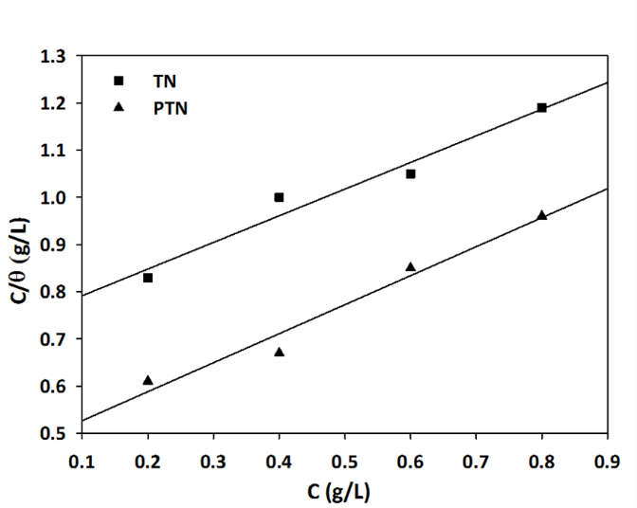  (a) | 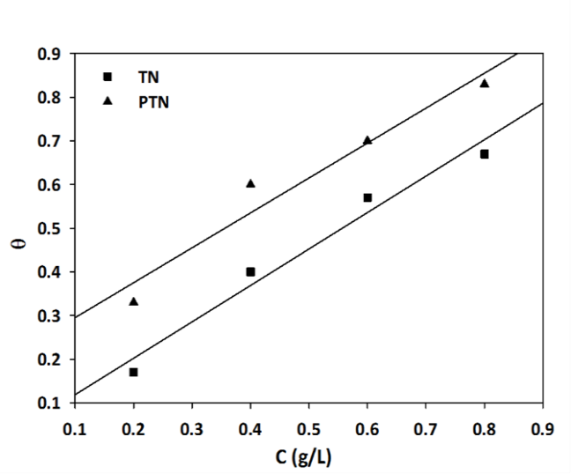  (b)

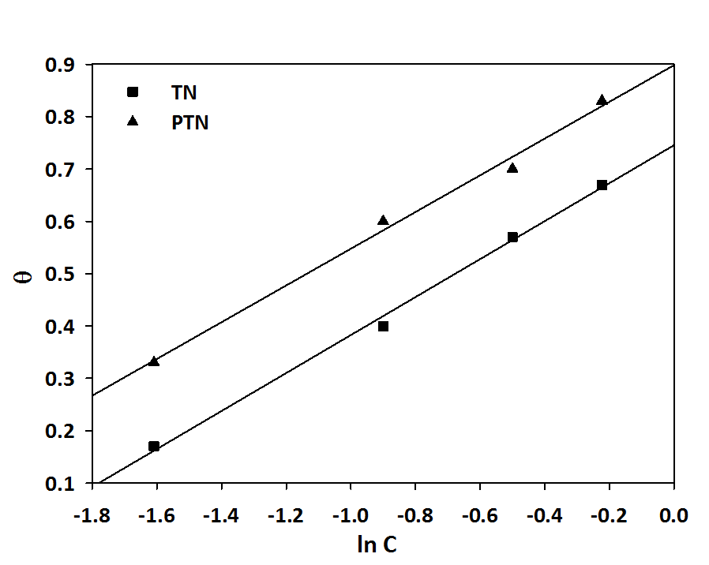
(c)

Figure 6. Adsorption mechanism of (a) Langmuir, (b) Freundlich and (c) Temkin isothermal for mild steel in 1 M HCl medium containing TN and PTN corrosion inhibitor

Table 4. Adsorption isotherm data model for Langmuir, Freundlich and Temkim in 1 M HCl medium at 300 K
Isotherm | Inhibitor | R² | K_{ads} | G_{ads} (kJ/mol⁻¹)
Langmuir | TN | 0.96330 | 1.36 | -10.79
Langmuir | PTN | 0.96880 | 2.1505 | -11.93
Temkin | TN | 0.99828 | 7.80 | -15.14
Temkin | PTN | 0.99220 | 12.94 | -16.40
Freundlich | TN | 0.97056 | 1.09 | -10.22
Freundlich | PTN | 0.94095 | 8.73 | -17.12

Morphological analysis: Optical microscope analysis

The circle in Figure 7(a) shows that there are tiny holes present on the surface of mild steel. These holes were formed due to the aggressive chloride ion that eroded the surface of mild steel, leading to the dissolving process also known as pitting corrosion. The dark brown on the sample’s surface showed that the corrosion process had happened. Figure 7(b), (c) and (d) show the microscope images of mild steel immersed in 1 M HCl solution containing tannin at different concentration. Dark blue formation was found shrouding the mild steel, indicating that the tannin has been adsorbed onto the surface of mild steel and combined with the iron ion to form ferric tannate which was blue-black in colour [10−12]. The formed ferric tannate acted as a thin layer or film to protect the mild steel from further corrosion [13].

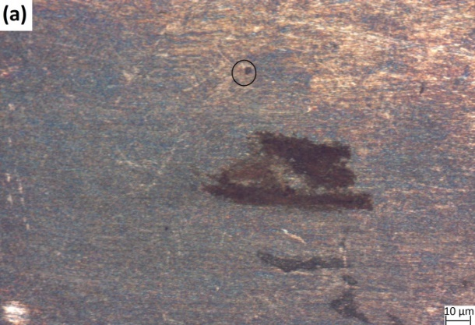 | 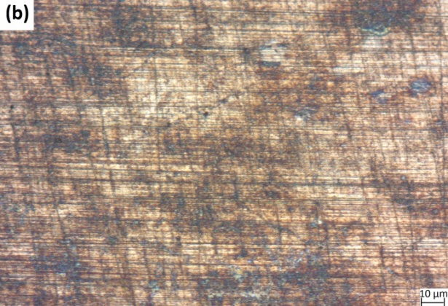
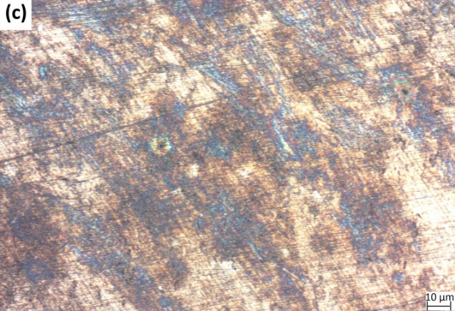 | 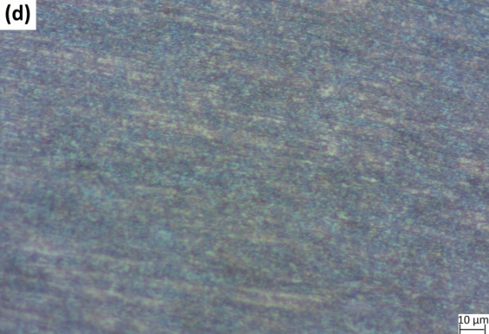

Figure 7. Microscopy images of mild steel after gravimetric test at room temperature for (a) without inhibitor and TN at concentration of (b) 200 ppm, (c) 400 ppm and (d) 600 ppm

Scanning electron microscope (SEM)

Figure 8 shows the SEM images of mild steel before and after corrosion test. It can be seen that mild steel immersed in 1 M HCl containing tannin inhibitor presence a white layer (tannin inhibitor) on the surface of the mild steel (Figure 8(b)). This layer could be observed as a coating which acted as a passive layer adsorbed on the mild steel surface. It also could protect the mild steel from chloride ion attacks that corroded the mild steel surface [10−12].

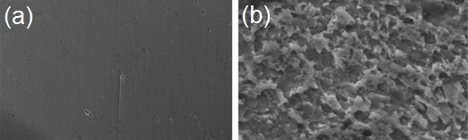

Figure 8. SEM images of (a) mild steel surface before corrosion test performed and (b) mild steel immersed in 1 M HCl containing 800 ppm concentration of TN

Conclusion

Tannin from gelam bark was successfully extracted using acetone. From the FTIR analysis, the presence of aromatic groups can be found in tannin (TN) and purified (PTN) tannin compound. The intensity peak of these aromatic groups decreased after being purified, indicating that the purification process had eliminated some of the tannin’s aromatic groups. The weight loss test revealed that at higher concentration of inhibitor, the corrosion rate decreased, and inhibition efficiency increased. Both inhibitors exhibited excellent inhibition performance as a mixed-type inhibitor. The Langmuir isotherm was the best model to describe the adsorption isotherm of tannin on mild steel, giving the highest R² value (R²>0.9). Microscopy analysis showed the formation of ferric tannate as indicated by the blue-black colour on the surface of the mild steel. This complex compound protected the mild steel from corrosion attacks in the presence of tannin as a green corrosion inhibitor. Hence, the natural tannin from gelam bark can be used as an alternative to replace other sources based on the observed corrosion inhibitor property.

Acknowledgement
The authors gratefully acknowledge the Ministry of Higher Education Malaysia for the financial support via the research project PRGS/1/2015/SG06/UKM/01/1. The authors also acknowledge support from the Centre for Research and Instrumentation (CRIM) for providing the instrument for analysis purposes.

References
- Benali, O., Benmehdi, H., Hasnaoui, O., Selles, C. and Salghi, R. (2013). Green corrosion inhibitor: Inhibitive action of tannin extract of chamaerops humilis plant for the corrosion of mild steel in 0.5M H₂SO₄. Journal of Materials and Environmental Science, 4:127-138.
- Tan, K. W. and Kassim, M. J. (2011). A correlation study on the phenolic profiles and corrosion inhibition properties of mangrove tannins (Rhizophora apiculata) as affected by extraction solvents. Corrosion Science, 53: 569-574.
- Iloamaeke, I. M., Onuegbu, T. U., Ajiwe, V. I. E. and Umeobika, U. C. (2012). Corrosion inhibition of mild steel by Pterocarpus soyauxi leaves extract in HCl medium. International Journal of Plant, Animal and Environmental Sciences, 2: 22-28.
- Okafor, P. C., Ebenso, E. E. and Ekpe, E. J. (2010). Azadirachta indica extracts as corrosion inhibitor for mild steel in acid medium. International Journal of Electrochemical Science, 5: 978-993.
- Oki, M., Charles, E. Alaka, C. and Oki, T. K. (2011). Corrosion inhibition of mild steel in hydrochloric acid by tannins from Rhizophora racemose. Materials Sciences and Applications, 2: 592-595.
- Umoren, S. A., Ogbobe, O., Igwe, I. O. and Ebenso E. E. (2008). Inhibition of mild steel in acidic medium using synthetic and naturally occurring polymers and synergistic halide additives. Corrosion Science, 50: 1998-2006.
- Al-Amiery, A. A., Kassim, F. A., Kadhum, A. A. H. and Mohamad A. B. (2016). Synthesis and characterization of a novel eco-friendly corrosion inhibition for mild steel in 1 M hydrochloric acid. Scientific Reports, 6:19890-19912.
- Shah, A. M., Rahim, A. A., Hamid, S. A. and Yahya, S. (2013). Green inhibitors for copper corrosion by mangrove tannin. International Journal of Electrochemical Science, 8: 2140-2153.
- Chigondo, M. and Chigondo, F. (2016). Recent natural corrosion inhibitors for mild steel: an overview. Journal of Chemistry, 2016: 1-7.
- Rahim, A. A., Rocca, E. and Steinmetz, J. (2007). Mangrove tannins and their flavanoid monomers as alternative steel corrosion inhibitors in acidic medium. Corrosion Science, 49: 402-417.
- Rahim, A. A. and Kassim, J. (2008). Recent development of vegetal tannins in corrosion protection of iron and steel. Recent Patents on Materials Science, 1: 223-231.
- Rahim, A. A., Rocca, E., Steinmetz, J., Kassim, M. J., Adnan, R. and Sani Ibrahim, M. (2008). Inhibitive action of mangrove tannins and phosphoric acid on pre-rusted steel via electrochemical methods. Corrosion Science. 50: 1546-1550.
- Peres, R. S., Cassel, E. and Azambuja, D. S. (2012). Black wattle tannin as steel corrosion inhibitor. ISRN Corrosion, :1−9.
- Fouda, A. S., Megahed, H. E., Fouad, N. and Elbahrawi, N.M. (2016). Corrosion inhibition of carbon steel in 1 M hydrochloric acid solution by aqueous extract of Thevetia peruviana. Journal of Bio- and Tribo-Corrosion, 2(3): 16.
- Barbosa, V., Ramires, E. C., Razera, I. A. T. and Frollini, E. (2010). Biobased composites from tannin–phenolic polymers reinforced with coir fibers. Industrial Crops and Products, 32: 305-312.
- Elgailani, I. E. H. and Ishak, C. Y. (2016). Methods for extraction and characterization of tannins from some acacia species of Sudan. Pakistan Journal of Analytical & Environmental Chemistry. 17: 43-49.
- Mailoa, M. N., Mahendradatta, M., Laga, M. and Djide, N. (2013). Tannin extract of guava leaves (Psidium Guajava L) variation with concentration organic solvents. International Journal of Scientific & Technology Research, 2:106-110.
- Kundu, M., Prasad, S. K. and Kumar, V. (2016). A review article on green inhibitors of reinforcement concrete corrosion. International Journal of Emerging Research in Management &Technology, 5: 42-46.
- Oo, C. W., Kassim, M. J. and Pizzi, A. (2009). Characterization and performance of Rhizophora apiculata mangrove polyflavonoid tannins in the adsorption of copper(II) and lead(II). Industrial Crops and Products, 30: 152-161.
- Behpour, M., Ghoreishi, S. M., Mohammadi, N., Soltani, N. and Salavati-Niasari, M. (2010). Investigation of some Schiff base compounds containing disulfide bond as HCl corrosion inhibitors for mild steel. Corrosion Science, 52: 4046-4057.
- Bakarudin, S. B., Zakaria, S., Chia, C. H. and Jani, S. M. (2012). Liquefied residue of kenaf core wood produced at different phenol-kenaf ratio. Sains Malaysiana, 41: 225-231.
- Li, J., Li, C., Wang, W., Zhang, W. and Li, J. (2016). Reactivity of larch and valonia tannins in synthesis of tannin-formaldehyde resins. Bioresources, 11: 2256-2268.
- Manimegalai, S. and Manjula, P. (2015). Thermodynamic and adsorption studies for corrosion inhibition of mild steel in aqueous media by Sargasam swartzii (brown algae). Journal of Materials and Environmental Science, 6: 1629-1637.
- Shukla, S. K, Singh, A. K. and Quraishi, M. A. (2011). Corrosion inhibition and adsorption properties of n-phenylhydrazine-1,2-dicarbothioamide on mild steel in hydrochloric acid. International Journal of Electrochemical Science, 6: 5779-5791.
- Peme, T., Olasunkanmi, L. O., Bahadur, I., Adekunle, A. S., Kabanda, M. M. and Ebenso, E. E. (2015). Adsorption and corrosion inhibition studies of some selected dyes as corrosion inhibitors for mild steel in acidic medium: gravimetric, electrochemical, quantum chemical studies and synergistic effect with iodide ions. Molecules, 20: 16004-16029.
- Emregul, K. C. and Hayvali, M. (2006). Studies on the effect of a newly synthesized Schiff base compound from phenazone and vanillin on the corrosion of steel in 2 M HCl. Corrosion Science, 48: 797-812.
- Chia, C. H., Razali, N. F., Sajab, M. S., Zakaria, S., Huang, N. M. and Lim, H. N. (2013). Methylene blue adsorption on graphene oxide. Sains Malaysiana, 42: 819-826.
- Singh, A., Pramanik, T., Kumar, A. and Gupta, M. (2013). Phenobarbital: A new and effective corrosion inhibitor for mild steel in 1M HCl solution. Asian Journal of Chemistry. 25(17): 9808-9812.

