

MALAYSIAN JOURNAL OF ANALYTICAL SCIENCES
ISSN 1394 - 2506

Published by The Malaysian Analytical Sciences Society

CORROSION INHIBITIVE EFFECT OF THIOUREA ON 1100 ALUMINIUM ALLOY SHEET IN HYDROCHLORIC ACID SOLUTION

(Kesan Perencatan Kakisan Thiourea Terhadap kepingan Aloi Aluminium 1100 Dalam Larutan Asid Hidroklorik)

Maria Fazira Mohd Fekeri¹, Chan Kok Sheng²*, Lee Hou Yi¹

¹School of Ocean Engineering
²School of Fundamental Science
Universiti Malaysia Terengganu, 21030 Kuala Nerus, Terengganu, Malaysia

*Corresponding author: chankoksheng@umt.edu.my

Received: 2 September 2018; Accepted: 3 October 2018

Abstract
Corrosion is the degradation of material properties or mass over time due to environmental effects. It cannot be avoided but can be prevented using appropriate inhibitor for corrosion resistant. In this work, the beneficial role of thiourea as organic inhibitor for the 1100 aluminium (Al) alloy sheet corrosion in hydrochloric (HCl) acid solution was first investigated in detail by a simple gravimetric method. The result showed that increasing concentration of thiourea reduced the weight loss percentage and corrosion rate of Al. Meanwhile, the inhibition efficiency increased up to 52.54% with the increase of thiourea concentration for 30 days of immersion time. The surface morphology of the samples was characterized by metallurgical microscope. It can be observed that the number of corrosion pits distributed on Al surface became fewer as the concentration of thiourea increased, proving the effective retardation of corrosion on Al sheet.

Keywords: thiourea, aluminium, hydrochloric acid, corrosion rate, inhibition efficiency

Abstrak
Kakisan adalah degradasi ciri-ciri bahan dari semasa ke semasa disebabakan oleh kesan alam sekitar. Kakisan tidak dapat dielakkan tetapi boleh dicegah dengan menggunakan perencat kakisan yang sesuai. Dalam kajian ini, peranan tiourea sebagai perencat organik atas kakisan kepingan 1100 aloi aluminium (Al) dalam larutan asid hidroklorik (HCl) telah dikaji secara terperinci dengan menggunakan kaedah gravimetrik yang mudah. Hasil kajian menunjukkan peningkatan kepekatan tiourea telah mengurangkan peratus kehilangan jisim dan seterusnya kadar kakisan Al. Sementara itu, kecekapan perencatan meningkat kepada 52.54% dengan penambahan kepekatan tiourea dalam larutan HCl. Morfologi permukaan spesimen telah dicirikan melalui mikroskop metalorgikal. Bilangan pit kakisan yang bertaburan pada permukaan Al berkurangan apabila kepekatan tiourea meningkat membuktikan keberkesanan perencatan kakisan pada kepingan Al.

Kata kunci: tiourea, aluminium, hidroklorik asid, kadar kakisan, kecekapan perencatan

Introduction
Corrosion is an electrochemical process by which metallic structures are destroyed gradually through anodic dissolution. It is one of the main concerns in the durability of materials and structures; as a result, studies are continuously carried out to develop an effective corrosion control. This phenomenon necessitates the continuous search for better corrosion inhibitors, due to vast differences in the media encountered in industry which remains a focal point in corrosion control as the inhibitors slow down the corrosion process on metals [1, 2].

Inhibitor use has become one of the most practical methods for protection against corrosion in acidic media. Generally, the first stage in the action mechanism of the inhibitors in aggressive acid media is the adsorption of the inhibitors on the metal surface, where acid is used for the pickling of metal for its chemical or electrochemical etching. An effective inhibitor must also transfer water from the metal surface, interact with anodic or cathodic reaction sites to retard the oxidation and reduce corrosion reaction, and further prevent transportation of water and corrosion-active species on the metal surface [2 - 4]. Recently, the use of organic compounds to inhibit corrosion has great significance due to their application in preventing corrosion under various corrosive environments. These compounds have shown great effectiveness for inhibiting aqueous corrosion due to film formation on the metal surface [4 - 6].

Organic compounds containing nitrogen (N) and sulphur (S) have also been proven to be good inhibitors for the prevention of corrosion under acidic condition [5]. Therefore, thiourea [S(NH₂)₂] and its derivatives have been extensively investigated as corrosion inhibitors in acidic medium. The corrosion inhibition of thiourea is superior to the metal surface due to its strong polar coordinate. S compounds, such as thiourea and amine-based inhibitors in acidic media can simultaneously act in both anodic and cathodic media. The multiple bonds in the thiourea molecules that facilitate adsorption are very effective inhibitors for metal corrosion in acidic medium because the S atom is easily protonated in acidic solution and a stronger electron donor than N, therefore S atom is more strongly adsorbed to the metal surface [5 - 10]. Also, it has been reported by Loto et al. [5] that S-containing and N-containing inhibitors exert their best efficiencies in the acid solution.

Aluminum (Al) is one of the best metals used in construction, packaging and transportation because of its unique mechanical strength and electrical conductivity. It is also used in electronics as an anodic material for power sources with high energy density due to its superior purity. Although Al has an adhesive protective passivating oxide film, this film also has an amphoteric susceptibility, leading the metal to dissolve readily in acidic and basic solutions concentrated above and below pH (4-9) [3]. In our efforts to mitigate the electrochemical corrosion of Al, the main solution is to isolate the metal from corrosive agents and this can be achieved by using corrosion inhibitors which prevent the adsorption of the aggressive anions or by the formation of a more resistance oxide film on the metal surface [4].

Recently, there are plenty of published studies using organic inhibitors such as sodium benzoate [1], thiadiazole derivatives [5] and triazole derivative [10] for corrosion control of metal. However, studies based on the inhibition effect on Al in acidic solution utilizing the thiourea as an organic inhibitor are very limited. Hence, in this study, we presented a detailed investigation on the effect of thiourea as an organic inhibitor for the 1100 Al alloy corrosion in 5 wt.% dilute HCl solution. The corrosion rate and inhibition efficiency were determined by the gravimetric method for 6-day interval until 30 days of immersion duration. The surface morphology of the specimens was then observed under a metallurgical optical microscope.

Materials and Methods
Al alloy 1100 (99.0% Al) was used as received. Firstly, the Al was cut into a rectangular dimension of 25 mm x 35 mm x 2 mm. It was then mechanically polished with 1200 emery paper, lubricated with 50 ml of distilled water and acetone to remove the oxide layer, and further dried at room temperature for one day. After weighing, the Al was immersed in 5 wt. % HCl solution with different concentrations of thiourea (i.e. 0 wt.%, 5 wt.%, 10 wt.%, 15 wt.%, 20 wt.% and 25 wt.%) for an immersion duration of 6-day intervals until 30 days. Meanwhile, a typical sample immersed in HCl without the presence of thiourea was used as reference. After immersion, the Al was removed from the solution and immersed in nitric acid for 2-3 minutes to remove the corrosion residues. The specimen was then rinsed with distilled water, dried in air and weighted to determine the final weight. The weight loss percentage was determined by the gravimetric method as:

(1)

where WL is the weight loss percentage, W_{I} is the initial weight before corrosion and W_{F} indicates the final weight after corrosion. The corrosion rate was then determined from the following expression [11]:

(2)

where CR is the corrosion rate in mm/year, Δwt is the weight loss, ρ_{A} is the density of Al in g/cm³, and t is the exposure time. Lastly, the inhibition efficiency (IE) was determined from corrosion rate values by the following equation [12]:

(3)

where CR₀ and CR₁ are corrosion rates without and in the presence of inhibitor, respectively. TM-1000 Hitachi tabletop metallurgical microscope was used to examine the specimen surface before and after the immersion in HCl at 20x magnification for a clear surface imaging.

Results and Discussion
The gravimetric method for corrosion studies is a time-tested and reliable technique with good correlation between impedance and polarization techniques [11, 12]. Figure 1 shows the weight loss percentage (%) against time for the Al immersed in HCl solution with different concentration of thiourea. From the figure, it shows that the weight loss of Al increased gradually with immersion time. A clear difference was noticed between the Al exposed to thiourea as compared to the one without thiourea with the highest weight loss, which indicated that the thiourea is effective to protect the Al from corrosion. The weight loss also decreased with the increase of thiourea concentration, which means a higher concentration of inhibitor reduced the corrosion effect by protecting the Al surface at longer immersion time. This inhibition effect agrees with the work reported by Ahmad and Hassan [10], in which the adding of the desired concentration of triazole derivative as organic corrosion inhibitor into the hydrochloric acid solution would substantially reduce the corrosion rate. The highest and lowest weight losses of Al in HCl were determined respectively as 18.52% and 3.50% for the samples without inhibitor and for the specimens with 25 wt.% of thiourea concentration at 30 days of immersion time. This result shows that thiourea is an appropriate inhibitor for Al corrosion in HCl acid that can retard the corrosion process.

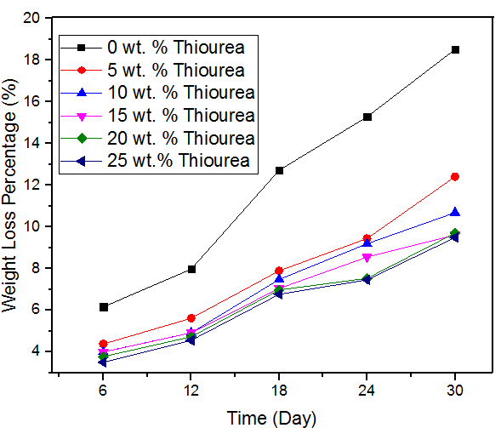

Figure 1. The weight loss percentage (%) of the Al immersed in HCl solution against immersion time

Subsequently, the corrosion rate of the present samples was calculated by equation (2). Figure 2 depicts the plot of corrosion rate versus the immersion time of the Al with different concentrations of thiourea. As can be seen from the figure, the corrosion rate showed a significant decrease from days 6 to days 12, and afterwards, it showed only a slight variation with immersion time until days 30. Furthermore, the Al immersed in thiourea solution gave a lower corrosion rate as compared to the one without inhibitor since there was protection provided by thiourea on the specimen from being attacked by chloride ions. This result also indicated that the corrosion rate has been remarkably reduced after thiourea was added into the solution. As stated by Rosliza [13], corrosion inhibitor is a substance which, when added in small amount to a medium normally corrosive to a metal or alloy in contact with it, can effectively reduce the corrosion rate as it protects the metal surface from being further attacked by chloride ion. The lowest corrosion rate obtained in this study was for the Al immersed in 25 wt.% of thiourea followed sequentially by 20 wt.%, 15 wt.%, 10 wt.% and 5 wt.% of thiourea. Again, this result gave evidence that higher thiourea concentration and longer immersion time will protect the samples from undergoing further corrosion.

Figure 2. The corrosion rate of the Al against immersion time at different thiourea concentrations

The inhibition efficiency (%) was calculated by equation (3). Table 1 shows the inhibition efficiency for Al immersed in HCl with different thiourea concentrations from days 6 until days 30. The plot of inhibition efficiency versus immersion time for different concentrations of thiourea is shown in Figure 3.

Table 1. The inhibition efficiency of Al corrosion at different immersion durations and thiourea concentrations.
Samples  (5 wt.% HCl) | Inhibition Efficiency (%)
Samples  (5 wt.% HCl) | Day 6 | Day 12 | Day 18 | Day 24 | Day 30
5 wt.% thiourea | 28.59 | 30.87 | 31.55 | 35.57 | 39.33
10 wt.% thiourea | 35.28 | 37.10 | 37.50 | 37.32 | 46.85
15 wt.% thiourea | 36.85 | 40.09 | 40.86 | 43.90 | 47.40
20 wt.% thiourea | 39.59 | 39.06 | 41.28 | 47.54 | 49.87
25 wt.% thiourea | 40.31 | 42.02 | 45.32 | 51.31 | 52.54

From the figure, it can be seen that the inhibition efficiency increased with the increasing of thiourea concentration and immersion time. This again indicated that thiourea can be utilized to retard the Al corrosion in HCl for a prolonged time. The inhibitors will react with and remove the active corrosive species from the metal surface by creating a barrier between the metal and their environment to decrease the attack of chloride ion [13]. Hence, we can elucidate that the role of thiourea as an inhibitor becomes more effective when the concentration of thiourea increases. This effect is in agreement with the work reported by Prabhu and Rao [14], in which a corrosion inhibitor is a chemical substance that, when a small concentration is added into the environmental medium would effectively increases the inhibition efficiency. Also, the inhibition efficiency range obtained in this work is comparable with those obtained by Ahmad and Hassan [10], Rosliza [13], and Prabhu and Rao [14], in which the thiourea can provide an alternative and better solution to metal corrosion in an acidic med

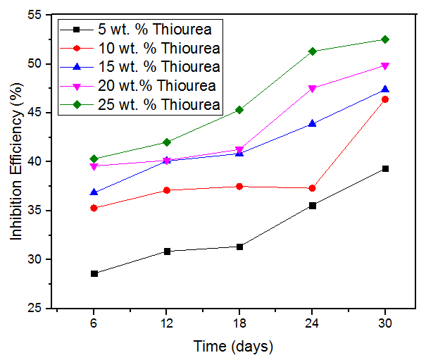

Figure 3. The inhibition efficiency of the Al corrosion against immersion time for different thiourea concentrations

Pitting is a particular characteristic of chloride ion (Cl⁻) attacks and is considered to be autocatalytic in nature; once a pit starts to grow, the local conditions are altered such that further pit growth is promoted [15]. Figure 4 illustrates the microstructure surface images of pure Al and the Al immersed in 5 wt.% and 25 wt.% thiourea concentrations for 6 days and 30 days of immersion duration. As shown in Figure 4(a), the surface of the Al before corrosion was homogeneous without any pitting or crack. However, the Al after immersing in the HCl solution had the irregular mixtures of conical, hemisphere and cylindrical pits on the surface. Corrosion of Al appeared to occur principally at flaws or grain boundaries within the surface film and at sites where the film was damaged mechanically under conditions in which self-repair will not occur. This acidic chloride environment is aggressive to most metals and tends to prevent re-passivation and promote continued propagation of the pit. As a result, pitting will occur during active dissolution if certain regions of the samples are susceptible and dissolve faster than the rest of the surface. In practice, pits have a tendency to form an irregular geometry associated with increasing size [15, 16].

From Figure 4, the corrosion pits observed on the Al surface as indicated by the dark region became wider when the immersion time increased. However, the number of pits decreased with the increasing of thiourea concentration. This is due to the role of thiourea inhibitor to protect the surface from further corrosion. Nevertheless, the corrosion cannot be avoided from occurring on Al, even when there an inhibitor is present in the solutions, but the corrosion can be retarded from getting worse for a prolonged time. Consequently, this finding proved the coverage of thiourea as a corrosion inhibitor on the Al surface and significantly decreased the corrosion attack in HCl solution.

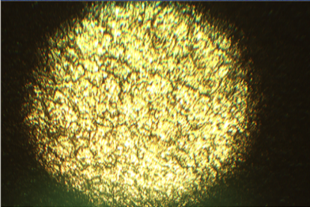
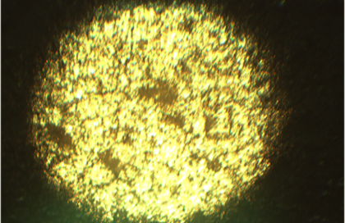
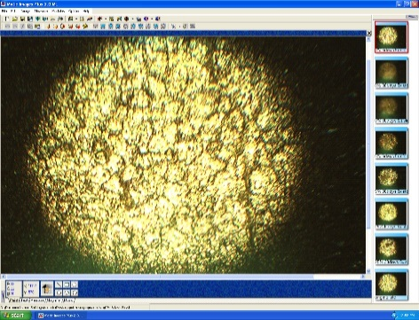
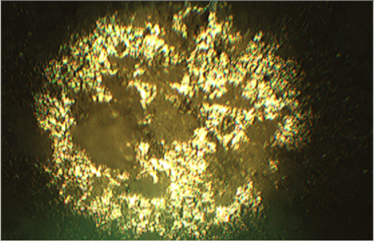
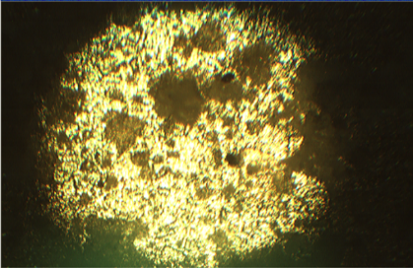
(a)
(b)
(c)
(d)
(e)

Figure 4. Surface morphology (50X) of (a) pure Al, (b) Al immersed with 5 wt. % thiourea for 6 days; (c) 25 wt.% thiourea for 6 days; (d) 5 wt.% thiourea for 30 days and (e) 25 wt.% thiourea for 30 days in HCl solution

Conclusion
In this work, the beneficial role of thiourea as an organic inhibitor on 1100 Al alloy corrosion in HCl acid solution was successfully investigated in detail by a simple gravimetric method. The results showed that increasing the concentration of thiourea has reduced the weight loss percentage and corrosion rate of Al specimens in HCl, thereby increasing the inhibition efficiency. Microstructure images showed that the number of pits distributed on the Al surface became fewer as the concentration of thiourea increased, which evidences the prevention of corrosion attacked on Al surface by thiourea. Based on this finding, further study on the corrosion inhibition effect by thiourea may be carried out in the future with different types of etchant mediums and applied metals to meet multiple commercialization purposes.

Acknowledgements
The authors would like to thank the School of Fundamental Science, School of Ocean Engineering, Universiti Malaysia Terengganu and the Malaysian Government for the assistance and support in conducting this work.

References
- Nik, W. B. W., Sulaiman, O., Giap, S. G. E. and Rosliza, R. (2010). Evaluation of inhibitive action of sodium benzoate on corrosion behaviour of AA6063 in seawater. International Journal of Technology, 1: 20–28.
- Palou, R. M., Xomelt, O. O., and Likhanova, N. V. (2014). Environmentally friendly corrosion inhibitors. Developments in Corrosion Protection, 431-464.
- Meena, S. L. and Verma, P. S. (2014). Effect of inhibitors on corrosion of aluminum in acidic medium. Indian Journal of Chemical Technology, 21: 220-223.
- Fouda, A. S., Shalabi, K. and Mohamed N. H. (2014). Corrosion inhibition of aluminum in hydrochloric acid solutions using some chalcone derivatives. International Journal of Innovative Research in Science, Engineering and Technology, 3(3): 9861-9875.
- Loto, C. A., Loto, R. T. and Popoola, A. P. I. (2012). Corrosion inhibition of thiourea and thiadiazole derivatives: A review. Journal of Materials and Environmental Science, 3(5): 885-894.
- Dariva, C. G. and Galio, A. F. (2014). Corrosion inhibitors–principles, mechanisms and applications. Developments in Corrosion Protection, 365-379.
- Shettya, S. D. and Shetty, P. (2008). Inhibition of mild steel corrosion in acid media by N-benzyl-Nʹphenyl thiourea. Indian Journal of Chemical Technology, 15: 216-220.
- Yaro, A. S. and Abdulaaima, D. A. (2012). Phenyl thiourea as corrosion inhibitor for mild steel in strong hydrochloric acid. Iraqi Journal of Chemical and Petroleum Engineering, 13(2): 1-9.
- Ali, A. I., and Foaud, N. (2012). Inhibition of aluminum corrosion in hydrochloric acid solution using black mulberry extract. Journal of Material Environmental Science, 3(5): 917-924.
- Ahmad, Y. H. and Hassan, W. M. (2012). Corrosion inhibition of steel in hydrochloric acid solution using a triazole derivative: Electrochemical and computational studies. International Journal of Electrochemical Science, 7:12456-12469.
- Kingsley, O. O. and Gideon C. O. (2014). Comparison of percentage weight loss and corrosion rate trends in different metal coupons from two soil environments. International Journal of Environmental Bioremediation & Biodegradation, 2(5):243-249.
- Eldwaib, K. A. (2013). Corrosion behavior of Al-alloy in NaCl contains some inhibitors. International Journal of Chemical, Environmental & Biological Sciences, 1(3): 524–527.
- Rosliza, R. (2012). Improvement of corrosion resistance of aluminium alloy by natural products. Corrosion Resistance, 377-396.
- Prabhu, D. and Rao, P. (2017). Coriandrum sativum L.—A novel green inhibitor for the corrosion inhibition of aluminium in 1.0 M phosphoric acid solution. Journal of Environmental Chemical Engineering, 1: 676-683.
- Leygraf, C. and Graedel, T. E. (2000). Atmospheric Corrosion. New York: John Wiley & Sons, Inc.
- Pereira, M. C., Silva, J. W., Acciari, H. A., Codaro, E. N. and Hein, L. R. (2012). Morphology characterization and kinetics evaluation of pitting corrosion of commercially pure aluminium by digital image analysis. Materials Sciences and Applications, 3: 287-2

