

MALAYSIAN JOURNAL OF ANALYTICAL SCIENCES
ISSN 1394 - 2506

Published by The Malaysian Analytical Sciences Society

COMBINED MECHANICAL-CHEMICAL PRE-TREATMENT OF OIL PALM EMPTY FRUIT BUNCH (EFB) FIBERS FOR ADSORPTION OF METHYLENE BLUE (MB) IN AQUEOUS SOLUTION

(Gabungan Rawatan Mekanik-Kimia ke atas Gentian Tandan Kosong Kelapa Sawit untuk Penjerapan Metilena Biru dalam Larutan Akues)

Chee Mun Chan¹, Siew Xian Chin^{1,2}*, Soon Wei Chook², Chin Hua Chia², Sarani Zakaria²

¹ASASIpintar Programme UKM, Pusat Permata Pintar Negara
²Bioreousrces and Biorefinery Laboratory, Faculty of Science and Technology
Universiti Kebangsaan Malaysia, 43600 UKM Bangi, Selangor, Malaysia

*Corresponding author: chinsiewxian@ukm.edu.my

Received: 27 July 2017; Accepted: 28 April 2018

Abstract
The effectiveness of combined mechanical-chemical pre-treatment on oil palm empty fruit bunch (EFB) fibers in removing organic dye from aqueous solution was studied. The efficiency of dye adsorption in aqueous solution using natural fibers is generally affected by several factors, such as pH, temperature, and the concentration of dye. However, the effect of the size of the fibers (adsorbent) has rarely been investigated. Prior to any MB adsorption process, mechanical-chemical pre-treatment was performed on EFB fibers via a high-shear process using a Silverson mixer. Shearing duration and the introduction of sodium hydroxide (NaOH) influenced the rate of adsorption, due to the changes in fiber size and accessible surface after the treatment process. From these results, it was found that smaller EFB fibers enhanced the rate and adsorption capacity of MB. However, this was not a linear relationship, as the rate of adsorption decreased when the shearing duration was prolonged to 30 minutes. Meanwhile, treatment with 0.1 M NaOH also improved the adsorption performance of the fibers. Hence, combined mechanical-chemical pre-treatment of EFB fibers can increase the adsorption rate and capacity of the fibers. This study may provide useful information on a practical pre-treatment approach for natural fibers as dye adsorbent in wastewater treatment.

Keywords: adsorption, oil palm empty fruit bunch fibres, methylene blue, pre-treatment

Abstrak
Keberkesanan proses pra-rawatan gabungan mekanik-kimia ke atas gentian tandan kosong kelapa sawit (TKKS) untuk penyingkiran pewaran organik telah dikaji. Kajian lepas membuktikan bahawa tahap keberkesanan proses penjerapan pewarna dalam larutan akues adalah bergantung pada beberapa faktor penting, seperti suhu, keasidan dan kepekatan pewarna. Namun, faktor saiz gentian (bahan jerapan) dalam proses penjerapan jarang dikaji. Sebelum proses penjerapan, pra-rawatan secara mekanik-kimia telah dilakukan pada gentian TKKS dengan menggunakan pengacau Silverson. Didapati bahawa jangka masa pra-rawatan yang berbeza dan penambahan NaOH akan mempengaruhi kadar penjerapan MB ekoran daripada perubahan saiz dan permukaan terdedah gentian selepas proses pra-rawatan. Malahan, saiz gentian TKKS yang lebih kecil berupaya untuk meningkatkan kadar dan kapasiti penjerapan MB. Akan tetapi, keputusan kajian ini adalah tidak linear kerana kadar penjerapan gentian TKKS didapati menurun apabila masa pra-rawatan mekanikal dipanjangkan 30 minit dan ke atas. Sehubungan itu, modifikasi gentian TKKS dengan menggunakan 0.1 M NaOH dapat meningkatkan prestasi kadar dan kapasiti penjerapan MB. Kesimpulannya, pra-rawatan gabungan mekanik-kimia terhadap gentian TKKS dapat meningkatkan kadar dan kapasiti gentian. Kajian ini dapat memberi maklumat penting bagi kaedah pra-rawatan yang praktikal kepada gentian semula jadi sebagai bahan penjerap pewarna dalam rawatan air buangan.

Kata kunci: penjerapan, gentian tandan kosong kelapa sawit, metilena biru, pra-rawatan

Introduction
Dye industries, such as textile, paper, printing, and cosmetics, produce water pollutants that have caused environmental problems. Currently, there are about 10,000 different commercial dyes and pigments in existence and over 7 × 10⁵ tonnes of synthetic dyes produced worldwide [1]. Among all industries, the textile industry was the first to use dyes for the coloration of fibers [2]. The release of dye compounds into water systems without proper treatment will harm aquatic life [3]. Also, these dyes can cause several health issues, such as allergies, infections, and dysfunction of systems in humans [4]. For example, upon inhalation, it can give rise to a short period of rapid and difficult breathing, while ingestion through the mouth results in a burning sensation and may even cause nausea, vomiting, profuse sweating, mental confusion, and methemoglobinemia [5]. Methylene blue (MB) is one of the most common dyes that is used and is abundant in the effluent that is discharged into water. Therefore, the treatment of effluent containing such a dye is paramount due to its harmful impacts on receiving water [6].

Chemical and physical adsorption processes are some of the most effective techniques for color removal from wastewater [4]. Adsorbents, such as activated carbon, have been reported to be the most promising material for adsorption of MB due to its high adsorption efficiency, based on its large surface area, micro-porosity structure, and high surface reactivity. However, several number of problems arise with the regeneration of activated carbon, because it is a tedious and costly procedure [1]. Therefore, as an alternative approach, there is growing research interest in the production of alternative sources to replace the activated carbons from renewable and cheaper precursors, mainly industrial and agricultural polymers, such as oil palm fibers, rice hulls, natural clay, corn hubs, wood chips, silica ash, and coal [6, 7].

Natural cellulosic materials, such as oil palm fibers, are some of the most renewable sources of environmentally friendly raw material. Lignocellulose fibers can be obtained from the tree trunk, frond, fruit mesocarp, and empty fruit bunch (EFB) [8]. EFB is the fibrous mass that is extracted from the seed hair of the oil palm [9]. Based on a review by Shinoj et al. [8], EFB has the potential to yield up to 73% fibers and is thus preferable in terms of availability and cost. Malaysia is the world’s second largest palm oil exporter, and about 3.0 million tons of oil palm EFB fibers are produced every year [5, 10]. To make better use of this cellulosic material, it has been suggested that EFB fibers be converted into an alternative adsorbent in light to replace the high cost of activated carbon [6].

To enhance the adsorption process, the fiber surface has functional groups, such as hydroxyl groups, that increase its hydrophilic property, reducing their affinity to bind to hydrophobic molecules. Also, pre-treatment of EFB fibers is essential to alter the structure of cellulosic biomass to increase the accessibility of the pores and surface of the cellulose. This can be achieved by unsealing the lignin and disrupting the crystalline structure of the cellulose. As a result, EFB fibers are more efficient in removing MB from wastewater [8, 11].

The aim of this study is to investigate the efficiency of combined mechanical-chemical pre-treatment of oil palm EFB fibers for the removal of MB in aqueous solution via an adsorption approach, in which the size of the fibers can be correlated with the rate of adsorption of MB. Smaller EFB fibers are predicted to increase the rate of adsorption of MB [12]. Also, chemical modification with alkali, such as sodium hydroxide (NaOH), will also enhance the adsorption capacity of the EFB fibers, thus increasing the rate of adsorption of MB [1]. Alkali pre-treatment increases the physical and adhesion properties and reduces water absorption of EFB fibers. Also, the removal of lignin (which holds the cellulose and hemicellulose tightly by adhesion forces) by alkali increases the surface area of porous pores that are exposed for adsorption [9]. The data obtained from the experiment were then fitted to a calibration curve for studying the adsorption rate and adsorption capacity. This study can benefit the country by proving the potential of EFB fibers in treating one of the most serious problems in Malaysia: wastewater.

Materials and Methods
Oil palm EFB fibers were obtained from Szetech Engineering Sdn. Bhd. (Malaysia). The fibers were sieved into sizes ranging from 150–500 µm and dried at 105 °C before the pretreatment process. The sodium hydroxide (NaOH) (Sigma-Aldrich), hydrochloric acid (Sigma-Aldrich), and methylene blue (MB) (Mallinckrodt >99%) were analytical-grade.

Pre-treatment of EFB fibers
Briefly, 10 g of EFB fibers (in 500 mL deionized) was sheared at 8000 rpm using a Silverson homogenizer (L5M-A) for various durations (ranging from 15 to 60 minutes). The homogenizer was fitted with a square-hole high-shear screen to provide high-shear mixing to defibrillate the fibers. The pre-treated EFB fibers were rinsed with deionized water until the pH of the fibers decreased to pH 7. The same procedure was repeated using 0.1 M NaOH.

Preparation of MB solution
Methylene blue (MB) solutions were prepared and diluted according to the required initial concentration i.e. 100 mg/L. The concentration of the MB was determined using a UV-visible spectrometer (Jenway 7315 Spectrometer) at 665 nm in a quartz cuvette.

Adsorption of MB using pre-treated EFB fibers
Adsorption experiments were performed to determine the effect of mechanical-chemical modification on the adsorption performance of the pre-treated fibers. Briefly, 0.5 g of EFB fibers from different samples was added to a beaker containing 100 ml of diluted MB solution (50 mg/L). The mixture was stirred at 250 rpm until equilibrium readings were achieved. The MB concentration of the supernatant solution was measured at various intervals, ranging from 5 to 30 minutes, using the UV-visible spectrophotometer. Prior to that, the mixture was centrifuged for 2 minutes at 250 rpm to fully separate the fibers. The amount of dye that adsorbed onto the fibers was calculated using the following equation:

(1)

where C_{o} and C_{e} are initial and subsequent concentrations of dye (mg/L), respectively.

Scanning electron microscope (SEM)
The morphology of the raw and pretreated EFB fibers was observed using a scanning electron microscope (Phenom ProX SEM).

Results and Discussion
The morphology of the raw and pretreated EFB fibers is shown in Figure 1(a-e). As observed in Figure 1a, the surface of the raw untreated EFB fibers was smooth and rigid with the presence of embedded silica particles. The surface of the fibers became rougher after the pre-treatment process and homogenized in water for 15 minutes, as shown in Figure 1b. Hence, the presence of silica and empty craters was also observed. As the shearing duration was prolonged to 60 minutes, as shown in Figure1c, the structure of fibers was disrupted and opened up. The size of the fibers decreased, and the existence of microfibrils could be clearly seen. In the comparison between Figure 1b and Figure 1d with the same shearing duration (15 minutes), the EFB fibers in Figure 1d had a more disrupted cellulosic structure, and a larger surface area of the fibers was exposed. This was due to the alkali modification, which swelled and delignified the fibers during the shearing process [13]. Similarly, the EFB fibers in Figure 1e were completely disrupted and were the smallest, resulting in a rougher and larger surface than EFB fibers that were sheared with water in Figure 1c. The differences in its morphology show that a longer shearing duration and incorporation with NaOH as the shearing medium may reduce the size of EFB fibers efficiently and enhance the removal of impurities from the fibers.

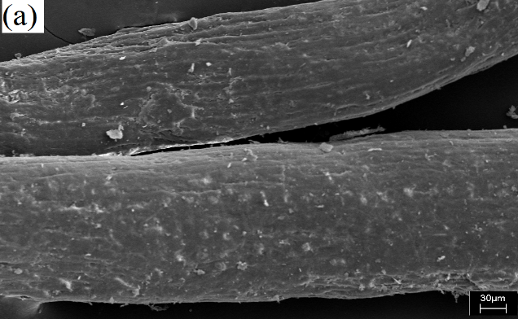
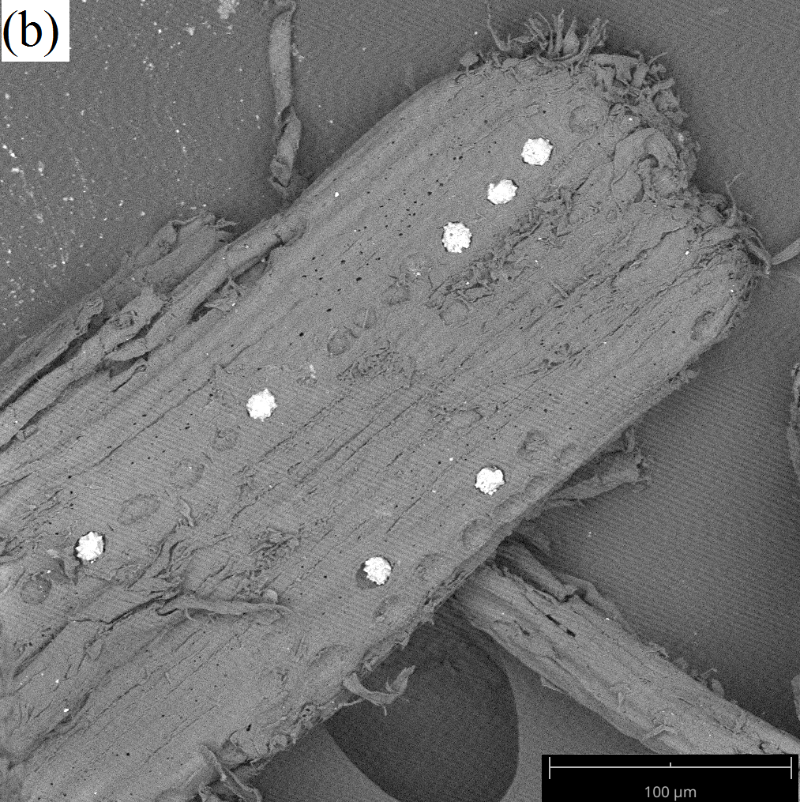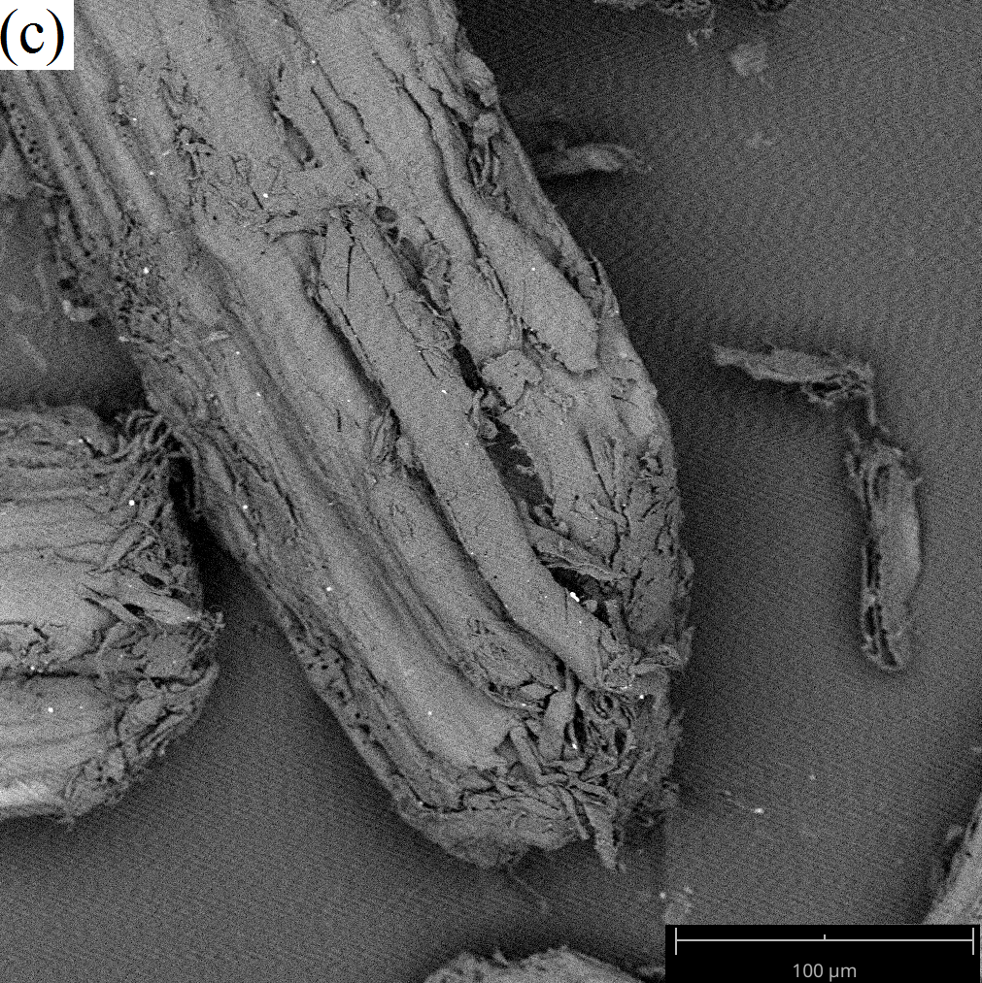
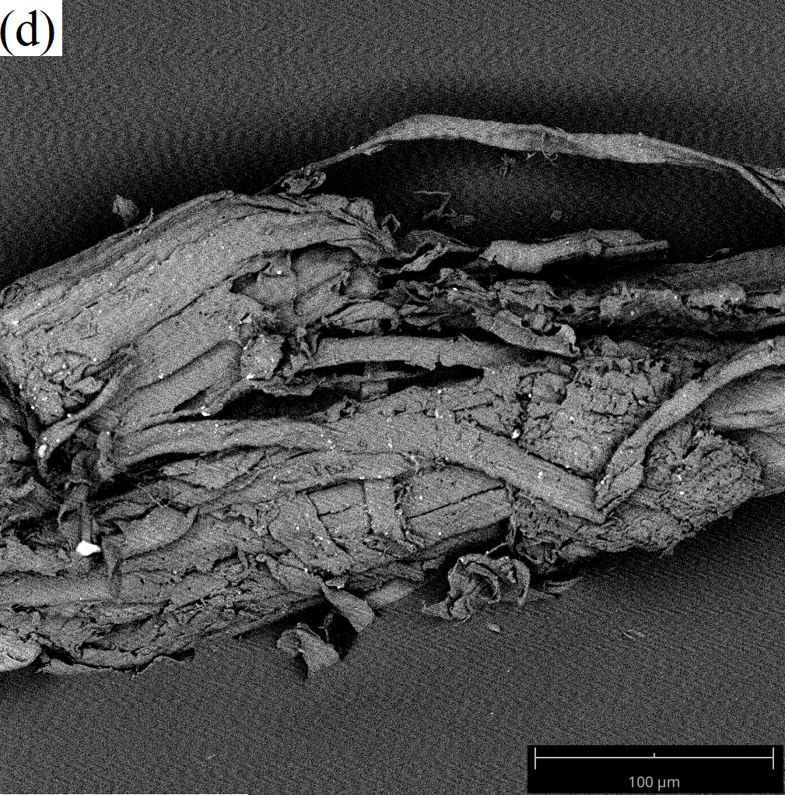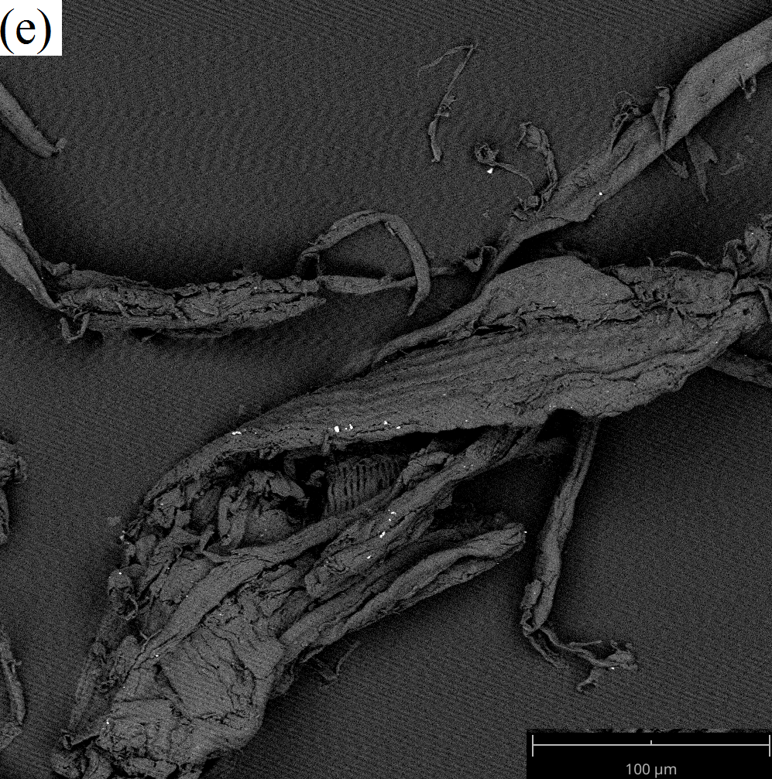
Figure 1. SEM micrographs of (a) raw EFB fibers, (b) EFB fibers sheared with H₂O for 15 minutes (H₂O-15), (c) EFB fibers sheared with H₂O for 60 minutes (H₂O-60), (d) EFB fibers sheared with 0.1 M NaOH for 15 minutes (NaOH-15), and (e) EFB fibers sheared with 0.1 M NaOH for 60 minutes (NaOH-60)

The rates of removal of MB via adsorption using different pretreated fibers are shown in Figure 2. The adsorption curves were characterized by an initial step with an increase in adsorption capacity assuming a convex shape. The initial rate had a steep slope due to the peak rate of MB adsorption.

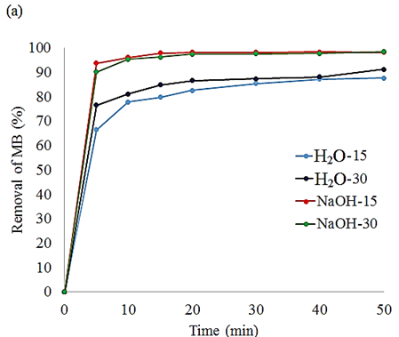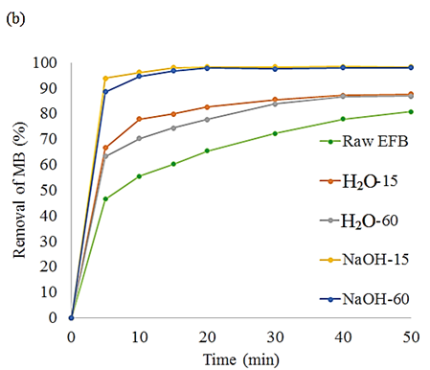
Figure 2. Rate removal of MB using (a) EFB fibers sheared with H₂O for 15 and 30 minutes (H₂O-15, H₂O-30) and EFB fibers sheared with 0.1 M NaOH for 15 and 30 minutes (NaOH-15, NaOH-30). (b) Raw EFB fibers (Raw EFB), EFB fibers sheared with H₂O for 15 and 60 minutes (H₂O-15, H₂O-60) and with 0.1 M NaOH for 15 and 30 minutes (NaOH-15, NaOH-30)

To study the effect of duration of the combined mechanical-chemical pretreatment of EFB fibers on MB adsorption, a control sample (raw EFB) was used to adsorb MB. From Figure 2b, it can be seen that the control sample had the lowest initial rate of removal of MB, while alkali pre-treated fibers (NaOH-15 and NaOH-60) yielded highest initial removal rate of MB. The results also suggested that there is no significant difference between (H₂O-15 and H₂O-30) and (NaOH-15 and NaOH-30), as shown in Figure 2a. This may be due to the short shearing duration, effecting insignificant changes in fibers size. Therefore, the result is not reported in Figure 2b.

It can be seen that the rate of removal of MB and adsorption capacity of MB using EFB fibers that were sheared with 0.1 M NaOH were higher than those of EFB fibers that were sheared with water. According to a review by Shweta and Jha [14], fibers are bonded tightly in a complex matrix, thus closing most of the porous pores on the cellulose. Hence, it is difficult for MB molecules to diffuse into the fibers. Alkali may swell and remove some of the lignin and impurities in the fibers, thus exposing the pores of the rigid fibers and increasing the surface area, which correlate with the micrograph images in Figure 1d and e. Therefore, this enhances the diffusion of MB molecules. The obtained result is consistent with the analysis by Oh and co-workers, in which alkali pre-treatment increased the hydrogen bond intensity (HBI) of EFB fibers, thus increasing the rate of adsorption of MB molecules [15].

It was predicted that as the shearing duration increases, the rate of MB adsorption will also rise due to the smaller size of the fibers (Figure 1 b-e). However, from the obtained result, the rate of removal of MB decreased when the shearing duration was prolonged to 30 and 60 minutes. Based on Kim and co-workers, the effect of pre-treatment on the structure of EFB is quite complex and not fully understood. The Crystalline Index (CI) of EFB is increased by the removal of lignin but not by the disruption of its structure. In other words, smaller EFB fibers do not expose their porous pores or increase their number of microfibrils [16]. Hence, this factor might decrease the rate of removal and adsorption capacity of MB as the pre-treatment duration increases. Yet, as the shearing duration increases, the removal of lignin, impurities, and hemicellulose from the fibers also increases. This is due to the decrease in the size of the EFB fibers during shearing and their incorporation with NaOH. As in a previous study, alkali pre-treatment will remove some of the hemicellulose in fibers [17, 18]. Hemicellulose in EFB is composed of a xylan backbone with O-acetyls and 4-O-methylglucuronic acid side chains. These can serve as functional groups to attract MB via electrostatic attraction [19]. However, as the duration of shearing with NaOH increases, the hemicellulose content will be reduced. Therefore, prolonged shearing of EFB fibers did not increase the rate of adsorption/adsorption of MB any further, as shown in Figure 2b.

Figure 3 shows the rate of MB removal by fibers that underwent shearing with H₂O and NaOH (H₂O-30 and NaOH-30) and control EFB fibers (stirred with 0.1 M NaOH for 30 minutes, without shearing) (Control-30). EFB fibers that were subjected to the shearing process were able to adsorb MB at a higher rate as compared with the Control-30 sample. This is consistent with the SEM results, where shearing reduced the size of the EFB effectively, providing a larger surface area of porous pores that were exposed; thus, more MB molecules could diffuse into the pores at an earlier stage. Control-30 resulted in a higher adsorption capacity than H₂O-30 due to surface and mechanical modifications that were made by the alkali, even though the size of the fibers was not reduced by shearing. Hence, we can conclude that chemical modification plays a larger role in affecting the rate of MB adsorption than the size of the EFB fibers. NaOH-30 induced the highest rate of MB adsorption compared with the H₂O-30 and Control-30 samples. In conclusion, mechanical-chemical pretreatment of EFB fibers has a synergistic effect in MB removal via the absorption by pretreated EFB fibers.

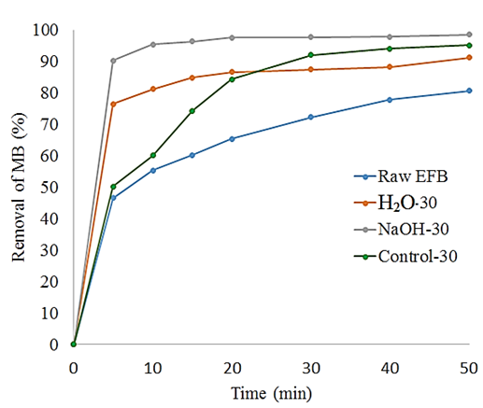
Figure 3. Removal rate of MB using raw EFB fibers (Raw EFB), sheared with H₂O for 30 minutes (H₂O-30), shearing with 0.1M NaOH for 30 minutes (NaOH-30) and EFB fibers without shearing but stirred with 0.1 M NaOH for 30 minutes (Control 30)

Conclusion
Oil palm EFB fibers were used to remove MB via an adsorption process. The rate of adsorption was faster with high adsorption capacity using pretreated EFB fibers via combined mechanical-chemical pre-treatment. Up to 98.4% of MB could be removed. This may be attributed to the increase in accessible pores and microfibrils in EFB fibers, as well as the hydroxyl functional groups, thus enhancing the rate of adsorption of MB. Pre-treatment of EFB fibers in the presence of NaOH effected the highest rate of MB adsorption compared with water pre-treated EFB fibers, suggesting that alkali can help swell the fibers and remove impurities and lignin during the shearing process.

Acknowledgments
The authors acknowledge the financial support provided by the research grants GGPM-2017-089 and FRGS/1/2016/STG01/UKM/02/3.

References
- Sajab, M. S., Chia, C. H., Zakaria, S. and Khiew, P. S. (2013). Cationic and anionic modifications of oil palm empty fruit bunch fibers for the removal of dyes from aqueous solutions. Bioresource Technology, 128: 571-577.
- Saad, S. A., Daud, S. D., Kasim, F. H. and Saleh, M. N. (2007). Methylene blue removal from simulated wastewater by adsorption using treated oil palm empty fruit bunch. International Conference on Sustainable Materials: pp. 293-296.

- Almeida, C. A., Debacher, N. A., Downs, A. J., Cottet, L. and Mello, C. A. (2009). Removal of methylene blue from colored effluents by adsorption on montmorillonite clay. Journal Colloid and Interface Science, 332: 46-53.
- Mohammed, M. A., Shitu, A. and Ibrahim, A. (January 2014). Removal of methylene blue using low cost adsorbent: A review Research Journal of Chemical Sciences, 4(1): 91-102.
- Rebitanima, N. Z., Ghani, W. A. W. A. K., Mahmoud, D. K., Rebitanim, N. A. and Salleh, M. A. M. (2012). Adsorption of methylene blue by agricultural solid waste of pyrolyzed EFB biochar. Journal of Purity, Utility Reaction and Environment, 1(7): 376-390.
- Tan, I. A. W. and Hameed, B. H. (2010). Adsorption isotherm, kinetics, thermodynamics and desorption of studies of basic dye on activated carbon derived from oil palm empty fruit bunch. Journal of Applied Sciences, 10(21): 2565-2571.
- Robinson, T., McMullan, G., Marchant, R. and Nigam, P. (2001). Remediation of dyes in textile effluent: A critical review on current treatment technologies with a proposed alternative. Bioresource Technology, 77: 247-255.
- Shinoj, S., Visvanathan, R., Panigrahi, S. and Kochubabu, M. (2011). Oil palm (OPF) and its composites: A review. Industrial Crops and Products, 33(1): 7-22.
- Thakur, V. K. and Thakur, M. K. (2014). Processing and characterization of natural cellulose fibres/themoset polymer composites. Carbohydrate Polymers, 109: 102-117.
- Mohammed, M. A., Salmiaton, A., Wan Azlina, W. A. and Mohamad Amran, M. S. (2012). Gasification of oil palm empty fruit bunches: A characterization and kinetic study. Bioresource Technology, 110: 628-636.
- Mosier, N., Wyman, C., Dale, B., Elander, R., Lee, Y. Y., Holtzapple, M. and Ladisch, M. (2005). Features of promising technologies for pretreatment of lignocellulosic biomass. Bioresource Technology, 96(6): 673-686.
- Cherifi, H., Fatiha, B. and Salah, H. (2013). Kinetic studies on the adsorption of methylene blue onto vegetal fiber activated carbons. Applied Surface Science, 282: 52-59.
- Rollin, J. A., Zhu, Z., Sathitsuksanoh, N. and Zhang, Y. H. (2011). Increasing cellulose accessibility is more important than removing lignin: A comparison of cellulose solvent-based lignocellulose fractionation and soaking in aqueous ammonia. Biotechnology and Bioengineering, 108(1): 22-30.
- Shweta, K. and Jha, H. (2015). Rice husk extracted lignin-TEOS biocomposites: Effects of acetylation and silane surface treatments for application in nickle removal. Biotechnology Reports, 7: 95-106.
- Oh, S. Y., Yoo, D. I., Shin, Y., Kim, H. C., Kim, H. Y., Chung, Y. S., Park, W. H. and Youk, J. H. (2005). Crystalline structure analysis of cellulose treated with sodium hydroxide and carbon dioxide by means of X-ray diffraction and FTIR spectroscopy. Carbohydrate Research, 340(15): 2376-2391.
- Kim, T. H., Kim, J. S., Sunwoo, C. and Lee, Y. Y. (2003). Pre-treatment of corn stover by aqueous ammonia. Bioresource Technology, 90(1): 39-47.
- Jung, Y. H., Kim, I. J., Han, J. I., Choi, I. G. and Kim, K. H. (2011). Aqueous ammonia pretreatment of oil palm empty fruit bunches for ethanol production. Bioresource Technology, 102(20): 9806-9809.
- Chin, S. X., Chia, C. H. and Zakaria, S. (2014). Green liquor pretreatment of oil palm empty fruit bunch (EFB) fibers for high yield of reducing sugars. Journal of Biobased Materials and Bioenergy, 8(3): 352-357.
- Gong, R., Sun, Y., Chen, J., Liu, H. and Yang, C. (2005). Effect of chemical mmodification on dye adsorption capacity of peanut hull. Dyes and Pigments, 67(3): 175-181.

