

MALAYSIAN JOURNAL OF ANALYTICAL SCIENCES
ISSN 1394 - 2506

Published by The Malaysian Analytical Sciences Society

ENZYMATIC HYDROLYSIS OF OIL PALM EMPTY FRUIT BUNCH AND ITS KINETICS

(Hidrolisis Enzim Tandan Buah Kelapa Sawit dan Sifat Kinetik)

Nazlee Faisal Ghazali* and Nurul Aqilah Makhtar

Department of Bioprocess Engineering,
Faculty of Chemical and Energy Engineering,
Universiti Teknologi Malaysia, 81310 Skudai, Johor Bahru, Johor, Malaysia

*Corresponding author: nazlee@utm.my

Received: 16 April 2017; Accepted: 7 March 2018

Abstract
Oil palm lignocellulosic biomass is a potential substrate for the production of renewable chemicals from agricultural wastes. Empty fruit bunch (EFB) is one of the biomass waste aside from the trunk and frond from oil palm plantation. Bioconversion of oil palm lignocellulose using enzymes to fermentable sugar could be used for the production of bioethanol. However, the bioconversion is challenging due to the complex interactions between substrate and enzymes. In order to utilize EFB as the feedstock, it is important to understand the effect of enzyme concentration and substrate concentration on the bioconversion of EFB. In this study, we investigated the effect of enzyme loading and substrate loading for the maximum conversion of oil palm lignocellulose. The results show that as the enzyme loading increased, the rate of reaction and also the yield of reducing sugar (RS) and glucose initially increased and then plateaued. High enzyme loading might lead to enzyme in excess and enzyme layering around the substrate. Similar pattern was also observed on the reaction rate as the substrate loading increased. However, the yield of RS and glucose decreased as the substrate loading increase. It could be explained by the substrate recalcitrance and product inhibition. The initial product formation rates were used to determine the kinetic parameters such as maximum rate constant V_{max} and the half saturation constant K_{m}. From this study, feasible amount of cellulase and EFB substrate could be identified for maximum conversion and facilitate bioethanol production.

Keywords: cellulase, oil palm lignocellulose, biomass, empty fruit bunch

Abstrak
Biojisim kelapa sawit lignoselulosa ialah substrat yang berpotensi untuk pengeluaran bahan kimia boleh diperbaharui daripada sisa pertanian. Tandan buah sawit (EFB) merupakan salah satu daripada sisa biojisim selain daripada batang dan pelepah dari ladang kelapa sawit. Penukaran biologi daripada lignoselulosa kelapa sawit menggunakan enzim untuk menghasilkan gula boleh digunakan untuk pengeluaran bioetanol. Walau bagaimanapun, penukaran biologi adalah mencabar berikutan interaksi kompleks antara substrat dan enzim. Dalam usaha untuk menggunakan EFB sebagai bahan mentah, ia adalah penting untuk memahami kesan kepekatan enzim dan substrat kepekatan pada penukaran EFB. Dalam kajian ini, kami telah menyiasat kesan enzim dan substrat untuk penukaran maksimum lignoselulosa kelapa sawit. Keputusan menunjukkan apabila muatan enzim meningkat, kadar tindak balas dan hasil gula (RS) dan glukosa pada awalnya meningkat tetapi kemudiannya mendatar. Muatan enzim tinggi mungkin membawa kepada enzim yang berlebihan dan enzim lapisan sekitar substrat. Corak yang sama berlaku pada kadar tindak balas apabila muatan substrat meningkat. Walau bagaimanapun, hasil RS dan glukosa menurun apabila muatan substrat meningkat. Ia boleh dijelaskan oleh kesusahan degradasi substrat dan perencatan oleh produk. Kadar pembentukan produk awal digunakan untuk menentukan parameter kinetik seperti kadar maksimum malar V_{max} dan pemalar separuh tepu K_{m}. Daripada kajian ini, jumlah celulase dan EFB substrat dapat dikenalpasti untuk penukaran maksimum dan memudahkan pengeluaran bioethanol.

Kata kunci: selulosa, lignoselulosa kelapa sawit, biojisim, tanda buah kelapa sawit

Introduction
Malaysia as one of the largest contributor of palm oil industry in the world is now facing a great environmental issues regarding the palm oil waste. To be able to convert this waste into product would be a great benefit to the country. Empty fruit bunch (EFB) is one of biomass waste aside from the trunk, frond and fruit mesocarp from oil palm plantation. It could be an alternative to renewable feedstock for the production of bioethanol. In order to utilize lignocellulose, it must be hydrolyze into its sugar components. The hydrolysis process can be achieved using chemically (acid) and biologically (enzyme). However, enzymatic process is milder, environmental friendly and allow better fermentability. Lignocellulose biomass consists of cellulose, hemicellulose, lignin and extractive. Cellulase attack the cellulose and the enzyme system consists of endoglucanase, cellobiohydrolase and β-glucosidase. These enzymes work in a synergistic manner in order to hydrolyze cellulose into sugars [1]. As the study on EFB hydrolysis by cellulase enzymes is still limited, we are taking an approach to provide more understanding in this hydrolysis. There are few factors affecting enzymatic hydrolysis such as pH, temperature [2], substrate concentration, enzyme concentration [3] and structure of lignocellulose [4]. In order to utilize EFB as the biofuel feedstock, it is important to understand the effect of enzyme concentration and substrate concentration on the bioconversion of EFB. Moreover, the significant cost in bioconversion is the enzymes and therefore the total amount of enzymes used in hydrolysis is important. Substrate loadings are also factor in creating economical enzymatic conversion and have to be high enough to achieve sufficient sugar levels for fermentation [5]. Therefore, the identification of the optimal enzyme and substrate loadings have to be made. In this study, we investigated the effect of enzyme loading and substrate loading for the maximum conversion of lignocellulose.

Materials and Methods
Materials
The lignocellulosic biomass used in this study was oil palm empty fruit bunch (EFB). This fibre was collected from Malaysia Palm Oil Berhad (MPOB) which located in Bangi, Selangor. After sampling the EFB was dried in an oven at 60 °C to avoid fungal growth and then followed by grinding process. The EFB was grounded into particles in size of 300-500 µm using grinder. Then, it was stored in an oven at 50 °C until the pre-treatment process. This pre-treatment includes hot water treatment and alkali treatment using method documented by Hamzah et al. [6]. Cellulase was purchased commercially from Novozymes Malaysia Sdn. Bhd. This cellulase is commercially known as Celluclast 1.5 L. It is cellulolytic system in brown solution with a slight fermentation odour with density 1.2 g/mL at 25 °C. It generally consisted of endoglucanase, exoglucanase and 1,4-β-glucosidase. This cellulase is produced by submerged fermentation of a selected strain of the fungus Trichoderma reesei and catalyzes the breakdown of cellulose into glucose, cellobiose and higher glucose polymers. The activity of Cellulclast 1.5 L was determined using filter paper assay and was found to be 137 FPU/mL.

Enzymatic hydrolysis of EFB
Enzymatic hydrolysis of EFB was carried out in a batch process using cellulase as the catalyst. Two parameters were investigated in this hydrolysis namely enzyme loading and substrate loading. The total reaction volume was 20 mL with citrate buffer of pH 5.0 as the reaction medium. For substrate loading, the hydrolysis experiments were carried out for 2.5 g/L, 5.0 g/L, 10.0 g/L, 20.0 g/L and 50.0 g/L treated EFB with 0.1 mL cellulase at 50 °C for 24 hours. For enzyme loading, the hydrolysis experiments were carried out for 10 g/L treated EFB with different cellulase amount (0.05 mL, 0.1 mL, 0.2 mL, 0.5 mL and 1.0 mL) at 50 °C for 24 hours. All samples were analysed for glucose and reducing sugar content at 1st and 24th hour using glucose analyser and dinitrosalicyclic acid (DNS) assay respectively. Adsorption was done at 50 for 24 hours using different enzyme loading at constant substrate concentration (10 g/L). The protein content in the supernatant was determined using Bradford reagent.

Analytical method
There are two important analysis that were carried out throughout this study which are determination of reducing sugar using dinitrosalicyclic acid (DNS) and determination of glucose concentration using glucose analyser. The main product of this lignocellulose hydrolysis is reducing sugar such as glucose, cellobiose and xylose. To determine the amount of reducing sugar released, dinitrosalicyclic acid (DNS) method by Miller [7] was used. Prior to DNS method, all samples were heated at 90 °C for 10 minutes to stop the enzymatic reaction. After that the tubes were centrifuged for 5 minutes at 10000 rpm to separate the fibre. An amount of 3 mL of DNS reagent was added to 3 mL of sample in a capped test tube. Then, the mixture was heated in water bath at 90 °C for 5-15 minutes to develop the colour. After that, the mixture was taken out and 1 mL of 40% potassium sodium tartrate solution (Rochell salt) was added to stabilize the colour. The mixture was cooled in a cold water bath until it reaches room temperature. Then, the absorbance was recorded at wavelength 540 nm using UV-Vis spectrophotometer (Jenway, UK). Anhydrous glucose was used for standard curve and sugar calibration. As DNS method only determine the presence of reducing sugar in product, an accurate test of glucose concentration was needed. Thus remaining supernatant from centrifuged sample was isolated and tested for glucose content using biochemistry analyser (YSI Incorporated, USA) with standard glucose of 2.5 g/L.

Kinetic study
The kinetics of the hydrolysis were studied following Michalis-Menten (equation 1):

$V=\frac{V_{m}\left[S\right]}{K_{m}+[S]}$ (1)

where V is defined as enzymatic reaction rate (g/L.h), V_{m} is maximum rate of enzymatic reaction (g/L.h), K_{m} is Michaelis Menten constant (g/L) and S is substrate concentration (g/L).

The kinetic parameters were estimated by double reciprocal plot linearization of Lineweaver Burke plot.

$\frac{1}{V}=\frac{1}{V_{m}}+\frac{K_{m}}{V_{m}}\frac{1}{[S]}$ (2)

V_{m} and K_{m} were calculated from the slope and intercept of the double reciprocal plot.

Results and Discussion
The effect of substrate loading on EFB hydrolysis was carried out in batch reaction with the 0.1 mL (0.25 g/L) enzyme at 50 °C. The product was analysed for protein, glucose and reducing sugar content. The results were analysed for rate of reaction, yield of RS, yield of glucose and also percent of glucose in the product. Hydrolysis of EFB with respect to substrate loading shows that the rate of RS and glucose production initially increased rapidly and then slowed down as substrate loading increased, as shown in Figure 1. It seems that the rate is relatively linear below 10 g/L of substrate but the rate starts to plateau between 20 g/l to 50 g/L. This indicates that at 10 g/l, the enzyme to substrate ratio is not limiting, but at 20 to 50 g/l, the enzyme attaching to substrate start to becomes saturated (adsorption limiting). This might also cause by product inhibition and also noncellulosic interference which decelerated the reaction process [2].

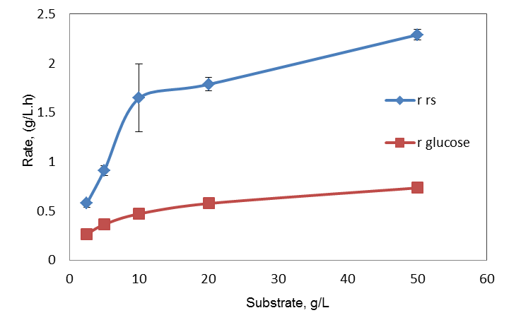
Figure 1. Rate of reducing sugar and glucose production for different substrate loading with 0.25 g/L cellulase at 50 °C
In contrast, Figure 2 shows that the percent yield of RS and glucose decreased as the substrate loading increased. This might happen as the substrate loading increased, cellulase was not sufficient to hydrolyse more substrate in the timeframe. Besides, the increase in substrate loading also increase the lignin components which create physical barrier for direct interaction between the enzyme and substrate thus lowering the hydrolysis yield. The yield of RS for 50 g/L and 10 g/L are around 40% and 70%, respectively. The lower yield of 50 g/L are probably due to mass transfer problem such as high viscosity and mixing and kinetic effects such as enzyme deficiency, product and substrate inhibition.
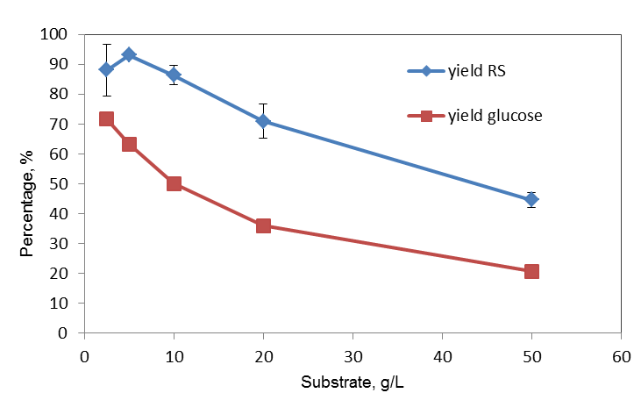
Figure 2. Yield of reducing sugar and glucose at 24th hour hydrolysis reaction for different substrate loading with 0.1 mL cellulase at 50 °C

In Figure 3, the percent of glucose decreased as the substrate loading increased at both 1st and 24th hour, respectively. The percent of glucose decreased as the substrate increased suggesting that available β-glucosidase is not enough to convert cellobiose to glucose as the substrate increased.

Figure 3. Percent of glucose at 1st and 24th hour hydrolysis reaction for different substrate loading with 0.1 mL cellulase at 50 °C

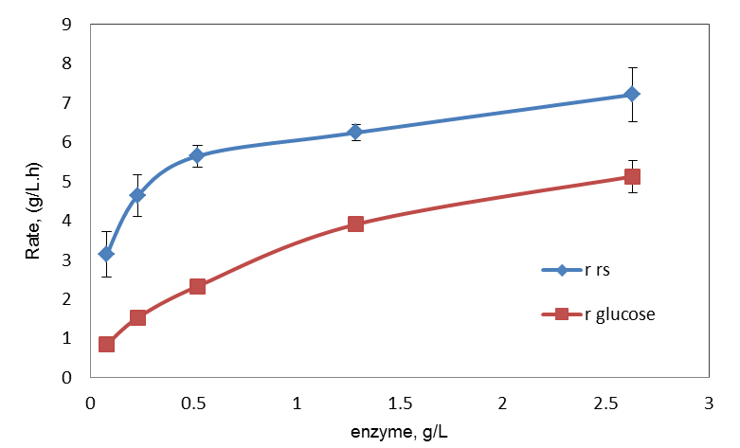
Figure 4 and 5 show that the rate of RS and glucose production and yield of RS and glucose initially increased then plateaued as enzyme loading increased. The reaction was initially increased as more enzymes were available to hydrolyse the fibres and then started to decelerate at one point as higher enzyme loading became in excess to the substrate. It also could be explained by Lee and Fan [8] that initially adsorbed enzyme on the substrate forms a single layer where the excess enzyme adsorbed forms additional later. This has restricted diffusion process of the excess enzyme from to substrate surface. Based on Figure 5, the enzyme to substrate ratio (E/S) that give constant maximum yield is around 0.05 (0.5 g enzyme/10 g EFB). In terms of enzyme cost, putting more enzyme in the reaction would not be feasible because the yield has reached its maximum.

Figure 4. Rate of reducing sugar and glucose production for different enzyme loading with 10 g/L treated EFB at 50 °C

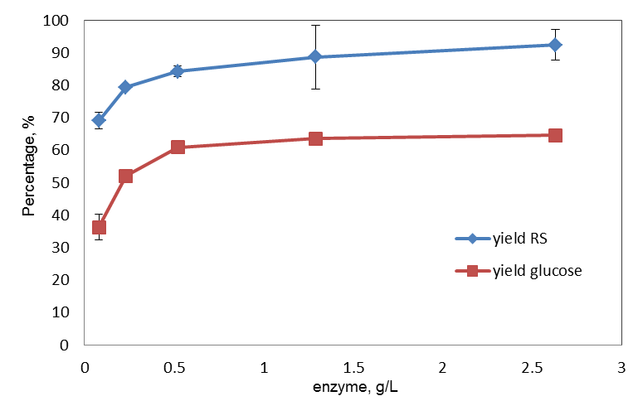

Figure 5. Yield of RS and glucose at 24th hour hydrolysis reaction for different enzyme loading with 10 g/L treated EFB at 50 °C

Adsorption of cellulase
The studies on the effect of enzyme loading on cellulase adsorption were carried out for 10 g/L treated EFB at different time frame. The product was analysed for the protein content in supernatant, adsorbed and percent of protein adsorbed to the substrate. In Figure 6 and 7, the protein concentration at supernatant and amount of protein adsorbed to the substrate increased as the enzyme loading increase after 30 minutes reaction. However, the percent of protein adsorbed to the substrate also decreased as the enzyme loading increase at 30 °C (Figure 8).

Figure 6. Concentration of protein at supernatant for 10 g/L treated EFB at 1st, 24th and 48th hours for different enzyme loading at 30 °C. (Note: 0.1 ml enzyme/20 mL solution = 0.25 g enzyme/L)

Figure 7. Concentration of protein adsorbed to 10 g/L treated EFB at 1st, 24th and 48th hours for different enzyme loading at 30 °C. (Note: 0.1 ml enzyme/20 mL solution = 0.25 g enzyme/L)

Figure 8. Percent of protein adsorbed to 10 g/L treated EFB at 24th for different enzyme loading at 30°C. (Note: 0.1 mL enzyme/20 mL solution = 0.25 g enzyme/L)
Figure 8 also shows that most of the cellulase is adsorbed at low concentration of enzyme (0.05 mL). Almost all of enzyme is absorbed in the substrate at low enzyme concentration however that high concentration (0.5 to 1.0 mL) with the percentage absorbed was around at 30%. In other words, at high concentration of enzyme, 70% of cellulase was in the liquid phase. This result also confirms the constant yield result at high enzyme concentration (Figure 5), the yield is almost constant at 4 g/L to 5g/L of enzyme. In an earlier study, Desphande and Erikson [9] showed that around 80% of endoglucanase were free in the liquid fraction after 24 hours of Avicel (crystalline cellulose) hydrolysis. However, this value decreased to less than 50% when lignin containing substrate is used. In a recent study, hydrolysis of wheat straw lignocellulose showed that proteins in supernatant increased from 30% to 65% when lignin substrate was decreased from 20% to 3.6% [10].

Based on adsorption, the substrate is saturated with enzyme at 4 g/L. Moreover based on the result, adding more enzyme to the reaction will not increase the yield. In terms of economics, this is significant, since enzyme is costly. Adding more enzyme will not be feasible since enzyme could denatured with time. Furthermore, Fox et al. [11] confirmed that rate of cellulose adsorption to substrate is important to determine the cellulose hydrolysis. Kumar et al. [12] observed that a positive correlation was found between adsorption and hydrolysis of cellulosic substrate at temperature below 60 °C.

Kinetic parameters
Kinetic parameters were determined using Michaelis-Menten approach. From the Lineweaver Burk plot, the value of the K_{m} and V_{m} are 9.866 g/L and 2.838 g/L.h. The reaction rate obtained from the experiment was well fitted with Michalis-Menten model describing by the high coefficient of R² which equal to 0.989. Therefore, it confirms the rate of EFB hydrolysis follows the Michalis-Menten model. The kinetic parameters offer quantitative information about the catalytic properties of the enzyme and maybe useful for reactor design. The higher value of Km means that the affinity of the substrate towards enzyme is low.

Conclusion
This study showed that as the enzyme loading increased, concentration of reducing sugar and glucose, yield of glucose and percent of glucose also increased. For substrate loading, reducing sugar and glucose concentration increased as the substrate loading increased. However, yield of RS, yield of glucose and percent of glucose decreased as the substrate loading increased. This could be due to substrate recalcitrance and product inhibition. The link between cellulase adsorption and hydrolysis rate and yield was elucidated. The influence of substrate concentration on the production of reducing sugar was studied by the Michaelis-Menten equation showing good correlation with experimental results. Our results show that substrate and enzyme loading are some of the key parameters in optimizing conversion of oil palm lignocellulose biomass to sugars using cellulase.

References
- Kumar, R. and Wyman, C. E. (2009). Effects of cellulase and xylanase enzymes on the deconstruction of solids from pretreatment of poplar by leading technologies. Biotechnology Progress, 25(2): 302-314.
- Jorgensen, H., Kristensen, J. B. and Felby, C. (2007). Enzymatic conversion of lignocellulose into fermentable sugars: challenges and opportunities. Biofuels Bioproducts Biorefining, 1(2): 119-134.
- Tengborg, C., Galbe, M. and Zacchi, G. (2001). Influence of enzyme loading and physical parameters on the enzymatic hydrolysis of steam pretreated softwood. Biotechnology Progress, 17(1): 110-117.
- Zhao, X., Song, Y. and Liu, D. (2011). Enzymatic hydrolysis and simultaneous saccharification and fermentation of alkali/peracetic acid-pretreated sugarcane bagasse for ethanol and 2, 3-butanediol production. Enzyme and Microbial Technology, 49(4): 413-419.
- Van Dyk, J. S. and Pletschke, B. I. (2012). A review of lignocellulose bioconversion using enzymatic hydrolysis and synergistic cooperation between enzymes – factors affecting enzymes, conversion and synergy. Biotechnology Advances, 30(6): 1458-1480.
- Hamzah, F., Idris, A. and Shuan, T. K. (2011). Preliminary study on enzymatic hydrolysis of treated oil palm (Elaies) empty fruit bunch fibre (EFB) by using combination of cellulose and β 1-4 glucosidase. Biomass and Bioengineering, 35(3): 1055-1059.
- Miller, G. L. (1959). Use of dinitrosalicyclic acid reagent for determination of reducing sugar. Analytical Chemistry, 31(3): 426-428.
- Lee Y. H. and Fan L. T. (1983). Kinetic studies of enzymatic hydrolysis of insoluble cellulose: (II). Analysis of extended hydrolysis times. Biotechnology and Bioengineering, 25(4): 939-966.
- Desphande, M. V. and Erikson, K. E. (1984). Reutilization of enzymes for saccharification of lignocellulosic materials. Enzyme and Microbial Technology, 6(8): 338-340.
- Qi, B., Chen, X., Su, Yi. and Wan, Y. (2011). Enzyme adsorption and recycle during hydrolysis of wheat straw lignocellulose. Bioresource Technology, 102(3): 2881-2889.
- Fox, J. M., Levine, S. E., Clark, D. S. and Blanch, H. W. (2012). Initial-and processive-cut products reveal cellobiohydrolase rate limitations and the role of companion enzymes. Biochemistry, 51(1): 442-452.
- Kumar, R., Singh, S. and Singh, O. V. (2008). Bioconversion of lignocellulosic biomass: Biochemical and molecular perspectives. Journal of Industrial Microbiology & Biotechnology, 35(5): 377-339.

