ALGINATE AEROGELS DRIED BY SUPERCRITICAL CO₂ AS HERBAL DELIVERY CARRIER

(Pengeringan Gel Aero Alginat oleh CO₂ Supergenting Sebagai

Pembawa Penghantaran Herba)

Ana Najwa Mustapa^{1*}, Ángel Martín¹, María José Cocero²

¹Faculty of Chemical Engineering,
Universiti Teknologi MARA, 40450 Shah Alam, Selangor, Malaysia
²Department of Chemical Engineering and Environmental Technology,
University of Valladolid, Calle Doctor Mergelina s/n, 47011 Valladolid, Spain

*Corresponding author: anajwa@salam.uitm.edu.my

Abstract
Herbal medicinal plant have been recognized as alternative and natural drugs for therapeutic purposes due to their high content of phytocompounds with anti-bacterial, antioxidant and anti-inflammatory properties. Low solubility and poor absorption of medicinal compounds are seen as major challenges for herbal drugs. Impregnation of these substances into aerogels as a carrier is an innovative to improve poorly soluble compounds. In this work, alginate hydrogels were produced via sol-gel processing method and dried by supercritical CO₂ drying to obtain high porous structure of alginate aerogels. Alginate is a type of polysaccharides that is widely applied in biomedical, pharmaceuticals, cosmetics, and foods due to its nontoxic, stability and versatility properties. Plant extracts of Clinacanthus nutans Lindau (C. nutans) were impregnated into the alginate aerogels via liquid media followed by supercritical drying and via supercritical CO₂ assisted impregnation technique. Results exhibited that the initial concentration of polyphenols of the C.nutans extracts impregnated in the alginate aerogels is stable in the range of 0.796 to 0.745 mg/g in 6 month and drastically reduced after 9 month of storage duration. The herbal extract type C.nutans-100 loaded via supercritical CO₂ impregnation has a comparable specific loading to the method of liquid media, range from 1.4 to 1.5 × 10⁻⁴ g/m² whereas the specific loading of C.nutans-50 extract impregnated via liquid media showed higher compared with the loading by method of supercritical CO₂.

Keywords: supercritical, drying, alginate, aerogels, Clinacanthus nutans Lindau

Abstrak

Tumbuhan ubatan herba telah diiktiraf sebagai ubat-ubatan alternatif dan semula jadi untuk tujuan terapeutik kerana kandungan sebatian fito yang tinggi dengan ciri-ciri anti-bakteria, anti-pengoksidaan dan anti-radang, kelarutan dan penyerapan yang rendah sebatian perubatan dilihat sebagai cabaran besar untuk ubat-ubatan herba. Hal memberi bahan ke dalam gel aero sebagai pembawa adalah suatu tindakan yang inovatif untuk meningkatkan keterlarutan sebatian yang kurang larut dalam air. Dalam kajian ini, gel aero alginat telah dihasilkan melalui kaedah pemprosesan sol-gel dan dikeringkan melalui CO₂ supergenting untuk mendapatkan struktur berliang tinggi. Alginat adalah sejenis polisakarida yang sinonim dalam bioperubatan, farmaseutikal, kosmetik dan makanan disebabkan oleh sifatnya yang tidak toksik, kestabilan yang tinggi dan serba boleh dalam pelbagai bidang. Dalam kajian ini, ekstrak tumbuhan Clinacanthus nutans Lindau (C. nutans) yang diperolehi daripada teknik pengekstrakan gelombang mikro (MAE) telah diimpregnasi ke dalam gel aero alginat menggunakan kaedah penjerapan cecair diikuti dengan pengeringan menggunakan CO₂ supergenting dan juga impregnasi menggunakan CO₂ supergenting. Ekstrak herba C. nutans-100 yang diimpregnasi menggunakan bendalir CO₂ supergenting menunjukkan kandungan spesifik yang hampir sama dengan kaedah media cecair iaitu dalam lingkungan 1.4 hingga 1.5 × 10⁻⁴ g/m² berat. Manakala, bagi ekstrak C. nutans-50, kandungan spesifiknya yang diimpregnasikan menggunakan kaedah media cecair adalah lebih tinggi berbanding dengan kaedah CO₂ supergenting iaitu , masing-masing. sebanyak 5.4 × 10⁻⁵ g/m² dan 4.9 × 10⁻⁶.

Kata kunci: supergenting, pengeringan, alginat, aerogel, Clinacanthus nutans Lindau

Introduction
Alginate aerogels is a class of biopolymer polysaccharides characterized by a combination of unique properties of aerogels and polysaccharides mainly high surface area, open porosity, good compatibility and biodegradable. Aerogels are porous structure materials derived either from synthetic inorganic precursor such as silica or from organic resources such as polysaccharides biopolymer via sol-gel method to obtain wet gels and dried by supercritical CO₂ drying. Nowadays, there is considerable growing attention on the use of biopolymer as aerogels for variety application. Numerous extensive works reported on the utilization of alginate aerogels contain desirable therapeutic properties as drug delivery application [1, 2]. Alginate is defined as natural polysaccharide biopolymer mainly recovered from brown algae. It contains of α-L-guluronic acid and β-D-mannuronic acid (M) residues, which linearly linked by 1,4-glycosidic linkage [3]. The natural biopolymer has been widely applied in several fields such as biomedical, pharmaceuticals, absorptions due to its biodegradable, biocompatible, non-toxic, low cost and stable.

Over many decades, herbs has been recognized as complementary and alternative supplement to modern drugs. In fact, World Health Organization (WHO) has estimated that about 80% of world population use herbal medicine in their primary healthcare. However, a systematic approach to measure their safety [4] and the poor compounds absorption remain as major challenges to extensively apply in the pharmaceutical industry [5]. There are many techniques have been introduced to improve the solubility and bioavailability of poorly soluble drugs or compounds such as production of drugs in nanoparticles [6, 7], incorporation in lipid based carrier such as micelles, liposomes, micro- and nanoemulsion [8, 9] and use of highly-soluble incipient such as β-cyclodextrin via formation of inclusion complex [10, 11]. Another promising way that has received considerable interest is by impregnating the compounds via supercritical CO₂ assisted technique in polymer or biopolymer materials [12, 13] and aerogels [14, 15].

The excellent characteristics of aerogels with large surface area and high pore volume make them attractive candidate for drugs delivery system to improve solubility of poorly soluble compounds [16]. In theory, high surface area and pore volume contribute to high compounds loading in the aerogels. The high loading capacity is very important as it provide large space for the compounds to be stored in pores of aerogels for drugs [14] and delivered to the target area with correct dosage or as absorbent for environmental issues [17]. However, these characteristics only can be obtained when the materials are dried by supercritical CO₂ (SCCO₂) to remove the liquid present in the solid pores. At supercritical condition, liquid-CO₂ present as a single phase and has zero surface tension avoid capillary forces on the mesopores of the aerogels. Furthermore, the unique properties of the CO₂ as the solvent such high diffusivity and low viscosity enables the penetration of the solvent into material pores and extract the liquid without deforming the structure of the material. On the other hand, in conventional method i.e. freeze and ambient pressure drying that are operated at sublimation pressure and by evaporation, respectively may lead to the formation of vapor-liquid phase that can create the capillary forces on the materials and cause high degree of shrinkage. As results, poor porosity and low specific surface area produced. Several studies have demonstrated that the SCCO₂ drying is more effective than freeze drying [18]. Density of aerogels dried by SCCO₂ showed higher density ranged from 0.08 to 0.24 g/cm³ and porosity as high as 96.1% in comparison to those dried by ambient pressure drying technique [19].

This works focus on the production of alginate aerogels via sol-gel method and dried by SCCO₂ to be used as herbal carrier delivery. To the best our knowledge, to-date the use of biopolymer as a carrier for herbal delivery is very limited. The development of herbal or medicinal plant carrier is one of innovative technique to improve solubility and bioavailability of herbs in pharmaceutical industry. In this present study, medicinal plant extracts were impregnated into the alginate aerogels via liquid media and supercritical media i.e. SCCO₂ assisted method.
In the impregnation via SCCO₂ assisted, the substance solubilized in SCCO₂ at specified pressure and temperature in a vessel containing aerogels for a certain duration of time to allow equilibrium adsorption of the substance on the aerogels pores. This technique is more attractive as the CO₂ is nontoxic, nonflammable and has been regarded as safe for food and pharmaceuticals application.

However, most of medicinal compounds have poor solubility in SCCO₂ that limits the application of the technique for wide range of compounds. On the other hand, via liquid media, the synthesized gels are contacted with the solution of substance for a certain time and followed by SCCO₂ drying to extract the organic solvent and leaves the substance precipitate in the pore of the aerogels. In principle, the substance must be soluble in an organic solvent and insoluble or poor solubility in SCCO₂. However, one of the drawbacks of the method is that the substance dissolved in an organic solvent may be co-extracted during the drying process due to effect co-solvent increase the solubility of the SCCO₂, hence reduced the extract content. In addition, the final product also may still contain some traces organic solvent which therefore need proper drying procedure to remove the solvent. Both methods offers their advantages but also have some drawbacks. Therefore, investigation on these methods for the impregnation of medicinal plant extracts is essential to determine the most promising method for future development.

Clinacanthus nutans Lindau (C. nutans) is a potential medicinal plant that has been traditionally applied to treat skin rashes, insect bites, gout, diabetes and to against herpes simplex virus [20]. The plant is widely grown in Southeast Asia countries such as Thailand, China, Indonesia and Malaysia. In this work, Clinacanthus nutans Lindau (C. nutans) extracts were impregnated into alginate aerogels by a conventional technique i.e. liquid media and more advance method that is SCCO₂ impregnation. The objectives of this study are to investigate the characteristics of alginate aerogels dried by supercritical CO₂ and to determine the specific loading of the alginate aerogels impregnated with the C. nutans extracts via liquid media and SCCO₂. The stability of the C. nutans extracts, particularly total phenols content (TPC) and physical color appearance was also evaluated. Eventually, C. nutans extracts dissolution was performed to determine the behavior of the extract releases from the alginate aerogels from both impregnation methods.
Materials and Methods
The Clinacanthus nutans Lindau (C. nutans) plant was supplied by a traditional practitioner from Kuala Lumpur, Malaysia. For the extraction of the C. nutans by microwave-assisted extraction (MAE), the plant was grinded and dried prior to the extraction process. The method of the extraction has been described in Mustapa et al. [8]. For the preparation of alginate aerogels, sodium alginate, calcium carbonate (CaCO₃), glucono-δ-lactone (GDL) and ethanol were purchased from Sigma Aldrich whereas double distilled water was purified by a Milli-Q water purifier system Millipore (Milford, MA, USA). All chemicals and materials used as received without any purification.

Preparation of alginate aerogels
Alginate aerogels were prepared via internal setting method. In this technique, the GDL was added to the solution of sodium alginate and CaCO₃ to lower the pH of the solution and initiate the gelation. Initially, the alginic sodium salt was dissolved in water (to obtain 1.5 to 2% w/w) followed by the addition of CaCO₃ and stirred until it completely dissolved. The GDL was then added to the solution with continuous stirring. The hydrogels were then transferred into molds and stored in refrigerator (4 ºC) until they were completely gelled. Prior to the supercritical drying (SCD), the hydrogels undergone a successive solvent exchange (30, 50, 70, 90% v/v in 24 hours for each concentration, and finished by twice washing with pure ethanol) to remove water and its impurities. The alginate hydrogels are then called as alcogels after the solvent exchange procedures was completed.

Supercritical CO₂ drying and liquid media
To obtain blank alginate aerogels, the alcogels were subjected to the SCD which were conducted at 120 ± 5 bar and 40 ºC for a duration of 4–5 hours. For the impregnation of C. nutans extracts via liquid media, the alcogels were soaked in solution of C. nutans in ethanol for maximum 3 days before the SCD, to allow maximum absorption of C. nutans extracts by the alginate alcogels. Previously, the C. nutans extracts were first extracted using microwave-assisted extraction [21]. Two types of C. nutans extracts were impregnated into the alginate aerogels i.e. C. nutans-50 and C. nutans-100. Briefly, the C. nutans extracted using 50-50% ethanol/water content are called as C. nutans-50 meanwhile the C. nutans extracted using absolute ethanol was named as C. nutans-100. After the duration was completed, the alcogels were dried by the supercritical CO₂ like has been done for the blank alginate aerogels.

Supercritical CO₂ assisted impregnation
For the supercritical impregnation, the C.nutans extracts were loaded into the alginate aerogels using supercritical CO₂ at 150 bar and 40 ºC in 24 hours with small addition (10 wt.%) of absolute ethanol as a co-solvent to the SCCO₂. The setup of the supercritical impregnation are similar to the work presented in Mustapa et al. [11]. The amount of C. nutans-50 and C. nutans-100 placed in the supercritical impregnation was same to the amount of the extracts used in the liquid method. From our preliminary study, higher portion of ethanol, more than 10 wt.% caused a severe shrinkage on the alginate aerogels during the depressurization. The large amount of ethanol lead to the vapor-liquid interface caused capillary forces on the pores structure and deformed the alginate aerogels. Furthermore, the duration of 24 hours was chosen to allow equilibrium adsorption of the plant extracts on the alginate aerogels. A known amount of C. nutans extracts was placed in an autoclave while the aerogels were placed on top of the C. nutans extracts separated by a mesh metals to avoid direct contact between the extracts and the aerogels. After the 24 hours was completed, the system was depressurized slowly at rate of 2 bar/min to avoid the formation of liquid CO₂ in the autoclave. The presence of liquid CO₂ may shrink the aerogels due to the formation of two phases of liquid-gas in the pores of the aerogels.

Characterization of alginate aerogels
The textural properties of the alginate aerogels was characterized by nitrogen adsorption-desorption analysis using (Micrometer Analyzer, ASAP 2020 V4.02) at low temperature to determine the specific surface area, pore diameter and pore distribution. The alginate aerogels were degassed at 70 ºC under vacuum prior to the analysis. The surface area was calculated based on the method of Brunauer, Emmett and Teller (BET) meanwhile the pore diameter and its distribution was calculated from the desorption isotherms. To determine thermal stability and residue decomposition of the alginate, differential scanning calorimetry (DSC) were carried out from 20 to 600 ºC at a rate of 10 ºC/min using DSC 822e Mettler Toledo SAE. All the analysis were repeated three times and the value was calculated as average and standard deviation. To examine the surface texture of the blank and impregnated alginate aerogels with C.nutans extracts were analyzed by using SEM JEOL JSM 820 and microanalysis (Bruker Quantax 2000). Before the analysis, the samples were splattered coated with gold layer and scanned at voltage of 2-4kV.

Physical stability test
Stability analysis in terms of the physical appearance and color of the impregnated aerogels with the C. nutans extracts was also performed. This is to identify the quality of the product varies over a time period. To achieve this objective, alginate aerogels containing C. nutans-50 and C. nutans-100 were kept in glass vials, sealed, covered properly with aluminum foil to protect the aerogels from light and stored in vacuum desiccator at room temperature. After 3 months, the appearance of the aerogels were observed and recorded. The measurement were made in each 3 months interval for total duration of 12 months. In each measurements of 3 month, the extract content were quantified by UV-Vis spectrophotometer to determine the changes of the extract concentration over time, particularly the total phenols content (TPC). Prior to the analysis, the alginate aerogels were ground and submerged in ethanol to dissolve the extracts. The aliquot were then filtered and subjected to the TPC analysis preparation as mentioned in Mustapa et al. [21] followed by UV-Vis measurement against 765nm wavelength. This physical stability test was repeated twice and calculated as average and standard deviation.

Dissolution test of C. nutans extracts
To determine the release kinetics behavior of the plant extracts impregnated in the alginate aerogels, dissolution tests were conducted in USP-certified Copley NE4-COPD dissolution tester equipment with saline phosphate buffer at pH 6.8. A known weight of the impregnated aerogels were placed in a basket and immersed in vessel containing the buffer solution. The system was maintained at a temperature of 37 ± 0.5 ºC and kept stirred at 100 rpm. At each interval time, 2 ml of the aliquots was collected and replaced with 2 ml of fresh buffer solution that was maintained at 37 ºC. The samples were analyzed by UV-Vis spectrophotometer at the wavelength with maximum absorption of the plant extract. The cumulative (%) amount of C. nutans released was calculated and plotted against time of the measurement.

Results and Discussion

The nitrogen-desorption analysis on the blank alginate aerogels showed that the specific surface area, pore volume and diameter of the alginate were found in range from 86.94 to 125.9 m²/g, 0.42 to 0.8 cm³/g and 19.2 to 25.5 nm, respectively. The textural surface properties of alginate was increased with the increases of alginate concentration ratio from 1 to 2% w/w. Higher alginate content increase the crosslinking and the specific surface area of the aerogels. This is because increasing the alginate concentration would provide more functional groups of alginate molecules to be interacted with calcium cross linker agent [22]. Veronovski et al. [23] also reported that increasing the alginate concentration result to more crosslinking of the alginate chains with the physical structure of the aerogels are more compact and stiff. High surface area of the aerogels is very important for the impregnation purposes. As a rule of thumb, higher specific surface area contribute to higher loading capacity. Nevertheless, other factors also may influence the aerogels capacity such as solubility of substance in solvent carrier, affinity interaction of aerogels material-solute and material-solvent.

For the thermal analysis, a DSC diagram of the alginate aerogels is presented in Figure 1. It can be observed that a broad endothermic peak occurred at 70 ºC was may attributed to the loss of water from the alginate aerogels. As the temperature increased, an exothermic appeared at 240 ºC corresponds to the decomposition of the biopolymer. This observation was apparently different from the result reported by Veronovski et al. [23] where they found the decomposition of the alginate occurred at from 330 to 450 ºC.

Figure 1. Thermal stability and residue decomposition of alginate aerogel by DSC measurement

Surface textures of blank and impregnated alginate aerogels with C.nutans extracts analyzed by SEM are presented in Figure 2. The images show that the textural of the blank alginate aerogels (Figure 2a) looks uniformly cross-linked and has smaller open pores in comparison to the texture of the alginate aerogels impregnated with the C. nutans-100 extract (Figure 2b). The structure of the alginate impregnated with C. nutans extract appear to be slightly swollen and bigger compared with the blank alginate aerogels. This could be due to the interaction between ethanol and alginate material during the impregnation via liquid media and effect of CO₂ swell the material during the supercritical drying. In addition, longer impregnation time for 24 hours for this case also may lead to higher extent of swelling of the material matrix [24]. Eventually, higher swelling degree and high CO₂ sorption facilitated the diffusion of compounds solution into the material matrix [25]. Future thorough investigation on the interaction between multicomponent of C. nutans extracts and alginate materials in the presence of other solvent such as alcohol or CO₂ could interesting in order to understand the behavior of the impregnation using SCCO₂.

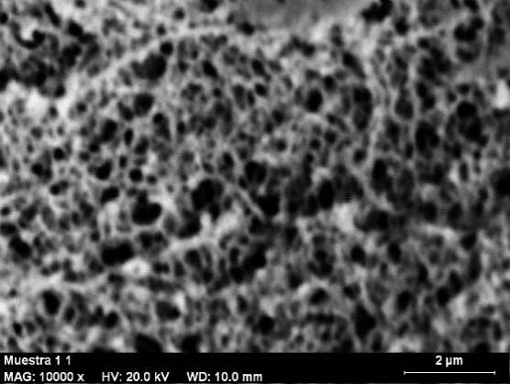
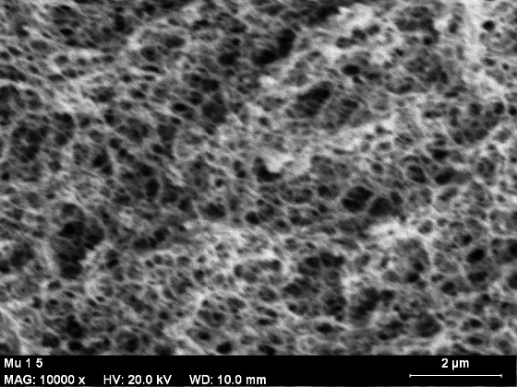
(a)
(b)

10k ×
10k ×

2µm
2µm

Figure 2. Textural surface of alginate aerogels: a) blank alginate (2 wt.%) and b) alginate aerogels (2 wt.%) impregnated with C. nutans-100 extract by liquid media impregnation method

The physical stability test of the alginate aerogels impregnated with the C. nutans-100 extracts are presented in Figure 3. It shows that at the first 3 month of the storage, the decreasing of the TPC content was insignificant from 0.796 to 0.745 mg/g. Meanwhile after 6 month, the TPC was started to decreased and found to be drastically reduced at month-12 to 0.332 mg/g of TPC. The decreasing of the TPC was continuously reduce until month-14 with 0.224 mg/g remained in the alginate aerogels. This result indicated that the reduction of the TPC still occur despite the samples were carefully covered and stored at room condition, due to the oxidation of some phenolic acid in the extract impregnated in the aerogels. However, the reduction of the TPC was slow could be due to minimal oxygen presence in the alginate pores [26]. As the duration continued until 12 month, the decreasing of the TPC became remarkable from 0.612 to 0.332 mg/g as more empty pores are occupied with oxygen thus encourage the oxidation of the polyphenols. Few study on the stability polyphenols content impregnated into a material also showed that the TPC was lower at the end of the storage that due to the oxidation process [26].

Figure 3. Variation of polyphenols content during storage

On the other hand, qualitative analysis on the color variations of the impregnated aerogels with C. nutans extracts are presented in Figure 4. As exhibited in Figure 4, the color of the alginate aerogels had faded away after 13 month in the storage. It was observed that the green color of the C. nutans-100 extracts changed from green to yellow pale. This indicate that the chlorophyll was degraded with extension of storage duration. Theoretically, the degradation of chlorophyll can be influenced by environmental factors such as enzyme degradation and oxidation bleaching that caused by reactive oxygen [27]. Additional test was also observed for silica aerogels impregnated with C. nutans-100. The degree of decolorized of the C. nutans extracts was higher than the extracts impregnated into alginate aerogels. High opacity of the alginate aerogels may affects this observation.

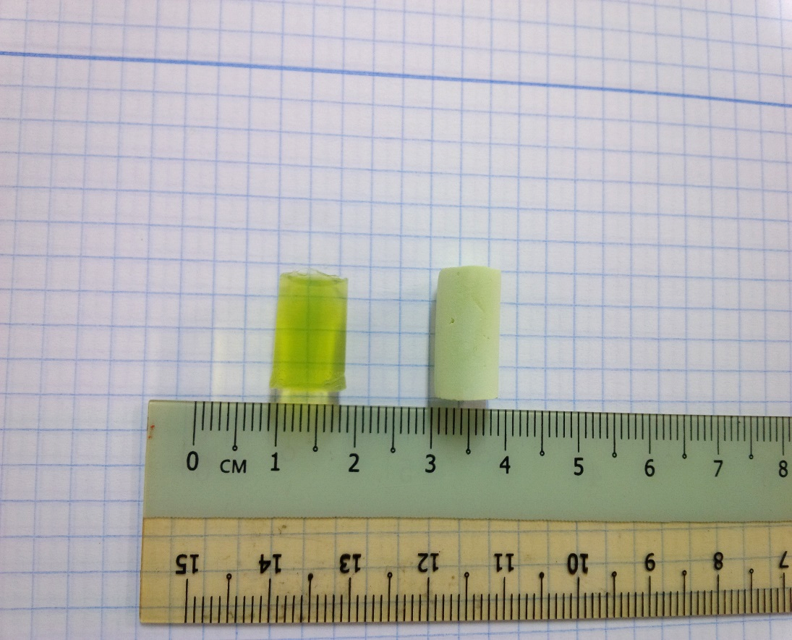
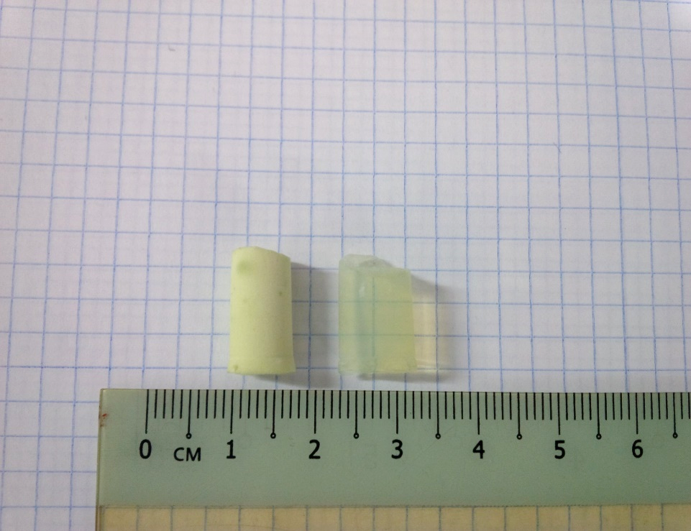
(a)
(b)

Figure 4. Sample of aerogels impregnated with C.nutans-100 images in stability test a) month-1 and b) month-12

The specific loading of C. nutans extracts into alginate aerogels were presented in Table 1. It is showed that the loading of the C. nutans-50 extracts via liquid media impregnation was higher with 5.4 × 10⁻⁵ g/m² in comparison to the SCCO₂ technique that yielding 4.9 × 10⁻⁶ g/m². Poor solubility of phytocompounds in the C. nutans-50 extracts in SCCO₂ that mainly comprises of large molecules compounds such as tannin, saponin and terpenoid was anticipated influenced the loading. Results also showed that the addition of 10 wt.% absolute ethanol in the SCCO₂ impregnation did not enhanced the specific loading of C. nutans-50 and C. nutans-100, relatively to the liquid media method. The specific loading of C. nutans-100 via liquid media was found to have comparable values to the loading obtained by SCCO₂ range from 1.4 to 1.5 × 10⁻⁴ g/m². This situation probably due to competitive of affinity of CO₂ sorption [28] and hydroxyl group on the alginate material may the loading of the extract. Thus, in this case, the selection of impregnation method for the C.nutans-100 extract is anticipated not crucial, considering the extract loading in the alginate aerogels.

Table 1. Specific loading of C.nutans extracts by liquid media and supercritical CO₂ impregnation into alginate aerogels

Impregnation Technique | Extracts | Specific Loading  (g/m²)
Liquid media | C.nutans-50 | 5.4 × 10⁻⁵ ± 1 × 10⁻⁵
Liquid media | C.nutans-100 | 1.4 × 10⁻⁴ ± 2 × 10⁻⁵
Supercritical CO₂ assisted | C.nutans-50 | 4.9 × 10⁻⁶ ± 4 × 10⁻⁵
Supercritical CO₂ assisted | C.nutans-100 | 1.5 × 10⁻⁴ ± 1 × 10⁻⁵

C.nutans release kinetics
C. nutans extracts release profile from the alginate aerogels are presented in Figure 5. The dissolution of the C. nutans-50 extract impregnated via SCCO₂ is faster than the release from the alginate impregnated by liquid media; 70% of the C. nutans-50 in 2 hours. Meanwhile for the C. nutans-50 extract impregnated via liquid media, lower kinetic was observed i.e. 60% in 2 hours and tend to increase after 4 hours of the dissolution test. On the other hand, the release of the C. nutans-50 that impregnated via SCCO₂ began to reduce after 3 hours and stabilize towards the end, with approximately 75% of total extract was released in 6 hours. The C. nutans-100 extract impregnated by liquid media showed apparently slower kinetics than the release of C. nutans-50. It is anticipated that the slow release of C. nutans-100 extract could be due to interaction between carboxyl groups on the alginate aerogels and hydroxyl groups that may present in some of multi-phytocompounds in the extract. This probably explain the extremely poor dissolution of C. nutans-100 extract impregnated by SCCO₂, which only 3.5% (data not presented here) of the extract released after 8 hours of the duration. In contrast, high solubility of the phytocompounds present in the C. nutans-50 extract in water is anticipated enhance good dissolution of the extract into the fluid test from the alginate aerogels.

These results indicated that, for the case of C. nutans-50 extract, the compounds impregnated by SCCO₂ exhibited faster release from alginate biopolymer in comparison to the extracts impregnated by conventional technique i.e. liquid media method. Previous studies [29, 30] also have demonstrated that compounds loaded by SCCO₂ showed faster compounds release than the conventional impregnation.

Figure 5. Release kinetics of C.nutans extracts from alginate aerogels (average ± standard deviation)

Conclusion
Impregnation of medicinal plant extracts, C.nutans results a variation of specific loading pattern, dependent on the type of C. nutans extracts and technique of impregnation. The selection of the most promising technique is based on the solubility of compounds and the target of the impregnation i.e. loading and release kinetics behavior. High loading of C. nutans-50 extract can be achieved via liquid media impregnation but exhibits slower release. Meanwhile the C. nutans-100 extract, liquid media and SCCO₂ shows a comparable loading values but the impregnation via liquid media exhibited faster kinetic release. The release kinetics study revealed that the impregnation of the plant extracts in the alginate might have different behavior depending on the solubility of the compounds, interaction between the compounds and alginate matrix as well as the method of impregnations. The physical stability test on the C.nutans extracts impregnated in the alginate aerogels deteriorate after 13 months loaded in the carrier material. This indicates that the shelf-life of the extracts in the aerogels can be maintained until 6-9 months considering the quality of the polyphenols content. A proper coating on alginate aerogels to protect the impregnated compounds or design micro- or nanoparticles carrier shape could be stimulating and enhanced for future development of new herbal carrier.

Acknowledgement
Ana Najwa Mustapa acknowledges a sponsorship of the program from Ministry of Education (MOE), Malaysia, supported together with Universiti Teknologi MARA. Ángel Martín thanks the Spanish Ministry of Economy and Competitiveness for a Ramón y Cajal research fellowship.

References

- Mehling, T., Smirnova, I., Guenther, U. and Neubert, R. H. H. (2009). Polysaccharide-based aerogels as drug carriers. Journal of Non-Crystal Solids, 355(50-51): 1-7.
- Veronovski, A., Knez, Ž. and Novak, Z. (2013). Preparation of multi-membrane alginate aerogels used for drug delivery. Journal of Supercritical Fluids, 79(1): 209-215.
- Paques, J. P., Sagis, L. M. C., Van Rijn, C. J. M. and van der Linden, E. (2014). Nanospheres of alginate prepared through w/o emulsification and internal gelation with nanoparticles of CaCO₃. Food Hydrocolloid, 40(1): 182-188.
- Wachtel-Galor, S. and Benzie, I. (2011). Herbal medicine: An introduction to its history, usage, regulation, current trends, and research needs. CRC Press/Taylor and Francis, Boca Raton.
- Devi, V. K., Jain, N., and Valli, K. S. (2010). Importance of novel drug delivery systems in herbal medicines. Pharmacognosy Reviews, 4(7): 27-31.
- Kalishwaralal, K., BarathManiKanth, S., Pandian, S. R. K., Deepak, V. and Gurunathan, S. (2010). Silver nanoparticles impede the biofilm formation by Pseudomonas aeruginosa and Staphylococcus epidermidis. Colloids and Surfaces B: Biointerfaces, 79(2): 340-344.
- Shekunov, B. Y., Chattopadhyay, P., Seitzinger, J. and Huff, R. (2006). Nanoparticles of poorly water-soluble drugs prepared by supercritical fluid extraction of emulsions. Pharmaceutical Research, 23(1): 196-204.
- de Paz, E., Martín, Á., Bartolomé, A., Largo, M. and Cocero, M. J. (2014). Development of water-soluble β-carotene formulations by high-temperature, high-pressure emulsification and antisolvent precipitation. Food Hydrocolloid, 37(1): 14-24.
- Gonçalves, V. S. S., Rodríguez-Rojo, S., De Paz, E., Mato, C., Martín, Á. and Cocero, M. J. (2015). Production of water soluble quercetin formulations by pressurized ethyl acetate-in-water emulsion technique using natural origin surfactants. Food Hydrocolloid, 51(1): 295-304.
- Abarca, R. L., Rodríguez, F. J., Guarda, A., Galotto, M. J. and Bruna, J. E. (2016). Characterization of beta-cyclodextrin inclusion complexes containing an essential oil component. Food Chemistry, 196(1): 968-975.
- Chowdary, K. P. R. and Nalluri, B. N. (2000). Nimesulide and β-Cyclodextrin inclusion complexes: Physicochemical characterization and dissolution rate studies. Drug Development and Industrial Pharmacy, 26(11): 1217-1220.
- Gong, K., Rehman, I. U. and Darr, J. A. (2007). synthesis of poly(sebacic anhydride)-indomethacin controlled release composites via supercritical carbon dioxide assisted impregnation. International Journal of Pharmaceutics, 338(1-2): 191-197.
- Duarte, A. R. C., Casimiro, T., Aguiar-Ricardo, A., Simplício, A. L. and Duarte, C. M. M. (2006). Supercritical fluid polymerisation and impregnation of molecularly imprinted polymers for drug delivery. Journal of Supercritical Fluids, 39(1): 102-106.
- Veres, P., López-Periago, A. M., Lázár, I., Saurina, J. and Domingo, C. (2015). Hybrid aerogel preparations as drug delivery matrices for low water-solubility drugs. International Journal of Pharmaceutics, 496(2): 360-370.
- Pantić, M., Knez, Ž. and Novak, Z. (2016). Supercritical impregnation as a feasible technique for entrapment of fat-soluble vitamins into alginate aerogels. Journal of Non-Crystal Solids, 432: 516-526.
- Arruebo, M. (2012). drug delivery from structured porous inorganic materials. Wiley Interdisciplinary Reviews: Nanomedicine and Nanobiotechnology, 40(1): 16-30.
- Cheng, Y., Lu, L., Zhang, W., Shi, J. and Cao, Y. (2012). Reinforced low density alginate-based aerogels: preparation, hydrophobic modification and characterization. Carbohydrate Polymers, 88(3): 1093-1099.
- Ciftci, D., Ubeyitogullari, A., Huerta, R. R., Ciftci, O. N., Flores, R. A. and Saldaña, M. D. A. (2017). Lupin hull cellulose nanofiber aerogel preparation by supercritical CO₂ and freeze drying. Journal of Supercritical Fluids, 127(1): 137-145.
- Shahzamani, M., Bagheri, R., Masoomi, M., Haghgoo, M. and Dourani, A. (2017). Effect of drying method on the structure and porous texture of silica-polybutadiene hybrid gels: supercritical vs. ambient pressure drying. Journal of Non-Crystalline Solids, 460(1): 119-124.
- Sakdarat, S., Shuyprom, A., Pientong, C., Ekalaksananan, T. and Thongchai, S. (2009). Bioactive constituents from the leaves of Clinacanthus nutans Lindau. Bioorganic & Medicinal Chemistry, 17(5): 1857-1860.
- Mustapa, A. N., Martin, Á., Mato, R. B. and Cocero, M. J. (2015). Extraction of phytocompounds from the medicinal plant Clinacanthus nutans Lindau by microwave-assisted extraction and supercritical carbon dioxide extraction. Industrial Crops and Products, 74(1): 83-94.
- Daemi, H. and Barikani, M. (2012). Synthesis and characterization of calcium alginate nanoparticles, sodium homopolymannuronate salt and its calcium nanoparticles. Scientia Iranica, 19(6): 2023-2028.
- Veronovski, A., Novak, Z. and Knez, Z. (2012). Synthesis and use of organic biodegradable aerogels as drug carriers. Journal of Biomaterials Science Polymer Edition, 23(7): 873-886.
- Marizza, P., Pontoni, L., Rindzevicius, T., Alopaeus, J. F., Su, K., Zeitler, J. A., Keller, S. S., Kikic, I., Moneghini, M., De Zordi, N., Solinas, D., Cortesi, A. and Boisen, A. supercritical impregnation of polymer matrices spatially confined in microcontainers for oral drug delivery: Effect of temperature, pressure and time. Journal of Supercritical Fluids, 107(1): 145-152.
- Champeau, M., Thomassin, J. M., Tassaing, T. and Jérôme, C. Drug loading of polymer implants by supercritical CO₂ assisted impregnation: A review. Journal of Controlled Release, 209(1): 248-259.
- Tappi, S., Tylewicz, U., Romani, S., Dalla Rosa, M., Rizzi, F. and Rocculi, P. (2017). Study on the quality and stability of minimally processed apples impregnated with green tea polyphenols during storage. Innovative Food Science and Emerging Technologies, 39(1): 148-155.
- Sun, Y. and Li, W. (2017). Effects the mechanism of micro-vacuum storage on broccoli chlorophyll degradation and builds prediction model of chlorophyll content based on the color parameter changes. Scientia Horticulturae, 224(1): 206-214.
- Masmoudi, Y., Ben Azzouk, L., Forzano, O., Andre, J. M. and Badens, E. (2011). Supercritical impregnation of intraocular lenses. Journal of Supercritical Fluids, 60(1): 98-105.
- Manna, L., Banchero, M., Sola, D., Ferri, A., Ronchetti, S. and Sicardi, S. (2007). Impregnation of PVP microparticles with ketoprofen in the presence of supercritical CO₂. Journal of Supercritical Fluids, 42(3): 378-384.
- Marizza, P., Keller, S. S., Müllertz, A. and Boisen, A. (2014). Polymer-filled microcontainers for oral delivery loaded using supercritical impregnation. Journal of Controlled Release, 173(1): 1-9.

