SUPERCONDUCTING PROPERTIES OF Y₂Ba₅Cu₈O_{δ} (Y258) POROUS

AND NON- POROUS STRUCTURE

(Sifat Superkonduktor Y₂Ba₅Cu₈O_{δ} (Y258) Struktur Berliang dan Tidak Berliang)

Suazlina Mat Ali¹, Syamsyir Akmal Senawi², Azhan Hashim^{2*}, Azman Kasim², Wan Aizuddin Wan Razali², Hartini Ahmad Rafaie², Norihan Yahya²

¹Faculty of Applied Sciences Universiti Teknologi MARA Shah Alam,

40450 Shah Alam, Selangor, Malaysia

²Faculty of Applied Sciences Universiti Teknologi MARA Pahang,

26400 Bandar Jengka, Pahang, Malaysia

*Corresponding author: dazhan@pahang.uitm.edu.my

Abstract

Solid state reaction method was applied to produce porous and non-porous ceramic materials through a series of heating and grinding. This study revealed the distinguish properties of Y258 in terms of their porous and non-porous structure. The bulk material usually loses its high temperature features due to increase in critical current density. Therefore, it is essential to investigate the porous structure that influences the superconducting properties. The electrical properties of superconductor due to critical temperature, T_{c} and critical current density, J_{c} were determined using Resistivity Measurement System (RMS). The morphological structure of superconductor material was analysed by using Scanning Electron Microscopy (SEM). The grain boundary of porous structure is significant to induce higher conductivity without detriment the critical temperature of the superconductor. The higher J_{c} recorded for porous Y258 was 1.59 A/cm² at 50 K. The J_{c} value was higher compared to non-porous optimal structure which is 1.42 A/cm². The T_{c zero} for porous and non-porous sample gives the same value which is 78 K for both samples. Results of Y247 doped with Ca were determined for comparison.

Keywords: porous, non-porous, critical temperature, current density, morphology

Abstrak

Kaedah tindak balas keadaan pepejal telah diaplikasikan bagi menghasilkan seramik berliang dan tidak berliang melalui siri-siri pembakaran dan kisaran. Kajian yang telah dilakukan adalah berkisar kepada perbandingan sifat superkonduktor Y258 berliang dan tidak berliang. Bahan pukal kebiasaannya hilang bersifat suhu tinggi disebabkan peningkatan dalam ketumpatan arus. Oleh yang demikian, adalah satu keperluan bagi mengkaji sifat struktur berliang dalam mempengaruhi sesuatu sifat superkonduktor. Sifat elektrik superkonduktor melalui suhu genting dan ketumpatan arus genting adalah ditentukan menggunakan Sistem Pengukuran Rintangan (RMS). Struktur permukaan superkonduktor dianalisis melalui Mikroskop Imbasan Elektron (SEM). Sempadan butiran bagi struktur berliang adalah penting bagi mempengaruhi kekonduksian yang lebih tinggi tanpa menjejaskan nilai suhu genting superkonduktor. Dapatan tertinggi J_{c} melibatkan Y258 berliang adalah 1.59 A/cm² pada suhu 50 K. Nilai J_{c} adalah tinggi dibandingkan dengan struktur optimum tidak berliang sekitar 1.42 A/cm². T_{c sifar} bagi sampel berliang dan tidak berliang memberikan nilai suhu yang setara pada 78 K melibatkan kedua-dua sampel. Dapatan Y247 yang di dopkan Ca turut dijadikan sebagai rujukan serta perbandingan bagi teras kajian yang dilakukan.

Kata kunci: berliang, tidak berliang, suhu genting, ketumpatan arus, morfologi

Introduction

Materials in foam and porous structures can be considered as a novel class among bulks, films and single crystal since this materials have specific properties that has potentially high critical temperature as well as critical current density (J_{c}) [1]. A porous high temperature superconductor material can be considered as an aggregate of single crystals that are spatially separated and attach each other predominantly through their faces [2]. Materials containing tailored porosity exhibit special properties and features that usually cannot be achieved by their conventional dense counterparts [3]. The high specific surface of foam makes porous high temperature superconductor (HTSC) attractive for various practical applications. However, the influence of porosity on critical current is still unclear [4]. The porous structure also could be highly favourable for good oxygenation and better cooling for an efficient heat extraction from the superconducting element. This is used to overcome the typical hot-spot phenomena commonly observed in superconducting fault current limiters [5]. Moreover, many papers concerning the synthesis of bulk superconductor ceramics since fabrication of open-pores superconductive ceramics. It was found that crystalline sucrose was the best filler in order to obtain a homogeneous localization of free spaces [6]. Filling of crystalline sucrose does not destroy the superconductive properties yet it enables the fabrication of samples with good mechanical properties. Superconducting porous with small open porosity can be easily and continuously reinforced in order to improve their mechanical properties hence can overcome the forces encountered in levitation and quasi-permanent magnet applications [7].

Materials and Methods

Two distinguish structured porous and non-porous sample were prepared for Y258 and Ca doped Y247. Each series comprise four identical structures which were Y258 porous, Y258 non porous, Ca doped Y247 porous, and Ca doped Y247 non porous. Bulk samples were prepared by considering the relevant amount of high purity chemicals of Yttrium Oxide (Y₂O₃), Barium Carbonate (BaCO₃), Copper Oxide (CuO) and Calcium Carbonate (CaCO₃) for each series Y₂CaBa₄Cu₇O_{δ} and Y₂Ba₅Cu₈O_{δ} respectively. The powder and ethanol were mixed in alumina jar and milled about 24 hours in order to have homogeneous mixture. The mixture was dried in an oven at 120 ºC for 6 hours. Then the mixture was pulverized using an agate mortar to ensure the chemicals were homogenously mixed and become fine powder. The powder was pre-sintered in the box furnace at 850 ºC for 5 hours before pulverizing it again [11, 12]. For non-porous, 2g of powder was pressed to form a pellet while 1.8 g of powder and 0.2 g of sucrose was mixed together to obtain a porous pellet. The pellet and porous powder that mixed with sucrose was sintered at 400 ºC for 2 hours before the execution of final sintering at 920 ºC for 5 hours. The resistivity measurement system (RMS) was done to determine the critical temperature, T_{c} and critical current density, J_{c}. The crystallographic structures and lattice parameter were identified using X-Ray Diffraction (XRD). The surface morphology of the samples was observed by Scanning Electron Microscopy (SEM) [13]. Analysis of Y247 with Ca-doped was carried out for comparison.

Results and Discussion
The electrical resistivity analysis was performed to investigate the effect of porosity on superconducting properties of Y₂Ba₅Cu₈O_{δ} samples. The normalized resistance at room temperature as a function of temperature between 20 and 100 K with addition of crystalline sucrose as filler to Y258 and Y247 Ca-doped powders are shown in Figure 1(a). The curve indicated a metallic behaviour for all samples at normal state with a single step of superconducting transition. Both samples (porous and non-porous) for Y258 showed the same value of T_{c zero} that is 78 K while sample of Y247 Ca-doped shows decreasing in T_{c zero.} The Y258 for both structures possess highest T_{c} but for non -porous Ca doped Y247 has least T_{c} as shown in Table 1. The decline in T_{c} value is justified by the orthorhombicity properties of the samples. XRD results in Figure 2(b) shows that, the orthorhombicity of the system degraded varied to the doping level of Ca [8]. The porosity of Ca doped Y247 also indicates that the possibility of T_{c} reduction via orthorhombicity detrimental.

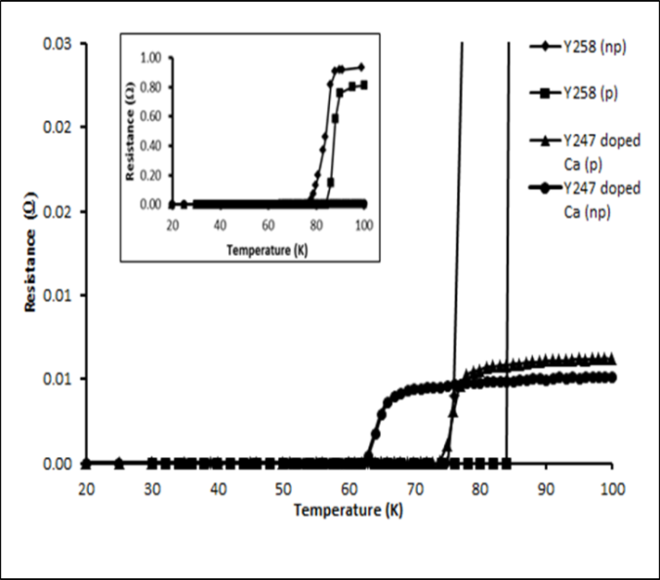
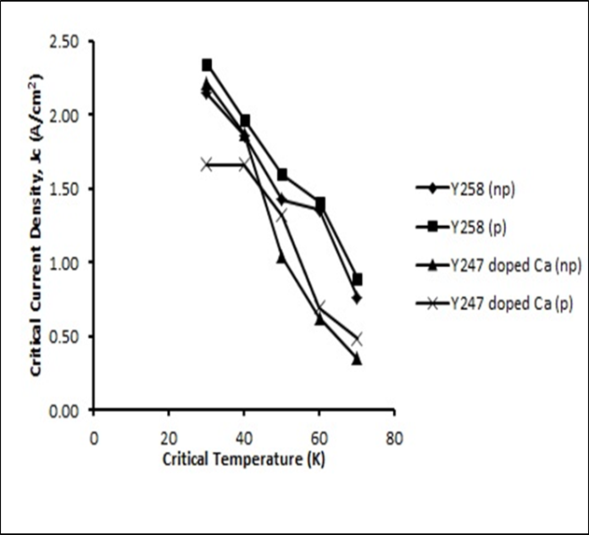
(b)
(a)

Figure 1. (a) Normalized resistance versus temperature of the samples (b) Critical current density versus temperature

Table 1 also shows the critical current density, J_{c} value for the samples. The value of J_{c} was increased for samples with low density that has been created by introducing pores. This enhancement of J_{c} is due to the grain alignment of the porous structure [9]. In addition, the increase of J _{c} for porous sample might be due to the good electrical contact within the porous ceramic body rather than one just on the surface as in a dense sample [4].

Table 1. Lattice parameter, critical temperature and critical current density of the samples.
Sample | Lattice parameter |  |  | Volume (Å)³ | T_{C}  (K) | Critical | Current
Sample |  | (Å) |  | Volume (Å)³ | T_{C}  (K) | Density, J_{C} | (A/cm²)
Sample | a | b | c | Volume (Å)³ | T_{C}  (K) | 50 K | 60 K
Y₂Ba₅Cu₈O_{δ} non-porous | 3.89 | 3.84 | 11.79 | 174.47 | 78.0 | 1.42 | 1.35
Y₂Ba₅Cu₈O_{δ} porous | 3.89 | 3.84 | 11.79 | 174.47 | 78.0 | 1.59 | 1.41
Y₂CaBa₄Cu₇O_{δ} non-porous | 3.83 | 3.88 | 50.80 | 754.51 | 75.0 | 0.62 | 0.35
Y₂CaBa₄Cu₇O_{δ} porous | 3.90 | 3.88 | 49.81 | 752.84 | 62.9 | 0.69 | 0.48
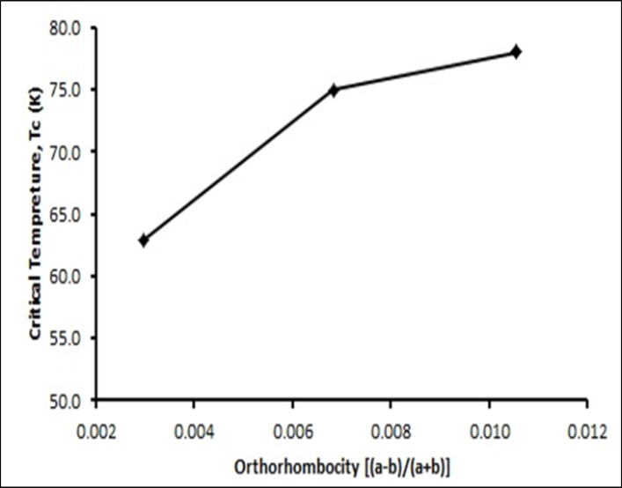

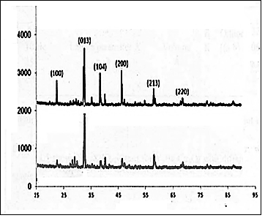
(b)
(a)
Relative intensity (a.u)
2 Theta (º)

Figure 2. (a) Critical temperature versus orthorombicity (b) X-ray diffraction pattern of samples
Figure 3 shows the SEM micrograph of the samples. Morphology of the samples from SEM images revealed that the porous Y258 sample had the larger average grain size compared to non-porous structure. Larger grain size manifests the lessen of grain boundaries [8, 10]. The grain boundaries are significant to influence the current density in the polycrystalline form. Optimal sintering time is essential to increase the superconducting volume fraction as well as grains connectivity for better current transport. Short sintering period can produce smaller grain size, resulting in weak connectivity between grains. Longer sintering period possibly lead to phase decomposition but decreasing the superconducting phases can weaken the weak links [14]. Larger grain size will enhance the grains continuity, lessen the porosity thus increased the J_{c} value. Smaller grain size and irregular grain shape in non-porous Y258 system decrease the J_{c} value.

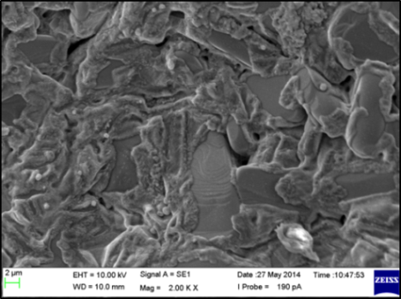
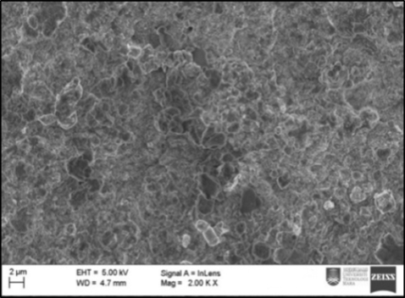
a
b

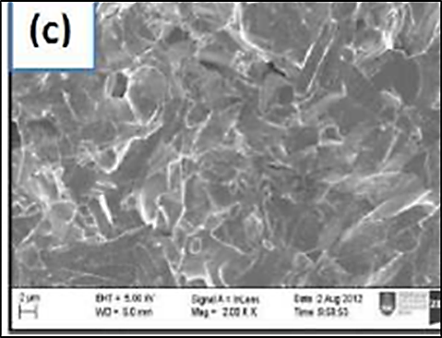
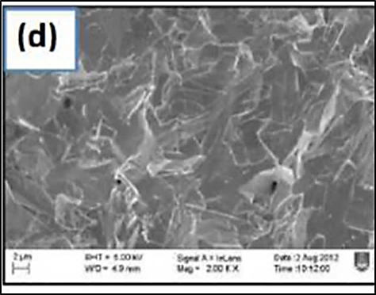
d
c

Figure 3. SEM photograph of samples (a) Y₂Ba₅Cu₈O_{δ}non-porous (b)Y₂Ba₅Cu₈O_{δ}porous (c)Y₂CaBa₄Cu₇O_{δ}non-porous (d)Y₂CaBa₄Cu₇O_{δ} porous

Conclusion

The effect of porosity on the morphological of microstructure and the electrical resistance characteristics of Y258 porous structure were investigated in this study. The porous sample of YBCO 258 was successfully synthesized using solid state reaction method. It is found that the crystalline sucrose that used as filler does not affect the superconductive properties of the porous structure Y258 but changed the electrical properties which give lower critical current density, J_{c} than porous YBCO sample. Furthermore, it is found that the value of T_{c zero} of porous Y258 is 78 K which is the same as non-porous sample.

Acknowledgement

The authors would like to thank the Ministry of Higher Education (MOHE), Malaysia for the financial support via Research Acculturation Grant Scheme (RAGS) no. 600-RMI/RAGS 5/3 (7/2013).

References

- Petrov, M. I., Tetyeva, T. N., Kveglis, L. I., Efremov, A. A., Zeer, G. M., Balaev, D. A., Shaikhutdinov, K. A., Popkov S. I. and Ovchinnikov. S. G. (2005). The synthesis, microstructure, transport and magnetic properties of Bi-based low density HTSC. Journal of Materials Processing Technology, 161: 58–61.
- Terent’ev, K. Yu., Gokhfel’d, D. M., Popkov, S. I., Shaikhutdinov K. A. and Petrov, M. I. (2011). Pinning in a porous high-temperature superconductor Bi-2223. Physics of the Solid State, 53(12): 2409–2414.
- Studart, A. R., Gonzenbach, Urs T., Tervoort, E. and Gauckler, L. J. (2006). Processing routes to macroporous ceramics: A review. Journal of the American Ceramic Society, 89(6): 1771–1789.
- Gokhfeld, D. M., Balaev, D. A., Popkov, S. I., Shaykhutdinov, K. A. and Petrov, M. I. (2006). Magnetization loop and critical current of porous Bi-based HTSC. Physica C, 434: 135-137.
- Schwartz, R. W., Noudem, J. G. and Reddy, E. S. (2006). Single grain YBa₂Cu₃O_{y}, porous ceramic superconductors. Electroceramic Materials and Applications: Ceramic Transactions Series, 196: 33–43.
- Fiertek, P. and Sadowski, W. (2006). Processing of porous structures of YBa₂Cu₃O_{7–δ} high-temperature superconductor. Materials Science, 24: 1103-1108.
- Norazidah, A. W., Azhan, H., Azman, K., Hidayah, H. N. and Hawa, J. S. (2014). Effect of heat treatment on Ca substitution in a porous Y(Ba_{1-x}Ca_{x})₂Cu₃O_{7-δ} superconductor. Advanced Materials Research, 895: 71–74.
- Shlyk, L., Krabbes, G., Fuchs, G. and Nenkov, K. (2002). Melt-processed YBCO doped with Ca and Cd: Comparison of superconducting properties. Physica C, 383: 175-182.
- Norazidah, A. W., Azhan, H., Azman, K., Hidayah, H. N. and Hawa, J. S. (2012). Superconducting properties of calcium substitution in barium site of porous YBa₂Cu₃O₇ ceramics. Advanced Materials Research, 501: 294–298.
- Noel A. R., John, H. D., Sibe, H. M., Mark, G. B. and Judith, L. M. (2005). Transport properties of Ca-doped YBCO coated conductors. IEEE Transactions on Applied Superconductivity, 15: 2570-2573.
- Roaa F. A. and Emad K. A. (2015). New high temperature superconductor phase of Y-Ba-Cu-O system. International Journal of Advanced Research in Physical Science, 2 (7): 33-39.
- Pimentel Jr, J. L., Martinez Buitrago, D., Supelano, I., Parra Vargas, C. A., Mesquita, F. R. and Pureur, P. (2015). Synthesis and characterization of the superconductors Y₃Ba₅Cu_{8−x} Fe_{x}O₁₈(0.0597 ≤ x ≤ 0.1255). Journal of Superconductivity and Novel Magnetism, 28: 509–512.
- Khalida, S.. Fariesha, F.. Azhan, H. and Yusainee, S. Y. (2013). Influence of heat treatments on electrical properties and microstructure of 10% mass fraction of sucrose YBCO superconductor. Malaysian Journal of Analytical Sciences, 17(1): 1 – 10.
- Shalaby, M. S., Hashem, H. M., Hammad, T. R., Wahab, L. A., Marzouk, K. H. and Soltan, S. (2016). Higher critical current density achieved in Bi-2223 High-T_{C} superconductors. Journal of Radiation Research and Applied Sciences, 9: 345–351.

