

MALAYSIAN JOURNAL OF ANALYTICAL SCIENCES
ISSN 1394 - 2506

Published by The Malaysian Analytical Sciences Society

RAPID SYNTHESIS AND CHARACTERIZATION OF LEAF-LIKE ZEOLITIC IMIDAZOLATE FRAMEWORK

(Sintesis Cepat dan Pencirian Kerangka Seperti Daun Imidazolat Zeolitik)

Imran Ullah Khan^{1, 2, 3}, Mohd Hafiz Dzarfan Othman^{1*}, Juhana Jaafar¹, Haslenda Hashim³, Ahmad Fauzi Ismail¹, Mukhlis A Rahman¹, Norafiqah Ismail¹

¹Advance Membrane Technology Research Center (AMTEC), Faculty of Chemical and Energy Engineering,
Universiti Teknologi Malaysia, 81310 Skudai, Johor, Malaysia
²School of Chemical and Material Engineering (SCME),
National University of Science and Technology (NUST), H-12, Islamabad, Pakistan
³Process System Engineering Centre (PROSPECT), Faculty of Chemical and Energy Engineering,
Universiti Teknologi Malaysia, 81310 Skudai, Johor, Malaysia

*Corresponding author: hafiz@petroleum.utm.my

Received: 16 April 2017; Accepted: 7 March 2018

Abstract
A two-dimensional zeolitic imidazolate framework with a leaf-like structure (ZIF-L) was synthesized in aqueous solution at room temperature with a molar ratio of Zn⁺²/Hmim (1: 8). Various triethylamine (TEA) concentrations were also used for the rapid production of ZIF-L. Different characterization techniques like X-ray diffraction (XRD), field emission scanning electron microscopy (FESEM), transmission electron microscopy (TEM) and thermogravimetric analysis (TGA) were performed to investigate the effect of base type additive triethylamine (TEA) on the crystal morphology, crystallinity, particle size and thermal stability of ZIF-L particles. From the experimental results, it was found that ZIF-L with a particle size of 5.3 μm was formed at TEA/total mole ratio of 0, but particle size was decreased when TEA/total mole ratio was increased up to 0.0003. The smallest ZIF-L particles obtained were 3 μm that showed excellent thermal stability. It can be concluded that this promising synthesis method with base-type additive would provide the new insights in the development of ZIFs materials in economical ways.

Keywords: zeolitic imidazolate framework, leaf-like structure, base-type additive, characterization, particle size

Abstrak
Kerangka imidazolat zeolitik dua dimensi dengan struktur seperti daun (ZIF-L) telah disintesis dalam larutan akueus pada suhu bilik. Trietilamina (TEA) pelbagai kepekatan juga digunakan untuk penghasilan cepat ZIF-L. Teknik-teknik pencirian yang berbeza seperti pembelauan sinar-X (XRD), mikroskop imbasan elektron pancaran medan (FESEM), mikroskop transmisi elektron (TEM) dan analisis termogravimetri (TGA) telah dijalankan untuk menyiasat kesan jenis asas tambahan trietilamina (TEA) pada morfologi kristal, penghabluran, saiz zarah dan kestabilan haba zarah ZIF-L. Daripada keputusan eksperimen, ianya didapati bahawa ZIF-L dengan saiz zarah 5.3 μm terbentuk pada nisbah molekul TEA/jumlah 0, tetapi saiz zarah berkurangan apabila nisbah TEA/jumlah mol meningkat sehingga 0.0003. Partikel ZIF-L yang terkecil diperoleh adalah 3 μm yang menunjukkan kestabilan terma yang sangat baik. Sebagai kesimpulan, kaedah sintesis cepat ini berpotensi dengan bahan tambahan jenis asas akan memberikan gambaran baru dalam pembangunan bahan ZIF lebih ekonomik.

Kata kunci: kerangka imidazolat zeolitik, struktur seperti daun, asas-jenis bahan tambahan, pencirian, saiz zarah

Introduction
Zeolitic imidazolate frameworks (ZIFs), a sub class of metal-organic frameworks (MOFs) have created great research interest due to their unique advantages for a variety of applications such as gas storage [1], gas separation, and adsorption [2], catalysis [3], and chemical sensing [4]. They have permanent zeolitic porous structure with uniform microporosity, tunable crystal surface and having exhibit excellent thermal and chemical stability [5]. ZIFs are made up of tetrahedral metal ions (Zn or Co) bridged by 2-methyl imidazole (Hmim) as an organic linker and possess highly order porous structure [6]. ZIFs can be produced using various processes such as the solvothermal, the microwave assisted solvothermal and aqueous room temperature synthesis process [7].

Commonly solvothermal process and microwave-assisted solvothermal process are used to synthesize ZIFs as they produce better yield and smaller particle size [8-10]. A large variety of ZIFs with different crystal structure such as ZIF-21, ZIF-62, ZIF-11, ZIF-100, ZIF-95, ZIF-75 had been typically synthesized in organic solvents such as methanol (CH₃OH), diethylformamide (DMF) and diethylformamide (DEF) [1, 11]. Nevertheless, high-energy demand, time consumption, and expensive and pollutant organic solvents limit the utilization of these processes [12]. Therefore, cost effective and environmentally friendly synthesis approach for ZIFs is crucial and major challenge for researchers. To overcome the issues, an aqueous room temperature synthesis process has been explored.

Aqueous room temperature synthesis method had improved product yield with much shorter time compared to the synthesis processes developed in organic media. In addition, the product showed excellent thermal and chemical stabilities, and improved hydrothermal stability [8, 12]. The advantages of aqueous room temperature synthesis process such as low energy consumption, smaller particle size, shorter reaction time and higher yield have been successfully highlighted by various researchers [1, 2, 5, 7, 12-14]. Chen et al. [1], Low et al. [2], Zhong et al. [14] and Yao et al. [13] had successfully synthesized ZIF-L with a unique cushion-shaped cavity and leaf like structure from zinc nitrate hexahydrate and Hmim in deionized water at room temperature. They identified that molar ratio of Zn⁺²/Hmim was the key synthesis parameter to produce leak like structure of ZIF. Although, they have produced leaf- like structure but particles size was bigger and longer time for synthesis was required.

Controlling crystal growth and morphology of synthesized ZIFs is also another important and research feature for large-scale productions. It is easy to fabricate thin mixed matrix membrane with smaller particle size and subsequently high adsorption capacity was achieved due to smaller pores [2]. Crystal growth is highly dependent on ligand to metal ratio as excess amount of ligand could limit the linkage with metal ions, subsequently reduce the yield [8, 12]. The amount of organic ligand can be significantly reduced by the addition of modulating agent (base-type additive) in the ZIF synthesis solution that can ease the ligand-metal interaction [11, 15, 16]. Subsequently, it gives rapid interaction between metal ion and ligand and produce smaller crystals in shorter time with low metal to ligand ratio. Among base type additives, triethylamine (TEA) has shown excellent compatibility with various organic ligands [7, 13, 17]. ZIF-8 nanoparticles were previously produced using TEA as a deprotonation agent at a relatively low ratio of Zn⁺²/Hmim (1:16) [7]. To the best of our knowledge, no research has been reported to use TEA as an additive during synthesis of ZIF-L to reduce particle size, shorter synthesis time with lower cost and develop green synthesis process. Hence, the present work investigates the synthesis of ZIF-L at aqueous room temperature with various concentrations of TEA in the synthesis mixture. The effect of various concentration of TEA on the particle size, crystal growth and thermal stability were investigated and discussed in details. Such developments will undoubtedly lead to better understanding of ZIF crystallization mechanisms and facilitate the development of ZIF-L for large-scale applications.

Materials and Methods
Materials
Materials used to synthesize ZIF-L were zinc nitrate hexahydrate (Zn (NO₃)₂.6H₂O, 99% purity), Organic linker, 2-methylimidazole (Hmim, 99% purity), base-type additive triethylamine (TEA, 99.5% purity), purchased from Sigma-Aldrich. No further purification was needed for all chemicals.

Synthesis of ZIF-L
The molar ratio of Zn⁺² and Hmim (1:8) was used during synthesis of ZIF-L in basic solution. The synthesis of ZIF-L was described in literature [1, 2, 7] but some changes were made to enhance the yield as well as reduce the time for synthesis. Typically, 2.95 g (1.98 mmol) of Zn (NO₃)₂.6H₂O and 6.5 g (15.83 mmol) of Hmim was dissolved in 200 mL deionized water respectively. The appropriate amount of TEA was added to Hmim solution as a deprotonation agent (Table 1), and then the aqueous solution of zinc nitrate was added into the aqueous solution of Hmim under stirring. The mixture was stirred at room temperature for 60 minutes. The product was obtained by repeated centrifugation (10000 rpm for 10 minutes) and washed by deionized water to remove residual chemicals, and then dried in an oven at 60 °C for 12 hours. The yield of the product was calculated using equation (1).

$Yield(\%)= \frac{Mass of ZIF-L (obtained)}{Mass of ZIF-L (theoretical)}⨉100$ (1)

Table 1. Different volume of TEA for synthesis of ZIF-L
Sample Name | TEA/Total Mole | TEA Volume (ml)
A0 | 0 | 0
A1 | 0.0002 | 0.5
A2 | 0.0003 | 1
A3 | 0.0004 | 1.5

Characterization
The field emission scanning electron microscopy (FESEM) images were taken using a Hitachi SU 8020 microscope. The X-ray diffraction (XRD) analysis was performed on a Rigaku smart lab diffractometer using CuKα radiation at 40 KV and 30 mA in the 2Ө range of 3-100°. Thermogravimetric analysis (TGA, Q 500, TA Instrument, USA) was used to check the thermal stability of the synthesized samples at different TEA loading. TGA records the weight changes of sample when heated from 30 to 900°C at the heating rate of 10°C/min under nitrogen atmosphere. The transmission electron microscopy (TEM) images were taken using Hitachi, HT7700 microscope. Samples were prepared by dispersing ZIF-L powder into concentrated ethanol solution. A drop of ethanol was used for the dispersion of ZIF-L onto carbon-coated copper grids operating at 120 KV. All the characterization were carried out at Central Lab UTM, Johor Bahru, Malaysia.

Results and Discussion
Figure 1 shows the XRD pattern of various synthesized samples of ZIF-L. The intensity of the peaks was in good agreement with the previous works [1,2]. In the first attempt (Figure 1, sample A0), ZIF-L was synthesized in zinc salt and Hmim aqueous solution at room temperature with no addition of TEA. After continues stirring the synthesis solution turned cloudy that shows the occurrence of reaction between reactants. FESEM image (Figure 2a) also confirm the leaf-like structure of ZIF-L. However, longer time of synthesis (4 hours) was required due to low reaction rate and insufficient deprotonation of Hmim. When the small amount of TEA (0.5 ml and 1ml) (TEA/total mole ratio = 0.0002, 0.0003) was added in the synthesis solution, surprisingly, ZIF-L particles were formed after 60 minutes (Figure 1, sample A1, A2). Furthermore, their FESEM images confirmed the leaf-like particles with 2D crystalline structure (Figure 2b, 2c). The possible reason was the fast deprotonation of Hmim to produce more reactive sites for reaction with Zn⁺² [18–20]. Thus, ZIF-L was successfully synthesized in shorter time with high yield (Table 2).

Figure 1. XRD pattern of synthesized ZIF-L samples with different TEA/total mole ratio: A0 (0), A1 (0.0002), A2 (0.0003) and A3 (0.0004)

Further increase in TEA/total mole ratio up to 0.0004 was not favorable for the formation of ZIF-L, as particles started to break up (Figure 2d). Higher TEA/total mole ratio increased the reaction rate by rapid deprotonation of Hmim, lead to break down the leaf-like structure. The series of FESEM images were used to estimate particle size. It was identified that particle size decreased from 5.3 to 3 μm when TEA/total mole ratio was increased from 0 to 0.0003 as shown in Table 2 and Figure 2a – c.

Table 2. Yield and particle size of ZIF-L
Sample Name | Yield (%) | Particle Size (μm)
A0 | 80 | 5.3
A1 | 90 | 3.2
A2 | 90 | 3

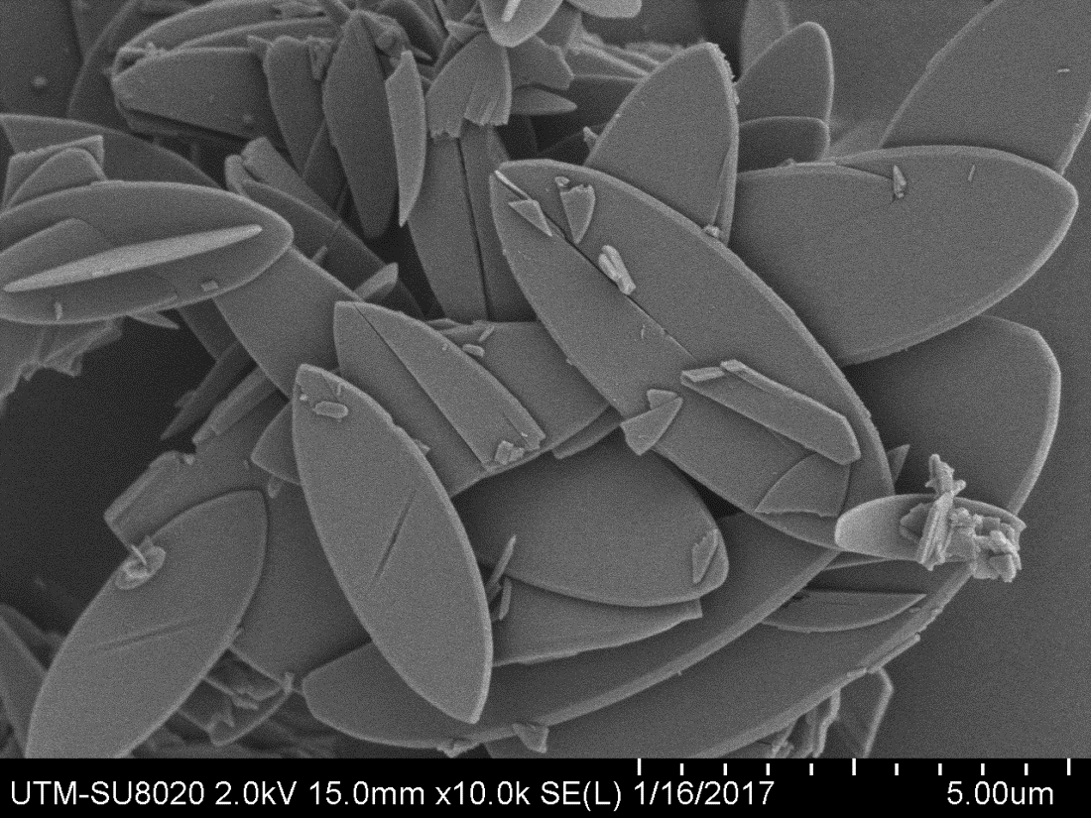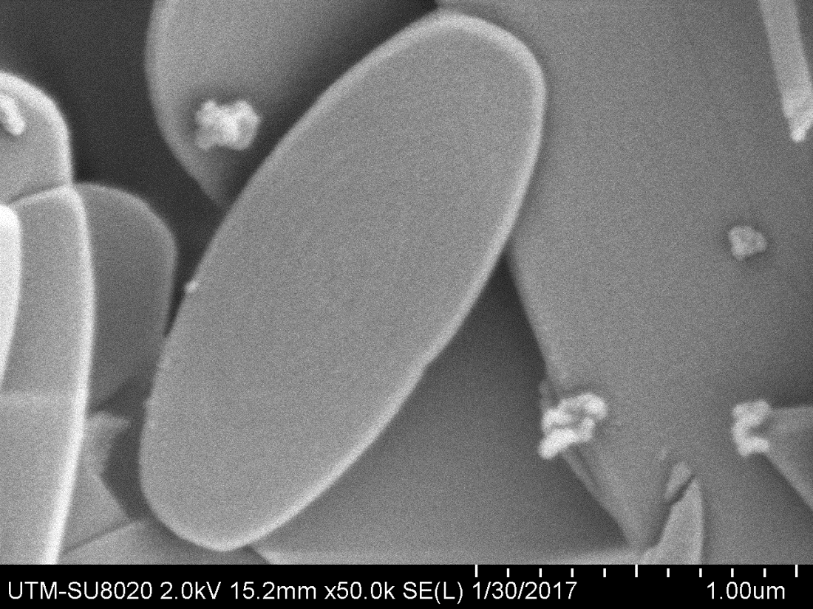
(1μm)
(5μm)
(b)
(a)
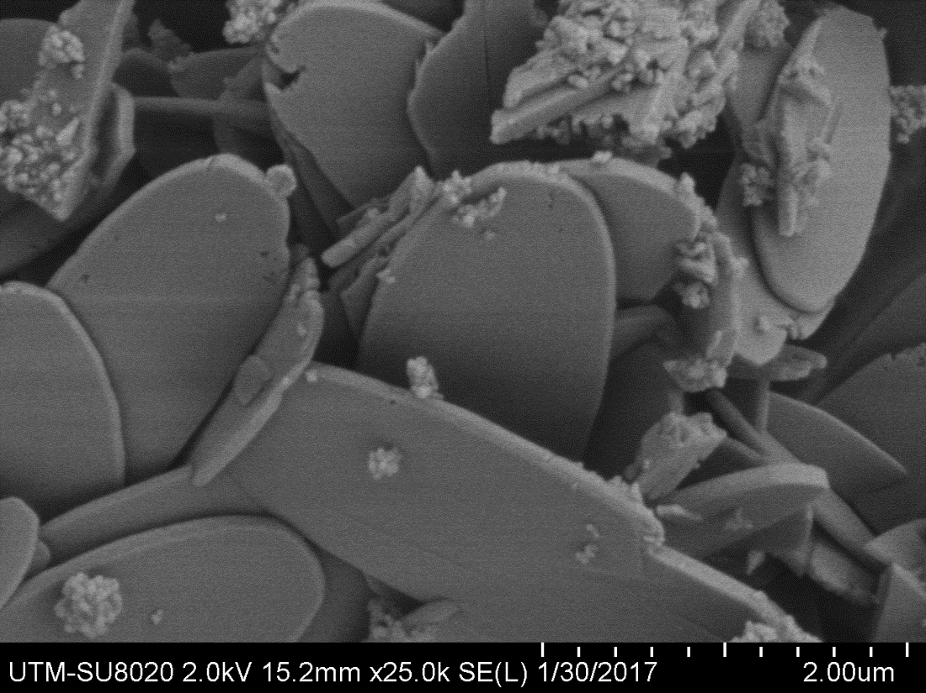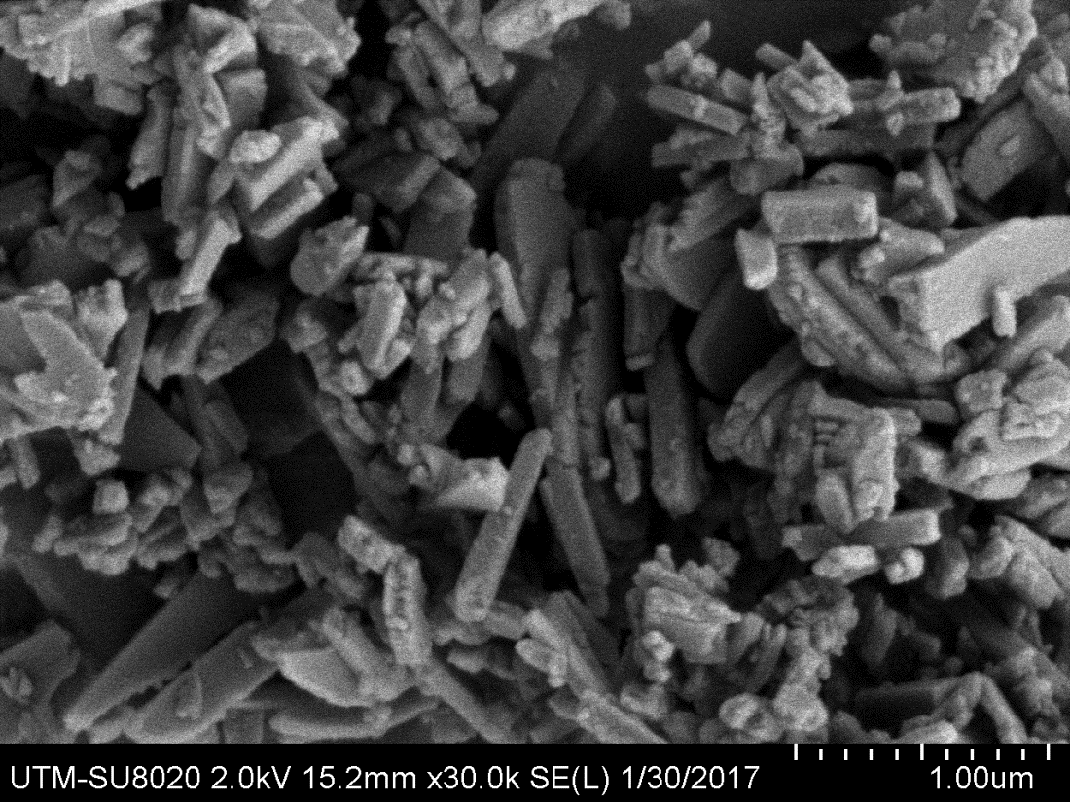
(d)
(1μm)
(2μm)
(c)
Figure 2. FESEM images of the synthesized ZIF-L samples at different TEA/total mole ratio: (a) A0 (0), (b) A1 (0.0002), (c) A2 (0.0003) and (d) A3 (0.0004)

The structure of ZIF-L was further confirmed by the transmission electron microscopy (TEM) images (Figure 3) that well agreed with the above FESEM images. Two samples of ZIF-L with maximum and minimum particle size were selected for this analysis. These TEM images clearly identified the 2D leaf-like structure of ZIF-L without TEA (Figure 3a, TEA/total mole = 0) and with the addition of TEA (Figure 3b, TEA/total mole = 0.0003).

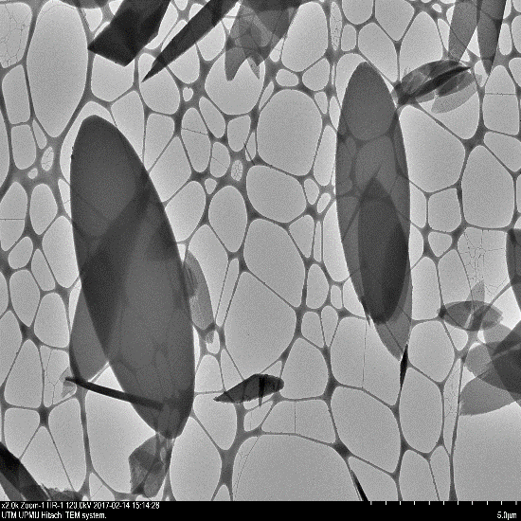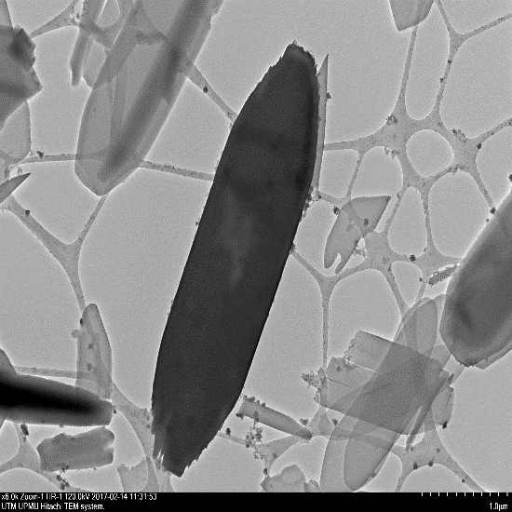
(b)
(1μm)
(a)
(5μm)
Figure 3. TEM images of the synthesized ZIF-L samples at different TEA/total mole ratio: (a) A0 (0) and (b) A2 (0.0003)

The thermal stability of the synthesized products of ZIF-L was also measured by thermogravimetric analysis (TGA) in which the mass of the product was monitored as a function of temperature as shown in Figure 4. We reported the higher thermal stability of products compared to previous work [1, 2]. Sudden weight loss started around 255°C was due to the decomposition of organic linkers and ZIF-L crystal structure.

Figure 4. Thermal stability of synthesized ZIF-L samples with weight loss profile at different temperature and TEA/ total mole ratio: A0 (0) and A2 (0.0003)

Further confirmation of thermal stability was done by calculating the peaks at different temperature on derivative of the weight loss curves (Figure 5). The highest derivative peak was obtained around 255 °C indicated the point of greatest rate of change on the weight loss curve and was due to the structural decomposition ZIF-L. It could be concluded that thermal stability was not reduced due to the addition of TEA during synthesis process.

Figure 5. Thermal stability of synthesized ZIF-L samples with derivative of weight loss profile at different temperatures TEA/ total mole ratio: A0 (0) and A2 (0.0003)

Conclusion
In this study, ZIF-L with leaf like structure was rapidly synthesized in an aqueous solution at ambient temperature with smaller particle size and high thermal stability. The Zn⁺²/Hmim ratio of 8 was used with various concentration of TEA. The addition of TEA was very important for the rapid synthesis of ZIF-L as it deprotonated the organic ligand. The particle size was also decreased from 5.3 to 3 μm as the TEA/total mole ratio increased from 0 to 0.0003. However, an excessive TEA would break down the particles due to more rapid reaction. In addition, ZIF-L particles showed excellent thermally stability around 255 °C. We expect this new synthesis approach with low reagent ratio and base type additive will undoubtedly provide a better understanding of morphology control of ZIFs during synthesis and thus reduce the production cost for industrial applications.

Acknowledgement
The authors gratefully acknowledge financial support from the Universiti Teknologi Malaysia under the Research University Grant Tier 1 (Project number: Q. J130000.2546.12H25) and Nippon Sheet Glass Foundation for Materials Science and Engineering under Overseas Research Grant Scheme (Project number: R. J130000.7346.4B218). Lastly, the first author would also like to thank National University of Science and Technology (NUST), Pakistan for their scholarship under Faculty Development Programme (FDP).

References
- Chen, R., Yao, J., Gu, Q., Smeets, S., Baerlocher, C. and Gu, H. (2013). A two-dimensional zeolitic imidazolate framework with a cushion-shaped cavity for CO₂ adsorption. Chemical Communications, 49 (1): 9500-9502.
- Low, Z. X., Razmjou, A., Wang, K., Gray, S., Duke, M. and Wang, H. (2014). Effect of addition of two-dimensional ZIF-L nanoflakes on the properties of polyethersulfone ultrafiltration membrane. Journal of Membrane Science, 460: 9-17.
- Lee, J., Farha, O. K., Roberts, J., Scheidt, K. A., Nguyen, S. T. and Hupp, J. T. (2009). Metal-organic framework materials as catalysts. Chemical Society Reviews, 38(5): 1450-1459.
- Yao, J. and Wang, H. (2014). Zeolitic imidazolate framework composite membranes and thin films: Synthesis and applications. Chemical Society Reviews, 43(13): 4470-4493.
- Low, Z. X., Yao, J., Liu, Q., He, M., Wang, Z., Suresh, A. K., Bellare, J. and Wang, H. (2014). Crystal transformation in zeolitic-imidazolate framework. Crystal Growth and Design, 14(12): 6589-6598.
- Banerjee, R., Furukawa, H., Britt, D., Knobler, C., O’Keeffe, M. and Yaghi, O. M. (2009). Control of pore size and functionality in isoreticular zeolitic imidazolate frameworks and their carbon dioxide selective capture properties. Journal of the American Chemical Society, 131(11): 3875-3877.
- Nordin, N. A. H. M., Ismail, A. F., Mustafa, A., Goh, P. S., Rana, D. and Matsuura, T. (2014). Aqueous room temperature synthesis of zeolitic imidazole framework 8 (ZIF-8) with various concentrations of triethylamine. RSC Advances, 4(63): 33292-33300.
- Yamamoto, D., Maki, T., Watanabe, S., Tanaka, H., Miyahara, M. T. and Mae, K. (2013). Synthesis and adsorption properties of ZIF-8 nanoparticles using a micromixer. Chemical Engineering Journal, 227: 145-150.
- Schlichte, K., Kratzke, T. and Kaskel, S. (2004). improved synthesis, thermal stability and catalytic properties of the metal-organic framework compound Cu₃(BTC)₂. Microporous and Mesoporous Materials, 73(1): 81-88.
- Wen, L., Wang, D. E., Wang, C., Wang, F., Li, D. and Deng, K. (2009). A 3D porous zinc MOF constructed from a flexible tripodal ligand: synthesis, structure, and photoluminescence property. Journal of Solid State Chemistry, 182(3): 574-579.
- Biemmi, E., Christian, S., Stock, N. and Bein, T. (2009). High-throughput screening of synthesis parameters in the formation of the metal-organic frameworks MOF-5 and HKUST-1. Microporous and Mesoporous Materials, 117(1): 111-117.
- Pan, Y., Liu, Y., Zeng, G., Zhao, L. and Lai, Z. (2011). Rapid synthesis of zeolitic imidazolate framework-8 (ZIF-8) nanocrystals in an aqueous system. Chemical Communications, 47(7): 2071-2073.
- Yao, J., He, M. and Wang, H. (2015). Strategies for controlling crystal structure and reducing usage of organic ligand and solvents in the synthesis of zeolitic imidazolate frameworks. CrystEngComm, 17(27): 4970-4976.
- Zhong, Z., Yao, J., Low, Z. X., Chen, R., He, M. and Wang, H. (2014). Carbon composite membrane derived from a two-dimensional zeolitic imidazolate framework and its gas separation properties. Carbon, 72: 242-249.
- Cravillon, J., Nayuk, R., Springer, S., Feldhoff, A., Huber, K. and Wiebcke, M. (2011). Controlling zeolitic imidazolate framework nano- and microcrystal formation: insight into crystal growth by time-resolved in situ static light scattering. Chemistry of Materials, 23(8): 2130-2141.
- He, M., Yao, J., Li, L., Zhong, Z., Chen, F. and Wang, H. (2013). Aqueous solution synthesis of ZIF-8 films on a porous nylon substrate by contra-diffusion method. Microporous and Mesoporous Materials, 179: 10-16.
- Pan, Y., Heryadi, D., Zhou, F., Zhao, L., Lestari, G., Su, H. and Lai, Z. (2011). Tuning the crystal morphology and size of zeolitic imidazolate framework-8 in aqueous solution by surfactants. CrystEngComm, 13(23): 6937-6940.
- He, M., Yao, J., Liu, Q., Wang, K., Chen, F. and Wang, H. (2014). Facile synthesis of zeolitic imidazolate framework-8 from a concentrated aqueous solution. Microporous and Mesoporous Materials, 184: 55-60.
- Hu, Y., Kazemian, H., Rohani, S., Huang, Y. and Song, Y. (2011). In situ high pressure study of ZIF-8 by FTIR spectroscopy. Chemical Communications, 47(47): 12694-12696.
- Jian, M., Liu, B., Liu, R., Qu, J., Wang, H. and Zhang, X. (2015). Water-based synthesis of zeolitic imidazolate framework-8 with high morphology level at room temperature. RSC Advances, 5(60): 48433-48441.

