

MALAYSIAN JOURNAL OF ANALYTICAL SCIENCES
ISSN 1394 - 2506

Published by The Malaysian Analytical Sciences Society

SYNTHESIZED AND CHARACTERIZATION OF SODIUM COBALT OXIDE AS SODIUM-ION CATHODE BATTERIES USING SOL-GEL METHOD

(Sintesis dan Pencirian Sodium Kobalt Oksida Sebagai katod Bateri Ion-Sodium Menggunakan Kaedah Sol-Gel)

Sarah Laila Mohd Jan¹*, Nur Athirah Mohd Azhar¹, Musfiroh Jani²

¹Faculty of Applied Sciences,

Universiti Teknologi MARA Pahang, 26400 Bandar Tun Abdul Razak Jengka, Pahang, Malaysia

²Faculty of Earth Science,

Universiti Malaysia Kelantan, Kampus Jeli, 17600 Kelantan Malaysia

*Corresponding author: sarahlaila@pahang.uitm.edu.my

Received: 4 December 2016; Accepted: 1 December 2017

Abstract

Sodium’s chemical properties are like lithium and as batteries it has potential to be environmentally friendly, easier to recycle but five times much cheaper than lithium-ion batteries. Sodium cobalt oxide (NaCoO₂) cathode material in a sodium-ion battery was synthesized by a polyvinyl alcohol (PVA) assisted sol-gel method and its physical characterization was being analysed by using thermogravimetric analysis (TGA), attenuated total reflectance-fourier transform infrared (ATR-FTIR) spectroscopy, field emission scanning electron microscope (FESEM) and X-ray diffractometer (XRD). PVA was chosen as gelating agent as well as carbon source for the synthesized material in this study. The cathode material is observed to have smooth morphology and the particle sizes reach to sub-micrometre level which benefit for the high rate performance, although the shape of particles was irregular.

Keywords: sodium-ion batteries, cathode material, sol gel

Abstrak

Sifat kimia sodium menyerupai lithium dan sebagai bateri ia mempunyai potensi untuk mesra alam sekitar, mudah di kitar semular dan lima kali lebih murah berbanding bateri litium. Sodium kobalt oksida (NaCoO₂) iaitu bahan katod yang digunakan dalam ion-sodium bateri disintesiskan dengan kaedah sol- gel dibantu oleh polivinil alkohol (PVA) dan pencirian fizikal dianalisa menggunakan analisa termogravimetrik (TGA), spektroskopi inframerah transformasi fourier (ATR-FTIR), mikroskopi imbasan elektron pancaran medan (FESEM) dan teknik pembelauan sinar-X (XRD). PVA dipilih sebagai agen gelatin dan juga sebagai sumber karbon untuk mensintesiskan bahan kajian ini. Bahan katod yang dihasilkan menunjukkan morfologi permukaan yang rata dan saiz partikel yang mencecah sub-mikrometer memberi kelebihan dari segi kadar prestasi yang tinggi walaupun bentuk partikel tidak seragam.

Kata kunci: bateri ion-sodium, bahan katod, sol gel

Introduction

Over the past decade, electronic devices have boomed rapidly in the market. Smartphones especially have gained attention in the market and competition among producers are very high. These companies will always look for novel characteristic to sell to users. One of them is durability of the smartphone batteries. The performance of batteries relies on the characteristics and properties of their components materials [1]. Lithium-ion batteries have been widely used as rechargeable batteries in electronic devices namely smartphones, laptops, cameras and even digital audio players. Its high-energy densities and long lifespan make it a perfect option as an energy storage for electronic devices especially portable electronic devices. However, the cost of lithium-ion batteries became debatable as a cheaper option for broader market application. It became limited and not enough to satisfy the needs in the market due to the high demand of lithium-ion batteries usage [2].

Therefore, an alternative to this problem have been investigated with the advances on sodium-ion batteries. High abundance and low cost of sodium-ion batteries offer an advantage compared to lithium-ion batteries. Electrochemical performance wise between these two types of batteries are similar and sodium ion batteries are expected to be an alternative especially in large-scale of energy reserve [2]. The aim of this paper is to synthesize cathode material for sodium-ion batteries using sol-gel method by utilizing the initial precursor of sodium nitrate (NaNO₃), cobalt nitrate hexahydrate (Co(NO₃)_{2.}6H₂O) and PVA. The synthesized material was then characterized using Thermogravimetric analysis (TGA), X-ray Diffraction (XRD), Attenuated Total-Reflectance Fourier Transform Infrared (ATR-FTIR) and Field Emission Scanning Electron Microscopy (FESEM).

Materials and Methods

Methods by previous researcher was used as a reference to synthesize sodium cobalt oxide cathode material by using sol-gel method with some modification [3]. A stoichiometric amount of NaNO₃ and Co(NO₃)_{2.}6H₂O were weighed, mixed and dissolved in distilled water. Then, 5 wt.% of PVA was added to the solution as chelating agent. The solution was constantly stirred in water bath for 6 hours at 80 °C. The resulting gel was dried in the oven at 120 °C for 24 hours. Later, the dried gel was calcined at 800 °C in a furnace for 16 hours [3]. Characterization of cathode material were done using ATR-FTIR, (Perkin Elmer, Model 1600) and TGA, (Perkin Elmer, Thermal TGA Pyris 1) was conducted in the temperature range from 25 to 900 °C. The crystallographic structure and morphologies of the prepared sample were characterized by XRD and FESEM (JEOL, JSM-7800F).

Results and Discussion

Field emission scanning electron microscope

The morphology of sodium cobalt oxide cathode material observed under 1000x and 2000x magnification was heterogeneous particles with smooth surface as refer to Figure 1. Most flake-shaped particles were seen. By increasing the calcination temperature, the particle shape become clear and smooth surface, imply that the sample are well crystallized [4]. Under 2000x magnification, flakes-shaped particles were more clearly. In addition, there were some particles that agglomerate with each other. Research conducted done by previous researcher which is Li₃V₂(PO₄)₃ cathode materials that prepared by PVA assisted sol-gel method shown agglomerated particles and form larger secondary particles under observation of SEM [3]. The agglomeration will be useful in order to raise the density of the synthesized cathode material [5].

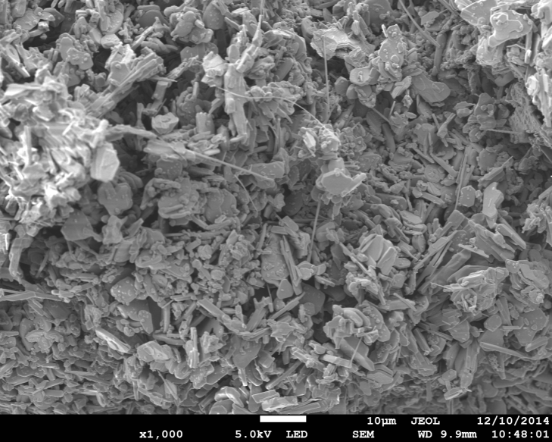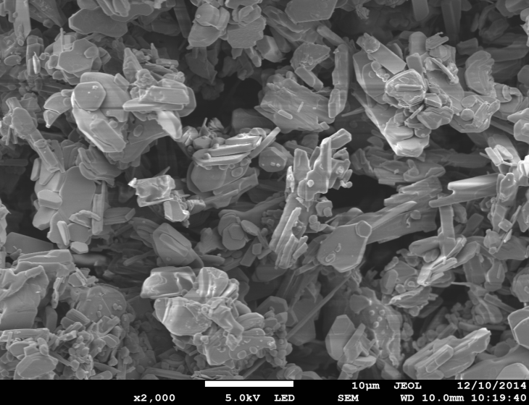
(b)
(a)

Figure 1. FESEM images of NaCoO₂ cathode material at magnification (a) 1000x and (b) 2000x

The morphology of NaCoO₂ cathode material under magnification of 3000x and 5000x are shown in Figure 2. Under 3000x magnification, some rough and round features were noticed on the surface of the particles. There were no pores present on the surface particles and the surface was smooth. These features are due to the presence of sodium carbonate (NaCO₃) [6]. Indeed, they can originate from the sodium being extracted from the structure by exposure to air. It was confirmed by ATR-FTIR spectrum, which shows peak at 861 cm⁻¹ represents the carbonate peak. Based on such peak it was confirmed that there was NaCO₃ on the surface particles of the synthesized cathode material. Whereas, referring to Figure 2, the morphology of synthesized cathode material was obviously seen as inhomogeneous. There were flake-shaped particles, round particles scattered around and cylindrical needle-like particles. The inhomogeneous morphologies are related to the existence of impurity [7].

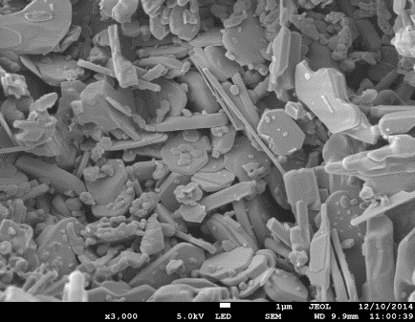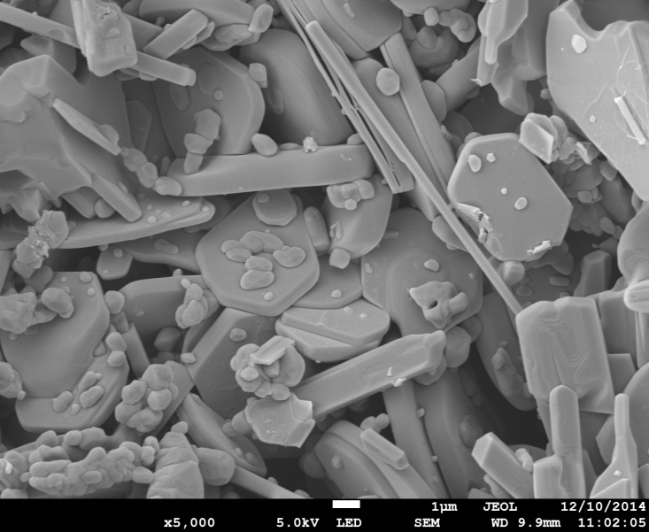
(b)
(a)

Figure 2. FESEM images of NaCoO₂ cathode material at magnification (a) 3000x and (b) 5000x

The FESEM image of the particle size under magnification 30,000x and 45,000x are shown in the Figure 3. Most of particles were distributed in the range of 731 nm to 1470 nm. The average particle size was measured to be 1100 nm. From the FESEM image, clearly observed that the NaCoO₂ sample had smooth morphology and the particle sizes reach to sub-micrometer level, although the shape of particles was irregular. This microstructure has a large specific surface area allowing the electrolyte to keep adequate contact with the active material, which is a benefit for the high rate performance [8].

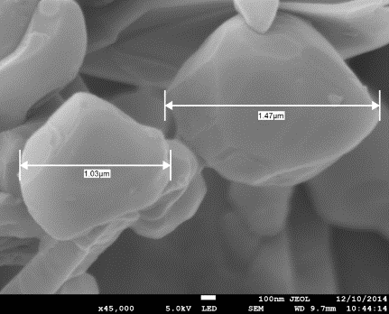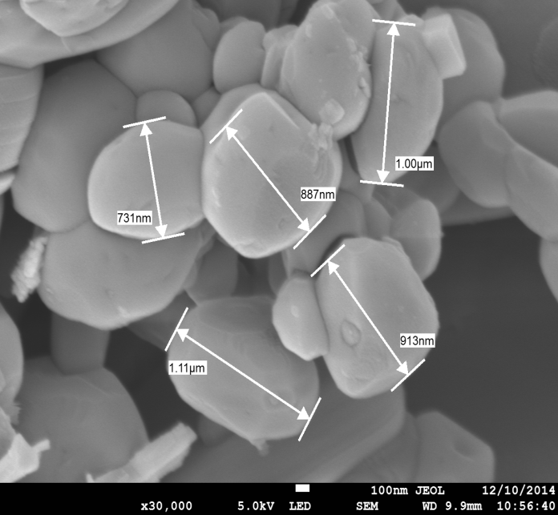
(b)
(a)

Figure 3. Particle size of NaCoO₂ cathode material at magnification (a) 30,000x and (b) 45,000x

Under 30,000x magnification, the round particles were seen to be agglomerated and there was space between the agglomerated particles. In this study, calcination temperature for synthesis of cathode material was set up at 800 °C. The agglomeration resulted in the particles in agreement with the finding of other researcher which is palpable agglomeration occurs when the temperature increase to 800 °C [8]. Others, under magnification of 45,000x of FESEM, the particles were seen to be sharp at the edges of round particles. Clearly, it shows that the synthesized NaCoO₂ cathode material was inhomogeneous and the shape of particles was irregular.

Attenuated total reflectance-fourier transform infrared spectroscopy

The ATR-FTIR spectrum of powdered NaCoO₂ cathode material after being calcined is shown in Figure 4. The peak appears at 567 cm⁻¹ corresponding to the metal cobalt to oxygen bond (Co-O). These absorption bands at 616 and 539 cm⁻¹ are represent the metal to oxygen (M-O) bond [9]. During preparation of NaCoO₂ cathode material, the sample may expose to the air. Therefore, initial precursor of sodium from NaNO₃ will react to the exposed air then form NaCO₃, thus carbonate peak (O-C-O) appeared at 861 cm⁻¹. Another peak that appears sharper and more intense is at 1356 cm⁻¹. This peak is known as NO₂ symmetric stretching. Whereas, peak for nitro (N=O) forms at 1407 cm⁻¹. Furthermore, a very intense peak at 1708 cm⁻¹ is corresponding to the Co-NO₃⁻ bond. This peak is also known as anti-symmetric stretching peak. In this study, the initial precursors used were NaNO₃ and Co(NO₃)_{2.}6H₂O. In both chemicals contain NO₃⁻ ion bond, this is reason for the presence of NO₃⁻ peak in the ATR-FTIR spectrum. Studies of Co(NO₃)_{2.}6H₂O by previous researcher stated that the stretch peak of anti-symmetric Co-NO₃⁻ bond is appeared at 1629 cm⁻¹ [10].

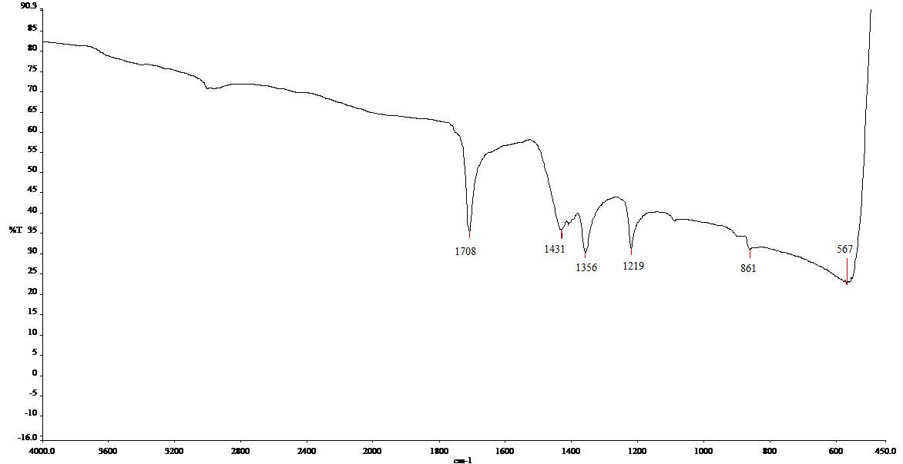

Figure 4. ATR-FTIR spectrum of powdered sodium cobalt oxide cathode material

Thermogravimetric analysis

The thermal property of synthesized NaCoO₂ cathode material was studied by thermogravimetric analysis (TGA). TGA curve of dried gel sodium cobalt oxide cathode material is shown in Figure 5. First mass loss was occurred from 26.82 to 139.25 °C is due to the removal of water content in that material. Researcher stated that, the weight loss before 220 °C is attributed by evaporation of water and ammonia from the precursor [3]. In addition, the slight weight loss from TGA curve appears around 102 °C due to the volatilization of residual water and the organic solvents [11]. Briefly, the weight loss in the next temperature region of 139.25–325.23 °C accompanied by a rapid chain-stripping elimination of water. In this region, one could observe melting of the precursor which caused the precursor to foam or intumesce [3]. Meanwhile, another 13.5% weight loss began at 130 °C with an endothermic peak at 194°C, might be the removal of crystalliferous water incorporated in the lattice of the material [4].

Furthermore, the TGA plot between 325.23 to 698.08 °C showed the pyrolysis process of PVA. The observance of multiple weight loss steps is attributed to the continuous elimination of H and O, leads to higher and higher carbon-to-hydrogen (C/H) ratios in the pyrolysis residue. Carbonization reaction also occurred in that temperature region [3]. Hence, the precursor is heat treated between 400 and 530 °C, polycrystalline carbon is formed due to the carbonization reaction that take place within the temperature range. The TGA curve becomes flat and no changes in the mass loss above 750 °C, indicating the completion of the entire reaction. Therefore, 800 °C was chosen as calcination temperature in order to obtain NaCoO₂ cathode material with high purity.

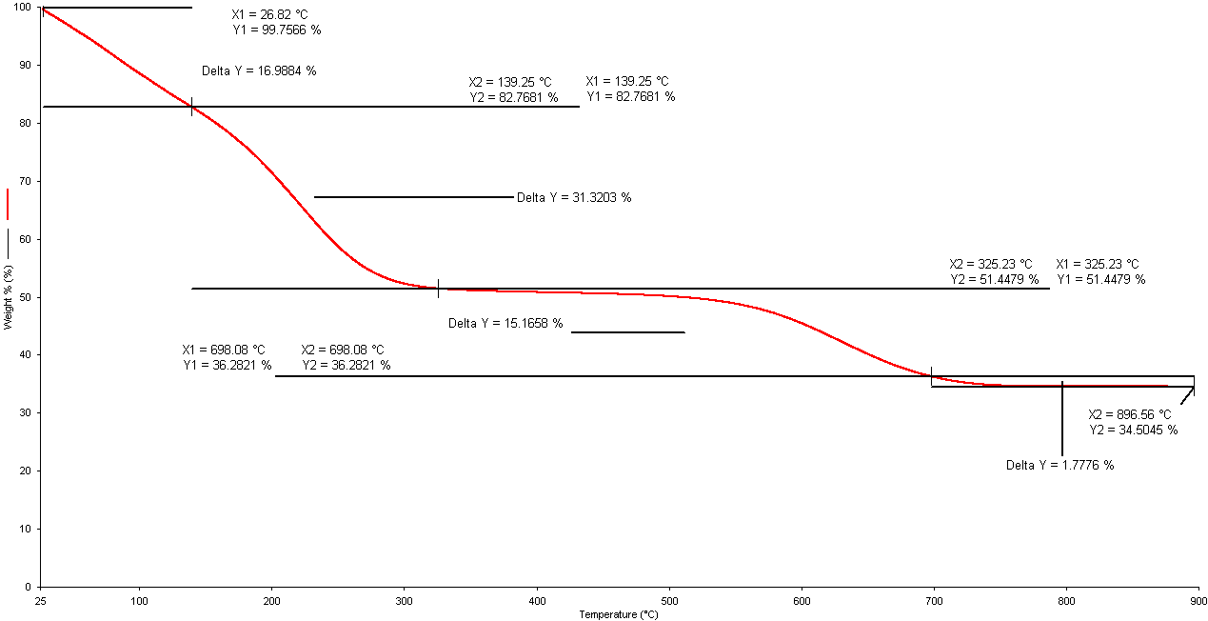

Figure 5. TGA curve of sodium cobalt oxide cathode material

X-Ray diffraction

The XRD analysis for synthesized material was conducted. From the diffractogram in Figure 6, the result shows that the sample was crystalline from two sharp peaks and high intensity diffraction pattern at 2 theta around 16° and 37°. This result also be supported from similar diffractograms obtained from previous researchers confirming the sodium cobalt oxides batteries [12, 13]

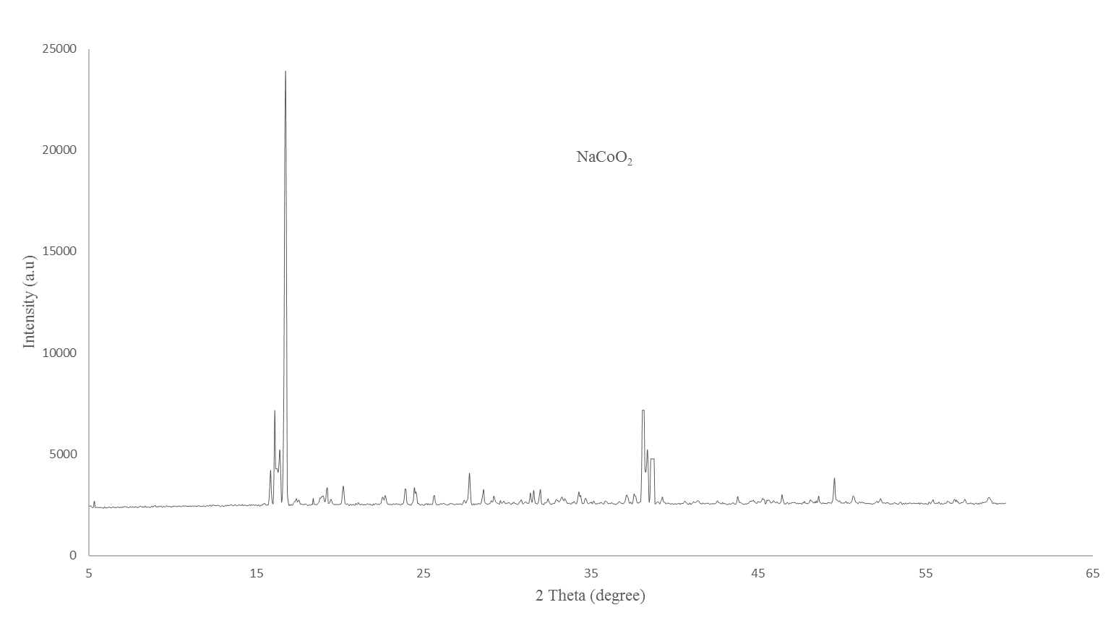

Figure 6. Sodium cobalt cathode material diffractogram from XRD analysis

Conclusion
In this research, the cathode material of sodium cobalt oxide as sodium-ion cathode battery was successfully synthesized by using sol-gel method. From the FESEM Analysis, the morphology of synthesized NaCoO₂ cathode material was heterogenous particles with smooth surface and agglomerated particles was present. Due to the agglomeration, the electrochemical performance of the synthesized cathode material might be lower if compared to the cathode material which has less agglomeration particles. However, electrochemical characterization was not being performed in this study, so the electrochemical performance of the synthesized cathode material cannot be confirmed. In general, low cost and environmental friendly cathode material will be possible to be produced hence can be used for electric storage applications.

Acknowledgement

Appreciation goes to all the staffs involved including the lab assistant from UiTM Cawangan Pahang, Universiti Malaysia Pahang (UMP) and Universiti Malaysia Kelantan (UMK) for their sincere assistance and help. This research was done without any national grant.

References
- Islam, M. S. and Fisher, C. A. J. (2014). Lithium and sodium battery cathode materials: Computational insight into voltage, diffusion and nanostructural properties. Chemical Society Reviews, 43: 185-204.
- Jian, Z., Yu, H. and Zhou, H. (2013). Designing high-capacity cathode materials for sodium-ion batteries. Electrochemistry Communications, 34: 215-218.
- Jiang, T., Pan, W., Wang, J., Bie, X., Du, F., Wei, Y., Wang, C. and Chen, G. (2010). Carbon coated Li₃V₂(PO₄)₃ cathode material prepared by a PVA assisted sol-gel method. Electrochimica Acta, 55: 3864-3869.
- Liu, Z., Jiang, Y., Zeng, X., Xiao, G., Song, H. and Liao, S. (2014). Two-step oxalate approach for the preparation of high performance LiNi_{0.5}Mn_{1.5}O₄ cathode material with high voltage. Journal of Power Sources, 247: 437-443.
- Qiu, W., Liu, J., Yu, L., Zhang, G., Zhao, H. and Li, T. (2007). Studies on the low-heating solid-state reaction method to synthesize LiNi_{1/3}Co_{1/3}Mn_{1/3}O₂ cathode materials. Journal of Power Sources, 174: 701-704.
- Doubaji, S., Valvo, M., Saadoune, I., Dahbi, M. and Edstrom, K. (2014). Synthesis and characterization of a new layered cathode material for sodium ion batteries. Journal of Power Sources, 266: 275-281.
- Shun-yi, Y., Xian-you, W., Ying, W., Quan-qi, C., Jiao-jiao, L. and Xiu-kang, Y., (2010). Effects of Na content on structure and electrochemical performances of Na_{x}MnO₂ +δ cathode material. Transactions of Nonferrous Metals Society of China, 20: 1892-1898.
- Yan, J, Yuan, W, Tang, Z, Sha, O, Wang, J, Mao, W and Ma, L (2012). Synthesis of Li₃V₂(PO₄)₃ cathode material via a fast sol-gel method based on spontaneous chemical reactions. Journal of Power Sources, 201: 301-306.
- Zhang, M., Guo, S., Zheng, L., Zhang, G., Hao, Z., Kang, L. and Liu, Z., (2013). Preparation of NiMn₂O₄ with large specific surface area from an epoxide-driven sol-gel process and its capacitance. Electrochimica Acta, 87: 546-553.
- Garry, P. G., Paul, W. J. and Manivannan, A. (2004). Formation of cobalt nitrate hydrate, cobalt oxide and cobalt nanoparticles using laser vaporization controlled condensation. Journal of Physical Chemistry B, 108 (28): 9604–9607.
- Zhao, J., He, J., Ding, X., Jianhua, Z., Ma, Y., Wu, S. and Huang, R. (2010). A novel sol-gel synthesis route to NaVPO₄F as cathode material for hybrid lithium ion batteries. Journal of Power Sources, 195: 6854-6859.
- Lei, Y., Li, X., Liu, L. and Ceder, G. (2014). Synthesis and stoichiometry of different layered sodium cobalt oxides. Chemistry of Materials, 26(18): 5288-5296.
- Wang, Y., Chou, S., Wexler, D., Liu, H. and Dou, S. X. (2014). High performance sodium-ion batteries and sodium-ion pseudocapacitors based on MoS₂ graphene composites. Chemistry - A European Journal, 20(31): 9607-9612.

