DETERMINATION OF POLYPHENOL CONTENTS IN

Hevea brasiliensis AND RUBBER-PROCESSING EFFLUENT

(Penentuan Kandungan Polifenol dalam Hevea brasiliensis dan

Sisa Pemprosesan Getah)

Azmi Ismun¹, Marinah Mohd Ariffin², Shamsul Bahri Abd Razak¹, Chin Wei Ong³,

Fauziah Tufail Ahmad¹, Aidilla Mubarak^{1*}

¹School of Food Science and Technology,

Universiti Malaysia Terengganu, 21030 Kuala Nerus, Terengganu, Malaysia

²School of Marine and Environmental Science,

Universiti Malaysia Terengganu, 21030 Kuala Nerus, Terengganu, Malaysia

³Crop Improvement and Protection Unit,

Rubber Research Institute of Malaysia, Sungai Buloh, 47000 Selangor, Malaysia

*Corresponding author: aidilla@umt.edu.my

Abstract

The information on polyphenol composition of Hevea brasiliensis is limited despite the importance of understanding the value of this phytochemical, especially in terms of plant protection. There are also no reports available on the polyphenols content of rubber-processing effluent. The objective of this study is to determine the presence of polyphenol compounds in latex C-serum and effluent using Fourier-transform infrared spectroscopy (FTIR) analysis. This study also aims to profile specific phenolics using High Performance Liquid Chromatography (HPLC). Results from the FTIR analysis showed the presence of polyphenols in both latex and effluent. The optimal method for determining polyphenol by HPLC was determined which uses methanol and 0.5% acetic acid as the mobile phases. Several polyphenol peaks, including gallic acid, naphtoic acid, quercetin, chlorogenic acid and rutin, were detected in both latex and effluent when compared to authentic polyphenol standards. Optimization of the solid phase extraction using weak anion-exchange reversed-phase (WAX + C18) chromatography was shown to yield a higher recovery percentage compared to a C18-E cartridge. The results of this study show the potential for understanding polyphenol composition in latex of H. brasiliensis and effluent from rubber processing which has not been explored before.

Keywords: Hevea brasiliensis, polyphenols, latex, effluent, solid phase extraction

Abstrak

Maklumat mengenai komposisi polifenol di dalam Hevea brasiliensis adalah terhad walaupun kefahaman ke atas fitokimia ini penting, terutama bagi aspek perlindungan tanaman. Kandungan polifenol di dalam sisa buangan pemprosesan getah juga masih belum dilaporkan. Objektif kajian ini adalah untuk menentukan kehadiran sebatian polifenol di dalam C-serum lateks dan sisa buangan menggunakan analisis spektroskopi inframerah transformasi Fourier (FTIR). Kajian ini juga mensasarkan untuk mencirikan fenolik yang spesifik di dalam kedua-dua sampel lateks dan sisa buangan menggunakan analisis kromatografi cecair prestasi tinggi (HPLC). Analisis menggunakan FTIR telah membuktikan kehadiran sebatian polifenol di dalam kedua-dua sampel lateks dan sisa buangan. Kaedah optimum untuk menentukan kandungan polifenol menggunakan HPLC telah dapat dibangunkan dengan penggunaan metanol dan 0.5% asid asetik sebagai fasa bergerak. Analisis HPLC mengenalpasti beberapa puncak polifenol telah dikenalpasti di dalam sampel lateks dan sisa buangan yang sepadan dengan piawai polifenol termasuk asid galik, asid naftoik, kuersetin, asid klorogenik dan rutin. Pengoptimuman pengekstrakan fasa pepejal menggunakan kromatografi gabungan pertukaran anion lemah bersama C18 (WAX+C18) telah menunjukkan hasil peratus perolehan kembali yang lebih tinggi berbanding katrij C18-E. Hasil kajian ini menunjukkan potensi bagi memahami komposisi polifenol di dalam lateks H. brasiliensis dan sisa buangan pemprosesan getah yang masih belum diterokai.

Kata kunci: Hevea brasiliensis, polifenol, lateks, sisa buangan, pengekstrakan fasa pepejal

Introduction

Hevea brasiliensis is the common rubber tree grown in tropical regions for the commercial production of rubber latex. Rubber is one of the world’s important commodities and Malaysia is one producer and contributed RM 16.5 billion to the nation’s income in 2016 [1]. The valuable latex yielded by the rubber tree contains several components including 36% as the rubber fraction, 5% as non-rubber components such as C-serum and B-serum proteins, sugars and lipids and 59% as water [2]. C-serum protein, a clear serum corresponding to latex cytosol [3], has been reported to have anti-fungal effects on Aspergillus niger [4] and is a rich source of protein, nucleic acid and multitude of organic compounds [5].

Polyphenols, also known as polyhydroxyphenols, are a structural class of compounds characterized by the presence of multiple phenol structural units. Many studies have explored the pharmacological benefits of polyphenols, including their potential as antioxidants [6,7], anti-cancer agents [8] and other health-promoting properties [9,10]. They are also considered crucial in regulating plant defenses and have been reported for their role in plant defense mechanisms in tapping wounds of rubber plants, specifically of H. brasiliensis [11].

In addition to latex from Hevea, the effluent from rubber processing is another output from the rubber industry that attracted our attention. The effluent from rubber processing has possible deteriorating effects on surface water quality. It may contain high concentrations of organic matter, suspended solids and nitrogen, besides generating malodor when discharged into the environment [12]. The effluent has the potential to increase the biochemical oxygen demand (BOD) index of the water if the waste is released untreated. Higher BOD number determines the consumption of oxygen by microorganisms for oxidation [13]. Polyphenols in rubber may be passed into the aqueous phase of waste effluent. These valuable natural antioxidants may be utilized to optimize resources from the rubber industry. Such utilization has been explored in other studies of other industrial effluents [14,15]. Thus, understanding the polyphenol composition of the effluent from rubber processing is valuable knowledge that can generate possible financial benefits through its isolation, rather than otherwise being a waste product.

Solid phase extraction (SPE) is considered to be a convenient technique, demonstrating better chromatographic separation and its use is common in environmental, pharmaceutical and food laboratories for isolating organic compounds from a variety of matrices [16]. Many studies have reported the application of SPE for the purpose of polyphenol extraction from various samples [17-20]. To date, SPE has never been reported in the literature with regard to polyphenol extraction from H. brasiliensis latex or its processing effluent.

This study aims to contribute towards a fundamental understanding of rubber plant secondary metabolites and to increase the information available on rubber plants. In addition, the study aims to assess the potential purification of polyphenol, which is important in terms of waste management from the processing industry. This study also aims to determine the accuracy of the SPE method for extracting the major polyphenols in latex serum of H. brasiliensis and its rubber-processing effluent that can be measured using HPLC analysis. The method and conditions for HPLC analysis are also optimized to obtain the best separation.

Materials and Methods

Sample collection and preparation

Latex from H. brasiliensis was freshly obtained from a rubber plantation in Setiu, Terengganu, Malaysia and placed on ice without any additive to avoid coagulation. The latex was then centrifuged at 19,000 rpm for 60 minutes at 4 °C to separate it into a three-layer form, containing latex at the top, followed by C-serum and B-serum at the bottom layer. Then C-serum was obtained and freeze-dried for further analysis. The rubber-processing effluent sample was obtained from Pond 1, MARDEC factory in Kuala Berang, Terengganu, Malaysia. The effluent was then filtered through Whatman No. 1 filter paper to remove the suspended debris and centrifuged at 9,000 rpm at 4 °C. The supernatant was then freeze-dried before further analysis.

Fourier-transform infrared spectroscopy (FTIR) analysis

The ATR-FTIR screening was carried out by placing a small amount of concentrated crude extract directly on the surface of a diamond crystal of a Nicolet iS10 infrared spectrometer (Thermo Fisher Scientific, USA). Subsequently, a constant pressure was applied to the sample [21]. Spectra were obtained with the aid of an OMNI-sampler ATR accessory with a wavenumber range of 400–4000 cm⁻¹ with 32 scans. The reference spectra were acquired from the cleaned blank diamond crystal. Detection was based on the peak value in the region of the infrared spectrum and compared results of the study by Coates [22].

Total phenolic content analysis

Total phenolic content was determined using the Folin-Ciocalteu assay [23] in order to quantify the value of the total phenolic concentration. Total phenolic concentration was measured in C-serum of latex using a UV-Vis spectrophotometer. Gallic acid with a range of concentration between 0 to 100 mg/L was used as phenolic standard in this assay. 1 mL of 70% ethanol was added to 20 mg of the dried C-serum and effluent sample and heated at 70 °C. The mixture was then centrifuged at 200 g for 10 min. The supernatant was collected and diluted up to a 20-mL volume with distilled water. 1 mL of standards, blank and samples extracts were loaded into each cuvette and 5 mL of diluted Folin-Ciocalteu reagent (1:10 v/v with ultrapurified water) was added and mixed. The mixtures were incubated at room temperature for five minutes. Then, 80 μL of 7.5% sodium carbonate was added to each mixture to stop the reaction and incubated at 45 °C for 30 minutes in the dark. The mixtures were then read at 765 nm using the UV-Vis spectrophotometer. The area under the curve was calculated against the gallic acid standard curve and results expressed as gallic acid equivalent (GAE).

Optimization of High Performance Liquid Chromatography (HPLC) methods

Polyphenol analysis was carried out using an Agilent® HPLC 1260 system with UV detector at 280 nm using a flow rate of 1.0 mL/min and a sample injection volume of 20 µL. The stationary phase used was Agilent® Zorbax C-18 Eclipse Plus. Method development for HPLC analysis was performed by optimizing each of the HPLC parameters, including solvent systems, solvent ratios, gradient programme and ion-pairing agents. Four methods were tested to determine the best separation of the polyphenols standard mixture. Methanol and 0.5% acetic acid were used as mobile phases for Method A and B, while for Method C and D, acetonitrile and phosphoric acid were used at different gradient ratios, according to Mradu et al. [24] with a slight modification of acid concentrations in the mobile phase. Table 1 shows the specifications of the four HPLC methods that were tested.

Table 1. Four tested HPLC method with different conditions of running time, mobile phases and gradient elution’s

Method | Running Time (minute) | Mobile Phase |  | Gradient Elution’s
Method | Running Time (minute) | Solvent A | Solvent B
A | 22 | Methanol | 0.5% acetic acid | 0-4 min  4-10 min  10-20 min  20-22 min | 100 % solvent B  50 % solvent A, 50 % solvent B  80 % solvent A, 20 % solvent B  50 % solvent A, 50 % solvent B
B | 25 | Methanol | 0.5% acetic acid | 0-5 min  5-10 min  10-25 min | 60 % solvent A, 40 % solvent B  35 % solvent A, 65 % solvent B  60 % solvent A, 40 % solvent B
C | 30 | Acetonitrile | 0.1% phosphoric acid | 0-12 min  12-22 min  22-30 min | 15 % solvent A, 85 % solvent B  25 % solvent A, 75 % solvent B  15 % solvent A, 85 % solvent B
D | 45 | Acetonitrile | 0.1% phosphoric acid | 0-35 min  35-45 min  45 min | 8 % solvent A, 92 % solvent B  22 % solvent A, 78 % solvent B  8 % solvent A, 92 % solvent B

Five standards were used, including chlorogenic acid, gallic acid, naphthoic acid, quercetin and rutin. All the standards were prepared at 400 ppm. The best separation of the standards mixture was used on the C-serum latex and effluent samples. HPLC was chosen to further the analysis of polyphenol profiling due to the capacity of polyphenols to completely dissolve in solvents and their characteristic of high polarity [25].The polyphenols of C-serum latex and effluent were determined using HPLC with the best optimized method.

Optimization of solid phase extraction

Two types of SPE cartridges were tested in the study: C18-E (silica-based sorbent) and the combination of weak anion-exchange and C18 (WAX + C18, polymer-based sorbent) from Phenomenex®. Every equilibration, washing and elution were done separately with regard to the SPE cartridges. All cartridges were activated with 3 mL methanol. The polyphenol with the highest concentration that was demonstrated in the sample was chosen for the optimization of SPE.

The C18-E cartridge was equilibrated with 3 mL deionised water before 1 mL of 10 ppm gallic acid standard was loaded. Washing was then carried out using 3 mL of 25 mM sulphuric acid and, finally, elution with 3 mL methanol. The procedure was conducted according to de Villiers et al. [26]. The WAX+C18 cartridge was equilibrated with deionised water pH 6.5 before 10 ppm gallic standard was loaded, followed by washing using ammonium acetate buffer pH 6.5 and elution with a mixture of 6 mL methanol and 5% formic acid. All the sample eluents were dried in a nitrogen gas concentrator prior to being re-dissolved in 1 mL of HPLC-grade methanol. The extracts were then filtered through a 0.45-µL pore-size syringe filter, and subsequently analyzed by HPLC using the optimized method described in the previous section. The percentage of end-product from the eluent of both cartridges was calculated by comparing the area values of the HPLC chromatogram of the eluent with the gallic acid standard to determine the concentration of specific polyphenol compounds present in the samples.

Results and Discussion

Identification of polyphenol content using FTIR analysis

The peak values and probable functional groups present in the C-serum and effluent crude samples are presented in Figure 1a and 1b, respectively. The peaks were analyzed and correlated according to Coates [22].

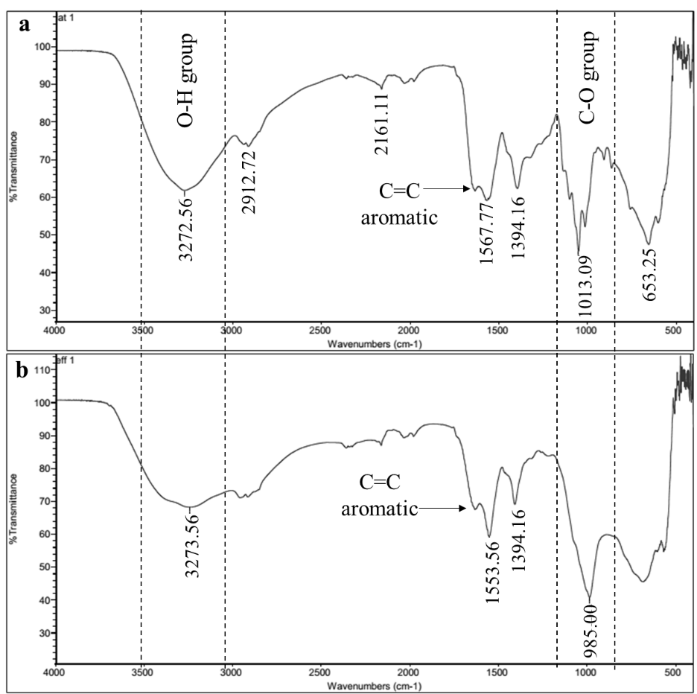

Figure 1. The FTIR spectrum for a) C-serum of latex and b) rubber-processing effluent, both of which are crude samples

The FTIR spectrum for C-serum shows the following characteristic peaks: 3272.56 cm⁻¹, 2912.72 cm⁻¹, 2161.11 cm⁻¹, 1567.77 cm⁻¹, 1394.16 cm⁻¹, 1013.09 cm⁻¹ and 653.25 cm⁻¹. The polyphenol was detected by the peak at wavenumber 3272.56 cm⁻¹ which represents the O-H phenolic group and supported by the presence of C-O group peak at wavenumber 1394.16 cm⁻¹. The 2912.72 cm⁻¹ peak is specific for aldehyde group, 2161.11 cm⁻¹ for alkene group, 1567.77 cm⁻¹ for amine group, 1013.09 cm-1 for halogen group.

For the effluent, the FTIR spectrum detected the two same peaks at wavenumber 3273.56 cm⁻¹ and 1394.16 cm⁻¹, which represent O-H phenolic group. The other peaks that were also present were 1553.56 cm⁻¹ for amine group and 985.00 cm⁻¹ for C-X halogen and fluoride group, which are the main groups to generate an odor. Aromatic C=C groups were also present in the both crude samples.

This study successfully determined the O-H group as the main indicator of the polyphenol present in both C-serum and rubber-processing effluent. Several studies have used FTIR as a tool for analyzing and determining polyphenols in plants and crops [27,28]. However, the results of the FTIR analysis were insufficient and have been supported by other analyses including HPLC.

Quantification of total phenolic content

The total polyphenol content of C-serum and effluent were expressed as GAE (standard equation of the curve: y = 0.0116x; R² = 0.9921). Figure 2 illustrates the polyphenol content quantified in C-serum which was 0.0393 GAE/mL, and in effluent which was 0.0099 GAE/mL. Total polyphenol content of C-serum latex were higher (p<0.05) by approximately 75% than in rubber-processing effluent. However, considering effluent as a waste product of rubber processing, the phenolic quantified is considered to be valuable. Previously, polyphenols, including rutin, luteolin and tyrosol, were detected in olive oil wastewater [29]. Identification of polyphenols in such waste sources can present a valuable element for gaining optimal profit and minimizing loss from waste reprocessing. In addition, polyphenols in olive-mill wastewater were reported to contribute to the phytotoxic effects that cause ecological problems when released to the environment [14]. Thus, knowing the composition of polyphenols in effluent from rubber processing may therefore indicate the importance of removing these compounds from the effluent to reduce risks to the environment.

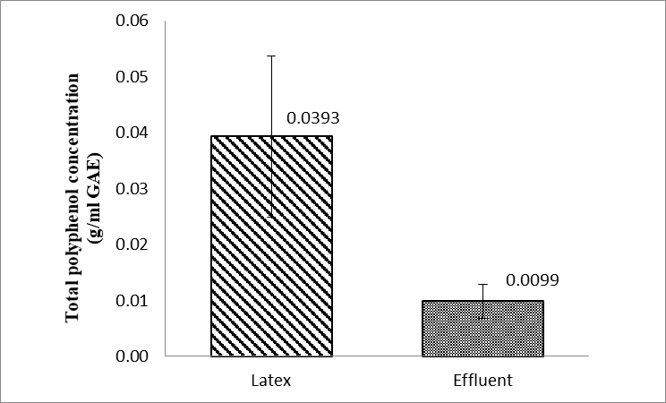

Figure 2. Total polyphenol content of C-serum of latex and effluent expressed as g/mL gallic acid equivalents. Data are mean values of triplicate extractions from pooled latex samples from five trees; and triplicate extractions of the effluent

Optimized HPLC method for identification of polyphenols

Method A (Figure 3a) possessed the best separation for the polyphenol mixture compared to the other methods. All the peaks that represented gallic acid, cholorogenic acid, rutin, quercetin and naphtoic acid were well separated when compared to the other tested methods.

The presence of acetic acid in the mobile phase facilitated the increased chromatogram resolution of a compound that possessed a carboxyl and hydroxyl group in their structures [26]. Acetic acid concentration, which was higher with method A than method B (Figure 3b), contributed to the better resolution of the chromatograms.

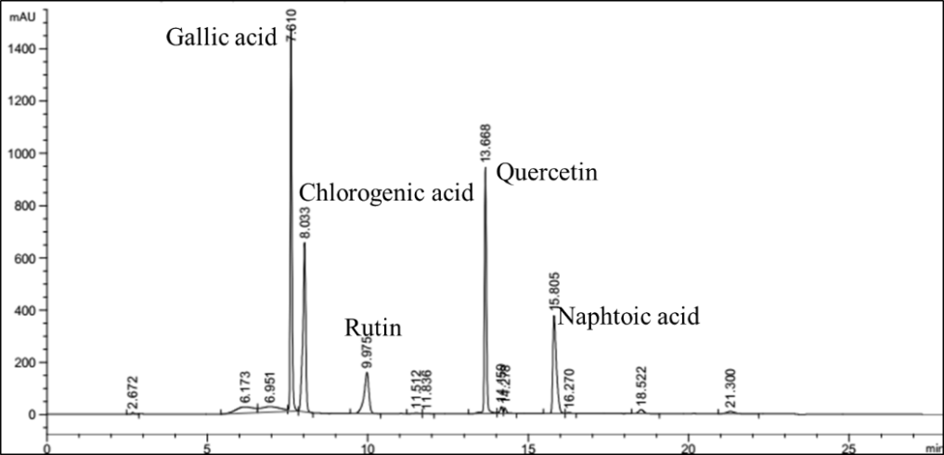
(a)

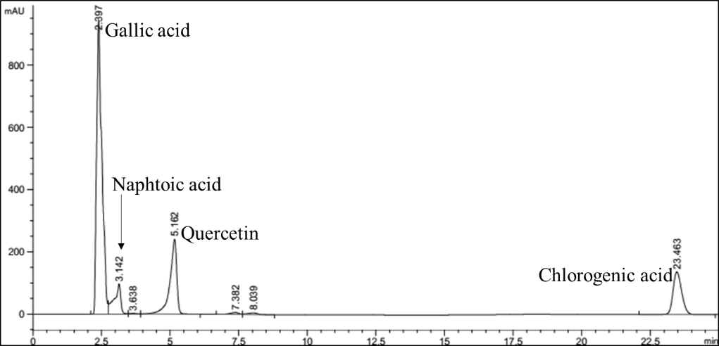
(b)

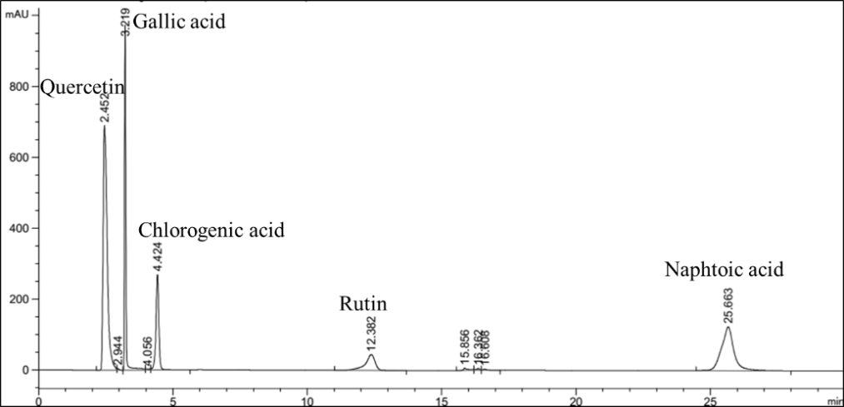
(c)

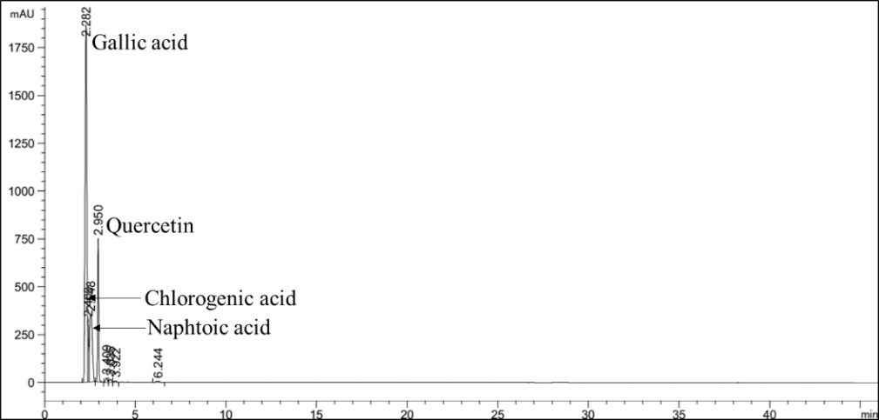
(d)

Figure 3. Chromatogram of HPLC from method A (a), method B (b), method C (c) and method D (d): the peaks represent gallic acid, cholorogenic acid, rutin, quercetin and naphtoic acid

The chromatograms obtained from analysis using method C (Figure 3c) and D (Figure 3d) show that the addition of phosphoric acid to the mobile phase also conveyed a good resolution of the chromatograms with method C and D. However, the run time of 30 min was considered as inefficient in terms of solvent usage compared to method A and B. The peaks that spiked from analysis using method D were considered sharp, but the retention time between the peaks was too close to each other. Addition of formic acid to the mobile phase has been previously reported to contribute to the good resolution of peaks for a compound, but it decreased the retention time due to its co-solvent effect in the mobile phase [30].

Figure 4a and Figure 4b show the separation of polyphenols using HPLC analysis of C-serum of latex and the effluent, respectively. There were two major peaks present in the C-serum of latex, representing gallic acid and naphthoic acid (Figure 4a), while the presence of gallic acid, naphtoic acid and quercetin was detected in the effluent from rubber processing (Figure 4b). Identity of the peaks was verified by comparing the retention times with those of authentic standards. Unknown peaks were observed in both samples at a similar retention time. The unknown peaks found in both C-serum of latex and the rubber-processing effluent will be analysed and identified using Liquid Chromatography Mass Spectrometry (LCMS).

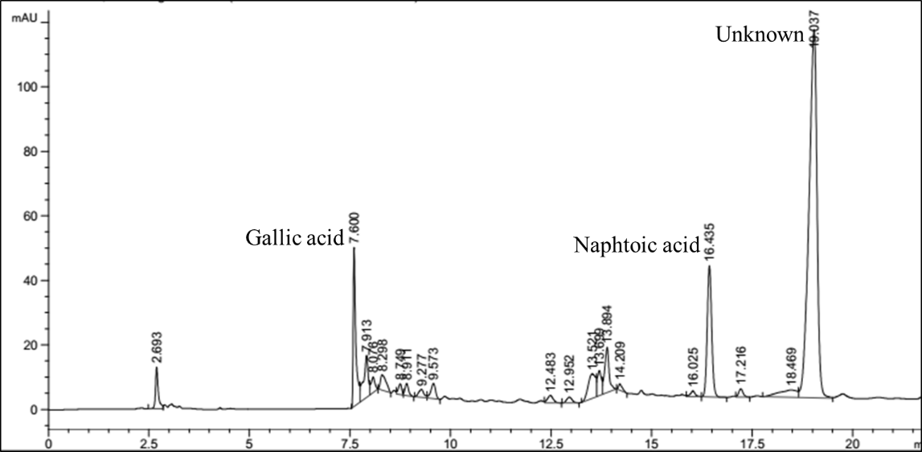
(a)

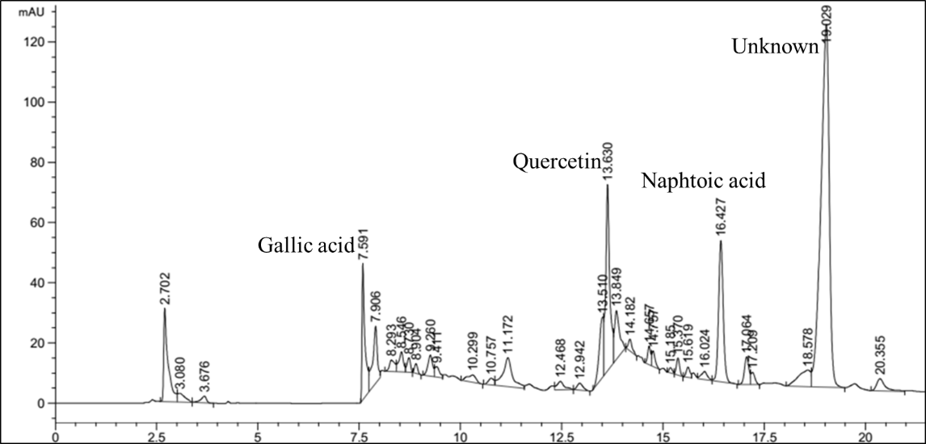
(b)

Figure 4. HPLC chromatogram of (a) C-serum from latex and (b) rubber-processing effluent

Previous studies have suggested that latex plays a role in fighting diseases and pests [31-34]. Several studies have discovered certain compound of interest and defense activity in the C-serum of latex. This includes the discovery of hevein, a single chain serine protease that has been described as an antifungal protein [35]. Daruliza et al. [4] also successfully determined the presence of antifungal activity of C-serum of latex towards Aspergillus niger.

Polyphenols have been associated with resistance mechanisms in plants [36]. Previous studies have reported antifungal activities of phenolics, including gallic acid, quercetin and naphthoic acid, isolated from various plants [37-39]. In addition, plants with high content of phenolics were reported to be less infested by crop aphids, suggesting a natural insecticide activity of phenolics [40]. Furthermore, polyphenols in rubber plants were reported to protect the tapping wound from pathogens, which supports the suggestion that polyphenols may play an important role in plant defense systems [11].

To our knowledge, information on the composition of polyphenols in latex is scarce. It is therefore important to study the composition of phenolics in latex which may also contribute to activities concerning rubber plant defense systems, and C-serum of the latex is a good target for analysing these bioactive compounds. Our study successfully determined the presence of polyphenols in the C-serum of latex by spectrophotometry, FTIR and HPLC analysis. This information could provide a foundation for further research on the determination of specific polyphenol compounds that could be related to resistance activities in rubber plants.

Profiling of polyphenols in many crops provides valuable knowledge which could be used to indicate potential markers for breeding in horticultural sectors. This has mainly been an effort to produce polyphenol-enriched plants due to interest in the pharmacological benefits of polyphenols. However, information obtained from profiling can also be useful for producing elite lines of Hevea species that may have profitable potential, such as pest resistance. Metabolic engineering of some crops has been performed via secondary metabolism pathways in an attempt to improve their tolerance to stress and productivity [41].

To date, there are no reports of investigations of polyphenol content of the effluent from processing of rubber latex. There have been studies conducted on the effluent, but these have focused only on the waste management aspect [42-44]. This study is therefore an initial attempt to determine the existence of polyphenols in the effluent using spectrophotometry, infrared analysis and HPLC. We found that the effluent contains valuable polyphenol compounds that have the potential to be extracted and isolated before being discarded as waste into the environment.

Solid phase extraction (SPE)

For the purpose of optimizing the extraction technique for polyphenols from latex and effluent using SPE, gallic acid standard was used and tested due to the consistency of its appearance in both samples. 10 ppm of gallic acid dissolved in methanol was loaded into both tested SPE cartridges, C18-E and WAX+C18. As shown in Table 2, extraction using the WAX+C18 cartridge showed output with a higher percentage of gallic acid recovery (61.2%, equivalent to 6.12 ppm) than using the C18-E cartridge. There was a small leakage which occurred during gallic acid loading and washing with ammonium acetate buffer [45]. Extraction using the C18-E cartridge had a very low recovery of gallic acid (0.99 %, equivalent to 0.099 ppm).

The SPE cartridge is considered the most convenient method for extracting the desired analytes and compounds from various samples from the environment, pharmaceutical sector and food industries [16]. It has the capacity to operate with smaller elution volumes and yield cleaner extracts with lower interferences due to the optimization of the bed mass to reduce non-specific matrix adsorption [46]. Furthermore, it is also able to retain organic compounds, even when high flow rates are used. However, it also has some limitations including the loss of the sample volume during the elution process [47], restricted flow rates and plugging of the top frit for samples containing suspended solids [48]. SPE has been used for polyphenols extraction from various samples, including wine [26], beer [18] and vegetables [49, 50]. The approach could save sample preparation time and disposal costs, and can be used with very small volumes of sample [51], proving it to be a promising technique for extracting polyphenols from our sample of interest.

Table 2. Comparison of area and percentage values of SPE output as analysed by HPLC
Solid Phase Extraction Cartridge | Area±SD |  |  | Percentage Recovery  From Eluent (%)
Solid Phase Extraction Cartridge | Loading | Wash | Eluent | Percentage Recovery  From Eluent (%)
C18-E | 68.2±0.7 | 90.6±0.5 | 11.65±0.6 | 0.99
WAX+C18 | 60.7±0.5 | 90.6±0.4 | 719.43±0.5 | 61.2

Conclusion

This study has successfully demonstrated that both C-serum of the latex and effluent from rubber processing contained polyphenols, assessed using Fourier-transform infrared spectroscopy (FTIR) and HPLC analysis. The results obtained fulfilled the research objective which was to determine the polyphenols in the C-serum latex and rubber-processing effluent through optimized analytical and extraction techniques. We are currently analysing the C-serum and rubber-processing effluent using LCMS to further identify the unknown peaks that were detected by HPLC analysis. We are also attempting to complete the method development by means of method validation process. These findings present a promising prospect for further investigation of specific polyphenols which may possess important plant defense activities in H. brasiliensis.

Acknowledgement

We would like to thank the Malaysian Ministry of Higher Education (FRGS: 59328) for funding this project.

References

- Malaysia External Trade (MATRADE) Statistics (2016). Top 10 Major Export Products 2016. MATRADE. http://www.matrade.gov.my/en/malaysia-exporters-section/33-trade-statistics/4554-top-10-major-export-products-2016. [Access online 27 November 2016].
- Sansatsadeekul, J., Sakdapipanich, J. and Rojruthai, P. (2011) Characterization of associated proteins and phospholipids in natural rubber latex. Journal of Bioscience and Bioengineering, 111(6): 628-934.
- Kongsawadworakul, P. and Chrestin, H. (2003). Laser diffraction: a new tool for identification and studies of physiological effectors involved in aggregation coagulation of the rubber particles from Hevea latex. Journal of Plant and Cell Physiology, 44(7): 707-717.
- Daruliza, K. M. A. Lam, K. L. Yang, K. L. Priscilla, J. T. Sunderasan, E. and Ong, M. T. (2011). Anti-fungal effect of Hevea brasiliensis latex C-serum on Aspergillus niger. Journal of European Review for Medical and Pharmalogical Sciences, 15(9): 1027-1033.
- Lam, K. L., Yang, K. L., Sunderasan E. and Ong, M. T. (2012). Latex C-serum from Hevea brasiliensis induces non-apoptic cell death in hepatocellular carcinoma cell line HepG2. Cell Proliferation, 45(6): 577- 585.
- Abeywickrama, G., Debnath, S. C., Ambigaipalan, P. and Shahidi, F. (2016). Phenolics of selected cranberry genotypes (Vaccinium macrocarpon Ait.) and their antioxidant efficacy. Journal of Agricultural and Food Chemistry, 64(49): 9342-9351.
- Rouphael, Y., Bernardi, J., Cardarelli, M., Bernardo, L., Kane, D., Colla, G. and Lucini, L. (2016). Phenolic compounds and sesquiterpene lactones profile in leaves of nineteen artichoke cultivars anticancer Journal of Agricultural and Food Chemistry, 64(45): 8540-8548.
- Manach, C., Scalbert, A., Morand, C., Rémésy, C. and Jiménez, L. (2004). Polyphenols: Food sources and bioavailability. American Journal of Clinical Nutrition, 79(5): 727-747.
- Boudet, A. M. (2007). Evolution and current status of research in phenolic compounds. Journal of Phytochemistry, 68(22): 2722-2735.
- Feng, J., Wang, Y., Yi, X., Yang, W. and He, X. (2016). Phenolics from durian exert pronounced no inhibitory and antioxidant activities. Journal of Agricultural and Food Chemistry, 64(21): 4273-4279.
- Wititsuwannakul, D., Chareonthiphakornb, N., Pacec, M. and Wititsuwannakul, R. (2002). Polyphenol oxidases from latex of Hevea brasiliensis: Purification and characterization. Phytochemistry, 61(61): 115-121.
- Kumlanghan, A., Kanatharana, P. and Asawatreratanakul, P. (2008). Microbial BOD sensor for monitoring treatment of wastewater. Enzyme and Microbial Technology, 42(6): 483-491.
- Arimoro, F. O., Iwegbue, C. M. A. and Osiobe, O. (2008). Effects of industrial wastewater on the physical and chemical characteristics of a tropical coastal river. Research Journal of Environmental Sciences, 2(3): 209-220.
- Casa, R., Annibale, A. D., Pieruccetti, F., Stazi, S. R., Sermanni, G. and Cascio, B. L. (2003). Reduction of the phenolic components in olive-mill wastewater by an enzymatic treatment and its impact on durum wheat (Triticum durum Desf.) germinability. Chemosphere, 50: 959-966.
- Achak, M., Hafidi, A., Ouazzani, N., Sayadi, S. and Mandi, L. (2009). Low cost biosorbent “banana peel” for the removal of phenolic compounds from olive mill wastewater: Kinetic and equilibrium studies. Journal of Hazardous Materials, 166(1): 117-125.
- Brenneman, C. and Ebeler, S. E. (1999). Chromatographic separations using solid-phase extraction cartridges: Separation of wine phenolics. Journal of Chemical Education, 76(12): 1710-1711.
- Papagiannopoulos, M., Wollseifen, H. R., Mellenthin, A., Haber, B. and Galensa, R. (2004). Identification and quantification of polyphenols in carob fruits (Ceratonia siliqua L.) and derived products by HPLC-UV-ESI/MS. Journal of Agricultural and Food Chemistry, 52(12): 3784-3791.
- Dvořáková, M., Hulín, P., Karabín, M. and Dostálek, P. (2007). Determination of polyphenols in beer by an effective method based on solid-phase extraction and high performance liquid chromatography with diode-array detection. Czech Journal of Food Sciences, 25(4): 182-188.
- Šeruga, M., Novak, I. and Jakobek, L. (2011). Determination of polyphenols content and antioxidant activity of some red wines by differential pulse voltammetry, HPLC and spectrophotometric methods. Food Chemistry, 124(3): 1208-1216.
- Xie, F. (2011). Rapid and sensitive analysis of eight polyphenols in tobacco by rapid resolution liquid chromatography. American Journal of Analytical Chemistry, 2(8): 929-933.
- Das, A. J., Khawas, P., Miyaji, T. and Deka, S. C. (2015). Phytochemical constituents, ATR-FTIR analysis and antimicrobial activity of four plant leaves used for preparing rice beer in Assam, India. International Journal of Food Properties, 19(9): 2087-2101.
- Coates, J. (2006). Interpretation of infrared spectra, a practical approach. In Encyclopedia of Analytical Chemistry, Meyers, R.A., Ed; John Wiley and Sons, Inc., Hoboken, New Jersey, USA: pp.10815- 10837.
- Folin, O. and Ciocalteu, V. (1927). On tyrosine and trytophane determination in protein. Journal of Biological Chemistry, 27: 627-650.
- Mradu, G., Saumyakanti, S., Sohini, M. and Arup, M. (2012). HPLC profiles of standard phenolic compounds present in medicinal plants. International Journal of Pharmacognosy and Phytochemical Research, 4(3): 162-167.
- Yu, J., Ahmedna, M. and Goktepe, I. (2005). Effects of processing methods and extraction solvents on concentration and antioxidant activity of peanut skin phenolics. Food Chemistry, 90(1): 199-206.
- de Villiers, A., Lynen, F., Crouch, A., and Sandra, P. (2004). Development of a solid-phase extraction Procedure for the simultaneous determination of polyphenols, organic acids and sugars in wine. Chromatographia, 59 (7-8): 403-409.
- Loeser, E. (2009). Peculiarities of mobile phases containing formic acid. Chromatographia, 69(9-10): 807-811.
- Singh, R. and Mendhulkar, V. D. (2015). FTIR studies and spectrophotometric analysis of natural antioxidants, polyphenols and flavonoids in Abutilon indicum (Linn) sweet leaf extract. Journal of Chemical and Pharmaceutical Research, 7(6): 205-211.
- Trifunschi, S., Munteanu, M. F., Agotici, V., Ardelean, S. P., and Gligor, R. (2015). Determination of flavonoid and polyphenol compounds in Viscum album and Allium sativum extracts. International Current Pharmaceutical Journal, 4(5): 382-385.
- Li, S., Tian, M. and Row, K. (2010). Effect of mobile phase additives on the resolution of four bioactive compounds by RP-HPLC. International Journal of Molecular Sciences, 11(5): 2229-2240.
- Mulinnaci, N., Romani, A., Galardi, C., Pinelli, P., Giaccherini, C. and Vincieri, F. F. (2001). Polyphenolic content in olive oil waste waters and related olive samples. Journal of Agriculture and Food Chemistry, 49(8): 3509-3515.
- Dussourd, D. E. and Eisner, T. (1987). Vein-cutting behavior: insect counterploy to the latex defense of plants. Science, 237(4817): 898-901.
- Farrell, B. D., Dussourd, D. E. and Mitter, C. (1991). Escalation of plant defenses: Do latex and resin canals spur plant diversification? American Naturalist, 138(4): 881-900.
- Sangsil, P., Nualsri, C., Woraathasin, N. and Nakkanong, K. (2016). Characterization of the phenylalanine ammonia lyase gene from the rubber tree (Hevea brasiliensis Mull. Arg.) and differential response during Rigidoporus microporus infection. Journal of Plant Protection Research, 56(4): 380-388.
- Ko, J. H., Chow, K. S. and Han, K. H. (2003). Transcriptome analysis reveals novel features of the molecular events occurring in the laticifers of Hevea brasiliensis (para rubber tree). Journal of Plant Molecular Biology, 53(4): 479-492.
- Lattanzio, V., Kroon, P. A., Quideau, S., and Treutter, D. (2008). Plant phenolics – secondary metabolites with diverse functions. In Recent Advances in Polyphenol Research, Daayf, F.; Lattanzio, V., Eds; Wiley-Blackwell, Oxford, UK: pp. 1-386.
- Aziz, N. H., Farag, S. E., Mousa, L. A. and Abo-Zaid, M. A. (1998). Comparative antibacterial and antifungal effects of some phenolic compounds. Microbiology, 93(374): 43-54.
- Tempesti, T. C., Alvarez, M. G., de Araújo, M. F., Catunda Júnior, F. E. A., de Carvalho, M. G. and Durantini, E. N. (2012). Antifungal activity of a novel quercetin derivative bearing a trifluoromethyl group on Candida albicans. Medicinal Chemistry Research, 21(9): 2217-2222.
- Nguyen, D. M. C., Seo, D. J., Lee, H. B., Kim, I. S., Kim, K. Y., Park, R. D. and Jung, W. J. (2013). Antifungal activity of gallic acid purified from Terminalia nigrovenulosa bark against Fusarium solani. Microbial Pathogenesis, 56: 8-15.
- Leszczyński, B., Warchoł, J. and Niraz, S. (1985). The influence of phenolic compounds on the preference of winter wheat cultivars by cereal aphids. International Journal of Tropical Insect Science, 6(2): 157-158.
- Verpoorte, R., van der Heijden, R., ten Hoopen, H. J. G. and Memelink, J. (1999). Metabolic engineering of plant secondary metabolite pathways for the production of fine chemicals. Biotechnology Letters, 21(6): 467-479.
- Nguyen, N. H. and Luong, T. T. (2012). Situation of wastewater treatment of natural rubber latex processing in the Southeastern region, Vietnam. Journal of Vietnamese Environment, 2(2): 58-64.
- Mohammadi, M., Man, H., Hassan, M. and Yee, P. (2013). Treatment of wastewater from rubber industry in Malaysia. African Journal of Biotechnology, 9(38): 6233-6243.
- Owamah, H. I., Enaboifo, M. A. and Izinyon, O. C. (2015). Treatment of wastewater from raw rubber processing industry using water lettuce macrophyte pond and the reuse of its effluent as biofertilizer. Agricultural Water Management, 146: 262-269.
- Andersson, L. I., Paprica, A. and Arvidsson, T. (1997). A highly selective solid phase extraction sorbent for pre-concentration of sameridine made by molecular imprinting. Chromatographia, 46(1-2): 57-62.
- Abd-Talib, N., Mohd-Setapar, S. H. and Khamis, A. K. (2014). The benefits and limitations of methods development in solid phase extraction: Mini review. Jurnal Teknologi (Sciences and Engineering), 69(4): 69-72.
- Thurman, E. M. and Snavely, K. (2000). Advances in solid-phase extraction disks for environmental chemistry. TrAC - Trends in Analytical Chemistry, 19(1): 18-26.
- Nema, T., Chan, E. C. Y. and Ho, P. C. (2010). Application of silica-based monolith as solid phase extraction cartridge for extracting polar compounds from urine. Talanta, 82(2): 488-494.
- Garcia-Salas, P., Morales-Soto, A., Segura-Carretero, A. and Fernández-Gutiérrez, A. (2010). Phenolic-compound-extraction systems for fruit and vegetable samples. Molecules, 15(12):8813-8826.
- Rosa, L., Alvarez-Parrilla, E. and Gonz, G. A. (2010). Fruit and vegetable phytochemicals fruit and vegetable phytochemicals. Wiley-Blackwell, Iowa, USA: pp. 53-88.
- Kumar, A., Malik, A. K. and Tewary, D. K. (2009). A new method for determination of myricetin and quercetin using solid phase microextraction-high performance liquid chromatography-ultra violet/visible system in grapes, vegetables and red wine samples. Analytica Chimica Acta, 631(2): 177-181.

