

MALAYSIAN JOURNAL OF ANALYTICAL SCIENCES
ISSN 1394 - 2506

Published by The Malaysian Analytical Sciences Society

MORPHOLOGY AND CHEMICAL STRUCTURE OF Sn(Oct)₂ THIN LAYER ADDED BINDER VIA SOL GEL METHOD

(Morfologi dan Struktur Kimia bagi Lapisan Nipis Sn(Oct)₂ ditambah Bahan Pengikat Melalui Kaedah Sol Gel)

Rafizah Zaiton*, Nor Afifah Omar, Norliza Ibrahim

Faculty of Chemical Engineering,

Universiti Teknologi MARA, 40450 Shah Alam, Selangor, Malaysia

*Corresponding author: rafizah_fiezah@yahoo.com

Received: 15 February 2017; Accepted: 2 January 2018

Abstract

This paper contains a selection of parameters in sol gel synthesis to produce thin layer tin octoate, Sn(Oct)₂. The main purpose is to discuss the effect of binder on morphology and chemical structure in order to produce high quality coating. The sol-gel method gives better control of the texture, composition homogeneity and structural properties of the final product. However, the disadvantages of this process is the formation of cracks during drying of gels. Binder is one of the compounds help to prevent cracking. In this research, Sn(Oct)₂ was synthesized through sol-gel method with the addition of binders which are polyvinyl alcohol (PVA) and polyethylene glycol (PEG) to enhance mechanical strength of sol gel coating on glass substrate. Different concentration of binder were varied to produce Sn(Oct)₂ thin film. The paper first describes the effect of binder on spectral characteristic from chemical bonding. Then, the effect of binders toward membrane features also studied. The characteristic of thin layer with binders were also discussed. FTIR characterization used to determine the chemical compound and crystalline structure was confirmed by XRD analysis. It has been shown that, added binder into the solution is an effective method to improve the strength of thin layer.

Keywords: sol gel, binder, thin layer, polyvinyl alcohol, polyethylene glycol

Abstrak
Kertas ini membincangkan pilihan parameter dalam sintesis sol gel untuk menghasilkan lapisan nipis bagi Sn (Oct)₂. Tujuan utama adalah untuk membincangkan kesan pengikat ke atas morfologi dan struktur kimia bagi menghasilkan salutan berkualiti tinggi. Kaedah sol-gel memberikan kawalan yang lebih baik terhadap tekstur,homogeniti komposisi dan struktur produk. Walau bagaimanapun, kelemahan proses ini adalah pembentukan keretakan semasa pengeringan gel. Bahan pengikat adalah salah satu daripada sebatian yang dapat membantu mencegah keretakan. Dalam penyelidikan ini, Sn (Oct)₂ telah disintesis melalui kaedah sol-gel dengan penambahan pengikat seperti polivinil alkohol (PVA) dan polietilena glikol (PEG) untuk meningkatkan kekuatan mekanik salutan sol gel pada substrat kaca. Kepekatan yang berbeza dari pengikat diubah untuk menghasilkan Sn(Oct)₂ lapisan nipis. Kajian ini adalah yang pertama menerangkan kesan pengikat pada ciri spektral dari ikatan kimia. Kemudian kajian itu menerangkan kesan pengikat ke atas ciri-ciri membran. Ciri-ciri lapisan nipis dengan pengikat juga dibincangkan. Analisis FTIR digunakan untuk menentukan sebatian kimia dan struktur kristal telah disahkan oleh analisis XRD. Telah ditunjukkan bahawa, penambahan pengikat ke dalam sebatian adalah kaedah penyelesaian yang berkesan untuk menambahbaik lapisan nipis.

Kata kunci: sol gel, pengikat, lapisan nipis, polivinil alkohol, polietilena glikol

Introduction
Tin(II) octoate, or stannous octoate, Sn(Oct)₂, is applied as glass coating, PVC heat stabilizer, biocides and agrochemicals. Sn(Oct)₂ also used as catalyst for glycolysis of polyurethane waste [1] and as Lewis catalyst for esterification and transesterification of acid vegetables oil [2]. It also prefer for biomedical application because of its low toxicity, FDA approval,and high catalytic activity [3, 4]. Besides that, it has high efficiency and solubility in most of organic solvent [5, 6].

Sol-gel synthesis may be used to prepare materials with a variety of shapes, such as porous structures, thin fibers, dense powders and thin films [7]. Sol-gel method is specialized in mixing organic and inorganic materials in one process [8]. In this process, an organometallic compound solution was hydrolysed to create a “sol” which is a colloidal suspension of a solid in a liquid and the sol will undergo further process to form a gel that will produce a ceramic object with required shape [9]. It is one of the favourable methods in making thin, and homogenous at low cost and yield excellent attachment between metallic substrate and the top coat other than provide an efficient, and economic method to produce coatings with high quality [7].

It is generally essential for ceramic powder to be added with binder because binder is a material that enhance the green ceramic mechanical strength in order to get through the production steps so cracking can be prevented or minimized [9]. Binder provides the necessary plasticity for shaping technique and also dry (green) shape with enough strength that can bear the shaping and sintering process. There are two types of binder, organic and inorganic. The most well-known organic binders for ceramic dry-pressing are polyethylene glycol (PEG) and polyvinyl alcohol (PVA) which provide high green strength and high green density for ceramic respectively [10].

In the presence work, the Sn(Oct)₂ thin films with different binders were prepared on glass substrate by sol-gel method. Thin films deposition on glass substrate by dip coating technique was used due to low cost of preparation, homogeneity and uniformity of the final products. The influence on morphology, and chemical structure also studied by varying binder concentrations and characterizations of thin film were carried out using Fourier Transform Infrared Spectroscopy (FTIR), X-ray Diffraction (XRD), Optical Microscope, and also Scanning Electron Microscope (SEM) [11].

Materials and Methods

Materials
Tin octoate (95 % Sigma Aldrich), nitric acid, ethylene glycol (EG), polyvinyl alcohol (PVA), and polyethylene glycol (PEG).

Film preparation and characterization
The Sn(Oct)₂ thin film was prepared by sol gel method. Reagent grade of tin octoate as the precursor and Ethylene Glycol as organic solvent were used. One mole of Sn(Oct)₂ was added into 10 mol of ethylene glycol and stirred for 30 minutes. Then, diluted HNO₃ was added to peptize the sol and molar ratio of H⁺ to Sn²⁺ in the ratio of 0.1:1. The solution was stirred for 6 hours at 90 ºC under reflux condition to ensure complete mixing and hydrolysis. The binder in different concentration was diluted in deionized water at 60 ºC and stirred to dissolve it completely. In this study, PEG and PVA were used as binders. Binder was added in initial solution followed by 6 hours peptization period. After aging of solutions for 24 hours, deposition of thin films on glass substrates was performed by dip coating technique at room temperature. The coated substrates was calcined in an oven at 200 ºC for 2 hours. Fourier Transform Infrared (FTIR) characterization was carried out to investigate the spectral characteristic indicating the chemical bonding of tin octoate thin film. Hence, crystalline phase of resulted powder were identified using X-ray diffraction (XRD). The optical microscope was used to determine the macroscopic appearance and the microstructure of the Sn(Oct)₂ coatings on the glass substrate while Scanning Electron Microscope (SEM) is used to determine the surface morphology of Sn(Oct)₂ film.

Results and Discussion

Effect of binder on spectral characteristic from chemical bonding

FTIR spectroscopy gives qualitative information about the way in which the adsorbed PVA and PEG molecules are bonded to the surface of the Sn (Oct)₂ particles. Figure 1a, and 1b compares the IR spectra of Sn (Oct)₂ particles with the presence of adsorbed PVA and PEG after calcination temperature of 200 °C.
The FTIR analysis was recorded using an FTIR spectrometer in a range between 4000 cm⁻¹ to 500 cm⁻¹. The absorption peaks between 700 cm⁻¹ to 500 cm⁻¹ are assigned to Sn-O and Sn-O-Sn vibrations of SnO₂. Small peaks between 1900 cm⁻¹ to 1600 cm⁻¹ are attributed to Sn-OH vibrational mode. Since the precursor solution contains water, Sn-OH vibrational mode appears in the spectrum. The absorption peak in the 2850 cm⁻¹ in the spectrum corresponds to the CH group stretching vibration of PEG and also PVA [12]. It proves that the molecules of PVA and PEG were absorbed by the Sn (Oct)₂ particles while typical rutile type Sn (Oct)₂ peak 615 cm⁻¹[13]. This result supported by Attia and El-Kader [12] proving that the addition of binders does not affect the spectral structure of sample.

(a) | (b)
Figure 1. FTIR Spectra of (a) PEG and (b) PVA after drying at 200 ºC

Figure 2a and 2b shows the XRD patterns of Sn (Oct)₂ with PEG 1500 and PVA. XRD is a technique used to identify the crystalline species in material. Therefore, this analysis is done in order to characterize the crystalline species in Sn(Oct)₂ powder with different concentration of binders addition. The structure of the Sn(Oct)₂ and binders were studied using X-ray diffraction with angle of 20–80◦, 40V and 30A with speed time of 1min/s with radiation of CuKα in wavelength λ=1.5406 Å [14].

From the XRD measurements of Sn(Oct)₂ with binder addition as shown in Figure 2a and 2b, it can be seen that the gel is X-ray amorphous where it only shows broad humps in every diagrams. This is because most tin ions are bonded with oxygen in the xerogel and they are still in an amorphous state when dried at temperature below 250 °C. It clearly shows that the XRD patterns of Sn(Oct)₂ coated with PVA and PEG in Figure 2a and 2b have same patterns for all different concentration of binders which are 4g, 6g and 8g. This fact shows that adsorption of PVA and PEG and with different concentrations on Sn(Oct)₂ particles does not gives any effect towards the crystallinity of Sn(Oct)₂ particles since sharp peaks on the pattern indicated the crystalline structure of material. All coated samples revealed the same sharp peaks at the same wavelength range.

When comparing the XRD patterns of Sn(Oct)₂ with PVA binder of different concentration shown in Figure 2a, it can be clearly seen that the intensity of diffraction peaks increased as the concentration of PVA increased. Same goes to XRD patterns of Sn(Oct)₂ with PEG binder. The intensity of diffraction peaks also increased as the concentration of PEG increased. However, the intensity of PEG is higher compared with PVA. It is clearly shown at the first peak from wavelength range 25 to 29. This proved that Sn(Oct)₂ coated with PEG is more crystalline compared to PVA since the intensity peaks indicates the crystalline structure of material.

(a) | (b)
Figure 2. XRD patterns of (a) PEG and (b) PVA in powder form

Optical microscope is used to characterize the macroscopic appearance and the microstructure of the Sn(Oct)₂ coatings on the glass substrate. In this test, Sn(Oct)₂ sol gel was coated on a glass slide. The structure of coated Sn(Oct)₂ with PVA and PEG binders were characterized by using optical microscope at magnification of 10x as displayed in Figure 3. The result shows that with an increment in the amount of binder, the porosity of the coatings decreased because the compactness and density of coating particles increased. For PVA images, it can be seen that as PVA concentration increased, the binder images that coated on glass slide can be seen more clearly. The binder look strongly attached to each other as the concentration of binder increased since the function of binder is to enhance the strength of coating on substrate.
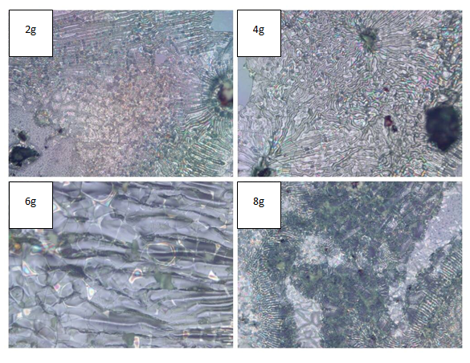
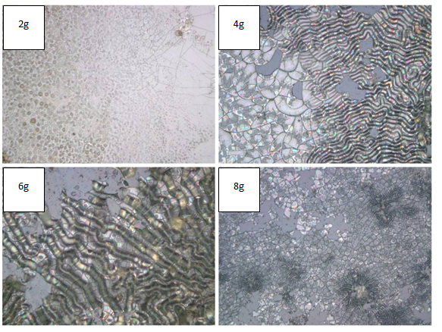
(a)
(b)

Figure 3. Optical imagesof Sn(Oct)₂ with (a) PVA and (b) PEG 1500 binder coated after drying at 200 ºC

Scanning Electron Microscope (SEM) is used to characterize the surface morphology of Sn(Oct)₂ after calcination temperature of 200 °C for 2 hours. In this analysis, the cracking formation were observed for each sample that consists of Sn(Oct)2 with PVA and PEG binders under different concentration of binders. The magnification used in this test was 500x.

Based from the result obtained in Figure 4 and Figure 5, crack formation can be seen throughout the powder particles for both PVA and PEG binders. This is because the drying process that take place up until 200°C had caused densification of the whole gel structure which pulled all the colloid particles close to each other. It formed surface tension and internal stress in the structure of gel which water was actually needed to bind the colloid particles and prevent constant crack after the coating [15].

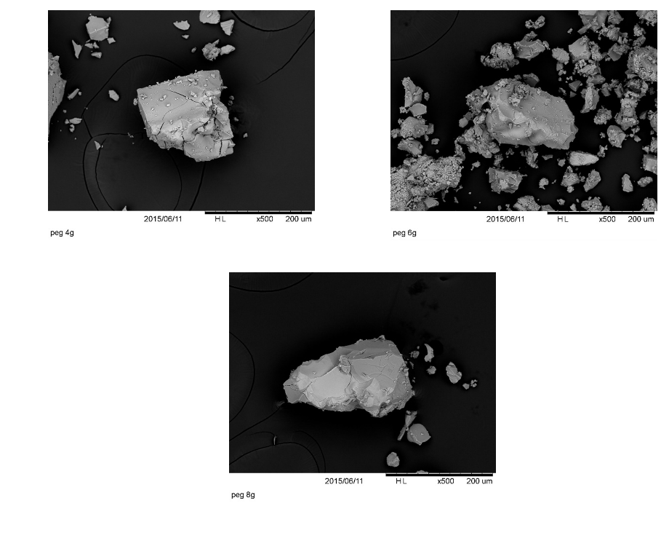
(b)
(a)

(c)

Figure 4. The SEM micrographs of cross-sectional view of Sn(Oct)₂ with a) 4g PVA b) 6g PVA and c) 8g PVA

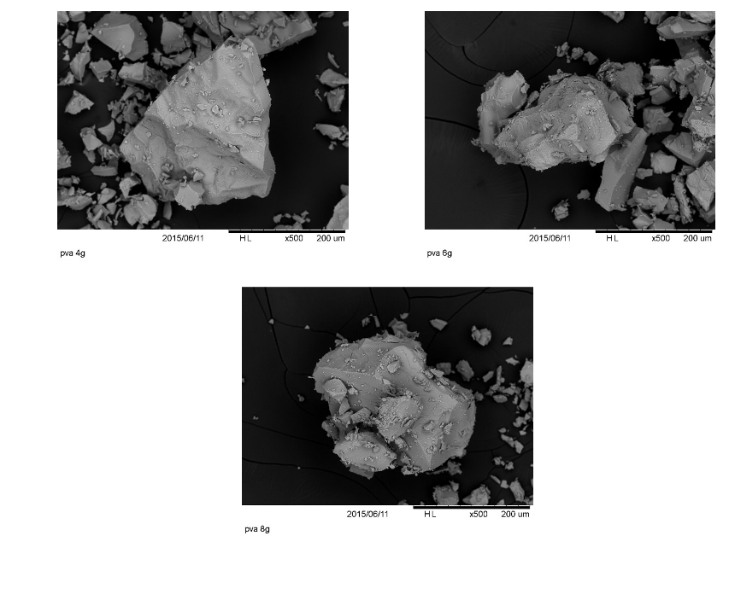
(c)
(b)
(a)
Figure 5. The SEM micrographs of cross-sectional view of Sn(Oct)₂ with a) 4g PEG b) 6g PEG and c) 8g PEG

However, as concentration of both binders increased, the crack formations were reduced. This is because the binders had begun to crystallize and necking process starts to occur causing the particles to connect towards each other through the atomic diffusion. Despite that, drying process that involved binders must be done at lowest heating rate in order to avoid the membrane microstructure layer from having micro cracks because binders can be totally decomposed at temperature near 400 °C [15].

Conclusion
In conclusion, as the binder concentration increased, the formation of crack on Sn(Oct)₂ coatings will be decreased. The coating attachment on glass slide are stronger with the addition of binder amount. It was due to the increment of density and also viscosity of binders for both PVA and PEG since the function of binder is to enhance the mechanical strength of coating on substrate. However, in comparison of PVA and PEG binder, PEG is better compared to PVA because it has more tendencies to have crystalline structure compared to PVA, other than it shows much stronger attachment of Sn(Oct)₂ sol coating on glass slide compared to PVA.

Acknowledgement
The authors would like to thank the Ministry of Education Malaysia for financial support via Fundamental Research Grant Scheme (600-IRMI/FRGS 5/3 (93/2016)). The authors also gratefully acknowledged use of services and research facilities available at the Faculty of Chemical Engineering, Universiti Teknologi MARA, Malaysia.

References
- Batt, J. M. and Stewardship, D. P. (2004). The world of organotin chemicals: applications, substitutes, and the environment. ATOFINA Chemicals, Inc, 6.
- Casas, A., Ramos, M. J., Rodríguez, J. F. and Pérez, Á. (2013). Tin compounds as Lewis acid catalysts for esterification and transesterification of acid vegetable oils. Fuel Processing Technology, 106: 321-325.
- Molero, C., de Lucas, A. and Rodriguez, J. F. (2009). Activities of octoate salts as novel catalysts for the transesterification of flexible polyurethane foams with diethylene glycol. Polymer Degradation and Stability, 94(4): 533-539.
- Sobczak, M. (2012). Ring opening polymerization of cyclic esters in the presence of choline/SnOct₂ catalytic system. Journal of the Polymer Bulletin, 68: 2219-2228.
- Wheaton, C. A. and Hayes, P. G. (2011). Designing cationic zinc and magnesium catalyst for coordination-insertion polymerization of lactide. Comments on Inorganic Chemistry, 32: 127-162.
- Torres, T. and Bottari, G. (2013). Organic nanomaterials: synthesis, characterization, and device applications. John Wiley & Sons.
- Znaidi, L., Touam, T., Vrel, D., Souded, N., Ben Yahia, S., Brinza, O., and Boudrioua, A. (2012). ZnO thin films synthesized by sol-gel process for photonic applications. Acta Physica Polonica-Series A General Physics, 121(1): 165-168.
- Wright, J. D. and Sommerdijk, N. A. (2014). Sol-gel materials: chemistry and applications. CRC press.
- Binders for Ceramic Bodies. (2008). Digitalfire Reference Database: http://digitalfire.com/4sight/ education/ binders_for_ceramic_bodies_345.html [Access online July 15, 2014].
- Carter, C. B. and Norton, M. G. (2007). Ceramic materials: science and engineering. Springer Science & Business Media.
- Ceramic Materials Analysis. (2014). Anderson Materials Evaluation, Inc.: http://www.anderson materials.com/ceramics.html [Acess online Retrieved July 1, 2014].
- Attia, G. and El-Kader, M. A. (2013). Structural, optical and thermal characterization of PVA/2HEC polyblend films. International Journal of Electrochemical Sciences, 8: 5672-5687.
- Nabiyouni, G., Barati, A. and Saadat, M. (2011). Surface adsorption of polyethylene glycol and polyvinyl alcohol with variable molecular weights on zinc oxide nanoparticles. Iranian Journal of Chemical Engineering, 8(1): 20-30.
- Liu, Y. C., Lu, Y. F., Zeng, Y. Z., Liao, C. H., Chung, J. C. and Wei, T. Y. (2011). Nanostructured mesoporous titanium dioxide thin film prepared by sol-gel method for dye-sensitized solar cell. International Journal of Photoenergy, 2011: 1-9.
- Ahmad, A. L., Jaya, M. A. T. and Chieh, D. C. J. (2011). Effect of binder concentration on titania sol turbidity and palladium-titania membrane. Journal of Materials Science and Engineering, 5(5): 534-540.

