

MALAYSIAN JOURNAL OF ANALYTICAL SCIENCES
ISSN 1394 - 2506

Published by The Malaysian Analytical Sciences Society

Characterization of TiO₂ Thin Films Derived using

Acetic ACID and Nitric Acid

(Pencirian Filem Nipis TiO₂ yang Dihasilkan Menggunakan Asid Asetik dan Asid Nitrik)

Nur Munirah Safiay¹, Syahman Shamsuddin², Nur Najwa Yunus², Fazlena Hamzah²*

¹Centre of Nanoscience and Nonaotechnology, Institute of Science

²Biocatalysis and Biobased Material Research Group, CoRe of Green Technology & Sustainable Development,

Faculty of Chemical Engineering

Universiti Teknologi MARA, Shah Alam Campus, 40450 Shah Alam, Selangor, Malaysia

*Corresponding author: fazlena@salam.uitm.edu.my

Received: 15 February 2017; Accepted: 2 January 2018

Abstract

Titanium dioxide (TiO₂) thin films were prepared via sol gel method using different concentration of glacial acetic acid and nitric acid. The deposition of TiO₂ gel on the ITO substrate was conducted using spin coating techniques at a rate of 3,000 rpm for 30 s and was calcinated at 500 ºC for 10 minutes. The study was conducted to determine the surface morphology and characteristic of the TiO₂ thin film based on the different acid precursor. The GAA – TiO₂ and HNO₃ - TiO₂ thin film were analyzed using Contact Angle Goniometer for absorption property study and Scanning Electron Microscope (SEM) for surface topography study. The result indicated that different acid and different concentration influence wettability of the synthesized TiO₂ thin film. Higher concentration of GAA results in higher contact angle of TiO₂ thin film whereas higher concentration of HNO₃ reduced the contact angle of TiO₂ thin film. However, the contact angle obtained through this study was in a range of 27.55º – 67.55º for the concentration acid of 8 – 10 mmol which represent hydrophilic characteristic of the TiO₂ thin film. For surface analysis, uneven and not uniform surface of thin film was detected for the entire sample. This might be due to the several factors such as temperature and particle size that limited the adhesion of the TiO₂ sol gel to the ITO substrate. Transform Infrared Spectroscopy (FTIR) analysis was used to validate the present of the Ti-O bond vibrations in the sample and it was observed in ranges of 515–800 cm⁻¹. On the other hand, the crystallinity structure of the synthesized TiO₂ was validated using X-ray Diffraction (XRD). The results indicated that both GAA - TiO₂ and HNO₃ - TiO₂ mixtures gave a strong anatase crystal structure. The major XRD diffraction peaks can be attributed to (101), (004), (200), (211), (204) and (116) plane of the tetragonal TiO₂-anatase phase.

Keywords: characterization, acid, thin films, titanium dioxide, titanium isopropoxide

Abstrak

Titanium dioksida (TiO₂) filem nipis telah dihasilkan melalui kaedah sol gel dengan menggunakan kepekatan asid asetik glasial dan asid nitrik yang berbeza. Pemendakan gel TiO₂ pada substrat ITO dilakukan menggunakan teknik salutan berputar pada kadar 3,000 rpm selama 30 s dan dikalsinasi pada 500 ºC selama 10 minit. Kajian ini dijalankan untuk menentukan morfologi permukaan dan ciri-ciri filem TiO₂ nipis berdasarkan kepekatan asid yang berbeza. Filem nipis GAA - TiO₂ dan HNO₃ - TiO₂ dianalisis dengan menggunakan goniometer sudut sentuh untuk kajian ciri-ciri penyerapan dan mikroskop imbasan elektron (SEM) untuk kajian topografi permukaan. Hasil kajian menunjukkan bahawa asid yang berbeza dan kepekatan yang berbeza mempengaruhi kelembapan TiO₂ filem nipis yang dihasilkan. Kepekatan GAA yang tinggi menghasilkan sudut sentuh yang lebih tinggi pada TiO₂ filem nipis manakala kepekatan HNO₃ yang lebih tinggi mengurangkan sudut sentuh TiO₂ filem nipis. Walau bagaimanapun, sudut hubungan yang diperolehi melalui kajian ini adalah dalam lingkungan 27.55º - 67.55º untuk kepekatan asid 8 - 10 mmol yang mewakili ciri hidrofilik TiO₂ filem nipis. Untuk analisis permukaan, permukaan filem nipis adalah tidak rata dan tidak seragam dikesan untuk semua sampel. Hal ini mungkin disebabkan beberapa faktor seperti suhu dan saiz zarah yang menghadkan pelekatan sol gel TiO₂ kepada substrat ITO. Analisis Spektroskopi Inframerah (FTIR) digunakan untuk mengesahkan kehadiran getaran Ti-O di dalam sampel dan keputusan menunjukkan kehadiran getaran Ti-O di dalam lingkungan 515-800 cm⁻¹. Manakala struktur kristal TiO₂ yang disintesis telah disahkan dengan menggunakan pembelauan sinar-X (XRD). Keputusan menunjukkan bahawa campuran GAA - TiO₂ dan HNO₃ - TiO₂ memberikan struktur kristal anatase yang kuat. Puncak pembelauan XRD yang utama boleh dikaitkan dengan fasa TiO₂-anatase tetragonal pada (101), (004), (200), (211), (204) dan (116).

Kata kunci: pencirian, asid, filem nipis, titanium dioksida, titanium isopropoksida

Introduction

Titanium dioxide, also known as titanium (IV) oxide or titania, is the naturally occurring oxide of titanium with chemical formula of TiO2. It is sourced from ilmenite, rutile and anatase [1]. It has been explored in a widen industrial application due to its unique physical, chemical and electro-optic characteristic such as low cost, easy handling, non-toxicity, and resistance to photochemical and chemical erosion. TiO₂ has been used as a material in solar cells, chemical sensors, for hydrogen gas evolution, as pigments, self-cleaning surfaces, and environmental purification applications [2]. Another potential of TiO₂ is in form of thin film. The research of the thin film TiO₂ has been explored by Kajitvichyanukul et al. [3] for photocatalytic reduction of chromium(VI) in photocatalysis process. The photocatalytic reactivity of the obtained thin film is at a par with the reactivity using powder TiO₂. The results indicate that the differences in photocatalytic reduction of Chromium(VI) could be correlated with the structural morphology of the thin film. As indicated by Qiu et al. [4], TiO₂ nanostructured thin films possess a large surface area and show unique chemical, physical and electronic properties that are different from those bulk materials. These characteristics make it a potential material in in constructing a novel sensing device such as electrochemical sensors and biosensors. However, the characteristic of the thin film TiO₂ might be varies based on the method used to fabricate it. Several methods have been employed to fabricate TiO₂ films, including sputtering, chemical vapor deposition, and sol-gel process [5, 6, 7]. However, the sol-gel process is one of the most appropriate technologies to prepare thin oxide coating. The interest in application of sol-gel method is due to several advantages including; good homogeneity, ease of composition control, low processing temperature, large area coatings, low equipment cost, and good photocatalytic properties [8].

This paper, aims to investigate effects of the preparation conditions on the surface morphology and properties of TiO₂ thin film. Titanium dioxide (TiO₂) thin film was prepared by glacial acetic acid- sol-gel method and nitric acid -sol-gel method. The phase transformation was investigated by an X-ray diffractometer (XRD) and the microstructure was characterized by a scanning electron microscope (SEM).

Materials and Methods

Preparation of sol-gel solution

The preparation of titanium dioxide solutions had been performed by sol-gel method. Fifty milliliter of absolute Ethanol (99% Merck) was mixed with 5 ml glacial acetic acid (99.5% GCC), 6.6 ml titanium tetra isopropoxide TTIP (99%, sigma-Aldrich). Then, these liquids were continuously stirred by using a magnetic stirrer on a hot plate. Acetylacetone, glacial acetic acid (GAA), distilled water and polyethylene glycol (PEG) were added and these solutions were stirred vigorously for 2 hours at temperature 50 °C and 300-500 rpm. After 2 hours, the solution was sonicated inside the ultrasonic cleaner for 30 minutes. ITO glass slides (25 mm x 25 mm x 2 mm) were used as substrate after cleaned with acetone, ethanol, and deionized water in an ultrasonic bath. Thereafter, the slides were dried with filter paper. Spin coating method was used for deposition of TiO₂ gel on the substrate at a rate of 3,000 rpm for 30 s. Then, the samples was dried at 150 °C for 5 minutes and calcined at 500 °C for 10 minutes. Reagents were used as we received from supplier without more purification. Similar procedure was repeated for nitric acid - sol-gel solution.

Characterization of TiO₂ film
The crystal structure of the TiO₂ coated on ITO was characterized by θ/2θ X-ray diffractometer (Seifert, PTS 3000, USA) using Cu Kα radiation (λ=0.154 nm) (45 kV at 200 mA). The XRD pattern was obtained at 2θ angle range of 20–80° with a scanning step of 0.02°/step and a scanning speed of 5°/min. Scanning electron microscopy (SEM – EFI Company) was used to investigate the surface morphology of the thin films. The Fourier Transform Infrared Spectroscopy (FTIR) (Thermo Fisher, Nicolet iG50, USA) was used to evaluate the functional group present in the synthesized TiO₂ and Contact Angle (AST, VCA 3000S, USA) analysis was used to evaluate the absorption property of the TiO₂ thin film. The method used is according to Miao et al. [9].

Results and Discussion

Absorption properties of the TiO₂ thin films
To evaluate the surface properties of the thin films, contact angle analysis was carried out in order to determine the hydrophilicity of the sample. The contact angle is the angle, conventionally measured through the liquid, where a liquid–vapor interface meets a solid surface. It quantifies the wettability of a solid surface by a liquid. Table 1 shows the result of contact angle analysis of the TiO₂ thin films. From the results, it was found that the contact angles for synthesizing TiO₂ thin films was less than 90º which consider that the solid surface of TiO₂ thin films is hydrophilic. Two different acids were used in the preparation of TiO₂ thin film and the results indicated that nitric acid (HNO₃) gave higher contact angle value as compared to glacial acetic acid (GAA) thin film. However, increment of acid concentration reduced contact angle of the TiO₂ thin film to 34.86º at 10 mmol HNO₃ instead of 67.6º at 8mmol HNO₃. On the other hand, increment of GAA concentration up to 10 mmol, increased contact angle of TiO2 thin film to 39.95º from 27.55º at 8mmol GAA. However, all of the samples were hydrophilic film and it is suitable to be used in application of bio-liquid detection system. According to Li et al. [10], hydrophilic characteristic of thin film gave a great application potential on serving as biosensor. The finding indicated that SiN thin film surface is hydrophilic with contact angle of 45º. Similar finding had been reported by Miao et al. [9] which indicated that the deposited porous and amorphous TiO₂ thin films enable an increase of the surface tension of the material, thereby improving absorption property of the composite structure.

Table 1. Contact angle of TiO₂ thin films with different concentration of GAA and HNO₃
Concentration GAA  (mmol) | Contact Angle  (°) | Concentration HNO₃  (mmol) | Contact Angle  (°)
8 | 27.55 | 8 | 67.60
9 | 39.35 | 9 | 52.40
10 | 39.95 | 10 | 34.85

Surface morphology and surface area of the TiO₂ thin films

The surface morphology of the TiO₂ films was examined using SEM and is revealed in Figure 1. SEM images of different films derived from GAA and HNO₃ catalyst was very similar to each other. The adhesion of the TiO₂ thin film was observed for both sample but the surface was not smooth with irregularities. SEM image of GAA – TiO₂ and HNO₃ – TiO₂ at 9 mmol had shown a crack surface and not uniform structure (Figure 1b and e).

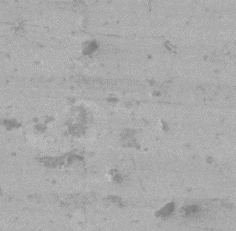  (a) | 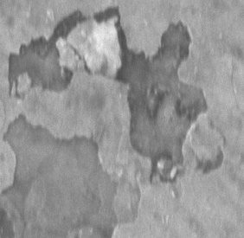  (b) | 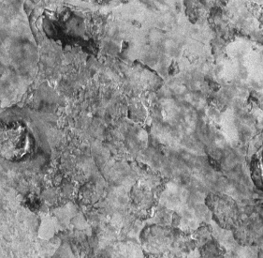  (c)
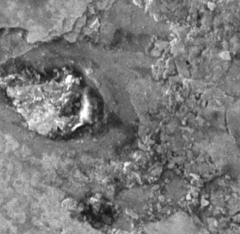  (d) | 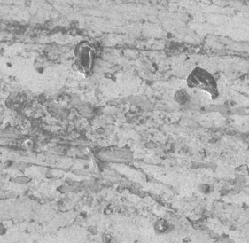  (e) |   (f)
Figure 1. FE-SEM images of TiO₂ thin films (a) 8 mmol GAA (b) 9 mmol GAA and (c) 10 mmol GAA (d) 8 mmol HNO₃ (e) 9 mmol HNO₃ (f) 10 mmol HNO₃

The surface was almost plain for all sample with some agglomerations were detected at 8 mmol GAA – TiO₂ and 10 mmol HNO₃ – TiO₂ thin film (Figure 1a and f). The tendency of particle agglomeration might happen which is directly related to the increase in crystallite size. On the other hand, the temperature might influent the surface morphology of the thin film. Higher temperature during annealing may lead to non-uniform and cracked coating and reduce coating lucidity and transparency. According to Alzamani et al. [11], this is due to substrate plasticity and softening or crystalline size increase or film structure variation. In a sol-gel process of transition metal alkoxides, hydrolysis and condensation reactions occur very rapidly, so uniform and ultrafine products are difficult to obtain. With the use of bulky, branched alkoxy groups (i.e. isopropoxides), the hydrolysis and condensation rates can be reduced to favor the formation of nanometric clusters, yielding a more uniform particle size.

Fourier transform infrared spectroscopy analysis of TiO₂ powder

Figure 2 shows the FTIR pattern of TiO₂ synthesized from sol-gel method with glacial acetic acid and nitric acid in range of 515-4000 cm⁻¹. Both graph shown a similar trend and intensity of the spectrum. In all spectra measured, the bands assigned to the stretching vibrations of OH groups (at about 3400-3437 cm⁻¹) together with the bending vibrations in H₂O molecules (at about 1529 cm⁻¹) were observed, which relates to the sol-gel synthesis. The intensity of all those bands will decreases during an annealing process. While, bands connected with Ti-O bond vibrations occur in the ranges of 515-800 cm⁻¹. Similar finding was recorded by Fatma et al. [12] and Adamczyk and Dlugon [13]. Moreover, the bands at 1050, 1089, and 1138 cm⁻¹ were ascribed to stretching of Ti-O-C while lower mode of amorphous TiO₂ appeared at 932 cm⁻¹ [14-15]. While the peak appeared at 1249-1250 cm⁻¹ and 1285 cm⁻¹ was the vibration mood of C-O-O group. The doublet in 1349-1350 cm⁻¹ and 1443-1445 cm⁻¹ designated the symmetric and asymmetric stretching vibration of the carboxylic group coordinated to Ti as a bidentate ligand [16].

(a) | (b)
Figure 2. (a) FTIR pattern of TiO₂-GAA powder, (b) FTIR pattern of TiO₂-HNO₃ powder

X-Ray diffraction analysis of TiO₂ powder
Figure 3 shows the XRD images of GAA-TiO₂ and HNO₃-TiO2. The GAA-TiO₂ and HNO₃-TiO₂ diffraction peaks showing similar crystallinity properties. On diffractograms, the dominant peaks were associated with anatase (A), rutile (R) and brookite (B) phases. It can be seen that both samples showed the anatase TiO₂ crystal structure. The major XRD diffraction peaks can be attributed to (101), (004), (200), (211), (204) and (116) plane of the tetragonal TiO2-anatase phase. Theoretically, all the TiO₂ samples are polycrystalline in nature with most intense peak corresponding to (110) plane. Similar result was obtained by Tsegaa and Dejeneb [17], Yu et al. [18] and Thamaphat et al. [19]. The results show that low concentration of GAA results in higher intensity of the anatase phase at (101) plane.

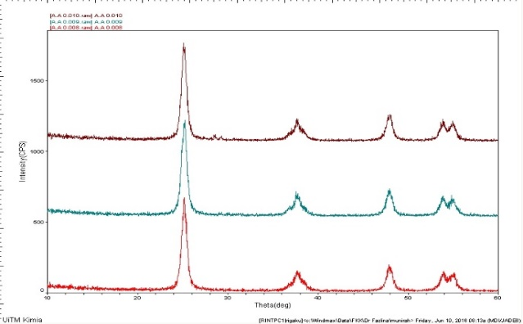  (a)  (i)  (ii)  (iii) | 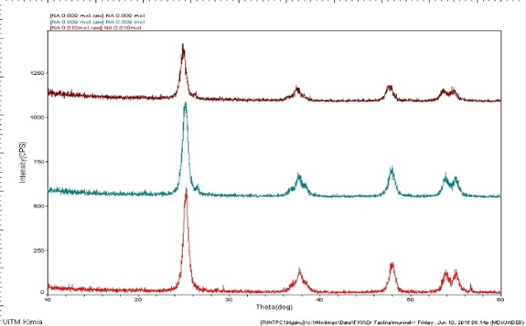  (b)  (i)  (ii)  (iii)
Figure 3. (a) XRD pattern of (i) 8 mmol GAA (ii) 9 mmol GAA (iii) 10 mmol GAA of TiO₂ powder, (b) XRD pattern of (i) 8 mmol HNO₃ (ii) 9 mmol HNO₃ (iii) 10 mmol HNO₃ of TiO₂ powder

On the other hand, higher concentration of HNO₃ was leaded for higher intensity of the anatase peak in HNO₃-TiO₂ sample at (101) plane. This might occurred due to the different kinds of strain such as tensile and compressive in the TiO₂ particle. In the study by Tsegaa and Dejeneb [17], the diffraction peaks of the TiO₂ were shifted slightly to the higher angle side with the increase of acid concentration. While, Serrano et al. [20] claim that nitric acids lead to the development of TiO₂ photocatalysts with convenient textural properties which produce the selective crystallization into anatase with small nanocrystals being present within the pore walls. This shown that concentration of the acid will influence the crystallinity polymorphs of the material.

Conclusion

Titanium dioxide (TiO₂) thin films was developed using 2 different acid which is GAA and HNO₃ gave different characteristic and properties of TiO₂ thin film. Both acid results in hydrophilic characteristic of thin film with contact angle value less than 90º. However, increasing the concentration of GAA reduced hydrophilicity value of TiO₂ thin film. On the other hand, higher concentration of HNO₃ results in higher hydrophilicity value of TiO₂ thin film. On the other hand, different acid and its concentration results in similar topography image of the thin film. Deposition of TiO₂ sol gel was observed on ITO substrate but uneven and not uniform layer of TiO₂ was presented. While for FTIR and XRD analysis of the both sample, the present of Ti-O group was observed at the absorbance range of 515-800 cm⁻¹ and the crystal peak observed for both sample were associated with anatase (A), rutile (R) and brookite (B) phases which represents the nature characteristic of TiO₂.

Acknowledgement
The present study was made possible through funding from Faculty of Chemical Engineering and Universiti Teknologi MARA - 600-RMI/GIP 5/3(0041/2016), and continuous support from Research Management Institute (RMI) of University Technology MARA is gratefully acknowledged. Authors also like to show gratitude to the facilities and constant encouragement from Faculty of Chemical Engineering, Universiti Teknologi MARA.

References
- Titanium dioxide definition, https://en.wikipedia.org/wiki/Titanium_dioxide [Access online 20 October 2016].
- Hoffmann, M. R., Martin, S. T., Choi, W. and Bahnemann, D.W. (1995). Environmental applications of semiconductor photocatalysis. Chemical Reviews, 95: 69-96.
- Kajitvichyanukula P., Ananpattarachaia J. and Pongpom S. (2005). Sol–gel preparation and properties study of TiO₂ thin film for photocatalytic reduction of chromium(VI) in photocatalysis process. Science and Technology of Advanced Materials, 6: 352-358.
- Qiu J., Zhang S. and Zhao H. (2011). Recent applications of TiO₂ nanomaterials in chemical sensing in aqueous media. Sensors & Actuators: B. Chemical, 160: 875-890.
- Ding Z., Hu X., Yue P. L., Lu G. Q. and Greenfield P. F. (2001). Synthesis of anatase TiO₂ supported on porous solids by chemical vapor deposition. Catalysis Today, 68: 173-182.
- Pecchi G., Reyes P. and Sanhueza, J. P. (2001). Photocatalytic degradation of pentachlorophenol on TiO₂ sol–gel catalysts. Chemosphere, 43: 141–146.
- Sonawane, R. S., Hegde, S. G. and Dongare, M. K. (2002). Preparation of titanium (IV) oxide thin film photocatalyst by sol–gel dip coating. Materials Chemistry and Physics, 77: 744–750.
- Sakka, S., Yoko, T. in: Jørgenson, J. C. and Reisfield, R. (Eds.) (1991). Chemistry, spectroscopy, and application of sol–gel glasses, Springer, Heidelberg: 89–91.
- Miao, D., Hu, H., Li, A., Jiang, S. and Shang, S. (2015). Fabrication of porous and amorphous TiO₂ thin films on flexible textile substrates. Ceramics International, 41: 9177-9182.
- Li, Y. G., Ma, L. X., Sarro, P. M., Du, D. X. and Liu, X. F. (2016). Mass sensitivity of aluminum nitride thin film based surface acoustic wave sensors prepared for biosensing application. Symposium on Piezoelectricity, Acoustic Waves, and Device Applications, 21-24 Oct. 2016.
- Alzamani, M., Shokuhfar, A., Eghdam, E. and Mastali, S. (2013). Influence of catalyst on structural and morphological properties of TiO₂ nanostructured films prepared by sol–gel on glass. Progress in Natural Science: Materials International, 23(1):77–84.
- Parra, R., Góes, M. S., Castro, M. S., Longo, E., Bueno, P. R. and Varela, J. A. (2008). Reaction pathway to the synthesis of anatase via the chemical modification of titanium isopropoxide with acetic acid. Chemistry of Materials, 20: 143-150.
- Gonzalez, R. J., Zallen, R. and Berger, H. (1997). Infrared reflectivity and lattice fundamentals in anatase TiO₂s. Physic Review B, 55: 7014-7017.
- Nolan, N. T., Seery, M. K. and Pillai, S. C. (2009). Spectroscopic investigation of the anatase-to-rutile transformation of sol-gel-synthesized TiO₂ photocatalysts. Journal of Physical Chemistry C, 2113: 16151-16157.
- Gökdemir, F. P., Yüzbaşıoğlu, V. E., Keskin, B., Özdemir O. and Kutlu, K. (2014). Formation of TiO₂ thin films by a modified sol gel route and characterization of structural, optical and electrochromic properties. Advance Materials Letter, 5(7): 367-371.
- Adamczyk, A. and Długoń E. (2012). The FTIR studies of gels and thin films of Al₂O₃ – TiO₂ and Al₂O₃ – TiO₂ – SiO₂ systems. Spectrochimica Acta Part A: Molecular and Biomolecular Spectroscopy, 89: 11-17.
- Tsegaa, M. and Dejeneb, F. B. (2017). Influence of acidic pH on the formulation of TiO₂ nanocrystalline powders with enhanced photoluminescence property. Heliyon, 3:246.
- Yu, J. C., Yu, J., Ho, W. K, Jiang, Z. and Zhang, L. Z (2002). Effects of F- doping on the photocatalytic activity and microstructures of nanocrystalline TiO₂ powders. Chemistry of Materials, 14: 3808-3816.
- Serrano, D. P., Calleja, G., Sanz, R. and Pizarro, P. (2007). Development of crystallinity and photocatalytic properties in porous TiO₂ by mild acid treatment. Journal of Materials Chemistry, 17(12): 1178-1187.
- Thamaphat, K., Limsuwan, P. and Ngotawornchai, B. (2008). Phase characterization of TiO₂ powder by XRD and TEM Kasetsart Journal (Natural Science), 42: 357-361.

