

MALAYSIAN JOURNAL OF ANALYTICAL SCIENCES
ISSN 1394 - 2506

Published by The Malaysian Analytical Sciences Society

TRANSESTERIFICATION OF WASTE COOKING OIL IN BIODIESEL PRODUCTION UTILIZING CaO/Al₂O₃ HETEROGENEOUS CATALYST

(Transesterifikasi Sisa Minyak Masak Dalam Pengeluaran Biodiesel Menggunakan CaO/Al₂O₃ Mangkin Heterogenus)

Norshahidatul Akmar Mohd Shohaimi* and Fatin Nur Syahirah Marodzi

Faculty of Applied Sciences,
Universiti Teknologi MARA Pahang, 26400 Bandar Tun Abdul Razak Jengka, Pahang, Malaysia

*Corresponding author: akmarshohaimi@pahang.uitm.edu.my

Received: 4 December 2016; Accepted: 1 December 2017

Abstract
The increasing demand for fossil fuel brings a great concern as it is natural and non-renewable sources. There are several studies on biodiesel using renewable sources such as waste cooking oil. The process of transforming waste cooking oil into biodiesel is called transesterification reaction which involved one step (esterification) and two step (esterification-transesterification) reaction. The performance of the CaO/Al₂O₃ catalyst was investigated. The parameters studied were reaction time and catalyst loading. In this study, it was found that the highest yield was obtained from the two step transesterification reaction, 30.91% with optimum condition of 3 wt.% of Ca/Al₂O₃ catalyst, 12:1 methanol to oil ratio, reaction temperature of 65 ºC for 3 hours. Esterification reaction reduce the free fatty acid (FFA) content in the feedstock, because, in order to achieve high biodiesel yield, the acid value of feed stock should below than 1 mg KOH/g oil. Gas chromatography mass spectrometry results showed that six methyl ester species was found in the product and this finding reveals that the FFA had successfully converted to methyl ester by using two step esterification-tranesterification reaction.

Keywords: biodiesel, heterogeneous catalyst, transesterification, waste cooking oil

Abstrak
Permintaan yang semakin meningkat bagi bahan api fosil membawa kebimbangan besar kerana ia adalah sumber semula jadi dan tidak boleh diperbaharui. Terdapat beberapa kajian mengenai biodiesel menggunakan sumber yang boleh diperbaharui seperti sisa minyak masak. Proses mengubah sisa minyak masak kepada biodiesel dipanggil tindak balas transesterifikasi yang melibatkan tindak balas satu langkah (pengesteran) dan dua langkah (pengesteran- transesterifikasi). Prestasi pemangkin CaO/Al₂O₃ dikaji. Parameter yang dikaji ialah masa tindak balas dan jumlah pemangkin. Dalam kajian ini, didapati bahawa hasil tertinggi diperoleh daripada tindak balas transesterifikasi dua langkah, 30.91% dengan keadaan optimum daripada 3% berat pemangkin Ca/Al₂O₃, 12: 1 metanol kepada nisbah minyak, suhu tindak balas 65 ºC selama 3 jam. Tindak balas pengesteran mengurangkan kandungan asid lemak bebas (FFA) dalam bahan mentah, kerana untuk mencapai hasil biodiesel tinggi, nilai asid stok suapan sepatutnya kurang dari 1 mg KOH/g minyak. Keputusan kromatografi cecair spektrometri jisim menunjukkan bahawa enam spesies metil ester ditemui dalam produk dan penemuan ini mendedahkan bahawa FFA telah berjaya ditukar kepada metil ester dengan menggunakan dua langkah tindak balas pengesteran- transesterifikasi.

Kata kunci: biodiesel, mangkin heterogenus, transesterifikasi, sisa minyak masak

Introduction
The widespread use of diesel fuel in the world and the rapid reduction of crude oil reservoir has spurred interest and extensive research into an alternative fuels. Biodiesel as an alternative fuel is an eco-friendly and proven to be environmentally safe. Biodiesel mainly consisting of alkyl esters of fatty acid and can be generated from renewable sources such as animal fat, vegetable oils and waste cooking oils [1]. The advantage of biodiesel over diesel is less carbon dioxide was produced and emits to the atmosphere. Meanwhile, biodiesel contains no sulfur or aromatics compounds and its combustion will results in reducing the unburned hydrocarbons, carbon monoxide and particulate matter. Moreover, the reducing amount of carbon released to the atmosphere will overcome the global warming emission including air toxic [2]. In the year of 2000, biodiesel had became the only alternative fuel in the country which have successfully completed and fulfilled the severe health effects testing under the Clean Air Act [2, 3].

There are several studies on alternative diesel as an initiative to reduce the usage of the natural sources. Transesterification is the common technique used for biodiesel production in order to reduce the viscosity of triglycerides [1]. The transesterification also called alcoholysis, where the displacement of alkyl alcohol group with alkyl from the ester thus produces different ester and alcohol. The mechanism of transesterification involve three steps, where at first, the triglycerides from feedstock is reduced to form diglycerides and a fatty-acid-methyl-ester and repeated stepwise until the monoglyceride is converted to glycerine [1]. Acidic, basic, enzyme, solid metal catalyst and solid super base are the most common catalyst used in biodiesel production.

In this study, heterogeneous base catalyst, calcium oxide with alumina support, Ca/Al₂O₃, was studied. The heterogeneous base catalyst is neither being consumed nor dissolved in the reaction which easier for the catalyst separation. Besides, it produce high biodiesel yield, high glycerol purity [4, 5], low cost and environmental friendly as it does not required large amount of solvent in the washing step of crude ester [6]. In addition, the heterogeneous catalyst poses large surface area compared to homogeneous catalyst [1]. Waste Cooking Oil (WCO) was chosen as a feedstock material due to its low viscosity [1] and easily to be obtain. In addition, the cost of raw vegetable oils is higher compared to the edible vegetable oils.

Materials and Methods
Material and feedstock
The important ingredients to ensure successful reaction were calcium nitrate (Ca(NO₃).4H₂O), Alumina beads (Al₂O₃), methanol and waste cooking oil. All the solvents and chemicals were purchased and directly used without any purification except for WCO. Ethanol, potassium hydroxide and potassium hydrogen phthalate, were used in the titration process to determine acid value. Lastly, hexane was used to dilute the biodiesel obtained for biodiesel analysis.

Sample pre-treatment
The solid particles and other impurities were removed from the WCO obtained by filtration technique. The filtered WCO then was heated at 120 ºC while stirred for 2 hours to remove water content. Then, the pre-treatment WCO was stored in a clean container.

Catalyst preparation
In this study, an alkaline earth metal which is calcium with alumina support has been used in the transesterification reaction. For screening purpose, three different catalyst concentration were used which are 3, 5 and 8 M. The 5 mm diameter of Alumina, Al₂O₃ beads was used in this study. The catalyst has been prepared using aqueous Incipient Wet Impregnation (IWI) method. Firstly, 5.90 g of calcium nitrate has been weighed and dissolved in 5 ml of distilled water in a 50 mL-beaker to obtain 5 M concentration. The mixture was stirred for 30 minutes at room temperature.

Next, the alumina support was submerged in the catalyst solution for 20 to 30 minutes to ensure it is fully coated by the catalyst. The fully coated alumina support was then transferred onto a glass wool on an evaporating dish to ensure homogeneity and was ripened in an oven at 80 to 90 for 24 hours to remove excess water and to guarantee for a good coating metal onto the surface of the alumina support [7]. This alumina supported catalyst was then calcined at temperature of 1000 for 5 hours using carbolite chamber furnace to produce a metal oxide and remove any impurities left. The catalyst was then stored in the closed-tight vials to avoid any contact with the atmosphere and to be used in next analysis. Similar procedure was repeated for 3 and 8 M catalyst concentration.

One step transesterification reaction
WCO, methanol and catalyst were the main ingredient in this transesterification process. The parameters selected in this study were catalyst loading, reaction time and catalyst concentration. The reaction process has been carried out in the 250 mL of three-necked round-bottom flask fitted with a reflux condenser, heating mantle with stirrer and a thermometer. Firstly, the catalyst was activated by dispersing it in the 120 g methanol at 50 with a constant stirring speed for 20 minutes. After the catalyst activation, 10 g of waste cooking oil (pre-heated again for 20 minutes) was introduced into the three-necked round-bottom flask. The mixture was then reflux at reaction temperature of 65 with continuous stirring [8] for various reaction time.

After the transesterification reaction complete, the reaction mixture was filtered through a filter paper to separate the solid catalyst and other residual. The solution was poured into separatory funnel and left overnight to separate the glycerol compound and biodiesel. The biodiesel obtained as the top layer and glycerol at the bottom [8]. The biodiesel then was purified using distillation technique to remove the excess methanol present [9]. The purified biodiesel was stored in a closed-tight vial. The quality of biodiesel produce was analyzed by using Agilent Technologies 7890B GC system–5977A MSD (GC-MS) and Perkin Elmer Spectrum TM 100 FTIR spectroscopy to determine the composition of methyl ester.

Two-step reaction (esterification-transesterification)
Two step reactions consist of acid esterification and base transesterification process. Acid esterification utilized sulphuric acid as a catalyst with 0.35 wt.% based on 10 g of oil. Firstly, the catalyst with 120 g of methanol and 10 g of WCO were poured into 250 mL of three necked round bottom flask. The mixture was heated using water bath technique and continued stirred at 65ºC for various reaction times. After the reaction was completed, the reaction mixture was poured into a separatory funnel and left overnight. On the next day, the bottom phase was collected and purified by using rotator evaporator before proceed to the next step. The upper phase which contained catalyst and water were discarded [10].

Transesterification reaction was begun with activation of the catalyst with methanol for 20 minutes. The catalyst was weighed for 3 wt.% based on 5 g oil and the methanol to oil ratio was set to be constant 12:1. The reaction was heated at 65 ºC and continuous stirred for various reaction times (3, 4, and 5 hours). The reaction mixture was then transferred into the separatory funnel and left overnight to allow the separation of glycerol and FAME. The upper phase was obtained and purified using distillation technique. The purified biodiesel was stored in a closed-tight vial to be used for biodiesel characterization using Agilent Technologies 7890B GC system–5977A MSD (GC-MS) and Perkin Elmer Spectrum TM 100 FTIR spectroscopy.

The conversion of acylglycerols into biodiesel was calculated by using equation 1:

Yield(%) = $\frac{Weight of biodiesel produced}{Weight of oil used} x 100\%$ (1)

Blank sample
The one step reaction and two step reaction for a blank sample were conducted. The blank sample is a sample that only contains of WCO and methanol. The reaction condition of these blank were followed the highest biodiesel yield. The biodiesel produced was analyzed by using GC-MS and FTIR.

Biodiesel analysis: Fourier transform infrared spectroscopy
The crystal and plate was clean and background scanning was performed before sample analysis. The instrument spectrum was set up from 4000 to 400 cm⁻¹. A little of biodiesel sample was drops on the crystal plate. By using the spectrum data, the chemical constituent of the compound could be determined and the formation of the fatty acid methyl ester could be confirmed.

Gas chromatography mass spectrometry
The GC-MS is an instrument build with a library that will provide a complete list of components detected in the sample. The instrument was set up as follow: Injection port : Split, injection port temperature : 250 °C, oven temperature : 100 °C to 290 °C at 40°C min⁻¹, column flow rate : 40 mL/s and detector temperature : 250 °C.

An amount 1 μL of sample was introduced to the GC. The sample was repeatedly injected to get reproducible peak areas. The structure and chemical constituent present in the biodiesel was determined from the chromatograph.

Results and Discussion
One step transesterification reaction
In the transesterification reaction, the methanol to oil ratio, catalyst loading, reaction temperature and reaction time were crucial variables because each of these variables influence the amount of FFA converted to FAME. Two variables were set constant from the references [11] were reaction temperature and methanol to oil ratio, 65 ºC and 12:1 while another two variables were applied for screening process to find optimum condition for the reaction.

Effect of catalyst concentration
To determine the optimal catalyst concentration to be used, an experiment was performed with reaction condition, 3 wt.% catalyst loading and 12:1 methanol to oil ratio at temperature of 65 ºC for 3 hours. The result was exemplified in the Figure 1 where lower catalyst concentration of 3 M offer lower biodiesel yield of 18.6%. Increasing the catalyst concentration to 5 M will also increased the FAME yield and the yield was maintained when the catalyst concentration further increased to 8 M. This is due to at lower concentration, there is less presence of active site for reaction to take place while, at high concentration the reaction mixture become too viscous thus increase mass transfer resistance [8]. Thus, 5 M was the optimum catalyst concentration to be applied in the one step reaction which gave the FAME yield of 28.5%.

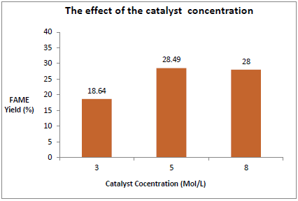
18.6
28.0
28.5
Figure 1. The effect of the catalyst concentration on the FAME yield (3 wt.%, 12:1 MeOH:oil, 65 ºC and 3 hours)

Optimization of reaction conditions
The optimum reaction condition of one step transesterification was obtained for further investigation. The experimental results illustrated in Figure 2 indicate the trend for catalyst loading to the biodiesel yield in relation with the reaction time. Firstly, the effect of catalyst loading was investigated prior to the FAME yield obtained. The addition of catalyst proved its significance in the biodiesel production. The highest biodiesel recorded was 28.5% utilizing 3 wt.% of CaO/Al₂O₃ with 3 hours reaction time. As for blank reaction, the FAME yield obtained was only 13.0% without addition of catalyst for the same reaction condition. The trend of yield produced was slightly declined as catalyst loading increased. The excess catalyst loading lowering the conversion of FFA to FAME as it reacts with triglyceride to produce soap and emulsion [12]. In addition, a high dosage of catalyst increased the viscosity of reaction mixture which will resist the mass transfer in the multiphase system (liquid-liquid-solid) [13]. During the experimental process, an emulsion was observed at 5 hours using 4 wt.% of catalyst during the separation process.

Figure 2. The effect of catalyst loading in relation with reaction time (12:1 MeOH:oil and 65 ºC)

Next, the effect of reaction time was also studied because it affect the trend of biodiesel yield produced. The reaction time of 3, 4 and 5 hours was tested employing 12:1 methanol to oil ratio, 3 wt.% catalyst loading at 65 ºC. From Figure 3 we can see the trend of biodiesel produced decreased as time increased. In longer reaction time, the methyl ester favors to undergo backward reaction producing more glycerol than methyl ester [14].

In addition, the presence of emulsion was observed at 5 hours reaction time and this also lowering the yield of FAME [15]. Furthermore, the optimum reaction time was interrelated with methanol ratio used. As reported by Ramadhas et al. [16], high molar ratio required shorter time because it has sufficient methanol to driven the reaction to completion with high yield. Hence, the reaction time of 3 hours was chosen for the optimum reaction time which offers high biodiesel yield.

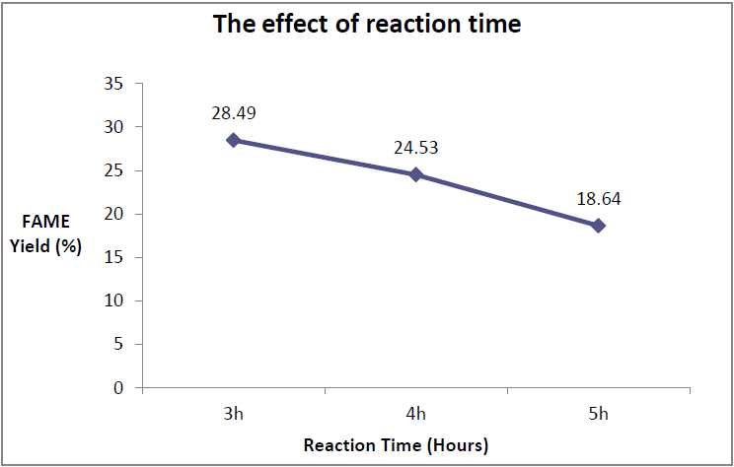
Figure 3. The effect of reaction time (3 wt.%, 12:1 MeOH:oil and 65 ºC)

Two step reaction
Due to lower biodiesel yield obtained in the one step reaction, the WCO was treated with sulphuric acid to reduce the level of FFA. The only manipulated variable in the acid-esterification was esterification time. Other parameters were taken from Muciño et al. [13] in which, 12:1 methanol to oil ratio, 0.35 wt.% of H₂SO₄ at 50 ºC were employed. As for the transesterification reaction, the optimum condition obtained from the earlier investigation was employed (3 wt.% of CaO/Al₂O₃, 12:1 methanol to oil ratio, 65 ºC and 3 hours reaction time). The results of esterified oil and its corresponding FAME were illustrated in the Figure 4.

The conversion of FFA to FAME was increased from 75.29% at 0.5 h to 77.65 at 1 hour. After 2 hours, the trend was declined to 74.67%. The same result was obtained by Ullah et al. [17] where after 2 hours reaction, the yield of FFA conversion was declined. Therefore, 1 hour was chosen as the optimum reaction time of esterification reaction. Although, from the GC-MS analysis the WCO was completely converted to biodiesel, acid catalyst was not recommended to use as it gave drawbacks to the environment. Acid catalyst was corrosive and unable to recover thus will increase the cost of operation process.

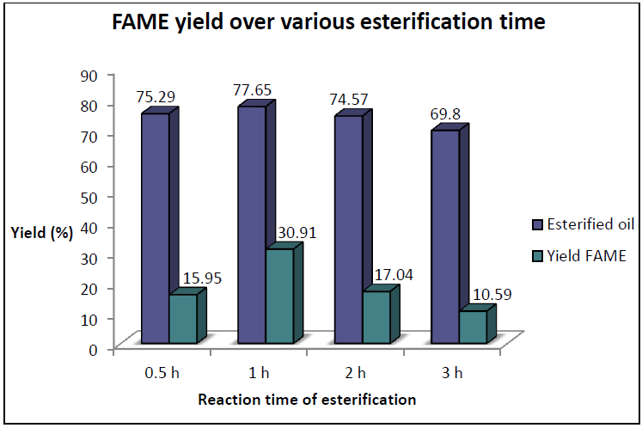
Figure 4. FAME yield over various esterification time (0.5, 1, 2 and 3 hours).

In this study, the effect of reaction time of transesterification to esterified oil was also investigated, the results was illustrated in Figure 5. The highest biodiesel yield from the reaction was 30.91% at 3 hours of reaction time. As compared to blank, transesterification utilized metal alkali catalyst offers higher yield, in which blank only offers 18.55%. Thus, CaO/Al₂O₃ was added in the production biodiesel from esterified oil.

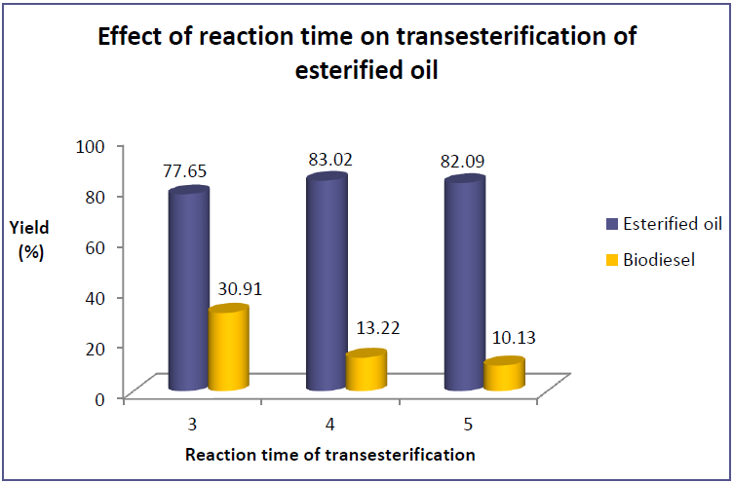
Figure 5. Effect of reaction time on transesterification of esterified oil

Confirmation of ester group using FTIR
FTIR is an instrument that can only give information of compound that has dipole moment and functional group. In this study, the information on the shifted of carbonyl group of carboxylic acid to ester was investigated. This information proved that the FFA was fully converted into FAME. However, the absorption peak of carbonyl group for feedstock and biodiesel showed no significant different. Figure 6 showed the overlay spectra of different type of oil which were WCO, esterified oil and the FAME of two step reaction.

The assignation peak for C=O observed for all oil samples was belong to the ester group. The peak region for C=O carboxylic acid as state in Pavia et al. [18] was in the region 1725 cm⁻¹ to 1700 cm⁻¹, which means the peak appeared for feedstock should shifted slightly to the right. This situation has been report by Rabelo et al. [19] in which the reason was because of the WCO and the biodiesel was chemically similar. Because of that, it is difficult to prove the FFA was completely converted into FAME by running FTIR analysis only. Thus, GC-MS was performed to support the result.

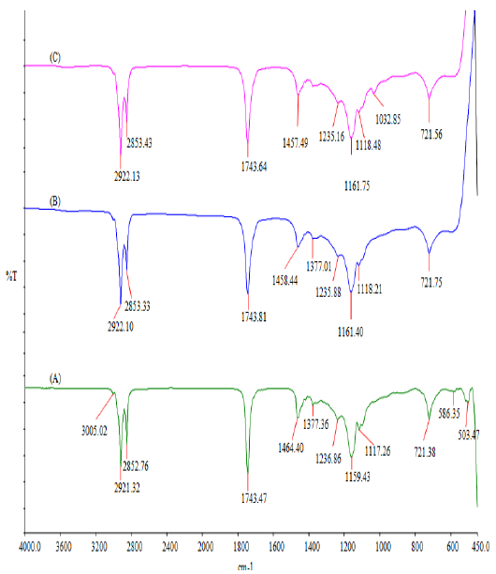
Figure 6. FTIR spectra of (a) WCO, (b) esterified oil and (c) FAME

Confirmation of FAME using GCMS
The chromatogram as in Figure 7 clearly showed the entire compound present in the biodiesel. There were nine major peaks observed and six peaks were corresponds to the ester group. The identified FAME were dodecanoic acid methyl ester, methyl tetradecanoate, hexadecanoic acid methyl ester, 9-octadecenoic acid methyl ester, 9,12-octadecadienoic acid methyl ester and 10-octadecenoic acid methyl ester. All peaks appeared were corresponds to different type of ester and were confirmed using MS-NIST program. The details of the composition were tabulated in the Table 1.

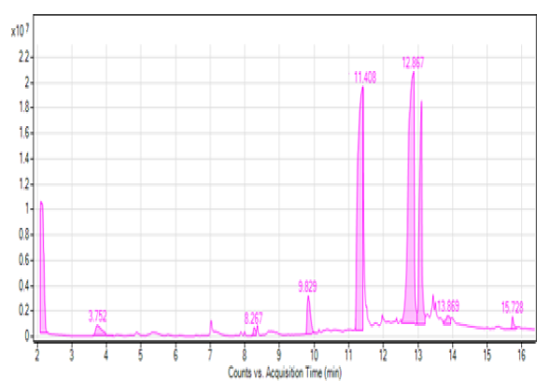
Figure 7. GC-MS chromatogram of FAME yield

Table 1. FAME composition in biodiesel
Retention Time  (min) | Identified Compound | Common Name | Chemical  Formula
8.267 | Dodecanoic acid methyl ester | Lauric acid ME | C₁₃H2₆O₂
9.829 | Methyl tetradecanoate | - | C₁₅H₃₀O₂
11.408 | Hexadecanoic acid methyl ester | Palmitic acid ME | C₁₇H₃₄O₂
12.867 | 9-octadecenoicacid(Z), methyl ester | Oleic acid ME | C₁₉H₃₆O₂
13.102 | 9,12-octadecadienoic acid (Z,Z), methyl ester | Linoleic acid ME | C₁₉H₃₄O₂
13.869 | 10-octadecenoic acid methyl ester | - | C₁₉H₃₆O₂

Conclusion
Two step reaction processes offers high FAME yield than one step process. The FAME yield for two step process was 30.91% with transesterification reaction condition of 3 hours of reaction time, 12:1 methanol to oil ratio, and temperature of 65 ºC with the best CaO/Al₂O₃ loading, 3 wt.%. Although the yield is low, the FFA content in the sample was verified had been converted into FAME using GCMS and FTIR. Even though, there are subtle differences observed in the FTIR spectra since the biodiesel is chemically similar to WCO, the GCMS gave positive results as few common groups of methyl esters were present.

Acknowledgement
We gratefully acknowledged the financial support by the Research Grant, iRAGS (Vote no.: 600RMI/IRAGS 5/3 (14/2015)) and UiTM Pahang for providing facilities in order to complete this work.

References
- Lan, J.C-W., Tsui, A., Wang, S. S. and Wu, H-S. (2009). A review of biodiesel as renewable energy. In Biochemical Engineering. Dumont, F. E. and Sacco. J.A. (eds.). Nova Science Publisher, Inc., New York: pp. 1-40.
- Srinivasan, S. P., Malliga, P. and Murugan, S. (2008). Supply chain network of jatropha oil for biodiesel. In Bio-Fuels: Marketing stratergies and impact on rural development. Mehla., S.K. (eds.). Aavishkar Publiser, Distributors., India: pp. 29-40.
- Sastry, G. R. (2008). Biodiesel: biodegradable alternative fuel for diesel engine. New Delhi: Readworthy Publications (P) Ltd, India.
- Wen, Z., Yu, X., Tu, S-T., Yan, J. and Dahlquist, E. (2010). Biodiesel production from waste cooking oil catalyzed by TiO₂-MgO mixed oxides. Bioresource Technology, 101(24): 9570-9576.
- Lam, M. K., and Lee, K. T. (2011). Production of biodiesel using palm oil. In Biofuels: Alternative feedstocks and conversion process. Elsevier Inc, USA: pp. 353-374.
- Agarwal, M., Chauhan, G., Chaurasia, S. and Singh, K. (2012). Study of catalytic behaviour of KOH as homogeneous and heterogeneous alkali catalyst for biodiesel production. Journal of the Taiwan Institute of Chemical Engineers, 43(1): 89-94.
- Shohaimi, N. A. M., Bakar, W. A. W. A. and Jaafar, J. (2014). Catalytic neutralization of acidic crude oil utilizing ammonia in ethylene glycol basic solution. Journal of Industrial and Engineering Chemistry, 20(4): 2086–2094.
- Farooq, M., Ramli, A. and Naeem, A. (2015). Biodiesel production from low FFA waste cooking oil using heterogeneous catalyst derived from chicken bones. Renewable Energy, 76: 362–368.
- Mahesh, S. E., Ramanathan, A., Begum, K.M.M.S. and Narayanan, A. (2015). Biodiesel production from waste cooking oil using KBr impregnated CaO as catalyst. Energy Conversion and Management, 91: 442–450.
- Chongkhong, S. Ã., Tongurai, C., Chetpattananondh, P. and Bunyakan, C. (2007). Biodiesel production by esterification of palm fatty acid distillate. Biomass and Bioenergy, 31: 563–568.
- Liu, X., He, H., Wang, Y., Zhu, S. and Piao, X. (2008). Transesterification of soybean oil to biodiesel using CaO as a solid base catalyst, 87: 216-221.
- Sirisomboonchai, S., Abuduwayiti, M., Guan, G., Samart, C., Abliz, S., Hao, X. and Abudula, A. (2015). Biodiesel production from waste cooking oil using calcined scallop shell as catalyst. Energy Conversion and Management, 95: 242–247.
- Muciño, G. G., Romero, R., Ramírez, A., Luz Martínez, S., Baeza-Jiménez, R. and Natividad, R. (2014). Biodiesel production from used cooking oil and sea sand as heterogeneous catalyst. Fuel, 138: 143–148.
- Leung, D. Y. C., Wu, X. and Leung, M. K. H. (2010). A review on biodiesel production using catalyzed transesterification. Applied Energy, 87(4): 1083-1095.
- Lee, S. L., Wong, Y. C., Tan, Y. P. and Yew, S. Y. (2015). Transesterification of palm oil to biodiesel by using waste obtuse horn shell-derived CaO catalyst. Energy Conversion and Management, 93: 282–288.
- Ramadhas, A. S., Jayaraj, S and Muraleedharan, C. (2004). Biodiesel production from high FFA rubber seed oil. Fuel, 84: 335-340.
- Ullah, Z., Bustam, M. A. and Man, Z. (2015). Biodiesel production from waste cooking oil by acidic ionic liquid as a catalyst. Renewable Energy, 77: 521-526.
- Pavia, D. L., Lampman, G. M., Kriz, G. S. and Vyvyan, J. R. (2015). Introduction to spectroscopy (5th ed). Cengage Learning,Washington, USA.
- Rabelo, S. N., Ferraz, V. P., Oliveira, L. S. and Franca, A. S. (2015). FTIR analysis for quantification of fatty acid methyl esters in biodiesel produced by microwave-assisted transesterification. International Journal of Environmental Science and Development, 6(12): 964–969.

