

MALAYSIAN JOURNAL OF ANALYTICAL SCIENCES
ISSN 1394 - 2506

Published by The Malaysian Analytical Sciences Society

BIOLOGICAL REMOVAL OF AMMONIA BY NATURALLY GROWN BACTERIA IN SAND BIOFILTER

(Penyingkiran Ammonia Secara Biologi Menggunakan Bakteria Semulajadi dalam Biopenuras Pasir)

Fuzieah Subari^{1, 2}*, Siti Rozaimah Sheikh Abdullah¹, Hassimi Abu Hasan¹, Norliza Abd. Rahman¹

¹Department of Chemical and Process Engineering, Faculty of Engineering and Built Environment

Universiti Kebangsaan Malaysia, 43600 UKM Bangi, Selangor, Malaysia

²Faculty of Chemical Engineering,

Universiti Teknologi MARA, 40450 Shah Alam, Selangor, Malaysia

*Corresponding author: fuzieahs@gmail.com

Received: 15 February 2017; Accepted: 2 January 2018

Abstract

Drinking water treatment through biological process is commonly applied in developed countries, but not yet in developing countries such as Malaysia. The non-existence of biological treatment has urged drinking water treatment plant operator in Malaysia to shut down the plants whenever there are ammonia contaminations. This is to avoid the formation of disinfection byproducts (DBPs), which are toxic and carcinogenic, when ammonia reacts with chlorine as the disinfectant. The study aims to develop a biological drinking water treatment for to remove ammonia in a biological sand filter column. The derived biofilm, a mixed bacterial consortium is naturally cultured from surface lake water, hence eliminating the potential of pathogenic microorganism occurrence, which is not suitable for drinking water application. The biofilm was inoculated in the batch down flow column consisting of heterogeneous fine sand with diameter of 1.2 mm (top layer) and 6.7 mm (bottom layer). The study was conducted by varying the flowrate (0.09, 0.13, and 0.18 m³/h) and hydraulic retention time (HRT) (5 and 24 hours). The water sample was taken at different depths of 0.05 m (SP4), 0.1 m (SP3) and 0.2 m (SP2) from the column base for the ammonia analysis. Significant reduction of ammonia with 96-98% was observed at 0.09 m³/h and 24 hours and the final treated effluent had complied with the stringent regulation stipulated by the Malaysia, Ministry of Health that is lower than 1.5 mg/L.

Keywords: ammonium removal, biological treatment, drinking water treatment plant, sand biofilter

Abstrak

Rawatan air minuman menggunakan proses biologi telah lama digunakan di negara maju tetapi belum lagi di negara membangun seperti Malaysia. Ketiadaan teknologi rawatan air secara biologi ini telah memaksa operator di loji rawatan air minuman menutup loji rawatan air minuman setiap kali berlakunya pencemaran ammonia. Ianya dilakukan untuk mengelakkan pembentukan hasil sampingan disinfektan (DBP) yang toksik dan karsinogen apabila ammonia bertindak dengan klorin yang digunakan sebagai disinfektan. Objektif kajian ini dijalankan adalah untuk membangunkan satu rawatan air secara biologi untuk menyingkir ammonia dalam biopenuras pasir. Biofilem yang digunakan, merupakan konsortium bakteria campuran, di inokulasi secara semula jadi daripada air tasik untuk mengurangkan kebarangkalian kehadiran bakteria patogen memandangkan aplikasi sistem ini dibangunkan untuk rawatan air minuman. Biofilem di inolukasi dalam kelompok turus dengan aliran ke bawah yang menempatkan pasir bersaiz berbeza dengan garis pusat 1.2mm (lapisan atas) dan 6.7mm (lapisan bawah). Kajian dilakukan dengan mengubah kadar aliran (0.09, 0.13 dan 0.18 m³/jam) dan masa penahanan hidraulik (HRT) (5 dan 24 jam). Sampel air di ambil pada ketinggian berbeza iaitu 0.05 m (SP4), 0.1 m (SP3) dan 0.2 m (SP2) dari tapak turus untuk analisis kandungan ammonia. Pengurangan ammonia sebanyak 96-98% di 0.09 m³/jam and 24 jam dengan air terawat telah mematuhi had kawalan yang telah ditetapkan oleh kemeterian kesihatan Malaysia iaitu dibawah 1.5 mg/L.

Kata kunci: penyingkiran ammonia, rawatan biologi, loji rawatan air minuman, biopenuras pasir

Introduction
Depletion in water quality should not be taken lightly especially when it deals with survival needs of human life for drinking water. In Malaysia, sources of drinking water mainly collected from surface water while remaining 1% from groundwater [1]. Surface and groundwater naturally consist of ammonia and manganese but in very low level. However, the level may increase due to human activities such as agricultural activity and rapid development nearby the water intake [2]. Rapid development with improper planning may cause surface water polluted with heavy metal, dissolved organic carbon, dissolved organic nitrogen and many other harmful that consequently give adverse impact to human health.

In drinking water treatment plant (DWTP), ammonia needs to be removed before water being disinfected with the chlorine. Ammonia naturally may reacts with chlorine to produce chloramines, which is known to be carcinogenic [3]. The presence of ammonia in water system leads to oxygen depletion, eutrophication of surface water and toxicity for fish. A study showed that occasionally high level of ammonia was found at the water intake than of regulated one which 1.5 mg/L for ammonia in treated water [4]. As a result treatment plant need to be shut off until ammonia level reduced to its allowable limit. Water disruption not only cause interruption to the household, business premises and factories activities but it is also a signal to improvise current treatment method to prevent such cases repeated.

Removal of ammonia can be achieved via physico-chemical treatment and biological treatment. Chlorination, ion exchange and membrane filtration known as common physiochemical treatment method apply in DWTP [5-7]. However biological approach has gain much attention nowadays and consider as a future technology for drinking water production. This is due to rapid filtration rates, low operation and maintenance cost, single stage filtration and no chemical required [8]. In biological treatment, ammonia will undergo oxidation process to form nitrite by the ammonia oxidizing bacteria (AOB) or ammonia oxidizing archae (AOA) and further oxidized to nitrate by nitrite oxidizing bacteria (NOB). Most of the microorganisms detected are Nitrosomonas and Nitrobacter type of bacteria [9-11]. Sand filter column can be operated at different hydraulic loading rates, which then differentiate the operation of slow sand filter (SSF) and rapid sand filter column (RSF). Normally RSF was used in drinking water treatment plant rather than SSF mainly to produce large volume of treated water with high capacity of flowrate that is 5-30 m³/h. Unfortunately, least biological impacts was observed on treated water flowing through RSF [12]. Furthermore, hydrodynamic conditions such as flow rate, velocity and residence time significantly affect the stability of biofilm developed which majority of the microorganism involve in ammonia degradation attached to subsequently made the RSF not suitable for biological treatment [13]. Hence, SSF with flowrate slower than RSF will be used in this study to determine the removal of ammonia at different flowrate using naturally grown bacteria in slow sand filter column and finally microbial community will be microscopically observed under scanning electron microscope.

Materials and Methods
Lake water from Universiti Kebangsaan Malaysia (UKM), Malaysia was used throughout the study. The collection point of the lake water was surface water at the downstream of the lake where it is situated 300 m away from the laboratory. A 5 L plastic bottle was placed on the surface of flowing water to collect the water sample and brought to the laboratory for immediate analyses. The physiochemical properties of water such as turbidity, total suspended solid, color, COD, phosphate, nitrate, and ammonium nitrogen were measured using spectrophotometric measurement. Standard analytical method of the water properties is presented in Table 1. The biofilm was observed using E100 LED Trinocular microscope (Nikon, Japan) and the morphology of the bacteria colony was observed using the High-resolution Field Emission Scanning Microscope Electron (FESEM) (Merlin Compact, USA). Sand was taken at different heights (top surface water, 10cm and 5cm above the biofilter base) to represent the biofilm development in accordance to height.

Table 1. Standard analytical method for water characterization
Parameter | Equipment /Wavelength | Method
Turbidity | HACH 2100 AN Turbiditimeter | DOC022.52.80205
Suspended Solid | HACH DR 3900 (USA), 630 nm | Method 8006
Phosphate | HACH DR 3900 (USA), 490 nm | Method 8048
COD | DRB 200 reactor,  HACH DR 3900 (USA), 430 nm | Method 8000 (HACH, 1999)
NH₄⁺-N | HACH DR 3900 (USA), 425 nm | Method 8038 (HACH 1999)
NO₃⁻-N | HACH DR 3900 (USA), 355 nm | Method 8039 (HACH 1999).

Set-up of sand biofilter
The experimental set up of the sand biofilter is illustrated in Figure 1. Column is made of PVC with a diameter of 0.25 m and 0.3 m in height. Two sizes of grain sand were used such that the grain sand has an average diameter of 1.2 mm stacked at the upper layer of the column while the sand filled at the bottom layer has an average particle diameter of 6.7 mm. The sand was initially rinsed with tap water and oven dried to remove fine particulate matter prior to load in the filter. Bacteria used in this study were naturally grown from the surface lake water to minimize the occurrence of pathogenic bacteria. Future investigation will be conducted to determine pathogenic characteristic of the grown bacteria. The biofilm was inoculated for about 3 months prior to the experiment. During innoculation period, no additional nutrients were added to the system except continuously aerated at a rate of 0.36 m³/hr via an air pump to ensure sufficient oxygen supplied for bacteria growth. Column temperature measured in between 28±1 °C. The sand biofilter operated batchwise in downward flow. In this study, the filtration rate was varied at 0.18 (Run 1), 0.13 (Run 2) and 0.09 (Run 3) m³/h. Hydraulic retention time (HRT) was set up at 5hr and 24 hr to monitor the reduction of ammonia and manganese level. Sampling point was taken at three different sampling ports that are 0.05 m (SP4), 0.1 m (SP3) and 0.2 m (SP2) from the column base.

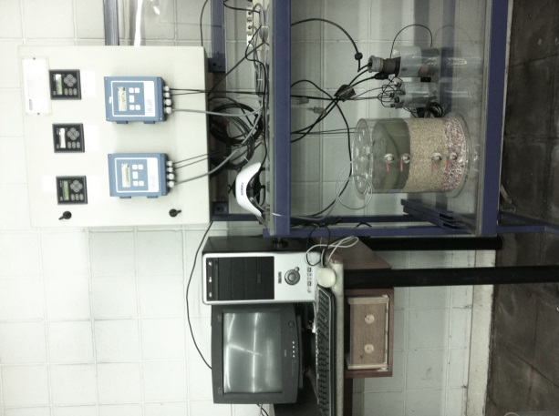

Sand
(1.2 mm)
Sand gravel
(6.7 mm)
Raw water

Air Pump
SP 4
5 cm
SP 3
SP 2
5 cm
10 cm
Figure 1. Schematic diagram of biological slow sand filter

Results and Discussion
Characterization of lake water
Lake water quality was monitored throughout the study both physically and chemically. Physiochemical properties of the surface lake water during the study are depicted in Table 2.

Table 2. Characterization of surface water
Parameter | Standard Ministry of Health | Run 1 (12/4/16) | Run 2 (19/4/16) | Run 3 (26/4/16)
Turbidity (NTU) | 100 | 39.2 ± 0.2 | 42.4 ± 1.1 | 26.6 ± 0.3
Suspended solid (mg/L) | - | 53.3 ± 0.7 | 42.0 ± 1 | 22.3 ± 1
pH | 5.5-9.0 | 7.1 ± 0.04 | 7.9 ± 0.25 | 7.6 ± 0.01
Color (Pt co) | 300 | 408.7 ± 1.3 | 337.0 ± 2 | 269.7 ± 1
Ammonia Nitrogen (mg/L) | 1.5 | 4.7 ± 0.02 | 6.3± 0.0 | 3.5± 0.01
Chemical Oxygen Demand (COD) (mg/L) | 10 | 27.3 ± 0.7 | 48.7 ± 1 | 17.0 ± 0.0
Phosphate (mg/L) | - | 0.18 ± 0.01 | 0.65 ± 0.15 | 0.97 ± 0.01
Nitrate (mg/L) | 10 | 0.17 ± 0.1 | 0.20 ± 0.00 | 0.70 ± 0.0

Water quality parameters of ammonia, color and Chemical Oxygen Demand (COD) exceeded the allowable limit set by the Ministry of Health (MOH), Malaysia [14] for surface lake water. The maximum color level and COD was observed during Run 1 while the ammonia reached its maximum value by 6.3 mg/L during Run 2. High level of ammonia during Run 2 can cause eutrophication process to the sampling area, supported by higher COD content than usual sampling. In overall, other measured properties show normal trend and within stipulated standard.

Analysis of biofilm morphology
Sand particles were sampled from biofilter at different height to monitor biofilm development in according to the column height. Figure 2(a) shown the sand morphology before innoculation while Figure 2(b) shown biofilm attached on the media after 3 month innoculation period. Microbial biomass increased generally with time and decreased with depth and most biomass development occurred in the upper layer of the filter [15]. Figure 2(c) shows the sand before inoculation while Figure 2(d) to (f) showed sands after three months of inoculation stage at different depth in the sand biofilter. The presence of microorganism was observed attached on the fine sand located at the top surface (Figure 2(d)) of the sand biofilter and none was observed on the sand located at the bottom of biofilter (10cm from the surface).

  (a) | 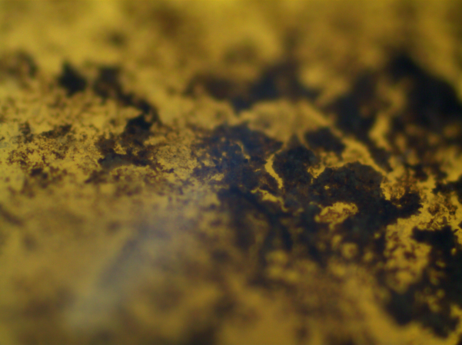  (b)
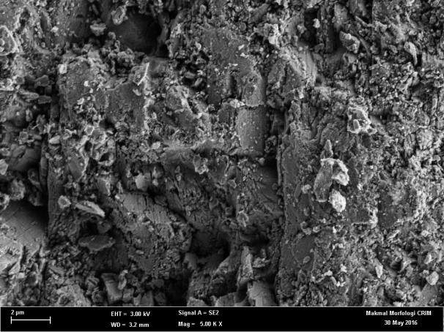  (c) | 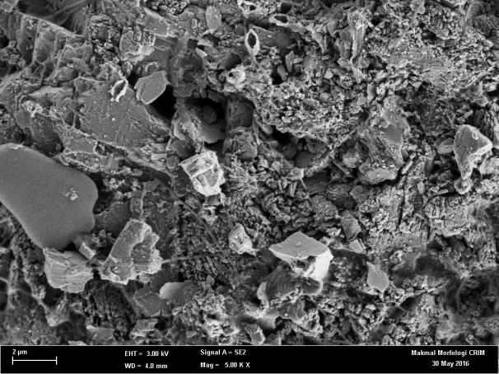  (d)
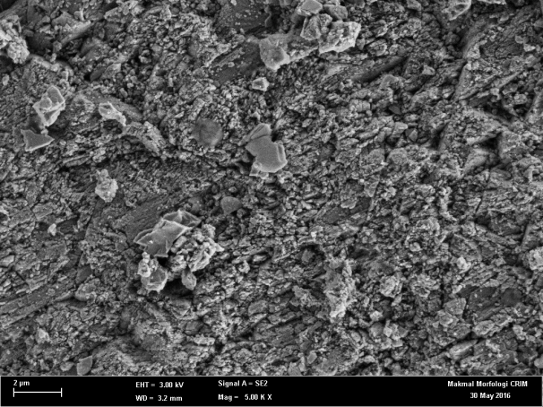  (e) | 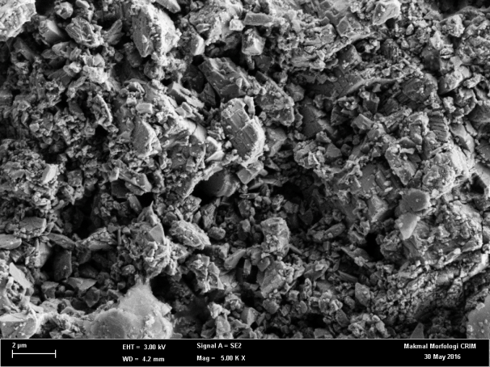  (f)
Figure 2. Sand morphology (a) Sand before innoculation (b) biofilm attached on the media after innoculation using Trinocular microscope under 4X magnification (c) Control (d) Biofilter surface (e) 5cm under biofilter surface (f) 10cm under biofilter surface under 5000X magnification using FESEM

Removal efficiency of ammonia in biofilter
Ammonia removal observed at all conditions in all runs shows the presence of AOB in the sand biofilter. Figure 3 depicts the surface water profile at different HRT, sampling point and filtration rate. Initial concentration of ammonium was varied at 3.5 to 6.3 mg/L. Generally, the ammonia removal trend shows an increment as the flowrate reduces. Hydrodynamic conditions such as flowrate and velocity have an adverse impact on the biofilm stability. Higher flowrate could interrupt microorganism colonies (AOB) responsible to reduce ammonia directly and hence decreasing the removal efficiency at higher flow rate [12, 13]. The ammonium concentration both at 5 and 24 HRT at 0.19 and 0.13 m³/h as shown in Figure 3(a) and (b) respectively, was still unsatisfactorily removed with the values are still above the water quality standard. On the other hand, the removal rate of ammonium reached 98 and 97% respectively at sampling point 2 after 24 hr HRT at a slower flowrate of 0.09 m³/h (Figure 3(c)).

At 5 hr HRT only 58% reduction was observed at the same flowrate and the concentration of ammonium still above the drinking water standard of 1 mg/L. Samples were taken at different height in the sand biofilter with ammonium concentration at all runs was observed reduced remarkably at sampling point 4 which is located at 5cm from the column base. Even though the microorganism colonies were observed available only on the sand located at the top column, it may have entrapped between void spaces of the sand at the bottom layer. Under the influence of liquid flow velocity and at its maturation time, biofilm may have been detached from the media to recolonization to the other places [16].

(c)  (a) | (b)
Figure 3. Concentration and percent reduction of ammonia nitrogen at vary flowrate (a) 0.18 m³/h (b) 0.13 m³/h (c) 0.09 m³/h

Conclusion
Natural biofilm, a mixed bacterial consortium, cultured from a surface water lake in UKM had shown great potential in ammonia removal through biological pathway. The high removal of more than 90% removal efficiency was achieved after 24 hr HRT. It is flexible and very cost effective to be adapted in any conventional water treatment plant system since it is naturally grown from the water source eliminating any concern of the presence of pathogenic microorganism coming from biomass derived from wastewater treatment plant to be applied in drinking water treatment plant. The presence of the microbial colony and biofilm matrix were clearly captured under scanning electron microscope under 5000x magnification. Identification of microbial colony responsible for ammonia removal using molecular technique will be conducted for future study.

Acknowledgement
The authors would like to acknowledge Universiti Kebangsaan Malaysia (UKM) for providing research grants of DIP-2016-030 and AP-2015-013 to accomplish this study. The first author would also like to acknowledge the Ministry of Higher Education (MOHE) Malaysia and Universiti Teknologi MARA (UiTM) for granting the PhD scholarship.

References
- Ab Razak, N. H., Praveena, S. M., Aris, A. Z. and Hashim, Z. (2015). Drinking water studies: A review on heavy metal, application of biomarker and health risk assessment (a special focus in Malaysia). Journal of Epidemiology and Global Health, 5(4): 297-310.
- Aslan, S. and Cakici, H. (2007). Biological denitrification of drinking water in a slow sand filter. Journal of Hazardous Materials, 148(1–2): 253–258.
- Sadiq, R. and Rodriguez, M. (2004). Disinfection by-products (DBPs) in drinking water and predictive models for their occurrence: a review. Science of The Total Environment, 321(1–3): 21–46.
- Abu Hasan, H., Sheikh Abdullah, S. R., Kamarudin, S. K. and Tan Kofli, N. (2011). Ammonia and manganese problems in Malaysian drinking water treatment. World Applied Sciences Journal, 12: 1890–1896.
- Ersahin, M. E., Ozgun, H., Dereli, R. K., Ozturk, I., Roest, K. and van Lier, J. B. (2012). A review on dynamic membrane filtration: Materials, applications and future perspectives. Bioresource Technology, 122: 196–206.
- Kulkarni, P. and Chellam, S. (2010). Disinfection by-product formation following chlorination of drinking water: Artificial neural network models and changes in speciation with treatment. Science of The Total Environment, 408(19): 4202–4210.
- Primo, O., Rivero, M. J., Urtiaga, A. M. and Ortiz, I. (2009). Nitrate removal from electro-oxidized landfill leachate by ion exchange. Journal of Hazardous Materials, 164(1), 389–393.
- Sahabi, D. M., Takeda, M., Suzuki, I. and Koizumi, J. (2009). Removal of Mn²⁺ from water by “aged” biofilter media: The role of catalytic oxides layers. Journal of Bioscience and Bioengineering, 107(2): 151–157.
- Jun, Y. and Wenfeng, X. (2009). Ammonia biofiltration and community analysis of ammonia-oxidizing bacteria in biofilters. Bioresource Technology, 100(17): 3869–3876.
- Leyva-Díaz, J. C., González-Martínez., A., González-López, J., Muñío, M. M. and Poyatos, J. M. (2015). Kinetic modeling and microbiological study of two-step nitrification in a membrane bioreactor and hybrid moving bed biofilm reactor-membrane bioreactor for wastewater treatment. Chemical Engineering Journal, 259: 692–702.
- Nicolaisen, M. H. and Ramsing, N. B. (2002). Denaturing gradient gel electrophoresis (DGGE) approaches to study the diversity of ammonia-oxidizing bacteria. Journal Microbiol Methods, 50(2): 189–203.
- Bar-Zeev, E., Belkin, N., Liberman, B., Berman, T. and Berman-Frank, I. (2012). Rapid sand filtration pretreatment for SWRO: Microbial maturation dynamics and filtration efficiency of organic matter. Desalination, 286: 120–130.
- Gomes, I. B., Simões, M. and Simões, L. C. (2014). An overview on the reactors to study drinking water biofilms. Water Research, 62: 63–87.
- Ministry of Health (2012). Drinking water quality standard. http://kmam.moh.gov.my/public-user/drinking-water-quality-standard.html [Access online 1 December 2015].
- Campos, L. C., Su, M. F. J., Graham, N. J. D. and Smith, S. R. (2002). Biomass development in slow sand filters. Water Research, 36(18): 4543–4551.
- Codony, F., Morató, J. and Mas, J. (2005). Role of discontinuous chlorination on microbial production by drinking water biofilms. Water Research, 39(9): 1896–1906.

