

MALAYSIAN JOURNAL OF ANALYTICAL SCIENCES
ISSN 1394 - 2506

Published by The Malaysian Analytical Sciences Society

PREPARATION OF EPOXIDIZED NATURAL RUBBER/ POLY(VINYLIDINE FLUORIDE) MEMBRANE BY USING SOLUTION CASTING METHOD FOR PALM OIL MILL EFFLUENT TREATMENT

(Penyediaan Membran Getah Asli Terepoksida/Poli(Vinilidina Fluorida) Dengan Menggunakan Kaedah Pengacuanan Larutan Untuk Rawatan Efluen Kilang Minyak Sawit)

Norliyana Mod, Farah Hannan Anuar, Rizafizah Othaman*

School of Chemical Sciences and Food Technology,
Faculty of Science and Technology,
Universiti Kebangsaan Malaysia, 43600 UKM Bangi, Selangor, Malaysia

*Corresponding author: rizafizah@ukm.edu.my

Received: 12 April 2017; Accepted: 4 September 2017

Abstract
Poly(vinylidine fluoride) (PVDF) membrane is generally a chosen membrane for palm oil mill effluent (POME) treatment. The focus is to make freestanding and robust PVDF based composite membranes with different ratio of epoxidized natural rubber (ENR) (ENR/PVDF: 0/100 wt%, 20/80 wt%, 40/60 wt%, 60/40 wt%, 80/20 wt%, 100/0 wt%) by solution casting method. Subsequently, these membranes were characterized using fourier transform infrared (FTIR), differential scanning electron (DSC) and vapor pressure scanning electron microscope (VPSEM). The FTIR spectrums showed that ENR blended well with PVDF and the peak intensity followed the composition of the membranes. Meanwhile, the ENR and PVDF mixtures were miscible due to the formation of single peak glass transition temperature (T_{g}) as observed in DSC thermogram. Shifting in peaks of T_{g} suggested important interaction taking place between polymers. Surface morphology by SEM displayed the formation of random pores caused by the nature of PVDF polymer and phase inversion process. High composition of ENR caused a dense membrane and vice-versa while phase inversion contributed to the pores existences. The fluxes during POME treatment were lower than water fluxes. Higher flux was a sign of higher rejection which is efficient for separation of water and effluents. Thus, ENR/PVDF 40/60 wt% and 20/80 wt% has been selected as promising membranes to be applied for POME treatment.

Keywords: membrane, epoxidised natural rubber, poly(vinylidine fluoride)

Abstrak
Membrane poli(vinilidina fluorida) (PVDF) umumnya adalah membran terpilih untuk rawatan efluen kilang minyak sawit (POME). Tumpuan adalah untuk membuat membran komposit berasaskan yang fleksibel dan PVDF teguh dengan nisbah yang berbeza getah asli terepoksida (ENR) (ENR/PVDF: 0/100 wt%, 20/80 wt%, 40/60 wt%, 60/40 wt%, 80/20 wt%, 100/0 wt%) dengan kaedah pemutus penyelesaian. Selepas itu, membran ini dicirikan menggunakan inframerah transformasi Fourier (FTIR), perbezaan imbasan elektron (DSC) dan tekanan wap imbasan mikroskop elektron (VPSEM). Spektrum FTIR menunjukkan bahawa ENR dicampur dengan baik dengan PVDF dan intensiti puncak di ikuti komposisi membran. Sementara itu, ENR dan PVDF campuran adalah terlarut campur disebabkan oleh pembentukan puncak tunggal suhu peralihan kaca (Tg) sebagaimana yang berlaku di DSC termogram. Peralihan di puncak Tg mencadangkan interaksi penting yang berlaku di antara polimer. Permukaan morfologi oleh SEM dipaparkan pembentukan liang rawak disebabkan oleh sifat polimer PVDF dan proses penyongsangan fasa. Komposisi tinggi ENR menyebabkan membran padat dan sebaliknya manakala fasa penyongsangan menyumbang kepada liang kewujudan. Fluks semasa rawatan POME adalah lebih rendah daripada fluks air. Fluks tinggi adalah tanda penolakan yang lebih tinggi yang cekap untuk pemisahan air dan efluen. Oleh itu, ENR/PVDF 40/60 wt% dan 20/80 wt% berat telah dipilih sebagai membran yang menyakinkan untuk digunakan bagi rawatan POME.

Kata kunci: membran, getah asli terepoksida, poli(vinilidina fluorida)

Introduction
Polymer composite is a process where two or more polymers are combined together using various methods such as internal mixture and solution casting. This combination can improve the properties of individual polymer at the end of processing. For example, the combination between thermoplastic and rubber produces thermoplastic rubber (TPR) composite that exhibits the properties of elastomeric materials with possibility of thermoplastic at the ambient temperature [1]. Membrane is one of the examples that can be made through the process of composite. It can be used as a selective barrier for various separation in industries such as for wastewater [2] and gas separation [3]. Membrane is a layer that allows permeation and selection of certain components in the fluid and it also has a porous support layer to provide mechanical strength of the membrane [4]. Advantages of using membrane for fluid separation are minimum energy consumption, no addition of chemical is required and separation can be done continuously under controlled operation [5].

Epoxidised natural rubber (ENR) is a modified natural rubber (NR) by addition of epoxide group in the chains via performic epoxidation process [6]. In most industries such as automotive, ENR-50 contains of 50% epoxide group is used to react with other polar polymers. Thus, it will give more advantages for tensile strength, oil resistance, and fluid permeability [7]. Poly(vinylidine fluoride (PVDF) is a semi-crystalline polymer that contains crystalline and amorphous phases. Crystalline phase provides thermal stability, while amorphous phase has flexibility towards membranes. Phase of crystalline formed are named α (form II), β (form I), and γ (form III) [8]. Various ways can be used to control the crystallization, as such by using suitable temperature [9,10], solvent [4], and addition of additives [11]. PVDF is easy to dissolve in many solvents, has chemical resistivity and thermal stability. PVDF is very high in modulus that makes it brittle to apply as it is. However, PVDF is widely used in polymer industries as a membrane by combining with other polymers for example poly(methyl methacrylate) (PMMA) [12], poly(ethylene glycol) (PEG) [13], and poly(vinyl chloride) (PVC) [14]. PVDF has also been used for microfiltration (MF), ultrafiltration (UF), gas separation and pollutant removal from wastewater. ENR/PVDF composite had been reported by using internal mixture at high temperature [15]. According to the research, they had proven that the brittleness for PVDF decreased by increasing ratio of ENR in the blending. Elastic properties from ENR can help to decrease brittleness of PVDF.

Palm oil mill effluent (POME) is one of the effluents that contains high value of oil, chemical oxygen demand (COD), biological oxygen demand (BOD) and total suspended solid (TSS) which leads to water pollution [16]. As reported from Malaysian Palm Oil Board (MPOB), POME can be treated by ponding system, open tank digester and extended aeration system, and closed anaerobic system and land application system [17]. This system is less efficient to be used for now days because it takes large area for treatment, produce unpleasant smell, and it takes a long time to treat [17, 18]. So that, the membrane was introduced to replace this conventional system. The focus of this study is to prepare ENR/PVDF composite membrane with various compositions by using solution casting method and to characterize the composite membranes using Fourier transform infrared (FTIR), differential scanning calorimetry (DSC), vapor pressure scanning electron microscope (VPSEM). Lastly, to apply the membranes for palm oil mill effluent (POME) treatment.

Materials and Methods
Raw materials
ENR with 50% mol of epoxidation level (ENR-50) (M_{w} = 640 000 g/mol) was obtained from Rubber Research Institute of Malaysia (RRIM). PVDF (M_{w} = 543 000 g/mol) was purchased from Sigma-Aldrich (M) Sdn. Bhd in powder formed. Tetrahydrofuran (THF) was purchased from Systerm Sdn. Bhd with purity 99.8%. N,N-dimethylacetamide (DMAC) was purchased from Merck with purity 99%. Distilled water was used as a coagulation bath for exchanging between solvent and non-solvent.

Membrane preparation
ENR/PVDF was prepared in different compositions (0/100 wt%, 20/80 wt%, 40/60 wt%, 60/40 wt%, 80/20 wt%, 100/0 wt%). ENR was swelled in THF for 24 hours and subsequently stirred vigorously until homogeneous. At the same time, PVDF was stirred in DMAC solution in a separate container until homogeneous. Then, the PVDF solution was poured into ENR solution and continuously stirred. Once the membrane solution was homogeneous, the solution was degassed to eliminate the bubbles. Next, the solution was cast onto a glass plate with thickness of 0.15 mm using a casting knife. The solvent evaporated into the air for 2 minutes before the sample was transferred to the coagulation bath. When the white solid membrane was formed, the sample was removed from coagulation bath and dried at ambient temperature. The average thickness of membrane after dried was about 0.05 mm.

Membrane characterization
Chemical characterization of ENR/PVDF membrane was performed by using Fourier transform infrared (FTIR). FTIR spectra were recorded by using Perkin Elmer (GX FTIR System) in wavelength between 4000 cm⁻¹ to 400 cm⁻¹. FTIR characterization was conducted to analyze functional group that present in the membrane. The absorption band in the spectrum resulted from the change in energy caused by vibration of the molecules either stretching or bending.

Differential scanning calorimeter (DSC) is a thermal study that was used to characterize homogeneity of the sample via glass transition temperature (T_{g}). The DSC analyzer used was Mettler Toledo using STARe software. Samples were weighted between 6 – 9 mg with rate of heating 20 °C/min. Temperature used for cooling and heating was in the range of – 70 °C to 200 °C and the carrier gas was nitrogen gas.

Morphology of the membrane was studied by using variable pressure scanning electron microscope (VPSEM) with energy dispersion X-ray (EDX). The VPSEM model was ZEISS EVO MA 10 (UK) with EDAX APOLLO X (USA). The sample used for analyzing cross section was prepared by breaking the membrane after immersing in liquid nitrogen. Then, all the samples were sputter coated with gold before testing. Magnification for membrane surface sample is 5000x, while for cross section is 1000x.

Permeation test was done to study the flux of the membrane by using dead end stirred cell model HP4750. Membrane was cut into size of 49 mm in diameter and then tested under nitrogen gas at pressure of 0.5 bar at ambient temperature. POME sample from final discharge pond from Malaysian Palm Oil Board (MPOB) at Labu Negeri Sembilan was used in the experiment. Flux is calculated as given in equation 1 below [19]:

$\text{Fluxs=} \frac{\text{Q}}{\text{A}\text{∆}\text{T}}$ (1)

where Q (L) is the volume of permeate, A (m²) is the active surface area of the membrane, and ∆T (h) is the time taken for permeation.

Results and Discussion
Functional group analysis
Figure 1 shows the FTIR spectrum for different ratio of ENR/PVDF membrane (0/100 wt%, 20/80 wt%, 40/60 wt%, 60/40 wt%, 80/20 wt%, 100/0 wt%). Peaks for pure ENR (100/0 wt%) are 3498 cm⁻¹, 3022 cm⁻¹, 2960 cm⁻¹, 1664 cm⁻¹, 1452 cm⁻¹, 1379 cm⁻¹, 1252 cm⁻¹ and 876 cm⁻¹. Meanwhile, peaks for pure PVDF (0/100 wt%) are 2960 cm⁻¹, 1452 cm⁻¹, 1182 cm⁻¹, 1066 cm⁻¹, 876 cm⁻¹ and 761 cm⁻¹, respectively.

It can be seen that there are significant changes of peaks between IR spectrums of all ratios for ENR/PVDF membrane. Peak at 3498 cm⁻¹ wavelength is the stretching of OH group in the ENR. Presenting of this peak due to the ENR characteristic which tend to absorb water from surrounding [20]. Peak for ~3022 cm⁻¹ was referred to =CH stretching from ENR and PVDF. This peak can be referred to the olefinic unsaturation for the pure ENR and other peaks also can be seen at 1664 cm⁻¹, while for PVDF due to the end chain of PVDF polymer. Stretching of C–H at peak 2960 cm⁻¹ and bending of C–H at 1452 cm⁻¹ shows for ENR and PVDF. However, the intensity for PVDF is lower because of crystallization of PVDF [21]. Intensity peak at 876 cm⁻¹ present also due to the PVDF crystal [22]. Peaks at 1252 cm⁻¹ and 876 cm⁻¹ were obtained due to C-O stretching from epoxy group in ENR. Peaks at 1182 cm⁻¹ and 1066 cm⁻¹ are two strong peaks referred to polyfluoroalkane group in PVDF. All the described peaks were proportional with the amount of ratio ENR and PVDF in the composite membranes.
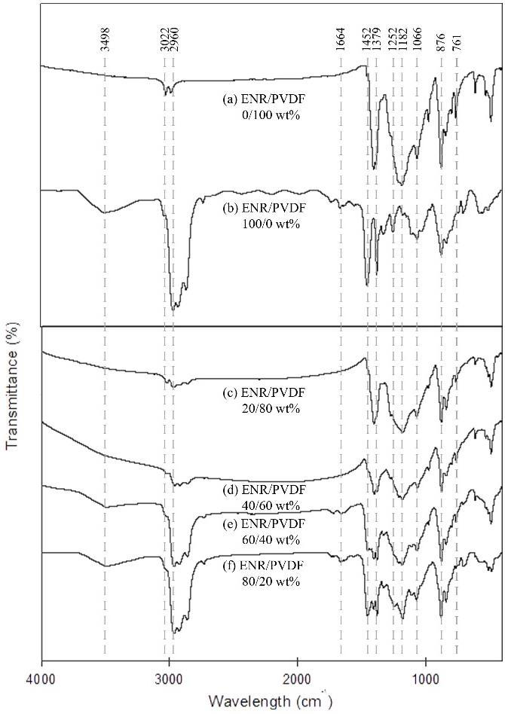

Figure 1. FTIR for ENR/PVDF membrane at different ratio of ENR/PVDF: a) 0/100 wt%, b) 100/0 wt%, c) 20/80 wt%, d) 40/60 wt%, e) 60/40 wt%, f) 80/20 wt%

Thermal properties
DSC is an analysis to study the homogeneity of the composite in terms of thermal stability. Single peak of T_{g} is an indicator for the miscibility of composite [23]. Figure 2 shows the DSC thermograms for ENR/PVDF membrane at different ratio and it can be seen that for all ratios, T_{g} appeared as a single peak. Besides, shifting in peaks occurred when ratio of ENR increased due to the existence of interfacial adhesion between ENR and PVDF [1]. The T_{g} of each sample was tabulated in Table 1. T_{g} for pure PVDF membrane was the lowest because of the semi crystalline property of PVDF. Meanwhile, for pure ENR is -19.67 ˚C due to amorphous structure from ENR tends to absorb heat that has been supplied to become soft. Tg for all the composites were higher than the pure polymer. It implies that there was interaction between ENR and PVDF, which has resulted in a shifted and single peak to deduce the T_{g} value.

(a)  (b)  (d)  (e)  (c)  (f) | 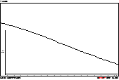
 | 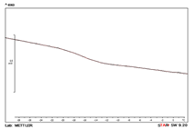

Figure 2. DSC thermograms for ENR/PVDF membranes at ratio (a) 0/100 wt% (b) 20/80 wt% (c) 40/60 wt% (d) 60/40 wt% (e) 80/20 wt% (f) 100/0 wt%

Table 1. Glass transition (T_{g}) for ENR/PVDF membrane

ENR/PVDF (wt%) | T_{g} (ºC)
0/100 | -32.19
20/80 | -16.19
40/60 | -15.64
60/40 | -14.03
80/20 | -15.12
100/0 | -19.67

Surface morphology
SEM micrograph for ENR/PVDF membranes with different ratio were shown in Figure 3. PVDF in nature is a porous membrane (Fig. 3(a)) and ENR is a nonporous membrane (Figure 3(b)). The combination of these two polymers had produced composite membranes with random pores as can be seen from the micrographs. However as the amount of ENR increased, the pure became bigger. This might due to the phase inversion, which is the exchange between solvents and non-solvents that induced pores [13]. Thus, choice of solvent for the membrane will affect the formation of pore [24]. ENR predominant the membrane and caused no pore on the surface as can see for ENR/PVDF membrane at ratio 80/20 wt% (Figure 3(f)). In Figure 3(e) for ENR/PVDF membrane 60/40wt%, where ENR was 60%, there was a layer of dense structure sandwiched between the porous layer (as shown in cross section), showing that the non-solvents did not reach some of the middle part of the membrane. This will affect the membrane porosity and permeability. However the pores are relatively bigger than that from the other ratios. Figure 3(c) and 3(d) shows relatively a good distribution of pores from surface to another surface and could be adopted as membrane.

(b)
(a)

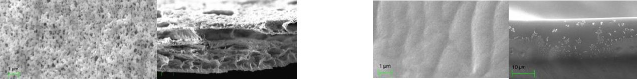

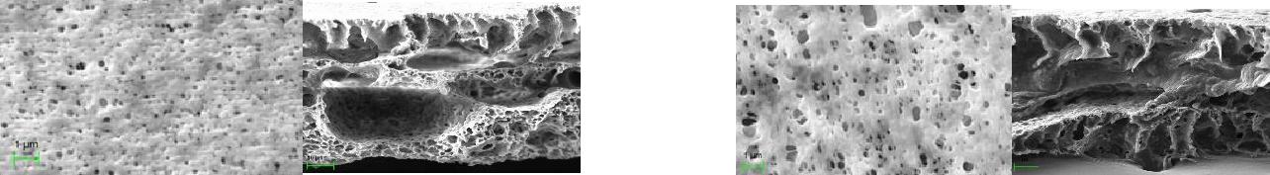
(d)
(c)

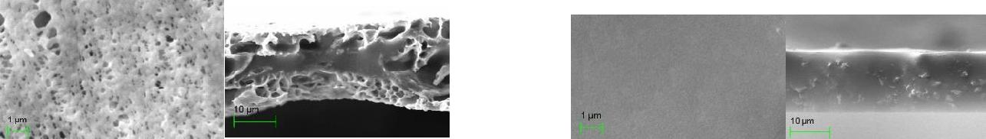
(f)
(e)

Figure 3. SEM micrograph for ENR/PVDF membrane free surface (5000x magnification) and cross section (1000x magnification): (a) 0/100 wt% (b) 100/0 wt% (c) 20/80 wt% (d) 40/60 wt% (e) 60/40 wt% (f) 80/20 wt%

Application of membrane
Flux is used to express the rate of permeates through membrane and were calculated by using equation 1. Pores are very important for water to permeate through membrane especially for wastewater like POME. Figure 4 shows the water flux value for ENR/PVDF membranes. Since membrane ratio for 100/0 wt% was a dense membrane without pore, thus water were unable to permeate through the membrane within the experimental conditions. The highest water flux was for ENR/PVDF 0/100 wt%, and followed closely by 60/40 wt% composition. ENR/PVDF 80/20 wt% membrane showed the lowest flux since the membrane was still dense.

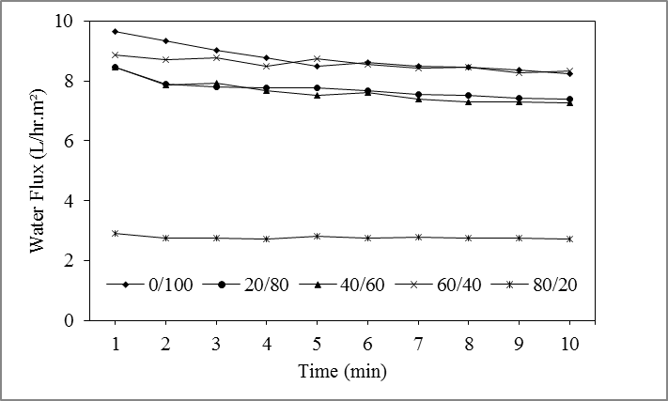
Figure 4. Water flux value for ENR/PVDF membranes

The fluxs for POME sample was shown in Figure 5. Overall, the flux was lower than the water flux (Fig. 4). Initially, the flux was higher but slowly reduced and maintained after some time. We reasoned that, initially the pores inside the membrane permitted any particles in POME so that water could easily pass through. After a while, particles begin to block the pores causing the pore size to reduce, further decreased in the value of flux. ENR/PVDF 100/0 wt% and 80/20 wt% membranes could not be used for POME treatment since no water permeated as can see the formation of pores in SEM micrograph.The trends of the fluxes were the same with water fluxes for respective membranes. Thus, ENR/PVDF membranes with mixing ratios 40/60 wt% showed the possibility to be applied for POME treatment.

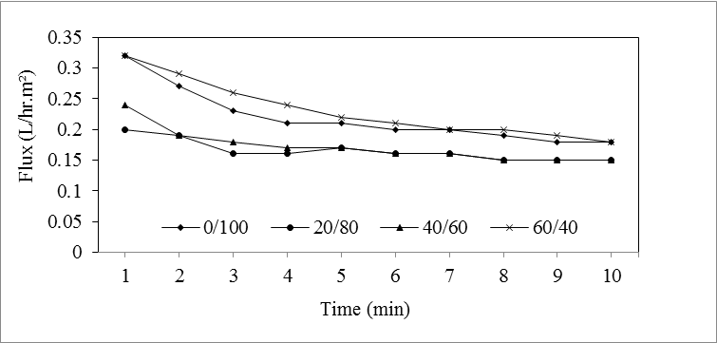
Figure 5. POME flux for ENR/PVDF membranes

Conclusion
ENR/PVDF membranes with different ratio of ENR/PVDF (0/100 wt%, 20/80 wt%, 40/60 wt%, 60/40 wt%, 80/20 wt%, 100/0 wt%) were successfully prepared using solution casting method. FTIR detected the present of functional groups for ENR and PVDF and the intensity of the peaks was proportional with the compositions. Analysis from DSC showed that there was single peak of T_{g} for each of sample and proved that ENR and PVDF composites were miscible. T_{g} of the composite membranes shifted from each single polymer showed the existence of interaction between ENR and PVDF. The membrane with smaller ENR composition displayed porous structure with random pores formed due to the PVDF nature and the solvents exchanged during phase inversion. It has been proven that these pores helped to increase the flux for water and during POME treatment. Thus, it can be concluded that the ENR/PVDF, 40/60 wt% membranes will give higher rejection with slightly lower flux from permeation test to be able to separate water and other components in POME.

Acknowledgement
The authors gratefully acknowledge the financial support from grant 03-01-02-SF115, Universiti Kebangsaan Malaysia (UKM), UKM-UCA International Joint Seminar on Science and Technology 2016, Institut Sel fuel (SELFUEL) and Polymer Research Centre (PORCE) for the facilities that was given to do this project.

References
- Salaeh, S., Nakason, C., Boiteu, G. and Cassagnau, P. (2013). Co-continuous phase structure and properties of poly(vinylidene fluoride)/epoxidized natural rubber blends. Advanced Materials Research, 626: 71-74.
- Sulaiman, N. M. N. & Ling, C. K. (2004). Membrane ultrafiltration of treated palm oil mill effluent (POME). Jurnal Teknologi, 41: 113-120.
- Shilton, S. J., Ismail, A. F., Gough, P. J., Dunkin, I. R. and Gallivan, S. L. (1997). Molecular orientation and the performance of synthetic polymeric membranes for gas separation. Polymer, 38(9): 2215-2220.
- Bottino, A., Camera-Rodab, G., Capannelli, G. and Munari, S. (1991). The formation of microporous polyvinylidene difluoride membranes by phase separation. Journal of Membrane Science, 57: l-20.
- Yan, L., Honga, S., Li, M. L. and Li, Y. S. (2009). Application of the Al₂O₃–PVDF nanocomposite tubular ultrafiltration (UF) membrane for oily wastewater treatment and its antifouling research. Separation and Purification Technology, 66: 347-352.
- Yoksan, R. (2008). Epoxidized natural rubber for adhesive applications. Kasetsart Journal (Nat. Sci.), 42: 325-332.
- Ismail, H. and Chia, H. H. (1998). The effects of multifunctional additive and epoxidation in silica filled natural rubber compounds. Polymer Testing, 17: 199-210.
- Hasegawa, R., Takahashi, Y., Chatani, Y. and Tadokoro, H. (1972). Crystal structures of three crystalline forms of poly(vinylidine fluoride). Polymer Journal, 3(5): 600-610.
- Salaeh, S., Boiteux, G., Gain, O., Cassagnau, P. and Nakason, C. (2014). Dynamic mechanical and dielectric properties of poly(vinylidene fluoride) and epoxidized natural rubber blends. Advanced Materials Research, 844: 97-100.
- Tao, M.-M., Liu, F., Ma, B.-R. and Xue, L.-X. (2013). Effect of solvent power on PVDF membrane polymorphism during phase inversion. Desalination, 316: 137-145.
- Wang, X., Zhang, L., Sun, D., An, Q. and Chen, H. (2009). Formation mechanism and crystallization of poly(vinylidene fluoride) membrane via immersion precipitation method. Desalination, 236: 170-178.
- Cao, X., Ma, J., Shi, X. and Ren, Z. (2006). Effect of TiO₂ nanoparticle size on the performance of PVDF membrane. Applied Surface Science, 253: 2003-2010.
- Freire, E., Bianchi, O., Monteiro, E. E. C., Nunes, R. C. R. and Forte, M. C. (2009). Processability of PVDF/PMMA blends studied by torque rheometry. Materials Science and Engineering C, 29: 657-661.
- Wang, P., Tan, K. L., Kangb, E. T. and Neohb, K. G. (2002). Plasma-induced immobilization of poly(ethylene glycol) onto poly(vinylidene fluoride) microporous membrane. Journal of Membrane Science, 195: 103-114.
- Zhong, Z., Cao, Q., Jing, B., Wang, X., Li, X. and Deng, H. (2012). Electrospun PVdF–PVC nanofibrous polymer electrolytes for polymer lithium-ion batteries. Materials Science and Engineering B, 177: 86-91.
- Igwe, J. C. and Onyegbado, C.C. (2007). A review of palm oil mill effluent (POME) water treatment. Global Journal of Environmental Research 1(2): 54-62.
- Malaysia Palm Oil Board (MPOB) (2014). Access online http://www.mpob.gov.my/ms/info-sawit/alam-sekitar/520-achievements.
- Chin, K. K., Lee, S. W. and Mohammad, H. H. (1996). A study of palm oil mill effluent treatment using a pond system. Water Science Technology, 34(11): 119-123.
- Saljoughi, E., Sadrzadeh, M. and Mohammadi, T. (2009). Effect of preparation variables on morphology and pure water permeation flux through asymmetric cellulose acetate membranes. Journal of Membrane Science, 326: 627-634.
- Zurina, M., Ismail, H. and Bakar, A. A. (2004). Rice husk powder–filled polystyrene/styrene butadiene rubber blends. Journal of Applied Polymer Science, 92: 3320-3332.
- Boccaccio, T., Bottino, A., Capannelli, G. and Piaggio, P. (2002). Characterization of PVDF membranes by vibrational spectroscopy. Journal of Membrane Science, 210: 315-329.
- Ma, W., Yuan, H. and Wang, X. (2014). The effect of chain structures on the crystallization behavior and membrane formation of poly(vinylidene fluoride) copolymers. Membranes, 4: 243-256.
- Bourara, H., Hadjout, S., Benabdelghani, Z. and Etxeberria, A. (2014). Miscibility and hydrogen bonding in blends of poly(4-vinylphenol)/poly(vinyl methyl ketone). Polymers, 6: 2752-2763.
- Bottino, A., Capannelli, G., Munari, S. and Turturro, A. (1988). High performance ultrafiltration membranes cast from LiCI doped solutions. Desalination, 68: 167-177.

