

MALAYSIAN JOURNAL OF ANALYTICAL SCIENCES
ISSN 1394 - 2506

Published by The Malaysian Analytical Sciences Society

PHYSICOCHEMICAL AND SENSORIAL PROPERTIES OF OPTIMISED ROSELLE-PINEAPPLE LEATHER

(Ciri-Ciri Fizikokimia dan Sensori Snek Rozel-Nenas yang Dioptimumkan)

Noorlaila Ahmad*, Siti Nadiah Shafi’i, Nor Hasanah Hassan, Asmeda Rajab, Azizah Othman

Faculty of Applied Sciences,

Universiti Teknologi MARA, 40450 Shah Alam, Selangor, Malaysia

*Corresponding author: dnoorlaila@salam.uitm.edu.my

Received: 4 September 2017; Accepted: 11 January 2018

Abstract

Roselle-pineapple leathers added with maltodextrin and hydrocolloids (locust bean gum and xanthan gum) were formulated to develop a new healthy-functional snack. The optimisation was carried out by the response surface methodology using a 5-level central composite rotatable design. The optimised fruit leather (pH= 3.2, TSS= 75°Brix) were dehydrated and subjected to physicochemical and antioxidant analyses as well as sensorial evaluation. The combination of 0.2% xanthan gum – 0.2% locust bean gum – 1.0% maltodextrin significantly maintained the fruit leather's colour and increased its extensibility. However, it significantly had lower (p < 0.05) total phenolic, total flavonoid, ferric reducing ability of plasma and 2,2-diphenyl-1-picrylhydrazyl radical-scavenging activity of the optimised fruit leather as compared to the control sample. Untrained panellists have assessed the sensory acceptability of the formulated snack food. They preferred the optimised roselle-pineapple leather added with maltodextrin and hydrocolloids as compared to the control roselle-pineapple leather.

Keywords: roselle-pineapple leather, antioxidant, hydrocolloid, extensibility, sensorial properties

Abstrak

Snek rozel-nenas yang ditambah maltodekstrin dan hidrokoloid (gam kacang lokus dan gam xantan) di formulasi untuk menghasilkan snek baru yang berkhasiat. Proses pengoptimuman dijalankan menggunakan kaedah gerak balas permukaan. Snek buah-buahan yang terhasil (pH= 3.2, jumlah pepejal larut= 75°Brix) dinyahhidrasi dan analisis fizikokimia, antioksida dan ciri-ciri sensori telah dijalankan. Kombinasi 0.2% gam xantan – 0.2% gam kacang lokus – 1.0% maltodekstrin mempunyai kesan signifikan terhadap warna snek rozel-nenas dan ekstensibilitinya berjaya ditingkatkan. Walau bagaimanapun, ia mempunyai kandungan fenolik, flavonoid, keupayaan penurunan ferik dan aktiviti pemerangkapan radikal bebas 2, 2-difenil-1-pikrilhidrazil yang rendah (p < 0.05) berbanding snek kawalan. Panel tidak terlatih telah membuat penilaian sensori ke atas snek yang di formulasi. Panel sensori lebih menggemari snek rozel-nenas yang ditambahkan maltodekstrin dan hidrokoloid berbanding snek kawalan.

Kata kunci: snek rozel-nenas, antioksida, hidrokoloid, ekstensibiliti, ciri-ciri sensori

Introduction

Roselle (Hibiscus sabdariffa Linn.) has vivid red colour and contains various polyphenols, including anthocyanins, proanthocyanidins and flavonols [1]. It also contains various organic acids such as oxalic, malic, citric, stearic and tartaric [2]. Each part of roselle plants (seed, calyx, leaf and stem) contains antioxidant properties that can be extracted using water and ethanol extraction [3].

The importance of antioxidant properties in roselle plant has attracted the food researchers to produce roselle-based products. Fruit leather is one of the food products which is produced through dehydration of fruit puree by using the red acid calyx of roselle [4, 5]. The drying of fruit to make rolls or leathers offers a convenient method for fruits’ marketing. In addition, the drying process can enhance their shelf life to avoid any losses when there is an overproduction of the fruit. Fruit leather can be made from a variety of fruits such as apple [6, 7], roselle [8], pineapple [9] and pomegranate [10]. Typically, the fruit leather produced from roselle puree is mixed with other ingredients to improve consumer acceptance.

Various drying methods and conditions that affect the quality of fruit leathers have been previously studied [11]. The addition of various additives in fruit leathers leads to the improvement in extensibility of the finished products. A good combination of hydrocolloids should be able to maximise the extensibility of the fruit leather. One or more hydrocolloids (xanthan gum, locust bean gum, gellan gum, agar, Arabic gum, pectin, gelatine, modified or unmodified starch) may be present together with carrageenan in the hydrocolloid confectionery product [12]; it is reported to enable the creation of desirable gelling and textural properties [13]. Thus, the objective of this study is to develop new formulations of fruit leathers from roselle-pineapple and to assess its physicochemical and sensorial properties of the fruit leathers.

Materials and Methods

Raw materials

Fresh roselle fruit from Sudan cultivar (Hibiscus sabdariffa Linn.) of the red variety was purchased from Roselle Farms, Klang, Selangor. Pineapple of Morris variety was purchased from local market in Klang, Selangor. Xanthan gum, locust bean gum and carrageenan were purchased from Sigma-Aldrich, Malaysia while maltodextrin was purchased from Meilun Food Chemical Sdn. Bhd., Selangor, Malaysia.

Preparations of roselle-pineapple leather

In the production of fruit leather, the roselle and pineapple were initially washed with water to remove dirt, leaves and foreign materials. Then, the pineapple was sliced into small pieces, blended and filtered through muslin cloth. The pineapple juice was blended together with roselle (2:1 ratio) (w/w) as well as hydrocolloids and maltodextrin to produce mixed fruit puree. The function of these hydrocolloids and maltodextrin was to improve the extensibility and chewiness of the fruit leather. The optimised formulation of roselle-pineapple leather was generated by response surface methodology (RSM) software. For control sample, there was no addition of hydrocolloids (locust bean gum and xanthan gum) and maltodextrin in the fruit leathers’ formulation. Sugar and glucose syrup (dextrose equivalent = 42%) were added into the fruit puree mixture until 50º Brix was achieved in these mixtures. Sodium citrate was added to adjust the mixture to pH 3.2. These mixtures were then boiled and left to cool for about 60 minutes. Each treatment batch was poured into a 22.9 x 22.9 cm plastic mould to a depth of 3 mm and dried in the cabinet dryer at 55°C for 12 hours [14]. The roselle-pineapple leather was displayed in Figure 1.

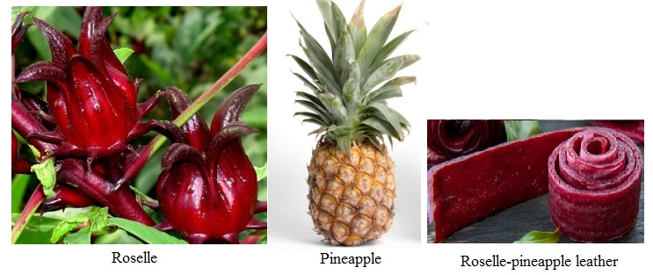

Figure 1. Roselle (Hibiscus sabdariffa Linn.), pineapple and roselle-pineapple leather

Optimisation of hydrocolloids and maltodextrin using CCRD

Design Expert Software version 6.0.4 (Stat-Ease Inc., USA) was used to generate the experimental designs, statistical analysis and regression model. The optimisation was carried out by employing the RSM using a 5-level CCRD. Table 1 shows the standard arrangement for three factors and the observed response. Three independent variables namely as xanthan gum (X₁), locust bean gum (X₂) and maltodextrin (X₃) were varied over five different levels (-α, -1, 0, +1 and +α). The response measured was the extensibility of the roselle-pineapple leather. A total of 20 experiments run (8 factorial points, 6 axial points and 6 replicated of the centre points) were unblocked and performed in random order to minimise the effects of unexpected variability in the observed response.

Table 1. Experimental design with actual levels for a 3-factors central composite rotatable design

and the response values
Exp. Runª | Independent Variable |  |  | Response
Exp. Runª | Xanthan Gum  (%), X₁ | Locust Bean Gum  (%), X₂ | Maltodextrin  (%), X₃ | Extensibility  (g), Y₁
1 | 0.20 | 0.20 | 1.00 | 860.15
2 | 0.50 | 0.20 | 1.00 | 1109.74
3 | 0.20 | 0.50 | 1.00 | 390.13
4 | 0.50 | 0.50 | 1.00 | 860.34
5 | 0.20 | 0.20 | 3.00 | 690.44
6 | 0.50 | 0.20 | 3.00 | 801.20
7 | 0.20 | 0.50 | 3.00 | 795.50
8 | 0.10 | 0.35 | 3.00 | 871.31
9 | 0.60 | 0.35 | 2.00 | 520.69
10 | 0.35 | 0.10 | 2.00 | 950.14
11 | 0.35 | 0.60 | 2.00 | 1050.57
12 | 0.35 | 0.35 | 2.00 | 790.21
13 | 0.35 | 0.35 | 0.32 | 850.63
14 | 0.35 | 0.35 | 3.68 | 798.59
15 | 0.35 | 0.35 | 2.00 | 1032.30
16 | 0.35 | 0.35 | 2.00 | 1061.68
17 | 0.35 | 0.35 | 2.00 | 1127.69
18 | 0.35 | 0.35 | 2.00 | 1116.15
19 | 0.35 | 0.35 | 2.00 | 1049.05
20 | 0.35 | 0.35 | 2.00 | 1047.48

ª Experiments were conducted in random order.

Determination of extensibility

Extensibility of roselle-pineapple fruit leathers with and without hydrocolloids was performed by using a TA.XT2i® Texture Analyser (Stable Micro Systems Ltd., Godalming, Surrey, U.K.) programmed with the Texture Exponent software. The samples were cut into uniform strips of 2.5 × 5.0 cm. A probe labelled Tensile Grips (A/TG) was used to extend each sample until it breaks. The measurement for extensibility was done in triplicate for each sample [15].

Preparation of fruit leather extracts for antioxidant assays

The extracts were prepared according to the method of Mohd-Esa et al. [3]. The fruit leathers were extracted with distilled water for 2 hours at room temperature, using an orbital shaker (Unimax 1010, Heidolph, Germany). The ratio of sample to extraction medium was 1:1000 (w/v). The mixture was filtered through a filter paper (Whatman no. 4). The filtrate was used for the antioxidant assays.

Antioxidant properties of roselle-pineapple leather: Total phenolic content

0.5 g gallic acid was dissolved in 10 ml ethanol (stock solution). From the stock solution, the standards with 50, 100, 250, 500 mg/litre concentration were prepared. 1 ml of sample extracts, gallic acid calibration standard, or blank (deionized or distilled water) was placed in a 100-ml volumetric flask. Approximately 70 ml of deionized water was added, followed by 5 ml Folin Ciocalteu reagent. The sample was incubated for about 1 to 8 minutes at room temperature. Next, about 15 ml of sodium carbonate solution was added to the sample. The sample was made up to 100 ml with distilled water and incubated for 2 hours at room temperature and the absorbance was measured at 765 nm with UV-Vis spectrophotometer. The calibration curve from the standards was created. This curve was used to determine the corresponding gallic acid concentration of the samples. The values were reported in gallic acid equivalents (GAE) using units of mg/litre [16].

Total flavonoid content

The total flavonoid content was measured using an aluminium chloride colorimetric assay. An aliquot (1 ml) of extracts or a standard solution of (+)-catechin (20, 40, 60, 80 and 100 mg/L) was added to a volumetric flask, containing 4 ml of distilled deionized water (ddH₂O). About 0.3 ml 5% sodium nitrite (NaNO₃) was added into these flasks. After 5 minutes, 0.3 ml 10% aluminium chloride (AlCl₃) was added and at the 6 minutes mark, 2 ml 1M sodium hydroxide (NaOH) was added. The sample was made up to 10 ml with ddH₂O. The sample was mixed, and the absorbance was measured against reagent blank at 510 nm with UV-Vis spectrophotometer. The total flavonoid contents of the fruit leather were expressed as milligrams of (+)-catechin equivalents (CE) per 100 g dry mass (mg CE/100 g dwb) [17].

Ferric reducing ability of plasma (FRAP)

The antioxidant capability of the extract based on ferric reducing power was determined according to the method described in Benzie and Strain [18] with some modifications. The stock solutions contained 300 mM acetate buffer (pH 3.6), 10 mM of 2,4,6-tripyridyl-s-triazine (TPTZ) solution in 40 mM HCl and 20 mM ferric chloride (Fe₂Cl₃.6H₂O) solution. The working solution was freshly prepared by mixing the acetate buffer, TPTZ solution and Fe₂Cl₃.6H₂O solution in 10:1:1 ratio and then incubated at 37 ºC for 10 minutes prior to the analysis. 0.1 ml of sample extracts were allowed to react with 2.9 ml of the FRAP solution for 30 minutes in the dark condition. The readings of the blue (ferrous tripyridyl triazine) complex were measured using UV-Vis spectrophotometer at 593 nm. The linear standard calibration curve ranging from 0-100 mM Trolox was established. The final results were expressed in mM TE/g of fresh extract weight.

2,2-diphenyl-1-picrylhydrazyl (DPPH) radical-scavenging activity

Radical scavenging activity of the sample extracts was conducted based on the method developed by Brand-Williams et al. [19] with slight modifications. About 600 µL of a various concentration of standards and samples ranging from 0-0.1 mg/ml were prepared. 4.5 ml of 60 µM DPPH solution in 95% ethanol was added to the sample solutions. The reaction was allowed to take place in the dark for 30 minutes and the absorbance reading at λ_{max} = 517 nm was recorded to determine the concentration of remaining DPPH. The results were expressed as EC₅₀ (Efficient Concentration at 50% scavenging activity). Ascorbic acid and the mixture of synthetic antioxidant BHA/BHT were used as standards in comparison with the extracts.

Colour measurement

The colour of roselle-pineapple leathers was measured with a Minolta CR-300 Chroma meter, using illuminant C (6774K) attached to a DP-100 Data Processor and a standard white reflection plate (Minolta Corp, Ramsey, NJ). The results were expressed as L* value (colour intensity changing from light to dark), chroma (intensity of colour) and hue angle (actual colour). The instrument was positioned with minimal pressure perpendicular to the sample surface and acquires CIELAB measurements over the 8-mm diameter interrogation area. The measurement of colour for each sample was run for at least three times [20].

Sensory evaluation

About 16 g of the samples (control and optimised fruit leather) were placed on coded plate accordingly. Sensory evaluation, using a 9-point hedonic scale (1=dislike extremely, 5=neither like nor dislike, 9=like extremely) was used to evaluate the samples [21] by 50 untrained panellists. The products were evaluated according to the degree of liking towards the appearance, colour, taste, texture and overall acceptability of roselle-pineapple leathers.

Statistical analysis

All data were expressed as a mean ± standard deviation from triplicate values. Data were analysed using SPSS 15.0.

Results and Discussion

Optimisation of hydrocolloids and maltodextrin using CCRD

The concentration of xanthan gum (X₁), locust bean gum (X₂) and maltodextrin (X₃) were selected using the CCRD as shown in Table 1 to investigate the effect of these hydrocolloids on the extensibility of roselle-pineapple leather. The concentration for XG (0.20-0.50%), LBG (0.20-0.50%) and maltodextrin (1.00-3.00%) were fixed accordingly to the previous study using two-level full factorial design [14].

Based on Table 1, the range values of extensibility for roselle-pineapple leathers were between 390.12 g to 1127.69 g. To analyse the data, the quadratic model (p<0.05) was suggested by CCRD because it has insignificant lack of fit (LOF) (p>0.05) and high R-squared (0.9762), which indicates a good fit of a model and there were good correlations between response and independent variables [9]. The effects and interaction between hydrocolloids and maltodextrin were observed in Equation 1, where X₁, X₂ and X₃ were coded for XG, LBG and maltodextrin, respectively. A positive sign for the coefficient estimated in the fitted model equation may indicate the tendency of the hydrocolloids and maltodextrin to increase the extensibility and vice versa.

Extensibility (g) = 1072.86 +119.25 X₁ – 71.91 X₂ – 10.94 X₃– 112.21 X₁² – 56.81 X₂² - 90.68 X₃²

+23.21 X₁X₂ – 66.65 X₁X₃ + 111.82 X₂X₃ (1)

Three different effects were determined through this equation, which are single effects, multiple effects and combination effects. For single effects, only addition of XG (X₁= +119.25) had the highest coefficient, indicating its major contribution on the extensibility of roselle-pineapple leather compared to LBG and maltodextrin. In contrast, LBG (X₂= -71.91) and maltodextrin (X₃= -10.94) had negative coefficient values, which indicate that these two factors tend to decrease the extensibility of roselle-pineapple leather. Also, in multiple additions, the different effects of hydrocolloid and maltodextrin were observed to have the tendency in reducing the extensibility of roselle-pineapple leather. In combination, the mixture of LBG-maltodextrin (X₂X₃= +111.82) had a more positive effect which tends to increase the value of extensibility compared to the mixture of XG-LBG (X₁X₂= +23.21) and XG-maltodextrin (X₁X₃= – 66.65). From this equation, it can be concluded that single addition of XG and mixtures of LBG-maltodextrin and XG-LBG are sufficient to increase the extensibility of roselle-pineapple leather compared to other treatments.

Figure 2 depicts the relationship of the mixture (XG-LBG-maltodextrin) with the extensibility of roselle-pineapple leather. At the concentration of 1% maltodextrin, the extensibility of roselle-pineapple leather increased with the presence of high concentration of XG and LBG. This indicated that the increased concentration of hydrocolloids resulted in an increased extensibility of the dried roselle-pineapple leather. For optimisation process, only response (extensibility) was fixed as maximum while hydrocolloids (0.2 - 0.5%) and maltodextrin (1 - 3%) were fixed in their concentrations’ range.

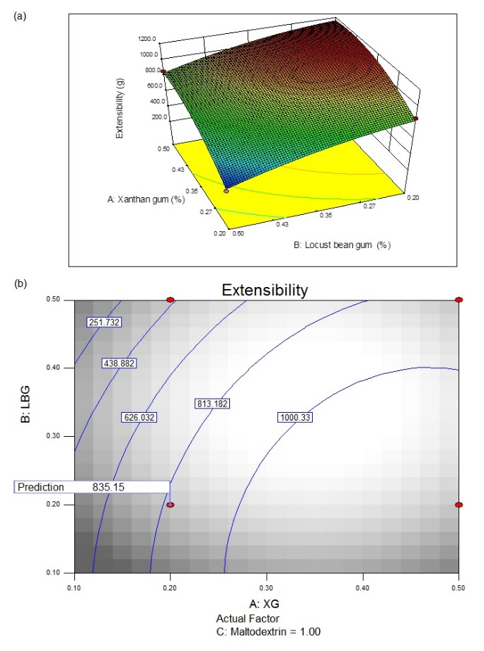

Figure 2. (a) Three-dimensional plot (3D), and (b) Two-dimensional plot (2D) showing the relationship between the extensibility, xanthan gum and locust bean gum at low level of maltodextrin (1% w/w)

The optimised hydrocolloids and maltodextrin composition obtained from the reduced factorial model was 0.2% XG - 0.2% LBG - 1% maltodextrin. The observed values from the experimental runs were used to evaluate the validity of the optimum point using Root Mean Squared Deviation (RMSD). The predicted value for the extensibility (835.15 g) has small RMSD value (0.94) with the verified values (836.09 g) which indicated the validity of the model. Jueanville and Badrie [22] and Dangkrajang et al. [23] also selected low concentration of hydrocolloids (0.15% and 0.20%) in their roselle leather formulations. It was also demonstrated that roselle leather containing a higher concentration of XG (0.30% and 0.60%) and guar gum (0.40% and 0.60%) exhibited greater extensibility which lowers their sensory acceptability.

Extensibility of roselle-pineapple leather

Referring to Table 2, there was significant difference between control and optimised leathers, which were 396.16 g and 836.09 g, respectively. High extensibility is desired to retain the shape of fruit leather, especially after drying. The addition of hydrocolloids (XG and LBG) at 0.20% as well as maltodextrin at 1.00% concentration promotes desirable extensibility of roselle-pineapple leather as described in sensory evaluation as the optimised fruit leather’s texture was preferred over the control fruit leather (Figure 3). It is associated that the increase in extensibility of optimised fruit leather requires a high force to break it as compared to the control sample [11].

Table 2. Physicochemical and antioxidant properties of roselle-pineapple leathers as well as correlations of antioxidant parameters
 | Control Leather |  | Optimised Leather
Initial pH | 2.80±0.08ª |  | 2.80±0.08ª
*Final pH | 3.20±0.08ª |  | 3.20±0.08ª
Extensibility (g) | 396.16±25.49^{b} |  | 836.09±29.93ª

Colour
- L* | 22.84±0.51ª |  | 23.39±0.71ª
- a* | 1.93±0.39^{b} |  | 9.43±0.47ª
- b* | 1.10±0.12ª |  | 2.71±0.99ª
Total phenolic (mg GAE/g) | 0.53±0.03ª |  | 0.50±0.02^{b}
Total flavonoid (mg QE/g) | 0.46±0.01ª |  | 0.35±0.02^{b}
FRAP (mM TE/g) | 0.71±0.01ª |  | 0.69±0.01^{b}
DPPH (%) | 33.91ª |  | 29.90^{b}

Correlations (r)
- Total phenolic x FRAP |  | 0.232; p<0.05
- Total phenolic x DPPH |  | 0.400; p<0.05
- Total flavonoid x FRAP |  | 0.858; p<0.05
- Total flavonoid x DPPH |  | 0.969; p<0.05

*Sodium citrate was added until the pH value reached 3.2.

Values are means ± standard deviation (n=3).

Means within the same row with different letters are significantly different at p<0.05.

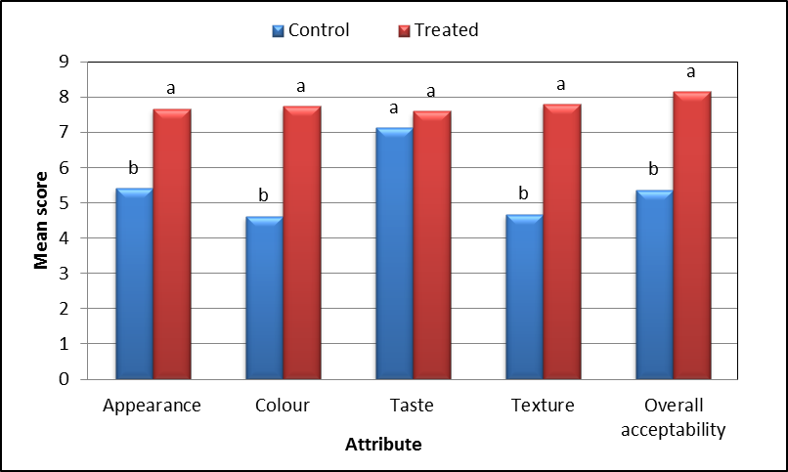

Figure 3. Acceptability scores of sensory attributes of control (left) and treated (right) roselle-pineapple leathers

Antioxidant properties of roselle-pineapple leather

Total phenolic content

As shown in Table 2, the total phenolic compound of control fruit leather (0.53 mg/GAE g) and optimised fruit leather (0.50 mg/GAE g) were lower than roselle leather (2.59 mg GAE/g) [8]. The roselle-pineapple leathers produced has lower phenolic content than roselle fruits itself, which is 1.85 mg of GAE/g [3]. The phenolic compounds in roselle include organic and phenolic acids, such as citric acid, hydroxycitric acid, hibiscus acid and protocatechuic acid [24]. The reduction of total phenolic content in the fruit leathers might be due to its losses during the heating process (100 °C). Sharma et al. [9] observed the decrease in total phenolic content of fruit leather with the increasing temperature and this is due to the decarboxylation of phenolic acids. In their study, the experimental values of total phenolic content, ascorbic acid content, flavonoid content and antioxidant activity were 46.91 mg GAE/100 g, 51.97 mg/100 g, 48.75 μg of quercetin/g and 95.95%, respectively. Heating process caused an increment in the concentration of mixtures containing maltodextrin and hydrocolloids; in which the reacting molecules becomes closer once the mixture is concentrated, accelerating the degradation of the compounds [25].

Total flavonoid content

Total flavonoid content (Table 2) of control fruit leather (0.46 mg QE/g) was significantly higher (p<0.05) than the optimised fruit leather (0.35 mg QE/g). Roselle contain polyphenols of the flavonol and flavanol type in simple or polymerised form. The following flavonoids have been described in roselle extracts: hibiscitrin (hibiscetin-3-glucoside), sabdaritrin, gossypitrin, gossytrin and other gossypetin glucosides, quercetin, luteolin chlorogenic acid, protocatechuic acid, pelargonidic acid, eugenol, quercetin, luteolin and the sterols b-sitosterol and ergosterol [26]. Flavonoids such as quercetin, luteolin or gossipetin, and their respective glycosides are also present [24]. Sharma et al. [9] also reported that flavonoid content of pineapple fruit leather was decreased up to 37% after extrusion cooking with increasing temperature.

Ferric reducing ability of plasma

The potential of the antioxidants component present in roselle-pineapple leathers to reduce ferric ion (Fe³⁺-TPTZ to a blue coloured Fe²⁺-TPTZ) was determined using FRAP assay [27, 28]. As shown in Table 2, the antioxidant potential for the control fruit leather (0.71) was significantly higher (p<0.05) than optimised fruit leather (0.69). Although there is only low correlation of total phenolic content with FRAP value (r = 0.232, p<0.05) in optimised fruit leather, it is previously claimed that low FRAP values was related with the low phenolic content in the fruit leather [27]. Without the presence of hydrocolloids and maltodextrin, antioxidant compounds were easily reachable to the ferric ion, which causes the redox reaction to occur faster, leading to higher antioxidant potential in the control fruit leather. Meanwhile, strong and positive correlation were observed between total flavonoid content and FRAP (r = 0.858, p<0.05) as well as with DPPH activity (r= 0.969, p<0.05) (Table 2); which indicate that the flavonoid content in these optimised roselle-pineapple leather has a strong relation to its antioxidant activity.

Scavenging activity on 2, 2-diphenyl-1-picrylhydrazyl

The scavenging of 2,2-diphenyl-1-picrylhydrazyl (DPPH) radical by hydrogen-donating antioxidant is characterised by a rapid decline in the absorbance at 515 nm followed by a slow step where the absorbance depreciates more gradually [29]. When DPPH encounters proton radical scavengers, its purple colour fades rapidly [27]. As shown in Table 2, DPPH of control fruit leather (33.91%) was significantly higher (p<0.05) than optimised fruit leather (29.90%). This result was quite similar to Mohd-Esa et al. [3], in which the scavenging activity for roselle calyx was 30.8% in water extracts. Lower scavenging ability on DPPH radicals in optimised roselle-pineapple leather extracts might be due to its low content of flavonoid. As shown through correlation analysis, there is a strong positive correlation between DPPH and total flavonoid content (r = 0.969).

Colour analysis

Based on Table 2, the lightness (L*) and yellowness (+b*) of control and optimised fruit leathers were similar (p>0.05), but for redness (+a*), optimised fruit leather (9.43) showed significantly higher (p<0.05) compared to control fruit leather (1.93). It signified that the reddish colour of roselle dominates over the yellowish colour of pineapples in roselle-pineapple leather. As reported by Dangkrajang et al. [23], roselle leather containing guar gum (4.17) which possessed higher thickening properties was more reddish compared to roselle leather containing pectin; with a* values of 4.17 and 3.81, respectively. In this study, the combination of hydrocolloids mixture (xanthan gum and locust bean gum) was able to preserve the original colour of roselle puree in its viscous mixture.

Sensory evaluation

Results from the sensory evaluation revealed that the appearance, colour, texture and overall acceptability (Figure 3) of optimised fruit leather had significantly higher (p<0.05) mean scores as compared to the control fruit leather, indicating its superior quality and preference to the panellists. Meanwhile, the sensory score of taste showed no significant difference between the tastes of optimised roselle-pineapple leather with the control roselle-pineapple leather. Both types of fruit leather had similar taste acceptability (p>0.05).

Conclusion

The panellists preferred the optimised roselle-pineapple leather added with maltodextrin and hydrocolloids compared to the control roselle-pineapple leather. The addition of maltodextrin and hydrocolloids significantly retained the fruit leather's colour, but it has also significantly lowered the total phenolic content, total flavonoid content, DPPH and FRAP values as compared to the control fruit leather. Optimised roselle-pineapple leather had significantly improved extensibility than the control leather. Further study on preserving the fruit leather’s antioxidant properties shall be conducted in complement with its commercial added value.

Acknowledgement

This work was supported by Universiti Teknologi MARA, Ministry of Higher Education (MOHE) for the FRGS grant, FRGS FASA 02/2010, Reference: 600-RMI/ST/FRGS 5/3/Fst (215/2009) and Research Management Institute for Excellent Funds 11/2010, Reference: 600-RMI/ST/DANA 5/3/Dst (122/2010).

References
- Formagio, A. S. N., Ramos, D. D., Vieira, M. C., Ramalho, S. R., Silva, M. M., Zárate, N. A. H., Foglio, M. A. and Carvalho, J. E. (2015). Phenolic compounds of Hibiscus sabdariffa and influence of organic residues on its antioxidant and antitumoral properties. Brazilian Journal of Biology, 75(1): 69 – 70.
- Ali, B. H., Al Wabel, N. and Blunden, G. (2005). Phytochemical pharmacological and toxicological aspects of Hibiscus sabdariffa L: A review. Phytotherapy Research, 19(5): 369 – 375.
- Mohd-Esa, N. Hern, F. S., Ismail, A. and Yee, C. L. (2010). Antioxidant activity in different parts of roselle (Hibiscus sabdariffa L) extracts and potential exploitation of the seeds. Food Chemistry, 122(4): 1055 – 1060.
- D’Heureux-Calix, F. and Badrie, N. (2004). Consumer acceptance and physicochemical quality of processed red sorrel/roselle (Hibiscus sabdariffa L) sauces from enzymatic extracted calyces. Food Service Technology, 4: 141 – 148.
- Sirichote, A., Ruangsri, P., Chumsri, P. and Itharat, A. (2008). Changes in quality and bioactive properties of concentrated Roselle (Hibiscus sabdariffa Linn) extract. Journal of Food Agriculture Industrial, 1(2): 62 – 67.
- Demarchi, S. M., Ruiz, N. A. Q., Concellon, A. and Giner, S. A. (2013). Effect of temperature on hot-air drying rate and on retention of antioxidant capacity in apple leathers. Food and Bioproducts Processing, 9: 310 – 318.
- Valenzuela, C. and Aguilera, J. M. (2015). Effects of maltodextrin on hygroscopicity and crispiness of apple leathers. Journal of Food Engineering, 144: 1 – 9.
- Dangkrajang, S. (2011). Development of roselle leather from roselle (Hibiscus sabdariffa L.) by-product. Thesis of Master Degree, Prince of Songkhla University.
- Sharma, P., Ramchiary, M., Samyor, D. and Das, A. B. (2016). Study on the phytochemical properties of pineapple fruit leather processed by extrusion cooking. Original Research Article LWT - Food Science and Technology, 72: 534 – 543.
- Yilmaz, F. M., Yüksekkaya, S., Vardin, H. and Karaaslan, M. (2017). The effects of drying conditions on moisture transfer and quality of pomegranate fruit leather (pestil). Journal of the Saudi Society of Agricultural Sciences, 16(1): 33 – 40.
- Gujral, H. S. and Brar, S. S. (2003). Effect of hydrocolloids on the dehydration kinetics colour and texture of mango leather. International Journal of Food Properties, 6(2): 269 – 279.
- Saha, D. and Bhattacharya, S. (2010). Hydrocolloids as thickening and gelling agents in food: A critical review. Journal of Food Science and Technology, 47(6): 587 – 597.
- Ong, M. H. and Whitehouse, A. S. (2003). United States Patent 20110256271. http://patentsjustiacom/inventor/mei-horng-ong. [Access online 12 March 2017].
- Siti-Nadiah, S., Noorlaila, A., Mohd Zahid, A., Norziah, M. H. and Normah, I. (2013). Optimization of hydro-colloids and maltodextrin addition on roselle-based fruit leather using two-level full factorial design. Inter-national Journal of Bioscience Biochemistry and Bioinformatics, 3(4): 387 – 391.
- Phimpharian, C., Jangchud, A., Jangchud, K., Therdthai, N., Prinyawiwatkul, W. and No, H. K. (2011). Physicochemical characteristics and sensory optimisation of pineapple leather snack as affected by glucose syrup and pectin concentrations. International Journal of Food Science and Technology, 46: 972 – 981.
- Stoica, R., Ion, R. M., Bunghez, I. R., Senin, R. and Bajenaru, I. G. (2011). Assessing the total phenolics of romanian wine varieties. The Scientific Bulletin of Valahia University – Materials and Mechanics, 6 (9): 101 – 103.
- Sulaiman, C. T. and Balachandran, I. (2012). Total phenolics and total flavonoids in selected Indian medicinal plants. Indian Journal of Pharmaceutical Sciences, 74(3): 258 – 260.
- Benzie, I. F. F. and Strain, J. J. (1996). The ferric reducing ability of plasma (FRAP) as a measure of ‘anti-oxidant power’: The FRAP assay. Analytical Biochemistry, 239: 70 – 76.
- Brand-williams, W., Cuvelier, M. E. and Berset, C. (1995). Use of free radical method to evaluate antioxidant activity. LWT - Food Science and Technology, 28 (1): 25 – 30.
- McGuire, R. G. (1992). Reporting of objective colour measurements. Hort-Science, 27(12): 1254 – 1255.
- Larmond, E. (1977). Laboratory methods for sensory evaluation of foods Ottawa: Canada Department of Agriculture. http://www.archive.org/details/laboratorymethodOOotta. [Access online 20 January 2017].
- Jueanville, M. and Badrie, N. (2007). Processed sorrel/roselle (Hibiscus sabdariffa L) leather from pectolase-treated alyces: Effects of xanthan gum on physicochemical quality and sensory acceptance. Journal of Food Technology, 5(2): 98 – 104.
- Dangkrajang, S., Sirichote, A. and Suwansichon, T. (2009). Development of roselle leather from roselle (Hibiscus sabdariffa L) by-product. Asian Journal of Food and Agro-industry, 2(4): 788 – 795.
- Borrás-Linares, I. S., Arráez-Roman, D. P. A., Palmeros-Suárez, P. A., Del Val-Díaz, R., Andrade-Gonzáles, I., Fernández-Gutiérrez, A. Gómez-Leyva, J. F. and Segura-Carretero A. (2015). Characterization of phenolic compounds anthocyanidin antioxidant and antimicrobial activity of 25 varieties of Mexican Roselle (Hibiscus sabdariffa). Industrial Crops and Products, 69: 385 – 394.
- Patras, A., Brunton, N. P., O’Donell, C. P. and Kumar, T. B. (2010). Effect of thermal processing on antho-cyanin stability in foods; mechanisms and kinetics of degradation. Trends in Food Science and Technology, 21: 3 – 11.
- Da-Costa-Rocha, I., Bonnlaender, B. Sievers, H., Pischel, I. and Heinrich, M. (2014). Hibiscus sabdariffa L.– A phytochemical and pharmacological review. Food Chemistry, 165: 424 – 443.
- Azizah, O., Amin, I., Nawalyah, A. G. and Ilham, A. (2007). Antioxidant capacity and phenolic content of cocoa beans. Food Chemistry, 100: 1523 – 1530.
- Hajimahmoodi, M., Oveisi, M. R., Sadeghi, N., Jannat, B., Hadjibabaie, M., Farahani, E., Akrami, M. R. and Namdar, R. (2008). Antioxidant properties of peel and pulp hydro-extract in ten Persian pomegranate cultivars. Pakistan Journal of Biological Sciences, 11: 1600 – 1604.
- Balasundram, N. Ai, T. Y., Sambanthamurthi, R., Sundram, K. and Samman, S. (2005). Antioxidant properties of palm fruit extracts. Asia Pacific Journal of Clinic Nutrition, 4(4): 319 - 324.

