

MALAYSIAN JOURNAL OF ANALYTICAL SCIENCES
ISSN 1394 - 2506

Published by The Malaysian Analytical Sciences Society

COMPLEXATION OF 5,5,7,12,12,14-HEXAMETHYL-1,4,8,11-TETRAAZACYCLOTETRADECA-7,14-DIENIUM DIPERCHLORATE WITH COPPER(II) ACETATE MONOHYDRATE IN IONIC LIQUID

(Pengkompleksan 5,5,7,12,12,14-Heksametil-1,4,8,11-Tetraazasiklo tetraazadeka-7,14-Dienium Diperklorat dengan Kuprum(II) Asetat Monohidrat dalam Cecair Ionik)

Noorhanani M. Ali, Nurzati Amani M. Zaid, Nurul Huda Abd. Karim, Bohari M. Yamin, Nur Hasyareeda Hassan*

School of Chemical Sciences and Food Technology,

Faculty of Science and Technology,

Universiti Kebangsaan Malaysia, 43600 UKM Bangi, Selangor, Malaysia

*Corresponding author: syareeda@ukm.edu.my

Received: 4 September 2017; Accepted: 19 December 2017

Abstract
In the previous study, 5,5,7,12,12,14–hexamethyl–1,4,8,11–tetraazacyclotetradeca–7,14–dienium diperchlorate, [Me₆C₁₀H₁₆N₄](ClO₄)₂ formed complex of C₁₆H₃₄N₄OCu(ClO₄)₂ and C₁₆H₃₂N₄Cu(ClO₄)₂ when reacted with copper(II) acetate monohydrate in acetonitrile and aqueous solutions, respectively. However, when the same reaction carried out in 1–butyl–3–methylimidazolium hexafluorophosphate ionic liquid, [Bmim][PF₆], disproportionation took place to give bis(ethylenediamine) bis(perchlorato-O) copper(II) complex, C₄H₁₆N₄Cu(ClO₄)₂. X-ray study showed that the central copper atom was coordinated to two ethylenediamine ligands and two oxygen atoms of perchlorate ions in a distorted octahedral environment. Thermogravimetric Analysis (TGA) study showed the complex decomposition in one spontaneous mass loss at 260 ºC due to the explosive nature of the perchlorate.

Keywords: ionic liquid, disproportionation, copper(II) complex

Abstrak
Dalam kajian yang lepas, 5,5,7,12,12,14-heksametil-1,4,8,11-tetraazasiklotetradeka-7,14-dienium diperklorat, [Me₆C₁₀H₁₆N₄](ClO₄)₂ membentuk kompleks C₁₆H₃₂N₄OCu(ClO₄)₂ dan C₁₆H₃₂N₄Cu(ClO₄)₂ apabila masing-masing bertindak balas dengan kuprum(II) asetat monohidrat dalam larutan asetonitril dan akues. Walaubagaimanapun, apabila tindak balas yang sama dilakukan dalam cecair ionik 1-butil-3-metilimidazolium heksaflorofosfat, [Bmim][PF₆], keperkadaran tidak seimbang berlaku dan menghasilkan kompleks kuprum(II) bis(etilenadiamina) bis(perklorato-O), C₄H₁₆N₄Cu(ClO₄)₂. Kajian X-ray menunjukkan atom kuprum berkoordinasi dengan dua ligan etilenadiamina dan dua atom oksigen ion perklorat dalam keadaan oktahedron terherot. Analisis termogravimetri (TGA) menunjukkan kompleks terurai dengan mengalami kehilangan jisim mendadak pada 260 ℃ disebabkan oleh sifat perklorat yang mudah meletup.

Kata kunci: cecair ionik, keperkadaran tidak seimbang, kompleks kuprum(II)

Introduction

5,5,7,12,12,14–hexamethyl–1,4,8,11 – tetraazacyclotetradeca – 7,14 – dienium diperchlorate, [Me₆C₁₀H₁₆N₄](ClO₄)₂ is a special macrocyclic tetraaza because it was obtained by templation when Curtis recrystallized bis(ethylenediamine) nickel in acetone [1]. Since then, many such complexes were synthesised by templation method. Very few reports were on the interaction or mechanism for the reaction between the ligand and metals. However, there were some studies on the stability of the complexes in basic and acidic solutions in which isomerisation or decomposition may have taken place [2-4]. The discovery of a deprotonated Curtis salt (Me₆C₁₀H₁₆N₄)X₂ where X= halogen has opened up a new scope to study the reaction from both synthetic and reaction point of view [5-7]. The complexation product is influenced by the type of tetraaza ligands, metal salts, and the solvents. For example, (Me₆C₁₀H₁₆N₄)Br₂ reacted with CuBr₂ and NH₄CuCl₄ was found to give [(Me₆C₁₀H₁₆N₄)BrCu]Br.2H₂O and [(Me₆C₁₀H₁₆N₄)Cu][Cl₄Cu] [8-9]. In our previous work on the reaction of [Me₆C₁₀H₁₆N₄](ClO₄)₂ with copper(II) acetate monohydrate, the same complex, [(Me₆C₁₀H₁₆N₄)Cu](ClO₄)₂ reported by Curtis was obtained [10].

Ionic liquid is a molten salt composed of ions and exist as liquid at ambient temperature. Its non-volatility, low vapor pressure and broad range of anion combination render them as well-known green solvent for many reactions and as an attractive alternative to conventional organic solvents [11]. Besides an ability to provide easy reaction medium, it may also involve in the reaction. The first report of synthesis in coordination chemistry using an ionic liquid was reported by Zhang et al. in 2013 where the reaction was carried out by using templation method [12]. To look at the role that ionic liquids can play in the complexation of tetraaza macrocyclic ligand with copper(II) acetate monohydrate, we decided to use [Bmim][PF₆] as solvent for the reaction without using templation method. It was anticipated that the basic nature of ionic liquid will have an influence at least on the stability of the complex.

Materials and Methods

Chemicals
Ammonium perchlorate, ethylenediamine, copper(II) acetate monohydrate, 1–butyl–3–methylimidazolium hexafluorophosphate ionic liquid, [Bmim][PF₆], methanol and acetone were purchased from Sigma-Aldrich and Friedemann Schmidt. All chemicals were of the analytical reagent grade (AR) and used without purification.

Physical measurement
Melting point was measured by using Barnstead Electrothermal Melting Point IA9100 series. Microelemental analyses were conducted using Thermo-Finnigan Flash EA 1112 Elemental Analyser. The metal content of the copper(II) complex was determined by atomic absorption technique using Perkin-Elmer AAnalyst 800 AA spectrometer. IR spectrum was recorded using FTIR Perkin-Elmer GX model with compound dispersed in KBr disks with the spectral range of 4000-400cm⁻¹. The electronic spectrum of the complex in water was recorded on Shimadzu UV-2450 and mass spectrometry was carried out using Bruker MicroTof Q Mass Spectrometer. Magnetic susceptibility was measured using Sherwood Magnetic Susceptibility Balance (Auto) at room temperature. Thermogram was obtained by using a Mettler Toledo TGA/SDTA 851 instrument under N₂ atmosphere with a flow rate of 20 mL min⁻¹, in the temperature range of 27 to 600 ºC at the heating rate of 10 ºC min⁻¹.

A single-crystal X-ray diffraction investigation was performed on Bruker D8 QUEST fitted with CCD area detectors (graphite monochromator, Mo Kα radiation). Cell constant and an orientation matrix for data collection was obtained by least-squares refinement of diffraction data from 8144 unique reflections. The structure was solved by direct methods and refined by full-matrix least-squares techniques on F² using the solution program shelxs-97 and refined using shelxl-97 [13, 14]. Non-hydrogen atoms were refined with anisotropic thermal parameters and hydrogen atoms were included from the difference Fourier maps and refined with isotropic thermal parameters. Molecular drawing was obtained using MERCURY software.

Syntheses
[Me₆C₁₀H₁₆N₄](ClO₄)₂ was prepared by the same method described in the previous paper [7]. A solution of Cu(CH₃COO)₂.H₂O (0.1 g, 0.0005 mol) in [Bmim][PF₆] (5 mL) and [Me₆C₁₀H₁₆N₄](ClO₄)₂ (0.24 g, 0.0005 mol) in [Bmim][PF₆] (5 mL) were mixed in round bottom flask. The mixture was then refluxed for 3 hours under constant stirring at 70 ºC. The solution was filtered using 150 mm filter paper and extracted with water in a separating funnel. The aqueous layer was left to evaporate at room temperature. Purple crystals were obtained after one week. The crystals were washed with cold methanol, dried, and kept in a desiccator. The synthetic route of copper(II) complex is shown in Scheme 1.

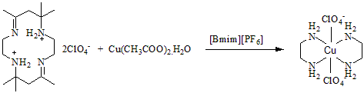

Scheme 1. Synthetic route of copper(II) complex

Results and Discussion
Physical and microelemental analysis (C, H, N)
The complex was synthesised in the form of a purple solid in 79% yield. The microelemental analysis data showed an agreement with the formula of C₄H₁₆N₄Cu(ClO₄)₂ which was different from previous reported [7]. The yield, melting point, colour, and microelemental analysis data are shown in Table 1.

Table 1. Analytical data and physical properties of copper(II) complex
Compound | Colour | Yield  (%) | Melting Point  (ºC) | Elemental Analysis
 |  |  |  | C | H | N | Cu
C₄H₁₆N₄Cu(ClO₄)₂ | Purple | 79 | 268.5-268.9 | 14.16  12.55 | 4.41  4.21 | 14.92  14.64 | 16.23  16.62
*Bold value = Theoretical value

Infrared spectroscopy
IR spectrum of the complex exhibited stretching frequency for NH₂, C-H, and C-N of 3308, 3217 cm⁻¹, 2965 cm⁻¹, and 1088 cm⁻¹, respectively as shown in Figure 1. The absence of a band at 1670 cm⁻¹ which corresponded to the ν(C=N) stretch indicated the breaking of macrocyclic ring. The stretching bands at 627 cm⁻¹ and 524 cm⁻¹ were assigned for O-Cl-O bond of perchlorate and Cu-O bond, respectively [15,16]. The band at 476 cm⁻¹ was assigned for ν(Cu-N) according to Nakamoto and Carthy [17].

Table 2. IR spectral data of Curtis ligand and copper(II) complex
Compound |  | FTIR wavenumbers (cm⁻¹)
Compound | ν(NH₂) | ν(N-H) | ν(C-H) | ν(C=N) | ν(C-N) | ν(Cl-O) | ν(Cu-N) | ν(Cu-O)
C₁₆H₃₄N₄(ClO₄)₂  (Ligand) | - | 3466-3407  (stretch) | 2981 | 1667 | 1079 | 623 | - | -
C₄H₁₆N₄Cu(ClO₄)₂  (Complex) | 3308, 3217 | 1580 (bend) | 2965 | - | 1088 | 627 | 476 | 524

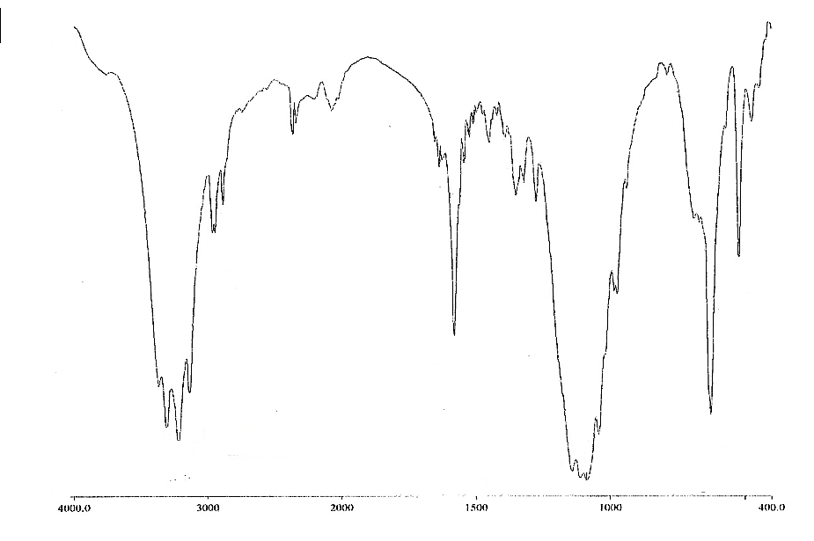
Cu-N
C-H
NH₂
C-N
Cu-O
ClO₄⁻
% Transmittance
Wavenumber (cm⁻¹)
N-H

Figure 1. The FTIR spectrum of copper(II) complex

Mass spectrometry
The ESI–mass spectrum was measured to confirm the composition and purity of the complex under investigation. Representative mass spectrum of a solution containing copper(II) complex in the positive ion mode is shown in Figure 2. The ESI mass spectrum that contained molecular ion peak at m/z 381.18 was attributable to [M-H]⁺. The molecular ion peak was in good agreement with the expected value of the copper(II) complex molecular weight. The peaks at m/z 281.24, 343.15 and 643.37 were assigned to [M⁺ - ClO₄⁻ - H⁺], [M⁺ - ClO₄⁻ + Na⁺ + K⁺ - H⁺], and [M⁺ - 2ClO₄⁻ - Na⁺ + K⁺], respectively. These assignments were based on ⁶³Cu.

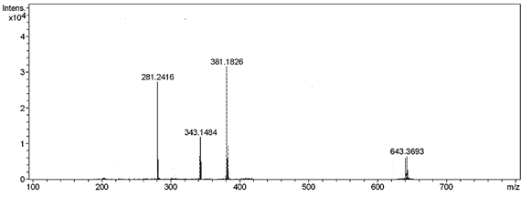
Figure 2. ESI mass spectrum in positive ion mode of copper(II) complex

Electronic spectral analysis

The UV-Vis spectrum of the complex is shown in Figure 3. The electronic spectra showed two characteristic absorption peaks at 229 nm (ε = 1370.0 Lmol⁻¹cm⁻¹) and 547 nm (ε = 1.7 Lmol⁻¹cm⁻¹) which were assigned for π→π* and d-d transition, respectively [6]. However, the maximum absorption at 547 nm was obtained at high concentration because of low extinction coefficient.

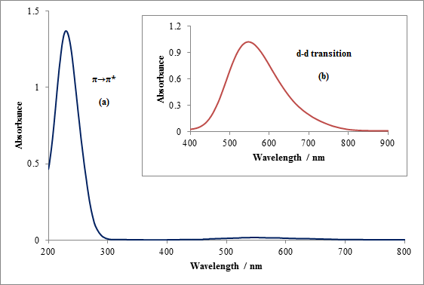
Figure 3. Absorption spectra of copper(II) complex (a) at 0.001 mol.L⁻¹ and (b) at 0.01 mol.L⁻¹

Magnetic susceptibility determination
The magnetic susceptibility measurement in the solid state showed that the present complex was paramagnetic at room temperature. The magnetic moment value (μ_{eff.}) of the complex was 1.82 B.M. for paramagnetic copper with octahedral geometry and lies within the range normally found for other copper(II) complexes [18].

Thermal analysis
Thermogram of the complex (Figure 4) showed its stability up to 260 °C followed by spontaneous mass loss with residual amount of 5.46%. Such behaviour corresponded to the loss of organic moiety in the complex [7].

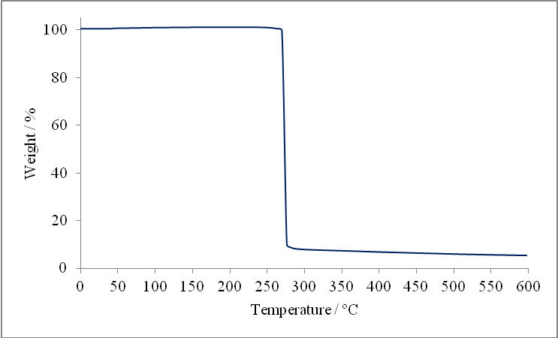
Figure 4. TGA curve of copper(II) complex

X-ray crystallography
Crystal structure of copper(II) complex, C₄H₁₆N₄Cu(ClO₄)₂ as shown in Figure 5 agreed with the data obtained from the physicochemical and the spectral studies. The structure of copper(II) complex was determined in a single crystal X-ray diffraction study. The X-ray of the single crystal structure for this copper(II) complex showed that the complex has a monoclinic system with a space group C 2/m, unit cell dimension with a = 12.4825(13) Å, b = 9.6470(11) Å and c = 5.7256(6) Å; α = 90º, β = 104.31º and γ = 90º. The crystallographic data, conditions for the collection of intensity data, and some features of the structure refinements are listed in Table 3. This complex formed an octahedral coordination with four nitrogen atoms in the basal plane and a definite coordination of two oxygen atoms from the perchlorate anion on the axial sites of the complex. The two Cu-O bonds (2.587 Å) were considerably shorter than the Van der Waals radii of copper and oxygen which was 2.92 Å and therefore proved that there was a definite coordination of oxygen to the copper centre. The selected bond lengths and bond angles are shown in Tables 4 and 5.

Table 3. Details of crystallographic data collection and structure refinement parameters
State | Data
Empirical formula | C4 H16 Cl2 Cu N4 O8
Formula weight | 382.65
Temperature | 300(2) K
Wavelength | 0.71073 Å
Crystal system | Monoclinic
Space group | C 2/m
Unit cell dimensions | a = 12.4825(13) Å α= 90°
 | b = 9.6470(11) Å β= 104.309(3)°
 | c = 5.7256(6) Å γ = 90°
Volume | 668.08(12) Å3
Z | 2
Density (calculated) | 1.902 Mg/m3
Absorption coefficient | 2.075 mm-1
F(000) | 390
Crystal size | 0.500 x 0.170 x 0.160 mm3
Theta range for data collection | 3.369 to 28.316°.
Index ranges | -16<=h<=15, -12<=k<=12, -6<=l<=7
Reflections collected/unique | 8144, 882 [R(int) = 0.0437]
Completeness to theta=28.32 | 99.8%
Refinement method | Full-matrix least-squares on F2
Data / restraints / parameters | 882 / 4 / 65
Goodness-of-fit on F^2 | 1.159
Final R indices [I>2sigma(I)] | R1 = 0.0384, wR2 = 0.0890
R indices (all data) | R1 = 0.0446, wR2 = 0.0921
Largest diff. peak and hole | 0.437 and -0.555 e.Å⁻³

Table 4. Selected bond lengths [Å] for the copper(II) complex
Bond | Bond length/[Å]
Cu(1)-N(1) | 2.011(3)
Cu(1)-N(1) | 2.011(3)
Cu(1)-N(1) | 2.011(3)
Cu(1)-N(1) | 2.011(3)
Cu(1)-O(1) | 2.587(3)
Cu(1)-O(1) | 2.587(3)

Table 5. Selected bond angles [°] for the copper(II) complex
Bond | Bond angle/[°]
N(1)-Cu(1)-N(1) | 180.0
N(1)-Cu(1)-N(1) | 95.30(18)
N(1)-Cu(1)-N(1) | 84.70(18)
N(1)-Cu(1)-N(1) | 84.70(18)
N(1)-Cu(1)-N(1) | 95.30(18)
N(1)-Cu(1)-N(1) | 180.0

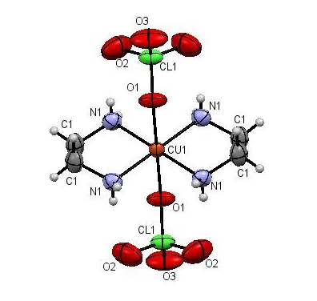
Figure 5. The ORTEP drawing of C₄H₁₆N₄Cu(ClO₄)₂ drawn at 50% probability ellipsoid

Conclusion
In the present communication, we have successfully synthesised and characterised copper(II) complex, C₄H₁₆N₄Cu(ClO₄)₂ in ionic liquid, [Bmim][PF₆]. Mass spectrum under ESI-condition was in line with the microelemental analysis, confirming the composition of the Cu(II) complex. Based on the analytical and spectral data, we assumed that the Cu(II) complex exhibited an octahedral geometry. TGA studies suggested that the complex was thermally stable up to 260 ºC before the major decomposition due to the loss of the organic moiety in the complex. X-ray crystallography also showed that copper ion was bound to two ethylene diamine ligands and two oxygen atoms of perchlorate ion forming an octahedral coordination. The full mechanism of this reaction is still under investigation as we are looking at the effect of using different types of ionic liquids in this reaction. We believe ionic liquid does not act only as a solvent but is also involved in this reaction.

Acknowledgement

The authors would like to thank the Faculty of Sciences and Technology, Universiti Kebangsaan Malaysia for providing necessary laboratory facilities and the lab assistants who were equally helpful in making this work. The authors also gratefully acknowledged the research grant from FRGS/1/2014/ST01/UKM/02/1 and GGPM2013-038 for financial support.

References
- Curtis, N. F. and House, D. A. (1961). Structure of some aliphatic Schiff base complexes of nickel(II) and copper(II). Chemistry and Industry, 6: 1708 – 1709.
- Chen, F. T., Lee, C. S. and Chung, C. S. (1983). Steric effects in the complexation kinetics of copper (II) with Rac-5,7,12,12,14-hexamethyl-1,4,8,11-tetraazacyclotetradecane in basic aqueous media. Polyhedron, 12(2): 1301 – 1306.
- Kou, F., Zhu, S., Lin, H., Chen, W., Chen, Y. and Lin, M. (1997). Kinetics and mechanism of the acid dissociation of copper(II) complex of novel c-functionalized macrocyclic dioxotetraamines. Polyhedron, 12(16): 2021 – 2028.
- Hay, R. W. and Pujari, M. P. (1985). The dissociation of [Cu(cyclen)]²⁺ in acid solution. A kinetic study. Inorganica Chimica Acta, 100(2): 1 – 3.
- Yusoff, L. M., Yusoff, S. F. M., Ismail, W. and Yamin, B. M. (2013). Synthesis and characterization of Ni(II) complex with 5,5,7,12,12,14-hexamethyl-1,4,8,11-tetraazacyclotetradeca-7,14-dienium bromide. AIP Conference Proceedings, (1614): 358 – 361.
- Huddin, A. A. S, Yamin, B. M. and Yusoff, S. F. M. (2014). Complexation of 5,5,7,12,12,14- hexamethyl-1,4,8,11-tetraazacyclotetradeca-7,14-dienium Bromide with copper Salts. AIP Conference Proceedings, (1614): 371 – 374.
- Ali. N. M., Hassan, N. H., Yamin, B. M., Karim, N. H. A. and Ghani, N. A. A. (2014). Synthesis and characterization of 5,5,7,12,12,14–hexamethyl -1,4,8,11-tetraazacyclotetradeca-7,14-dienium diperchlorate copper(II) complex. Malaysian Journal of Analytical Sciences, 18(3): 562 – 571.
- Shi, F. F. and He, X. L. (2011). Bromido(meso-5,5,7,12,12,14-hexamethyl-1,4,8,11-tetraazacyclotetradeca-1,7-diene)copper(II) bromide dehydrate. Acta Crystallographica Section E Structure Report Online, 67(5): 607.
- Yamin, B. M., Ismail, W. and Daran, J. C. (2012). Catena - Poly[[ (5,5,7,12,12,14 – hexamethyl - 1,4,8,11 – tetraazacyclotetradeca -1,7- diene) copper(II)] –μ– chloride - [dichlorocuprate(II)] -μ- chlorido]. Acta Crystallographica Section E Structure Report Online, 68(7): 886 – 887.
- Curtis, N. F. (2003). Fundamentals: Ligands, complexes, synthesis, purification and structure. Comprehensive Coordination Chemistry II: pp. 447 – 474.
- Szefczyk, B. and Sokalski, W. A. (2014). Physical nature of intermolecular interactions in [Bmim][PF6] ionic liquid. The Journal of Physical Chemistry B, 118: 2147 – 2156.
- Zhang, J., Luo, S., McCluskey, A. and Lawrance, G. A. (2013). Metal-templated macrocycle synthesis in an ionic liquid: A comparison with reaction in protic solvents. Synthesis and Reactivity in Inorganic, Metal-Organic, and Nano-Metal Chemistry. 43(1): 1 – 5.
- Sheldrick, G. M. (2008). A short history of SHELX. Acta Crystallographica Section A: Foundations of Crystallography, 64(1): 112 – 122.
- Sheldrick, G. M. (1993) SHELX-97, Program for the refinement of crystal structure. University of Göttingen.
- Gu, B. and Coates, J. D. (2006). Perchlorate: Environmental occurrence, interactions and treatment. Springer Science & Business Media: pp. 137.
- Saif, M., Mashaly, M. M., Eid, M. F. and Fouad, R. (2011). Synthesis and thermal studies of tetraaza macrocylic ligand and its transition metal complexes. DNA binding affinity of copper complex. Spectrochimica Acta Part A, 79: 1849 – 1855.
- Nakamoto, K. and Carthy, M. (1968). Spectroscopy and structure of metal chelate compound. John Wiley, New York.
- Procter, I. M., Hathaway, B. J. and Nicholls, P. (1968). The electronic properties and stereochemistry of the copper(II) ion. Part I. bis(ethylenediamine)copper(II) complexes. Journal of the Chemical Society A: Inorganic, Physical, Theoretical: 1678 – 1684.

