CHARCOAL BASE METALLIC COMPOSITE ELECTRODE FOR WASTEWATER TREATMENT

(Elektrod Komposit Logam Berasaskan Arang Bagi Rawatan Air Buangan)

Majd Ahmed Jumaah¹*, Mohamed Rozali Othman^{1, 2}, Muhammad Rahimi Yusop¹

¹School of Chemical Sciences and Food Technology, Faculty of Science and Technology

²Centre for Water Research and Analysis (ALIR), Faculty of Science and Technology

Universiti Kebangsaan Malaysia, 43600 UKM Bangi, Selangor, Malaysia

*Corresponding author: majd.ahmed88@yahoo.com

Received: 28 November 2016; Accepted: 6 March 2017

Abstract

In this study, a charcoal base metallic composite electrode which is low in cost and effective to treat wastewater from landfill leachate by electrochemical oxidation technique has been fabricated. The charcoal base metallic composite electrode was prepared by mixing together a weighed portion of charcoal, graphite and metals powder in different composition percentage with PVC as a binder in 4 mL THF which act as a solvent. Metals used in the preparation of the electrodes are Ag, Al, Co, Cu and Ni. The results show that the mixture of commercially available charcoal, metals and PVC at a composition of 50:20:30 (w/w), known as C50M20-PVC30 electrode give a good stability, low cost and high formation of OCl-. OCl- has been produced due to the presence of chloride ions that is responsible to make hypochlorite ions in order to degrade the pollutants in wastewater.

Keywords: charcoal, electrode, treatment, wastewater

Abstrak

Dalam kajian ini, elektrod komposit logam berasaskan arang dengan kos rendah dan efektif dalam merawat air buangan daripada larut resap tanah melalui teknik pengoksidaan elektrokimia telah dibangunkan. Elektrod komposit logam berasaskan arang telah disediakan dengan mencampurkan arang, grafit dan serbuk logam pada peratus komposisi yang berbeza di mana polivinil klorida sebagai pengikat di dalam 4 mL tetrahidrofuran (THF) sebagai pelarut. Logam yang digunakan dalam penyediaan elektrod ialah Ag, Al, Co, Cu dan Ni. Keputusan menunjukkan campuran arang komersial, logam dan PVC pada nisbah 50:20:30 (w/w), yang dikenali sebagai elektrod C50M20-PVC30 memberi kestabilan yang baik, berkos rendah dan menghasilkan OCl- yang tinggi. Semasa pengoksidaan elektrokimia, OCl- telah dihasilkan disebabkan oleh kehadiran ion klorida yang bertangungjawab membentuk ion hipoklorit bagi menyingkirkan bahan pencemar di dalam air buangan.

Kata kunci: arang, elektrod, rawatan, air sisa

Introduction

Water purification is one of the most pervasive problems affecting people throughout the world [1]. Various methods of treating of wastewater have been reported and this process is divided into three, namely chemical, physical and biological [2]. Up to now, electrochemical oxidation process has been proved to be promising for wastewater treatment mainly due to its high effectiveness, easy to operate and more economic [3, 4]. Especially in the case of landfill leachate, this has rich chloride ions and good conductivity. Many researchers have investigated the electrochemical oxidation of various types of wastewater including the leachate wastewater [5, 6]. Leachate can be categorized a liquid waste that contains high chemical oxygen demand (COD), high levels of ammonia and phosphorus as well as elevated values of total dissolved solid (TDS) [7]. To reach environmental friendly criteria for landfill leachate, these pollutant level should be minimized to an acceptable discharge limit [8].

The main aim of this study is evaluation of the effectiveness of electrochemical oxidation for leachate using charcoal base metallic composite electrode in terms of color removal and monitoring the characterization of the charcoal electrodes.

Materials and Methods

Preparation of electrodes

The composite electrodes at the composition of charcoal-metals-PVC were prepared accordingly as already discuss by other author elsewhere, by mixing together a weighed portion of charcoal powder, metals with PVC in 4 mL tetrahydrofuran (THF) solvent and swirled flatly to homogeneous followed by drying in an oven at 100˚ C for 3 hours. The mixture was then placed in 1 cm diameter stainless steel mould and pressed at 10 ton/cm [9]. The pellets were connected to silver wire with silver conducting paint prior covered with epoxy gum.

Experimental procedures

All experiments were carried out at lab ambient. The experiment equipment which consisted of a DC power supply, glass reactor and magnetic stirrer was added with a known amount of supporting electrolyte to 50 mL of leachate. The sample in the electrochemical cell was mixed at 300 rpm by a magnetic stirrer throughout the experiments to keep the sample homogeneous. The effect of pH was studied using HCl or NaOH to adjust the pH value. The effect of sodium chloride concentration as the supporting electrolyte was also evaluated. The reaction was started by applying the specified voltage. Samples were electrolyzed at different time, different operating parameters and analyzed at determine the removal efficiency (% R) of color during electrochemical treatment with respect to their initial values (equation 1) and was calculated by the following formula as reported by Majd et al. [10].

$\% R=\frac{\left[100 \left(R_{0}-R_{t}\right)\right]}{R_{0}}$ (1)

where % R is the removal percentage for color, R₀ is initial value of color, R_{t} is the value color at time t.

Sampling

Leachate samples were collected from Jeram Sanitary Landfill, which is situated in an oil palm plantation near Mukim Jeram, Kuala Selangor. The samples were transported to the laboratory and stored in a refrigerator at 4˚C prior analysis.

Results and Discussion

The stability of electrode

Different compositions of commercially available charcoal powder base metallic composite electrode were prepared from a mixture of commercially available charcoal powder and metal powders with PVC. Different types of metals consisting; silver (Ag), aluminum (Al), cobalt (Co), copper (Cu) and nickel (Ni) were used. All electrodes were tested to determine whether the mix of charcoal and metal powders can gave a high stability to use it in electrochemical treatment. Table 1 shows a summary of electrode stability of charcoal base metallic composite electrode.

The results show that ten groups of electrodes have good stability which can be used in electrochemical treatment for landfill leachate processes. At more than 80% (w/w) quantity of charcoal in the prepared the electrode shown Crumble, but when the PVC was increased, the stability of the electrode is good. This is due to PVC which acts as a binder and also the addition of PVC part of the porosity of the charcoal and also causes an increase in resistivity [10]. The amount of PVC therefore should be kept as low as possible, in order not to reduce surface area or conductivity in the electrode. At the same time, ample amount of PVC should be added to ensure that charcoal particles are compact and so that the electrode is manageable [11].

Table 1. The stability of commercially available charcoal powder base metallic composite electrode
Percentage % (w/w) |  |  | Electrode Stability
Charcoal | PVC | Metal Powder | Electrode Stability
10 | 10 | 80 | Hard
20 | 10 | 70 | Hard
30 | 15 | 60 | Hard
40 | 15 | 45 | Hard
50 | 20 | 30 | Hard
60 | 30 | 10 | Hard
70 | 20 | 10 | Hard
80 | 10 | 10 | Crumble
85 | 10 | 5 | Crumble
90 | 5 | 5 | Crumble
95 | 5 | - | Crumble
90 | 10 | - | Crumble
85 | 15 | - | Breakable
80 | 20 | - | Breakable
75 | 25 | - | Breakable
70 | 30 | - | Hard
60 | 40 | - | Hard
50 | 50 | - | Hard

Note: stability of electrode = The hardness of pellet after preparation

Optimization of anode material composition

Electrode materials have an effect on the efficiency of the electrochemical process for the wastewater treatment [12, 13]. In this study, various anode materials consists of charcoal, metal powder and PVC as binder were fabricated and landfill leachate was used as case study. The best electrode was selected based on the color removal from leachate under the operating condition of applied voltage of 10 V, different electrolysis time and NaCl concentration of 1.5% (w/v) was chosen. The costs of all electrodes used in this study were calculated based on the price of Sigma-Aldrich Company. The results obtained are as summarized in Table 2.

Table 2. Electrochemical oxidation of landfill leachate in 1.5% w/v, NaCl using various charcoal base metallic composite electrode as an anode and stainless-steel rod as cathode, voltage of 10V was applied with different electrolysis time

Electrode | Electrolysis Time (min) | Decoloring (%) | Observation |  | Cost  USD | OCl- Production  Abs
Electrode | Electrolysis Time (min) | Decoloring (%) | Electrolysis Product | Anode | Cost  USD | OCl- Production  Abs
C50Ag20PVC30 | 360 | 61 | Yellowish  Solution | Slightly corroded | 1.13 | 3.9
C50Co20PVC30 | 120 | 58 | Yellowish  Solution | Unchanged | 0.30 | 1.2
C50Cu20PVC30 | 180 | 44 | Yellowish  Solution | Completely corroded | 1 | -
C50Al20PVC30 | 300 | 23 | Yellowish  Solution | Unchanged | 0.15 | 0.3
C50Ni20PVC30 | 360 | 4 | Color unchanged | Completely corroded | 0.97 | -
C60Ag10PVC30 | 180 | 33 | Yellowish  Solution | Slightly corroded | 0.63 | 1
C60Co10PVC30 | 120 | 29 | Yellowish  Solution | Unchanged | 0.20 | 0.7
C60Cu10PVC30 | 180 | 22 | Yellowish  Solution | Completely corroded | 0.86 | -
C60Al10PVC30 | 180 | 7 | Color unchanged | Unchanged | 0.13 | 0.08
C60Ni10PVC30 | 180 | 5 | Color unchanged | Completely corroded | 0.71 | -
C70Ag10PVC20 | 180 | 32 | Yellowish  Solution | Slightly corroded | 0.60 | 0.9
C70Co10PVC20 | 240 | 32 | Yellowish  Solution | Unchanged | 0.19 | 0.4
C70Cu10PVC20 | 180 | 28 | Yellowish  Solution | Completely corroded | 0.81 | -
C70Al10PVC20 | 180 | 9 | Color unchanged | Unchanged | 0.11 | 0.05
C70Ni10PVC20 | 240 | 6 | Color unchanged | Completely corroded | 0.67 | -

Note: OCl- = the formation of OCl- in 50 mL deionized water, 1.5% (w/v) NaCl and 30 min electrolysis time for only the stable electrodes.

The result as summarized in Table 2. shown that the best electrode which gave 58% color removal without any change in its physical properties is with the composition of C50Co20PVC30. Although at the composition of C50Ag20PVC30 where the color removal was 61% but the stability is low and the cost to fabricate the electrode is a bit higher. As the electrode used in any electrochemical process should be stable chemically and physically [14, 15], so based on these criteria, the selection of the best electrode is not only to remove the color, but also on the basis of chemical stability. The best composition electrode was then used for further study.

In a separate experiment, formation of OCl- has been investigated by adding 1.5% (w/v) NaCl to 50 mL of deionized water by using only the stable electrodes in Table 2. During electrolysis, OCl- has been produced due to the presence of chloride ions that is responsible to make hypochlorite ions to degrade the pollutants in leachate [16]. The formation of OCl- in aqueous solution has been monitored using UV-visible spectrophotometer. The compare between the four properties (color, cost, OCl- formation and electrode stability) to determine the best electrode and the results obtained is as shows in Figure 1.

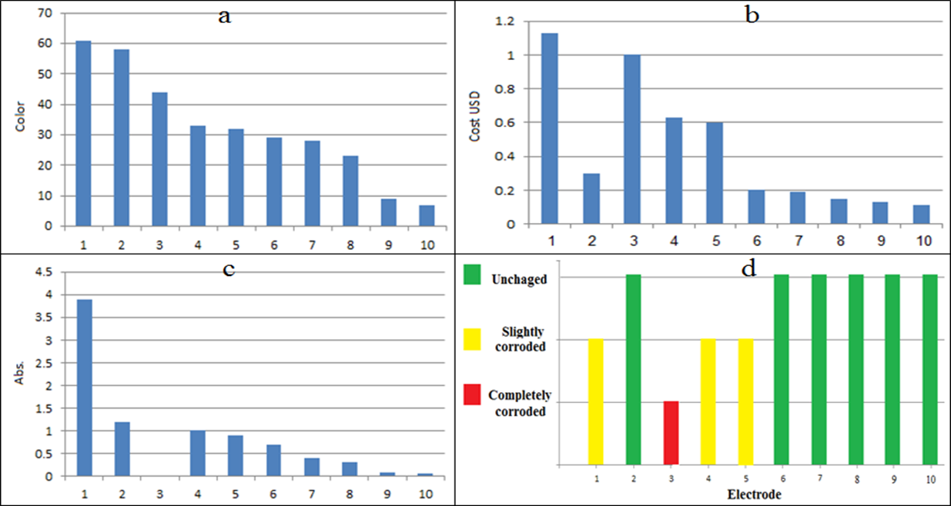

Note 1: C50Ag20PVC30, 2: C50Co20PVC30, 3: C60Ag10PVC30, 4: C70Ag10PVC30, 5: C70Ag10PVC20, 6: C60Co10PVC30, 7: C70Co10PVC30, 8: C50Al20PVC30, 9: C60Al10PVC30 and 10: C70Al10PVC20

Figure 1. Various charcoal base metallic composite electrode as an anode using in electrochemical oxidation, a) color removal, b) electrode cost in USD, c) OCl- formation in deionize water and d) electrode stability

In the light of above results, it could be concluded that, C50Co20PVC30 composition electrode was considered as an optimum electrode due to highest color removal in landfill leachate, low cost, good production of hypochlorite (OCl-) that could oxidize colored substances and stable chemically and physically [17, 18]. C50Ag20PVC30 composition electrode also has color removal more than C50Co20PVC30 composition electrode and the formation of OCl- was 3.9, but has high cost and the electrode slightly corroded after electrolysis. The formations of OCl- didn’t measure for C50Cu20PVC30, C50Ni20PVC30, C60Cu10PVC30, C60Ni10PVC30, C70Cu10PVC20 and C70Ni10PVC20 composition electrodes, due to the stability of electrode not good were completely corroded.

