Dr. Siti Fairus Mohd Yusoff
Senior Lecturer
School of Chemical Sciences and Food Technology
Faculty of Science and Technology
The National University of Malaysia
43600 Bangi, Selangor
Malaysia

Dr. Wan Mohd Afiq Wan Mohd Khalik
Executive Editor
Malaysian Journal of Analytical Science (MJAS)
Persatuan Sains Analisis Malaysia

December 12th, 2017
RE: Galley Proofs Corrections of Research Article

Dear Dr. Wan Mohd Afiq:
Thank you very much for your e-mail regarding the galley proofs of our manuscript for publication in the Malaysian Journal of Analytical Science (MJAS).
With regards to your email, we want to make the following changes:
Composition changes:

- We should change “…resonans magnet nukleus…” to “…resonans magnet nukleus ¹H…” (Abstrak part, page 0).
- We should change “…Mahittikul et al. report…” to “…Mahittikul et al. reported an…” (Introduction part, paragraph 2, page 1).
- We should change Scheme 1 (Introduction part, page 1),
From 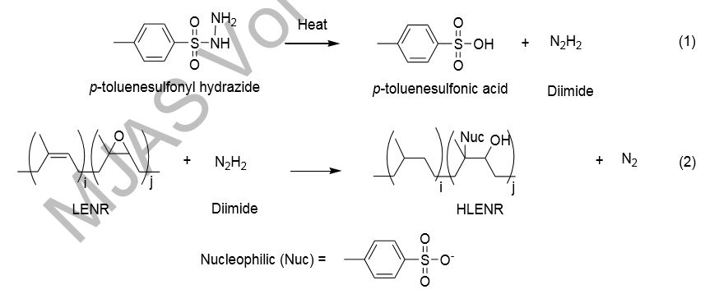
To 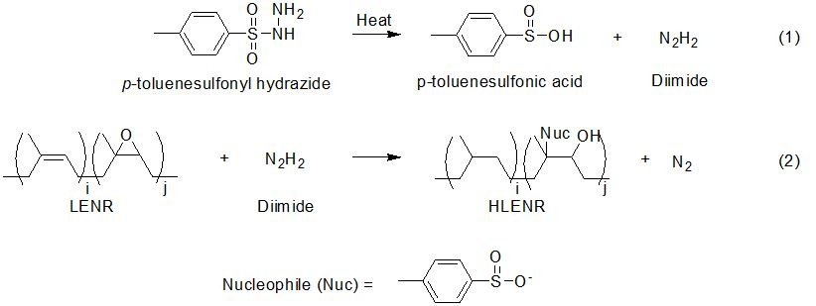
4. We should change “…any change…” to “…any changes…” (Characterization part, line 2, page 2).
5. We should change “…GUP-2015-020…” to “…GUP-2017-004…” (Acknowledgement part, page 7).

We hope that our revisions are satisfactory.

With kind regards,

Dr. Siti Fairus Mohd Yusoff
Senior Lecturer
School of Chemical Sciences and Food Technology
Faculty of Science and Technology
The National University of Malaysia
E-mail: sitifairus@ukm.edu.my
Fax:+603-89215490

