SYNTHESIS, MODIFICATION, CHARACTERIZATION
AND BIOLOGICAL ACTIVITY OF
3 HYDROXYBENZALDEHYDESALICYLHYDRAZIDE

(Sintesis, Modifikasi, Pencirian dan Aktiviti Biologi
3-Hidroksibenzaldehidesalisilhidrazida)

Nornadia Jasin¹, Meng Guan Tay¹, Hashimatul Fatma Hashim²
¹Department of Chemistry,
²Department of Molecular Biology,
Faculty of Resource Science and Technology,
Universiti Malaysia Sarawak, 94300 Kota Samarahan, Sarawak, Malaysia

*Corresponding author: nornadiajasin@gmail.com
Abstract
A series of hydrazone Schiff base (compounds S, S8, S10 and S12) were synthesized by condensation reaction of salicylhydrazide with 3-hydroxybenzaldehyde, 3-(octyloxy)benzaldehyde, 3-(decyloxy)benzaldehyde and 3-(dodecyloxy) benzaldehyde, respectively. Herein, the addition of alkane numbers also been reported using suscessful Williamson etherification method by reacting 3-hydroxybenzaldehyde with bromooctane, bromodecane and bromododecane, respectively. All compounds were characterised using Fourier Transformation Infrared and ¹H Nuclear Mangnetic Resonance spectroscopic. The compounds were assayed to antibacterial activity against gram-positive and gram-negative bacteria using Bacillus cereus and Escherichia coli by disc diffusion method. Interestingly, among the compounds tested S8 showed a strong inhibition against Escherichia coli and none of the compounds tested show significant result against Bacillus cereus.

Keywords : 3-hydroxybenzaldehyde, Williamson etherification, hydrazone Schiff base, antibacterial activity

Abstrak
Satu siri bes Schiff hidrazon (sebatian S, S8, S10 dan S12) telah disintesis mengunakan tindakbalas pemeluwapan oleh salisilhidrazida dengan 3-hidroksibenzaldehid, 3-(oktiloksi)benzaldehid, 3-(deciloksi)benzaldehid dan 3-(dodeciloksi) benzaldehid. Di sini, penambahan nombor alkana juga telah dilaporkan menggunakan kaedah pengeteran Williamson yang berjaya daripada tindak balas 3 -hidroksibenzaldehid dengan bromooktana, bromodekana dan bromododekana. Semua sebatian telah dicirikan menggunakan spektroskopi inframerah transformasi Fourier dan ¹H nukleus magnetik resonan. Sebatian yang terhasil telah diuji dengan aktiviti antibakteria terhadap bakteria gram-positif dan gram- negatif menggunakan Bacillus cereus dan Escherichia coli dengan kaedah cakera resapan. Menariknya, diantara sebatian yang telah diuji, S8 menunjukkan perencatan yang kuat terhadap Escherichia coli dan tiada sebatian menunjukkan hasil yang ketara terhadap Bacillus cereus.

Kata kunci : 3- hidroksibenzaldehid, pengeteran Williamson, bes Schiff hidrazon, aktiviti antibakteria

Introduction
Hydrazone Schiff base compounds have been widely reported regarding its effectiveness in biological activities including antibacterial [1], antifungal, antituberculosis [2], anticancer and antimalarial activities [3]. This is due to the presence of azomethine C=N group. The nitrogen atom of the schiff base contains a lone pair electron with sp² hybridised orbital that contributes to various biological and chemical properties [4]. In most cases, the structure of hydrazone Schiff base is the main factor in controlling the biological activites. As some reports demostrated that the antibacterial activity of some compounds become enhance by controlling the lipophilicity [5, 6], stereochemistry and the nucleophilicity of the compounds [5]. Due to this reason, in order to increase the lipophilic ability of the compound which increasing the antibacterial property, Williamson etherification method was introduced to prolong the side chains of parent ligands by addition of C8, C10 and C12 alkyl chains in the compounds.

In this study, we herein report the synthesis, modification, characterization and antibacterial studies of hydrazone shiff base namely 3-hydroxybenzaldehyde salicylhydrazide, 3-(octyloxy)benzaldehyde salicylhydrazide, 3-(decyloxy)benzaldehyde salicylhydrazide and 3-(dodecyloxy)benzaldehyde salicylhydrazide.

Materials and Methods
Materials and characterizations
3-hydroxybenzaldehyde, salicylhydrazide, 1-bromooctane, 1-bromodecane and 1-bromododecane were obtained from Sigma Aldrich and Fluka. All chemicals and solvent were used as received without further purification.
The infrared spectra were recorded using Thermo Scientific/Nicolet iS10 Fourier Transform Infrared spectrophotometer. The ¹H and ¹³C NMR spectrum were recorded on a JEOL ECA-500 MHz NMR spectrophotometer and the chemical shift were reported relative to TMS and were referenced via residual proton NMR resonances of the appropriate diturated solvent (DMSO-d₆: 2.50 ppm).
Etherification of 3-hydroxybenzaldehyde (T) to 3-alkoxybenzaldehyde (T8 – T12)
3-alkoxybenzaldehydes were prepared by a reported method with slightly alteration using 1-bromooctane, 1-bromodecane and 1-bromododecane [7]. The reaction was prepared by addition of ethanolic 3-hydroxybenzaldehyde (0.488g, 4 mmol) solution, anhydrous K₂CO₃ (1.035g, 7.5 mmol) and corresponding n-alkyl bromide (6 mmol) into the round bottom flask with present of KI and 20 ml of absolute ethanol as a solvent. The reaction mixture was heated under reflux for 20 hours and allowed to cool at room temperature. Then, the solution was transfered into separatory funnel and distilled water was added into the mixture and oily layer of 3-alkoxybenzaldehyde was formed. The mixture was extracted twice with diethyl ether (2 x 15 ml). Lastly, 5% NaOH solution (10 ml) was added into the mixture and distilled water was used to alter the mixture into pH 7. The oily ether extract was collected and dried under room temperature.

Synthesis of 3-hydroxybenzaldehydesalicylhydrazide (S) and 3-alkoxybenzaldehydesalicylhydrazide (S8 –S12))
Salicylhydrazide (0.304g, 2 mmol) was dissolved in 20 ml of absolute ethanol in a round bottom flask with constant stirring. Ethanolic solution of 3-hydroxybenzaldehyde (T) or 3-alkoxybenzaldehydes (T8 – T12) (3 mmol) was then added dropwise into the mixture. The reaction mixture was refluxed with constant stirring for 20 hours and allowed to cool at room temperature. The precipitate formed was filtered and washed several times with ethanol and dried in vacuo.

Antibacterial screening
Compounds S, S8, S10 and S12 were screened for their antibacterial property using disc diffusion method against Bacillus cereus and Escherichia coli. These bacteria were inoculated and incubated into Luria Bertani (LB) broth for 16 hours in an incubator at 37 °C. The culture was then diluted with a fresh LB broth and adjusted to 0.168 at wavelength of 550 nm in a UV-Vis spectrophotometer which represent 2.0 x 10⁶ (CFU/ml). A sterile cotton swab was lightly dipped into the culture and evenly inoculated into LB agar. After that, sterile 6mm paper disc was placed on agar in equal distance. Subsequently, 20 µl of compounds at 250 ppm in EtOH were dispensed individually to each of the disc and EtOH itself was tested to act as control. The agar plate was incubated at 37 °C for 24 hours. The presence of inhibition zone was recorded and measured in diameter (mm).

Results and Discussion
Characterization study: 3-octyloxybenzaldehyde (T8)
Colour: Oily yellowish brown. Yield: 57%. Main IR peaks (cm⁻¹): ν(C-H) aliphatic (CH₂) 2924, ν(C-H) alkanes
(CH₃) 2854, ν(C=O) 1697, ν(C-O) 1260. ¹H NMR (DMSO-d6, ppm): 9.96 (s, 1H, HC=O); 7.49 – 7.21 (m, 4H, H_{aromatic}); 4.02 – 3.99 (t, 2H, HC-O); 1.42 – 1.23 (m, 15H, H_{alkanes}): ¹³C NMR (DMSO-d6, ppm): 192.97 (HC=O); 159.20 (C-O); 137.65 – 113.59 (aromatic); 67.75 – 13.98 (aliphatic).

3-decyloxybenzaldehyde (T10)
Colour: Oily yellowish brown. Yield: 59%. Main IR peaks (cm⁻¹): ν(C-H) aliphatic (CH₂) 2922, ν(C-H) alkanes
(CH₃) 2853, ν(C=O) 1697, ν(C-O) 1260. ¹H NMR (DMSO-d6, ppm): 9.95 (s, 1H, HC=O); 7.50 – 7.22 (m, 4H, H_{aromatic}); 4.01 – 3.98 (t, 2H, HC-O); 1.38 – 1.23 (m, 17H, H_{alkanes}): ¹³C NMR (DMSO-d6, ppm): 192.93 (HC=O); 159.20 (C-O); 137.64 – 113.53 (aromatic); 67.73-13.96 (aliphatic).

3-dodecyloxybenzaldehyde (T12)
Colour: Oily yellowish brown. Yield: 60%. Main IR peaks (cm⁻¹): ν(C-H) aliphatic (CH₂) 2921, ν(C-H) alkanes
(CH₃) 2852, ν(C=O) 1699, ν(C-O) 1260. ¹H NMR (DMSO-d6, ppm): 9.96 (s, 1H, HC=O); 7.49 – 7.24 (m, 4H, H_{aromatic}); 4.02 – 3.99 (t, 2H, HC-O); 1.39 – 1.21 (m, 19H, H_{alkanes}): ¹³C NMR (DMSO-d6, ppm): 192.95 (HC=O); 159.20 (C-O); 137.64 – 113.54 (aromatic); 67.74 – 13.98 (aliphatic).

3-hydroxybenzaldehydesallycylhydrazide (S)
Colour: White fluffy paper-like structure. Yield: 98%. Main IR peaks (cm⁻¹): ν(NH) 3255, ν(O-H) 3059, ν(C=O) 1643, ν(C=N) 1611, ν(N-N) 1147. ¹H NMR (DMSO-d6, ppm): 8.36 (s, 1H, HC=N); 9.69 (s, 1H, NH); 11.84 (s, 2H, OH); 7.89 – 6.83 (m, 8H, H_{aromatic}): ¹³C NMR (DMSO-d6, ppm): 148.77 (C=N); 157.74 (C-O); 135.43 –116.01 (aromatic).

3-octyloxybenzaldehydesallycylhydrazide (S8)
Colour: White needle shape crystal. Yield: 89%. Main IR peaks (cm⁻¹): ν(NH) 3246, ν(O-H) 3045, ν(C-H) aliphatic (CH₂) 2916, ν(C-H) alkanes (CH₃) 2846, ν(C=O) 1658, ν(C=N) 1627, ν(C-O) 1278, ν(N-N) 1145. ¹H NMR (DMSO-d6, ppm): 8.42 (s, 1H, HC=N); 10.28 (s, 1H, NH); 11.89 (s, 1H, OH); 7.92 – 6.98 (m, 8H, H_{aromatic}); 4.01 – 3.98 (t, 2H, HC-O); 1.41 – 1.25 (m, 15H, H_{alkanes}): ¹³C NMR (DMSO-d6, ppm): 148.50 (C=N); 159.02 (C-O); 135.56 – 116.06 (aromatic); 67.54 – 14.00 (aliphatic).

3-octyloxybenzaldehydesallycylhydrazide (S10)
Colour: White granules. Yield: 92%. Main IR peaks (cm⁻¹): ν(NH) 3246, ν(O-H) 3049, ν(C-H) aliphatic (CH₂) 2918, ν(C-H) alkanes (CH₃) 2849, ν(C=O) 1658, ν(C=N) 1626, ν(C-O) 1278, ν(N-N) 1147. ¹H NMR (DMSO-d6, ppm): 8.41 (s, 1H, HC=N); 10.27 (s, 1H, NH); 11.88 (s, 1H, OH); 7.90 – 6.94 (m, 8H, H_{aromatic}); 4.01 – 3.98 (t, 2H, HC-O); 1.41 – 1.24 (m, 17H, H_{alkanes}): ¹³C NMR (DMSO-d6, ppm): 148.53 (C=N); 159.03 (C-O); 135.56 – 116.01 (aromatic); 67.53 – 14.03 (aliphatic).

3-octyloxybenzaldehydesallycylhydrazide (S12)
Colour: White granules. Yield: 93%. Main IR peaks (cm⁻¹): ν(NH) 3246, ν(O-H) 3043, ν(C-H) aliphatic (CH₂) 2918, ν(C-H) alkanes (CH₃) 2847, ν(C=O) 1655, ν(C=N) 1625, ν(C-O) 1277, ν(N-N) 1148. ¹H NMR (DMSO-d6, ppm): 8.41 (s, 1H, HC=N); 10.27 (s, 1H, NH); 11.89 (s, 1H, OH); 7.92 – 6.93 (m, 8H, H_{aromatic}); 4.00 – 3.98 (t, 2H, HC-O); 1.41 – 1.22 (m, 19H, H_{alkanes}): ¹³C NMR (DMSO-d6, ppm): 148.51 (C=N); 159.02 (C-O); 135.55 – 115.99 (aromatic); 67.52 – 14.01 (aliphatic).

Spectroscopic studies: Etherification of 3-hydroxybenzaldehyde
The yield of 3-(alkoxy)benzaldehyde from the reaction of 3-hydroxybenzaldehyde with 1-bromooctane, 1-bromodecane and 1-bromododecane, respectively were shown in Scheme 1. All figures shown were corresponding to T8 and S8, while the rest of the data were tabulated in Table 1 till Table 3.
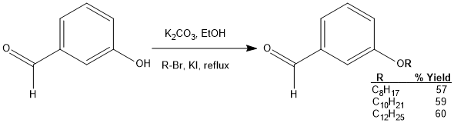
Scheme 1. Etherification of 3-hydroxybenzaldehyde
The IR spectrum of T8 in Figure 1 shows the disappearance of ν(-OH) peak compared to the IR spectrum of 3-hydroxybenzaldehyde at 3194 cm⁻¹ and the appearance of new peaks attributed to ν(-CH₃) alkyl chain in range of 2854 and 2924 cm⁻¹. The intensity of the peaks is depended on the length of an alkyl chain presence in the compounds; the longer alkyl chains the stronger intensity of the peak and vice versa.

Similarly, the ¹H NMR spectra of the three etherified products (i.e. ¹H NMR spectrum of T8 in Figure 2) showed the disappearance of OH⁻ signal at 10.10 ppm and the existence of new proton signals for the alkoxy group at the high field region (δ: 1.00 – 4.00 ppm) has indicated the success of the etherification of 3-hydroxybenzaldehyde.

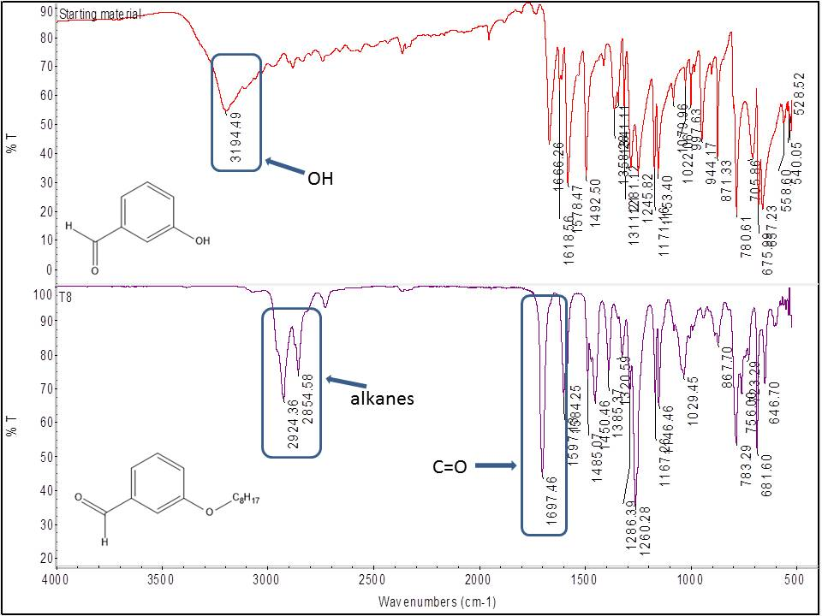
Figure 1. IR spectra of 3-hydroxybenzaldehyde (top) and T8 (bottom)
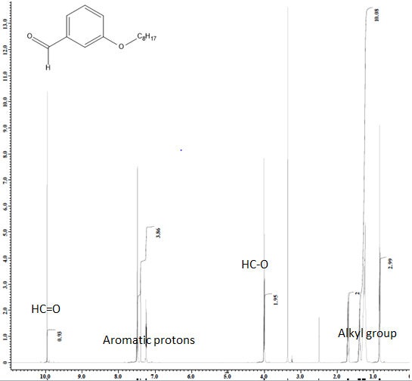
Figure 2. ¹H NMR spectrum of T8

Characterization of hydrazone Schiff base
The yield of 3-(alkoxy)benzaldehydesalicylhydrazide were shown in Scheme 2.

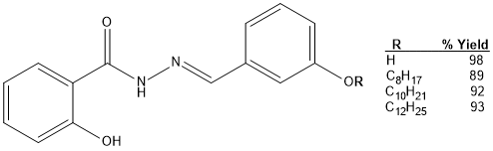
Scheme 2. Percentage yield of 3-(alkoxy)benzaldehydesalicylhydrazide
The IR spectrum of S8 is shown in Figure 3. The disappearance of ν(C=O) peak in 3-(octyloxy)benzaldehyde at 1697 cm⁻¹ and appearance of new peaks at 1627, 3045 and 3246 cm⁻¹ was attributed to ν(C=N) stretching, ν(-OH) and ν(-NH) of S8, respectively.

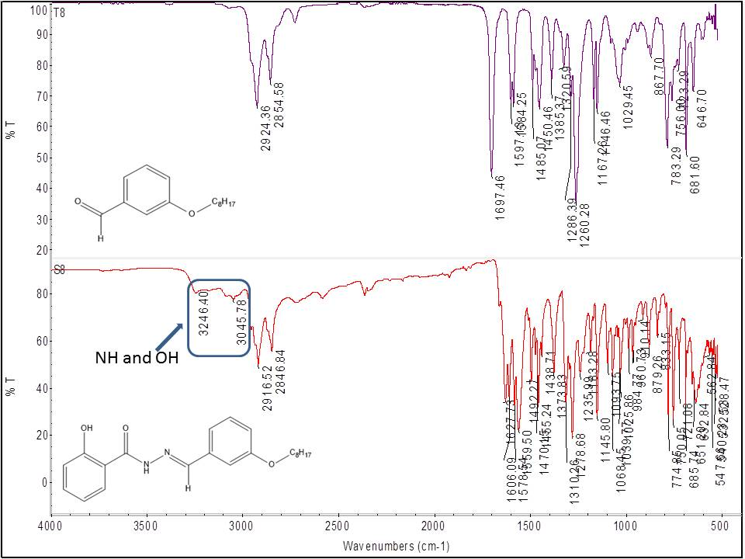
Figure 3. IR spectra of T8 (top) and S8 (bottom)
The ¹H NMR spectrum of S8 is shown in Figure 4. Similarly, the formation of S8 can be represented by the deshielded of HC=N resonance at 8.42 ppm. This is due to the formation of C=N from C=O. In addition, the appearance of new peaks at 10.28 and 11.89 ppm confirmed the presence of NH and OH supporting the formation of S8.

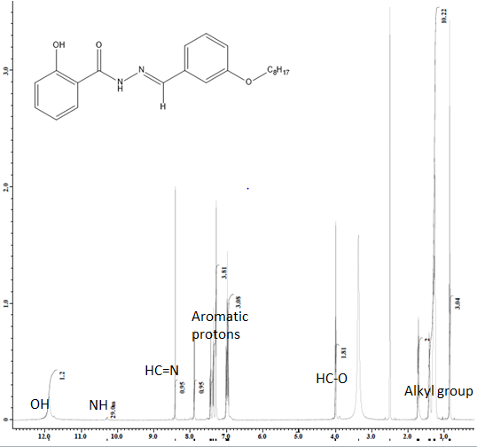
Figure 4. ¹H NMR spectrum of S8
Table 1. Data of infrared spectroscopy (cm⁻¹)
Compound | ν(NH) | ν(O-H) | ν(C-H) aliphatic (CH₂) | ν(C-H) alkanes  (CH₃) | ν(C=O) | ν(C=N) | ν(C-O) | ν(N-N)
T8 | - | - | 2924 | 2854 | 1697 | - | 1260 | -
T10 | - | - | 2922 | 2853 | 1697 | - | 1260 | -
T12 | - | - | 2921 | 2852 | 1699 | - | 1260 | -
S | 3255 | 3059 | - | - | 1643* | 1611 | - | 1147
S8 | 3246 | 3045 | 2916 | 2846 | 1658* | 1627 | 1278 | 1145
S10 | 3246 | 3049 | 2918 | 2849 | 1658* | 1626 | 1278 | 1147
S12 | 3246 | 3043 | 2918 | 2847 | 1655* | 1625 | 1277 | 1148
*Due to present of another C=O at salicylhydrazide side
Table 2. Data of ¹H NMR spectroscopy (ppm)
Compound | HC=O | HC=N | NH | OH | H_{aromatic} | H_{alkanes}
T8 | 9.96 s | - | - | - | 7.49 – 7.21m | 1.42 – 1.23 m
T10 | 9.95 s | - | - | - | 7.50 – 7.22 m | 1.38 – 1.22 m
T12 | 9.96 s | - | - | - | 7.49 – 7.24 m | 1.39 – 1.21 m
S | - | 8.36 s | 9.69 s | 11.84 s | 7.89 – 6.83 m | -
S8 | - | 8.42 s | 10.28 s | 11.89 s | 7.92 – 6.98 m | 1.41 – 1.25 m
S10 | - | 8.41 s | 10.27 s | 11.88 s | 7.90 – 6.94 m | 1.41 – 1.24 m
S12 | - | 8.41 s | 10.27 s | 11.89 s | 7.90 – 6.93 m | 1.41 – 1.22 m

Table 3. Data of ¹³C NMR spectroscopy (ppm)

Compound | HC=O | HC=N | C-O | C_{aromatic} | C_{aliphatic}
T8 | 192.97 | - | 159.20 | 137.65-113.59 | 67.75-13.98
T10 | 192.93 | - | 159.20 | 137.64-113.53 | 67.73-13.96
T12 | 192.95 | - | 159.20 | 137.64-113.54 | 67.74-13.98
S | - | 148.77 | 157.74 | 135.43-116.01 | -
S8 | - | 148.50 | 159.02 | 135.56-116.06 | 67.54-14.00
S10 | - | 148.53 | 159.03 | 135.56-116.01 | 67.53-14.03
S12 | - | 148.51 | 159.02 | 135.55-115.99 | 67.52-14.01

Antibacterial screening
The antibacterial activity of hydrazine Schiff base compounds S, S8, S10 and S12 were examined using disc diffusion method and the result were illustrated in Figure 5. The results show that, there is no significant inhibition of all the tested compounds to the activity of gram-positive bacteria represented by Bacillus cereus. On the other hand, there were strong inhibitions shown for the gram-negative bacteria, Escherichia coli. The increase of carbon chains in the structure has enhanced the inhibitory of bacteria activity. However, the activity showed slightly decrease as the length of carbon chain extended to C12. By these results, it is suggested that the moderate carbon chain size of lipophilic substituents might be vital for the optimal antimicrobial activity.

Figure 5. Antibacterial activity against Escherichia coli
Conclusion
Hydrazone shiff base 3-hydroxybenzaldehyde salicylhydrazide (S), 3-(octyloxy)benzaldehyde salicylhydrazide (S8), 3-(decyloxy)benzaldehyde salicylhydrazide (S10) and 3-(dodecyloxy)benzaldehyde salicylhydrazide (S12) were successfully synthesised and characterized using FTIR, ¹H NMR and ¹³C NMR. The presence of long carbon chain in the structure has enhanced the antibacterial activity which in good agreement with lipophilic effect. However, the result suggested that there is an optimum carbon chain number that give the highest inhibitory effect in antibacterial grow for gram-negative bacteria while non affect can be observed in gram-positive tested bacteria.

Acknowledgement
The authors would like to express their sincere appreciation to Malaysian Ministry of Higher Education for financial support under the research grant number of RAGS/ST01/(1)/1038/2013/(05).

References

- Khanmohammadi, H., Abnosi, M. H., Hosseinzadeh, A. And Erfantalab, M. (2008). Synthesis, biological and computational study of new Schiff base hydrazones bearing 3-(4-pyridine)-5-mercapto-1,2,4-triazole moiety. Spectrochimica Acta Part A, 71: 1474 – 1480.
- Hearn, M. J., Cynamon, M. H., Chen, M. F., Coppins, R., Davis, J., Kang, H. J. O., Noble, A., Sekine, B. T., Terrot, M. S., Trombino, D., Thai, M., Webster, E. R. and Wilson, R. (2009). Preparation and antitubercular activities in vitro and in vivo of novel Schiff base of isoniazid. European Journal of Medicinal Chemistry, 44: 4169 – 4178.
- Walcourt, A., Loyevsky, M., Lovejoy, D. B., Gordeuk, V. R. and Richardson, D. R. (2004). Novel aroylhydrazone and thiosemicarbazone iron chelators with anti-malarial activity against chloroquine-resistant and –sensitive parasites. The International Journal of Biochemistry & Cell Biology, 36: 401 –407.
- Mishra, N., Poonia, K. and Kumar, D. (2013). An overview of biological aspects of Schiff base metal complexes. International Journal of Advancements in Research & Technology, 2(8): 52 – 66.
- Devinsky, F. and Gorrod, J. W. (1987). Microsomal N-oxidation of long chain N,N-dimethylalkylamines: Quantitative structure-activity relationships. European Journal of Drug Metabolism and Pharmacokinetics, 12: 267 – 273.
- Park, K. D., Park, Y. S., Cho, S. J., Sun, W. S., Kim, S. H., Jung, D. H. and Kim, J. H. (2004). Antimicrobial activity of 3-O-acyl-(-)-epicatechin and 3-O-acyl-(+)-catechin derivatives. Planta Medica, 70: 272 – 276.
- Tay, M. G., Ngaini, Z., Sarih, N. M., Foo, S.W. and Tiong, M. H. (2011). A convenient way for the etherification of p-hydroxyacetophenone. Research Bulletin, Faculty of Resource Science and Technology, Universiti Malaysia Sarawak: pp. 1 – 3.

