PERFORMANCE ENHANCEMENT OF DYE SENSITIZED SOLAR CELL USING GRAPHENE OXIDE DOPED TITANIUM DIOXIDE PHOTOELECTRODE

(Peningkatan Prestasi Bagi Sel Suria Pemeka Warna Menggunakan Grafin Oksida di dalam Titanium Dioksida Sebagai Fotoelektrod)

Ahmad Muslihin Ramli, Mohd Zikri Razali, Norasikin Ahmad Ludin*
Solar Energy Research Institute, Universiti Kebangsaan Malaysia, 43600 Bangi, Selangor, Malaysia
*Corresponding author: sheekeen@ukm.edu.my
Abstract
Dye-sensitized solar cell (DSSCs) is one of the photovoltaic cells that have attracted extensive research over decade. In this study, different weight percentage (wt.%) of graphene oxide (GO) was used with titanium dioxide (TiO₂) as photoelectrode in DSSCs. GO was synthesized by simplified Hummer’s method at ambient temperature. The amount of GO in composite film are designed from 0.0 wt.%, 0.4 wt.%, 0.6 wt. % and 0.8 wt.%. The prepared samples were characterized by Field Emission Scanning Electron Microscopy (FESEM), X-ray Diffraction (XRD), Atomic Force Microscopy (AFM) and Incident Photon to Current Efficiency (IPCE). The photocurrent-voltage characteristics of the fabricated dye sensitized solar cells were examined using a solar simulator under 100 mW/cm² AM 1.5 xenon illumination. The results indicated that optimum the power conversion efficiency (PCE) was obtained for the device doped with 0.6 wt.% GO with the short circuit current density (J_{sc}), open circuit voltage (V_{oc}) and PCE of 9.8 mA/cm², 0.7 V and 3.7 %, respectively. It was observed that the introduction of 0.6 wt.% GO into TiO₂ photoelectrode has successfully increased the performance of DSSCs as much as 28% compared to the sample without GO. This is due to the increment in dye absorption and enhanced electron transportation as proven by IPCE analysis.

Keywords: Dye sensitized solar cells, graphene oxide, photoelectrode, power conversion efficiency, titanium dioxide

Abstrak
Sel suria pemeka warna (DSSCs) adalah salah satu sel fotovolta yang telah menarik minat penyelidik sejak kebelakangan ini. Dalam kajian ini, peratusan berat grafin oksida (GO) yang berbeza telah digunakan bersama titanium dioksida (TiO₂) sebagai fotoelektrod di dalam DSSCs. GO telah disintesis dengan kaedah Hummer dipermudah pada suhu persekitaran. Jumlah GO dalam filem komposit telah ditetapkan dari 0.0 wt.%, 0.4 wt.%. 0.6 wt.% dan 0.8 wt.%. Sampel-sampel yang disediakan telah dicirikan dengan menggunakan analilsis Mikroskopi Imbasan Pancaran Medan Elektron (FESEM), Analisis Pembelauan sinar-X (XRD), Analisis Mikroskopi Daya Atom (AFM) dan analisis kejadian foton kepada keberkesanan pembawa arus (IPCE). Ciri – ciri fotoarus-voltan bagi sel suria pemeka warna telah diperiksa menggunakan simulator suria dengan intensiti dikawal pada 100 mW/cm² AM 1.5 pengcahayaan. Keputusan menunjukkan bahawa kecekapan penukaran kuasa (PCE) yang optimum telah dicatatkan oleh peranti DSSC yang ditambah 0.6 wt.% GO, dengan ketumpatan arus litar-pintas (J_{sc}), voltan litar-terbuka (V_{oc}) dan PCE masing-masing adalah 9.8 mA/cm², 0.7 V dan 3.7 %. Ini jelas menunjukkan bahawa penambahan 0.6 wt.% GO ke dalam TiO₂ fotoelektrod telah meningkatkan kecekapan prestasi bagi DSSCs sebanyak 28% berbanding dengan sampel tanpa GO. Peningkatan ini disebabkan oleh peningkatan penyerapan pewarna dan pengangkutan elektron seperti yang dibuktikan dalam analisis IPCE.

Kata kunci: Sel suria pemeka warna, grafin oksida, fotoelektrod, kecekapan penukaran kuasa, titanium dioxide

Introduction
Dye sensitized solar cells (DSSCs), the third generation of photovoltaic are currently proposed as the alternative to the conventional silicon solar cells. This is due to its low production cost, simple manufacturing procedures and practically under ambient condition with acceptable power conversion efficiency [1-3]. Generally, a monolayer of organic dye is attached to mesoporous metal oxide semiconductor with wide band-gap. The incident light is absorbed by the dyes and electrons are excited, and then injected into the conduction band of the metal oxide semiconductor. The electrons are then transported across the TiO₂ nanoparticles layer to the anode (current collector) and later, pass through the external circuit. The sensitizer is regenerated by the organic hole conductor which transport the positive charges to the counter electrode [4]. As a wide band gap semiconductor material, TiO₂ is commonly used as photoelectrode in DSSCs due to its abundances, low cost, good chemical stability, non-toxicity, and etc. [5]. It functions as a dye loader, electron acceptor and electron transporter in DSSCs. However, the particles sizes of TiO₂ in photoelectrode films are too small to support any space charge and form inner electric field, causing transportation of electrons in the TiO₂ porous film is a random process of electron diffusion and hopping [6]. These electron transportations modes encourage to electron recombination with oxidized states of dye or oxidized particles in electrolyte. The transportation of electrons was disturbed and thus decreased the photoelectric conversion efficiency (PCE) of DSSCs [7]. Currently, numerous ways are being explored by researchers to enhance the electron transportation in photoelectrodes and reduce the charge recombination in order to increase the performances of DSSCs. According to Yen et al. [8], both of the V_{oc} and J_{sc} can be enhanced by incorporating carbon nanotubes (CNTs) into TiO₂ to form compound photoelectrode. However, this enhancement is limited by poor contact between TiO₂ with CNT. In order to optimize the structure of photoelectrode in DSSCs, three different layers of TiO2 were designed by Hu et al. [9]. These layers including small pore size films, larger pore size films, and light-scattering particles. Their results show that DSSCs with optimized microstructures had better lightscattering effects and gaining a higher PCE compared to conventional DSSCs. Recently, a study was reported by Bai et al. [10] to enhance the electron transfer by introducing a new type of photoelectrode architecture. The photoelectrode was prepared by in situ direct growth of ZnO nanowires within a TiO₂ nanoparticle film through a hydrothermal process. The results show that by embedding an optimal amount of ZnO in TiO₂, it can enhance the PCE remarkably from 6.65% to 8.44%. Mane et al. [11] was reported the recombination between electron and oxidized dye as well as I³⁻ in the electrolyte was reduced by introducing a core−shell structure by using the layer-by layer deposition to coat a 30 nm ZnO layer on TiO₂ film. The ZnO layer acts as an energy barrier to block electron transportation out of TiO₂, then reducing the recombination and increased the PCE from 3.31% to 4.51%.

Recently, the extensive investigation has been carried out on the graphene-based composite nanomaterials because of the synergistic effects of the different functional components in the composites. With excellent electron mobility and large specific area, graphene can be incorporated into TiO₂- based DSSCs photoelectrode as electron transport enhancer and support material for PCE improvement [12-14]. Numerous synthetic methods to produce graphene/TiO₂ composites as photoelectrode materials have been developed [15], and the positive effects of the incorporated graphene have been revealed and summarized in the following two main aspects: (1) increased dye adsorption and (2) significant longer exciton lifetime. The incorporation of graphene gives rise to the porosity of the anode films, which increases the surface area for more dye adsorption sites, therefore enhancing the dye loading and the light harvesting efficiency. Furthermore, graphene dispersed in TiO₂ matrix forms a continuous 2D conduction network. The photogenerated electrons in the network can be effectively transported across the TiO₂ matrix, which reduce the charge recombination, and extending the electron lifetime [13]. In this study, different amount of graphene oxide (GO) was doped with TiO₂ as the photoelectrode in DSSCs. The influences of different wt.% of GO on the photovoltaic parameters were studied. It exhibited that GO improved the J_{sc}, V_{oc} and PCE of DSSCs in comparison to control device. The device with optimum doping concentration of 0.6 wt.% GO exhibited J_{sc} = 9.80 mA/cm², V_{oc} = 0.72 V and FF = 53.2 %, resulting in a PCE of 3.7 %.

Materials and Methods
Materials
Graphite nanopowder (400nm – 1.2µm, 99.9%) and titanium dioxide nanopowder (TiO₂, anatase, 99.5%, 15 nm) were purchased from US Research Nanomaterials. Potassium permanganate (KMnO₄, 99.9%), sulfuric acid (H₂SO₄, 98%), phosphoric acid (H₃PO₄, 85%), hydrogen peroxide (H₂O₂, 30 %), hydrogen chloride (HCl, 37%), polyethylene glycol (M_{w} $=$10,000) from Sigma Life Science, nitric acid ~70.0%, triton X-100 purchased from Sigma-Aldrich, iodolyte AN-50 from Solaronix and platinum paste PT-1 from Dyesol company.

Synthesis of graphene oxide
GO was synthesized using simplified Hummer’s method at ambient temperature [16] as illustrated in Figure 1. Oxidation of graphite was carried out by mixing H₂SO₄:H₃PO₄ (72:8 mL), graphite nanopowder: KMnO₄ (0.72 g), and KMnO₄ (3 g) using a magnetic stirrer. After adding all the materials slowly, the one-pot mixture was left for stirring for 3 days at ambient temperature to allow the oxidation of graphite. The colour of the mixture changed from dark purplish green to dark brown. Several drop of H₂O₂ solution was added to stop the oxidation process, and the colour of the mixture changed to bright yellow, indicating a high oxidation level of graphite. The graphite oxide formed was washed three times with 1 M of HCl aqueous solution and repeated with deionized water until a pH 4 – 5 was achieved. The washing process was carried out using simple decantation of supernatant via a centrifugation technique with a centrifugation speed 10,000 rpm and 10 minutes. During the washing process with deionized water, the graphite oxide experienced exfoliation, which resulted in the thickening of the graphene solution, forming a GO paste.

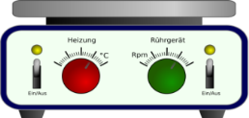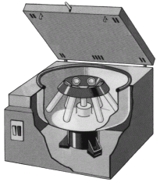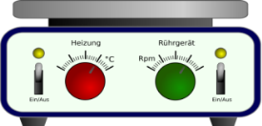

H₂O₂
GO paste

Graphite powder + KMnO₄
H₂SO₄: H₃PO₄
Magnetic stirrer

(a) Oxidation process by adding graphite nonopowder, KMnO₄, H₂SO₄ and H₃PO₄ at ambient temperature

(b) Addition of H₂O₂ to stop oxidation process

(c) Washing process using
centrifugation technique

Figure 1. Synthesis of graphene oxide at ambient temperature

Graphene oxide/TiO₂ preparation
Graphene oxide paste was heated on hot plate at 70 °C for 15 minutes to remove the water. An amount 3 g of TiO₂ nanopowder, polyethylene glycol (PEG, M_{w} $=$10,000), 0.13 ml nitric acid and 4ml distilled water were stirred well in the mortar for half an hour until a uniform paste formed. After that, several drops of Triton X-100 were added to the paste and stirred another 30 minutes to get shiny and uniform paste. 0.4 wt.% of GO was put into the paste and the procedures were repeated by using 0.6 wt.% and 0.8 wt.% of GO. TiO₂ paste without GO also prepared as the control sample.

Fabrication of DSSCs
A complete DSSC device requires working electrode (photoelectrode) and the counter electrode (Figure 2). In the preparation of working electrode for DSSC, conductive substrate (FTO) (8 ohm/cm²) was used. FTO substrate was cleaned by ultrasonic bath in acetone, ethanol and distilled water for 15 minutes each and was dried using nitrogen gas. GO/TiO₂ paste was deposited on FTO and form into a thin film using doctor blade technique. Single layer of magic tape was used to control the thickness and active area of GO/TiO₂. The active area of photoelectrode is 1.0 cm². The photoelectrode was annealed at 450 °C for 30 minutes, then was cooled down to 100 °C and followed by immersion in 0.03 mM N719 dye solution. After 24 hours immersion, photoelectrode was cleaned using ethanol to remove the excess dye in the GO/TiO₂ nanoparticle. In the preparation of counter electrode, platinum paste was deposited on the FTO substrates by doctor blade technique, and annealed at 450 °C for 30 minutes. The DSSC sample was assembled by sandwiching electrolyte layer between the GO/TiO₂ photoelectrode and Pt-coated conductive glass counter electrode. The electrodes were separated using U-shape Surlyn film and were pressed heated.

FTO glass substrate
(counter electrode)
Platinum layer
‘U’ shape Surlyn
FTO glass Substrate
(photoelectrode)
TiO₂/GO layer (active area)

Figure 2. Fabrication of DSSC

Characterization
The micro-morphologies and energy-dispersive X-ray (EDX) of the GO and GO/TiO₂ was observed with field emission scanning electron microscope (FESEM) instrument (Zeisz Supra: 15 kV). The X-ray diffraction patterns of the samples were obtained by using X-ray diffractometer (Bruker D8 Advance). The average surface roughness of the thin film was determined by atomic force microscopy (AFM). Incident photon to current efficiency was analyzed using G300 instrument with simulated AM 1.5 xenon illumination. The current-voltage curves and power conversion efficiency of the cell was measured by light-current-voltage (LIV) Tester model Keithley 2400 with 100mW/cm² light output.

Results and Discussion
Morphology and structure analysis
Figure 3 (a) and (b) show the field emission scanning electron microscopy (FESEM) images of synthesized GO at different magnification. Common process in chemical oxidation of graphite used ice bath during the initial addition of KMnO₄ and heating during the oxidation stage. But, the high temperature during the oxidation process reduces the size of GO produced [17]. In this study, the average lateral dimension of GO is obtained between about 600 – 900 nm, as shown in Figure 3 (b). According to Zhao et al. the electrical resistivity of GO sheets with large area is much lower compared to small GO sheets [18]. Figure 4 (a), (b) and (c) show the FESEM images of GO/TiO₂ thin films with different concentration of GO. As shown in Figure 4 (a), (b) and (c), GO/TiO₂, the porosity and specific surface area increased by increasing the concentration of GO in TiO₂. Several reports have shown that incorporation of GO into TiO₂ photoelectrode resulted in a coarse and porous surface, as a result of unique 2D structure of GO [19-21]. The evaporation of H₂O in GO during the annealing process at 450 °C resulted in an increase of GO/TiO₂ thin film porosity from volume shrinkage [6]. The porous structure of thin film increase light scattering, dye absorptions and enhance the photovoltaic properties [6, 22]. However, previous study reported the optimal porosity for the photoelectrode was considered to be between 50% and 60% [23]. The compact structure will destruct the produced film that has many porous and crack at the surface of the film. The EDX analysis used to study the appearance elements of GO at 0.4 wt.%, 0.6 wt.% and 0.8 wt.% mixed with TiO₂. Based on the GO nanosheet film, the appearance peaks of C and O are 78.8% and 21.2% respectively, as shown in Figure 5(a) After annealed at 450 °C , the C element in 0.4%, 0.6% and 0.8% GO/TiO₂ samples were 2.7%, 4.0% and 4.3% respectively. The percentage of C element slightly increased due to the increment of GO percentage in TiO₂.

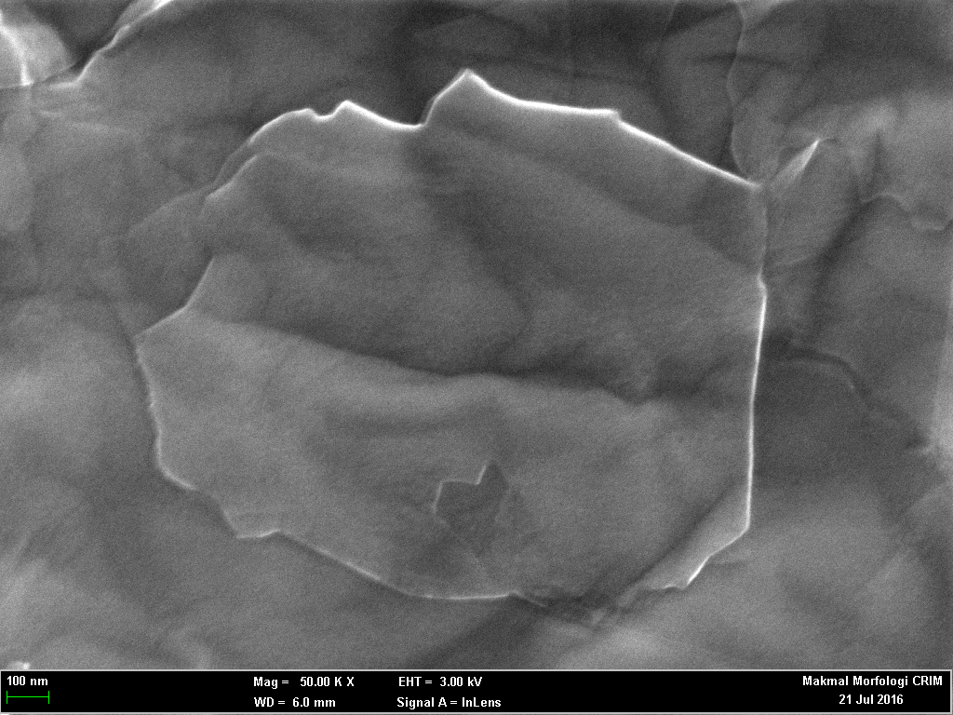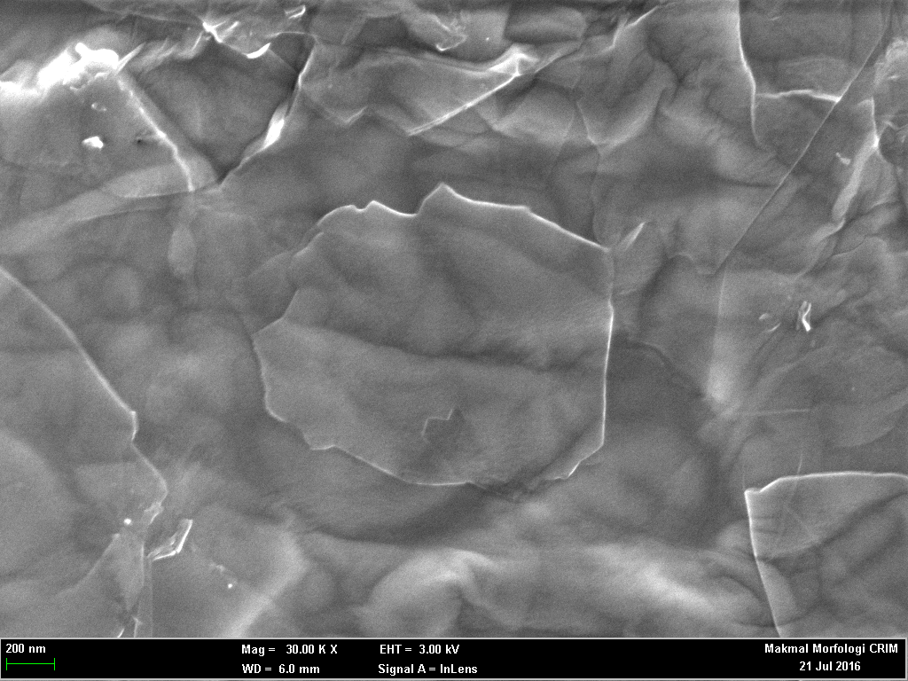
a)
b)

Figure 3. The FESEM images of synthesized (a) GO at low magnification and (b) GO at high magnification
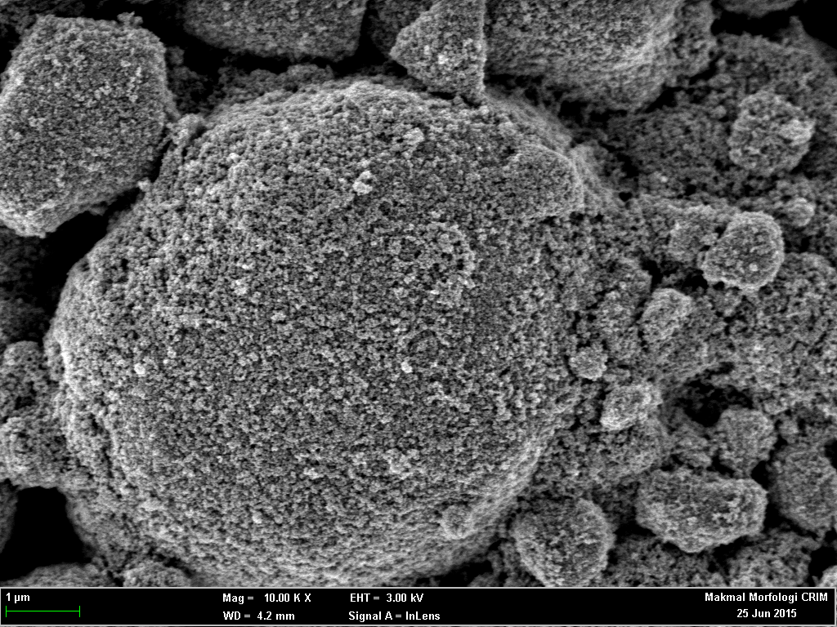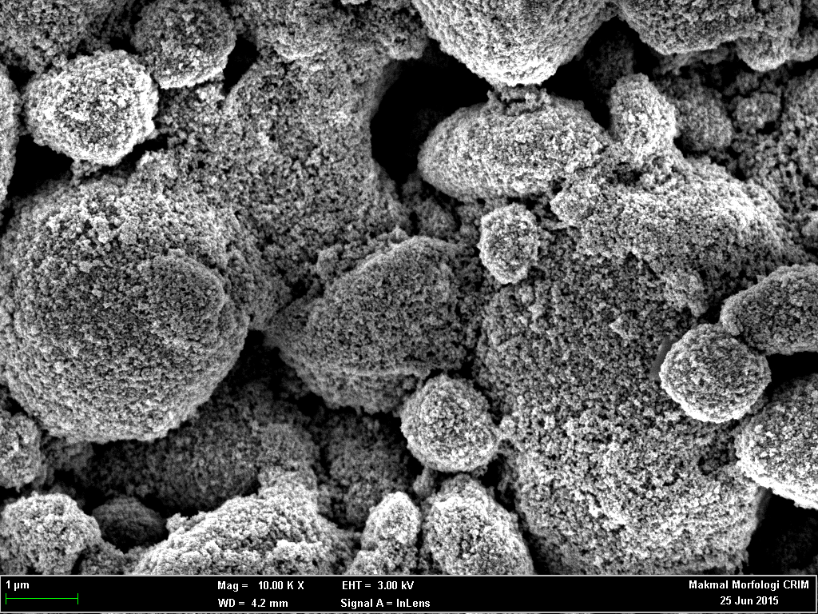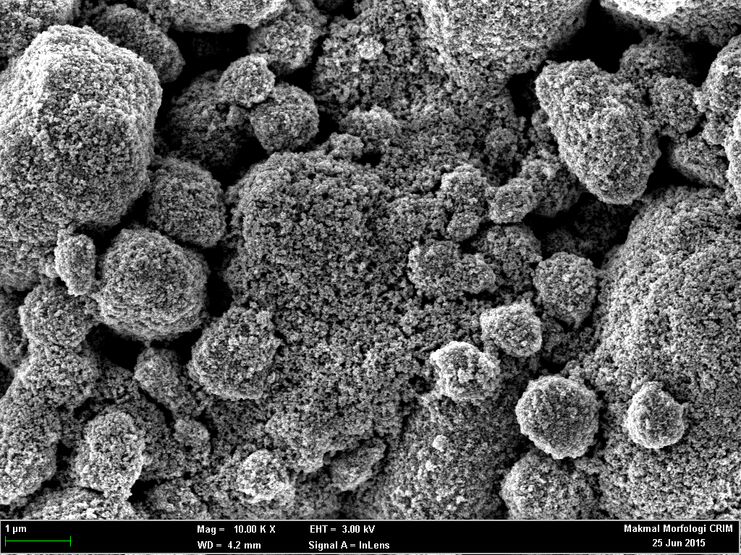
a)
c)
b)

Figure 4. The FESEM images of GO/TiO₂ thin film with (a) 0.4, (b) 0.6 and (c) 0.8 wt.% of GO
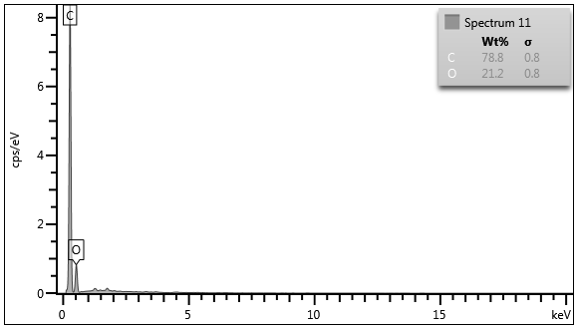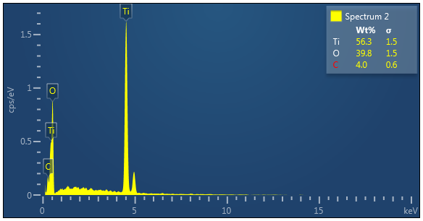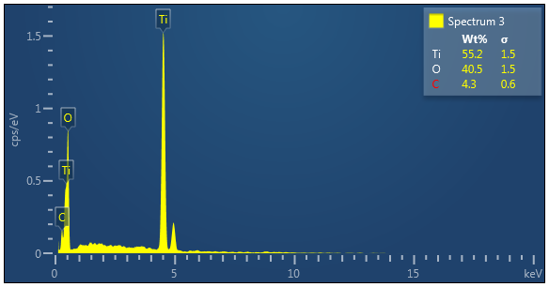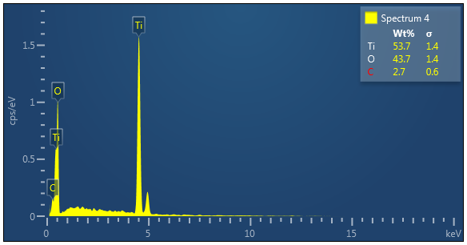
(a)
wt.%
C 78.8
O 21.2
(b)
wt.%
Ti 56.3
O 39.8
C 4.0
wt.%
Ti 55.2
O 40.5
C 4.3
(d)
wt.%
Ti 53.7
O 43.7
C 2.7

(c)

Figure 5. EDX analysis for (a) GO, GO/TiO₂ thin film with (b) 0.4 wt.%, (c) 0.6 wt.%, and (c) 0. 8 wt.% of GO
The morphology characterizations from AFM analysis are used to examine the surface roughness of the different percentage of GO doped in TiO₂ thin film. Figure 6(a), 6(b), and 6(c) and 6(d) show the three-dimensional surface morphology of the GO/TiO₂ thin films with 0.0 wt.%, 0.4 wt.%, 0.6 wt.% and 0.8 wt.% of GO, respectively. Based on the Table 1, the surface roughness values of 0.0 wt.%, 0.4 wt.%, 0.6 wt.% and 0.8 wt.% working electrode are 20.1 nm, 25.2 nm, 35.1 nm and 39.3 nm respectively. The high surface roughness indicates that GO/TiO₂ thin film exhibited high surface area, which in turn will give a greater absorption of the dye.
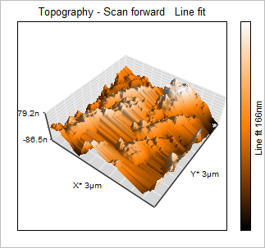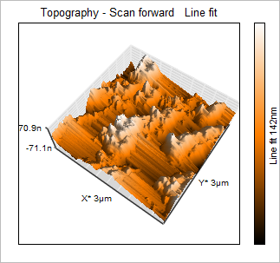
(b)
(a)

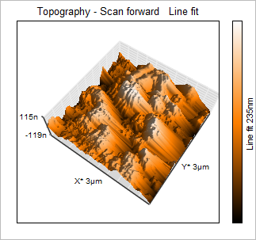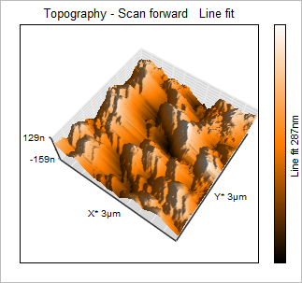
(c)
(d)

Figure 6. Topography AFM images of GO/TiO₂ film containing (a) 0.0 wt.%, (b) 0.4 wt.%, (c) 0.6 wt.% and 0.8 wt. % graphene oxide

Table 1. Roughness average parameter of thin films.
Sample | Doping concentration of GO  (wt.%) | Average Surface Roughness  (nm)
(a) | 0.0 | 20.1
(b) | 0.4 | 25.2
(c) | 0.6 | 35.1
(d) | 0.8 | 39.3

X-ray diffraction analysis
The results from XRD measurement are shown in Figure 7. The XRD pattern for TiO₂ shows obvious anatase phase with a characteristic peak of (1 0 1), (1 1 2), (2 0 0), (1 0 5), and (2 1 1). A small amount of rutile phase also are found in this pattern which assigned to (1 0 1) and (1 1 1) plane. The increasing of GO concentration in TiO₂ resulted in slight decrement of reflection peak intensity. However, due to its small content, the presence of
GO in GO/TiO₂ sample were not detected. [24]. The Debye-Scherer formula was used to estimate the particle size as shown in formula equation 1.

$D$ $=$ $\frac{k λ}{B\cos{θ}}$ (1)

where $λ$ is the wavelength of 1.492 nm, $B$ is the full width at half-maximum of the main peak and $θ$ is the main peak position divided by 2 [6]. The results of crystallite size were shown in Table 2.

(a) Graphene Oxide
(b) 0.0 wt.% GO
(c) 0.4 wt.% GO
(d) 0.6 wt.% GO
(e) 0.8 wt.% GO

Figure 7. XRD pattern of GO and different concentration of GO/TiO₂ films

Table 2. The crystallite size for TiO₂ and GO/TiO₂ samples

Samples | Doping Concentration of GO  (wt.%) | Crystallite Size  (nm)
(b) | 0.0 | 29.36
(c) | 0.4 | 29.29
(d) | 0.6 | 29.27
(e) | 0.8 | 27.08

DSSCs performance studies
IPCE is the ratio of the number of electrons in the external circuit produced by an incident photon at a given wavelength [25]. The generation of IPCE is explained by three main factors: (1) the light-harvesting efficiency of dyes, (2) the efficiency of electron injection and (3) the efficiency of collecting photo injected electrons at the FTO substrate. In DSSC, it primarily responds to the wavelength of visible light in the 300 – 800 nm regions. Figure 8 shows the IPCE spectra of DSSC different concentration of GO doped TiO₂ photoelectrode. The dye that reacted at a wavelength of 500 – 600 nm had the highest quantum number, which is corresponding to the absorption peak of N719 dye [26]. The fabricated DSSCs exhibited a maximum absorption peak at ~515 nm, which mainly originated from the light-harvesting of the N719 dyes adsorbed by the photoelectrode films upon light illumination. The highest IPCE value of fabricated DSSCs was recorded by GO/TiO₂ 0.6 wt.%, with 51.49%, while the GO/TiO₂ 0.0 wt.%, 0.4 wt.%, and 0.8 wt.% showed low IPCE values of 42.89 %, 47.14 % and 48.89 %, respectively. The IPCE percentage increased by adding GO with concentration 0.4 wt.% and 0.6 wt.%, but slightly decreased by further adding GO with 0.8 wt.% concentration. The enhancement of IPCE value is caused by the increasing in specific surface areas of the GO/TiO₂ materials, which results in a considerably higher dye molecules loading and the ability to convert more photons to electrons. On the other hand, the lower IPCE value in GO/TiO₂ 0.8 wt.% indicates the electron-collection efficiency at the TiO₂/FTO substrate is poor due to too porous structure of photoelectrode. [27].
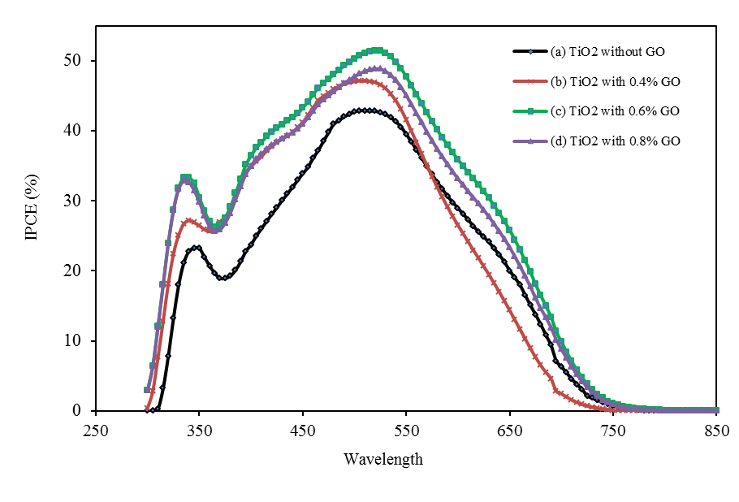

(a) 0.0 wt.% GO
(b) 0.4 wt.% GO
(c) 0.6 wt.% GO
(d) 0.8 wt.% GO

Figure 8. IPCE spectra of DSSC using different concentration of GO in TiO₂ photoelectrode

Table 3. IPCE parameter of DSSC

Sample | Doping Concentration of GO  (wt.%) | IPCE (%)
(a) | 0.0 | 42.89
(b) | 0.4 | 47.14
(c) | 0.6 | 51.49
(d) | 0.8 | 48.89

Figure 9 shows the J–V curve of the DSSCs under varying illumination intensity of 100 mW cm⁻¹ (AM1.5G). The photovoltaic parameters of TiO₂ and GO/TiO₂ were summarized in Table 4. Based on the photovoltaic parameters in Table 4, the J_{sc} and PCE of GO/TiO₂ DSSCs increased compared to the standard DSSC (without GO). This increment is similar to that reported in previous studies [28]. The highest J_{sc} and PCE were obtained at 0.6 wt.% of GO in TiO₂ DSSC, with the value of 9.8 mA/cm² and 3.7%, respectively. J_{sc} are mostly established by good charge injection from the excited state of dye into the GO/TiO₂ photoanode and great charge transport [29]. The J_{sc} of GO/TiO₂ from 0.0 wt.% to 0.8 wt.% was recorded as 8.1, 8.6, 9.1 and 8.7mA/cm², respectively. The increasing of J_{sc} and efficiency is due to following reasons: (a) improve the electron transfer efficiency from TiO₂ film to FTO substrate [30-32] and (b) reduce the charge recombination rate and resistance [33 – 37]. However, the value of J_{sc} and PCE decrease with a further increase the percentage of GO up to 0.8 wt.%. This may be due to the porosity became too large to act as a kind of recombination center instead of providing an electron pathway that resulted in longer charge migration routes or electron contacting directly with FTO to form a dark current due to more graphene oxide surrounding TiO₂ nanoparticles [25].

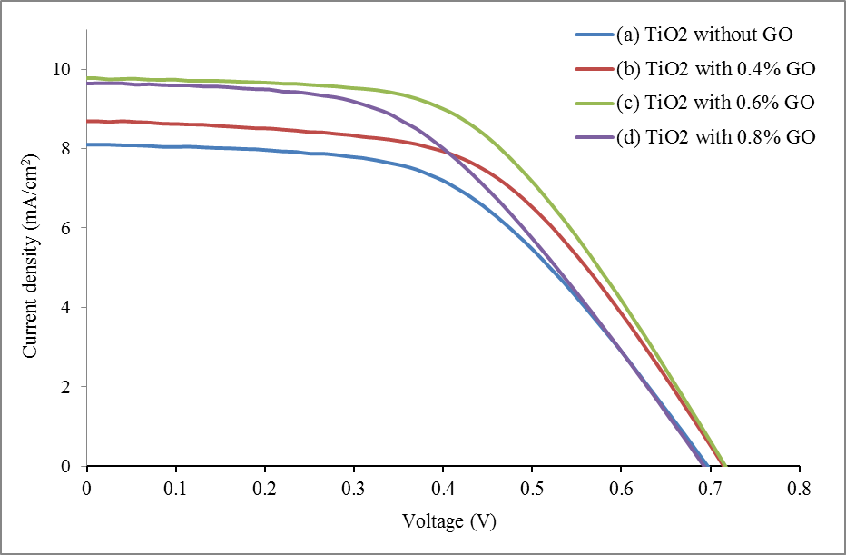
(a) 0.0 wt.% GO
(b) 0.4 wt.% GO
(c) 0.6 wt.% GO
(d) 0.8 wt.% GO

Figure 9. J-V curves of the DSSC with various wt.% of GO under illumination of simulated AM 1.5G sunlight at 100 mW/cm²

Table 4. The photovoltaic parameter of DSSC for TiO₂ and GO/TiO₂

Doping Concentration of GO  (wt.%) | V_{oc}  (V) | J_{sc}  (mA/cm²) | Fill Factor  (%) | Efficiency,  IPCE (%)
0.0 | 0.68 | 8.1 | 51.8 | 2.9
0.4 | 0.69 | 9.6 | 48.0 | 3.2
0.6 | 0.72 | 9.8 | 53.2 | 3.7
0.8 | 0.72 | 8.7 | 53.8 | 3.3

Conclusion
Graphene oxide (GO) was successfully synthesized at ambient temperature and GO was doped with TiO₂ as photoelectrode. The results of DSSC showed that the doping of 0.6 wt.% graphene oxide into TiO₂ paste enhanced the photoelectric conversion efficiency (PCE) by 28% compared to standard DSSC. The increment is due to increase in dye absorption and enhanced electron transportation. However, further increase in GO concentration in TiO₂ can cause the decrease the efficiency of DSSC due to too porous structure of photoelectrode and lead to charge recombination.

Acknowledgements
This research was supported by the Ministry of Higher Education Malaysia and Universiti Kebangsaan Malaysia under the Look East Policy (LEP) Grant (LEP 2.0/14/UKM/NT/03/1 and Arus Perdana (AP-2015-014). This research also was presented at UKM-ISESCO-COMSAT International Workshop on Nanotechnology for Young Scientists (IWYS2016) on Monday, 28 November 2016.

References

1. O’Regan, B. and Grätzel, M. (1991). A low-cost, high-efficiency solar-cell based on dye-sensitized colloidal TiO₂ films. Nature, 353: 737 – 740.
2. Gong, J., Liang, J. and Sumathy, K. (2012). Review on dye-sensitized solar cells (DSSCs): fundamental concepts and novel material. Renewable Sustainable Energy Reviews, 16: 5848 – 5860.
3. Zhang, S., Yang, X., Numata, Y. and Han, L. (2013). Highly efficient dye-sensitized solar cells: Progress and future challenges. Energy Environment Science, 6: 1443 – 1464.
4. Smestad, G.P. and Grätzel, M. (1998). Demonstrating electron transfer and nanotechnology: A natural dye-sensitized nanocrystalline energy converter. Journal of Chemical Education, 75: 752 – 756.
5. Grätzel, M. (2004). Conversion of sunlight to electric power by nanocrystalline dye-sensitized solar cells. Journal of Photochemistry and Photobiology, 164: 3 − 14.
6. Fang, X., Li, M., Guo, K., Hu, Y. Z., Liu, X., Chen, B. and Zhao, X. (2012). Improved properties of dye-sensitized solar cells by incorporation of graphene into the photoelectrodes. Electrochimica Acta, 65: 174 – 178.
7. Tang, B., Hu, G., Gao, H. and Shi, Z. (2013). Three-dimensional graphene network assisted high performance dye sensitized solar cells. Journal of Power Sources, 234: 60 – 68.

8. Yen, C. Y., Lin, Y. F., Liao, S. H., Weng, C. C., Huang, C. C., Hsiao, Y. H., Ma, C. C. M., Chang, M. C., Shao, H., Tsai, M. C., Hsieh, C. K., Tsai, C.H. and Weng, F. B. (2008). Preparation and properties of a carbon nanotube-based nanocomposite photoanode for dye-sensitized solar cells. Nanotechnology, 19(37): 375305.
9. Hu, L. H., Dai, S. Y., Weng, J., Xiao, S. F., Sui, Y. F., Huang, Y., Chen, S., Kong, F., Pan, X. and Liang, L. (2007). Microstructure design of nanoporous TiO₂ photoelectrodes for dye sensitized solar cell modules. Journal of Physical Chemistry B, 111: 358 − 362.
10. Bai, Y., Yu, H., Li, Z., Amal, R., Lu, G. Q. M. and Wang, L. (2012). In-situ growth of a ZnO nanowire network within a TiO₂ nanoparticle film for enhanced dye-sensitized solar cell performance. Advance Material, 24: 5850 − 5856.
11. Mane, R. S., Lee, W. J., Pathan, H. M. and Han, S. H. (2005). Nanocrystalline TiO₂/ZnO thin films: fabrication and application to dye sensitized solar cells. Journal of Physical Chemistry B, 109: 24254 − 24259.
12. Sun, S., Gao, L. and Liu, Y. (2010). Enhanced dye-sensitized solar cell using graphene-TiO₂ photoanode prepared by heterogeneous coagulation. Applied Physics Letters, 96: 083113.
13. Yang, N. L., Zhai, J. Wang, D., Chen, Y. S. and Jiang, L. (2010). Two-dimensional graphene bridges enhanced photoinduced charge transport in dye-sensitized solar cells. ACS Nano, 4(2): 887 – 894.
14. Zhu, C. Z., Wang, S. J. P., Xing, L. Y., Fang, X., Zhai, Y. M. and Dong, S. J. (2010). One-pot, water-phase approach to high-quality graphene/TiO₂ composite nanosheets. Chemical Communications, 46(38): 7148 – 7150.
15. Tang, Y. B., Lee, C. S., Xu, J., Liu, Z. T., Chen, Z. H., He, Z. B., Cao, Y. L., Yuan, G.D., Song, H. S., Chen, L. M. Luo, L. B., Cheng, H. M. Zhang, W.J., Bello, I. and Lee, S. T. (2010). Incorporation of graphenes in nanostructured TiO₂ films via molecular grafting for dye-sensitized solar cell application. ACS Nano, 4(6): 3482 – 3488.
16. Huang, N. M., Lim, H. N., Chia, C. H., Yarmo, M. A. and Muhamad, M. R. (2011). Simple room-temperature preparation of high-yield large-area graphene oxide. International Journal of Nanomedicine, 6: 3443 – 3448.
17. Su, C. Y., Xu, Y. and Zhang, W. (2009). Electrical and spectroscopic characterizations of ultra-large reduced graphene oxide monolayers. Chemistry of Materials, 21: 5674 – 5680.
18. Zhao, J., Pei, S., Ren, W., Gao, L. and Cheng, H. M. (2010). Efficient preparation of large-area graphene oxide sheets for transparent conductive films. ACS Nano, 4: 5245 – 5252.
19. Yen, M., Hsiao, M., Liao, S., Liu, P., Tsai, H., Ma, C., Pu, N. and Ger, M. (2011). Preparation of graphene/multi-walled carbon nanotube hybrid and its use as photoanodes of dye-sensitized solar cells. Carbon, 49: 3597 – 3606.
20. He, Z., Guai, G., Liu, J., Guo, C., Loo, J., Li, C. and Tan, T. (2011). Nanostructure control of graphene composited TiO₂ by a one-step solvothermal approach for high performance dye-sensitized solar cells. Nanoscale, 3: 4613 – 4616.
21. Yen, C., Lin, Y., Hung, C., Tseng, Y., Ma, C., Chang, M. and Shao, H. (2008). The effects of synthesis procedures on the morphology and photocatalytic activity of multiwalled carbon nanotubes/TiO₂ nanocomposites. Nanotechnology, 19: 045604.
22. Wang, H., Leonard, S. L. and Hu, Y. H. (2012). Promoting effect of graphene on dye-sensitized solar cells. American Chemical Society, Industrial and Engineering Chemistry Research, 51: 10613 – 10620.
23. Kopidakis, N., Benkstein, K. D., Van de Lagemaat J. and Frank, A. J. (2003). Transport-limited recombination of photocarriers in dye-sensitized nanocrystalline TiO₂ solar cells. Journal of Physical Chemistry B, 107: 11307 – 11315.
24. Kim, D. Y., Joshi, B. N., Park, J. J., Lee, J. G., Cha, Y. H., Seong, T. Y., Noh, S. I., Ahn, H. J., Al-Deyabe, S. S. and Yoon, S. S. (2014). Graphene-titania films by supersonic kinetic spraying for enhanced performance of dye sensitized solar cells. Ceramics International, 40: 11089 – 11097.
25. Salam, Z., Vijayakumar, E., Subramania, A., Sivasankar, N. and Mallick, S. (2015). Graphene quantum dots decorated electrospun TiO₂ nanofibers as an effective photoanode for dye sensitized solar cells. Solar Energy Materials and Solar Cells, 143: 250 – 259.
26. Chang, J., Yang, J., Ma, P., Wu, D., Tian, L., Gao, Z., Jiang, K. and Yang L. (2012). Hierarchical titania mesoporous sphere/graphene composite, synthesis and application as photoanode in dye sensitized solar cells. Journal of Colloid and Interface Science, 394: 231 – 236.
27. Liu, R., Yang, W. D. and Qiang, L. S. (2012). Enhanced efficiency for dye-sensitized solar cells using a surface-treated photo-anode. Journal of Power Sources, 199: 418 – 425.
28. Tang, Y. B., Lee, C. S., Xu, J., Liu, Z. T., Chen, Z. H., He, Z., Cao, Y. L., Yuan, G., Song, H. Chen, L., Luo, L., Chen, H. M., Cheng, W., Zhang, J., Bello, I. and Lee, S. T. (2010). Incorporation of graphenes in nanostructured TiO₂ films via molecular grafting for dye-sensitized solar cell application. ACS Nano, 4: 3482 – 3488.
29. Wang, P., Wang, J., Wang, X., Yu, H., Yu, J., Lei, M. and Wang, Y. (2013). One-step synthesis of easy-recycling TiO₂–rGO nanocomposite photocatalysts with enhanced photocatalytic activity. Applied Catalysis B: Environmental, 132: 452 – 459.
30. Zhang, H., Lv, X., Li, Y., Wang, Y. and Li, J. (2010). P25-graphene composite as a high performance photocatalyst. American Chemical Society Nano, 4: 380 – 386.
31. Luan, X., Chen, L., Zhang, J., Qu, G., Flake, J. C. and Wang, Y. (2013). Electrophoretic deposition of reduced graphene oxide nanosheets on TiO₂ nanotube arrays for dye-sensitized solar cells. Electrochimica Acta, 111: 216 – 222.
32. Tsai, T. H., Chiou, S. C. and Chen, S. M. (2011). Enhancement of dye-sensitized solar cells by using graphene-TiO₂ composites as photoelectrochemical working electrode. International Journal of Electrochemical Science, 6: 3333 – 3343.
33. Andrade, L., Sousa, J., Ribeiro, H. A. and Mendes, A. (2011). Phenomenological modeling of dye-sensitized solar cells under transient conditions. Solar Energy, 85: 781 – 793.
34. Shu, W., Liu, Y., Peng, Z., Chen, K., Zhang, C. and Chen, W. (2013). Synthesis and photovoltaic performance of reduced graphene oxide-TiO₂ nanoparticles composites by solvothermal method. Journal of Alloys and Compounds, 563: 229 – 233.
35. Yang, N., Zhai, J., Wang, D., Chen, Y. S. and Jiang, L. (2010). Two-dimensional graphene bridges enhanced photoinduced charge transport in dye sensitized solar cells. ACS Nano, 4: 887 – 894.
36. Zhao, J., Wu, J., Yu, F., Zhang, X., Lan, Z. and Lin, J. (2013). Improving the photovoltaic performance of cadmium sulfide quantum dots-sensitized solar cell by graphene/titania photoanode. Electrochimica Acta, 96: 110 – 116.
37. Koide, N., Islam, A., Chiba, Y. and Han, L. (2006). Improvement of efficiency of dye-sensitized solar cells based on analysis of equivalent circuit. Journal of Photochemistry and Photobiology A. Chemistry, 182: 296 – 305.

