CARBON DIOXIDE SORPTION BY TETRADECYLAMINE
SUPPORTED ON SILICA GEL

(Serapan Karbon Dioksida Oleh Tetradesilamina Disokong Pada Silika Gel)

Maratun Najiha Abu Tahari^{1*}, Azizul Hakim¹, Tengku Sharifah Marliza², Mohd. Ambar Yarmo¹

¹School of Chemical Science and Food Technology, Faculty of Science and Technology,
Universiti Kebangsaan Malaysia, 43600 Bangi, Selangor, Malaysia
²Catalysis Science and Technology Research Centre, Faculty of Science, Universiti Putra Malaysia,
43400 UPM Serdang, Selangor, Malaysia

*Corresponding author: maratunnajiha@gmail.com

Abstract
Carbon dioxide emissions generated from fossil fuel-based power plants and other industries has reached 400 ppm in atmosphere. This negatively impact the environment, infrastructures and wildlife in particular. A lot of efforts are needed to produce CO₂ gas sorbent in order to reduce high CO₂ concentration. Therefore, porous silica gel (SG) is modified with amine compound for carbon dioxide capture. Calcinated silica gel functionalized with tetradecylamine (TDA) using wet impregnation has been developed as a porous media. The prepared sorbents is characterized by N₂ physisorption technique Brunauer-Emmet-Teller analysis (BET). Significant changes in physical properties of the sorbents further ascertained the dispersion of TDA on the internal channels and external surface of the SG. Reactivity of porous sorbent towards CO₂ was evaluated using isothermal CO₂ adsorption desorption technique. This study shows 65TDA/SG enable to adsorb CO₂ in the highest capacity which is 23.22 cm³ CO₂ per gram sorbent. Moreover, CO₂ capture consists of two type sorption which are physisorption and chemisorption. 55TDA/SG is the best sorbent in capturing CO₂ by chemisorption (19.62 cm³ CO₂ per gram adsorbent).

Keywords: Tetradecylamine, modified silica gel, carbon dioxide, chemisorption, physisorption

Abstrak
Pembebasan karbon dioksida terhasil daripada plan penghasilan tenaga berasaskan bahan api fosil dan pelbagai industri telah mencecah kepekatan 400 ppm di atmosfera. Perkara ini memberi kesan negatif kepada alam sekitar, infrastruktur dan kehidupan liar khasnya. Pelbagai usaha diperlukan untuk menghasilkan penjerap gas CO₂ dalam usaha untuk merendahkan kepekatan CO₂ yang semakin meningkat ini. Oleh itu, silika gel berliang (SG) telah di ubahsuai dengan sebatian amina untuk pemerangkapan karbon dioksida. Silika gel yang telah dikalsin akan difungsikan dengan teteradesilamina (TDA) menggunakan kaedah impregnasi basah telah dibangunkan sebagai media berliang. Penjerap yang dihasilkan akan dicirikan dengan teknik jerapan fizikal N₂ iaitu analisis Brunauer-Emmet-Teller (BET). Perubahan ciri fizikal yang ketara pada penjerap mengukuhkan lagi sebaran TDA pada permukaan dalam liang dan juga permukaan luaran SG. Kereaktifan penjerap berliang terhadap CO₂ telah dinilai menggunakan teknik penjerapan dan penyahjerapan isoterma CO₂. Hasil kajian ini menunjukkan bahawa 65TDA/SG mampu menjerap CO₂ dalam kapasiti yang tertinggi sebanyak 23.22 cm³ CO₂ per gram penjerap. Tambahan, pemerangkapan CO₂ terdiri daripada dua jenis serapan iaitu serapan fizikal dan jerapan kimia. Penjerap 55TDA/SG adalah penjerap terbaik dalam pemerangkapan CO₂ secara jerapan kimia (19.62 cm³ CO₂ per gram penjerap).

Kata kunci: Tetradesilamina, SG di ubahsuai, karbon dioksida, jerapan kimia, serapan fizikal

Introduction
In the era of globalization, carbon dioxide (CO₂) is well known as a main greenhouse gas. This gas is released into the atmosphere from human activities, industrial development including fossil fuel burning, chemical and petrochemical manufacturing as reported by [1]. Indoor air pollutants (IAPs) included that CO₂ is the representative pollutant of indoor air quality and its concentration is associated with the human activities while the outdoor concentrations of CO₂ range from 350 – 450 ppm. Therefore, studies have been done to collect CO₂ gas to be used as fuel feedstock and other chemicals. The great effort in reducing concentration of CO₂ in atmosphere is more important rather than lowering concentration of CO₂ gas emission [2]. The accumulated CO₂ traps the earth’s heat, thus creating global warming which has already altered weather patterns and further increasing sea levels due to the melting of the polar iceberg. There were several works reported in reducing CO₂ concentration by capture and separate the CO₂ gas. There are different unit operations such as liquid absorption phenomena [3], solid adsorption [4-6], cryogenic techniques and selective diffusion through polymer, metallic or ceramic membranes [7].

Therefore, research in developing CO₂ sorbents must be taken in order to reduce the concentration of CO₂ in the atmosphere. Amines are the most widely used organic chemicals for CO₂ capture due to their basicity. This allows them to react with acidic CO₂ to form a carbamate compounds. This reaction known as chemisorption. Previous study, straight chain alkylamine with C18 known as octadecylamine was developed as CO₂ sorbent. Octadecylammonium octadecylcarbamate ion pairs (alkylammonium alkylcarbamate) was formed on contact with dry CO₂ [8]. Belmabkhout et al. [9] reported, under dry conditions, carbamate with CO₂/N stoichiometry ratio of 0.5 is formed. This means two amine groups are needed in interact with one CO₂ molecule on the adsorbent surfaces as reported by Gray et al. [10] (refer Equation 1).

2 RNH₂ + CO₂ RNHCO₂⁻ + RNH₃⁺ (1)

alkylamine carbon dioxide alkylacarbamate alkylammonium

Nowadays, porous materials are widely used as supporter such as silica dioxide, silica gel, activated carbon and many more [1, 2, 4, 6]. Supporter is important to improve stability of the amine compound. Besides, porous materials have an ability to interact with CO₂ gas through physical interaction (physisorption). In this study, physical and chemical modifications at the external surface or internal channels of the supporter (silica gel, SG) using organic functional groups (tetradecylamine, TDA, C₁₄H₃₁N) have drawn much attention. The synthesized sorbents were characterized by Brunauer-Emmet-Teller analysis (BET).

Materials and Methods
Modification of silica gel (SG) by tetradecylamine (TDA) represented as TDA/SG was done through wet impregnation method with few modifications [11]. Silica gel powder (Fluka) was calcined at 600 °C for 3 hours before impregnation process with various percentage of TDA (ALDRICH®, 97%) and chloroform, CHCl₃ (SYSTERM®, 99 – 99.4%) as a solvent. After stirring for 4 hours in a closed system, the mixture was rested for 1 hour before sonication (S 4000-010 Sonicator 4000) and afterward evaporated in air for one night. The process followed by drying at 45 °C for 4 hours in a vacuum oven. Lastly, the adsorbents were physically characterized by N₂ adsorption desorption isothermal and reactivity towards CO₂ measured by CO₂ adsorption desorption isothermal at 30 °C using BET technique (Micrometiric ASAP 2020).

Results and Discussion
The sorption capacity of CO₂ on prepared sorbents were measured by CO₂ isothermal adsorption desorption using BET technique at 30 °C. Referring to Figure 1 and 2, unmodified SG was able to captured 9.39 cm³ CO₂ / g sorbent. This capacity is higher than another two modified SG, 5 and 15TDA/SG. Addition of 5-15 % TDA will prevent direct interaction of CO₂ towards SG due to formation of mono or multilayers TDA on SG surfaces. This happened during wet impregnation process in which mixture of TDA and chloroform were able to wet entire surface of SG including external and internal surfaces (small pores of SG). After drying process, chloroform was evaporated and TDA layers formed on the SG surfaces. It was clearly shown that pure SG is enable to adsorb CO₂. According to addition of 15 to 65 % TDA, the amount of CO₂ uptake increased proportional to the TDA percent loaded. The capacity of CO₂ gradually increased from 13.21 up to 23.22 cm³ CO₂ / g sorbent. However, CO₂ uptake by the SG modified with 75 % TDA was reduced drastically and lower than 45TDA/SG sorbent.

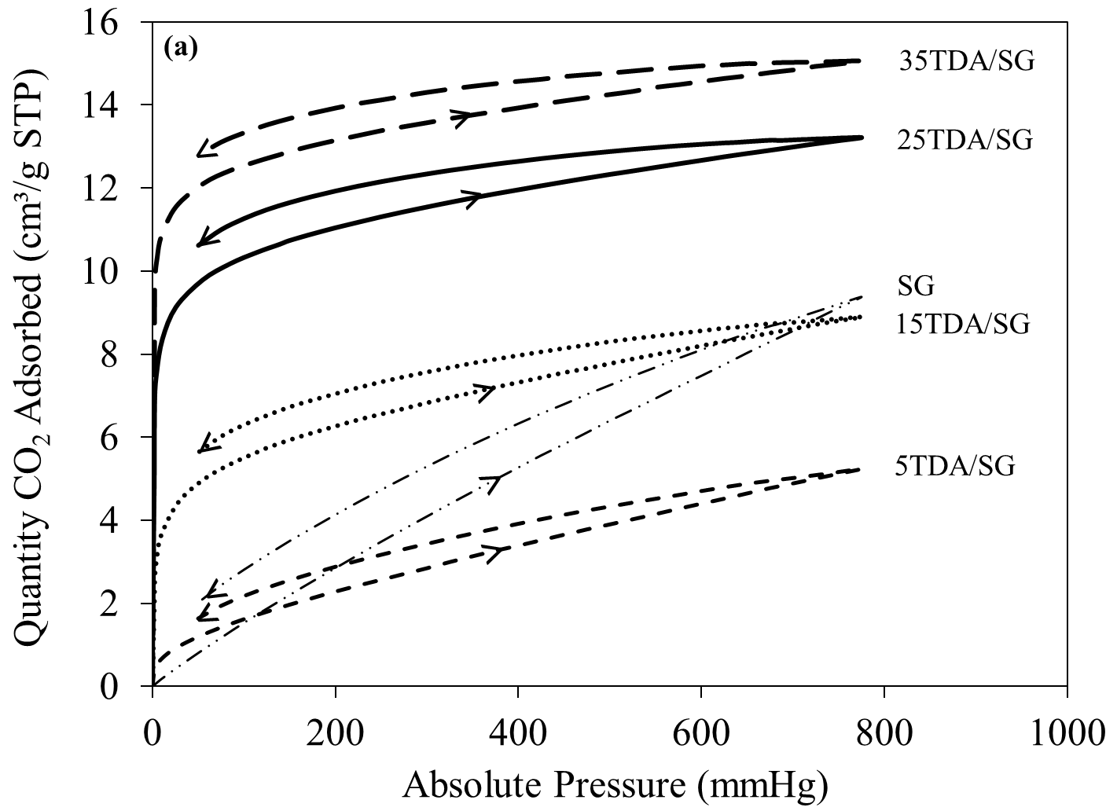

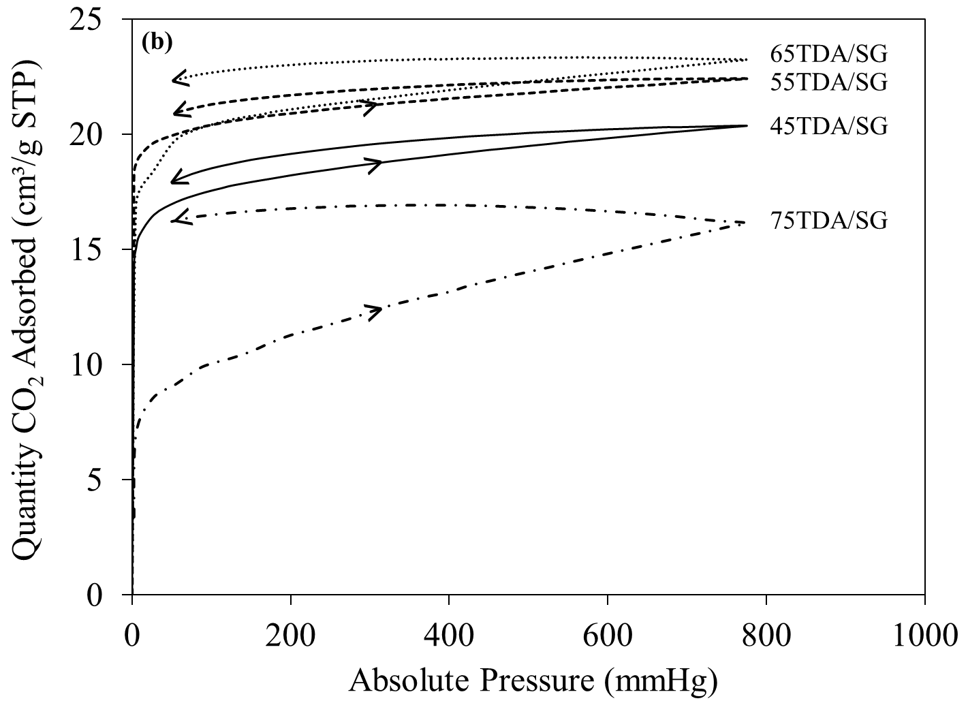
Figure 1. CO₂ adsorption-desorption isotherms of SG and modified SG with (a) SG, 5TDA/SG, 15TDA/SG, 25TDA/SG and 35TDA/SG and (b) 45TDA/SG, 55TDA/SG, 65TDA/SG and 75TDA/SG
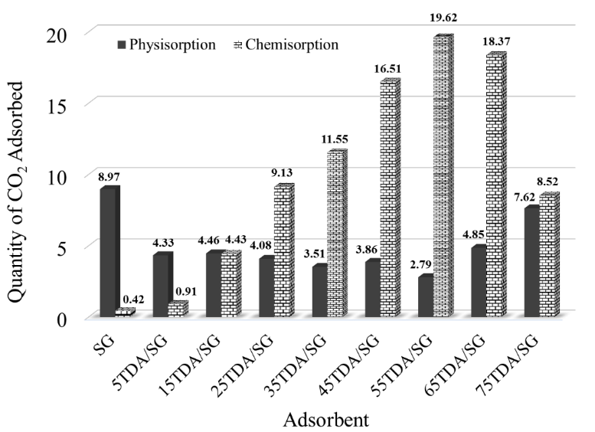
Figure 2. Quantity of CO₂ adsorbed physically and chemically measured by CO₂ adsorption desorption isothermal using BET technique

At a very low pressure, CO₂ sorption curve is very sharp and increased drastically around 0 – 20 mmHg. Formation of linear curve can be seen at higher pressure (more than 20 mmHg). This pattern is just applicable for modified SG whereas CO₂ sorption curve for unmodified SG sorbent was increased gradually without linear curve at the higher pressure. Shaw et al. [12] reported a very sharp sorption curve at the initial pressure showed that sorption of N₂ gas occurred in the small pores which known as micropores. Referring to Table 1, measured surface value t-plot_{mic} for SG is 12.89 m²/g and this proved SG contained small pores in micro size known as micropores. In this research which involved CO₂ gas, the very sharp curve proved that the CO₂ gas were able to enter the micropores of SG. It happened due to strong interaction between internal SG channels (micropores surfaces) towards CO₂ gas. This interaction known as physical interaction or so called physisorption. However, drastically increased CO₂ uptake at the initial sorption also clarified chemical reaction that formed between CO₂ and TDA molecules. This chemical reaction also known as chemisorption and can produce another compounds such as alkylcarbamate and alkylammonium. Bacsik et al. [13] suggested highest amount of CO₂ uptake happened at highest pressure and lower temperature by modified silica with (3-aminopropyl) methyldiethoxysilane (APMDES) was referred to chemical adsorption of CO₂.

There are two lines on the sorption curve which refers to adsorption (-˃-) and desorption (-˂-) line. Adsorption line starts from 0-760 mmHg whereas desorption line is vice versa (760 – 0 mmHg). Referring to the curve, we found desorption line is not converge with the adsorption line at lower pressure. This explained by changing pressure of the system was unable to fully desorp the captured CO₂ gas. Usually, this refers to CO₂ gas that entered micropores and chemically bonded with the TDA molecules. Therefore, energy (usually heat energy) is needed to break these chemical bonds. Therefore, captured CO₂ gas can be desorbed and sorbent can be used again in capturing CO₂.

Table 1. Effect of percent TDA loading towards SG surface properties

Adsorbent | S_{BET} (m²/g) | t-plot_{mic}  (m²/g) | V_{t}  (cm³/g) | W_{D}  (Å)
SG | 246.17 | 12.89 | 1.2 | 174.9
5 TDA/SG | 194.7 | n.d | 0.9 | 121.8
15TDA/SG | 159.6 | n.d | 0.7 | 111.2
25TDA/SG | 128.8 | n.d | 0.5 | 91.5
35TDA/SG | 113.2 | n.d | 0.4 | 87.9
45TDA/SG | 81.4 | n.d | 0.2 | 81.0
55TDA/SG | 61.3 | n.d | 0.2 | 73.0
65TDA/SG | 48.8 | n.d | 0.1 | 71.0
75TDA/SG | 29.2 | n.d | 0.1 | 67.5
n.d = note detected

Figure 2 shows quantity of CO₂ adsorbed that measured by adsorption desorption of CO₂ using BET technique. As discussed earlier, CO₂ sorption at initial pressure (0 – 20 mmHg) was corresponded to chemisorption and physisorption in the micropores. Therefore, by subtracting capacity of CO₂ at the highest pressure (760 mmHg) to the value at lower pressure, the amount of CO₂ captured by physical interaction can be measured. CO₂ uptake by physisorption on SG was the highest compared to other sorbents with value 8.97 cm³ CO₂/g sorbent. This value explained that SG is a porous material which able to attract and capture CO₂ gas in the SG pores through physical interaction. The absence of sharp sorption curve at the initial pressure proven physisorption was primarily occurred compared to chemisorption (0.42 cm³ CO₂/g sorbent).
Addition of TDA from 5 to 55 % exhibited an increasing capacity of chemisorption from 0.91 to 19.62 cm³ CO₂/g sorbent. Meanwhile, capacity of physisorption was reduced gradually with increasing percent of TDA. This clarified as amine was loaded onto SG, the pores of SG are filled with amine layers hence increasing the steric hindrance for physisorption of CO₂ to occur and more CO₂ affinity sites were exposed for chemisorption to take place [14]. Thus, it is suggested that the higher sorption of CO₂ on modified SG also due to more chemisorption process occurred in the internal channels and external surfaces (CO₂–TDA chemical interaction/reaction).
However, capacity of CO₂ sorption by SG loaded with 5 and 15% TDA are not improve significantly compared to ability of pure SG since the presence of TDA layers on the internal SG pores have reduced the CO₂–SG physisorption and yet improved chemisorption. Conversely, CO₂ uptake by chemisorption on higher percent TDA loading (65 and 75TDA/SG) was declined to 8.52 cm³ CO₂/g sorbent whereas capacity of physisorption was take place by increased up to 7.62 cm³ CO₂/g sorbent. Hence, addition of high amount of amine (more than 55% TDA) is not require due to formation of amine double or multilayer on the SG surfaces which reducing amount of active sites and further dropping the ability of formation alkylammonium alkylcarbamate compounds [15].
Amine modified SG was further examined using physisorption analysis (Micrometiric ASAP 2020). BET surface area, micropore surface area (t-plot_{mic}), pore volume and pore width values was summarized in Table 1. Figure 3(a) shows N₂ adsorption and desorption isotherms of all adsorbents. According to IUPAC (1972), the hysteresis curve of all adsorbents is type A where the mesopores are cylindrical in shape [16]. At the earlier stage of the sorption, which is involving low pressure, the adsorption of a single/mono layer of N₂ happened inside pores and followed by adsorption of multiple layers at higher relative pressures. Based on the isotherms, as the TDA loading percentage increases, the quantity of N₂ sorbed will decreases. This is due to physical changes that occurred on the SG surface after the impregnation of TDA. According to rapid pore filling theory, the long chain molecules (TDA) can rapidly fill into the mesopores. Consequently, it creates pore blockage and resulted in the lowering of the quantity of N₂ adsorbed which is directly refers to the decreasing in BET surface area.
Referring to Figure 3(b), average pore diameter appeared as a peak for each sorbent. The highest peak was the SG without any loading while the lowest peak was the 75TDA/SG. The average pore width of SG is 174.9 Å, which refers to the aperture or diameter of the mesopores. When the SG was modified with 35% TDA, the average pore width shifted to a lower value (100.42 Å) since the formation of TDA layer on the inner wall of the mesopores. This result suggests that more molecules are able to get into the pores during modification even though TDA is a straight and long chain molecules. Moreover, the addition of 75% TDA shows drastically decreased in pore volume which is from 1.2 to 0.1 cm³/g (Figure 3(c)). This explains the rapid entrance of amine molecules into the pores making the empty spaces to be filled with that amine molecules [17, 18]. Therefore, the decreasing values of average pore width are proportional with the total volume of the pores.
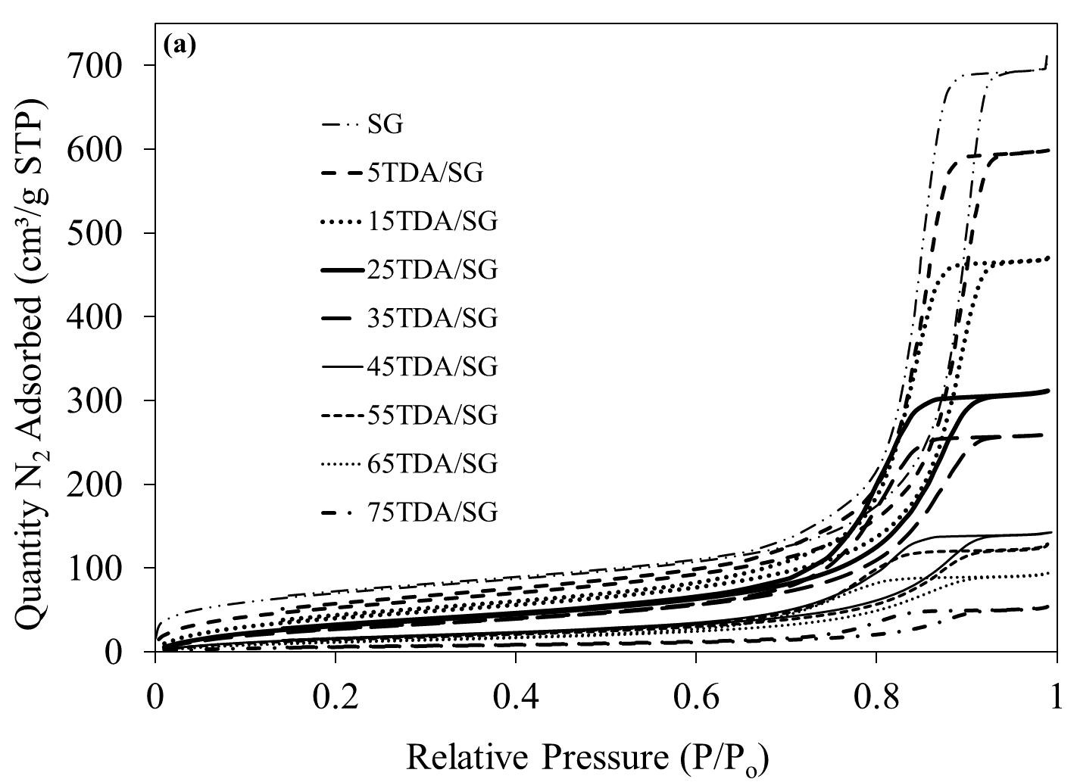

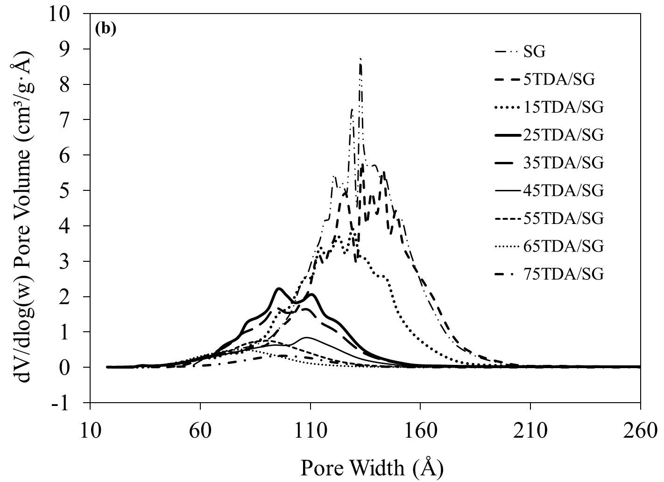

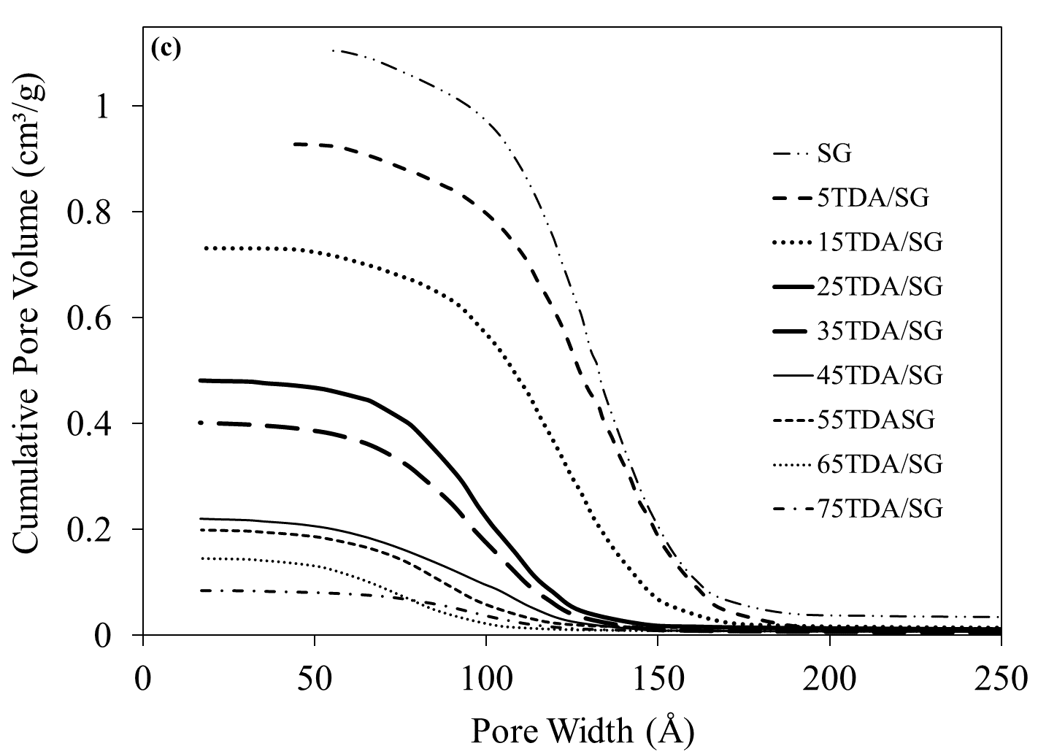

Figure 3. Surface properties of SG and modified SG (5TDA/SG, 15TDA/SG, 25TDA/SG, 35TDA/SG, 45TDA/SG, 55TDA/SG, 65TDA/SG and 75TDA/SG by BET technique with (a) N₂ adsorption desorption isotherms, (b) Pore size distributions and (c) Cumulative pore volume of sorbents.
Conclusion
CO₂ gas can be captured by prepared sorbent which is SG modified with different percentage of TDA. CO₂ isothermal adsorption desorption analysis shows that capturing CO₂ gas involved two types of sorption (physisorption and chemisorption). SG is a porous material acts as supporter and able to physically capture CO₂ gas whereas modified SG are mainly undergo chemically capture CO₂ gas. Moreover, 55TDA/SG was the optimum sorbent due to its ability in capturing highest amount of CO₂ through chemisorption. It is very important in order to increase retention time of CO₂ on the sorbent before it finally being desorb at different time and place (good for transport purposes). Various amount of TDA loading resulted in great changes in physical properties of the adsorbents in term of BET surface area, average pore diameter and total pore volume of adsorbents. Therefore, all significant changes happened actually ascertained the existence of TDA on the SG surfaces by wet impregnation method.

Acknowledgment
Authors would like to thanks Ministry of Higher Education and Universiti Kebangsaan Malaysia for funding this project under research grant number BKBP-FST-K003323-2014, STGL-008-2012, ETP-2013-066, TD-2014-024 and Centre of Research and Innovation Management (CRIM) for the instruments facilities.

References

1. Pevida, C., Plaza, M. G., Arias, B., Fermoso, J., Rubiera, F. and Pis, J. J. (2007). CO₂ capture by adsorption with nitrogen enriched carbons. Fuel, 86: 2204 – 2212.
2. Lee, S. C., Hsieh, C. C., Chen, C. H. and Chen, Y. S. (2013). CO₂ adsorption by y-type zeolite impregnated with amines in indoor air. Aerosol Air Quality Research, 13: 360 – 366.
3. Samanta, A. and Bandyopadhyay, S. S. (2009). Absorption of carbon dioxide into aqueous solution of piperazine activated 2-amino-2-methyl-1-propanol. Chemical Engineering Science, 64: 1185 – 1194.
4. Anson, A., Lina, C. C. H., Kuznickia, S. M. and Sawadab, J. A. (2009). Adsorption of carbon dioxide, ethane and methane on titanosilicate type molecular sieves. Chemical Engineering Science, 64: 3683 –3687.
5. An, H., Feng, B. and Su, S. (2011). CO₂ capturer by electrothermal swing adsorption with activated carbon fibre materials. International Journal of Greenhouse Gas Control, 5: 16 – 25.
6. Zhao, G. Y., Aziz, B. and Hedin, N. (2010). Carbon dioxide adsorption on mesoporous silica surfaces containing amine-like motifs. Applied Energy, 87: 2907 – 2913.
7. Brunetti, A., Scura, F., Barbier, G. and Drioli, E. (2010). Membrane technology for CO₂ separation. Journal of Membrane Science, 359: 115 – 125.
8. Tahari, M. N. A. and Yarmo, M. A. (2014). Adsorption of CO₂ on silica dioxide catalyst imoregnated with various alkylamine. AIP Conference Proceeding, 1614: 334 – 341.
9. Belmabkhout, Y., Serna-Guerrero, R. and Sayari, A. (2010). Amine-bearing mesoporous silica for CO₂ removal from dry and humid air. Chemical Engineering Science, 65: 3695 – 3698.
10. Gray, M., Soong, Y., Champagne, K. J., Pennline, H., Baltrus, J. P., Stevens Jr., R. W., Khatri, R., Chuang, S. S. C. and Fiburn, T. (2005). Improved immobilized carbon dioxide capture sorbents. Fuel Processing Technology, 36: 1449 – 1455.
11. Knowles, G. P., Graham, J. V., Delaney S. W. and Chaffe, A. L. (2005). Aminopropyl-functionalized mesoporous silica as CO₂ adsorbents. Fuel Processing Technology, 86: 1435 – 1448.
12. Shaw, D. J. (1980). Introductio to Colloid and Surface Chemistry. 3rd Edition. Liverpool: Butterworth & Co Ltd.
13. Bacsik, Z., Ahlsten, N., Ziadi, A., Zhao, G., Garcia-Bennett, A. E., Martin-Matute, B. and Hedin, N. (2001). Mechanisme and kinetics for sorption of CO₂ on bicontinuous mesoporous silica modified with n-Propylamine. Langmuir 27: 11118 - 11128.
14. Tahari, M. N. A., Hakim, A., Wahab, M. and Yarmo, M. A. (2016). Modification of porous materials by saturated fattry amine as CO₂ capturer. International Journal of Chemical Engineering and Applications, 6: 2 – 7.
15. Chernyshova, I. V. (2011). Near infrared spectroscopic characterization of surface hydroxyl groups on hydrothermally treated silica gel. International Journal of Chemical and Environment Engineering, 2 (1): 27 – 32.
16. Belman, N., Israelachvili, J. N., Li, Y., Safinya, C. R., Bernstein, J. and Golan, Y. (2009). The temperature-dependent structure of alkylamines and their corresponding alkylammonium-alkylcarbamates. Journal of the American Chemical Society, 131(25): 9107 – 9113.
17. International Union of Pure and Applied Chemistry (1972). Manual of symbols and terminology, colloid and surface chemistry. Pure Applied Chemistry, 31: 578.
18. Kamarudin, K. S. N. and Alias, N. (2013). Adsorption performance of MCM-41 impregnated with amine for CO₂ removal. Fuel Processing Technology, 106(41): 332 – 337.

