EFFECT OF RHODIUM ADDITIVE ON THE REDUCTION BEHAVIOUR OF IRON OXIDE IN CARBON MONOXIDE ATMOSPHERE

(Kesan Penambahan Rodium Terhadap Tindak Balas Penurunan Ferum Oksida

Di Dalam Atmosfera Karbon Monoksida)

Tengku Shafazila Tengku Saharuddin^{1*}, Fairous Salleh¹, Alinda Samsuri², Norliza Dzakaria¹, Rizafizah Othaman¹, Mohammad Bin Kassim¹, Mohammad Wahab Mohammad Hisham¹, Mohd Ambar Yarmo¹

¹School of Chemical Science and Food Technology, Faculty of Science and Technology

Universiti Kebangsaan Malaysia, 43600 Bangi, Malaysia

²Centre for Defense Foundation Studies, Universiti Pertahanan Nasional Malaysia,

Kem Sungai Besi, 57000 Kuala Lumpur, Malaysia

*Corresponding author: tengkushafazila@gmail.com, ambar@ukm.edu.my

Abstract

This study was carry out to investigate the effect of 3% rhodium on the reduction behaviour of iron oxide by (10%, v/v) carbon monoxide in nitrogen as a reductant. The Rh/Fe₂O₃ samples were prepared by impregnation method and the reduction behavior of Rh/Fe₂O₃ and pure Fe₂O₃ were investigated by using temperature programmed reduction (TPR). The prepared samples and the reduced phases were characterized by X-ray diffraction spectroscopy (XRD). The results indicate that Rh/Fe₂O₃ give a better reducibility compared to Fe₂O₃ with a complete reduction at 650 °C, which is 250 °C lower than Fe₂O₃. The TPR results indicate that the reduction of Fe₂O₃ proceed in three steps reduction (Fe₂O₃ → Fe₃O₄ → FeO → Fe) with Fe₃O₄ and FeO as intermediate states while for Rh/Fe₂O₃ as the TPR result showed the overlapping of second and third peak (Fe₃O₄ → FeO and FeO → Fe) at higher temperature. Addition of Rh may possibly reduce the formation of stable FeO that stable at higher temperature by accelerates the direct reduction of Fe₃O₄→ Fe so the reduction process of Fe₂O₃ become faster. The XRD pattern shows the diffraction peaks of Rh/Fe₂O₃ is more intense with improved crystallinity for the characteristic peaks of Fe₂O₃ compared to pure Fe₂O₃. No visible sign of rhodium particles peaks in the XRD spectrum that indicates the Rh particles loaded onto the iron oxide are well dispersed. The well dispersed Rh onto the iron oxide and the ability to reduce the sintering effect to the iron oxide also has been confirmed by FESEM. The study shows that addition of Rh gives a better reducibility of iron oxide is also due to the ability of Rh to interact with CO as confirmed by the thermodynamic data with higher surface area compared to Fe₂O₃.

Keywords: Temperature programmed reduction, rhodium, ferum oxide, carbon monoxide

Abstrak
Kajian ini dijalankan untuk melihat pengaruh 3% rodium kepada kelakuan penurunan ferum oksida di mana karbon monoksida (10%, v/v) di dalam nitrogen digunakan sebagai agen penurunan. Sampel Rh/Fe₂O₃ disintesis menggunakan kaedah impregnasi dan kelakuan penurunan dikaji menggunakan teknik suhu penurunan berprogram (TPR). Fasa - fasa yang terbentuk dicirikan menggunakan teknik pembelauan sinar X (XRD). Keputusan menunjukkan Rh/Fe₂O₃ memberikan kelakuan penurunan yang lebih baik berbanding Fe₂O₃ sahaja dengan penurunan lengkap berlaku pada suhu 650 °C dimana suhu penurunan berkurangan sebanyak 250 °C berbanding suhu penurunan lengkap Fe₂O₃. Profil TPR menunjukkan bahawa penurunan ferum oksida melalui tiga langkah tindak balas penurunan (Fe₂O₃ → Fe₃O₄ → FeO → Fe) dengan Fe₃O₄ dan FeO merupakan fasa perantara, sementara, Rh/Fe₂O₃ pada suhu penurunan tinggi menunjukkan pertindihan diantara puncak kedua dan puncak ketiga (Fe₃O₄ → FeO and FeO → Fe). Penambahan Rh didapati mengurangkan penghasilan FeO yang stabil pada suhu tinggi dengan menggalakkan penurunan terus Fe₃O₄→ Fe menjadikan tindak balas penurunan lebih cepat. Difraktogram XRD bagi Rh/Fe₂O₃ menunjukkan peningkatan pada kehabluran puncak Fe₂O₃ berbanding ferum oksida tulen. Tiada puncak tambahan diperhatikan dimana ia menjelaskan bahawa zarah Rh yang dimuatkan pada ferum oksida telah tersebar dengan baik. Penyerakan yang baik oleh Rh di atas ferum oksida telah menunjukkan pengurangan kesan pensinteran terhadap ferum oksida yang telah dibuktikan melalui FESEM. Kajian menunjukkan penambahan Rh memberikan kesan yang baik kepada proses penurunan ferum oksida berdasarkan kebolehan Rh untuk berinteraksi dengan gas CO yang telah disahkan oleh pengiraan termodinamik dan peningkatan kepada luas permukaan berbanding Fe₂O₃ tulen.

Kata kunci: suhu penurunan berprogram, rodium, ferum oksida, karbon monoksida

Introduction
The reduction behaviour of the iron species were highly important in such application in industry and some chemical processes [1, 2]. The reduction process of Fe₂O₃ is not a simple process which may include several steps relies on factors such as temperature, concentration reduction gas used, particle size, crystallinity and additives [3]. This reduction process of iron oxide involves several possible structural changes and complex compositions in the intermediate oxides such as hematite (Fe₂O₃) → magnetite (Fe₃O₄) → wüstite (FeO) → iron (Fe) and in most cases the reactions were usually simultaneous [2]. Pineau et al. investigate the effect of temperature on the reduction behaviour of iron oxide and proposed several reduction routes depending on the formation of metastable wüstite [4]. The reduction of Fe₂O₃ to metallic Fe can be a two-step (Fe₂O₃→ FeO → Fe) or three-step mechanisms (Fe₂O₃→ FeO → Fe) depending on temperature and affected the formation of metastable wüstite [5]. When the reduction temperature reached 570 °C and above, magnetite can be reduced to wüstite so higher temperature is needed to its reduction to metal iron [6].

In this study, we will focus on the addition of other element which is rhodium for the purpose of improving the reduction behaviour of Fe₂O₃. Good performance of Rh on the reduction behaviour of iron oxide has also been studied by Seak et. al. [7] using H₂ as a reductant. Their study revealed that Rh additive can promote the reduction corresponding to the reduction of Fe₂O₃→Fe₃O₄ as the reduction temperature at this transition was obviously decreased. Thus, we will report the results of an attempt to understand the influence of Rh species on the reduction behavior of the iron oxide with CO as a reductant.

Materials and Methods
Materials
Iron(III) oxide (99%) and Rhodium(III) nitrate (99%) were obtained from Sigma Aldrich Chemical Company and the gas mixture of 10% CO in nitrogen was obtained from MOX.

Catalyst preparation
The addition of 3% Rh (w/w, %) on Fe₂O₃ was prepared by impregnating Fe₂O₃ powder with aqueous solution containing rhodium cation additives. The Fe₂O₃ powder was directly impregnated into 50 ml distilled water corresponding metal cation additives in the above proportion and stirred vigorously for 4 hours at room temperature. The impregnated sample was dried at 110 °C overnight and subsequently calcined at 600 °C for 3 hours.

Characterization

Temperature programmed reduction (TPR) measurements using a Micromeritic Autochem 2920 Chemisorption Analyzer apparatus; a feed of 10% CO in N₂ at a flow rate of 20 mL min⁻¹ (STP) was used as reducing gas. The 50 mg of samples were heated up to 900 °C, at a rate of 10 °C min⁻¹ were applied to the samples. The carbon monoxide consumption was monitored using a thermal conductivity detector (TCD). Phase characterization was carried out by X-ray diffraction (XRD) Bruker AXS D8 Advance type with X-ray radiation source of Cu Kα (40 kV, 40 mA) to record the 2θ diffraction angle from 10 – 80 degree at wavelength (λ = 0.154 nm) to observe the lattice of the structures and were matched with standard diffraction (JCPDS) files. Physical surface analysis (Brunauer–Emmett–Teller, BET) of nitrogen adsorption at 77 K (liquid nitrogen) was conducted using a Micromeritics ASAP 2010 instrument to obtain the adsorption isotherm of each sample. The calcined sample of Rh/Fe₂O₃ and Fe₂O₃ were degassed at 350 °C for 6 hours before the BET surface area analyses were done. The Brunauer–Emmett–Teller (BET) surface areas were calculated from the isotherms. FESEM images were obtained using Merlin Ultra High Resolution FESEM operating with 3.0 kV.

Results and Discussion
Thermodynamic consideration data
Table 1 shows the thermodynamic data of iron oxide and rhodium oxide reduction process in CO atmosphere. Sequenced of three steps iron oxide reduction by using carbon monoxide are listed in the table as Eq. 1 to 3 together with the reduction process of rhodium oxide to rhodium metal as Eq. 4. The thermodynamic calculations based on the Gibbs free energy change due to the reactions below and the equilibrium composition of the oxides indicates all equations as written are favourable within the range that also has been mentioned by Svoboda and Bexter [8].

Table 1. Thermodynamics data of iron oxide reduction process in CO atmosphere

Reactions | ΔH  (kJmol⁻¹) | ΔS  (Jmol⁻¹K⁻¹) | ΔG  (kJmol⁻¹) | T  (°C) | Reaction  Possibility
3Fe₂O₃ + CO → 2Fe₃O₄ + CO₂ (1) | -47 | +47 | -88 | 600 | Favourable
Fe₃O₄ + CO → 3FeO + CO₂ (2) | +19 | +53 | -26 | 600 | Favourable
FeO + CO → Fe + CO₂ (3) | -12 | -18 | +4 | 600 | Favourable
Rh₂O₃ +3CO → 2Rh + 3CO₂ (4) | -564.5 | -9 | -556 | 600 | Favourable

Isotherm adsorption of N₂
The result indicates that the impregnation of Fe₂O₃ with rhodium nitrate (5.26 m²/g) shows the BET surface area was larger than pure Fe₂O₃ (4.67 m²/g). The higher BET surface area of Rh/Fe₂O₃ may contribute to the higher rate of reduction as mentioned by Hu et al. [9] as they mentioned that higher specific surface area was also an important factor which provide more unsaturated surface coordination sites exposed to the gas which may result in the increasing of the activity.

Crystallinity studies

Figure 1 shows the X-ray diffraction patterns of prepared samples Rh/Fe₂O₃ and pure Fe₂O₃ before reduction with CO in nitrogen (10%, v/v). The characteristic peaks are consistent with the standard data of rhombohedral (α-Fe₂O₃, JCPDS 33-0664) with the 2θ Fe₂O₃ main peaks revealed the presence of contribution at about 24.2, 33.2, 35.7, 40.9, 49.5, 53.5, 57.2, 62.4, 64.2, 72.4 and 75.7 with crystallite phases of (0,1,2), (1,0,4), (1,1,0), (1,1,3), (0,2,4), (1,1,6), (0,1,8), (2,1,4), (3,3,0), (10,1,0), (2,2,0), respectively. The diffraction peaks show improvement in the crystallinity when loading with Rh with no additional peak that can be explained by a high dispersion of the Rh particles, formation of non-crystalline compounds, compounds giving the same diffraction peaks as those of Fe₂O₃ or the amount of the Rh dopant may be too small to be detected significantly as suggested by Lorente et al. [10].

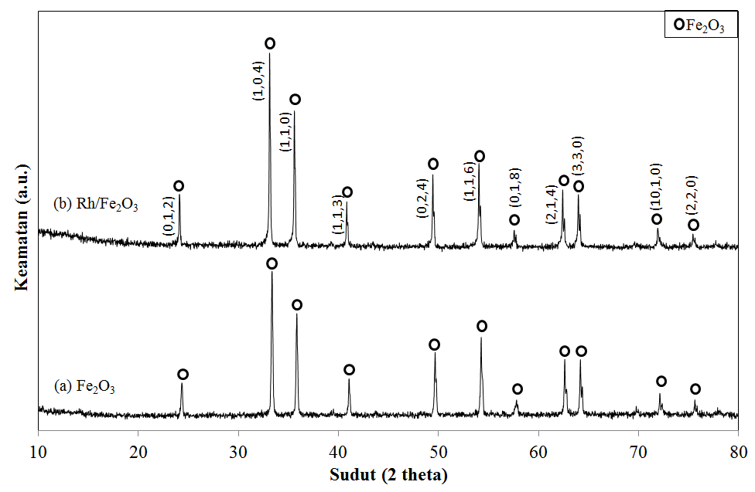
Figure 1. XRD diffractograms of (a) Fe₂O₃ and Rh/Fe₂O₃ after calcined at 600 °C

To investigate the role of Rh in the reduction behavior of Fe₂O₃ in CO atmosphere, all samples were collected according to the TPR pattern when the reduction of Rh/Fe₂O₃ in CO is assumed to be finished at 650 °C and also at 900 °C for comparison purposes. From the results display in Figure 2, Rh/Fe₂O₃ exhibit a complete reduction at temperature 650 °C with only metallic Fe diffraction peak observed (iron, JCPDS 65-4899). Meanwhile, for Fe₂O₃ the reduction accomplished only when the temperature reached 900 °C as it still exhibited a remaining unreduced Fe₃O₄ (magnetite, JCPDS 71-6336) and FeO (wustite, JCPDS 80-0686) at reduction temperature of 650 °C.

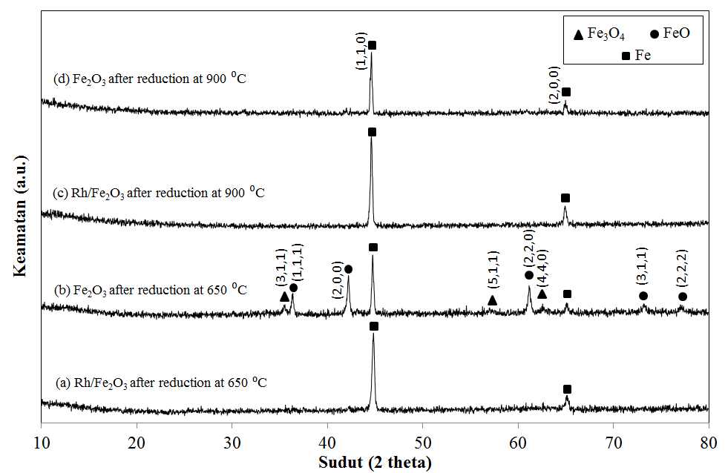
Figure 2. XRD diffractograms of Rh/Fe₂O₃ after reduction at (a) 650 °C and (c) 900 °C and Fe₂O₃ at (c) 650 °C and (d) 900 °C by CO
Catalyst characterization by TPR
The TPR pattern of non-isothermal CO reduction for Rh/Fe₂O₃ and Fe₂O₃ were shown in Figure 3. For Fe₂O₃, 3 reduction peaks were observed at temperature 361 °C, 509 °C and 807 °C which known to reflect the reduction reaction of iron oxides and proceeds the 3 steps reduction of Fe₂O₃→Fe₃O₄→FeO→Fe. The results are in agreement with the XRD diffractogram as shown before. Meanwhile, Rh/Fe₂O₃ also showed one sharp peak at early reduction temperature represents the first stage reduction of Fe₂O₃→Fe₃O₄. Nevertheless, as the temperature increased, a broad reduction peak was observed at 565 °C which may represents the overlapping of several reduction steps before completed to form metallic Fe. Based on the TPR profile together with the XRD diffractogram, Rh/Fe₂O₃ exhibited better reducibility compared to Fe₂O₃ as the reduction of Rh/Fe₂O₃ to metallic Fe completed at 650 °C compared to a much higher temperature (900 °C) of completion for Fe₂O₃ without Rh additive. According to Datta et al. [11], addition of other element as a dopant may activates the dissociation of CO and promotes the breaking of Fe-O and contribute to the enhancement of the reducibility process. Thus, the involvement of rhodium element in the structure of iron oxide inhibit the formation of FeO which is stable at higher temperature, thus promotes the direct reduction of Fe₃O₄→ Fe and accelerates the reduction process of Fe₂O₃. Moreover, Rh itself is favourable to react with CO as in agreement with the thermodynamic data of Eq. 4 as mentioned in Table 1 if compared to Fe₂O₃ alone.

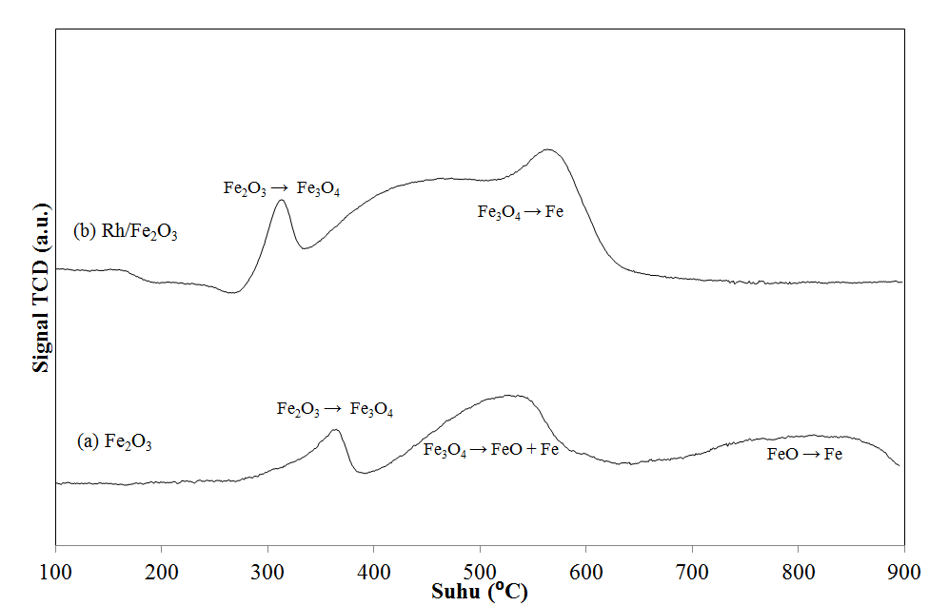

Figure 3. TPR profile of (a) Fe₂O₃ and (b) Rh/Fe₂O₃ in CO atmosphere

Catalyst characterization by FESEM
Figure 4 and Figure 5 show the FESEM images of Fe₂O₃ and Rh/Fe₂O₃ samples before and after the reduction process in 10% CO atmosphere as seen in magnification (20000x). It is clearly observed from the FESEM image that at reduction temperature of 650 °C, the particle size of Fe₂O₃ are slightly bigger that caused by sintering of iron oxide, while Rh-Fe₂O₃ sample showed no big changes in particles size compare with before and after the reduction process. Smaller in particles observed after reduction at 650 °C for Rh/Fe₂O₃ may contribute to better reducibility of Fe₂O₃.

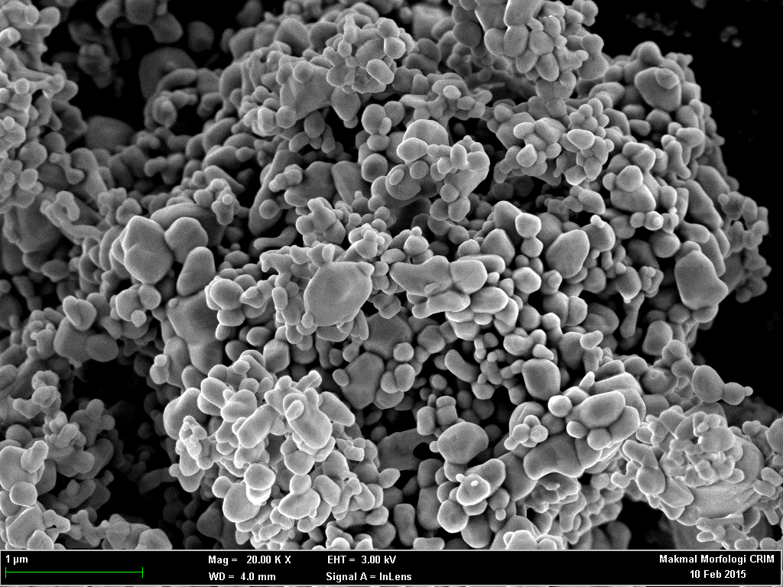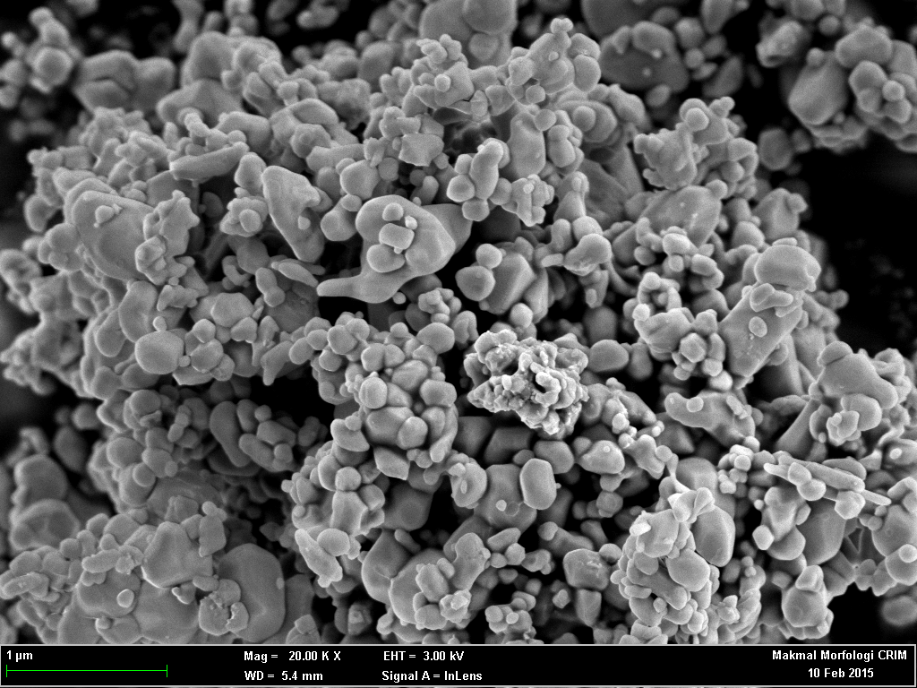
(b)
(a)

Figure 4. FESEM image of (a) prepared Fe₂O₃ and (b) prepared Rh/Fe₂O₃ calcined at 600 °C

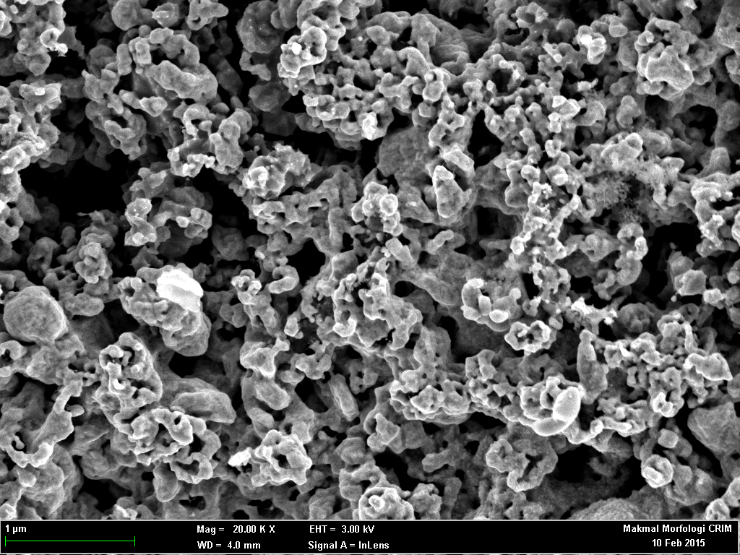
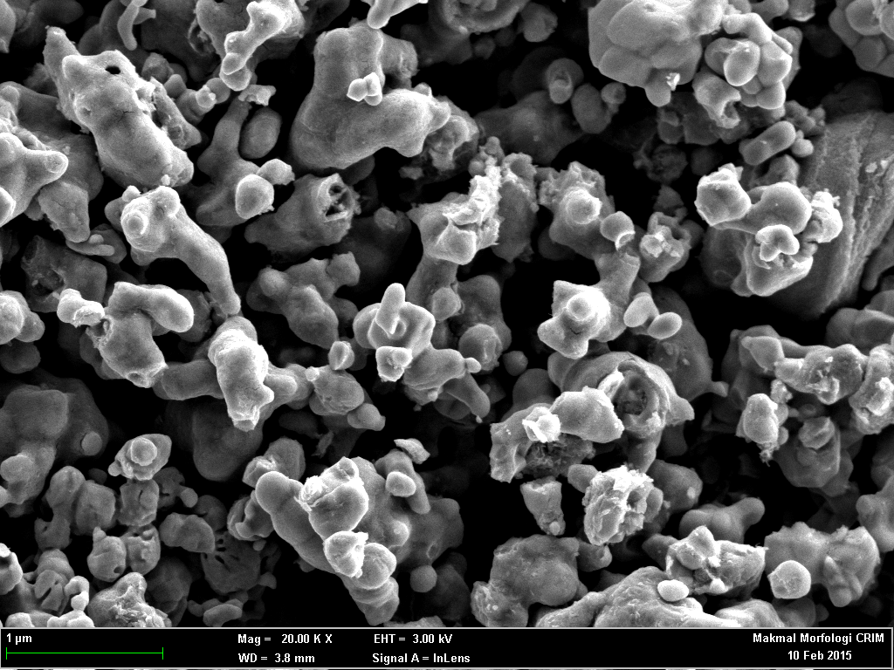
(b)
(a)

Figure 5. FESEM image of the surface of particle of (a) Fe₂O₃ and (b) Rh-Fe₂O₃ reduction at 650 °C in 10% CO atmosphere

Conclusion
The reduction behaviour of Rh added to the Fe₂O₃ in CO as a reductant was investigated and compared using TPR and XRD. Addition of Rh to the iron oxide showed the effect on enhancing the reduction process in CO atmosphere. The reduction process completed 250 °C lower compared to Fe₂O₃ with XRD patterns showed only metallic Fe peak at 650 °C. Rhodium species played important role on lowering the reduction temperature due to well dispersed of the Rh particle, good interaction with CO as prove by the thermodynamic data and higher of surface area.

Acknowledgement

The author wish to thank Ministry of Higher Education (MOHE) for funding this project under research grant number BKBP-FST-K003323-2014, FRGS/2/2013/TK06/UKM/02/3, ETP-2013-066, TD-2014-024 & Centre of Research and Innovation Management CRIM-UKM for instruments facilities.

References

- Jozwiak, W. K., Kaczmarek, E., Maniecki, T. P., Ignaczak, T. P. and Maniukiewicz, W. (2007). Reduction behavior of iron oxides in hydrogen and carbon monoxide atmospheres. Applied Catalysis A: General, 326(1): 17 – 27.
- Lorente, E., Herguido, J. and Peña, J. A. (2011). Steam-iron process: Influence of steam on the kinetics of iron oxide reduction. International Journal of Hydrogen Energy, 36(21): 13425 – 13434.
- Jian-Ming, P., Pei-Min, G., Pei Z., Chao-Zhen, C. and Dian-Wei, Z. (2009). Influence of size of hematite powder on its reduction kinetics by H₂ at low temperature. Journal of Iron and Steel Research, International, 6(5): 7 – 11.
- Pineau, Kanari N. and Gaballah, I., (2007). Kinetics of reduction of iron oxides by H₂. Thermochimica Acta, 456(2): 75 – 88.
- Kuo, Y., Hsu, W., Chiu, P., Tseng, Y. and Ku, Y. (2013). Assessment of redox behavior of nickel ferrite as oxygen carriers for chemical looping process. Ceramics International, 39: 5459 – 5465.
- Ramadan, W., Zaki, M. I., Fouad, N. E. and Mekhemer, G. H. (2014). Particle characteristics and reduction behavior of synthetic magnetite. Journal of Magnetism and Magnetic Materials, 355: 246 –253.
- Seak, Y., Chun, J., Hee, D. and Ho, Y. (2006). Hydrogen storage characteristics using redox of M/Fe₂ O₃ (M = Rh , Ce and Zr) mixed oxides. World Hydrogen Energy Conference Proceeding, 3: 2 – 8.
- Svoboda, K. and Baxter, D. (2007). Thermodynamic possibilities and constraints for pure hydrogen production by iron based chemical looping process at lower temperatures. Energy Conversion and Management, 48: 3063 – 3073.
- Hu, C., Gao, Z. and Yang, X. (2007). Facile synthesis of single crystalline α-Fe₂O₃ ellipsoidal nanoparticles and its catalytic performance for removal of carbon monoxide. Materials Chemistry and Physics,104: 429 – 433.
- Lorente, E., Peña, J. A. and Herguido, J. (2009). Separation and storage of hydrogen by steam-iron process: Effect of added metals upon hydrogen release and solid stability. Journal of Power Sources, 192(1): 224 – 229.
- Datta, P., Rihko-Struckmann, L., K. and Sundmacher, K. (2014). Quantification of produced hydrogen in a cyclic water gas shift process with mo stabilized iron oxide. Fuel Processing Technology, 128: 36 –42.

