EFFECT OF NICKEL ON BIMETALLIC NANOALLOY CATALYST FOR HYDROGEN GENERATION

(Kesan Nikel ke atas Mangkin Nanoaloi Dwilogam bagi Penghasilan Hidrogen)

Masitah Abdul Halim Azizi¹, Norliza Dzakaria², Wan Nor Roslam Wan Isahak^{1*}, Mohd Ambar Yarmo²

¹Department of Chemical and Process Engineering, Faculty of Engineering and Built Environment

Universiti Kebangsaan Malaysia, 43600 UKM Bangi, Selangor, Malaysia

²School of Chemical Science and Food Technology, Faculty of Science and Technology

Universiti Kebangsaan Malaysia, 43600 UKM Bangi, Selangor, Malaysia

*Corresponding author: wannorroslam@ukm.edu.my

Abstract

A mesoporous Fe-Ni catalyst was prepared by microwave combustion method by using glycine as a fuel to help the combustion occur in the microwave. The bimetallic catalyst synthesized was intend to accelerate the production of hydrogen via decomposition of formic acid. The hydrogen produced supposedly can substitute the energy source used now especially from fossil fuels to contribute to the reduction of greenhouse effect. The catalyst sample was characterized by powder X-ray diffraction (XRD), scanning electron microscopy (SEM) and N₂ adsorption-desorption isotherm (BET). From the BET isotherms, a type IV isotherm was observed, indicate the presence of mesoporous solid. XRD diffractograms of Fe-Ni have well-defined diffraction patterns with strong and sharp diffraction peaks, indicating that they are crystalline. The SEM images show the presence of voids and pores in the sample and spongy structure which also consisted of very fine crystalline. The selectivity for H₂ formation using the prepared bimetallic catalyst was achieved ranging of 94 to 99% for 120 minutes at optimum conversion of formic acid and merely at room temperature.

Keywords: iron nickel catalyst, hydrogen energy, microwave combustion method, H₂ selectivity

Abstrak

Mangkin Fe-Ni yang bersifat mesoporos telah disediakan dengan menggunakan kaedah pembakaran oleh gelombang mikro dengan bantuan glisin sebagai bahan bakar. Mangkin dwilogam yang disintesis bertujuan untuk mempercepatkan penghasilan hidrogen melalui penguraian asid formik. Hidrogen yang dihasilkan diharapkan dapat menggantikan sumber tenaga yang digunakan dewasa ini terutama daripada bahan api fosil supaya dapat mengurangkan kesan rumah hijau. Sampel mangkin dicirikan dengan pembelauan sinar-X (XRD), mikroskopi pengimbasan elektron (SEM), dan isoterma penyerapan-penyahjerapan N₂ (BET). Daripada isoterma BET, isoterma jenis IV telah dikenalpasti, menandakan kehadiran pepejal mesoporos. Difraktogram XRD bagi Fe-Ni menunjukkan corak yang terbentuk dengan puncak yang baik dan tajam, menunjukkan mangkin tersebut merupakan hablur. Imej SEM menunjukkan kehadian ruang dan pori di dalam sampel dan berstruktur span dimana ia juga terdapat hablur yang sangat halus. Keterpilihan terhadap penghasilan gas H₂ menggunakan mangkin dwilogam FeNi adalah 94 – 99% pada masa tindak balas 120 minit pada peratus penukaran asid fomik yang optimum pada suhu bilik.

Kata kunci: mangkin ferum nikel, tenaga hidrogen, kaedah pembakaran gelombang mikro, kepilihan H₂

Introduction

Global warming has been continuously increases the attention among scientists and the earth community. This popular problem was resulted from both human activity and natural variability [1]. The emission of greenhouse and toxic gases such as NOx and SO₂ to the atmosphere is the main reason of global warming other than environmental pollution due to the combustion of fossil fuel [2]. This all things happened because the source of energy nowadays is mainly from fossil fuels and scientist has found a way to change from petroleum to hydrogen as a new technology of energy source.

Hydrogen as a future energy carrier is very dependable due to its clean combustion pathways and high gravimetric energy density [3]. However, hydrogen has a very low volumetric energy density at atmospheric conditions [4]. To obtain a balanced gravimetric and volumetric hydrogen storage density, pure hydrogen can be stored in compressed gases or liquid form. Formic acid has been recognized as a potential hydrogen storage material due to its high gravimetric energy density, nontoxicity, and can be safely handled in aqueous solution [4]. This organic compound which is in liquid form at room temperature has limited uses including as a preservative and antifungal agent and it’s also contribute in the production of leather and could act as a lime scale remover [5]. Levulinic acid production from cellulosic biomass [6, 7] and glucose [8, 9] will produce formic acid as a side product and due to the redundancy of formic acid, it makes sense that we utilize the acid to make something useful for the earth and mankind.

To produce hydrogen, formic acid needs to react in the present of catalyst. Formic acid can undergo two path of reaction that is dehydration (1) and dehydrogenation (2).

HCOOH H₂O + CO ∆G_{298K} = -14.9 kJ mol⁻¹ (1)

HCOOH H₂ + CO₂ ∆G_{298K} = -35.0 kJ mol⁻¹ (2)

Carbon monoxide that liberated from reaction (1) is toxic to fuel cell catalysts which will reduce the catalytic performance [4, 10]. In order to avoid formic acid undergoing dehydration, the type of active catalyst used in the reaction at low temperature must be taken into account. Flaherty et al. [11] in their studies on decomposition of formic acid on the molybdenum (Mo) and molybdenum carbide (C-Mo) surfaces show that at 350 – 450 K, dehydration is the dominant pathway on clean Mo (110) with ~5% or less formic acid undergoing dehydrogenation, while C-Mo (110) selectively promotes 70 – 75% of hydrogen. Hence, the type of catalyst use is very important and here, we report the characteristic of nanoalloy catalyst at different ratio of Fe and Ni composition.

Materials and Methods

Synthesis of bimetallic nanoalloy catalysts

All chemicals were of analytical grades and were used without further purification. Fe-Ni bimetallic catalysts were prepared by microwave combustion method with the weight percentage (wt%) of Fe to Ni as 99:1, 97:3 and 95:5. In order to prepare NiFe₂O₄, Fe(NO₃)₂.9H₂O and Ni(NO₃)₂.6H₂O with ratio stated before were mixed in a crucible porcelain in the presence of glycine as fuel. The mixture was then put into a microwave with a power of 240 W for 3 minutes. The voluminous sponge-like product was produced and washed with distilled water and ethanol. The washed product was dried at 115 ºC in an oven for 24 hours. The product was then reduced in hydrogen gas at 500 ºC for 1 hour to get Fe-Ni bimetallic. The compositions of final obtained catalysts are (100-x)Fe:xNi (x = 0, 1, 3 and 5) in weight percentage ratio, which labelled as F100, FN991, FN973 and FN955, respectively.

Characterization of catalyst

Brunauer-Emmett-Teller (BET) surface area of every catalyst were analysed by N₂ adsorption and desorption isotherms. In this research, the BET instrument used was Micromeritics ASAP 2020. Samples were degassed at 350 ºC for 4 hours prior to the analysis and N₂ adsorption was carried out at -196 ºC. X-ray diffraction (XRD) diffractogram of the produced catalysts were recorded on a Bruker AXS D8 Advance using a Cu Kα radiation source (40 kV, 40 mA). Scans were taken over the 2θ range from 10º to 80º and wavelength, λ = 0.154 nm. 1 gram of sample was put on sample holder. The data obtain from the analysis was compared with standard peak data reported by Joint Committee on Powder Diffraction Standard (JCPDS) to get the structure and identity of the sample. The surface morphology of the catalyst was observed by variable pressure scanning electron microscopy (VPSEM).

Decomposition of formic acid and product analysis

Catalytic decomposition of formic acid by the produced catalyst was performed at room temperature (25 ºC) in a closed reactor containing formic acid with 50% concentration. The produced gases were analyzed using gas chromatography equipped with thermal conductivity detector (GC-TCD). The gases were collected from a gas bag connected to the reactor every 30 minutes and the volume released were recorded until 120 minutes.

Results and Discussion

Table 1 shows the BET surface area of the synthesized catalyst. The BET surface area of the catalysts ranging from 5.64 to 9.02 m²/g. The low surface area is due to the high temperature of the reaction in the microwave [12]. The surface area of the catalysts are gradually decreases as the percentage of Ni in the catalyst increase. The N₂ adsorption-desorption isotherms of the catalysts are shown in Figure 1. For all of them, a type IV isotherm is observed, indicate the presence of mesoporous solids [13]. A similar result has also been reported by Feyzi et al. (2010) [14] in the study of iron nickel oxide Fischer-Tropsch synthesis (FTS) catalyst. This result may be due to the electronic structure of the catalyst. Having greater surface area does not guarantee the excellency of catalytic activity as reported by Mandal et al. [15]. As in our work, F100 has larger BET surface area than FN991 but in term of H₂ selectivity, FN991 was more efficient than F100 as stated in Figure 4.

Table 1. Surface properties of catalyst
Catalyst | S_{BET} (m²/g) | V_{pore} (cm³/g) | d_{pore} (Ǻ)
F100 | 9.02±0.09 | 0.048±0.010 | 235.30±2.0
FN991 | 7.69±0.04 | 0.034±0.009 | 171.80±2.0
FN973 | 7.30±0.05 | 0.028±0.007 | 182.81±2.0
FN955 | 5.64±0.08 | 0.026±0.007 | 257.65±2.0
S_{BET}: BET surface area; V_{pore}: total pore volume; d_{pore}: average pore diameter

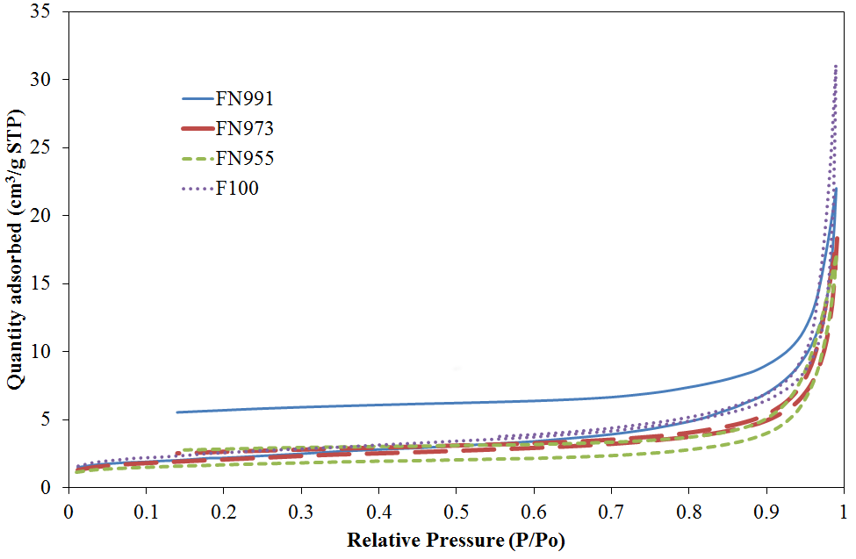
Figure 1. BET analysis of N₂ adsorption-desorption isotherms

XRD diffractograms for fresh Fe and FeNi bimetallic catalysts are shown in Figure 2. The XRD pattern of all the samples have well-defined diffraction patterns with strong and sharp diffraction peaks, indicating that they are crystalline. For F100 catalyst, two phases were detected; Fe (JCPDS file: 03-065-4899) and Fe₃O₄ (JCPDS file: 01-080-6402). For the Fe-Ni catalysts, besides the diffraction peaks of FeNi (JCPDS file: 01-080-7663), the diffraction peak of Fe₃O₄ also detected. A comparatively low intensity of Fe₃O₄ phase was detected on FN991 catalyst than other percentage ration. This indicate that low nickel composition is easy to reduce to form pure metallic.

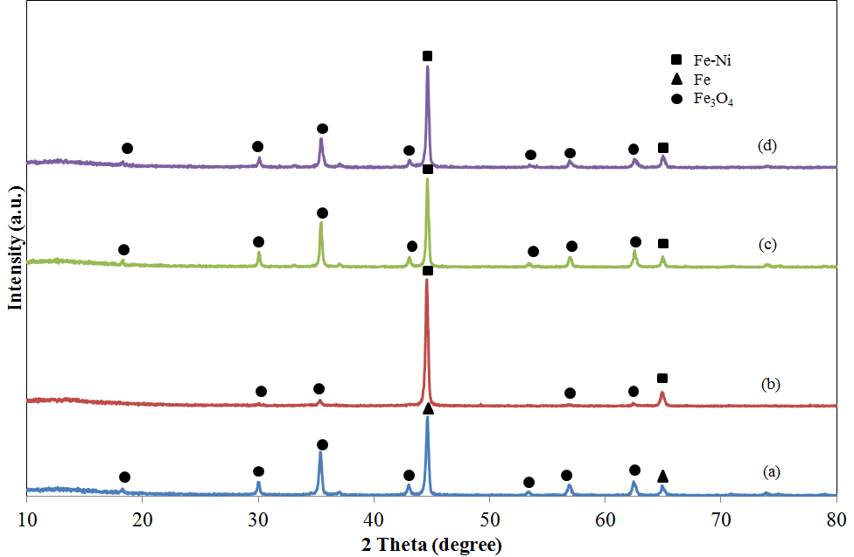
Figure 2. XRD diffractograms of prepared (a) F100, (b) FN991, (c) FN973 and (d) FN955

The SEM images in Figure 3 (a-d) show the porous structures of the prepared Fe and FeNi catalysts by microwave combustion method. Their morphological characteristics were investigated by variable pressure scanning electron microscope (VPSEM). As can be seen in Figure 3, the SEM images show the presence of voids and pores in the samples, which can be attributed to the release of large amount of gas during the combustion process. The sample has a spongy structure and one can see that the formation of multigrain agglomeration consisted of very fine crystallite.

(a) | (b)
(c) | (d)
Figure 3. SEM images of prepared (a) F100, (b) FN991, (c) FN973 and (d) FN955

Figure 4 shows the graph of H₂ production against time. As the time increases, the activity of catalyst decreases. The FN973 catalyst was showed a significant decrement in activity compared to other catalysts. This degradation of the catalysts activity is due to the decreases of formic acid concentration during the reaction process which some of them consumed and decompose into hydrogen and carbon dioxide [4]. It was found that the FN991 catalyst showed the most excellent H₂ selectivity. The selectivity for H₂ formation was 94-99% even at maximum conversion of formic acid.

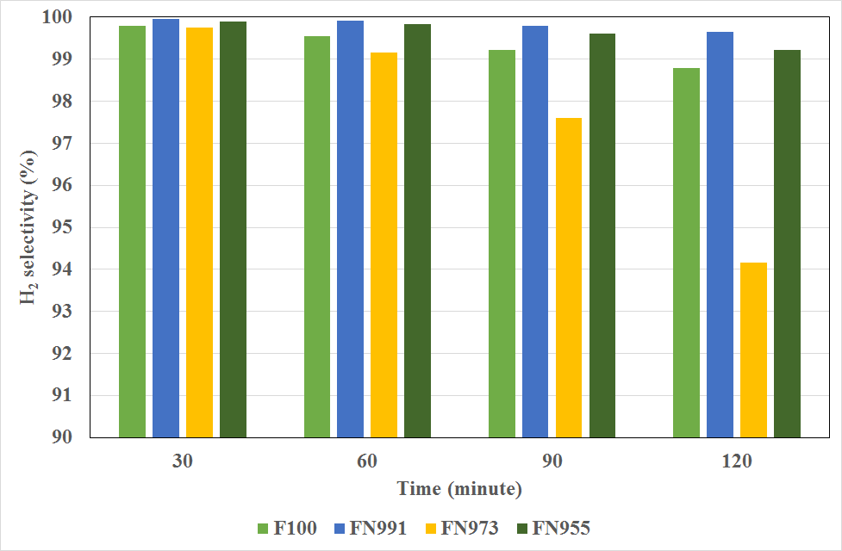
Figure 4. Production of H₂ for 120 minutes

Conclusion
In this study three bimetallic alloy have been successfully prepared by microwave combustion method using glycine as a fuel. The doping of Ni in the catalyst increase the activity of the produced catalyst. FeNi bimetallic were found to be an active catalyst for the formic acid decomposition at room temperature to produce hydrogen with selectivity ranging of 94 – 99% for 120 minutes at room condition. The lower Ni content at 1 wt.% showed a relatively higher selective to hydrogen rather than produce CO₂ gas. The utilization of low cost transition metal such as Fe and Ni to produce catalyst for dehydrogenation of formic acid may represent a new approach to develop an efficient catalyst.

Acknowledgement

Authors would like to thanks Ministry of Higher Education and Universiti Kebangsaan Malaysia (UKM) for funding this project under research grant number FRGS/1/2015/SG01/UKM/02/2 and DIP-2016-010 respectively, Centre of Research and Innovation Management (CRIM), UKM and Fuel Cell Institute, UKM for instruments facilities.

References

- Jian-bin, H., Shao-wu, W., Yong, L. U. O., Zong-ci, Z. and Xin-yu, W. E. N. (2012). Debates on the causes of global warming. Advances in Climate Change Research, 3(1): 38 – 44.
- El Naggar, A. M. A., Awadallah, A. E. and Aboul-Enein, A. A. (2016). Novel intensified nano-structured zero-valente nickel alloy based catalyst for hydrogen production via methane catalytic decomposition. Renewable and Sustainable Energy Reviews, 53: 754 – 765.
- Montandon-Clerc, M., Dalebrook, A. F. and Laurenczy, G. (2015). Quantitative aqueous phase formic acid dehydrogenation using iron(II) based catalysts. Journal of Catalysis, 343: 62 – 67.
- Wang, Z. L., Ping, Y., Yan, J. M., Wang, H. L. and Jiang, Q. (2014). Hydrogen generation from formic acid decomposition at room temperature using a NiAuPd alloy nanocatalyst. International Journal of Hydrogen Energy, 39(10): 4850 – 4856.
- Jia, L., Bulushev, D. A. and Ross, J. R. H. (2014). Formic acid decomposition over palladium based catalysts doped by potassium carbonate. Catalysis Today, 259: 453 – 459.
- Morone, A., Apte, M. and Pandey, R. A. (2015). Levulinic acid production from renewable waste resources: bottlenecks, potential remedies, advancements and applications. Renewable and Sustainable Energy Reviews, 51: 548 – 565.
- Yan, K., Jarvis, C., Gu, J. and Yan, Y. (2015). Production and catalytic transformation of levulinic acid: A platform for speciality chemicals and fuels. Renewable and Sustainable Energy Reviews, 51: 986 – 997.
- Ramli, N. A. S. and Amin, N. A. S. (2015). Fe/HY zeolite as an effective catalyst for levulinic acid production from glucose: characterization and catalytic performance. Applied Catalysis B: Environmental, 163: 487 – 498.
- Zhi, Z., Li, N., Qiao, Y., Zheng, X., Wang, H. and Lu, X. (2015). Kinetic study of levulinic acid production from corn stalk at relatively high temperature using FeCl₃ as catalyst : A simplified model evaluated. Industrial Crops & Products, 76: 672 – 680.
- Tedsree, K., Li, T., Jones, S., Chan, C. W. A., Yu, K. M. K., Bagot, P. A. J., Marquis, E. A., Smith, G. D. W. and Tsang, S. C. E. (2011). Hydrogen production from formic acid decomposition at room temperature using a Ag-Pd core-shell nanocatalyst. Nature Nanotechnology, 6(5): 302 – 307.
- Flaherty, D. W., Berglund, S. P. and Mullins, C. B. (2010). Selective decomposition of formic acid on molybdenum carbide: a new reaction pathway. Journal of Catalysis, 269(1): 33 – 43.
- Kooti, M. and Sedeh, A. N. (2012). Glycine-assisted fabrication of zinc and manganese ferrite nanoparticles. Scientia Iranica, 19(3): 930 – 933.
- Gregg, S. J. and Sing, K. S. W. (1982). Adsorption, surface area and porosity. Academic Press, New York.
- Feyzi, M., Mirzaei, A. A. and Bozorgzadeh, H. R. (2010). Effects of preparation and operation conditions on precipitated iron nickel catalysts for Fischer-Tropsch synthesis. Journal of Natural Gas Chemistry, 19(3): 341 – 353.
- Mandal, K., Bhattacharjee, D. and Dasgupta, S. (2015). Synthesis of nanoporous PdAg nanoalloy for hydrogen generation from formic acid at room temperature. International Journal of Hydrogen Energy, 40(14): 4786 – 4793.

