EFFECT OF ONE STEP ACTIVATION KOH MODIFIED CARBON IN DIMETHYL CARBONATE TRANSESTERIFICATION REACTIONS

(Kesan Satu Langkah Pengaktifan KOH Terhadap Karbon Terubahsuai

dalam Tindak Balas Transesterifikasi dengan Dimetil Karbonat)

Abdul Rahim Yacob*, Nor Wajihan Muda, Muhammad Azam bin Muhammad Zaki

Department of Chemistry, Faculty of Science

Universiti Teknologi Malaysia 81310 Skudai, Johor, Malaysia

*Corresponding author: manrahim@kimia.fs.utm.my

Abstract

In this work one step activation was introduced to potassium hydroxide (KOH) modified palm kernel shells. Various concentration of potassium hydroxide was used to activate and impregnate palm kernel shell before calcined at 600 ºC for 2 hours. All the prepared samples were characterized using Fourier Transform Infrared spectroscopy (FTIR), Nitrogen Adsorption Analysis and Field Emission Scanning Electron Microscope (FESEM), respectively. The basicity and basic strength of the prepared samples were determined using back titration methods. Following the preparation, the samples were used as base heterogeneous catalyst in palm oil transesterification reaction using dimethyl carbonate (DMC). Analysis of the products were performed using Gas Chromatography-Flame Ionization Detector (GC-FID) while to check the possibility of leaching, that is the presence of potassium in the biodiesel X-ray Fluorescence (XRF) spectroscopy was used. FTIR analysis of the raw palm kernel shell showed the presence of various functional groups. However, after the activation most of the functional groups were eliminated. A high BET surface area of 1054 m²/g was obtained from 10% AC/K, while the BET surface area for 15%, 20% and 25% AC/K decreases. This study shows, as the percentage of one step activation potassium doped carbon increases, the basic strength increases and followed by the increase in biodiesel production with leaching free reaction. The percentage conversion of biodiesel for 10% AC/KOH, 15% AC/KOH, 20% AC/KOH and 25% AC/KOH calculated were 35%, 45%, 63% and 67%, respectively.

Keywords: one step activation, dimethyl carbonate, biodiesel, leaching free

Abstrak

Dalam kajian ini pengaktifan satu langkah diperkenalkan dengan menggunakan kalium hidroksida (KOH) terubahsuai tempurung kelapa sawit. Pelbagai kepekatan kalium hidroksida digunakan bagi mengaktifkan dan menepukan tempurung kelapa sawit sebelum dikalsin pada 600 ºC selama 2 jam. Kesemua sampel yang telah disediakan dianalisis mengunakan teknik spektroskopi Inframerah Transformasi Fourier (FTIR), Analisis Penjerapan Nitrogen dan Mikroskopi Medan Pancaran Imbasan Elektron (FESEM). Kebesan dan kekuatan bes sampel yang disediakan ditentukan melalui pentitratan kembali. Sampel yang telah disediakan digunakan sebagai pemangkin bes heterogen untuk transesterifikasi minyak kelapa sawit dengan dimetil karbonat (DMC). Hasil yang didapati dianalisis dengan menggunakan Gas Kromatografi – Pengesan Pengionan Nyala (GC-FID) manakala untuk mengkaji kemungkinan larut resap iaitu kehadiran kalium dalam biodiesel, spektroskopi sinar-X pendarflour (XRF) digunakan. Analisis FTIR tempurung kelapa sawit mentah menunjukkan kehadiran pelbagai kumpulan berfungsi. Walaubagaimanapun, selepas pengaktifan dan karbonisasi, kebanyakan kumpulan berfungsi ini telah disingkirkan. Luas permukaan BET yang tinggi iaitu 1054 m²/g telah diperolehi daripada 10% AC/KOH, manakala luas permukaan BET untuk 15%, 20% dan 25% AC/KOH menurun. Hasil kajian menunjukkan apabila peratus penepuan karbon dalam pengaktifan satu langkah oleh kalium meningkat, kekuatan bes turut meningkat diikuti oleh peningkatan hasil biodiesel dalam tindak balas bebas larut resap. Peratus penukaran biodiesel untuk 10% AC/K, 15% AC/K, 20% AC/K dan 25% AC/K adalah masing-masing 35%, 45%, 63% dan 67%.

Kata kunci: pengaktifan satu langkah, dimetil karbonat, biodiesel, bebas larut resap

Introduction

Activated carbons (AC) are important material, which have been widely used in various industrial applications, which include separation/purification of liquid or gas and removal of heavy metal [1]. In the preparation of heterogeneous catalyst, activated carbon has proved to be highly effective as catalyst support. Activated carbon can be produced from a variety of raw material mostly coal and agricultural by products or lignocellulosic materials. Production of activated carbon from agricultural by products is preferable since it is more cost effective. There are numerous study regarding the production of activated carbon from agricultural by products such as coconut shell [2, 3], pistachio nut shell [4], sugar cane Bagasse [5], olive stones [6] and macadamia nut-shell [7]. Palm kernel shell (PKS) is one of the most abundant agricultural waste produce since palm oil industry is one of the major industries in Malaysia. Hence, palm kernel shell would be a better choice to be utilized for the raw material in the production of activated carbons.

Due environmental concerns, biodiesel has received many attentions to be used as an alternative diesel fuel since it has a unique advantage such as being biodegradable, non-toxic and suitable for domestic production. Biodiesel is a mono alkyl ester of long chain fatty acids obtain from transesterification reaction of triglyceride such as vegetable oil or animal fat with simple alcohol as shown in Figure 1.

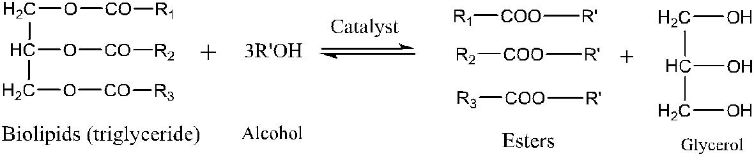

Figure 1. Transesterification of triglyceride with alcohol

Glycerol is produce as the undesired by product in this reaction. The separation process of glycerol could be costly and technically difficult. In this study dimethyl carbonate (DMC) will be introduced as a reagent to replace alcohol in the transesterification reaction. Free glycerol biodiesel can be obtained because fatty acid glycerol carbonates (FAGCs) is form and can be easily remove from the biodiesel as shown in Figure 2.

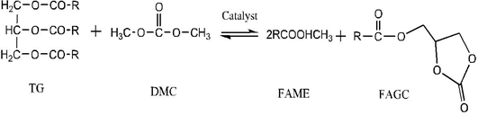

Figure 2. Transesterification of triglyceride with DMC

Another problem normally occur in the production of biodiesel is leaching [8]. In conventional method, normally part of the alkali metal catalyst would leach into the biodiesel, thus reducing the biodiesel quality. The removal of the catalyst would require a series of repeated washing and this will contribute to environmental problem. By immobilizing the catalyst in a suitable support can prevent the leaching problem and therefore separation can be easily done through centrifugation or filtration.

In this study, activated carbon from palm kernel shell was produced through one-step activation using potassium hydroxide (KOH) as activating agent Potassium doped activated carbon (AC/K) were then tested as a potential heterogeneous base catalyst in production of biodiesel from palm oil. In addition, by considering the advantages offered by DMC, it was chosen as a reagent and reactant in this reaction replacing alcohol.

Materials and Methods

This locally available palm kernel shell (PKS) were collected from the Kulai palm oil mill. Refined oil was purchased from local markets. Potassium hydroxide (KOH), n-hexane, n-heptane were purchased from QREC while dimethyl carbonate and 37% HCL were purchased from MERCK.

Preparation of AC/K catalyst

The base activation was carried out by using a liquid state KOH impregnation at different concentration. KOH solution at 10%, 15%, 20%, and 25% concentration were prepared by dissolving KOH pallets in deionized water in a 100-mL volumetric flask. About 10g of dried PKS were impregnated with different percentage concentration of KOH in a hot plate and stirred for 5 hours and dried in an oven overnight at 100 ºC. The impregnated carbon was further calcined in a furnace at 600 ºC for 2 hours and finally dried in an oven for 24 hours. All the samples were labeled as 10% AC/K, 15% AC/K, 20% AC/K and 25% AC/K according to the respective KOH percentage concentration.

Transesterification reaction with DMC

The reaction was conducted by mixing the palm oil and DMC with a 1:9 ratio in a two-necked 250-mL round bottom flask immersed in paraffin oil to control the temperature. The flask is equipped with a reflux and a magnetic stirrer. Firstly, the catalyst was added to the DMC and vigorously stirred with slight heating for 30 minutes until completely dissolved. About 10 g of palm oil were added into the mixture of catalyst and DMC then the mixture was refluxed at temperature close to the boiling point of DMC (80 – 90ºC). The reaction condition for are based on methodology reported by previous study [9,10]. After reflux, the mixture allowed to cool at room temperature and transferred into 15ml centrifuge tube. The mixture was centrifuged at 3000rpm for 30 minutes to separate the excess DMC and catalyst from the solution. The biodiesel was then collected for characterization by filtering out the catalyst.

All materials were characterized using Thermogravimetric Analyzer (TGA), Fourier Transform Infrared (FTIR), Nitrogen Adsorption Analysis-(BET) surface area, Field Emission Scanning Electron Microscope (FESEM) and Energy Dispersive X-ray fluorescence (XRF). While the transesterification reaction of palm oil with DMC to produce biodiesel was performed using gas chromatography – flame ionization (GC – FID) and Gas Chromatography – mass spectrometry (GC-MS).

Results and Discussion

Thermogravimetry analysis of raw palm kernel shell

Thermogravimetry analysis (TGA) is commonly used to study the thermal decomposition of agricultural by product. Raw palm kernel shell was first analyzed using diamond TG/DTA Perkin Elmer to estimate the optimum carbonization temperature for the activation process. Figure 3 shows the TGA thermogram of raw-PKS subjected in a temperature range 50 – 800 ºC at a heating rate of 10 ºC/min under air flow and nitrogen gas flow.

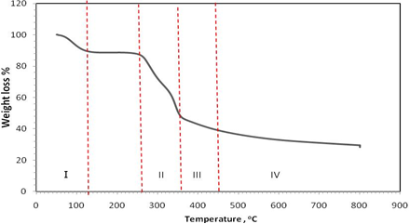

Figure 3. TGA curve of raw PKS

From the thermogram shown in Figure 3, there are various weight losses which can be separated into four different stages from stage I to IV. During stage I, 11.5% of weight loss occurred at the temperature of 50 – 130 ºC. This is due to the elimination of moisture in the raw material. Major weight loss of 47.4% occurs at temperature range from 240 – 360 ºC which is at stage II. It is assumed that the decomposition of the major components of lignocellulose biomass including hemicellulose, cellulose and lignin occur at this stage [11]. In stage III, at temperature of 360 °C to 450 °C, it shows the final decomposition or weight loss which corresponding to lignin decomposition and charcoal oxidation. The percentage weight lost recorded at this region were 16% and it is believed that most of these lignocellulosic materials in raw-PKS were decomposed. As reported by some researchers, lignin was gradually lost at temperature from 200 °C to 720 °C [12].

No significant change in weight loss on the stage IV for at which the temperature is around 450 ºC. Total weight loss occurs at 800 ºC. This is probably caused by the formation of volatile tar as the predominant product during the volatilization [13]. It is also believed that the organic compound in raw samples was completely carbonized at 500 °C. To ensure complete decomposition of organic compounds and liberation of volatile temperature for activation of activated carbon was set at 600 ºC.

Fourier transfer infrared spectroscopy analysis

Fourier transfer infrared spectroscopy (FTIR) was employed to identify the variety of functional group presence in the raw-PKS and activated carbon. It also provides information on the effect of the activation process that has been carried out as an evidence of the phase transformation which occurred in both raw-PKS and AC/K catalyst. Figure 4 shows the spectra of raw-PKS and the prepared 10%, 15%, 20% and 25% AC/K catalyst.

(a)
(c)
(e)
(d)
(b)

Figure 4. FTIR spectrum of (a) raw-PKS (b) 10%AC/K (c) 15%AC/K (d) 20%AC/K (e) 25%AC/K

Raw-PKS shows additional extra bond compares to AC/K. These extra bands are at 3343 cm⁻¹ which is usually assign to hydrogen bond OH group [6]. The absorption band at 2025.92 cm⁻¹ which was due to the C-H stretching in methyl and methylene groups. This band is different to the C-H vibrations band for –CH₃-and CH₂=, which are located around 1372.96 cm⁻¹ and 1453.10 cm⁻¹, and is very useful for identifying the methylene and methyl groups in each compound [14]. Moreover, peak at 1735 cm⁻¹ which represents the stretching of (C=O) carbonyl groups. The bands at 1595.21 cm⁻¹, 1507.95 cm⁻¹ and 1423 cm⁻¹ indicated the presence of C=C stretching of aromatic compounds. Another peak at 1239.90 cm⁻¹ and a subsequent small rise in 1161.97 cm⁻¹ could be assigned to the stretching of C-O in ester, ethers or phenol groups. The strong band at 1032.15 cm⁻¹ could be attributed to the (C-OH) alcohols group. From the analysis of the FTIR spectrum, carbonyl group, ether, esters, alcohols and the phenol groups can be suggested as the main oxygen group present in the raw PKS. This result supported by the thermogram of TGA analysis. The spectrum of raw PKS is quite similar to the study reported by previous study [15].

However, for the prepared AC/K at 10%, 15%, 20% and 25% concentration spectra illustrated less absorption peak compared with raw-PKS. From the spectra, it can be observed that most of the absorption peaks of functional groups were disappeared. This phenomenon might be explained as the process of carbonization in which most of the functional group presented in the raw-PKS were evaporated as volatile materials upon heating which indicated the activation process have taken place [16]. The spectra of prepared 10%, 15%, 20% and 25% AC/K showed a decreasing trend in the broad peak of C-O around 900-1300 cm⁻¹ and the C=C absorption band around 1500 –1650 cm⁻¹. This result in agreement by the previous studies [11, 17] indicating that by increasing the amount of activating agent, the activation reaction would increase and more weak bonds disappeared by thermal degradation.

Nitrogen adsorption analysis

The single point nitrogen gas adsorption characterization was performed to study the surface area of the prepared AC/K catalyst. The specific BET surface area, SBET of 10% AC/K, 15% AC/K, 20% AC/K and 25% AC/K samples are shown in Figure 5.

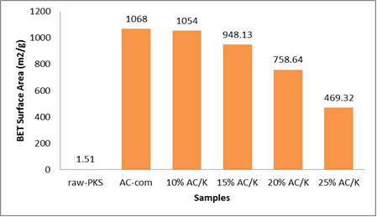

Figure 5. Single point BET surface area of raw PKS, AC-Com and prepared AC/K

Lowest surface area is shown in the raw-PKS which is 1.51 m²/g. This is because of the dense structure of raw-PKS with lack of pores. After activation, there is an increase in the surface area of the activated carbon. This shows that potassium hydroxide, KOH successfully act as an activating agent. However, there is a significant reduction in the specific BET surface area as the percentage concentration of KOH loading increases from 10% to 25%. Further increased in percentage of KOH loading caused the surface area of other activated carbons to decrease. The reduction of BET surface area may be caused by the filling of potassium hydroxide molecules into the pores of the activated carbon. The excessive amounts of KOH would promote a vigorous gasification reaction and diminished the carbon framework leading to a dramatic decrease of accessible area. Besides, an excessive KOH molecule might decompose following the reactions in equation 1 and 2 [18,19].

2KOH → K₂O + H₂O (1)

H₂O + C → CO + H₂ (2)

Field emission electron microscope

The morphological structure of raw-PKS and AC/K was characterized by field emission electron microscope (FESEM). Information on the structural change in the raw-PKS before and after activation we thoroughly studied. Figure 6 shows the FESEM micrographs of raw-PKS with 2.50KX magnifications. A dense and planar image with some occasional cracks can be seen. This mainly due to high percentage composition of lignin, a phenolic polymer that provides structural strength to the plant and give its hard and rough wood like structure.

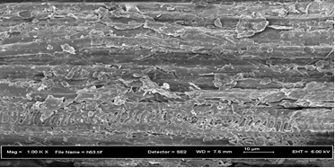
(a)

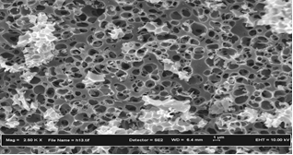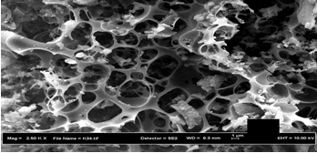
(b)
(c)
(b)

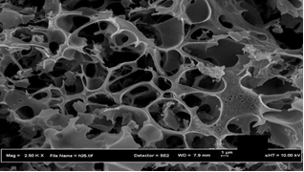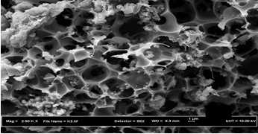
(e)
(d)

Figure 6. FESEM image of (a) raw PKS (b) 10%, (c) 15%, (d) 20% and (e) 25% AC/K with magnification of 2.50KX

Figure 6 (a – d) shows the FESEM micrograph at 2.50KX magnification of prepared AC/K at 10%, 15%, 20% and 25% concentration respectively. The FESEM micrographs reveal the presence of cavities and pores with different size and shapes. The development of pore and cavities in the AC/K is the result of the release of volatile components and the evaporation of KOH from the spaces, which were previously occupied by the reagent. Pore structure is one of the important characteristic in the heterogeneous catalysis process as the pore structure helps in the dispersion of the catalytic species throughout the carbon and thus increasing the catalytic performance [20]. The development of porosity by KOH activation is associated with the gasification reaction and formation of potassium species such as potassium dioxide, potassium carbonate and hydrogen [21]. However, as the percentage concentration of potassium hydroxide increase, a larger and wider pore can be seen. Beyond the optimum value, the excessive KOH would promote vigorous gasification reaction and may cause the excessive carbon burn-off, which can destroy the carbon framework, which collapse of some pore walls leading to a dramatic decrease of accessible area [22].

Back titration analysis

Determination of the amount of the basic site of the prepared AC/KOH catalyst was performed by the back titration method. This method was suggested in determining the amount of basic site of the bulk catalyst [23]. This analysis is important to identify the best prepared AC/KOH. Their basicity should be known first before applying as a catalyst for transesterification reaction. Figure 7 shows the amount of basic sites recorded in millimole per gram for the prepared 10% AC/K, 15% AC/K, 20% AC/K and 25% AC/K, respectively.

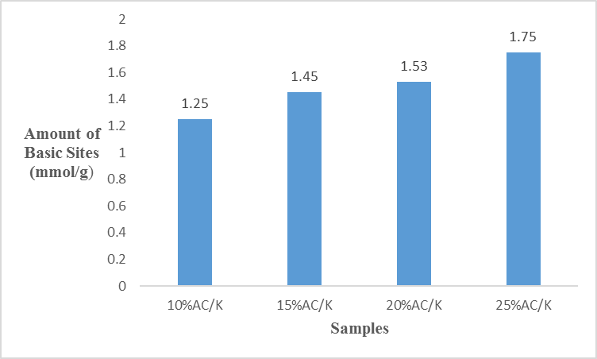

Figure 7. Amount of basic site of prepared AC/K catalyst

From the Figure 7, 25% AC/K shows highest amount of basic site of 1.75 mmol/g, follow by 20% AC/K and 15% AC/K, which have a basic site of 1.53 and 1.45 mmol/g respectively. While for 10% AC/K it shows a lower basic site of 1.25 mmol/g. It was found that the basic site increase with increase of percentage of KOH concentration. In addition, KOH can decompose into potassium species such as potassium oxide that acts as active site, which probably contribute to the basicity of the catalyst. Thus, increase the amount of KOH loading will probably increases the production of active site. This result in agreement with studies reported by Intarapong et al. [24], which found that the basicity and the activity of the catalyst increased with increased of the potassium loading to the ZrO₂.

Analysis and determination of transesterification product

The biodiesel obtained from the reaction process was analyzed to investigate the effectiveness of 10%, 15%, 20% and 25% AC/K as catalyst to catalyze the transesterification reaction of palm oil with DMC. Gas chromatography method was used for analysis and for the confirmation of the components in biodiesel produced. The biodiesel, which is fatty acid methyl esters (FAMEs), was firstly analyzed by GC-FID to determine the percentage conversion.

Figure 8 shows typical example of the GC chromatogram of the FAMEs. The elution order for the FAMEs obtain in the transesterification reaction with different percentage concentration catalyst is similar. The composition of FAME obtained including Methyl myristate (C14:0), Methyl palmitate (C16:0), Mehyl stearate (C18:0), Methyl oleate (C18:1) and Methyl linoleate (C18:2). Methyl palmitate and Methyl oleate are the main methyl esters for palm oil biodiesel. While Methyl myristate, Methyl stearate and Methyl limoleate exist in small percentage of the biodiesel. This data agrees with data reported in previous works [25,26].

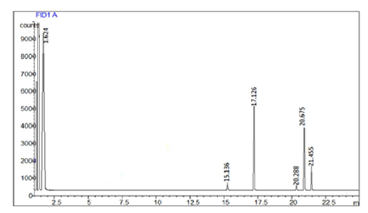

Figure 8. GC chromatograms of biodiesel using 25% AC/K catalyst

From the chromatogram obtained, percentage conversion of the biodiesel was calculated. Besides that, X-ray Fluorescence (XRF) analysis were done to determine the possibility of potassium leaching into the biodiesel after the reaction. Table 3.1 shows percentage conversion and the potassium content in the biodiesel produced from prepared 0% AC/K, 10% AC/K, 15% AC/K, 20% AC/K and 25% AC/K.

Table 1. Percentage conversion and potassium content of the biodiesel
Samples | Percentage Conversion  (%) | Potassium  (wt.%)
AC-Com | 0 | ND
10%AC/K | 35 | ND
15%AC/K | 45 | ND
20%AC/K | 63 | ND
25%AC/K | 67 | ND

ND: not detected

An increasing trend can be seen in the percentage conversion of biodiesel. For 10% AC/K, 15% AC/K, 20% AC/K and 25% AC/K the percentage conversion of biodiesel were 35%, 45%, 63% and 67% respectively. As the basicity of the catalyst used increase, the percentage conversion also increases. In addition, this proved that the production of biodiesel does not always depend on the surface area of the catalyst as reported in previous studies [26, 27]. As for the XRF analysis, it shows that there is no potassium content detected in the biodiesel after the reaction. This showed that by using DMC, the alkali catalyst in the one step activated KOH modified carbon do not dissolve or leach out into the reaction medium.

Conclusion

The prepared AC/K KOH was identified and could be an effective and potential heterogeneous base catalyst in transesterification of palm oil and DMC. The used of DMC in this reaction can prevent the leaching of KOH into the biodiesel and the transesterification produced glycerol free-FAME. The percentage conversion of biodiesel for 10% AC/K, 15% AC/K, 20% AC/K and 25% AC/K were 35%, 45%, 63% and 67%, respectively. Highest percentage conversion was obtained from 25% AC/K, although it has the lowest surface area compared with others. This showed that, the production of methyl ester in biodiesel not always depend on the large surface area. In addition, from the study, it shown that the basicity and the basic strength of the prepared AC/K play an important role in the catalytic performance of the catalyst. Increase in the basicity and basic strength of the catalyst. Higher percentage loading of potassium increased the basicity of the catalyst, which gives a significant impact to the percentage conversion of biodiesel.

Acknowledgement

The authors gratefully acknowledge the Chemistry Department, University Teknologi Malaysia and the International Conference on Catalyst (iCAT 2016) in helping for publication of this work.

References

- Largitte, L., Brudey, T., Tant, T., Dumesnil, P. C. and Lodewyckx, P. (2015). Comparison of the adsorption of lead by activated carbons from three lignocellulosic precursors. Microporous and Mesoporous Materials, 219: 265 – 275.
- Mohd Iqbaldin, M. N., Khudzir, I., Mohd Azlan, M. I., Zaidi, A. G., Surani, B. and Zubri, Z. (2013). Properties of coconut shell activated carbon. Journal of Tropical Forest Science, 25(4): 497 – 503.
- Govind Raj, K. and Alias Joy, P. (2015). Coconut shell based activated carbon–iron oxide magnetic nanocomposite for fast and efficient removal of oil spills. Journal of Environmental Chemical Engineering, 3(3): 2068 – 2075.
- Xu, J., Gao, Q., Zhang, Y., Tan, Y., Tian, W., Zhu, L. and Jiang, L. (2014). Preparing two-dimensional microporous carbon from pistachio nutshell with high areal capacitance as supercapacitor materials. Scientific Reports, 4: 5545 – 5551.
- Foo, K. Y., Lee, L. K. and Hameed, B. H. (2013). Preparation of activated carbon from sugarcane bagasse by microwave assisted activation for the remediation of semi-aerobic landfill leachate. Bioresource Technology, 134: 166 – 172.
- Bohli, T., Ouederni, A., Fiol, N. and Villaescusa, I. (2015). Evaluation of an activated carbon from olive stones used as an adsorbent for heavy metal removal from aqueous phases. Comptes Rendus Chimie, 18(1): 88 – 99.
- Rodrigues, L. A., De Sousa Ribeiro, L. A., Thim, G. P., Ferreira, R. R., Alvarez-Mendez, M. O. and Coutinho, A. D. R. (2013). Activated carbon derived from macadamia nut shells: an effective adsorbent for phenol removal. Journal of Porous Materials, 20 (4): 619 – 627.
- Di Serio, M., Tesser, R., Casale, L., D’apos;Angelo, A., Trifuoggi, M. and Santacesaria, E. (2010). Heterogeneous catalysis in biodiesel production: the influence of leaching. Topics in Catalysis, 53(11-12): 811 – 819.
- Fabbri, D., Bevoni, V., Notari, M. and Rivetti, F. (2007). Properties of a potential biofuel obtained from soybean oil by transmethylation with dimethyl carbonate. Fuel, 86 (5-6): 690 – 697.
- Zhang, L., Sheng, B., Xin, Z., Liu, Q. and Sun, S. (2010). Kinetics of transesterification of palm oil and dimethyl carbonate for biodiesel production at the catalysis of heterogeneous base catalyst. Bioresource Technology, 101(21): 8144 – 8150.
- Buasri, A., Chaiyut, N., Loryuenyong, V., Phakdeepataraphan, E., Watpathomsub, S. and Kunakemakorn, V. (2013). Utilization of biodiesel wastes as a bioresource for the preparation of activated carbon. International Journal of Applied Physics and Mathematics, 3(3): 173 – 177.
- Hayashi, J., Horikawa, T., Takeda, I., Muroyama, K. and Nasir Ani, F. (2002). Preparing activated carbon from various nutshells by chemical activation with K₂CO₃. Carbon, 40(13): 2381 – 2386.
- Hanapi, S. Z., Masrom, N. I. and Yacob, A. R. (2010). Tungsten carbide synthesis by microwave-induced alloying using phosphoric acid activated palm kernel shell carbon. Journal of Materials Science and Engineering, 4(4): 68 – 73.
- Shoaib, M. and Al-Swaidan, H.M. (2015). Optimization and characterization of sliced activated carbon prepared from date palm tree fronds by physical activation. Biomass and Bioenergy, 73: 124 – 134.
- Misnon, I. I., Zain, N. K. M., Aziz, R. A., Vidyadharan, B. and Jose, R. (2015). Electrochemical properties of carbon from oil palm kernel shell for high performance supercapacitors. Electrochimica Acta, 174: 78 – 86.
- Yacob, A. R., Majid, Z. A., Sari, R. and Dasril, D. (2008). Comparison of various sources of high surface area carbon prepared by different types of activation. Malaysian Journal of Analytical Sciences, 12(1): 264 – 271.
- Mopoung, S., Moonsri, P., Palas, W. and Khumpai, S. (2015). Characterization and properties of activated carbon prepared from tamarind seeds by KOH activation for Fe(III) adsorption from aqueous solution. The Scientific World Journal, 2015: 1 – 9.
- Ahmadpour, A. and Do, D. D. (1997). The preparation of activated carbon from macadamia nutshell by chemical activation. Carbon, 35(12): 1723 – 1732.
- Cao, Q., Xie, K. C., Lv, Y. K. and Bao, W. R. (2006). Process effects on activated carbon with large specific surface area from corn cob. Bioresource Technology, 97(1): 110 – 115.
- Konwar, L. J., Boro, J. and Deka, D. (2014). Review on latest developments in biodiesel production using carbon-based catalysts. Renewable and Sustainable Energy Reviews, 29: 546 – 564.
- Gu, Z. and Wang, X. (2013). Carbon materials from high ash biochar: A nanostructure similar to activated graphene. American transactions on Engineering & Applied sciences, 2(1): 15 – 34.
- Jin, H., Lee, Y. S., and Hong, I. (2007). Hydrogen adsorption characteristics of activated carbon. Catalysis Today, 120(3-4): 399 – 406.
- Intarapong, P., Iangthanarat, S., Phanthong, P., Luengnaruemitchai, A. and Jai-In, S. (2013). Activity and basic properties of KOH/mordenite for transesterification of palm oil. Journal of Energy Chemistry, 22 (5): 690 – 700.
- Intarapong, P., Iangthanarat, S., and Luengnaruemitchai, A. (2014). Biodiesel production from palm oil using potassium hydroxide loaded on ZrO₂ catalyst in a batch reactor. Chiang Mai Journal of Science, 41(1): 128 – 137.
- Ivanoiu, A., Schmidt, A., Peter, F., Rusnac, L. M., and Ungurean, M. (2011). Comparative study on biodiesel synthesis from different vegetables oils. Chemical Bulletin of “POLITEHNICA” University (Timisoara)., 56 (70): 94 – 98.
- Irmawati, R., Shafizah, I., Sharina, A.N., and Ahangar, H. A. (2014). Transesterification of palm oil by using silica loaded potassium carbonate (K₂CO₃/SiO₂) catalysts to produce fatty acid methyl esters (FAME). Energy and Power, 4(1): 7 – 15.
- Singh, A. K. and Fernando, S. D. (2008). Transesterification of soybean oil using heterogeneous catalysts, Energy & Fuels, 9(5): 2067 – 2069.

