

MALAYSIAN JOURNAL OF ANALYTICAL SCIENCES
ISSN 1394 - 2506

Published by The Malaysian Analytical Sciences Society

PALLADIUM PINCER COMPLEXES AS CATALYSTS FOR SELECTIVE ACTIVATION AND FUNCTIONALIZATION OF 1-PROPANOL

(Kompleks Paladium Pincer Sebagai Mangkin untuk Pengaktifan dan Pefungsian Terpilih
1-Propanol)

Sri Sugiarti¹* and Craig M Jensen²

¹Department of Chemistry, Faculty of Mathematics and Natural Sciences,
Bogor Agricultural University, 16680 Bogor, Indonesia
²Department of Chemistry,
University of Hawaii at Manoa, Honolulu, 96822 Hawaii, United States

*Corresponding author: sri.sw07@gmail.com

Received: 20 September 2016; Accepted: 16 May 2017

Abstract
Selective activation and functionalization of saturated C-H bonds in the original Shilov system used a combination of PtCl₄²⁻ and PtCl₆²⁻ in aqueous solution to transform methane into methanol and/or methyl chloride. On the other hand, palladium phosphinito PCP pincer halides (PdX{C₆H₃-2,6-(OPr^{i}₂)₂}, X=Cl, Br, I) have been developed for the Heck reactions of aryl halide, and they are believed to operate by an alternative Pd(II)/Pd(IV) mechanism, made this catalyst potentially used for the Shilov type reaction. Palladium pincer complexes showed selectivity for terminal functionalization of 1-propanol at lower temperature. Successful substitution of PtCl₄ by the less expensive oxidation system, CuCl₂ and air was achieved. In the presence of CuCl₂, the Wacker-like oxidation is apparently involved in the reaction. The phosphorous donor palladium pincer complexes showed better activity and selectivity than other types of palladium pincer complexes such as NCN-Pd-Br and SCS-Pd-Cl.

Keywords: C-H bonds activation, palladium pincer complexes, 1-propanol, selective functionalization, Shilov system

Abstrak
Pengaktifan dan pefungsian terpilih ikatan C-H tepu pada sistem asal Shilov menggunakan kombinasi larutan akueus daripada PtCl₄²⁻ dan PtCl₆²⁻ untuk mengubah metana menjadi metanol dan/atau metil klorida. Selain itu, paladium fosfinito PCP pincer halida (PdX{C₆H₃-2,6-(OPr^{i}₂)₂}, X=Cl, Br, I) telah digunakan untuk tindak balas Heck daripada aril klorida, dan dipercayai beroperasi melalui mekanisme alternatif Pd(II)/Pd(IV), menjadikan mangkin ini berpotensi untuk digunakan pada tindak balas jenis Shilov. Kompleks – kompleks paladium pincer menunjukkan kepilihan terhadap pefungsian terminal 1-propanol pada suhu rendah. Kejayaan penggantian PtCl₄ oleh sistem pengoksidaan yang lebih murah iaitu CuCl₂ dan udara telah dicapai. Dengan kehadiran CuCl_{2,} tindak balas pengoksidaan Wacker terlibat secara tidak langsung. Kompleks pincer paladium dengan penderma fosforus menunjukkan aktiviti dan kepilihan yang lebih baik dibandingkan dengan jenis lain dari kompleks paladium pincer, seperti NCN-Pd-Br dan SCS-Pd-Cl.

Kata kunci: pengaktifan ikatan C-H, kompleks paladium pincer, 1-propanol, pefungsian terpilih, sistem Shilov

Introduction
Selective activation and functionalization of C-H bonds in alkanes is one of the biggest challenging problems in chemistry. The abundant saturated hydrocarbons are underutilized and require an efficient method to transform them into more valuable products [1, 2]. Alkanes are not readily able to participate in chemical reactions because they have no empty orbital of low energy or filled orbital of high energy [3]. Several practical processes can be used to convert alkanes directly into more valuable products. However, they usually require harsh conditions that are difficult to control to prevent conversion of the alkanes into the thermodynamically stable and unattractive products carbon dioxide and water.

It was reported that low valent precious metal complexes will oxidatively add to alkane C-H bonds to give an alkyl hydride. The attempt to activate and functionalize C-H bond of alkanes was first reported by Shilov in 1970 [4]. The reaction has been found to be selective for the least substituted carbon of the alkane. The system which is now known as the “Shilov-system” is platinum catalyzed C-H bond activation and functionalization in aqueous media. In Shilov chemistry, the C-H bond is activated and functionalized by metal complexes with unique selectivity. Activation and functionalization at the terminal position is preferred. The use of 1-propanol as a substrate gives several advantages, it is possible to distinguish whether the pincer complexes catalyze a Shilov-type reaction or if only a Fenton-type reaction occurs. In the Shilov system, the main product would be 1,3-propanediol, while the formation of 1,2-propanediol would indicate that a radical reaction had taken place. Another advantage is that it is miscible in aqueous media. Thus the reactions can be carried out in simple glassware and at atmospheric pressure [5]. The general equation and the proposed mechanism of the reaction are as follow (equation 1 and Figure 1):

(1)

Figure 1. Proposed catalytic cycle for the platinum-catalyzed oxidation of alkanes in aqueous solution

As seen in Figure 1, the C-H activation is catalytic in Pt(II). It is also shown that the Shilov system requires a stoichiometric amount of Pt(IV) as oxidant which is one of the drawbacks of this system. Also, the presence of metallic platinum promotes the over-oxidation of the Shilov reaction’s product. Pt(IV) plays dual roles in the reaction, as stoichiometric oxidant and also to prevent the formation of metallic platinum by suppressing the disproportionation of Pt(II), another drawback of the Shilov system [5]. Introducing a strong chelating ligand such as a pincer ligand into the platinum complex would be expected to stabilize Pt(II) from undergoing disproportionation. The use of pincer platinum complexes in the Shilov-type reaction has been reported [6, 7]. The most interesting result is that Pt(IV) can be replaced by the cheaper, CuCl₂ oxidant. However, the activity of pincer complexes to catalyze Shilov-type chemistry is reduced upon this substitution [8]. This leads to the exploration of the use of different metal pincer complexes as catalysts.

Previously, in Heck reaction, palladium pincer complexes were proposed to proceeds through Pd(II)/Pd(IV) chemistry rather than the typical Pd(0)/Pd(II) cycles [9]. It is arguable that palladium pincer complexes might proceed through Pd(II)/Pd(IV) cycles when applied in the Shilov-type system in the analogy to the platinum analogs. Here we report the development of palladium pincer complexes as catalysts for alkane hydroxylation. Four types of pincer complexes seen in Figure 2 were tested in the Shilov reaction to see if minor changes in the ligand would have any effect on the catalytic activity. Furthermore, the possibility of using CuCl₂ as primary oxidant was also investigated.

Figure 2. Pincer palladium complexes tested as hydroxylation catalysts

Materials and Methods
Materials
PtCl₄ (Pressure Chemicals), K₂PtBr₆ (Pressure Chemicals), trifluoromethanesulfonic acid (Aldrich), trifluoroacetic acid (Aldrich), acetic acid (Aldrich), 1-propanol (Fisher Scientific), CuCl₂⋅2H₂O (Fisher Scientific), Cu(OAc)₂.H₂O (Fischer Scientific), hydrochloric acid (Aldrich) and hydrogen peroxide (30%, Fisher Scientific) were used as purchased. Complexes 1 [9], 2 [10], 3 [11] and 4 [12] were prepared according to the published procedures.

Hydroxylation of 1-propanol catalysed by palladium pincer complexes
Water (3 ml), trifluoromethanesulfonic acid or trifluoroacetic acidoracetic acidorhydrochloric acid (3.33 mmol), the complex 1 or other type of palladium pincer complexes (0.18 mmol), and oxidant (PtCl₄, K₂PtBr₆, CuCl₂⋅2H₂O, Cu(OAc)₂.H₂O) were added to a round bottom flask equipped with a condenser. 1-propanol was added portion wise over a 4 hours period (4 x 1 ml, total 56 mmol). The flask was heated in the range from 65 to 95 ºC and the mixture was treated dropwise with 30% hydrogen peroxide at the rate of 1.0 to 2.0 ml/hour from a syringe pump. After eight hours, the resulting mixture was analyzed by gas chromatography – mass spectrometry (GC-MS).

Results and Discussion
In order to test the reactivity of palladium pincer complexes in Shilov type chemistry, the original oxidant, PtCl₄, was used coupled with H₂O₂ as co-oxidant, as seen on equation 2. De Vries et al. used H₂O₂ to oxidized Pt(II) to Pt(IV) in the presence of the strong acid trifluoromethanesulfonic acid [5]. The result is shown on Table 1.

(2)

Table 1. Hydroxylation of 1-propanol with palladium pincer complexesª
Entry | Catalyst | Rate of H₂O₂ | Time | TON^{b} |  | ³¹P NMR^{c}
 |  | (ml/h) | (hour) | 1,3-diol | 1,2-diol | (ppm)
1 | 1 | 1.0 | 1 | - | - | 188
2 | 1 | 2.0 | 2 | Trace | No | 65
3 | 1 | 1.9 | 3.5 | 5 | 2 | 65
4 | 2 | 1.9 | 3.5 | 4 | 1.8 | 65
5 | 3 | 1.9 | 0.5 | 1 | 0.4 | -
6 | 4 | 1.9 | 1 | 2 | 1 | -
7 | - | 1.0 | 4 | - | - | -
8 | - | - | 5 | - | - | -
ªAll reactions were carried out in the presence of PtCl₄ and H₂O₂ unless otherwise noted. The resulting mixtures were analyzed by GC. Nevertheless, the formation of 1,3-diol and 1,2-diol conformed by ¹H and ¹³C NMR ^{b}TON is the average of three runs. TON=mol of product/(mol of palladium complex + mol of PtCl₄) ^{c 31}P NMR at 65 ppm corresponds to phosphorous oxide and at 188 ppm corresponds to complex 1.

The rates of the addition of H₂O₂ must be controlled as such to prevent the formation of Pt(0), a black precipitate resulting from the disproportionation of Pt(II), once Pt(IV) is reduced to Pt(II) in the cycle. Apparently, at lower rates of H₂O₂, complex 1 quickly underwent redox reaction with PtCl₄ but not following the Shilov reaction’s pathway as no 1,3-propanediol was formed. Result on 1st entry showed that the rate of H₂O₂ at 1 ml/h was not fast enough to oxidize Pt(II) to Pt(IV). The rate of H₂O₂ addition to 2 ml/h resulted in the decomposition of complex 1 as shown by ³¹P NMR. Slightly reduced rate of H₂O₂ addition at 1.9 ml/h resulted in similar yield to that observed previously using the analogous platinum complex as catalyst.

Unlike the platinum analog, the Shilov reaction with the palladium pincer complexes showed ligand dependency. Changing the atom donor from phosphorous to nitrogen or sulphur resulted in poor turnover numbers. Unfortunately, the reaction only lasted 3.5 hours before the PCP pincer complex decomposed into a detectable black precipitate. Blank tests in the presence of PtCl₄, entry 7 and 8, confirmed that the product only formed in the presence of the catalyst. Even though the Shilov reaction is dominant, the formation of radical products was also significant as shown by the presence of 1,2-propanediol. The ratio between 1,3-propanediol and 1,2-propanediol is 3:1. It was considered that the higher reaction temperature of 95 ºC might promote the formation of radical products. Experiments carried out at the lower temperature of 65 ºC are presented in Table 2.

Table 2. Hydroxilation of 1-propanol in the presence of complex 1 at 65 ºC ª
Entry | Oxidant | Acid | TON
Entry | Oxidant | Acid | 1,3-diol | 1,2-diol
1 | PtCl₄ | Triflic | 3 | 0.8
2 | PtCl₄ | Trifluoroacetic | 3 | 0.8
3 | PtCl₄ | Acetic | 1 | 4
4 | PtCl₄ | Triflic^{b} | 2 | 0
ª Reactions were carried out in the presence of H₂O₂ as secondary oxidant. TON is the average of three runs. Catalysis with complex 2 showed very similar results with complex 1. Complex 3 and 4 always decomposed prematurely. ^{b} In the presence of 1 ml THF

Reducing the temperature resulted in reduced solubility of PtCl₄ compounds and in turn gave less turnover number. Introducing different acids was done to solve this problem with no success. However, a new conclusion was made that in the presence of acetic acid more radical product was formed.

A critical drawback with the Shilov reaction is the use of expensive Pt metal as oxidant. Substituting Pt with another cheaper redox metal is desirable. The best candidate was CuCl₂. In the catalytic reaction of the Wacker process, CuCl₂ is widely known to do redox reactions with Pd [13, 14]. Introducing CuCl₂ to the reaction almost did not result in any type of products as shown in Table 3. Apparently H₂O₂ oxidized the catalyst at a higher rate than the redox reaction between CuCl₂ and palladium pincer complexes. Introducing another source of copper, Cu(OAc)₂, resulted in a very significant turnover number of products. However, as mention earlier, acetic ion promotes the formation of radical reaction as more than twice as much 1,2-propanediol was formed.

Table 3. Impact of copper salt in the presence of complex 1ª
Entry | Oxidant | Additive | TON^{b}
Entry | Oxidant | Additive | 1,3-diol | 1,2-diol
1 | CuCl₂ | Triflic | Trace | -
2 | Cu(OAc)₂ | Triflic | 15 | 45
3 | Cu(OAc)₂ | Trifluoroacetic | 17 | 41
4 | Cu(OAc)₂ | Acetic | Trace | Trace
5 | Cu(OAc)₂ | - | Trace | Trace
ª Reactions were carried out in the presence of H₂O₂ at 0.5 ml/h. The temperature of the reactions was 65 ºC. ^{b} TON is the average of three runs. TON = mol of diol/mol of palladium complex. Similar results were showed by complex 2. Complex 3 and 4 produced only trace amount of product

Information from the Wacker system led to a better understanding of the Shilov reaction in the presence of palladium pincer complexes and CuCl₂ [13, 14]. The reaction was then carried out in the presence of CuCl₂, water, HCl and at temperature of 65ºC to give two kinds of products 1,3-propanediol and 3-chloro-1-propanol. However, the GC spectrum showed neither one of those expected products. Instead, one very dominant peak appeared at a higher retention time as shown in Figure 3. Mass spectrum fragmentation study showed that the compound at 10.46 minutes is a chloro compound. The compound at 10.46 minutes has m-1 at 135. Apparently 3-chloro-1-propanol compound was formed but in the acidic solution it quickly reacts with the starting material to form an ether compound, as seen on equation 3.

(3)

(a)
Abundance

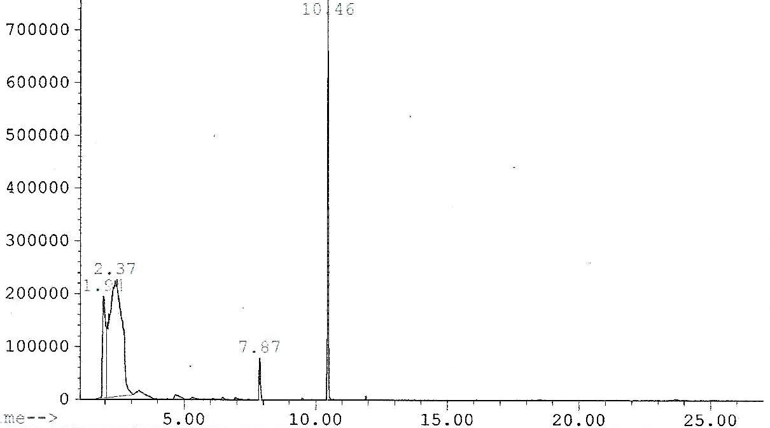
Time (minute)

(b)
Abundance

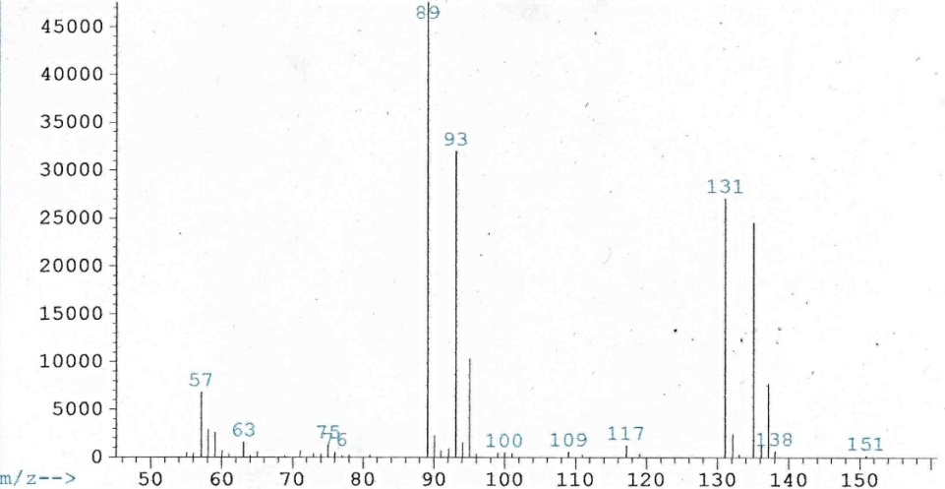
Time (minute)

Figure 3. GC spectrum of (a) the Wacker-type reaction of hydroxylation of 1-propanol and (b) the mass spectrum of ether complex at retention time of 10.46 minutes

The appearance of ether in the products led to a conclusion that there is a Lewis acid present in the solution, as alcohol would be converted to ether in the presence of a strong acid or Lewis acid [15]. Figure 3(b) features a peak at 93 that belongs to the 3-chloro-1-propanol which also results from loss of 43 molecular mass or a fragment of CH₃CH₂CH₂-. Detailed on mass fragmentation of ether compound can be seen Figure 4 below.

Figure 4. Detailed on mass fragmentation of ether compound

Experiments showed that the ether compound can be obtained in the presence of HCl and CuCl₂ or complex 1, suggesting that complex 1 acts as a catalyst in Shilov type chemistry as well acting as a Lewis acid [16]. Therefore, reducing the catalyst loading, consequently reducing the amount of Lewis acid, was expected to reduce the rate of formation of ether. Figure 5 shows the result from reaction with lower catalyst loading of complex 1.

Abundance

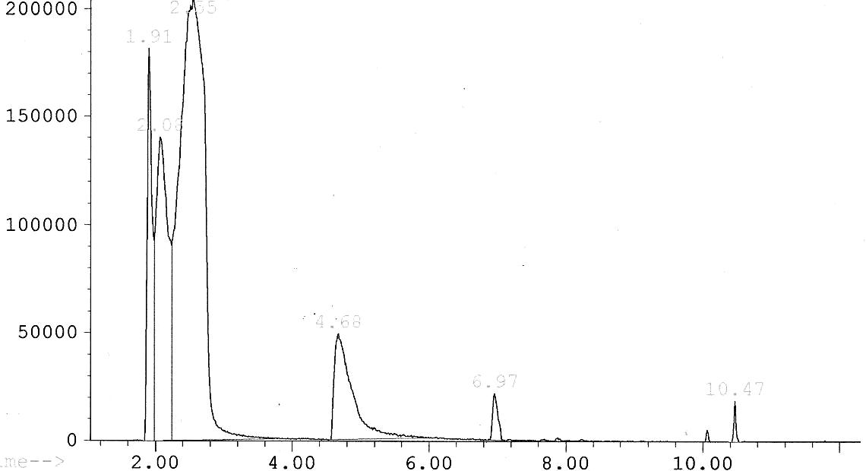
4.68
6.97
10.47
Time (minute)

Figure 5. Hydroxylation of 1-propanol at lower catalyst loading

The peak at 4.68 minutes is 3-chloro-1-propanol complex with turnover number of 23. This is the highest turnover number that was attained in all of the Shilov-type experiments with palladium pincercomplexes. Furthermore, this condition was the best in terms of not producing radical reactions. The dominance of 3-chloro 1-propanol in the products suggests that in the presence of CuCl₂, the nucleophilic attack by OH⁻ is less effective. This phenomenon is also known in the Wacker process where use of CuCl₂ as oxidant instead of CuCl results in product dominated by chloro compound [17]. One concern with using CuCl₂ and HCl system in our reaction is that since the dominant product is the chloro compound and the source of chloride in the system is either CuCl₂ or HCl or both, then as the reaction progresses, the concentration of CuCl₂ or HCl will decrease. Less Cl⁻ might reduce the re-oxidation of Cu(I) complex into Cu(II) complex, and eventually slow down the reaction.

Conclusion
Palladium pincer complexes are catalysts for Shilov-type chemistry by showing selectivity for terminal functionalization of 1-propanol at lower temperature. A cheaper alternative oxidant CuCl₂ and air was successfully applied, adapted from the Wacker process. The phosphorous palladium pincer complexes showed better activity and selectivity than other types of palladium pincer complexes such as NCN-Pd-Br and SCS-Pd-Cl.

References
- Konnick, M. M., Hashiguchi, B. G., Devarajan, D., Boaz, N. C., Gunnoe, T. B., Groves, J. T., Gunsalus, N., Ess, D. H., Periana, R. A. (2014). Selective CH functionalization of methane, ethane, and propane by perfluoroarene iodine(III) complex. Angewandte Chemie, 126(39): 10658 − 10662.
- Labinger, J. A. and Bercaw, J. E. (2002). Understanding and exploiting C-H bond activation. Nature, 417: 507 − 514.
- Crabtree, R. H. (2004). Organometallic alkane CH activation. Journal of Organometallic Chemistry, 689 (24): 4083 − 4091.
- Shilov, A. E. and Shul’pin G. B. (1997). Activation of C-H bonds by metal complexes. Chemical Reviews, 97(8): 2879 − 2932.
- DeVries, N., Roe, D. C., Thorn, D. L. (2002). Catalytic hydroxylation using chloroplatinum compounds. Journal of Molecular Catalysis A: Chemical, 189 (1): 17 − 22.
- Jensen, C. M. (1999). Irridium PCP complexes: Highly active and robust catalysts for novel homogenous aliphatic dehydrogenation. Chemical Communications, 24: 2443 − 2449.
- Morales-Morales, D., Redon, R., Yung, C. and Jensen, C. M. (2004). Dehydrogenation of alkanes catalyzed by an irridium phosphinito PCP pincer complex. Inorganica Chimica Acta, 357(10): 2953 − 2956.
- Wang, Z., Sugiarti, S., Morales, C. M., Jensen, C. A. and Morales-Morales, D. (2006). Catalytic hydroxylation of 1-propanol by platinum NCN and PCP pincer complexes using CuCl₂ as oxidant. Inorganica Chimica Acta, 359(6): 1923 − 1928.
- Morales-Morales, D., Grause, C., Kasaoka, K., Redon, R., Cramer, R. E. and Jensen, C. M. (2000). Highly efficient and regioselective production of trisubstituted alkenes through Heck couplings catalyzed by a palladium phosphinito PCP pincer complex.Inorganica Chimica Acta, 300: 958 − 963.
- Ohff, M., Ohff, A., van der Boom, M. E. and Milstein, D. (1997). Highly active Pd(II) PCP-type catalysts for the Heck reaction. Journal of the American Chemical Society, 119: 11687 − 11688.
- Van Beek, J. A. M., Van Koten, G., Dekker, G., Wissing, E., Zoutberg, M. C., Stam, C. H. (1990). Synthesis and reactivity towards diiodine of palladium(II) and platinum(II) complexes with non-cyclic and cyclic ligands (C₆H₃{CH₂NR¹R²}₂-2,6)- End-on diiodine platinum(II) bonding in macrocyclic [PtI(C₆H₃{CH₂NMe(CH₂)₇MeNCH₂}-2,6)(η¹-I₂)]. Journal of Organometallic Chemistry, 394: 659 − 678.
- Errington, J., McDonald, W. S. and Shaw, B. L. (1980). Cyclopalladation of C₆H₄(CH₂SBu^{t})₂-1,3 and the crystal structure of [PdCl{C₆H₃(CH₂SBu^{t})₂-2,6]. Journal of the Chemical Society-Dalton Transactions: 2312 − 2314.
- Smidt, J., Hafner, W., Jira, R., Sedlmeier, J., Sieber, R., Ruttinger, R. and Kojer, H. (1959). Katalytische umsetzungen von olefinen an platinmetall-verbindungen das consortium verfahren zur herstellung von acetaldehyd. Angewandte Chemie, 71(5): 176 − 182.
- Keith, J. A., Nielsen, R. J., Oxgaard, J. and Goddard, W. A. (2007). Unraveling the Wacker oxidation mechanisms. Journal of the American Chemical Society, 129(41): 12342 − 12343.
- Jaworski, M. A., Vega, S. R., Siri, G. J., Casella, M. L., Salvador, A. R. and Lopez, A. S. (2015). Glycerol etherification with benzyl alcohol over zirconia catalysts. Applied Catalysys A: General, 505: 36 – 43.
- Dijkstra, H. P., Meijer, M. D., Patel, J., Kreiter, R., van Klink, G. P. M., Lutz, M., Spek, A. L., Canty, A. J. and van Koten, G. (2001). Design and performance of rigid nanosize multimetallic cartwheel pincer compounds as Lewis acid catalysts. Organometallics, 20(14): 3159 − 3168.
- Tsuji, J. (1984). Synthetic applications of palladium catalyzed oxidation of olefins to ketones. Synthesis, 1984(05): 369 − 384.

