

MALAYSIAN JOURNAL OF ANALYTICAL SCIENCES
ISSN 1394 - 2506

Published by The Malaysian Analytical Sciences Society

CHITIN AND CHITOSAN EXTRACTION FROM Portunus pelagicus

(Pengekstrakan Kitin dan Kitosan dari Portunus pelagicus)

Norhidayah M. Ahyat, Faridah Mohamad, Azrilawani Ahmad, Alyza A. Azmi*

School of Marine and Environmental Sciences,

Universiti Malaysia Terengganu, 21030 Kuala Nerus, Terengganu, Malaysia

*Corresponding author: alyza.azzura@umt.edu.my

Received: 30 March 2017; Accepted: 4 June 2017

Abstract
Isolation of chitin and chitosan from natural sources are widely known as they can be used in many applications. Extraction of chitin and chitosan are carried out in exoskeleton of flower crab, Portunus pelagicus. Chemical treatments such as demineralization and deproteinzation processes are used for chitin extraction, and followed by deacetylation process of chitin, which is to produce its derivatives that known as chitosan. Characterization of chitin and chitosan has been done using Fourier Transform Infrared (FTIR) Spectroscopy, X-ray diffraction (XRD), CHNS elemental analysis and Thermogravimetric analysis (TGA). Preliminary results of FTIR vibrations patterns showed stretching of hydroxyl (O-H), amine (N-H) and carbonyl (C-O) groups indicated the presence of chitin and chitosan. XRD analysis indicates the crystalline nature of chitin and chitosan. The degree of deacetylation of chitin was characterized using CHNS elemental analyzer. The extracted chitosan will be used as reducing agent for silver nanoparticles synthesis in the future studies.

Keywords: crustacean, marine invertebrates, bio-polymers, natural reductant

Abstrak

Pengasingan kitin dan kitosan daripada sumber semulajadi telah dikenali secara meluas kerana dapat digunakan dalam banyak aplikasi. Pengekstrakan kitin dan kitosan dari exoskeleton ketam bunga, Portunus pelagicus telah dilakukan. Rawatan kimia seperti proses demineralisasi dan proses deprotenisasi telah digunakan untuk pengekstrakan kitin dan diikuti dengan proses deasetilasi daripada ktin untuk penghasilan terbitannya yang dikenali sebagai kitosan. Pencirian kitin dan kitosan telah dilakukan dengan menggunakan Spektoskopi Inframerah Transformasi Fourier (FTIR), pembelauan Sinar X (XRD), analisis unsur CHNS dan analisis termogravimetri (TGA). Dapatan awal getaran FTIR menunjukkan regangan bagi kumpulan hidroksil (O-H), amino (N-H) dan karbonil (C-O) menunjukan kehadiran sebatian kitin dan kitosan. Analisis XRD menunjukkan sifat kristal bagi kitin dan kitosan. Pencirian darjah deasetilasi kitin telah dilakukan menggunakan penganalisis unsur CHNS. Ekstrak kitosan akan digunakan sebagai agen penurun bagi sintesis nanopartikel perak untuk kajian masa hadapan.

Kata kunci: krustasea, invertebrata marin, bio-polimer, penurun semulajadi.

Introduction
Polysaccharides have given many advantages in life science as their unique structure has shown some potential as natural bioactive component. Chitin is the second most abundant of polysaccharides on earth after cellulose that formed a linear chain of acetylglucosamine group. Chitin can be isolated from exoskeleton of crustacean for instance; shrimp shells [1], crab shells [2], fish scales [3], gastropod shell and operculum [4]. Chitin is available in three different forms, which are α, ß and γ forms. In addition, chitin has a compact structure and strong intra and inters molecular hydrogen bonds [5] that may causes the insolubility in most of the organic solvents, thus limit it in many applications, especially in clinical field. Due to this concern, chemical modification on chitin is performed, which is to increase the solubility. Chitin can be deacetylated or partially deacetylated into chitosan that can be identified by calculating the percentage of degree of deacetylation (DD). Chitin and chitosan represent as white solid, non-toxic, odourless, biodegradable, biocompatible with living tissues and bio-absorbable with antibacterial, free from antigenic effect, polar in nature and can form stable complexes with heavy metals [6,7]. Chitosan has versatile properties that can be used in different fields such as biomedicals [8], tissue engineering [9], textiles [10,11], and food processing industries [12].

In general, three major steps are used in the isolation process. The processes include demineralization, deproteinization and deacetylation. Demineralization is a process of removing inorganic materials from the natural sources (i.e; exoskeleton of invertebrates), using dilute acidic solution. Then, the process is continued with deproteinization process that aided in the protein separation and followed by deacetylation process, which gives the final product of chitosan. Deacetylation process occurred at elevated temperature (in range 105 to 110 ºC) in concentrated bases solution (40% to 50%) [13 - 15]. Blue swimmer crab, Portunus pelagicus (P. pelagicus) is a major marine crab that distributed in the coastal water of western South China Sea. In the recent study, extraction of chitin and chitosan from blue swimmer crab, P. pelagicus (Figure 1) was conducted using this standard method and the obtained chitosan will be used as reducing agent to chelate metal ion in silver nanoparticles synthesis for upcoming research work.

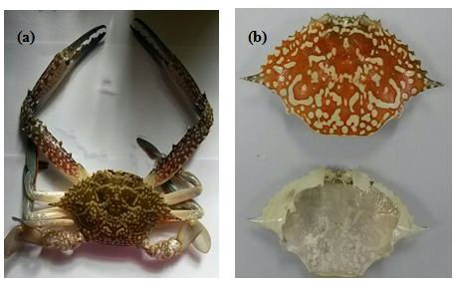

Figure 1. (a) Blue swimmer crab, P. pelagicus and (b) its carapace after drying process

Materials and Methods

Raw material preparations
Blue swimmer crab, P. pelagicus is bought from a local market in Kuala Terengganu, Malaysia. The carapace was scrapped free from any loose tissues, washed, dried and ground (Retsch PM 100) into fine powder with size average of 450 µm.

Extraction procedures
Chitin was extracted from P. pelagicus carapace following method by Sagheer et al. [16] with some modifications. The demineralization process begins by treating the pulverized carapace in 1.0 N hydrochloric acid, HCl solution (1:15 solid-to-solvent ratio, w/v) with constant stirring for 1 hour. No thermal heating used in this process. The deproteinization process was performed by heating the demineralized powder under reflux in 1.0 N sodium hydroxide, NaOH solution (1:15 solid-to-solvent ratio, w/v) at 80 °C for 6 hours. Then, removal colour of the deproteinized powder was conducted in acetone (1:100 solid-to-solvent ratio, w/v) with constant stirring for 24 hours. The purified chitin was filtered, washed to neutrality and dried in oven at 60 °C. White powder of carapace shell was obtained after undergo the demineralization, deproteinization and decolourization processes.

Chitin deacetylation
Chitin was deacetylated using traditional thermal heating. The samples was mixed in 50% (w/v) of sodium hydroxide, NaOH at 1:20 solid-to-solvent ratio and stirred for 6 hours at 110 °C. After the deacetylation process, the sodium hydroxide, NaOH was drained off and the pure chitosan was washed with deionized water to neutrality and dried in oven at 60 °C.

Characterization of chitin and chitosan: Fourier transform infrared spectroscopy
The vibration of functional groups spectra of chitin and chitosan prepared were analyzed using FTIR spectroscopy. All samples were KBr supported, pressed to result homogenous sample/KBr disc and analyzed over the frequency of 4000 to 400 cm⁻¹ at resolution of 4 cm⁻¹ using Perkin Elmer Spectrum 100 FT-IR Spectrometer.

X-ray powder diffractometry
The XRD measurement of powder samples were carried out using a model of Rigaku MiniFlex II diffractometer equipped with Ni – filtered Cu Kα radiation (λ = 1.5406 Å) as the X-ray source. The diffractometer was set up at 1.25° diverging and receiving slits at 40 kV and 30 mA. Data was collected at a scan rate of 2°/min with the scan angle from 3° to 40°.

Elemental analysis
The average degree of deacetylation (DD) of chitosan samples was determined using CH-NS Elemental Analyzer (CHNS Microanalysis / EA1112 CHNS – O Analyzer). The DD% value of chitosan samples were calculated from the following formula:

DD% = [(6.857 – C / N) / 1.7143] x 100 (1)

where C/N is the carbon to nitrogen ratio peak area measured from the elemental composition of the chitosan samples.

Thermogravimetric analysis
Thermogravimetric analysis (Perkin Elmer TGA analyzer) were carried out using approximately 20 mg of sample with temperature range of 30 to 600 °C, and with heating rate of 10 °C/min under (30 mL/min) nitrogen atmosphere.

Results and Discussion

Extraction of chitin and chitosan
In this study, extraction of chitin and chitosan from the carapace of crab, P. pelagicus was initiated by treatment of crab shells in dilute acidic solution for the removal the inorganic content such as calcium carbonate, CaCO₃ from the shells. Bubbles were released after the penetration of the acid on the surface of crab shell indicates the emission of carbon dioxide, CO₂ gas. During this treatment, low concentration of acidic solution, which is 15 mL/g of 1.0 N HCl was used to prevent the hydrolysis of chitin structure [17]. Deacetylation process is a conducted, which is to remove the acetyl group in chitin, thus produce chitosan [5]. Bolat et al. [18] reported the chitin and chitosan content for freshwater crab were 6.83% and 4.56%, respectively. In this study, the dry weight of chitin and chitosan contents for the carapace of P. pelagicus were 20.24% and 13.56%, respectively and the result is consistent with the result reported by Das et al. [19].

Characterization of chitin and chitosan: Fourier transform infrared analysis

Fourier transform infrared (FTIR) spectroscopy is a technique that is used to determine the vibration of functional groups in chitin and chitosan. The FTIR spectra of chitin and chitosan of P. pelagicus were examined as shown in Figure 2. Chitin spectrum shows bands at 3447 cm⁻¹, 3103 cm⁻¹ and 1657 cm⁻¹ corresponds to the vibration of hydroxyl, the O–H stretching, aliphatic compound, the CH₃ stretching and amide I, the stretching of C=O group, respectively. These peaks are pivotal to observe because they are used to differentiate the formation between chitin and chitosan from the extracted sample. The vibration of Amide III was observed at peak 1314 cm⁻¹ due to the presence of protein content in the chitin complexes. Vibration of N–H stretching that associated with O-H stretching was observed in chitosan FTIR spectrum at band 3447 cm⁻¹. The vibration of -CH₃ group in chitin spectrum was absence in the FTIR spectrum of chitosan after treating in concentrated NaOH for six hours, thus this finding proved that the acetyl group, COCH₃ in chitin backbone was removed during the deacetylation process, thus produced chitosan. Besides, there is no significant between the FTIR spectrum of prepared chitosan and commercial chitosan. Table 1 shows the spectral value of chitin, chitosan and commercial chitosan.

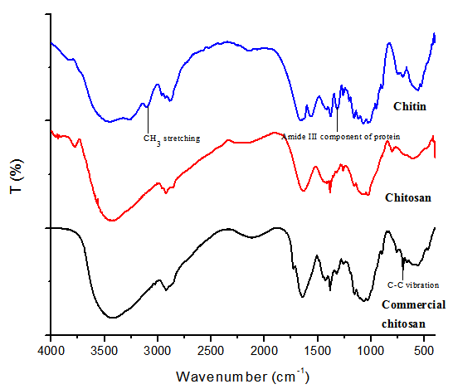

Figure 2. FTIR spectra of chitin, chitosan and commercial chitosan

Table 1. FTIR spectra value of chitin, chitosan and commercial chitosan
Assignment | Frequency (cm⁻¹)
Assignment | Chitin | Chitosan | Commercial Chitosan
Hydroxyl, O-H stretch (H-bonded) | 3445 | - | -
Amine, NH₂ stretch and hydroxyl, O-H stretch | - | 3435 | 3429
Amine, N-H stretch | 3264 | - | -
Aliphatic compound, -CH₃ stretch | 3102 | - | -
Aliphatic compound, -CH₂ stretch | - | 2924 | 2921
Secondary amide, C=O stretch | 1657 | 1636 | 1643
Amide, N-H bend | 1559 | - | -
Aliphatic compound, -CH₂ bend | 1417 – 1379 | 1412 - 1384 | 1430 - 1384
Amide III, component of protein | 1314 | - | -
Complex vibration of NHCO group | - | 1261 | 1262
C-O-C glycosidic linkage | - | 1160 | 1154
Carbonyl, C-O stretch | - | 1023 | 1070
Ring vibration (C-C) | - | - | 699

X-ray powder diffractometry analysis
X-ray diffraction analysis is applied to determine the crystallinity structure of extracted chitin and chitosan. In the crystallography study of the prepared samples (Figure 3), the XRD patterns of chitin shows three sharp peaks at 9.3º, 19.4º, 26.0º and a small peak at 13.0º. These peaks often used as reference peaks for α chitin [15, 20 - 21]. In addition, weak reflection of α chitin peak at 26º was observed in the chitosan of P. pelagicus. This condition is occurred may due to the partial deacetylation of chitin. Furthermore, strong reflection was observed at 9.3º and 19.2º belongs to chitosan and these peaks were almost similar to the peaks available in the commercial chitosan.

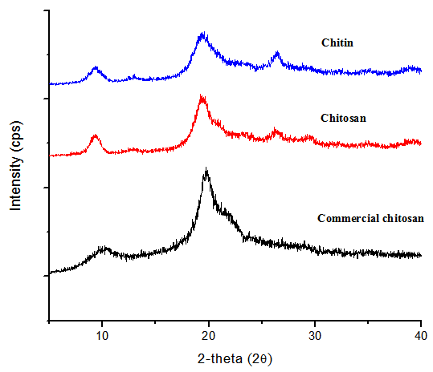

Figure 3. XRD patterns for chitin, chitosan and commercial chitosan

Elemental analysis
Table 2 shows the chemical composition of chitin and chitosan. The percentage for carbon, C in chitin and chitosan were 77.67% and 73.93%, respectively. The decreasing value of the C percentage is due to the removal of acetyl groups in the chitin structure. Kaya et al. [22] stated that the theoretical of N percentage for pure chitin is 6.9%. Hence, the N percentage in chitin and chitosan prepared were 9.62% and 12.00%, respectively, which are higher than 6.9% reported in literature. This is due to the present of protein residue in the both samples and supported by the results obtained from FTIR spectra. Furthermore, the two components (C and N) are important to determine the percentage of the DD of the chitosan sample followed by the formula given. The DD of the chitosan of P. pelagicus was 40.60% slightly lower than the suggested DD (approximately 50%). However, this might cause by partially deacetylation of chitin and the result is consistent with the crystallinity data obtained.

Table 2. The percentage composition of carbon, nitrogen and hydrogen in chitin and chitosan
Samples | Carbon (%) | Nitrogen (%) | Hydrogen (%) | C/N
Chitin | 77.67 | 9.62 | 12.71 | 8.07
Chitosan | 73.93 | 12.00 | 14.07 | 6.16

Thermogravimetric analysis
Thermogravimetric analysis (TGA) is conducted, which is to study on thermal degradation of chitin and chitosan. The TGA curves (Figure 4) was observed that chitin and chitosan have two degradation steps. The first stage of degradation chitin and chitosan occurred at temperature range 30 °C to 125 °C and 30 °C to 123 °C with 7% and 12% of weight loss, respectively. This degradation may attribute to the loss of water molecules because the chitin and chitosan structures have strong affinity towards water and lead dehydration. The second stage of chitin and chitosan degradation begins around 152 °C to 398 °C and 148 °C to 392 °C with 61% and 48% of weight loss, respectively. The second degradation belongs to thermal decomposition of chitin and chitosan. Although the chitin and chitosan prepared shows a similar trend of thermal degradation curves, but chitin has larger decomposition rate as compared to chitosan [15].

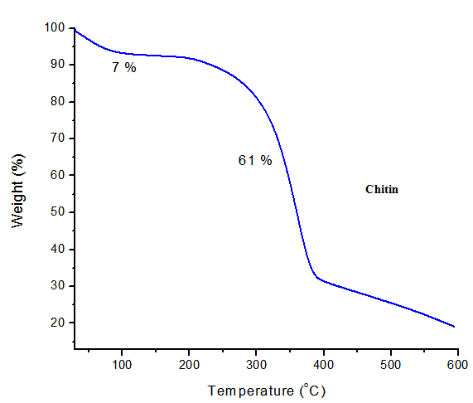
(a)

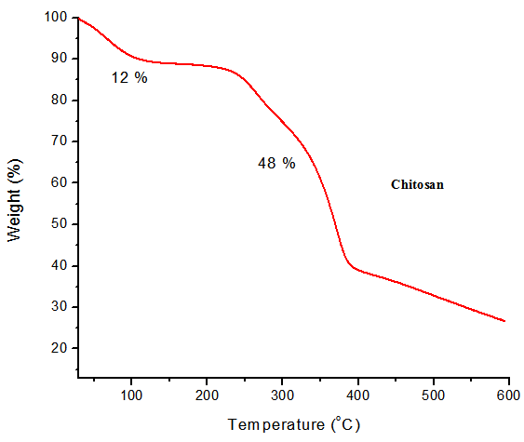
(b)

Figure 4. TGA analysis of (a) chitin and (b) chitosan

Conclusion
Chitin and chitosan were successfully extracted from the carapace of blue swimmer crab, P. pelagicus with significant outcomes. Dry weight of chitin and chitosan content were 20.24% and 13.56%, respectively. FTIR analysis confirmed the structural change between chitin and chitosan. Crystallinity analysis revealed the formation of α chitin from the studied species. Partially deacetylation of chitin into chitosan was observed with 40.60% of DD. Additionally, the thermal degradation analysis proved that α chitin exists as a stable structure towards thermal decomposition than chitosan. It is suggested that chitin and chitosan from the carapace of blue swimmer crab, P. pelagicus can be used as potential a reducing agent for synthesizing silver nanoparticles in future studies.

Acknowledgement
The authors are thankful to Ministry of Higher Education Malaysia for financial assistant in Research Acculturation Grant Scheme (RAGS) vote no. 57117, Mybrain15 for scholarship sponsor and Universiti Malaysia Terengganu for providing the facilities.

References
- Younes, I., Hajji, S., Frachet, V., Rinaudo, M., Jellouli, K. and Nasri, M. (2014). Chitin extraction from shrimp shell using enzymatic treatment. Antitumor, antioxidant and antimicrobial activities of chitosan. International Journal of Biological Macromolecules, 69: 489 – 498.
- Hajji, S., Ghorbel-bellaaj, O., Younes, I., Jellouli, K. and Nasri, M. (2015). Chitin extraction from crab shells by Bacillus bacteria. Biological activities of fermented crab supernatants. International Journal of Biological Macromolecules, 79: 167 – 173.
- Kumari, S. and Kumar, P. (2014). Extraction and characterization of chitin and chitosan from (Labeo rohit) fish scales. Procedia Materials Science, 6: 482 – 489.
- Palpandi, C., Shanmugam, V. and Shanmugam, A. (2009). Extraction of chitin and chitosan from shell and operculum of mangrove gastropod Nerita (Dostia) crepidularia Lamarck. International Journal of Medicine and Medical Sciences, 1(5): 198 – 205.
- Abdel-Rahman, R. M., Hrdina, R., Abdel-Mohsen, A. M., Fouda, M. M. G., Soliman, A. Y., Mohamed, F. K., Mohsin, K. and Pinto, T. D. (2015). Chitin and chitosan from Brazilian Atlantic Coast: Isolation, characterization and antibacterial activity. International Journal of Biological Macromolecules, 80: 107 –120.
- Gomes, J. R. B., Jorge, M., and Gomes, P. (2014). Interaction of chitosan and chitin with Ni, Cu and Zn ions : A computational study. Journal of Chemical Thermodynamics, 73: 121 – 129.
- Mohan, C. O., Ravishankar, C. N., Lalitha, K. V. and Gopal, T. K. S. (2012). Effect of chitosan edible coating on the quality of double filleted Indian oil sardine (Sardinella longiceps) during chilled storage. Food Hydrocolloids, 26: 167 – 174.
- Jayakumar, R., Prabaharan, M., Nair, S. V. and Tamura, H. (2010). Novel chitin and chitosan nanofibers in biomedical applications. Biotechnology Advances, 28 (1): 142 – 150.
- Shavandi, A., Bekhit, A. E.-D. A., Ali, M. A., Sun, Z. and Gould, M. (2015). Development and characterization of hydroxyapatite/β-TCP/chitosan composites for tissue engineering applications. Materials Science and Engineering: C, 56: 481 – 493.
- Demarchi, C. A., Campos, M. and Rodrigues, C. A. (2013). Adsorption of textile dye Reactive Red 120 by the chitosan–Fe(III)-crosslinked: Batch and fixed-bed studies. Journal of Environmental Chemical Engineering, 1(4): 1350 – 1358.
- Chandrasekar, S., Vijayakumar, S. and Rajendran, R. (2014). Application of chitosan and herbal nanocomposites to develop antibacterial medical textile. Biomedicine and Aging Pathology, 4(1): 59 – 64.
- Bae, M. J., Shin, H. S., Kim, E. K., Kim, J. and Shon, D. H. (2013). Oral administration of chitin and chitosan prevents peanut-induced anaphylaxis in a murine food allergy model. International Journal of Biological Macromolecules, 61: 164 – 168.
- Shanmugam, A., Subhapradha, N., Suman, S., Saravanan, R., Shanmugam, V. and Srinivasan, A. (2012). Characterization of biopolymer “chitosan” from the shell of donacid clam donax scortum (Linnaeus, 1758) and its antioxidant activity. International Journal of Pharmacy and Pharmaceutical Sciences, 4 (2): 460 – 465.
- Puvvada, Y. S., Vankayalapati, S. and Sukhavasi, S. (2012). Extraction of chitin from chitosan from exoskeleton of shrimp for application in the pharmaceutical industry. International Current Pharmaceutical Journal, 1(9): 258 – 263.
- Abdou, E. S., Nagy, K. S. A. and Elsabee, M. Z. (2008). Extraction and characterization of chitin and chitosan from local sources. Bioresource Technology, 99: 1359 – 1367.
- Sagheer, F. A., Al-Sughayer, M. A., Muslim, S. and Elsabee, M. Z. (2009). Extraction and characterization of chitin and chitosan from marine sources in Arabian Gulf. Carbohydrate Polymers, 77 (2): 410 – 419.
- Benhabiles, M. S., Salah, R., Lounici, H., Drouiche, N., Goosen, M. F. A. and Mameri, N. (2012). Antibacterial activity of chitin, chitosan and its oligomers prepared from shrimp shell waste. Food Hydrocolloids, 29: 48 –56.
- Bolat, Y., Bilgin, Ş., Günlü, Izci, L., Koca, D. B., Çetinkaya, S. and Koca, H. U. (2010). Chitin – chitosan yield of freshwater crab (Potamon potamios, Olivier 1804) Shell. Paskitan Veterinanry Journal, 30 (4): 227 – 231.
- Das, N. G., Khan, P. A. and Hossain, Z. (1996). Chitin from the shell of two coastal portunid crabs of Bangladesh. Indian Journal of Fisheries, 43(4): 413 – 415.
- Ramasamy, P., Subhapradha, N., Shanmugam, V. and Shanmugam, A. (2014). Extraction, characterization and antioxidant property of chitosan from cuttlebone Sepia kobiensis (Hoyle 1885). International Journal of Biological Macromolecules, 64: 202 – 212.
- Kaya, M., Baran, T. and Mentes, A. (2014). Extraction and characterization of α -chitin and chitosan from six different aquatic invertebrates. Food Biophysics, 145 – 157.
- Kaya, M., Baublys, V., Can, E., Šatkauskiene, I., Bitim, B., Tubelyte, V. and Baran, T. (2014). Comparison of physicochemical properties of chitins isolated from an insect (Melolontha melolontha) and a crustacean species (Oniscus asellus). Zoomorphology, 133(3): 285 – 293.

