POLY(EUGENOL SULFONATE) - SULFONATED POLYETHERIMIDE NEW BLENDS MEMBRANE PROMISING FOR
DIRECT METHANOL FUEL CELL

(Membran Campuran daripada Poli(Eugenol Sulfonat) dan Polieterimida Sulfonat yang Menjanjikan untuk Sel Bahan Api Metanol Langsung)

Eka Cahya Muliawati^{1,2}, Mardi Santoso², Ahmad Fauzi Ismail^{1,3}, Juhana Jaafar^{1,3},

Mohd. Taufiq Salleh^{1,3}, Silvana Dwi Nurherdiana², Nurul Widiastuti²*

¹Advanced Membrane Technology Research Centre (AMTEC), Universiti Teknologi Malaysia,

81310 UTM Skudai, Johor Bahru, Malaysia

²Department of Chemistry, Faculty of Mathematics and Natural Sciences,

Institut Teknologi Sepuluh Nopember, Surabaya, Indonesia

³Faculty of Petroleum and Renewable Energy Engineering, Universiti Teknologi Malaysia,

81310 UTM Skudai, Johor Bahru, Malaysia

*Corresponding author: nurul_widiastuti@chem.its.ac.id

Abstract

A new polymeric membrane blended from sulfonated polyetherimide (SPEI) and poly(eugenol sulfonate) (PES) was prepared as proton exchange membrane (PEM) for direct methanol fuel cell (DMFC). The membrane was characterized by Fourier Transform Infrared Spectroscopy (FTIR), thermogravimetric analysis (TGA) and Scanning Electronic Microscopy (SEM). Ion exchange capacity (IEC), proton conductivity, methanol barrier, water uptake, water contact angle and mechanical strength of the membrane was also being determined. The new PES/SPEI membrane with 3 wt.% PES and 20 wt.% SPEI show higher IEC, water uptake, proton conductivity and methanol barrier properties as compared to Naﬁon 117 membrane. As a conclusion, the results indicate that the SPEI/PES membrane has potential to be employed as PEM for DMFC application.

Keywords: sulfonated polyetherimide, poly(eugenol sulfonate), blend membrane, direct methanol fuel cell

Abstrak

Membran polimer baru diperbuat daripada campuran polieterimida sulfonat (SPEI) dan poli(eugenol sulfonat) (PES) telah disediakan sebagai membran pertukaran proton (PEM) untuk sel bahan api metanol langsung (DMFC). Membran ini telah dianalisis menggunakan Spektroskopi Inframerah Transformasi Fourier (FTIR), analisis termogravimetri (TGA) dan Mikroskop Imbasan Elektron (SEM). Sifat membran seperti kapasiti pertukaran ion (IEC), kekonduksian proton, halangan metanol, penyerapan air, sudut sentuhan air dan kekuatan mekanikal juga telah ditentukan. Membran baru PES/SPEI dengan 3 wt.% PES dan 20 wt.% SPEI telah menunjukkan nilai IEC, pengambilan air, kekonduksian proton dan halangan metanol yang lebih tinggi berbanding membran Nafion 117. Sebagai kesimpulan, hasil kajian menunjukkan bahawa membran SPEI/PES mempunyai potensi untuk digunapakai sebagai PEM untuk aplikasi DMFC.

Kata kunci: polieterimida sulfonat, poli(eugenol sulfonat), membran campuran, sel bahan api metanol langsung

Introduction

The Direct Methanol Fuel Cell (DMFC) is one of the attractive fuel cell type for mobile application which is clean technology to the environment, having high efficiency, portable, and can be operated at relatively low temperatures [1]. The key component in DMFC is proton exchange membrane, with respect to development of cell performance via an increase conductivity and a reduction of methanol permeability [2 – 5]. Perfluorosulfonic acid (PFSA) membrane, under Nafion commercial brand is a type (Proton Exchange Membrane) PEM that has been used widely with high proton conductivity, low dimensional change in water, and excellent cell performance in various environments [6 – 8]. However, Nafion membranes are expensive and lose their proton conductivity and durable properties at high temperature (>80 ºC) [5 – 11]. Therefore, many researchers have endeavored to develop inexpensive membranes for higher operation temperature and lower methanol permeability such as a variety of polymer blends.

The use of polymer blends means to combine two different characteristics then improving the comprehensive properties and modification of a matrix [5, 9 – 13]. Among many types of blend membranes, the sulfonated polymer organic blend membranes show many attractive properties. Polymer blend membranes described as organic materials are new class of interesting materials that exhibit improved proton conductivity and reduced methanol permeability when applied in DMFC. Many researchers have investigated the alternative cheap materials with new hydrocarbon polymers synthesized, or blended with a methanol hating material [11, 13, 16]. The improvement progress in the membrane for DMFC has been gradually made by physical and chemical changes of polymer materials, such as rigidity of main chains, length of side chains, equivalent weight of proton donors and concentration of introduced hydrophilic groups like sulfonic and phosphoric acids in the membranes [12]. The increase of concentration of those groups in the membranes produces more water clusters, which would be able to repair the controlled proton transport, water and methanol crossovers.

In previous study [7, 15], the preparation and characterization of a new type of proton exchange membrane based on SPEI, which was obtained by directly synthesis from sulfonated monomer, have been described. The conductivity values for the SPEI copolymers at a ion exchange capacity around 0.553 meq/g were 0.0014 S/cm at 25 °C, indicating that they are promising candidates for PEM materials [7].

In this study, we have reported a new blend membranes material from sulfonated polyetherimide and poly(eugenol sulfonate) who has never done. Poly(eugenol sufonate) have been aromatic phenol units provide high performance properties such as considerable mechanical strength, thermal stability and chemical resistance, while the ﬂexible sulfonate linkages provide good processability [14].

Materials and Methods

Materials

All the membranes characterized were prepared in the laboratory with polyetherimide and methyl-2-pyrrolidone (NMP) supplied by Sigma–Aldrich, Eugenol supplied by Merck, and Naﬁon 117 membrane was purchased from DuPont Co.

Synthesis of poly(eugenol sulfonate)

Poly(eugenol sulfonate) was synthesized from eugenol according to a previous study. Poly(eugenol sulfonate) (PES) is made from a mixture of concentrated sulphuric acid, eugenol and PbSO₄ in a steam bath at a temperature of 90 °C. The results are analysed with an infrared spectrophotometer [14].

Sulfonation of polyetherimide

The synthesis sulfonated polyetherimide (SPEI) was carried out by the previous procedure. First, 10 g of PEI was dissolved in dichloroethane (50 mL) at 60 °C for 5 hours. The solution was kept at room temperature for 1 hour. Chlorosulfonic acid (2.06 mL) in dichloroethane (35 mL) was added drop-wise to the polymer solution under vigorous stirring for 45 minutes. The product was dissolved in DMAc after 2 hours, and the polymer solution was precipitated in isopropanol. The product was filtered and washed with isopropanol three times to remove impurities, and dried in an oven at 50 °C for 48 hours. The results were characterized with an infrared spectrophotometer [7, 15, 17].

Preparation of membrane

The polymer blended membranes were prepared with three different mass ratios of SPEI (15%, 20%, 25%) and three different mass ratio of SPEI: PES blend (15: 3, 20: 3, 25: 3)%. PES and SPEI were simultaneously dissolved in NMP to form 15 wt.% solutions with stirring at 60 °C for 12 hours. After cooled to room temperature, the resulting polymer solutions were cast on glass plates and dried in a room temperature for 12 hours. Then immersed to sulfic acid for 12 hours.

Characterization of blend membranes

FTIR spectra of the membranes were measured by in the range of 4000 – 400 cm⁻¹. The samples were dried at 80 °C for 1 hour before measurement. The surface and cross-section morphology of the blend membranes were examined with a Zeuss ﬁeld emission scanning electron microscope. All the samples for cross-sectional view were fracture in liquid nitrogen. The mechanical properties of the blend membranes were measured by a tensile machine (Instron 5567, TA Instruments Co.) at room temperature. The samples were tested at elongation with rate of 5.0 mm min⁻¹. All membranes were tested ﬁve times to obtain an average value.

The contact angle (CA), of the membrane surface was measured using a Optima Surface Analysis System (AST Products Inc., Billerica, MA). Sample coupons with an area of about 5 cm x 1.5 cm were prepared by cutting to pieces at random locations within the membrane sheet. The sample was placed on a glass plate and fixed with a tape. A drop of distilled water was then placed on the sample surface using a microsyringe (Hamilton Company, Reno, NV). The CA was measured within a 30 s period after the water drop was placed. The CA was measured at 10 different spots on each membrane sample coupon and the values averaged.

Thermal stability of the samples was characterized using thermogravimetric analysis (TGA). Dry sample was ground into fine powder and the sample was placed in a platinum pan. The analysis was carried out at a heating rate of 10 °C min⁻¹ over 30 – 700 °C temperature range under air atmosphere. The sample powder was prepared in the pin stub holder and coated with gold for analysis.

Water uptake and swelling ratio

The membranes were dried at 80 ºC under vacuum for 24 hours and the dry weights of the samples were weighed. Subsequently, the membranes were immersed in deionized water for 24 hours at room temperature. After quickly wiping off the water adhered to the surface of the membranes, the weight and dimension of wet membranes were measured. The water uptake and swelling ratio could be determined according to the following equation 1 and 2 [18] :

$\text{Water uptake}\text{ = }\frac{W_{wet}\text{-}W_{dry}}{W_{dry}} \text{x 100}\text{\%}$ (1)

where $W_{wet}$ and $W_{dry}$ are the weight of membranes in wet and dry state, respectively.

$\text{Swelling ratio = }\frac{L_{wet}\text{-}L_{dry}}{L_{dry}} \text{x 100}\text{\%}$ (2)

where $L_{wet}$ and $L_{dry}$are the length of membranes in wet and dry condition, respectively [19].

Ion exchange capacity

The ion exchange capacity (IEC) of membranes was obtained by titration method. The dry membranes were immersed in the 1 mol L⁻¹ NaCl solution for 24 hours. This solution was titrated by 0.01 mol L⁻¹ NaOH with phenolphthalein as the indicator. The IEC of the samples was calculated by following equation 3:

$IEC = \frac{V_{NaOH}-C_{NaOH}}{W_{d}} x 100\%$ (3)

where $V_{NaOH}$ is the volume of consumed NaOH solution, $C_{NaOH}$ is the concentration of NaOH solution and $W_{d}$ is the weight of the dry membrane [17].

Methanol permeability and proton conductivity

Methanol permeability was determined using a two-compartment diffusion cell. Compartment A was filled with 1 M methanol solution and compartment B was filled with deionized water. The membrane was placed between compartment A and B. Samples from compartment B were taken out every 30 minutes for 6 hours to determine its methanol concentration using high-performance liquid chromatography (HPLC). The methanol permeability values were determined by using equation 4 [18].

$P= \left(\frac{∆C_{B}}{∆t}\right)\left(\frac{LV_{B}}{AC_{A}}\right)$ (4)

$P$P is methanol permeability of the membrane (cm².s⁻¹), ΔC_{B}/Δt is the slope variation of methanol concentration in compartment B as a function of time (mol L⁻¹.s⁻¹), L is the thickness of the membrane (cm), V_{B} is the volume of the water at compartment A (cm³), A is the membrane surface area (cm²), and C_{A} is the concentration of methanol in the cell A (mol L⁻¹). The proton conductivity of the membrane was measured using electrochemical impedance spectroscopy (EIS), at a frequency of 1-10⁶ Hz. The proton conductivity values were calculated using equation 5;

$σ = \frac{L}{R ×A}$ (5)

where σ is the proton conductivity of the membrane (S cm⁻¹), L is the membrane (cm), A is the membrane surface area (cm²), and R is the membrane resistance (Ω) [18].

Results and Discussion

Fourier transform infrared spectroscopy

Fourier transform infrared spectroscopy (FTIR) spectra of PES+SPEI polymer blend membranes are shown in Figure 1. As for the SPEI, PES, and PES+PEI membranes, the bands at 708 cm⁻¹, 1071 cm⁻¹, 1279 cm⁻¹ are assigned to the stretching vibration of –SO₃H groups [7, 9]. Furthermore, the broad band in the SPEI, PES and SPEI+PES spectra around 3600 cm⁻¹ was assigned to O–H vibration associated with the interaction between sulfonic acid groups and water molecules. This is confirmed that the sulfonic acid groups are successfully introduced to the resulting polymer. The hydrophilic clusters formed by the sulfonic acid groups could broaden the proton transfer channels. The bands for the stretching vibration of the C-N groups of SPEI can be observed at 1467 cm⁻¹ and the stretching vibration of the C=O groups of SPEI and PES can be seen at 1650 cm⁻¹.

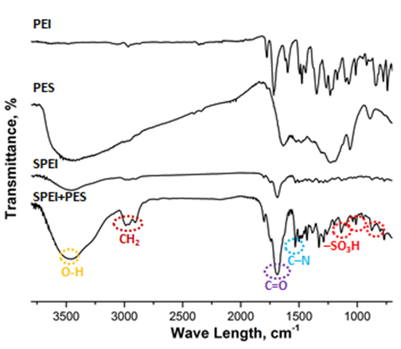

Figure 1. FTIR spectra of membranes

Mechanical properties

The mechanical strength of the blend membranes is signiﬁcant for DMFC application to assure its stability as the electrolyte passes across the membrane. The mechanical strength of SPEI membrane and the blend membranes (SPEI-PES) were measured at room temperature.

As shown in Figure 2, the blend membranes show higher tensile strength along with the decrease of SPEI. The tensile strength rises from 13.9 to 30.7 MPa with the content of SPEI decrease from 25 to 15%. The tensile strength decrease from 31 to 13 MPa with the content of SPEI increase from 15 to 25% with added 3% PES. Such enhancement in tensile strength is due to the ionic crosslinking and close packed molecules in sulfonated blend membranes. However, the ionic crosslinking also reduces molecular ﬂexibility, hence the blend membranes become more fragile and the elongation at break is decreased [9].

Figure 2. The mechanical properties of membranes

Physically properties

The water uptake, methanol uptake, swelling ratio, IEC and contact angle are important parameters for a membrane to be characterized. These properties of polymer blend membranes are presented in Figure 3. Many signiﬁcant properties of the membrane, such as proton conductivity and water uptake, are related to IEC [9]. Ionic exchange capacity (IEC) is defined as the fixed milli equivalents of exchangeable group per gram of polymer, which is usually considered to correspond to the amount of sites for proton transfer and has great relation to the proton conductivity [5]. IEC depends on the content of free sulfonic acid groups in the membrane [9]. It can be seen that the IEC of the blend membranes increase with increase amount of the SPEI and also addition PES. One reason is due to the content of SPEI increase with the increase of sulfuric acid group of added PES.

Figure 3. The physical properties of membranes

Water uptake is another important parameter for ion exchange membrane. It has a great inﬂuence on the proton conductivity and dimensional stability of the membrane [9]. High water uptake can improve the proton conductivity [9]. As expected, hydrophilic side groups in SPEI and PES improve the amount of free sulfonic acid groups by polymer blend interactions. High content of SPEI leads water uptake increase, indicating the increase of hydrophilicity within the blend membranes. Moreover, the formation of cross-linked network structure increase free volume in blend membranes for water molecules which leads to water uptake increase. The swelling ratio reﬂects dimensional stability, and the lower swelling ratio is required for keeping membrane dimensional stable for a long time. Similar to the water uptake, all blend membranes show develop swelling ratio with increase of the SPEI and PES added [5, 9]. Therefore, it needs optimization composition of polymer. 20% (% weight ratio) SPEI/ 3% PES are the best compositions.

Permeability of methanol is a crucial parameter for DMFC, which represents the ability to prevent the crossover of positive and negative electrolytes [9]. Since DMFC uses methanol as fuel, low methanol permeability PEM would contribute to high efficiency fuel usage and low fuel loss [18]. Diffusion of methanol across the membrane will lead to self-discharge of the cell [9]. In this study, the methanol permeability of blend membranes and Naﬁon 117 membrane was measured. The calculated methanol permeability and proton conductivity are illustrated in Table 1.

Table 1. Methanol permeability and proton conductivity of pure PEI and PEI-PES membranes

Membranes | Proton Conductivity  (S.cm⁻¹) |  | Methanol Permeability  (×10⁻⁷cm².s⁻¹)
PES 20% | 0.0010 |  | 5.75
SPEI 15% | 0.0018 |  | 11
SPEI 20% | 0.0078 |  | 10
SPEI 25% | 0.0069 |  | 13
SPEI 20%-PES 3% | 0.0080 |  | 15
Nafion® 117 | 0.0900 |  | 25

According to Table 1, all the blend membranes have lower methanol permeability than Naﬁon 117 membrane. However, methanol permeability can be improved by increasing hydrophilic polymer from sulfonic group addition. It caused the free volume of polymers will be bigger, which will result higher in their permeability’s [9, 20].

In general, the smaller of contact angle indicates increasing hydrophilicity of the samples. Figure 3 illustrates the contact angles of the SPEI, PES, SPEI+PES significantly decrease because the presence of hydroxyl and sulfonic groups. Moreover, another important reason is the SPEI and PES possesses a high degree of sulfonic and hydrophilicity. This finding confirms the result of the water absorption of the membranes. This following Figure 4, provides information of the interactions between SPEI and PES membrane.

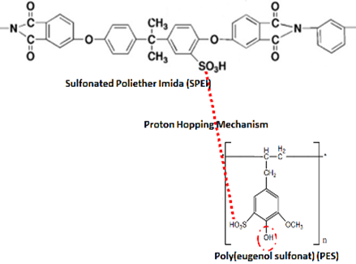

Figure 4. The interactions between SPEI and PES

Protons are largely transferred through the PEMs either as water-solvated species or by passing from one water molecule to another; hence, the ability of PEMs to imbibe large amounts of water molecules enhances the proton conductivity in the most cases. This effect is related to sufficient number of ionic sites and polar functional groups and also better formation and connection of proton-conducting channels in PEMs containing acid-bearing functionalities as well as higher dissociation degree of the ionic groups as the proton-conducting sites [21]. This statement is consistent as the figure 4 contained polar functional groups such as –SO₃H and –OH. With the sulfonate group will occur stepping proton from the one sulfonate group to another or called as proton hopping mechanism [21].

Thermo gravimetric analysis
Figure 5 illustrates the Thermo gravimetric analysis (TGA) curves of the membranes that under went both the dry method (slide casting and then vacuum), and wet method (spin coating and then waterbath), respectively. The changes in the sample weight with different temperatures under nitrogen ﬂow using a standard temperature program with two steps were used for the TGA obtained at 550, 600, and 650 ºC at a heating rate of 1 ºC /min.

In Figure 5, it can be observed that the SPEI begins weight loss at around 200 ºC, followed by a ﬁnal decomposition that began slowly around 450 ºC after heating. The thermal decomposition of organic polymers is characterized by the breaking of the main chains [9] and different thermal degradation routes of SPEI. The decomposition of PES and PES+SPEI membranes weight signiﬁcantly decreases after the temperature reaches approximately 550 ºC.This result may be due to the evaluation of a cleavage of the benzene ring of the SPEI and PES precursor. Consequently, the PEI-PES membrane can be expected to possess higher thermal stability characteristics compared to pure PEI membrane. Therefore, the resultant blend membrane is stable at desired operating temperatures (<100 ºC) for DMFC application.

Morphology of the membranes

Figure 6 shows the SEM images of SPEI and SPEI-PES particles. It appears that before the blending process, the 20% SPEI particles surfaces were less smooth and corrugated because casting solution is not perfect as shown in Figure 6 (a). After being blended with 3% PES (see Figure 6 (b)), the PES particles were dispersed and smooth its surface. These images prove that the PES has been successfully incorporated and dispersed into the SPEI. Also Figure 6 (c) and (d), with the elemental composition is given in Table 2, show the incorporation and dispersion of –SO₃H groups on SPEI+PES. Oxygen, nitrogen, sulfuric elements present are important for bonding formation with organic polymer, enhancing the mechanical strength of its blending membrane, and developing the pathway for protons, thus consequently increase the membrane proton conductivity [18].

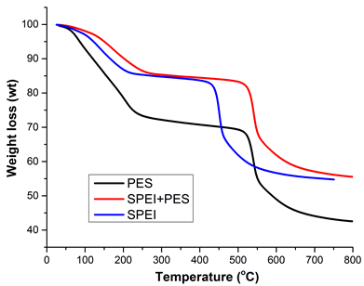

Figure 5. TGA curves SPEI, PES and SPEI+PES

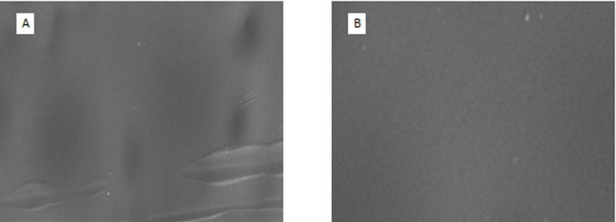
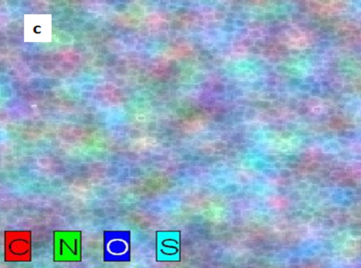 | 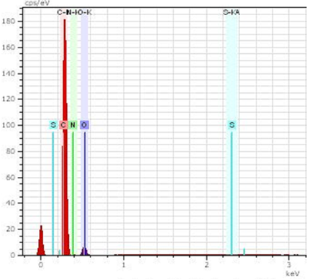  D

Figure 6. SEM images of (a) 20%SPEI, (b) 20%SPEI+3%PES, (c) Elements map and (d) EDX spectra of 20%SPEI+PES3%

Table 2. Elemental composition of 20%SPEI+PES3%

E1 | AN | Series | Unn. C (wt.%) | Norm. C (wt.%) | Atom. C (at.%) | Error (%)
C | 6 | K-series | 70.84 | 70.84 | 76.11 | 21.5
N | 7 | K-series | 4.01 | 4.01 | 3.70 | 1.6
O | 8 | K-series | 24.92 | 24.92 | 20.10 | 7.9
S | 16 | K-series | 0.23 | 0.23 | 0.09 | 0.0

Conclusion

The blended membrane of SPEI and PES was successfully prepared using solution casting method. SEM images showed the evidence of PES incorporation and disperse into the PEI polymer matrix. The water uptake for SPEI-PES membranes increase as the increasing of SPEI concentration. The DMFC with blended membranes shows higher proton conductivity 0.008 S.cm⁻¹ and low methanol permeability 15 × 10⁻⁷ cm².s⁻¹, which is better than the costly Naﬁon 117 membrane. Based on the obtained results, it can be concluded that PEI membrane blending with PES can be potentially used as promising polymer electrolyte membrane for DMFC applications.

Acknowledgement

The authors would like to acknowledge the Indonesian Ministry of Research and Higher Education for providing scholarship for pursuing Doctoral Degree for Eka Cahya Mulyawati in the Department of Chemistry, Institut Teknologi Sepuluh Nopember and financial support under research grant “Penelitian Disertasi Doktor” number 1444/E3/LT/2017. The authors also would like to express gratitude to the Ministry of Science, Technology and Innovation (MOSTI) Malaysia and Ministry of Higher Education for the financial support from the grants with the vote number of R.J130000.7942.4S507, R.J130000.7809.4F592 and Q.J130000.2509.05H52, and also to the research management centre (RMC), Universiti Teknologi Malaysia for supporting the research management activities.

References

- Ma, C. C. M., Hsiao, Y. H., Lin, Y. F., Yen, C. Y., Liao, S. H., Weng, C. C. and Weng, F. B. (2008). Effects and properties of various molecular weights of poly (propylene oxide) oligomers/Nafion® acid–base blend membranes for direct methanol fuel cells. Journal of Power Sources, 185(2), 846 –852.
- Yang, T. and Liu, C. (2011). SPEEK/sulfonated cyclodextrin blend membranes for direct methanol fuel cell. International Journal of Hydrogen Energy, 36(9), 5666 – 5674.
- Tsai, J. C. and Lin, C. K. (2011). Acid–base blend membranes based on Nafion®/aminated SPEEK for reducing methanol permeability. Journal of the Taiwan Institute of Chemical Engineers, 42(2), 281 –285.
- Muthumeenal, A., Neelakandan, S., Kanagaraj, P. and Nagendran, A. (2016). Synthesis and properties of novel proton exchange membranes based on sulfonated polyethersulfone and N-phthaloyl chitosan blends for DMFC applications. Renewable Energy, 86: 922 – 929.
- Yang, T. (2009). Composite membrane of sulfonated poly(ether ether ketone) and sulfated poly(vinyl alcohol) for use in direct methanol fuel cells. Journal of Membrane Science, 342(1): 221 – 226.
- Lufrano, F., Baglio, V., Staiti, P. and Antonucci, V. (2008). Polymer electrolytes based on sulfonated polysulfone for direct methanol fuel cells. Journal of Power Sources, 179(1): 34 – 41.
- Rajagopalan, M., Jeon, J. H. and Oh, I. K. (2010). Electric-stimuli-responsive bending actuator based on sulfonated polyetherimide. Sensors and Actuators B: Chemical, 151(1): 198 – 204.
- Awang, N., Ismail, A. F., Jaafar, J., Matsuura, T., Junoh, H., Othman, M. H. D. and Rahman, M. A. (2015). Functionalization of polymeric materials as a high performance membrane for direct methanol fuel cell: A review. Reactive and Functional Polymers, 86: 248 – 258.
- Liu S., Wanga L., Ding Y., Liu B., Han X., Song Y. (2014). Novel sulfonated poly(ether ether keton)/ polyetherimide acid-base blend membranes for vanadium redox flow battery applications. Electrochimica Acta, 130: 90 – 96.
- Jung, H. Y., and Park, J. K. (2007). Blend membranes based on sulfonated poly(ether ether ketone) and poly(vinylidene fluoride) for high performance direct methanol fuel cell. Electrochimica Acta, 52(26): 7464 – 7468.
- Kim, D. J., Lee, H. J. and Nam, S. Y. (2014). Sulfonated poly(arylene ether sulfone) membranes blended with hydrophobic polymers for direct methanol fuel cell applications. International Journal of Hydrogen Energy, 39(30): 17524 – 17532.
- Jung, B., Kim, B. and Yang, J. M. (2004). Transport of methanol and protons through partially sulfonated polymer blend membranes for direct methanol fuel cell. Journal of Membrane Science, 245(1), 61 – 69.
- Arnett, N. Y., Harrison, W. L., Badami, A. S., Roy, A., Lane, O., Cromer, F., Dong, L. and McGrath, J. E. (2007). Hydrocarbon and partially fluorinated sulfonated copolymer blends as functional membranes for proton exchange membrane fuel cells. Journal of Power Sources, 172(1): 20 – 29.
- Handayani, D. S. (2002). Sulfonasi dan polimerisasi eugenol. Alchemy Jurnal Penelitian Kimia, 1(2): 48 – 54.
- Guhathakurta, S. and Min, K. (2009). Influence of crystal morphology of 1H-1, 2,4-triazole on anhydrous state proton conductivity of sulfonated bisphenol A polyetherimide based polyelectrolytes. Polymer, 50(4): 1034 – 1045.
- Maier, G. and Meier-Haack, J. (2008). Sulfonated aromatic polymers for fuel cell membranes. In Fuel cells II. Springer Berlin Heidelberg: pp. 1 – 62.
- Shen, L. Q., Xu, Z. K., Liu, Z. M. and Xu, Y. Y. (2003). Ultrafiltration hollow fiber membranes of sulfonated polyetherimide/polyetherimide blends: Preparation, morphologies and anti-fouling properties. Journal of Membrane Science, 218(1): 279 – 293.
- Purwanto, M., Atmaja, L., Mohamed, M. A., Salleh, M. T., Jaafar, J., Ismail, A. F., Santoso, M. & Widiastuti, N. (2016). Biopolymer-based electrolyte membranes from chitosan incorporated with montmorillonite-crosslinked GPTMS for direct methanol fuel cells. RSC Advances, 6(3), 2314 – 2322.
- Liu, S., Wang, L., Ding, Y., Liu, B., Han, X. and Song, Y. (2014). Novel sulfonated poly(ether ether keton)/polyetherimide acid-base blend membranes for vanadium redox flow battery applications. Electrochimica Acta, 130: 90 – 96.
- Jaafar, J., Ismail, A. F. and Matsuura, T. (2009). Preparation and barrier properties of SPEEK/Cloisite 15A®/TAP nanocomposite membrane for DMFC application. Journal of Membrane Science, 345(1), 119 – 127.
- Tohidian, M., Ghaffarian, S. R., Shakeri, S. E., Dashtimoghadam, E. and Hasani-Sadrabadi, M. M. (2013). Organically modified montmorillonite and chitosan–phosphotungstic acid complex nanocomposites as high performance membranes for fuel cell applications. Journal of Solid State Electrochemistry, 17(8): 2123 – 2137.

