POROSITY CONTROL OF HOLLOW FIBER MEMBRANES USING A MODEL REFERENCE ADAPTIVE CONTROLLER

(Kawalan Keliangan Membran Serat Berongga Menggunakan

Model Pengawal Rujukan Adaptif)

Mohammad Abbasgholipourghadim^{1*}, Musa Bin Mailah¹, Intan Z. Mat Darus¹,

Masood Rezaei-Dasht Arzhandi², Ahmad Fauzi Ismail²

¹Department of Applied Mechanics and Design, Faculty of Mechanical Engineering,

Universiti Teknologi Malaysia, 81310 Skudai, Johor, Malaysia

²Advanced Membrane Technology Research Centre (AMTEC),

Universiti Teknologi Malaysia, 81310 Skudai, Johor, Malaysia

*Corresponding author: m.gholipour2010@gmail.com

Abstract

The conventional simple feedback controllers are not sometimes capable to properly perform online due to different dynamics during porous hollow fiber membranes (HFMs) fabrication process. This study implemented a model reference adaptive control (MRAC) for fabricating HFMs with the desired overall porosity. The artificial neural network (ANN) was used to identify the spinneret dynamic model. The developed ANN model was used as the plant model in the implemented MRAC to control the overall porosity of the HFMs. The proposed algorithms for controlling HFM overall porosity were simulated in MATLAB/Simulink. The Massachusetts Institute of Technology (MIT) rule was used for adaptive mechanism in the MRAC, where an appropriate cost function was determined as a function of error between the dynamic system and the reference output model. The controller parameters were adjusted after minimizing the selected cost function. The obtained results from the implemented MRAC scheme with MIT rule is found to be effective in controlling the porosity of the membranes. However, it was revealed that the system response is quite dependent on the changes of the input signal amplitude (overall porosity). In addition, large adaptation values reduced the stability of the system. Therefore, the MIT rule was normalized called as the normalized MIT towards the system response to be independent from different values of the porosity rule.

Keywords: Hollow fiber membrane, overall porosity, model reference adaptive control, artificial neural network

Abstrak

Pengawal konvensional tindak balas mudah kadangkala tidak mampu untuk melaksanakan tugas dalam talian kerana faktor dinamik yang berbeza semasa proses fabrikasi terhadap bahan membran serat berongga (HFM). Kajian ini menggunakan kawalan adaptif model rujukan (MRAC) untuk menghasilkan HFM dengan keliangan keseluruhan yang dikehendaki. Rangkaian neural buatan (ANN) telah digunakan untuk mengenal pasti model dinamik spinneret. Model ANN telah dibangunkan sebagai model sistem dinamik dalam MRAC untuk mengawal keliangan keseluruhan HFMs. Algoritma yang dicadangkan untuk mengawal keliangan keseluruhan HFM telah disimulasikan dalam MATLAB/Simulink. Peraturan MIT telah digunakan untuk mekanisme adaptif dalam MRAC dengan fungsi kos yang sesuai ditentukan sebagai fungsi ralat di antara model sistem dinamik dan rujukan keluaran. Parameter pengawal telah dapat diselaraskan selepas meminimumkan fungsi kos yang dipilih. Keputusan yang diperolehi daripada skim MRAC dengan peraturan MIT menunjukkan bahawa ia dapat mengawal keliangan membrane dengan berkesan. Walau bagaimanapun, tindak balas sistem ini didapati agak bergantung kepada perubahan amplitud isyarat masukan (keliangan keseluruhan). Di samping itu, nilai adaptasi tinggi mengurangkan kestabilan sistem. Dengan yang demikian, peraturan MIT telah diselaraskan dipanggil sebagai MIT diselaras ke arah menghasilkan tindak balas sistem yang bebas daripada perbezaan nilai peraturan keliangan.

Kata kunci: membran serat berongga, keliangan keseluruhan, kawalan adaptif model rujukan, rangkaian neural buatan

Introduction

The classical proportional integral derivative (PID) controllers with fixed gain are not capable to be used in systems with high complexity and uncurtains (nonlinear actuators and varied ambient conditions). Hwang et al. [1] and Tang et al. [2] gave the concept of fuzzy PID controller to deal with such problems for electrical and mechanical systems. Rubaai, et al. [3] developed the DSP-Based Laboratory model of Hybrid Fuzzy-PID Controller Using Genetic optimization for high-performance Motor Drives. Later on the concept of neural network is applied to develop the PID controllers to enhance the dynamic characteristics of controller. Sun and Meng [4] and Yao et al. [5] developed such PID controllers based on the artificial neural network technique. Still to obtain the complete adaptive nature, specific adaptive control techniques are needed. Out of many adaptive control schemes, this research mainly deals with the model reference adaptive control (MRAC) approach. In MRAC, the output response is forced to track the response of a reference model irrespective of plant parameter variations. The controller parameters are adjusted to give a desired closed-loop performance. Koo [6] and Tsai et al. [7] developed the concept of MRAC by using Fuzzy logic. The model reference adaptive controllers are mainly designed by using different approaches like MIT rule, Lyapunov theory and theory of augmented error. Ehsani [8] used the MIT rule to control the DC servo motor. Swarnkar et al. [9] applied this rule to systems of different order and compare the results with the conventional techniques for the same systems. Chen et al. [10] used the concept of Lyapunov theory to develop the MRAC system of Linear motor drive. Stefanello et al. [11] used the Lyapunov theory for improving the performance of shunt active power filter.

Separation and filtration processes using porous membranes have become one of the emerging technologies that undergo a rapid development throughout the past few decades. The membrane has drowned the attention of the world wide, especially in filtration technology field [12]. Porous HFMs are preferred as an efficient technology in terms of filtration and separation due to high recovery in individual units, higher productivity per unit volume and self-supporting [13, 14]. The membranes productivity and performance are recognized by several properties in which porosity is considered as a crucial factor in the design of porous membranes applied in any application. The aforementioned parameter is considered as an important parameter since it significantly affects the performance of the final membranes [15].

Since the HFM manufacturing system is quite complex, difficult in modeling and undefined disturbances, the simple feedback controllers are not able to control this process. Therefore, proper implementation of a suitable adaptive control strategy will result in improving the performance of the HFM manufacturing plant to produce the standard membrane in terms of overall porosity. Thus, this chapter presents the model reference adaptive control (MRAC) scheme for controlling the HFM overall porosity. The Massachusetts Institute of Technology (MIT) rule was first used for applying the MRAC scheme. The system response was highly depended to adaptation gain and amplitude of the input signal (overall porosity). The normalized MIT rule was then applied to overcome these problems in which the system response was sensitive to overall porosity values. Finally, the best results were obtained when the Lyapunov stability theory was utilized to adjust the control parameter in the MRAC. For this research, the controller design focused on the simple PID controller algorithm as benchmark to the implemented MRAC performance. The main reason to choose the PID controller is that it much easier to design and widely used compared to other controllers. The method used for tuning PID is trial and error algorithm. Trial and error method works by tuning the PID parameters until output response follow the desired value.

Materials and Methods

This section describes the various underlying principles, methods, techniques and tools that are used in the undertaken research. The operational framework of the proposed research is shown in Figure 1. The major activities are described briefly in the next section.

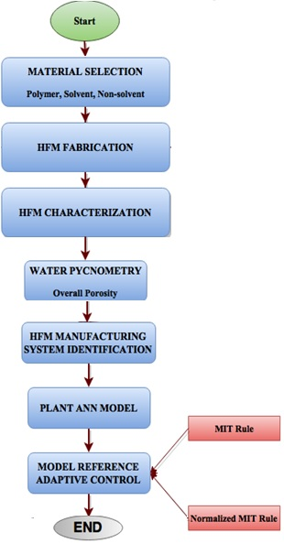

Figure 1. The operational framework

Polymer composition preparation

Commercial polyvinylidene fluoride (PVDF) polymer pellets were purchased from Arkema Inc., PA, USA. 1-Methyl-2pyrrolidone (NMP) and Lithium chloride (LiCl) were used as solvent and non-solvent additives in the polymer solution, respectively.

Membranes fabrication

The HFMs were fabricated at ambient temperature (22 – 25 °Ċ). Polymer concentration (PVDF = 12 – 22 wt.% NMP = 75.5 – 85.5 wt.% and LiCl = 2.5 wt.% ) and dope extrusion were assumed as variables. Water was used as external coagulant bath and the temperature was kept constant during the spinning. The fabricated HFMs were immersed in water for 72 hours to remove the rest of NMP and LiCl inside the spun HFMs. Table 1 lists specific detailed spinning as it was explained in previous study [16].

Table 1. HFMs spinning conditions

Dope extrusion rate (cm³/min) |  | 1.5-6.5
Bore flow rate (cm³/min) | 0.7-1.4
Bore fluid | Water
External coagulant | Water
Air gap distance (cm) | 0
Collection drum speed (m/min) | 4-8
Spinneret OD/ID (mm) | 1.1/0.55
Spinning dope temperature (◦C) | Ambient
External coagulant temperature (◦C) | Ambient

Overall porosity of HFMs

The porosity of the membrane has been defined as the ratio of the pore volume to the total volume of the membrane[17]. The overall porosity of the HFM can be calculated using the following equation 1 [18]:

$$ε_{m}=\frac{ρ_{w}(w_{1}-w_{2})}{ρ_{p}\left(w_{1}-w_{2}\right)-ρ_{w}(w_{2})}$$ | (1)

where, w₁ and w₂ are the weights of the wet and the dry membrane, respectively while ρw and ρp are density of the water and polymer solution, respectively. Based on the mentioned equation, the porosity εm can be described as a non-dimensional parameter and in most literature; it is written as a percentage concentrate (%).

Application of ANN

The objective of the neural network is to estimate the overall porosity values of HFMs by some internal calculations and weights [19]. Neurons (or cells) are processing elements that carry out simple computations from a vector of composition and dope extrusion flow rates [19]. A neuron performs a non-linear transformation of the weighted sum of the incoming neuron inputs to produce the output of the neuron. Generally, the ANNs based on networks are classified into three groups including feedforward (FFNN), feedback (FBNN) and recurrent (RNN). The feedforward network is the commonly used with high accuracy and the lowest error in comparison with others [20]. At present, and to the best of our knowledge, no study has yet been done on the application of ANN and MRAC to produce the HFMs with the desired overall porosity. Therefore, using ANN and MRAC to predict and control the HFM overall porosity is a novel approach and some publications which are related to other aspect of membranes replaced as literature. For example, Tardast et al. [21] used ANN to predict the of bioelectricity production in a membrane less microbial fuel cell. Mirbagheri et al. [22] studied about the evaluation and prediction of membrane fouling and Basile et al. [23] investigated theoretically modelling using NN and experimental validation. The model was trained, taking into account the obtained overall porosity of membranes differing in polymer concentration and dope extrusion flow rates. In this study, 75% of the obtained data was used as the training data, 15% as testing data and the rest was utilized as validation data.

Model reference adaptive control

The MRAC technique comes under the non-dual adaptive control category that the system performance is described by a proper reference model. It has two interconnected loops; first is the regulator or inner loop involving the ANN model for HFM manufacturing system and adjustment mechanism while the second is the adaptation or outer loop, which regulates the adjustment mechanism parameters with minimizing the error. It is obtained from the difference among the outputs of the reference model and real plant.

$$e=y-y_{m}$$ | (2)

The HFM manufacturing system as HFM manufacturing system was considered as the plant to develop the MRAC. The polymer concentration and dope extrusion flow rate were selected as the input variables as well as the HFM overall porosity was considered as output variable. The selected input-output variables were used to identify the HFM manufacturing system. The developed ANN model for HFM manufacturing system was used as plant model in designing the MRAC. It should be mentioned that the ANN model for HFM manufacturing system has two inputs, namely, the polymer concentration and dope extrusion flow rate. It means that in order to produce the HFMs with the desired overall porosity, the mentioned inputs should be changed during the membrane fabrication process. Therefore, the proposed approach helps membrane researchers to control the HFMs overall porosity during fabricate process and produce the HFMs with the desired overall without drying and any experiments. Since the concentration of the polymer inside the dope solution cannot be changed easily and simultaneously, it was predicted using the ANN as shown in Figure 2. In fact, the obtained data from the membrane characterization was again used to train the other ANN in which membrane overall porosity was used as input layer data and dope extrusion flow rate calculated by the ANN.

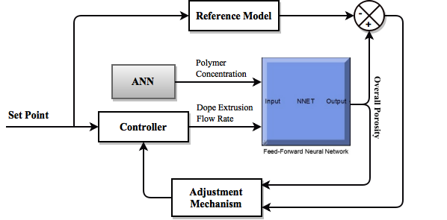

Figure 2. The MRAC using ANN model

The parameter in the control law was adjusted using an adjustment mechanism. The control parameter was searched through an adaptation law until the error between the HFM manufacturing system and reference model responses was minimized. It was designed to guarantee the control system well stability as well as conversance of tracking error to zero. Furthermore, two different mathematical techniques including MIT and normalized MIT rules were used to develop the adaptation mechanism [24] .

MIT rule

The MIT rule has been developed in Massachusetts Institute of Technology and was used to apply the MRAC approach to any practical system. In this rule, the cost function or loss function is defined as equation 3:

$$f\left(θ\right)=e^{2}/2$$ | (3)

where, θ and e are the adjustable control parameter and the error between the reference model and HFM manufacturing system respectively. The control parameter θ in this rule was adjusted based on minimizing the selected cost function. To do this, the control parameter was changed in the negative gradient of f direction, as follows (equation 4):

$$\frac{dθ}{dt}=-γ\frac{∂f}{∂θ}$$ | (4)

Substituting Eq. (3) in Eq. (4):

$$\frac{dθ}{dt}=-γe\frac{∂e}{∂θ}$$ | (5)

The system sensitivity derivative is usually defined by the achieved partial derivative term (∂e/∂θ) from the Eq. (5). It can be clearly figured out that the error is dependent on the adjustable control parameter. Several alternative techniques can be used for choosing the cost function, for example, it can also be taken as mode of error. Similarly, the term dθ/dt can also have different relations for different applications and describes the changes in parameter θ with respect to time so that the cost function f(θ) can be reduced to zero. The adaptation gain of the MRAC is depicted by γ, which is positive quantity.

For designing, the KG(s) was assumed as transfer function for the process that G(s) is the known transfer function as well as K is the unknown parameter. In MRAC, the purpose is designing an appropriate controller which the plant could track the reference model. Here G(s) is the reference model transfer function as well as the known parameter is shown by K_{m}. Then, from the Eq. (2),

$$E\left(s\right)=KG\left(s\right)U\left(s\right)-K_{m}G(s)U_{c}(s)$$ | (6)

The control law is defined as:

$$u\left(t\right)=θ{.U}_{c}$$ | (7)

From Eq. (6) and (7) as well as taking partial derivative,

$$\frac{ ∂E\left(s\right)}{∂θ}=KG\left(s\right)U_{c}\left(s\right)={\frac{K}{K_{m}}Y}_{m}\left(s\right)$$ | (8)

Substituting Eq. (8) in Eq. (5),

$$\frac{dθ}{dt}=-γe\frac{K}{K_{m}}y_{m}=-γ^{'}ey_{m}$$ | (9)

The obtained adjusting law in Eq. (9) was used to determine the control parameter θ. The Simulink block diagram of the MRAC using MIT rule is shown in Figure 3.

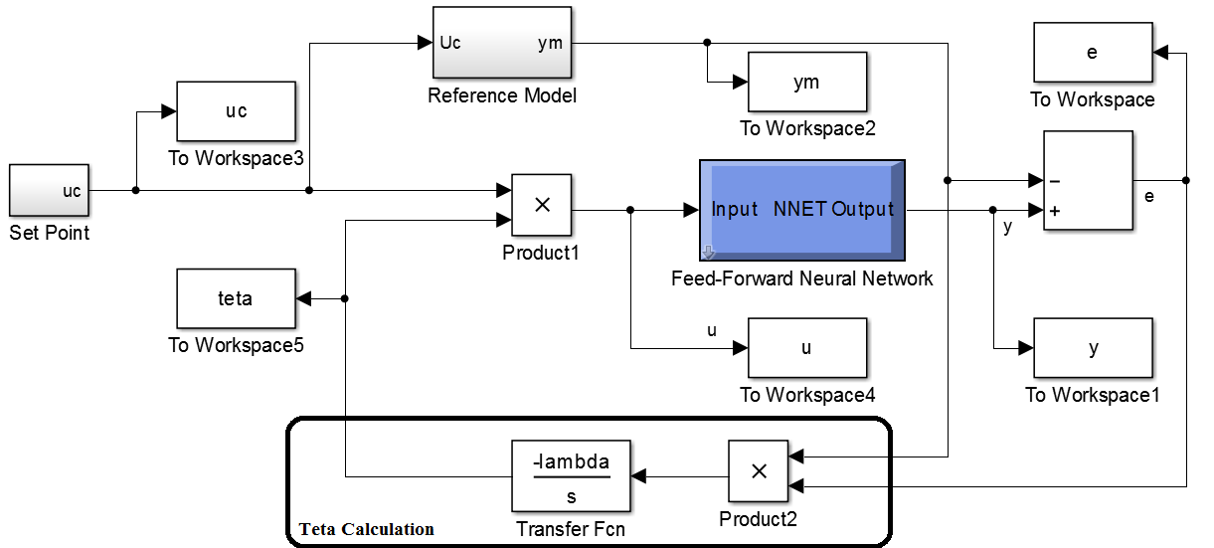

Figure 3. The Simulink block diagram of the MRAC scheme using MIT rule

The normalized MIT rule
123

As known, the selection of the adaptation gain in some industrial applications is critical and its value depends on the signal levels. For example, with increasing the adaptation gain the convergence conditions change, which means the convergence rate, is depended on adaptation gain and the system can be unstable for large reference input values. To overcome the mentioned problems, the MIT rule was normalized as follows (equation 10):

$\frac{dθ}{dt}=-γ φ e$ | (10)

where,

$φ= \frac{∂e}{∂θ}=\frac{K}{K_{m}}y_{m}$ | (11)

and also

$$\frac{dθ}{dt}=-γ φ e/(α+φ^{T}φ)$$ | (12)

This rule is known as the normalized MIT rule, where α > 0 (positive coefficient) is introduced to avoid the zero division when 𝜑^{T} 𝜑 is small. The used normalized MIT rule in the MRAC was simulated in MATLAB Simulink as shown in Figure 4.

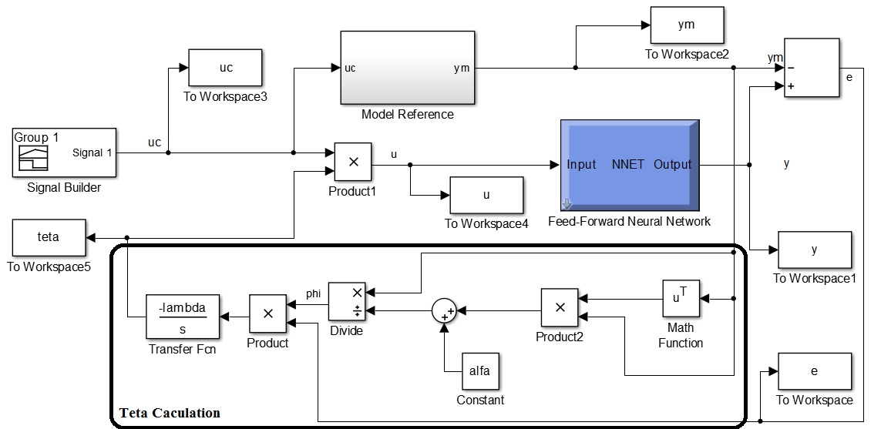

Figure 4. MRAC block diagram using the normalized MIT rule
126

Simulation results and discussion

In this research, the MRAC approach was applied to system with MIT and modified MIT rules. The models were simulated using MATLAB 2013Ra with Simulink, which the related block diagrams were shown in earlier sections. The obtained results using two different rules on the MRAC were detailed out in following sections.

MRAC with MIT rule

The responses of actual plant and reference model first using MIT rule under different adaptation gains (γ) are presented in Figure 5.

The figure summarizes the dynamic behavior of the system in time domain for various values of the membrane overall porosity. From the figure, it can be clearly observed that for small values of γ, the system responses are slow with small overshoot whereas they are very fast with large values of γ with larger overshoots. It means that the stability of the designed MRAC scheme using MIT is mostly depended on the adaptation gain values.

MRAC with the normalized MIT rule

The MRAC scheme was applied to system with the normalized MIT rule. The response of the system with three different values of adaptation gains is illustrated in Figure 6.

Figure 6 presents the effect of adaptation gain on time response curves for the normalized MIT rule. There is an improvement in the performance of the system with the increase of the adaptation gain. Every system gives its best for the limited range of the adaptation gain. It can be clearly seen that the system responds slowly when the value of the adaptation gain is smaller and there is no obvious oscillations in the system response. However, the adaptation gain with the normalized MIT has less influence on the system response than the MIT rule. Therefore, the MRAC using the normalized MIT rule is almost independent of the adaptation gain. In addition, the effect of different overall porosity of the HFM (input signal amplitude) was also examined and the results are shown in Figure 6.

γ = 0.1
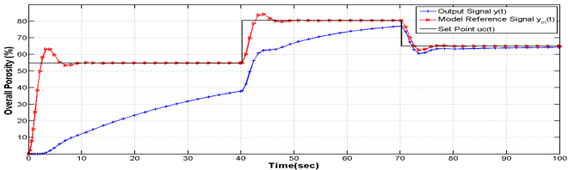
(a)
γ = 1
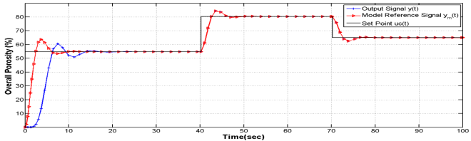
(b)
γ = 2
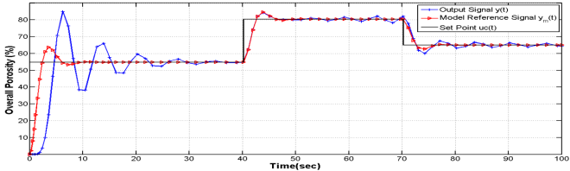
(c)

Figure 5. Simulation results of the used MIT on MRAC for different adaptation gains

γ = 0.1
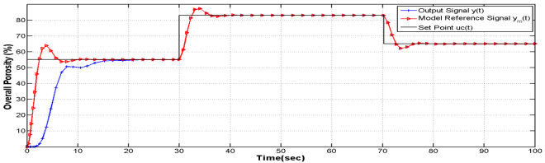
(a)
γ = 1
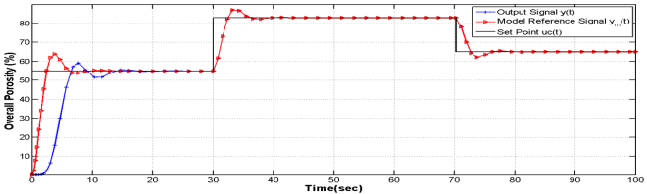
(b)
γ = 2
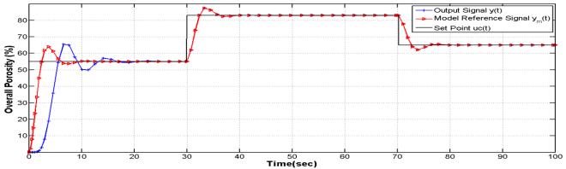
(c)

Figure 6. MRAC simulation results with the normalized MIT rule subjected to different adaptation gains

Method validation

The normalized MIT rule applied in this work was validated by comparing the proposed approach output versus fabricated HFMs overall porosity. Therefore, 5 HFMs were fabricated in different dope extrusion flow rates then overall porosity of the samples was determined using Eq. (1). The overall porosities for different dope extrusion flow rates were predicted using the normalized MIT rule. The obtained results from the normalized MIT rule were compared with the related actual values which are shown in Table 2.

From Table 2, slight differences can be observed between the fabricated HFMs overall porosity and the obtained results from the normalized MIT rule. The average error obtained between two methods for the HFM overall porosity can be computed as 1.47 (%). Therefore, the proposed normalized MIT rule is deemed capable to control the overall porosity during the HFM fabrication process.

Table 2. normalized MIT rule and actual HFMs overall porosity
Sample | DER  (cm³/min) | Actual  (%) | Normalized MIT  (%) | Error
1 | 3.75 | 72.25 | 72.66 | 0.57
2 | 5.50 | 67.25 | 68.07 | 1.20
3 | 1.50 | 77.69 | 79.16 | 1.80
4 | 4.25 | 69.22 | 67.60 | 2.30
5 | 3.00 | 74.23 | 75.36 | 1.52

Conclusion

A detailed comparison was done between two methods of MRAC schemes. The complicacy is reduced in the MRAC configuration with normalized MIT rule as compared to the MIT rule. Therefore, the physical realization for the system under consideration is comparatively more feasible with MIT rule. However, the mathematical modeling of system is simpler for the MIT rule. It can be easily observed that the performance of the system for both MIT and normalized MIT methods was improved with the increment in adaptation gains from 0.1 to 2. The system using normalized MIT rule responded faster for high gains and that the improvement rate is higher than MIT rule. In the MIT rule, there is no oscillations in the system response when γ = 0.1, though the performance is quite sluggish. On the other hand, the system with normalized MIT rule could overcome this problem and responded faster although small oscillations were visibly seen. Increasing the adaptation gain in MIT rule, the system speed was slightly increased but the response became oscillatory with an increase in settling time plus producing overshoots. The system using normalized MIT rule responded smooth for higher values of the adaptation gains with hardly any oscillations or overshoot. Therefore, MRAC with normalized MIT rule exhibits more stability of the system. The settling time is also less implying faster response. From the obtained results, it is concluded that the system response and performance was best when γ =1 with very minimal overshooting. In addition, the settling time was 7.5 s for system controlled by MRAC scheme with normalized MIT rule. Therefore, the applied MRAC with the proposed rule (normalized MIT rule) is capable to control the HFM overall porosity during the fabrication process accurately.

References

1. Zhang, L., Shi, G. Z., Qiu, S., Cheng, L. H. and Chen, H. L. (2011). Preparation of high-flux thin film nanocomposite reverse osmosis membranes by incorporating functionalized multi-walled carbon nanotubes. Desalination and Water Treatment, 34(1-3): 19 – 24.
2. Tang, K. S., Man, K. F., Chen, G. and Kwong, S. (2001). An optimal fuzzy PID controller. IEEE Transactions on Industrial Electronics, 48(4): 757 – 765.
3. Rubaai, A., Castro-Sitiriche, M. J. and Ofoli, A. R. (2008). DSP-based laboratory implementation of hybrid fuzzy-PID controller using genetic optimization for high-performance motor drives. IEEE Transactions on Industry Applications, 44(6): 1977 – 1986.
4. Sun, D. and Meng, J. (2006). A single neuron PID controller based PMSM DTC drive system fed by fault tolerant 4-switch 3-phase inverter. Industrial Electronics and Applications, 2006 1ST IEEE Conference: pp. 1 – 5.
5. Yao, J., Wang, L., Wang, C., Zhang, Z. and Jia, P. (2008). ANN-based PID controller for an electro-hydraulic servo system. 2008 IEEE International Conference on Automation and Logistics: pp. 18 – 22
6. Koo, T. J. (2001). Stable model reference adaptive fuzzy control of a class of nonlinear systems. IEEE Transactions on Fuzzy Systems, 9(4): 624 – 636.
7. Tsai, P. Y., Huang, H. C., Chen, Y. J. and Hwang, R. C. (2004). The model reference control by auto-tuning PID-like fuzzy controller. Proceedings of the 2004 IEEE International Conference: pp. 406 –411.
8. Ehsani, M. S. (2007). Adaptive control of servo motor by MRAC method. 2007 IEEE Vehicle Power and Propulsion Conference: pp. 78 – 83
9. Swarnkar, P., Jain, S. and Nema, R. K. (2010). Application of model reference adaptive control scheme to second order system using MIT rule. International Conference on Electrical Power and Energy Systems (ICEPES-2010), MANIT, Bhopal, India.
10. Chen, Y., Wu, J. and Cheung, C. N. (2004). Lyapunov’s stability theory-based model reference adaptive control for permanent magnet linear motor drives. Power Electronics Systems and Applications, 2004. Proceedings: pp. 260 – 266.
11. Stefanello, M., Kanieski, J. M., Cardoso, R. and Grundling, H. A. (2008). Design of a robust model reference adaptive control for a shunt active power filter. 2008. IECON 2008. 34th Annual Conference of IEEE: pp. 158 – 163.
12. Liu, Y., Sheng, C. and Nnanna, G. A. (2014). Detection of selected pharmaceutical contaminants and removal efficiency of emerging contaminants by application of membrane filtration technology. ASME 2014 International Mechanical Engineering Congress and Exposition. American Society of Mechanical Engineers.
13. Watari, K., Takeda, S., Kobayashi, M., Uchida, M., Uenishi, M., Fukushima, N. and Hayashi, S. (2002). U.S. Patent No. 6,447,679. Washington, DC: U.S. Patent and Trademark Office.
14. Kopp, C. V., Streeton, R. J. and Khoo, P. S. (1997). U.S. Patent No. 5,698,101. Washington, DC: U.S. Patent and Trademark Office.
15. Tweddle, T. A., Striez, C., Tam, C. M. and Hazlett, J. D. (1992). Polysulfone membranes I. Performance comparison of commercially available ultrafiltration membranes. Desalination, 86(1): 27 – 41.
16. Rezaei, M., Ismail, A. F., Hashemifard, S. A., Bakeri, G. and Matsuura, T. (2014). Experimental study on the performance and long-term stability of PVDF/montmorillonite hollow fiber mixed matrix membranes for CO₂ separation process. International Journal of Greenhouse Gas Control, 26: 147 –157.
17. Arthanareeswaran, G., Devi, T. S. and Mohan, D. (2009). Development, characterization and separation performance of organic–inorganic membranes: Part II. Effect of additives. Separation and Purification Technology, 67(3): 271 – 281.
18. Mansourizadeh, A. and Ismail, A. F. (2010). Effect of additives on the structure and performance of polysulfone hollow fiber membranes for CO₂ absorption. Journal of Membrane Science, 348(1): 260 –267.
19. Cartwright, H. (2015). Artificial neural networks. Humana press: pp. 1 – 340.
20. Karayiannis, N. and Venetsanopoulos, A. N. (2013). Artificial neural networks: Learning algorithms, performance evaluation, and applications. Springer Science & Business Media: pp. 1 – 345.
21. Tardast, A., Rahimnejad, M., Najafpour, G., Ghoreyshi, A., Premier, G. C., Bakeri, G. and Oh, S. E. (2014). Use of artificial neural network for the prediction of bioelectricity production in a membrane less microbial fuel cell. Fuel, 117: 697 – 703.
22. Mirbagheri, S. A., Bagheri, M., Bagheri, Z. and Kamarkhani, A. M. (2015). Evaluation and prediction of membrane fouling in a submerged membrane bioreactor with simultaneous upward and downward aeration using artificial neural network-genetic algorithm. Process Safety and Environmental Protection, 96: 111 – 124.
23. Basile, A., Curcio, S., Bagnato, G., Liguori, S., Jokar, S. M. and Iulianelli, A. (2015). Water gas shift reaction in membrane reactors: Theoretical investigation by artificial neural networks model and experimental validation. International Journal of Hydrogen Energy, 40(17): 5897 – 5906.
24. Ioannou, P. A., & Sun, J. (2012). Robust adaptive control. Courier Corporation: pp. 1 – 819.

