

MALAYSIAN JOURNAL OF ANALYTICAL SCIENCES
ISSN 1394 - 2506

Published by The Malaysian Analytical Sciences Society

REMOVAL OF LEAD(II) FROM AQUEOUS SOLUTION USING POLYACRYLONITRILE/ZINC OXIDE ACTIVATED CARBON NANOFIBERS

(Penyingkiran Plumbum(II) daripada Larutan Akues Mengunakan Gentian Nano Karbon Teraktif Poliakrilonitril/Zink Oksida)

Norfadhilatuladha Abdullah^{1,2}, Muhamad Hanis Tajuddin^{1,2}, Norhaniza Yusof^{1,2}*,Juhana Jaafar^{1,2},

Farhana Aziz^{1,2}, Nurasyikin Misdan³

¹Advanced Membrane Technology Research Centre (AMTEC)
²Faculty of Chemical and Energy Engineering (FCEE)
Universiti Teknologi Malaysia, 81310 Skudai, Johor Bahru, Malaysia
³Faculty of Engineering Technology,
Universiti Tun Hussein Onn Malaysia, 86400 Parit Raja, Johor, Malaysia

*Corresponding author: norhaniza@petroleum.utm.my

Received: 26 August 2016; Accepted: 8 January 2017

Abstract

This study aimed to prepare activated carbon nanofibers (ACNFs) from polyacrylonitrile (PAN) and zinc oxide (ZnO) via electrospinning process for removal of lead from aqueous solution. The ACNFs/ZnO were characterized in term of its morphological changes, specific surface area and functional groups analysis using Field Emission Scanning Electron Microscope (FESEM), Brunauer–Emmett–Teller (BET) and Fourier Transform Infrared (FTIR) analysis, respectively. The results showed that the specific surface area (SSA) of the ACNFs/ZnO were higher than the neat ACNFs which were 163.04 m²/g as compared to 67.6 m²/g, accordingly. FESEM analysis illustrated that composite ACNFs possessed more compact fibers with presence of ZnO beads and smaller fiber diameter whereas neat ACNFs possessed more aligned nanofibers with larger fiber diameter. Adsorption study showed that the composite ACNFs possessed higher capacity which was 120.3 mg/g as compared to 77.6 mg/g of neat ACNFs. This excellent adsorption performance of ACNFs PAN/ZnO exhibits the potential of this composite adsorbent to solve the environmental issue of heavy metal contamination.

Keywords: activated carbon, activated carbon nanofiber, adsorption capacity, lead adsorption

Abstrak

Kajian ini bertujuan untuk menyediakan gentian-nano karbon teraktif (ACNFs) daripada poliakrilonitril (PAN) and zink oksida melalui proses putaran-elektro untuk menyingkirkan plumbum (II) daripada larutan akues. ACNFs/ZnO dicirikan berdasarkan perubahan morfologi, luas permukaan spesifik, dan analisis kumpulan berfungsi mengunakan Mikroskopi Elektron Pengimbasan Pancaran Medan (FESEM), Brunauer–Emmett–Teller (BET) dan Inframerah Transformasi Fourier (FTIR). Keputusan kajian menunjukkan luas permukaan spesifik (SSA) komposit ACNFs adalah lebih tinggi berbanding ACNFs tanpa logam oksida iaitu 163.04 m²/g berbanding 67.6 m²/g. Analisis FESEM menunjukkan komposit ACNFs mempunyai gentian lebih padat dengan kehadiran manik zink oksida and mempunyai diameter gentian lebih kecil manakala ACNFs tanpa logam oksida mempunyai gentian lebih tersusun dengan diameter gentian yang lebih besar. Ujian penjerapan menunjukkan bahawa penyingkiran Pb(II) menunjukkan kapasiti penjerapan yang lebih tinggi, iaitu 120.0 mg/g berbanding 77.6 mg/g oleh ACNFs tanpa ZnO. Hasil kajian ini menunjukkan potensi PAN/ZnO ACNFs sebagai penjerap untuk menyelesaikan isu pencemaran logam berat dalam persekitaran.

Kata kunci: karbon teraktif; gentian nano karbon teraktif, kapasiti penjerapan, penjerapan plumbum

Introduction

Recently, contamination of water by heavy metals has becomes a major concern among researchers. Their exposure towards human and enviroment could cause acute effects due to their non-degradable property and their rapid bio-accumulation into body system [1]. In water, some heavy metals that are commonly present are cadmium, arsenic, copper, iron, manganese and lead. Out of these hazardous heavy metals, the removal of lead (Pb) has been extensively studied. In general, the major athrophogenic source of Pb disposal is mainly from industry, such as from leaded gasoline, leaded pipes, building construction, radiation shields, battery industries as well as lead smelting and bearings [2]. The effects of Pb exposure are well documented in which even a very small amount of Pb will results acute effects to nervous system, hematopoeitic system, cardicac and vascular system, metabolism, reproductive system and immune system [3]. To date, the maximum contaminant level (MCL) of Pb in drinking set by World Health Organization (WHO) and US Environmental Protection Agency (USEPA) is 15 μg/L [3]. With the increasing development of industrilization, the amount of Pb being released into water streams will aggravate. Therefore, the elevated amount of Pb in water is an important matter to be concerned.

Due to hazardous exposure of Pb on human and environment, there are various techniques have been implied for its removal from water streams; such as coagulation-flocculation, precipitation, ion exchange, membrane technology and adsorption [4]. Among the mentioned methods, adsorption stands as a promising techniques for removing heavy metals in which the process is relatively simple, effective and economic. In brief, adsorption is a process whereby the adsorbents are attached on the surface of solid or adsorbent [4]. There are wide range of adsorbents have been used for removal of Pb(II) such as natural products, zeolite, aluminosilicate, peat, clay, and activated carbon [5]. Among the wide range adsorbents, carbon-based materials particularly activated carbon (ACs) has become as one of the commonly used adsorbent for Pb(II) adsorption ascribed by their highly porous and high specific surface area [5]. In recent years, studies have been focusing on the development of activated carbon in nanofiber form (ACNFs). The developed ACNFs have been reported to possess smaller pore diameter with more concentrated pore size distribution which this properties are required for adsorption process [5].

There are several methods can be used to fabricate nanofibers such as melt fibrillation, island-in-sea, electro-spinning and gas jet technique [6]. Nevertheless, it seems that electro-spinning process as shown in Figure 1 provides more advantages in term of high production rate and relatively low in cost as compared to the other techniques mentioned previously. To prepare electrospun ACNFs, polymer polyacrylonitrile (PAN) serves as an excellent carbon precursor as it has high carbon yield as compared to other carbon precursors [6]. Recently, many researchers had focused on incorporating various metal oxides such as magnesium oxide, iron oxide, zinc oxide, aluminium oxide and manganese oxide as additive in the dope suspension of ACNFs [7]. Adding metal oxides such as zinc oxide can enhance adsorption capacity as it is reported that these additives can improve the properties of the ACNFs [8,9]. Thus, the aim of this study is to fabricate ACNFs based polyacrylonitrile (PAN) as carbon precursor and zinc oxide as additive by electrospinning process. The prepared ACNFs were evaluated based on its physicochemical properties as well as it adsorptive performance towards Pb(II) from aqueous solution.

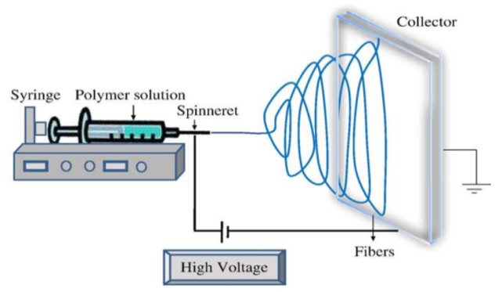

Figure 1. Schematic setup for electrospinning process [7]

Materials and Methods

Materials

Polyacrylonitrile (PAN) with molecular weight of 150kDa was purchased from Sigma Aldrich (USA). Similarly, N,N-Dimethylformamide (DMF) and zinc oxide (ZnO) powder with 99% purity were purchased from Alfa Aesar. Stock solution of Pb(II) was prepared using lead nitrate (Pb²NO³) powder (Sigma Aldrich, USA) while the pH of heavy metal solution was adjusted by using 0.1mol of NaOH and HCl.

Preparation of PAN-ZnO nanofibers by electrospinning

Initially, dope solution of PAN-ZnO was prepared by stirring 5 wt.% of ZnO powder with N-N dimethylformamide (DMF) for 5 hours followed by addition of 10 wt.% polyacrylonitrile (PAN). The mixture was again continuously stirred for another 24 hours to obtain a homogenous solution. The dope solution was later subjected to electrospinning process under the electric field of 12kV, suspension rate of 1.0mL/hour and distance of 20 cm. The collected nanofibrous mats were allowed to dry for at least a day prior to carbonization and activation process.

Preparation of PAN-ZnO ACNFs

The PAN-ZnO nanofibrous mats were later subjected to three pyrolysis processes: 1) stabilization; 2) carbonization and 3) activation following procedure [10]. The nanofibers were stabilized in pure air at temperature of 250 ºC for 4 hours with heating rate of 1 ºC/min. For the carbonization process, the process was carried out in nitrogen gas at temperature of 325 ºC for 1.5 hours with heating rate of 3 ºC /min. Lastly, the carbonized nanofibers were activated at a heating rate of 3 ºC/min with under carbon dioxide until temperature at 425 ºC. The physicochemical properties of the end product which is activated carbon nanofibers (ACNFs) was characterized as described in section 2.4. Figure 2 shows the procedures of ACNFs fabrication.

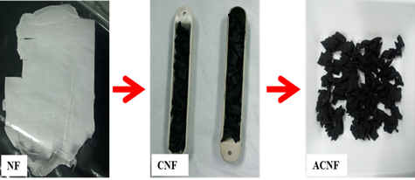

Figure 2. Preparation of nanocomposite ACNFs/ZnO

Characterization

In this study, characterizations were carried out in term of specific surface area (SSA), morphological structures and functional groups analysis by BET, FESEM-EDX and FTIR, respectively. To analyze the specific surface area of NFs and ACNFs, the specific surface area was determined by using automatic Tristar 3000 volumetric system.The surface morphologies of the ACNFs were examined using Field Emission Scanning Electron Microscopy (FESEM) respectively. The samples were placed on a staph and were sputtered with gold prior of FESEM analysis. The distribution and presence of Zn particles were analyzed by EDX, which was conducted by using the images captured by FESEM analysis. The functional groups present in PAN-ZnO ACNFs were identified using ATR-FTIR spectrometer (Model: IRTRACE100, Shimadzu). The samples were scanned by single-reflectance ATR accessory with IRTRACER100. The sample was prepared by cutting it into a small pieces and scanning at a wavelength 400 cm⁻¹ to 4000 cm⁻¹.

Pb(II) adsorption study
The adsorptive performance of ACNFs on lead removal was conducted by studying the effect of initial pH and initial concentration. In every sample, 0.01 g of neat ACNFs and composite ACNFs was added into 10 mL Pb(II) solution. The solution was agitated for 48 hours in rotary shaker. The pH was adjusted using 0.1 mol of NaOH and HCI. The equilibrium concentrations of each samples was measured by filtering the samples and analyzed using Atomic Absorption Spectrometer (AAS) (model 4100ZL, Perkin Elmers).

The removal efficiency, R(%) and adsorption capacity of prepared PAN-ZnO ACNFs were calculated using equation 1 and 2, respectively [9]:

R(%)= (C_{o}-C_{e})/C_{o} x 100 (1)

q_{e} (mg/g)=(C_{o}-C_{e})V/m (2)

where C_{o} is initial concentration of metal (mg/L); C_{e} is equilibrium concentration of metal (mg/L); V is volume of solution in (L) and m is mass of adsorbent.

Adsorption isotherm

Adsorption isotherm analysis was conducted to analyze the adsorption behavior of ACNFs for the removal of Pb(II) ions from aqueous solution. The linear equations of Langmuir and Freundlich models are described from equation 3 and 4, respectively [9].

C_{e}/q_{e} = 1/Q_{max}b + C_{e}/Q_{max} (3)

where q_{e} is amount of Pb (II) adsorbed to adsorbent (mg/g); C_{e} is equilibrium concentration of metal (mg/L). Q_{max} is maximum adsorption capacity (mg/g) and b is the Langmuir constant.

ln q_{e} = ln KF + (1/n) ln C_{e} (4)

q_{e} is amount of Pb (II) adsorbed to adsorbent (mg/g); C_{e} is equilibrium concentration of metal (mg/L); K_{F} is the Freundlich constant (mg/g) and 1/n is parameter related to adsorption intensity.

Results and Discussion
Characterizations of PAN-ZnO ACNFs
Specific surface area
Table 1 shows the specific surface area (SSA) of ACNFs and ACNFs/ZnO after activation process. From the table, it can be seen that addition of ZnO in the ACNFs increased the specific surface area from 67.60 m²/g for neat ACNFS to 163.04 m²/g for composite ACNFs/ZnO. The larger specific surface area could be resulted from the role of metal oxides (in our study, ZnO) that acts as catalyst that accelerates the process of carbonization and activation. As results, more pores were created which contributes to larger specific surface area [8]. Nevertheless, the SSA obtained by both ACNFs were lower as compared to the studies reported elsewhere [9]. It is believed that the carbonization and activation process of the ACNFs might be incomplete, and thus contributed to low SSA when analyzed by BET analysis. Thus, longer duration of activation and carbonization might be required.

Table 1. Specific surface area of NFs and ACNFs
Sample | Specific Surface Area (S.S.A) (m²/g)
Sample | Before Activation | After Activation
Neat ACNFs | 9.13 | 67.60
ACNFs/ZnO | 8.91 | 163.04

SEM/FESEM – EDX analysis
The structural morphologies of neat ACNFs and composite ACNFs are shown in Figure 3. It can be seen that the neat ACNFs possessed more aligned and straight fibers while the PAN-ZnO ACNFs showed more compact arrangement with bent surfaces. The result obtained is in agreement to study conducted by Imtiaz et al. where the activation process and the presence of ZnO led to cross-sectional shrinkage and causing the surface of fibers became rougher and more compact [11]. It can also be seen that there are white spots present alongside the fibers (as indicated by circle marks) which this could be referred as ZnO which is dispersed as beads alongside the PAN-ZnO nanofibers. Dispersion of ZnO beads further supported with EDX mapping as depicted in Figure 4 confirmed that ZnO exists in the ACNFs.

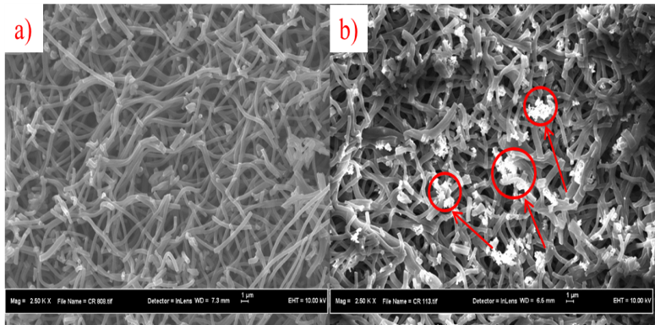

Figure 3. Structural morphologies of a) neat ACNFs and b) PAN-ZnO ACNFs

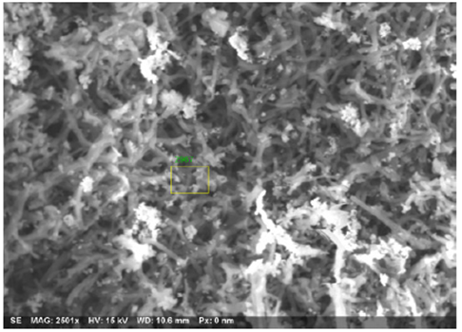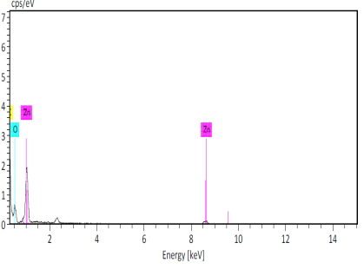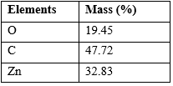

Figure 4. EDX mapping and elemental analysis of PAN-ZnO ACNFs

FTIR analysis
Figure 5 displays the FTIR spectrum of neat and PAN/ZnO based ACNFs. It can be seen that the activation process removed nitrile groups (C≡N) and methylene group (CH₂), only carbon and hydrogen remain as observed at wavelength peaks of 1573 cm⁻¹ and 1250 cm⁻¹ indicating aromatic C-C groups and alkyl halides C-H groups [9]. In addition, absorption peak at 436.5cm⁻¹ was identified as Zn-O, indicating the presence of ZnO nanoparticles in the composite ACNFs [11]. The result is supported by EDX-mapping as displayed by Figure 4 previously, which showing the presence of elements Zn.

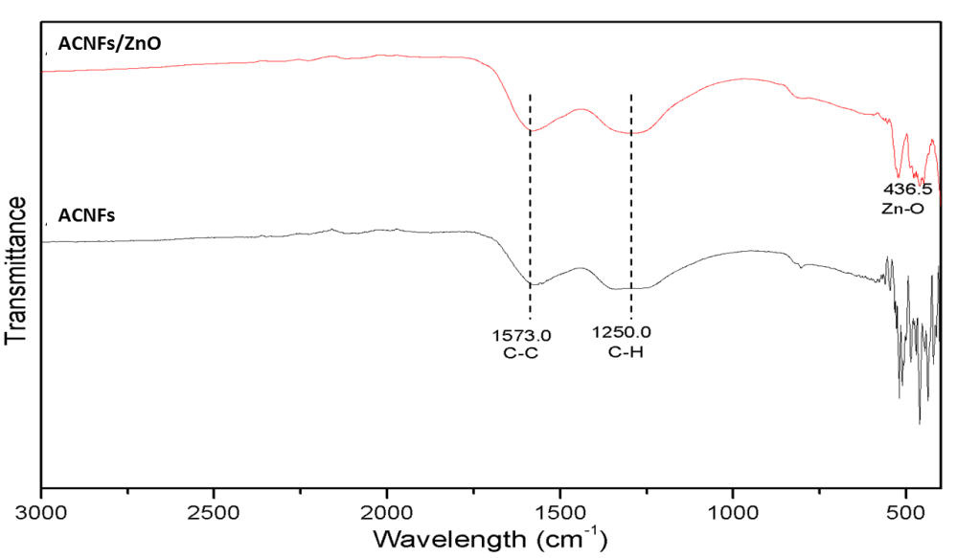

Figure 5. FTIR spectrum of ACNFs and ACNFs/ ZnO

Adsorptive performance of ACNFs on Pb removal
Effect of pH
The adsorption of Pb(II) on ACNFs/ZnO at different pH (1.0 to 6.0) was conducted and the results are shown in Figure 6. The pH values higher than 6 was not tested in order to avoid precipitation of Pb(II) with OH⁻ ions which will form lead salts as well as to avoid any inaccuracy [11]. It can be seen from the figure that increasing pH of the Pb solution increased the removal efficiency. For neat ACNFs, the removal efficiency of Pb is 20.1% (pH 1.0) to 99.4% (pH 4.0). After pH 4.0, there is no increment of removal was obtained. Therefore, the optimum pH of Pb(II) removal on ACNFs is from pH 4.0 to pH 6.0. Similarly, for ACNFs/ZnO, increasing the pH caused a gradual increase of Pb(II) removal from 20.0% (pH 1.0) to 99.4% (pH 6.0) in which the optimum pH for removal of Pb on ACNFs/ZnO is at pH 6.0. From the pH study, it can be seen that both ACNFs and ACNFs/ZnO have good removal efficiency which was more than 99.0%. From the trend shown by both ACNFs, it is evident that the removal of Pb(II) is strongly related to pH which is related to the protonation of the functional groups existed in ACNFs. In acidic condition, low adsorption efficiency was achieved due to the competition between H+ and metal ions for active sorption sites while at higher pH value, thus permitting the attraction between the metal ions and the surface of the adsorbent [8, 9].

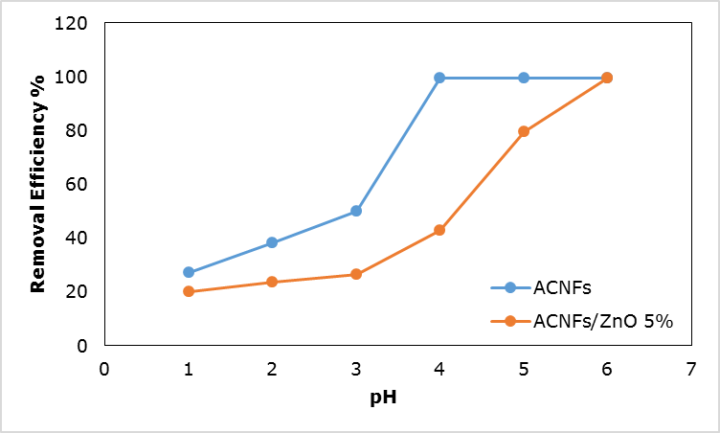

Figure 6. Effects of pH on removal of Pb(II)

Effect of initial concentration
Figure 7 depicts the removal of Pb(II) by neat and PAN-ZnO ACNFs with respect to different initial concentration (10 – 121 mg/L) of Pb(II) solution. For both ACNFs, it can be seen that the percentage of adsorption capacity increased with the increase of initial concentration. The highest adsorption capacity achieved for neat ACNFs was 77.60 mg/g. whereas the highest adsorption capacity achieved for ACNFs/ZnO 5% was 120.3 mg/g. For carbon-based adsorbents, the adsorptive capabilities are contributed surface area, pore volume as well as minor role of surface functional groups which adsorb the ions. For the adsorption process, enhancing the former features is necessary as higher SSA and pore volume facilitate the adsorption process due to the availability of more binding sites [11]. As discussed in the previous section, the SSA of ACNFs/ZnO were higher than the neat ACNFS. Thus, the higher adsorption capacity may be attributed to the higher number of active sites provided by ZnO. It is possible that addition of ZnO increased the active adsorption sites that increase the adsorption capacity of composite ACNFs towards Pb(II) [9]. The satisfactory adsorption capacity also contributed due to the fact that ZnO itself is adsorbent and very favorable towards sorption of heavy metals [9].

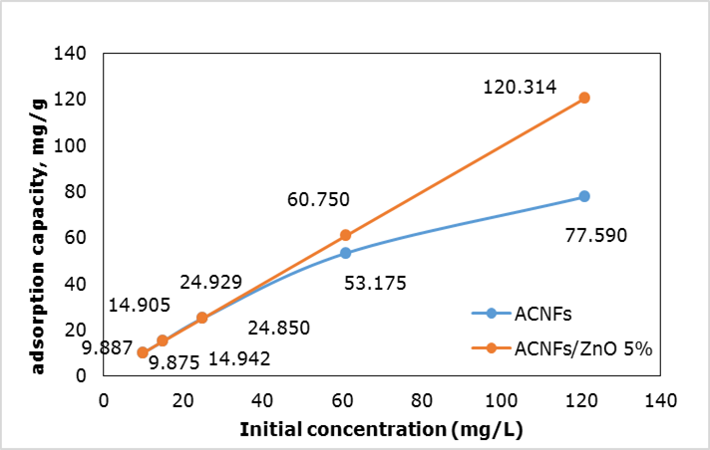

Figure 7. Effect of initial concentration

Adsorption isotherm study
In order to evaluate the mechanism of adsorption occurred on the surface of adsorbent, Langmuir and Freundlich isotherm models were applied and the results are presented in Table 2. As refer to Table 2, the R² values from Freundlich model (0.960) for ACNFs was higher than Langmuir model (0.608). Similar results were obtained for ACNFs/ZnO in which the R² values from Freundlich model (0.958) was higher than Langmuir model (0.939). Thus, Freundlich isotherm model is best fitted to describe the adsorption behaviour that took place between the ACNFs and ACNFs/ZnO with Pb(II) ions. From that, it is assumed that the attachment of Pb(II) ions occurred at heterogeneous surface of the neat ACNFs and ACNFs/ZnO [11].

Table 2. Langmuir and Freundlich isotherm parameters
Adsorbent | Langmuir Model |  |  | Freundlich Model
Adsorbent | Q_{max}  (mg/g) | b  (L/mg) | R² | K  (mg/g) | 1/n | R²
ACNFs | 54.6 | 0.778 | 0.608 | 9.314 | 0.882 | 0.960
ACNFs/ZnO | 169.5 | 1.594 | 0.939 | 2.920 | 0.011 | 0.958

Conclusion

In this study, the feasibility of ACNFs/ ZnO to remove Pb(II) from aqueous solution was demonstrated. The specific surface area was increased by addition of zinc oxide in the ACNFs component. Under SEM analysis the ACNFs/ZnO were found to have compact arrangement with dispersion of Zn beads. The adsorption studies revealed that the removal was dependant on pH and the adsorption mechanism were best fitted to be described by Freundlich model with the highest adsorption capacity in this study was 120.3 mg/g.

Acknowledgement

The authors would like to acknowledge the financial support from Malaysian Ministry of Education (Higher Institution Centre of Excellence) and Universiti Teknologi Malaysia under Grant No. R.J090301.7846.4J179 and R.J090301.7846.4J180. The authors would also like to acknowledge the technical and management support from Research Management Centre (RMC), Universiti Teknologi Malaysia.

References
- Sheet, I., Kabbani, A. and Holail, H. (2014). Removal of heavy metals using nanostructured graphite oxide, silica nanoparticles and silica/graphite oxide composite. Energy Procedia, 50: 130 – 138.
- Flora, G., Gupta, D. and Tiwari, A. (2012). Toxicity of lead: A review with recent updates. Interdisciplinary Toxicology, 5:47 – 58.
- Ghazy, S. E. and Ragab, A. H. (2007). Removal of lead ions from aqueous solution by sorptive-flotation using limestone and oleic acid. Iranian Journal of Chemistry and Chemical Engineering, 26: 83 – 92.
- Fu, F. and Wang, Q. (2010). Removal of heavy metal ions from wastewaters: A review. Journal of Environmental Management, 92: 407 – 418.
- Wang, G., Pan, C., Wang, L., Dong, Q., Yu, C., Zhao, Z. and Qiu, J. (2012). Activated carbon nanofiber webs made by electrospinning for capacitive deionization. Electrochimica Acta, 69: 65 – 70.
- Nataraj, S. K., Yang, K. S. and Aminabhavi, T. M. (2012). Polyacrylonitrile-based nanofibers – A state-of-the-art review. Progress Polymer Science, 37: 487 – 513.
- Ramakrishna, S., Fujihara, K., Teo, W., Yong, T., Ma, Z. and Ramaseshan, R. (2013). Electrospun nanofiber: Solving global issues. Materials Today, 9(3): 40 – 50.
- Dadvar, S., Tavanai, H. and Morshed, M. (2012). Effect of embedding MgO and Al₂O₃ nanoparticles in the precursor on the pore characteristics of PAN based activated carbon nanofibers. Journal of Analytical and Applied Pyrolysis, 98: 98 – 105.
- Faghihian, H., Kooravand, M. and Atarodi, H. (2013). Synthesis of a novel carbon nanofiber structure for removal of lead. Korean Journal of Chemical Engineering, 30: 357 – 363.
- Norhaniza, Y., Dipak, R., Ismail, A. F. and Takeshi, M. (2016). Microstructure of polyacrylonitrile-based activated carbon fibers prepared from solvent-free coagulation process. Journal of Applied Research and Technology, 14: 54 – 61.
- Imtiaz, A. and Rafique, U. (2011). Synthesis of metal oxides and its application as adsorbent for the treatment of wastewater effluents. International Journal of Chemical and Environmental Engineering, 2(6): 400 – 405.

