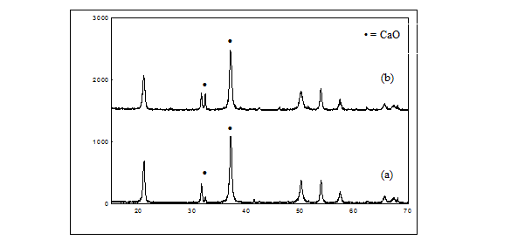
Intensity (a.u.)
2θ (degree)

