Correction for MJAS Vol 21 No 3 (2017)

Listed in the below are the changes required:

1. The clarity of Figure 2 in page 2 is quite poor. Kindly replace with figure below:
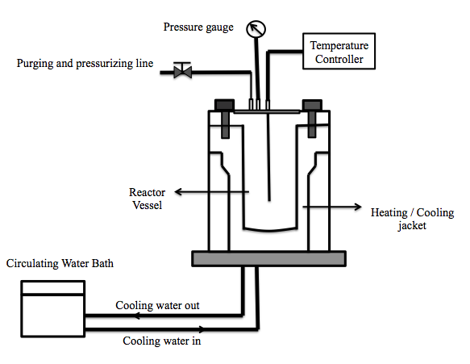

Figure 2. Schematic diagram of Buchiglasuster Kiloclave laboratory reactor system

2. 2 space (gap) in between highlighted words was spotted in page 3. Maybe can reduce to 1.

“extract stored in -20 °C refrigerator. Extract supernatant isolated from precipitate and sonicated for 10 minutes to evenly disperse the particle in water. During the sonication, 10 ml of sonicated extract collected then diluted with….. (Page 3)”

3. Typing error is spotted in the following sentence in page 3. … “The chromatographic separation was performed at a wavelength of 280 nm”. Kindly replace with “258 nm”.

4. The values for x-axis are missing in Figure 4 (page 4), kindly replace with a new figure as below:

Figure 4. Effects of different solid to solvent ratio on mangiferin yield. The extraction temperature and time were fixed at 100 °C and 5 hours, respectively. Values are mean ± standard deviations.

5. The values for x-axis and y-axis are missing in Figure 5 (page 5), kindly replace with a new figure as below:

Figure 5. Effects of different temperature on mangiferin yield. The extraction solid to solvent ratio and time were fixed at 60 g/L and 5 h, respectively. Values are mean ± standard deviations

6. The values for x-axis are missing in Figure 6 (page 6), kindly replace with a new figure as below:

Figure 6. Effects of different time on mangiferin yield. The extraction solid to solvent ratio and temperature were fixed at 60 g/L and 100 °C, respectively. Values are mean ± standard deviations

