

MALAYSIAN JOURNAL OF ANALYTICAL SCIENCES
ISSN 1394 - 2506

Published by The Malaysian Analytical Sciences Society

THE EFFECTS OF DIFFERENT RATIOS OF SONOCHEMICALLY ASSISTED NICKEL OXIDE AND ZIRCONIUM OXIDE CATALYSTS IN SYNGAS PRODUCTION

(Kesan-Kesan Pelbagai Nisbah Pemangkin Nikel Oksida dan Zirkonium Oksida dengan Rawatan Sonokimia Terhadap Penghasilan Singas)

Wan Nurdiyana Wan Amarina^{1,2}, Wong Yee Ching^{1,2}*, Taufiq Yap Yun Hin^{3,4}

¹Faculty of Agro Based Industry
²Faculty of Bioengineering and Technology

Universiti Malaysia Kelantan, Locked Bag No. 100, 17600 Jeli, Kelantan, Malaysia

³Centre of Excellence for Catalysis Science and Technology

⁴Department of Chemistry, Faculty of Science

Universiti Putra Malaysia, 43400 UPM Serdang, Selangor, Malaysia

*Corresponding author: yeeching@umk.edu.my

Received: 28 November 2016; Accepted: 5 February 2017

Abstract

Heterogeneous catalytic cracking is currently one of the most effective ways for both reducing tar content and enhancing hydrogen (H₂) content in syngas at relatively low temperature, besides being environmental friendly. Sonochemical treatment has also been shown to lower reaction times with enhanced reaction rate and enables production of particles with high surface area. Two different types of metal oxides, which are Nickel Oxide (NiO) and Zirconium Oxide (ZrO₂) at combinations of 1:1, 1:2 and 2:1 ratios with Zeolite NaY as the supporter were synthesized via sonochemical treatment. The catalysts were then characterized using X-Ray Diffraction (XRD), Temperature Programmed Reduction in H₂/Argon (TPR-H₂), Brunauer-Emmett-Teller surface measurement (BET), Scanning Electron Microscopy (SEM) and Transmission Electron Microscopy (TEM). From SEM and TEM analysis, nickel tends to agglomerate and form globular shapes, zirconium forms coral-like branching structure and Zeolite NaY forms stacks of cubic clumps. The most promising NiO to ZrO₂ ratio for syngas production is 1:1 because it removes the most reactive oxygen during hydrogen reduction at 0.83 x10²¹ atoms/g, has small crystallite size at 56.90 nm and has the highest surface area for maximum contact with the reactants at 506.52 m²/g. Generally, sonochemical treatment also reduces the catalysts crystallite size (54.83 nm) and increases the catalysts surface area (506.52 m²/g) and oxygen removal (0.83 x10²¹ atoms/g) as well as lowers the reduction temperature (637 K) which is favourable in term of production cost.

Keywords: heterogeneous catalysts, nickel oxide, zirconium oxide, zeolite, syngas

Abstrak

Perekahan pemangkin heterogen adalah salah satu cara terkini yang paling efektif untuk mengurangkan kandungan tar dan juga meningkatkan kandungan hidrogen (H₂) di dalam singas pada suhu rendah, di samping mesra alam sekitar. Rawatan sonokimia juga telah dibuktikan dapat mengurangkan masa tindak balas di samping meningkatkan kadar tindak balas dan membolehkan penghasilan partikel dengan luas permukaan yang tinggi. Dua jenis besi oksida berbeza, iaitu Nikel Oksida (NiO) dan Zirkonium Oksida (ZrO₂) dalam kombinasi nisbah 1:1, 1:2 dan 2:1 dan Zeolit NaY sebagai penyokong dihasilkan melalui rawatan sonokimia. Katalis – katalis tersebut kemudian dianalis menggunakan pembelauan sinar-X (XRD), Penurunan Suhu Berprogram (TPR-H₂), pengukuran permukaan Brunauer-Emmett-Teller (BET), Mikroskop Imbasan Elekron (SEM) dan Mikroskop Elektron Transmisi (TEM). Daripada analisis SEM dan TEM, nikel cenderung untuk bergumpal dan membentuk glob besar, zirkonium membentuk struktur seperti karang bercabang dan Zeolit NaY membentuk lapisan kubik. Nisbah NiO kepada ZrO₂ yang paling berpotensi adalah 1:1 kerana ia menyingkirkan banyak oksigen yang reaktif semasa reduksi hidrogen pada kadar 0.83 x10²¹ atom/g, mempunyai saiz kristal yang kecil iaitu 56.90 nm dan mempunyai luas permukaan yang paling tinggi pada 506.52 m²/g untuk kontak maksimum dengan bahan tindak balas. Umumnya rawatan sonokimia juga mengurangkan saiz kristal katalis (54.83 nm) dan meningkatkan luas permukaan pemangkin (506.52 m²/g) dan juga penyingkiran oksigen (0.83 x10²¹ atom/g) di samping mengurangkan suhu penurunan (637K) di mana ia adalah baik untuk penjimatan kos pengeluaran.

Kata kunci: pemangkin heterogen, nikel oksida, zirkonium oksida, zeolit, singas

Introduction

The depletion of world petroleum reserves and increased environmental concerns has stimulated the search for the alternative renewable fuels that are capable of fulfilling an increasing energy demand. The biomass fuels represent an abundantly available and renewable energy resource with CO₂ neutral impact. It is the only sustainable source of energy and organic carbon for industrial society [1]. Among different processes for their utilization, the biomass gasification is one of the best options in order to optimize the conversion of the chemical energy of the fuel. Instead of using edible biomass (sugars, starches, and vegetable oils) for large scale production of fuels, the development of nonedible biomass (lignocellulosic biomass) permits sustainable and cheaper production of fuels and chemicals without affecting food supplies [1]. Biomass gasification is one of the most promising options for converting lignocellulosic biomass to synthesis gas (syngas), a mixture of CO and H_{2,} which can be used either as a fuel to produce heat and power or as an intermediate in the production of liquid fuels (e.g. diesel fuel, dimethyl ether) and chemicals (e.g. methanol).

Tar is a complex mixture of condensable organic compounds, which includes single ring to 5-ring aromatic compounds along with other oxygen-containing hydrocarbons and complex polycyclic aromatic hydrocarbons (PAHs), which can foul the equipment and cover the surface of catalysts to slow or stop the reaction [2]. Tars present a number of process challenges, including coking of catalysts and condensation on downstream piping, filters, and other equipment. The tar removal cost is as expensive as the overall process to produce syngas [3]. Tars cause severe operational problems associated with their condensation and polymerization. Tar removal is a critical issue in the development of biomass gasification, especially in the Fischer–Tropsch (F–T) synthesis where those impurities can lower the F-T activity in the bio-syngas catalytic conversion [2]. Moreover, a high H₂/CO ratio in the gas stream is desirable for F-T synthesis.

Catalytic cracking/reforming is currently one of the most effective ways for both reducing tar content and enhancing H₂ content in syngas at relatively low temperature. Recently, conventional homogeneous base catalysts are expected to be replaced in the near future by environmentally friendly heterogeneous base catalysts mainly because of environmental constraints and simplifications in the existing processes. Heterogeneous catalytic is considered as a technology with the highest potential to contribute to the solution of tar decomposition. In addition, the use of a catalyst can enhance the gas yield and promote the reforming reactions of residual hydrocarbons. In heterogeneous reaction, the interaction of methane with metals results in H₂ evolution where at temperature above 400K, dehydrogenation of CH_{x} species becomes fast and the elemental carbon is more stable forming stronger bonds with the metal surface [4].

Several catalytic materials have been studied as additives in fluidized-bed reactor in order to achieve in situ catalytic conditioning of the product gas inside the gasifier reactor. Many works on in-bed catalysts consider dolomite [2,5,6], olivine [3,6], nickel [2,3,5-8] and noble metal (NM) based catalysts [4]. A tar conversion rate of 99% has been achieved by using dolomite and Ni-based catalysts [2]. The catalytic performance of dolomite in tar cracking is directly proportional to the number of surface base sites [3].

Although NMs, such as Ru, Rh, Pd, Pt, and Ir, have been studied extensively for dry reforming reaction, their high cost and limited availability limits their industrial applications [9]. Nickel-based catalyst has been considered as the most suitable due to its fast turnover rates, long-term stability and lower cost [4]. However, the major challenge in many processes involving Ni-based catalyst is deactivation by carbon deposition [2]. Therefore, an effective catalyst that minimizes coke deposition should be developed. Zirconium has been tested as a base catalyst to reform gas containing tarry impurities. Zirconium catalyst works efficiently in decomposing tars, especially heavier hydrocarbons. In several tests done by Simell and Kurkela [10], zirconium catalysts provided a tar conversion of 60 to 80% at a temperature of about 600⁰C. Zirconium has also been used as support for Ni-based catalyst for syngas production by dry reforming reaction, which enables direct conversion of natural gas into liquid fuels at remote extraction sites [4].

Metal oxides are constituents of the Earth crust and have been catalyzing different important reactions in chemical evolution. They are good adsorbents and efficient catalysts [11]. They consist of dispersed surface metal oxide species and catalytic active sites supported on high surface area oxides [12]. Mixed metal oxide catalysts are used in heterogeneous catalysis for chemical processes and being further developed for their catalytic performance and durability [13]. Supported metal oxide catalysts have been extensively investigated since 1950s. According to Lee and Wachs [14], the surface metal oxide species of supported metal oxide catalysts control the overall catalytic performance such as activity and selectivity. Zirconium oxide (ZrO₂) has high thermal stability as a catalyst support. It is proved to be a very good promoter for cobalt catalyst where it enhanced CO conversion rate and C5+ selectivity [2]. A study comparing Ni/CeO₂, Ni/ZrO₂, and Ni/CeO₂-ZrO₂ mixed oxide catalysts for methane partial oxidation at 700 °C showed higher activity and coke resistance on the composite supports as compared to the individual metal oxides [6]. Another study using combination of Ni-Ce-ZrO₂ catalyst showed high conversions of reactants (97%) and provide high resistance to catalyst deactivation, but still requires a high temperature [4].

Catalytic performances are expected to be improved by the optimization of the catalytic filter system and the use of more active in-bed catalysts. In this study, the catalysts used are two different types of metal oxides, which are Nickel Oxide (NiO) and Zirconium Oxide (ZrO₂) with Zeolite supporter. Zeolites have been added to the conventional F-T system in many studies. They have a shape-selective property that restrains the formation of products that are larger than the size of the zeolite channels and result in lighter hydrocarbons. Zeolites acid site can help with cracking, isomerization and aromatization reactions for F-T products [2]. They are also widely used in heterogeneous catalysis because of their well-defined pore structures and capabilities of extremely high surface area and surface acidity [6].

The catalysts used for this study were synthesized via sonochemical treatment. Sonochemically assisted reactions showed lower reaction times with enhanced reaction rate. It enables production of small and high uniform particles sizes with high surface area, metal dispersion and defects that have been shown to play a crucial role in catalysis [15-20]. The utilization of sonochemical treatment in the synthesis of the catalysts was proven to show significant increase in the catalytic activity, stability and selectivity of catalysts [20].

Materials and Methods

Preparation of mixed nickel oxide and zirconium oxide catalysts

Mixture of NiO and ZrO₂ catalysts was synthesized by conventional impregnation /co-precipitation method by mixing NiO (from Hmbg) and ZrO₂ (from Acros Organics) at three different NiO to ZrO₂ ratios of 1:1, 1:2 and 2:1 in 100 mL distilled water. The solutions were then sonicated separately for 30 minutes with 2 cm diameter Ti-horn, 20 kHz, 500W probe. The temperature was kept constant at 80 °C. The samples were then cooled to room temperature. The resultant solid (mixture of NiO and ZrO₂) was then recovered using centrifuge for 5 minutes at 2000 rpm [21]. It was then subsequently washed with distilled water followed by washing with acetone to remove the by-products [22] before oven dried overnight at 105 °C for 12 hours according to Tao et al. [23].

Preparation of Zeolite NaY supporter

The supporter used was Zeolite Y sodium (Zeolite NaY), procured from Alfa Aesar. Table 1 showed its mole ratio and surface area.

Zeolite NaY was first treated with sonochemical treatment and the resultant solid was recovered using centrifuge before oven dried overnight at 105 °C. The synthesized mixture of NiO and ZrO₂ were then added with Zeolite at a loading of 10g equally, in 100 mL distilled water. The mixture was then stirred on a hot plate with a magnetic stirrer for one hour. The solid was again recovered using centrifuge technique and subsequently washed with distilled water followed with acetone then oven dried overnight at 105 °C for 12 hours [23]. The catalysts mixtures were then calcined in air at 500 °C for 4 hours, yielding a homogeneous catalyst powder, according to Klimova et al. [24] and Maciel et al. [25]. Calcining the synthesized catalysts powders also removes structure directing agents and other organic substances present in them [26].

Table 1. Mole ratio and surface area of Zeolite NaY
Zeolite NaY Characterization | SiO₂ | Al₂O₃
Mole ratio | 5.1 | 1
Surface area (m²/g) | 900 900

Catalyst characterization
The catalysts were then characterized through a series of analysis as follows. X-ray diffraction (XRD) analysis was carried out using Shimadzu diffractometer model XRD 6000 at range 2ϴ from 5° to 80° in continuous scanning at 2° per minute and sampling pitch of 0.02°. Hydrogen temperature programmed reduction analysis (H₂-TPR) was performed using Thermo Fisher Scientific TPDRO 1100 apparatus that was equipped with a thermal conductivity detector (TCD). The total surface areas of the catalysts were then measured using Thermo Electron Sorptomatic 1990 and Quantachrome AS1WinTM Automated Gas Sorption Data Acquisition and Reduction utilizing Brunauer-Emmett-Teller (BET) method. The catalyst samples were degassed at 300 °C for 12 hours. Electron microscopy technique was used to obtain the information on the morphology and size of the catalyst samples by using LEO 1455 Variable Pressure scanning electron microscope (SEM). The particle sizes of the samples were examined using Hitachi H-7100 energy filter transmission electron microscope (TEM).

Results and Discussion

X-Ray diffraction analysis

X’Pert HighScore software from PANalytical B. V. was used to analyze the XRD data. From the XRD data of all samples, the presence of NiO phase appeared consistently at 2ϴ = 37.3°, 43.4°, 62.8° and 75.4° (JCPDS File No. 00-022-1189) but the peak intensities are very low. This might be due to high metal dispersion of NiO on the surface of Zeolite NaY due to the effect of sonochemical treatment in improving particles size distribution The presence of ZrO₂ phase appeared at multiple degrees = 24°, 24.3°, 28.4°, 31.7°, 34.4°, 35.6°, 40.9°, 49.4°, 50.3°, 50.8°, 54.2°, 55.5°, 58.6° and 62.2° (JCPDS File No. 00-013-0307). While Zeolite NaY showed multiple peaks at 2ϴ = 6.4°, 10.5°, 12.2°, 15.9°, 19.0°, 20.6°, 23.0°, 24.0°, 27.3°, 29.9°, 31.1°, 31.7°, 34.4°, 40.9°, 49.4° and 54.2° (JCPDS File No. 00-038-0239). Some of the peaks of ZrO₂ and Zeolite NaY seem to overlap with each other and it is quite difficult to distinguish the peaks between the two.

Based from the peak intensities shown in Figure 1, the sonochemically treated catalysts with NiO: ZrO₂ ratio of 1:1 shows the lowest peak intensities followed by catalysts ratio 2:1 and 1:2. It seems that equal amount of NiO and ZrO₂ contributes to higher dispersion of metal oxides on Zeolite’s surface compared to the unequal amounts of NiO and ZrO₂. Catalysts ratio 1:2 shows the highest peak intensities where ZrO₂ is double the amount of NiO. Since the peaks of ZrO₂ are more prominent than NiO, it can be said that ZrO₂ is not as well dispersed as NiO on the surface of Zeolite NaY supporter.

Zeolite NaY generally has the highest crystallinity and more defined structures compared to NiO and ZrO₂. It is identified to possess cubic crystal system. Its particle size is also the largest compared to NiO and ZrO₂ (average of 201 to 493 nm). The size of crystallite can be estimated from the XRD data as shown in Table 2, using Scherrer equation in equation 1 [27],

L = Kλ/β.cos ϴ (1)

where L = average crystallite size, K = constant which is normally taken as 0.9, λ = X-ray wavelength, β = peak width of the diffraction profile at half maximum height and ϴ can be either in degrees or radians.

Based from Table 2, catalyst ratio 2:1 showed the smallest crystallite size average of 54.83 nm compared to other catalysts with different ratios. This is to be expected since the TEM analysis images also show that Ni has the smallest particle size (average of 6 to 12 nm) and that the high amount of NiO means it is well dispersed on the surface of the catalyst, thus contributing to smaller crystallite size. However, the crystallite size of catalyst 2:1 is not significantly different than catalyst ratio 1:1. While catalyst ratio 1:2 shows the biggest crystallite size due to higher amount of ZrO₂.

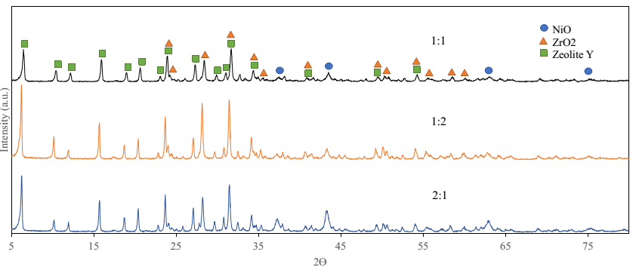

Figure 1. XRD patterns of NiO:ZrO₂ catalysts ratio of 1:1, 1:2 and 2:1 treated with sonochemical treatment for 30 minutes

Table 2. Crystallite size average from XRD data (nm)
Catalyst | Crystallite Size Average  (nm)
1:1 | 56.90
1:2 | 62.51
2:1 | 54.83

Temperature programmed reduction (TPR in H₂/Ar)

All catalyst samples produced a single reduction peak at temperature ranging from 637 K to 657 K as shown in Figure 2 and Table 3.

As can be seen in Table 3, catalyst ratio 1:1 removed the highest amount of oxygen at 0.83 x10²¹ atoms/g followed by catalysts ratio 2:1 and 1:2. From the data, it is shown that catalyst ratio 1:1 is the most efficient reactive oxygen removal while catalyst ratio 1:2 is the least efficient with reactive oxygen removal at 0.48 x10²¹ atoms/g. This is also in agreement with the XRD data discussed earlier where catalyst ratio 1:1 with equal distribution of NiO and ZrO₂ is well dispersed with small crystallite size. However, catalyst ratio 1:2 and 2:1 have lower T_{max} at 637K and 653K respectively compared to catalyst ratio 1:1 at 657K. Despite the 20K T_{max} difference between catalysts ratio 1:1 and 1:2, catalyst ratio 1:1 has almost double the amount of reactive oxygen removed compared to catalyst ratio 1:2.

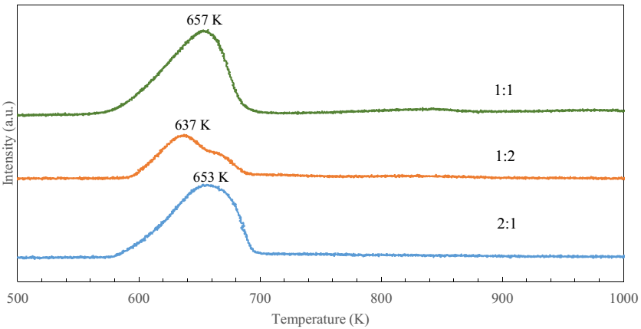

Figure 2. Temperature programmed reduction profiles for NiO: ZrO₂ ratio 1:1, 1:2 and 2:1

Table 3. Total amount of oxygen removed from the catalysts by reduction in H₂/Ar
Catalyst | T_{max} (K) | H₂ gas adsorbed  (x10⁻³ mol/g) | Total O₂ removed (x10²¹ atoms/g)
1:1 | 657 | 1.37 | 0.83
1:2 | 637 | 0.79 | 0.48
2:1 | 653 | 1.21 | 0.73

Scanning electron microscope

In all samples, NiO tends to agglomerate into large globular shape while Zeolite NaY forms stacks of cubic shaped clumps and mostly spread out trough out the entire sample. Generally ZrO₂ forms the smallest structures among the other two catalysts. It was seen to be in cylindrical form in coral-like branching structure distributed throughout the sample. Figure 3 shows large globular clumps of NiO surrounded by Zeolite NaY and some smaller coral-like ZrO₂ clumps can be seen around it.

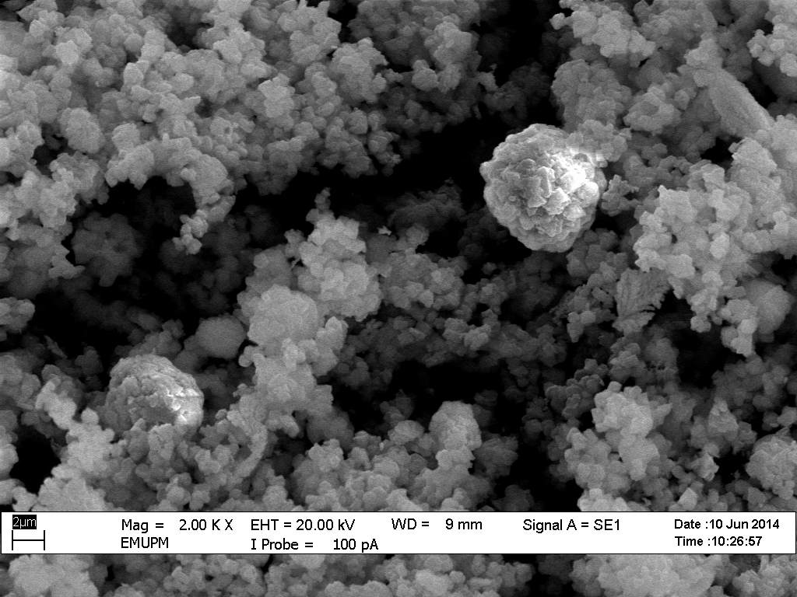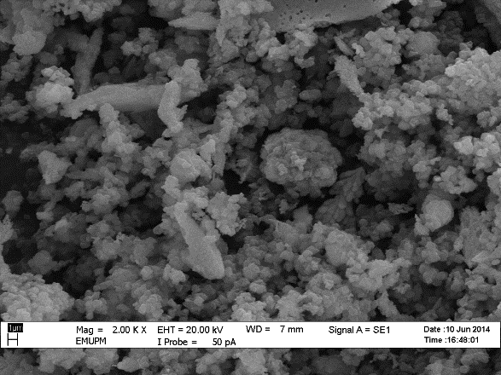
(a)
(b)

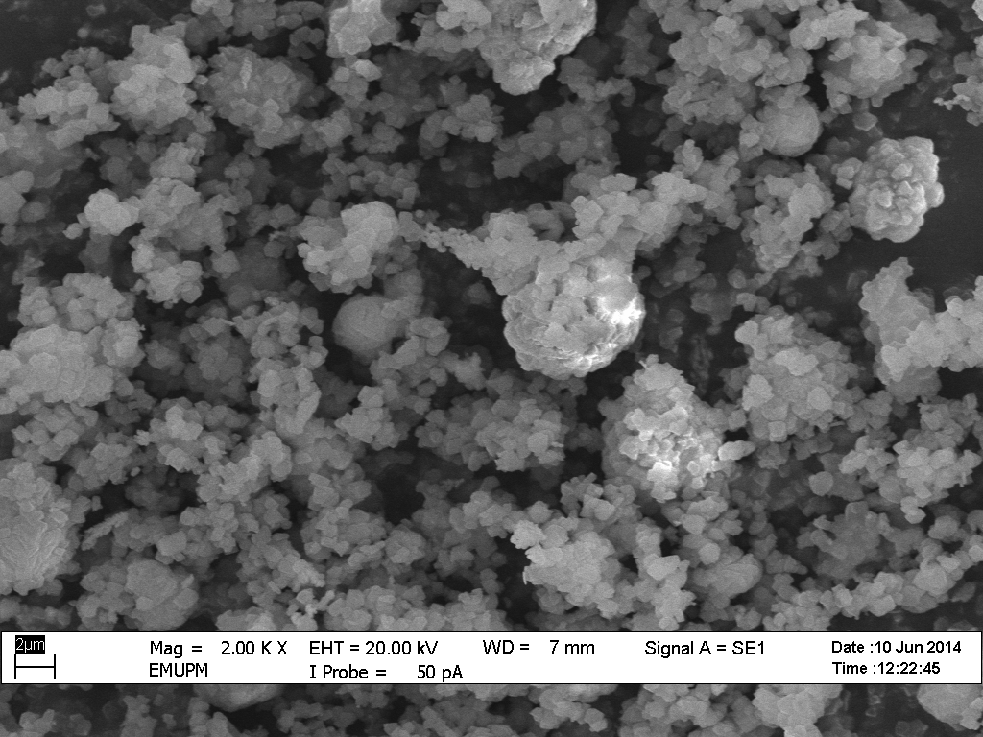
(c)
(c)
(c)
(a)
Figure 3. SEM micrograph of sample (a) 1:1, (b) 1:2, and (c) 2:1 at magnification 2000x

Catalyst ratio 1:1 shows NiO agglomerated globular clumps with ZrO₂ smaller structures are equally distributed on the surface of Zeolite NaY while catalyst ratio 1:2 shows more and bigger structures of ZrO₂ on the surface of the catalyst. Globular clumps of NiO are more apparent in catalyst ratio 2:1, as can be seen in Figure 3.

Transmission electron microscope

Figure 4 shows agglomerated NiO particles with sizes ranging from 6 to 12 nm in catalyst ratio 1:1. From the same sample, ZrO₂ forms coral-like branching structures with diameters ranging from 74 to 94 nm while crystal-like Zeolite NaY stacks up on each other with diameters ranging from 201 to 493 nm. TEM images shows that ZrO₂ average particle size is larger than NiO and this is in agreement with XRD results where catalysts ratio 1:2 also has the highest peak intensities where ZrO₂ is double the amount of NiO. Since the peaks of ZrO₂ are more prominent than NiO, it can be said that ZrO₂ is not as well dispersed as NiO on the surface of Zeolite NaY supporter due to its larger particle size and its branching structures.

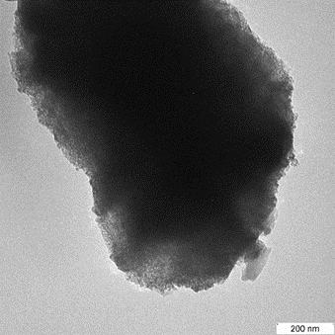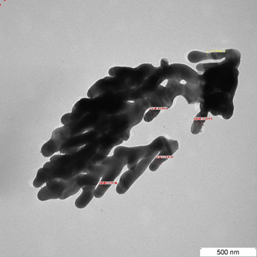
(a)
(b)

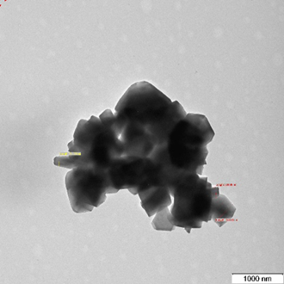
(c)

Figure 4. TEM micrograph of catalyst ratio 1:1 of (a) NiO at magnification 100 000x, (b) ZrO₂ at magnification 50 000x, and (c) Zeolite at magnification 20 000x

BET surface area measurement

Based from Table 4, catalyst with the highest surface area is catalyst ratio 1:1 with surface area of 506.52 m²/g and the lowest surface area is catalyst ratio 1:2 with surface area of 399.88 m²/g. This is in agreement with the XRD and TPR-H₂ data where catalyst ratio 1:1 has well dispersed metal oxides with average crystallite size of 56.90 nm and the highest reactive oxygen removal at 0.83 x10²¹ atoms/g compared to catalysts ratio 1:2 and 2:1.

While catalyst ratio 1:2, with its higher amount of ZrO₂ on the surface of Zeolite NaY has reduced the surface area of the catalyst (399.88 m²/g) as well as reduced contact with the active sites thus contributing to low removal of reactive oxygen as presented in previous TPR-H₂ section discussion.

The presence of Zeolite NaY supporter and ZrO₂ in catalysts was reported by Derekaya and Yasar [28] to give higher surface area compared to the catalysts without their presence. Zeolite NaY also has high surface area (900 m²/g) and well dispersed pore structure. ZrO₂ was also implied to act as a surface area agent. However, higher ratio of ZrO₂ to NiO is proven to significantly reduce the surface area of the catalysts.

There is also a huge discrepancy between pure Zeolite NaY surface area (900 m²/g) and treated Zeolite NaY surface area. The drying and calcination of catalyst could also possibly affect the total surface area. This also means that both NiO and ZrO₂ loading on Zeolite NaY significantly reduced the surface area of Zeolite NaY. This might be due to the effects of sonication treatment which caused the agglomeration of active metal Ni on the surface of Zeolite NaY where it could lead to blockage of pores and reduces the overall surface area of Zeolite NaY [17].

Table 4. Specific BET surface area of NiO: ZrO₂ catalysts
Catalyst | Surface Area  (m²/g)
1:1 | 506.52
1:2 | 399.88
2:1 | 436.37

A summary of comparisons between catalysts ratio 1:1, 1:2 and 2:1 is shown in Table 5.

Table 5. Comparisons of properties between catalysts with different ratio
Catalyst | Average Crystallite Size (nm) | T_{max} (K) | H₂ Gas Adsorbed  (x10⁻³ mol/g) | Total O₂ Removed (x10²¹ atoms/g) | Surface area (m²/g)
1:1 | 56.90 | 657 | 1.37 | 0.83 | 506.52
1:2 | 62.51 | 637 | 0.79 | 0.48 | 399.88
2:1 | 54.83 | 653 | 1.21 | 0.73 | 436.37

Conclusion

The catalysts studied, which are NiO and ZrO₂ with Zeolite NaY as supporter will help in the study of catalytic cracking/ reforming mechanisms in good quality and cleaner syngas production. However the results are not conclusive yet since syngas evaluation using Temperature Programmed Gasification (TPG) has not been done yet. The results from TPG analysis will determine the performance of the catalysts and will relate with the catalysts characterization data. For now, it can be said that the most promising NiO to ZrO₂ catalyst ratio is ratio 1:1 because of the well dispersion of mixed metal oxides on the catalyst surface with small average crystallite size of 56.90 nm, removal of reactive oxygen at the highest rate at 0.83 x10²¹ atoms/g as well as possessing the highest surface area at 506.52 m²/g. Equal distribution of mixed metal oxides on the surface of Zeolite NaY supporter produces favourable characteristics for the production of quality syngas. Higher amount of ZrO₂ however causes blockage of the pores, thus reduces the catalyst surface area because of its tendencies to agglomerate and form large branching structures, which produces catalyst of poorer profile compared to catalysts ratio 1:1 and 2:1. From SEM and TEM analysis, NiO tends to agglomerate and form sizable globular shapes, ZrO₂ forms coral-like branching structure and Zeolite NaY forms stacks of cubic clumps. From the catalysts characterization data and analysis obtained, catalysts with NiO: ZrO₂ ratio of 1:1 seems to be a promising catalyst for producing rich syngas with higher catalytic activity and reaction.

Acknowledgement

This work was supported by Research Grant R/FRAGS/A07.00/00457A/003/2014/000180 from the Ministry of Higher Education, Malaysia.

References
- Serrano-Ruiz, J. C., West, R. M. and Dumesic, J. A. (2010). Catalytic conversion of renewable biomass resources to fuels and chemicals. Annual Review of Chemical and Biological Engineering, 1: 79 - 100.
- Hu, J., Yu, F. and Lu, Y. (2012). Application of Fischer–Tropsch synthesis in biomass to liquid conversion. Catalysis, 2(2): 303 – 326.
- Rownaghi, A. A. and Huhnke, R. L. (2013). Producing hydrogen-rich gases by steam reforming of syngas tar over CaO/MgO/NiO catalysts. American Chemical Society Sustainable Chemistry & Engineering, 1: 80 – 86.
- Havran, V., Dudukovi, M. P. and Lo, C. S. (2011). Conversion of methane and carbon dioxide to higher value products. Industrial & Engineering Chemistry Research, 50: 7089 – 7100.
- Mohammed, M. A. A., Salmiaton, A., Wan Azlina, W. A. K. G., Mohamad Amran, M. S., Omar, R., Taufiq-Yap, Y. H. and Ahmadun, F. R. (2012). Catalytic gasification of empty fruit bunch for enhanced production of hydrogen rich fuel gas. Pertanika Journal of Science & Technology, 20(1): 139 – 149.
- Yung, M. M., Jablonski, W. S. and Magrini-Bair, K. A. (2009). Review of catalytic conditioning of biomass-derived syngas. Energy & Fuels, 23: 1874 – 1887.
- Deghedi, L., Basset, J. -M., Candy, J. -P., Dalmon, J. -A., Dubreuil, A-C. and Fischer, L. (2009). Nanosized bimetallic Ni-Sn and Ni-Zr catalysts prepared by SOMC/M route: Characterization and catalytic properties in styrene selective hydrogenation. Chemical Engineering Transaction, 17: 31 – 36.

- Nakayama, O., Ikenaga, N., Miyake, T., Yagasaki, E. and Suzuki, T. (2010). Production of synthesis gas from methane using lattice oxygen of NiO-Cr₂O₃-MgO complex oxide. Industrial & Engineering Chemistry Research, 49: 526 – 534.
- Moon, D. J. (2008). Hydrogen production by catalytic reforming of gaseous hydrocarbons (methane & LPG). Catalysis Surveys from Asia, 12(3): 188 – 202.
- Simell, P. and Kurkela, E. (2007). International Publication No. WO 2007/116121 A1. Helsinki, Finland: World Intellectual Property Organization (WIPO).
- Kamaluddin. (2013). Role of metal oxides in chemical evolution. In S. K. Chakrabarti, K. Acharyya, & A. Das (Eds.), AIP Conference Proceedings, 1543 (1): 90 – 98.
- Wachs, I. E. and Kim, T. (2009). Oxidation reactions over supported metal oxide catalysts: Molecular/ electronic structure-activity/selectivity relationships. In Jackson, S. D. and Hargreaves, Justin S. J. (Eds). Metal oxide catalysis. WILEY-VCH Verlag GmbH & Co. KGaA. Weinheim, Germany: pp. 487 – 488.
- Lee, D. W. and Yoo, B. R. (2014). Advance metal oxide (supoorted) catalysts: Synthesis and applications. Journal of Industrial and Engineering Chemistry, 20(6): 3947 – 3959.
- Lee, E. L. and Wachs, I. E. (2009). Use of oxide ligands in designing catalytic active sites. In Ozkan, U. S. (Ed). Design of heterogeneous catalysts: new approaches based on synthesis, characterization and modeling. WILEY-VCH Verlag GmbH & Co. KGaA. Weinheim, Germany.
- Gole, V. L. and Gogate, P. R. (2012). A review on intensification of synthesis of biodiesel from sustainable feed stock using sonochemical reactors. Chemical Engineering and Processing, 53: 1 – 9.
- Saminda, D., King’ondu, C. K., Pedrick, W., Lakshitha, P. and Suib, S. L. (2012). Direct sonochemical synthesis of manganese octahedral molecular sieve (OMS-2) nanomaterials using cosolvent systems, their characterization, and catalytic applications. Chemistry of Materials, 24(4): 705 – 712.
- Sharifi, M., Haghighi, M. and Abdollahifar, M. (2015). Sono-dispersion of bimetallic Ni-Co over Zeolite Y used in conversion of greenhouse gases CH₄/CO₂ to high valued syngas. Journal of Natural Gas Science and Engineering, 23: 547 – 558.
- Zhong, Y. L. and Bernasek, S. L. (2011). Mild and efficient functionalization of hydrogen-terminated Si(III) via sonochemical activated hydrosilylation. Journal of the American Chemical Society, 133: 8118 – 8121.
- Chavan, V. P. and Gogate, P. R. (2011). Intensification of synthesis of cumene hydroperoxide using sonochemical reactors. Industrial & Engineering Chemistry Research. 50(22): 12433 – 12438.
- Zhang, X., Jiang, W., Gong, X. and Zhang, Z. (2010). Sonochemical synthesis and characterization of magnetic separable of Fe₃O₄/Ag composites and its catalytic properties. Journal of Alloys and Compounds, 508(2): 400 – 405.
- Taufiq-Yap, Y. H., Joshua Hoh, J. R. and Wong, Y. C. (2011). Synthesis of nanostructured vanadium phosphate catalysts using sonochemical route for partial oxidation of n-butane. Journal of Applied Sciences, 11(13): 2370 – 2375.
- Meybodi, S. M., Hosseini, S. A., Rezaee, M., Sadrnezhaad, S. K. and Mohammadyani, D. (2012). Synthesis of wide band gap nanocrystalline NiO powder via a sonochemical method. Ultrasonics Sonochemistry, 19: 841 – 845.
- Tao, J., Zhao, L., Dong, C., Lu, Q., Du, X. and Dahlquist, E. (2013). Catalytic steam reforming of toluene as a model compound of biomass gasification tar using Ni-CeO₂/SBA-15 catalysts. Energies, 6: 3284 – 3296.
- Klimova, T., Pena, L., Lizama, L., Salcedo, C. and Gutierrez, Y. (2009). Modification of activity and selectivity of NiMo/SBa-15 HDS catalysts by grafting of different metal oxides on the support surface. Industrial & Engineering Chemistry Research, 48: 1126 – 1133.
- Maciel, C. G., Silva, T. D., Assaf, E. M. and Assaf, J. M. (2013). Hydrogen production and purification from the water-gas shift reaction on CuO/CeO₂-TiO₂ Catalysts. Applied Energy, 112: 52 – 59.
- Pal, P., Das, J. K., Das, N. and Bandyopadhyay, S. (2013). Synthesis of NaP Zeolite at room temperature and short crystallization time by sonochemical method. Ultrasonics Sonochemistry, 20: 314 – 321.
- Monshi, A., Foroughi, M. R. and Monshi, M. R. (2012). Modified Scherrer equation to estimate more accurately nano-crystallite size using XRD. World Journal of Nano Science and Engineering, 2: 154 – 160.
- Derekaya, F. B. and Yasar, G. (2011). The CO methanation over NaY-Zeolite supported Ni/Co₃O₄, Ni/ZrO₂, Co₃O₄/ZrO₂ and Ni/Co₃O₄/ZrO₂ catalysts. Catalysis Communications, 13: 73 – 77.

