

MALAYSIAN JOURNAL OF ANALYTICAL SCIENCES
ISSN 1394 - 2506

Published by The Malaysian Analytical Sciences Society

PRELIMINARY STUDY OF SULFUR DIOXIDE REMOVAL USING CALCINED EGG SHELL

(Kajian Awal Penyingkiran Sulfur Dioksida Menggunakan Kulit Telur yang Dikalsinkan)

Sumathi Sethupathi¹*, Yap Chen Kai¹, Leong Loong Kong², Yamuna Munusamy¹, Mohamed Jaber Khalil Bashir¹, Nurshasabila Iberahim¹

¹Faculty of Engineering and Green Technology,

Universiti Tunku Abdul Rahman, 31900 Kampar, Perak, Malaysia

²LKC Faculty of Engineering and Science,

Universiti Tunku Abdul Rahman, 43000 Kajang, Selangor, Malaysia

*Corresponding author: sumathi@utar.edu.my

Received: 28 November 2016; Accepted: 5 February 2017

Abstract

The combustion of coal for energy had created severe environmental issues mainly due to the release of particulate matter and flue gases containing sulphur dioxide (SO₂) during the processing. At present limestone based adsorbent is used to desulphurize flue gas. Egg shell is a type of food waste and it contains high amount of calcium carbonate which is similar to limestone. In this study, the potential of egg shell as a substitute material to replace commercial limestone based calcium oxide was investigated. Waste egg shell and commercial calcium carbonate (limestone)(CCC) were calcined at various temperatures (750 – 950 ºC) and holding time (2 and 4 hours). The calcined samples were tested for SO₂ adsorption using a gas reactor at room temperature with a flow rate of 300 mL/min. The initial concentration of SO₂ is 200 ppm. Characterization of the adsorbents will be done using Fourier Transform Infrared (FTIR), Brunauer-Emmett-Teller (BET) and X-ray Diffraction (XRD) to understand the sorption behavior. Calcined egg shell and calcined CCC takes about 110 min and 180 min for saturation. It is noted that calcined egg shell could remove SO₂ alike calcined CCC. However, the adsorption capacity of egg shell is lower compared to CCC and this could be due to impurities.

Keywords: sulphur dioxide, adsorption, egg shell, calcium carbonate

Abstrak

Pembakaran arang batu untuk sumber tenaga telah mewujudkan isu-isu alam sekitar yang teruk disebabkan oleh pembebasan habuk tertentu dan gas serombong yang mengandungi sulfur dioksida (SO₂) semasa pemprosesan. Pada masa ini, batu kapur berasaskan serapan digunakan untuk menyingkirkan gas serombong. Kulit telur adalah sejenis sisa makanan dan ia mengandungi jumlah kalsium karbonat yang tinggi dan sama seperti batu kapur. Dalam kajian ini, potensi kulit telur sebagai bahan pengganti untuk menggantikan kalsium oksida daripada batu kapur komersial telah dikaji. Sisa kulit telur dan kalsium karbonat komersial (batu kapur) (CCC) telah dibakar pada pelbagai suhu (750 – 950 ºC) dan masa induk (2 and 4 jam). Sampel yang telah dibakar kemudian diuji untuk penyerapan SO₂ menggunakan reaktor gas pada suhu bilik dengan kadar aliran 300 mL/min. Kepekatan awal SO₂ adalah 200 ppm. Pencirian serapan dilakukan dengan menggunakan Infra merah Transformasi Fourier (FTIR), Brunauer-Emmett-Teller (BET) dan pembelauan Sinar-X (XRD) untuk memahami keadaan penyerapan itu. Kalsin kulit telur and kalsin CCC masing-masing memerlukan tempoh selama 110 min and 180 min untuk mencapai ketepuan. Ternyata bahawa kalsin kulit telur boleh menyingkirkan SO₂ seperti kalsin CCC. Walau bagaimanapun, kapasiti penyerapan kalsin kulit telur lebih rendah berbanding dengan kalsin CCC yang mungkin disebabkan oleh berhadas.

Kata kunci: sulfur dioksida, penyerapan, kulit telur, kalsium karbonat

Introduction

Combustion of the sulphur containing fuel, such as coal and oil, results in the formation of sulphur dioxide (SO₂). Flue gas from coal processing is one of the major contributors of SO₂ to the environment. It has been reported that a typical coal-fired plant generates about 10,000 tons of SO₂ [1]. The releasing of SO₂ into the air will bring adverse effects to the human health and environment. Several technologies had been invented to treat SO₂ from flue gas before it is being released to the atmosphere. Flue gas desulphurization (FGD) is one of the methods that removes the SO₂ content in the flue gas from solid, liquid or gases [2]. Wet desulphurization method using limestone as adsorbent had been used widely due to the high removal efficiency (higher than 90 %) of the SO₂ [3]. However, the usage of limestone a depleting natural source for cleaning purpose is not economically viable. Besides using limestone as an adsorbent for FGD, many other types of adsorbents such as activated carbon, activated coke, fly ash have been reported in the literature to remove SO₂ [4-6].

Egg shell (ES) is an emerging abundant solid waste from the sources such as poultry, homes, restaurants, and food manufacturing industries [7]. In Malaysia about 642,600 tonnes of egg is produced every year and from this total about 70,686 tons of ES waste is expected to be generated every year [8]. Furthermore, recently in Malaysia egg cracking industries is growing rapidly giving largest chuck of ES. ES usually are disposed to landfills without prior treatment and this indirectly creates negative effect to the environment and human health [9-10]. Many investigations have been conducted to explore usefulness of ES such as ES based fertilizer, cement additive, heavy metal adsorbent, catalyst and collagen [11-13]. However, none have been tested for pollutant gas adsorption.

In present study, waste egg shells were tested as a new material to treat SO₂ from flue gases. Egg shells are calcined to calcium oxide (CaO). Calcined ccommercial calcium carbonate (CaCO₃) was also used to compare the performance of egg shell waste to commercially available adsorbent.

Materials and Methods

Eggshell preparation

ES was collected from the university campus canteen. About 1 kg of waste ES was collected in a day throughout the campus. The collected ES was thoroughly washed to remove any white or yellow egg residue and egg membrane. It is then dried at 105 °C till a constant weight is obtained. Prior to storage, ES powder was sieved to a particle size of 63 μm. This size was chosen to standardize the adsorbent size and preliminary study shows smaller size has better adsorption capacity due large surface area. In order to test the potential ES for SO₂ removal, it was further processed to form CaO. The calcination processes were done by varying the calcination temperature (750 – 950 °C) and time (2 and 4 hours). The temperature and time range was chosen based on a preliminary study and literature [8]. Similarly, was done for the commercial calcium carbonate (CCC) (lab grade, 99% purity) purchased from Merck.

Sulphur dioxide removal
Desulfurization experiments were performed in a laboratory scale of adsorption system with a fixed bed adsorber. Figure 1 shows the illustration of the experimental rig. The height and inner diameter of the reactor are 180 mm and 9 mm. The concentration of SO₂ gas was measured using a gas analyzer (Vario Plus Industrial Gas Analyzer, V: 1.78-000). About 0.5 g of adsorbent was placed in the reactor. 200 ppm SO₂ and N₂ as the balance was passed through the reactor at room temperature. The feed flow through the reactor was controlled at 300 ml/min. The amount of SO₂ adsorbed by the prepared adsorbent was expressed in breakthrough curves. Three sets of SO₂ adsorption study was done for each sample and the average data was used to plot the breakthrough curves.

The adsorption capacity was calculated based on the breakthrough curve data. The time equivalent to the total or stoichiometric capacity of SO₂ was calculated numerically by integrating the following equation 1;

$t_{t}=\int_{0}^{∞}{\left(1-\frac{C}{Co}\right)dt}$ (1)

Where t_{t} is the time equivalent to the total or stoichiometric capacity, t is the time, C is the concentration of SO₂ at time, t and Co is the feed concentration of SO₂. With t_{t} determined, the amount of adsorbed by adsorbent (the adsorption capacity) was calculated at STP condition from the following equation 2 and 3 [14];

$q=\frac{Q_{f}t_{t}y_{f}}{m_{c}}$ (2)

$q=\left(1-\frac{C}{Co}\right)\frac{Q_{f}t_{t}y_{f}}{m_{c}}$ (3)

where q is the adsorbent sorption capacity, q_{t} is the breakthrough sorption capacity at 5% from initial concentration, y_{f} is the mole fraction of SO₂ in the feed, Q_{f} is the volumetric feed flow rate at STP and m_{c} is the mass of adsorbent used in the bed.

- Gas cylinder
- Gas regulator
- Pinch valve
- Flow meter
- Gas mixing chamber
- Adsorbent
- Glass wool
- Fixed Bed Adsorber
- Gas analyzer
- Vent
SO₂
1
L
L

4
3
7
8
10
9
5
6
2
N₂

Figure 1. Experimental rig for desulphurization

Characterization
In this study, the prepared adsorbent will be characterized to determine their physical and chemical properties. The Fourier Transform Infrared (FTIR) was used to qualitatively identify the functional groups on the surface of ES and CCC using PerkinElmer FT-IR 2000. The spectra were obtained in the range of 400 – 4000 cm⁻¹ with a resolution of 4 cm⁻¹. The sample preparation consisted of mixing fine powder of each sample with KBr powder. The Brunauer-Emmett-Teller (BET) surface area analysis was done using N₂ adsorption and desorption isotherms measured at 77 K using Micromeritics (ASAP 2020 V4.02) volumetric gas adsorption instrument. Prior to measurements, the samples were degassed at 105 °C for 24 hours. The X-ray diffraction patterns of the samples were recorded by XRD-6000, Shimadzu using Cu-Ka radiation. The measurements were made at temperature range of 15 – 70 °C on 2θ with a step size of 0.02°. The diffraction patterns were analyzed using the Joint Committee on Powder Diffraction Standards (JCPDS). CaO crystallite size was calculated using Scherrer equation from the most intense CaO peak at 2θ of 37.6°.

Results and Discussion
The SO₂ adsorption performance by calcined ES and CCC at different temperature and time are shown in Figure 2(a) and 2(b) and Figure 3(a) and 3(b) respectively. The data was plot based on average of three replicates and the difference of each set was less than 4%. The longest time (180 minutes) taken for saturation by CCC was at temperature 900 °C with 2 hours of calcination. The adsorption capacity of this sample was calculated as 3.95 mg/g. It was noticed that as the temperature was increased from 750 to 900 °C the saturation time for CCC increased rapidly. However, at temperature 950 °C the adsorption curve was narrower and almost similar to 900 °C. Further increase in temperature did not show significant changes in the removal efficiency. This is because the maximum conversion of CaCO₃ to CaO happens at 900 °C [15]. Thus, any sample prepared at lower temperature is expected to give less adsorption capacity due to incomplete process of CaCO₃ calcination.

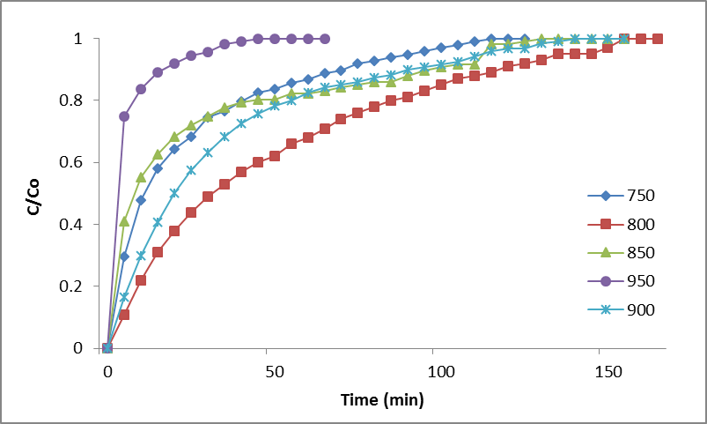
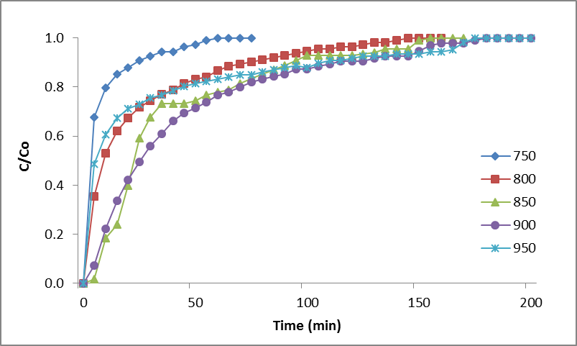
(b)
(a)

Figure 2. SO₂ breakthrough curve at different temperature for CCC at (a) 2 hours and (b) 4 hours of calcination

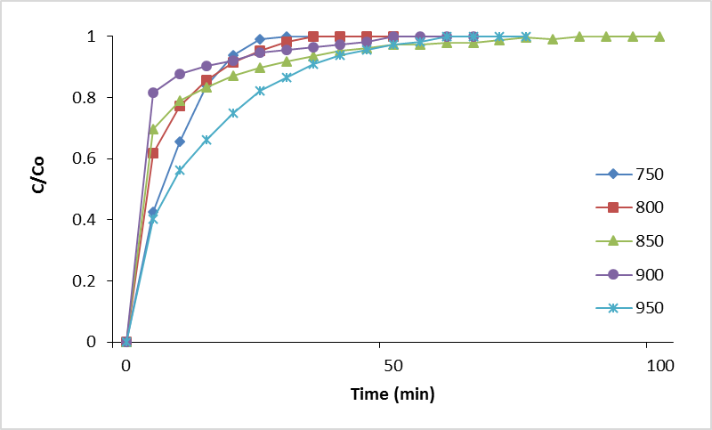
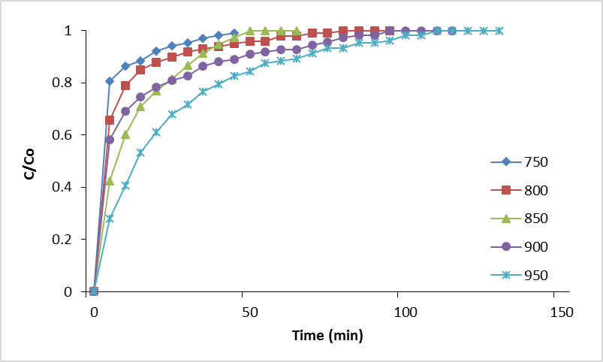
(b)
(a)

Figure 3. SO₂ breakthrough curve at different temperature for egg shell at (a) 2 hours and (b) 4 hours of calcination

Furthermore, it was noticed that further increase in time as shown in Figure 2(b), decreased the removal efficiency and saturation time. This could be due to overheating of the sample. Hu et al. reported that sintering of limestone particle could be the main reason. Limestone particles lost partly their reactivity after a heat treatment at 1123 K. The loss of the reactivity was also dependent on the duration of heat treatment, whereby a longer heat treatment will cause a greater loss of reactivity [16]. Sintering effect can be proven using the surface area data in Table 1. It is clearly seen that the surface area of calcined CCC at higher temperature was lower compared to the best removal sample. The best sample for 4 h of calcination was found to be at 800 °C for CCC. This further proves that increase in time and temperature at certain condition discourages SO₂ adsorption by CCC due to the reasons given above.

Table 1. Surface area of CCC, calcined ES and calcined CCC
Sample | BET Surface Area  (m²/g) | CaO Crystallite Size  (nm) | Adsorption Capacity (mg/g)
CCC | 1.12 | - | -
Eggshell | 0.56 | - | -
Calcined CCC – 900-2h | 9.51 | 3.29 | 3.95
Calcined ES – 950-2h | 6.54 | 2.95 | 2.15
Calcined CCC – 900-4h | 7.98 | 3.56 | 3.16
Calcined ES - 950-4h | 4.25 | 3.07 | 1.19

A similar trend was observed for calcined ES. It was noticed that the longest saturation time (110 minutes) was achieved at temperature 950 °C and 2 hours of calcination for ES. The adsorption capacity of this sample was calculated as 2.15 mg/g. Overall, it was observed that 4 h of ES calcination, did not improve the saturation time for SO₂ removal. Moreover, all adsorbents were not capable of removing 100% SO₂, as after a few seconds the SO₂ concentration started to increase immediately. The figures did not show any significant breakthrough point. These results most likely reflect the fact that the specific surface area of the adsorbents was low. This can be further proven from the surface area data shown in Table 1. All adsorbents have surface area of less than 10 m²/g. It was reported in the literature that most calcium-based materials have low sorption capacity due to low surface area [17-18].

Figure 4 shows XRD patterns of the best calcined CCC (a) and calcined ES (b). X-ray diffraction pattern of ES and CCC shows 2θ values of CaO at 32.4 and 37.6 when the eggshell was calcined at 950 °C for 2 hours (Figure 4b) and CCC was calcined at 900 °C for 2 hours (Figure 4a) which was indexed to JCPDS 82-1690. Similar peaks were also observed by Piker et al. and Joshi et al. [15,19]. XRD pattern of the calcined CCC (Figure 4a) appeared at almost at the same 2θ angles as that of the calcined ES. However, the peaks intensities of the calcined CCC were higher than those of the ES, suggesting that the CaO crystalline size of CCC was larger than that of the calcined ES. The CaO crystallite size calculated by using Scherrer equation is listed in Table 1. It was denoted that the best sample of calcined CCC generated CaO with a crystalline size of 3.29 nm while ES showed a much lower degree of crystallinity with the size of 2.95 nm for the its best performed sample. This could be also another reason for the poor performance of calcined ES compared to calcined CCC. It had been reported that the commercially available CaO has a larger crystalline size compared to calcined eggshell by other researchers as well [17].

FTIR spectra of the best calcined adsorbent prepared by ES and CCC were analyzed to identify chemical constituents in a compound. Figure 5 shows the functional group peaks of the samples and it was observed that both samples have similar peaks. Two well-defined infrared bands were noticed at about 1424 and 875 cm⁻¹. They are characteristics of the C–O stretching and bending modes of calcium carbonate, respectively [17]. Gergely et al. suggested that the OH stretching vibration band at 3639 cm⁻¹ is probably related to Ca–O bonds [20]. Furthermore, Joshi et al. suggested that normally stretching vibration associated to water molecule in uncalcined ES is a broad band around 3432 cm⁻¹. However, for calcined ES a sharp absorption band appeared at 3640 cm⁻¹ suggesting reaction of CaO with OH [15].

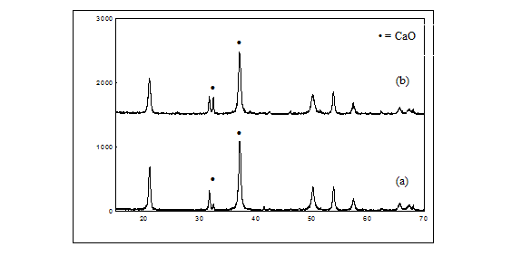
Intensity (a.u.)
2θ (degree)
Figure 4. XRD patterns of (a) calcined CCC (900 - 2h) and (b) calcined ES (950 – 2h)
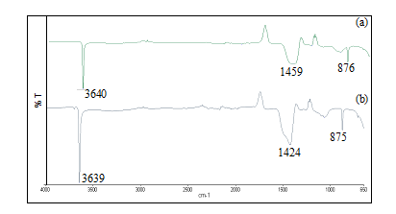
Figure 5. FTIR spectra of (a) calcined CCC (900 - 2h) and (b) calcined ES (950 – 2h)

Joshi et al. reported that peaks at 1424 cm⁻¹ and 1459 cm⁻¹ were broad and weak identifying reduced mass of the group CO₃²⁻ upon calcination at 900 °C. The trend is identical for this study, suggesting the samples have been transformed to CaO [15]. However, samples were not fully calcined. In order to further understand the main reason for the poorer adsorption capacity by ES comparatively to CCC even though the composition and level of calcination is alike, a detailed study on using XRF and EDX should be done. Impurities may exist in ES which causes a poorer adsorption.

Conclusion

The purpose of this study is to reutilize waste eggshell into an economic valuable product. The feasibility of ES to substitute limestone a depleting natural resource in flue gas desulphurization was tested. Results proved that ES can be used as a substitute of limestone for SO₂ removal. However, the capacity of removal was not as good as CCC. Even though the removal capacity was lower, the potential of ES to remove SO₂ was encouraging. The structure, surface area and functional groups of ES were also found to be like CCC. The most efficient calcined ES was found at 950°C for 2h. The adsorption capacity of the best calcined ES was 2.15mg/g. The surface area and crystallinity of the ES plays the major role in the adsorption of SO₂. This finding indicates that the CaO derived from the waste ES is attractive for the use as SO₂ sorbent due to its low cost (derived from waste), environmentally friendly and high removal capacity of SO₂.

Acknowledgement

The authors gratefully acknowledge the financial support from Universiti Tunku Abdul Rahman Research Fund (UTARRF 6200-S57).

References
- Liu, Y., Bisson, T. M., Yang, H. Q. and Xu, Z. H. (2010). Recent developments in novel sorbents for flue gas clean up. Fuel Processing Technology, 91: 1175 – 1197.
- Lawrence, K. W., Norman, C. P. and Hung, Y. T. (2005). Advanced air and noise pollution control. Handbook of Environmental Engineering. Humana Press Inc. New Jersey.
- Kallinikos, L. E., Farsari, E. I., Spatinos, D. N. and Papayannakos, N. G. (2010). Simulation of the operation of an industrial wet flue gas desulphuriztion system. Fuel Processing Technology, 91: 1794 – 1802.
- Li, J. J., Kobayashi, N. and Hu, Y. Q. (2008). The activated coke preparation for SO₂ adsorption by using flue gas from coal power plant. Chemical Engineering and Processing, 47: 118 – 127.
- Rubio, B. and Izquierdo, M. T. (2010) Coal fly ash based carbon for SO₂ removal from flue gases. Waste Management, 30: 1341 – 1347.
- Sumathi, S., Bhatia, S., Lee, K. T. and Mohamed, A. R. (2010). Adsorption isotherm models and properties of SO₂ and NO removal by palm shell activated carbon supported with cerium (Ce/PSAC). Chemical Engineering Journal, 162(1): 194 – 200.
- Sonenklar, C. (1999). Famous for eggwaste, penn state news. Access online http://news.psu.edu/ story/140891/1999/09/01/research/famous-egg-waste [ Date access 21st August 2016].
- Rohim, R., Ahmad, R., Ibrahim, N., Hamidin, N. and Abidin, C. Z. A. (2014). Characterization of calcium oxide catalyst from eggshell waste. Advances in Environmental Biology, 8: 35 – 38.
- Ho, W. F., Hsu, H. C., Hsu, S. K., Hung, C. W. and Wu, S. C. (2013). Calcium phosphate bioceramics synthesized from eggshell powders through a solid state reaction. Ceramic International, 39(6): 6467 –6473.
- Soares, M. R., Andrade, S. R., Martins, R. C., Quina, M. J. and Quinta-Ferreira, R. M. (2012). Organic biowastes blend selection for composting industrial eggshell by-product: Experimental and statistical mixture design. Water Science and Technology, 65(11): 1939 – 1945.
- Wei, Z., Xu, C. and Li, B. (2009). Application of waste eggshell as low-cost solid catalyst for biodiesel production. Bioresources Technology, 100(11): 2883 – 2885.
- Glatz, P., Miao, Z. and Rodda, B. (2011). Handling and treatment of poultry hatchery waste: Review. Sustainability, 3: 216 – 237.
- Oliveira, D. A., Benelli, P. and Amante, E. R. (2013) A literature review on adding value to solid residue: Eggshell. Journal of Cleaner Production, 46: 42 – 47.
- Cheremisinoff, P. N. (1993). Air pollution control and design for industry. New York.
- Joshi, G., Devendra, S. R., Bhawna Y. L., Kamal K. B., Pankaj K., Nayan K. and Sanjay K. (2015). Transesterification of jatropha and karanja oils by using waste egg shell derived calcium based mixed metal oxides. Energy Conversion and Management, 96: 258 – 267.
- Hu, G., Dam-Johansen, K., Wedel S. and Hansen, J. P. (2006). Review of the direct sulfation reaction of limestone. Progress in Energy and Combustion Science, 32: 386 – 407.
- Witoon, T. (2011). Characterization of calcium oxide derived from waste eggshell and its application as CO₂ sorbent. Ceramic International, 37: 3291 – 3298.
- Lin, R. B., Shih, S. M. (2003). Characterization of Ca(OH)₂/fly ash sorbents for flue gas desulphurization. Powder Technology, 131: 212 – 222.
- Piker, A., Tabah, B., Perkas, N. and Gedanken, A. (2016). A green and low-cost room temperature biodiesel production method from waste oil using egg shells as catalyst. Fuel, 182: 34 – 41.
- Gergely, G., Weber, F., Lukacs, I., Toth, A. L., Horvath, Z. E., Mihaly, J. and Balazsi, C. (2010). Preparation and characterization of hydroxyapatite from eggshell, Ceramic International, 36: 803 – 806.

