PHYSIOCHEMICAL CHANGES AND MASS BALANCE OF RAW AND ALKALINE PRE-TREATED OIL PALM FROND: PRESSED AND

NON-PRESSED SAMPLE

(Perubahan Fisiokimia dan Imbangan Jisim Pelepah Kelapa Sawit Asli dan Terawat Alkali: Sampel Perah dan Tidak Terperah)

Nurul Aina Fauzi¹, Shuhaida Harun^{1,2}*, Jamaliah Md Jahim^{1,2}

¹Department of Chemical and Process Engineering, Faculty of Engineering and Built Environment,
Universiti Kebangsaan Malaysia, 43600 Bangi, Selangor, Malaysia.
²Research Centre for Sustainable Process Technology (CESPRO),
Faculty of Engineering and Built Environment, Universiti Kebangsaan Malaysia,
43600 Bangi, Selangor, Malaysia

*Corresponding author: harun.shuhaida@ukm.edu.my

Abstract
Malaysia is the world second largest palm oil producer after Indonesia. Oil palm industry has generated approximately 83 million tonnes (wet weight) of Oil Palm Frond (OPF) annually from the production of crude palm oil and palm kernel oil. Thus, the abundantly available OPF as solid agrowaste is creating environmental problems and economically attractive approach is needed to effectively and efficiently utilize the OPF waste. In order to fully utilized OPF lignocellulosic biomass, the chemical composition in the oil palm frond fibre (OPFF) was quantified by conducted the standard Laboratory Analytical Procedure (LAP) developed by National Renewable Energy Laboratory (NREL). Alkaline pre-treatment by using sodium hydroxide (NaOH) was done toward the raw OPF (ROPF) as a step to breakdown the lignin structure and thus enhance the porosity of the biomass. This study also compares the physiochemical changes with mass balance for raw non-pressed OPF (RNPOPF), raw pressed OPF (RPOPF), pre-treated non-pressed OPF (PNPOPF) and pre-treated pressed OPF (PPOPF). Through this study, available sugar in the form of fresh juice obtained from pressing the ROPF contain 2.15 ± 0.01% glucose, 0.45 ± 0.02% sucrose and 0.10 ± 0.05% fructose. Meanwhile the RPOPF bagasse gave 61.42 ± 2.41% of total structural carbohydrate. RNPOPF fibre on the other hand gave 69.06 ± 1.50% of total structural carbohydrate on corrected dry weight basis. The physical morphological changes of each corresponding sample structure were viewed by using the scanning electron microscopy (SEM) analysis.
Keywords: Non-pressed oil palm frond, pressed oil palm frond, compositional analysis, NaOH pre-treatment, mass balance

Abstrak
Malaysia merupakan pengeluar minyak kelapa sawit kedua terbesar di dunia selepas Indonesia. Industri kelapa sawit menghasilkan sebanyak 83 juta tan (berat basah) pelepah kelapa sawit setiap tahun daripada pemprosesan minyak sawit mentah dan minyak isirong sawit. Dengan kehadiran besar jumlah pelepah kelapa sawit sebagai sisa buangan pepejal, ianya telah menyebabkan pencemaran alam sekitar dan langkah – langkah yang efektif serta sistematik secara ekonominya di perlukan untuk menggunakan sepenuhnya pelepah kelapa sawit ini. Dalam mengoptimumkan pengunaan lignosellulosa pelepah kelapa sawit, komposisi kimia yang terdapat di dalam fiber pelepah kelapa sawit (OPFF) ditentukan dengan menjalankan Prosedur Analitikal Makmal (LAP) yang dibangunkan oleh Makmal Tenaga di Perbaharui Kebangsaan (NREL). Pra-rawatan alkali dengan menggunakan natrium hidroksida (NaOH) dilakukan terhadap sampel mentah sawit (ROPF) sebagai satu langkah untuk memecahkan struktur lignin dan meningkatkan bukaan liang sampel. Kajian ini membandingkan juga perubahan fisiokimia dengan keseimbangan jisim untuk pelepah kelapa sawit mentah tidak terperah (RNPOPF), pelepah kelapa sawit mentah terperah (RPOPF), pra-rawat pelepah kelapa sawit tidak terperah (PNPOPF) dan juga pra-rawat pelepah kelapa sawit terperah (PPOPF). Melalui kajian ini, gula yang terdapat di dalam bentuk jus segar daripada memerah pelepah kelapa sawit mentah (ROPF) mengandungi 2.15 ± 0.01% glukosa, 0.45 ± 0.02% sukrosa dan juga 0.10 ± 0.05% fruktosa. Sementara itu, hampas RPOPF memberikan 61.42 ± 2.41% keseluruhan struktur karbohidrat. Fiber RNPOPF pula memberikan 69.06 ± 1.50% keseluruhan struktur karbohidrat pada berat kering. Perubahan morfologi fizikal untuk setiap struktur sampel dilihat dengan menggunakan analisis mikroskop imbasan elektron (SEM).
Kata kunci: pelepah kelapa sawit tidak terperah, pelepah kelapa sawit terperah, analisis komposisi, pra-rawatan NaOH, keseimbangan jisim

Introduction
Lignocellulosic biomass consisting forestry, agricultural and agro-industrial wastes are abundant, renewable and inexpensive energy sources [1]. Lignocellulosic biomass consists of cellulose, hemicellulose and lignin. The lignocellulosic chemical properties of the components make them a substrate of enormous biotechnological value [2]. Such well-known waste around the globe is sawdust, poplar trees, sugarcane bagasse, switchgrass, corn stover and others. In Malaysia, the palm oil industry is well-known generating abundant of biomass throughout the year comprising of oil palm fronds (OPF), oil palm trunks (OPT), empty fruit bunches (EFB), palm kernel shell (PKS), mesocarp fibre (MF) and palm oil mill effluent (POME) [3].

Among the solid biomass, OPF contributes the largest portion which makes up to 70% of the total residues generated from palm oil industry. Global production of oil palm fronds is estimated to be 250 million metric ton, MMT (wet weight) per annum and believe to show a corresponding increase soon [4, 5]. As the world’s second largest palm oil producer, OPF waste is generated abundantly daily during pruning for harvesting fresh fruit bunch (FFB) at minimal cost in terms of cropping practice, collection and storage [6]. It is estimated that per each ton of fresh fruit bunch harvested, one ton of fresh OPF is removed from the oil palm trees [7].

OPF contain high cellulose content that can be converted into fermentable sugars and subsequent value-added products. Production of fermentable sugars from OPFF has been recently reported by Goh et al. [4] and Fazilah et al. [8]. The entrapped structural carbohydrate in the form of cellulose by lignin required pre-treatment process in order to break down the lignocellulose complex structure, reduce the lignin content, cellulose crystalinity and increase the available surface area for enzymatic process in production of high yield of bio-sugar. However, Zahari et al. [9] found out that sugar can easily be obtained from OPF by pressing the fresh OPF using the sugarcane machine to obtain the readily soluble sugar in the form of fresh OPF juice. This process is crucial to identify whether the squeeze juice caused high percentage of sugar loss from the OPF bagasse or vice versa. Thus, RNPOPF was set as the standard for the whole composition of the ROPF.

This study has four main objectives which are to provide the chemical composition data for RPOPF, RNPOPF, PNPOPF and PPOPF, (b) analyze the alkaline pretreatment using NaOH in helping breaking down the lignin content as well as maintaining the cellulose and hemicellulose content, (c) determine which processing route could provide higher amount of sugar through a few key processes applying mass balance scheme and (d) view physical changes that occur to each OPFF sample through SEM analysis.

Materials and Methods
Type of biomass
Raw Non - Pressed OPF (RNPOPF)
Rachis
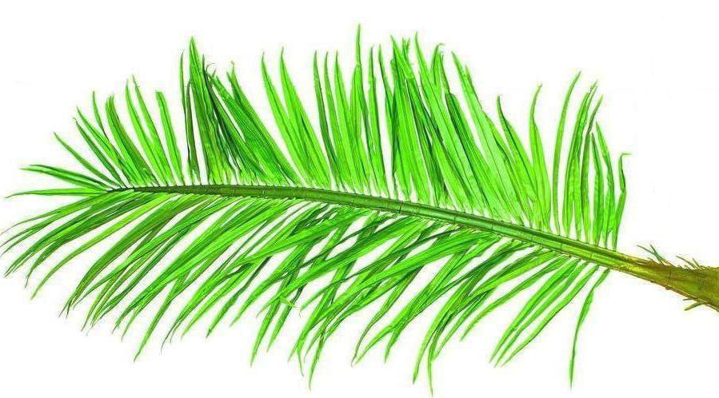
Leaflet

Stem
Petiole

Figure 1. Main part of oil palm frond

Several fresh OPF branches (Figure 1) without leaflet were collected from the oil palm plantation at Universiti Kebangsaan Malaysia (UKM) Bangi Lama, Selangor, Malaysia. The leaflet parts were left in the oil palm plantation as natural fertilizer and soil conservation. The freshly harvested OPF were cut into 1 meter length consisting OPF basal part (petiole) as shown in Figure 1. The fresh OPF were chopped again into pieces and directly dried under the sun for 2 days before grounded by using the grinder (Pulviresette 19, Fritsch, Germany) and sieved to a particle size of 2 mm. The moisture content of dried RNPOPF were previously tested with moisture analyzer (IR35M, Denver Instrument, Germany) and later packed in sealed plastic bags when the moisture content was below than 10%. The samples then were stored in the -40 ºC freezer (So-Low) upon used.

Pressed OPF
Approximately 1 meter length basal part (petiole) of fresh OPF were cut into few pieces and later were pressed by using a conventional sugarcane machine (SCM, 6.5HP Elephant) to extract the juice. The OPF juice were filtered by using the muslin cloth and the obtained juice were directly test for pH by using the pH meter (Eutech Instruments) and determine its sugar composition by using the High Performance Liquid Chromatography (HPLC) [9]. Meanwhile, the bagasse obtained in this process undergoes the same drying, grinding and sieving process to 2 mm particle size as described earlier. The sieved bagasse also packed in the sealed plastic bags and stored in the freezer upon used.

Characterization of oil palm frond fibre
Compositional analysis for OPFF was done following the Laboratory Analytical Procedure (LAP) developed by National Renewable Energy Laboratory (NREL). Through biomass characterization, NREL develop, refine and validate rapid and cost-effective method to determine the basic chemical composition of the lignocellulosic biomass. Compositional data obtained by using this method include ash content, water-soluble extractives including monomeric and oligomeric sugar, ethanol extractive, structural carbohydrate acid-insoluble (Klason) lignin and acid-soluble lignin [10].

Determination of moisture content
The percentage moisture contained in the OPFF was measured by using the moisture analyzer (IR35M, Denver Instrument, Germany).

Determination of ash content
OPFF of 1.2 ± 0.2 g was weighed into three empty porcelain crucibles and allowed to burn over the flame until there was no more smoke or flame present in the porcelain crucibles. Later, the porcelain crucibles were placed in the muffle furnace at 575 ± 25°C for 24 hours. Each sample were done triplicate [10].

Extraction procedure
Two-step soxhlet extraction (Favorit) was performed. The OPFF sample was extracted using deionized (DI) water followed by ethanol as the solvent. In the first step of analysis, the extraction of water-soluble compound was carried out using 190 mL of deionized water for 10 hours. Upon completion, the extraction thimble containing OPFF was carefully removed from the extraction set and dried in the oven (Venticell) overnight. The ethanol extraction was then performed on the same extraction thimble containing the previous extracted OPFF using 190 mL of 95% ethanol for 10 hours to remove chlorophyll, waxes and another minor component [11].

Determination of soluble and oligomeric sugar
Liquid sample obtained from the water extraction was used to determine the soluble sugar such as glucose, sucrose and fructose by using High Performance Liquid Chromatography (HPLC). In order to determine the total oligomers in the liquid sample, 2 mL of liquid sample was added with 69.7 µL of 72% H₂SO₄ and sample was run in triplicate in 10 mL HACH tubes [9, 10]. The tubes were then autoclaved for 1 hour at temperature set 121 ºC.

Determination of total structural carbohydrate
Acid hydrolysis by using 0.3g of extracted OPFF added with 3 mL of a 72% (w/w) H₂SO₄ in a screw-capped bottle was carried out. Triplicate samples of the process then were placed in the incubator shaker (Infors MT Ecotron) at 30 ºC and 150 rpm. Upon completion, 84 mL of deionized water was added to dilute the acid to a final concentration of 4% (w/w). The mixture was then autoclaved for 1 hour at 121 ºC [12]. The liquid sample obtained was then quantified by using HPLC. Sugar recovery standard containing known sugar concentration were also prepared in parallel to estimate post-hydrolysis losses [13].

Determination of lignin content
Lignin content both soluble and non-soluble was determined using the acid hydrolysate from (v). The autoclaved acid hydrolysate was then filtered by using Whatman No.1 filter paper. The solid residue remaining after the acid hydrolysis was dried overnight in the oven to a constant weight and later was weighed to quantify the acid-insoluble (Klason) lignin. The liquid obtained from the filtration was used to determine the acid soluble lignin using UV-VIS spectrophotometer (Lambda 35, PerkinElmer, Massachusetts, USA). Sum of acid-insoluble (Klason) lignin and acid-soluble lignin accounted for the total lignin content in the OPF fibre [10].

NaOH pre-treatment
NaOH pre-treatment of OPFF were carried out on both RNPOPF and RPOPF by using optimized conditions from previous study by Mohd Shukri et al. [14] where the conditions for the pre-treatment process were found optimum at 4.42% NaOH concentration, temperature of 100 ºC, 58.31 min of pre-treatment time and 0.15g/mL constant biomass loading to solvent volume. However, modification was made in this study for the biomass loading to solvent volume. The ratio of biomass loading to solvent volume chosen was 1 to 10 (w/v) adjusted due to the different particle size of the OPFF. The pre-treatment of the OPFF were carried out in screw cap bottles with the cap of the bottles slightly loose [15]. Sample were heated by using above conditions in a shaking water bath (Wise Bath, Lab Companion) at 50 rpm. After the pre-treatment reaction, the samples were filtered by using muslin cloth to separate the insoluble biomass fibre (pretreated OPFF) and the soluble fraction (black liquor). PNPOPF and PPOPF were washed with deionized (DI) water until it reached the neutral pH. Later, the pre-treated and washed OPFF was dried in the oven at 45 ºC until the moisture content reached 10% or below. The dried pre-treated OPFF was then undergo the same characterization process by using the NREL protocol as prescribe above to determined its lignin, cellulose and hemicellulose composition. Any changes between the raw and pre-treated OPFF were recorded in percentage. Meanwhile, for the soluble fraction (black liquor) were stored in the -40 ºC freezer for further analysis.

High performance liquid chromatography analysis: Fresh oil palm frond juice
Fresh OPF juice was filtered through 0.22 µm nylon syringe filter into the HPLC vials and determined its sugar content. The entire liquid sample together with calibration sugar standard was run by using the HPLC (Thermo Scientific Dionex - Ultimate 3000) employing the Rezex RPM (Phenomenex, USA) with a Refractive Index (RI) detector operated at 60 ºC. The mobile phase used was filtered and degassed deionized water at a flow rate of 0.6 mL/min. The component was identified by comparing their retention time with calibration sugar standard. The concentration of soluble sugar was also determined based on the calibration sugar standard [13, 16].

Composition in liquid sample
Liquid samples obtained in water extractives were determined directly by using HPLC. Meanwhile, the oligomeric and acid hydrolysate samples were neutralized to pH 5 - 6 by using the calcium carbonate were added slowly upon reaching pH 4. Samples then were swirl frequently. After reaching pH 5 – 6, samples were allowed to settle and decant off the clear liquid. The pH value of the liquid after settling was adjusted approximately pH 7. The liquid then was filtered through 0.22 µm nylon syringe filter into HPLC vials [10]. The HPLC condition in running the samples was similar as described earlier.

Physical characterization: Scanning electron microscopy analysis
Scanning electron microscopy (SEM) was conducted to view and compare the internal structural changes and surface characteristics between RNPOPF, RPOPF, PNPOPF and PPOPF. A sample of raw OPFF was prepared by attaching it on a specimen stub. Sample was sputter-coated with gold (Au) prior to imaging with a scanning electron microscope [14].

Mass balance around sample preparation
During sample preparation for RNPOPF and RPOPF, losses of water and losses of fibre were compiled at all streams when possible at each key process such as drying, grinding, sieving and pressing.

Results and Discussion
Chemical composition comparison for RNPOPF and RPOPF
As processing the OPF was different from the beginning, the composition of the processed OPF was also different. The comparison of chemical composition on corrected basis (dry weight) for both RNPOPF and RPOPF fibre was tabulated in Table 1. As prescribe above, in chemically characterize OPFF according to the NREL protocol, the first step was to extract the OPFF by using DI water followed by sequential extraction using 95% ethanol. The purpose of extracting the OPFF by using DI water was to remove inorganic materials, non-structural sugars soil and proteins while ethanol extraction step remove waxes, chlorophyll and phenolic compound [11]. From the process, total extractive which was the summative of water and ethanol extraction gain for both RNPOPF and RPOPF shows a close amount with 2.15 ± 0.65% and 1.95 ± 0.16%. Removal of these residual ensures that the biomass was residual-free and contained only structural carbohydrate and lignin [11].

The total structural carbohydrate on RNPOPF fibre accounted higher percentage compared to the RPOPF fibre. RNPOPF fibre contains 49.76 ± 1.10% glucan as the major component in the cellulose and the main C5 structural carbohydrate was made up of 16.90 ± 0.88% xylan and 2.40 ± 0.51% arabinan. In comparison to NPOPF fibre, RPOPF fibre accounted 46.10 ± 2.23% for glucan, 15.32 ± 0.91% for xylan and a small amount of arabinan that was appropriate to be neglected due to a very tiny percentage. As shown in the Table 1, slight reduction in the total structural carbohydrate composition of RPOPF fibre could be seen compared to the RNPOPF fibre. This could be best explained due to the soluble sugars that have been squeeze out in the form of juice during the pressing method. The total amount of pressed juice was 2.70% with soluble glucose of 2.15%, soluble sucrose of 0.45% and soluble fructose for 0.10%. As the percentage of juice is only 2.70 ± 0.05% which is small, the difference between the values of total structural carbohydrate in the structural carbohydrate of RPOPF fibre was significant.

Table 1. Chemical composition of oil palm frond fibre

Component | Composition of OPF  (results expressed as a percentage of the oven-dried)
Component | RNPOPF | PNPOPF | RPOPF | PPOPF
Structural Constituent  1. Total Structural Carbohydrates | 69.06 ± 1.50 | 65.36 ± 1.76 | 61.42 ± 2.41 | 53.64 ± 3.00
Glucan | 49.76 ±1.10 | 60.86 ± 1.71 | 46.10 ± 2.23 | 48.28 ± 2.56
Xylan | 16.90 ± 0.88 | 4.5 ± 0.43 | 15.32 ± 0.91 | 5.36 ± 1.56
Arabinan | 2.40 ± 0.51 | NA | NA | NA
2. Total lignin | 22.31 ± 0.29 | 18.99 ±1.26 | 23.55 ± 3.65 | 22.33 ± 0.78
Acid Soluble Lignin | 5.20 ± 0.29 | 2.28 ± 1.01 | 5.34 ± 0.52 | 5.07 ± 0.13
Acid Insoluble Lignin | 17.11 ± 0.01 | 16.71 ± 0.76 | 18.21 ± 3.61 | 17.26 ± 0.77
Non-Structural Constituent | 3.86 ± 0.65 | 4.41 ± 6.70 | 3.38 ± 0.23 | 4.32 ± 0.86
1. Ash | 1.71 ± 0.04 | 0.03 ± 0.02 | 1.43 ± 0.16 | 0.03 ± 0.01
2. Extractives | 2.15 ± 0.65 | 4.38 ± 6.70 | 1.95 ± 0.16 | 4.29 ± 0.86
Total Chemical Composition (%) | 90.37 | 88.76 | 88.35 | 80.29

NA denotes not available

The total lignin content is the summation of both acid soluble lignin and acid insoluble lignin. Lignin is also the major building blocks in the lignocellulosic biomass. Thus, the total lignin percentage is important to be determined in the raw sample. The total lignin composition for RNPOPF fibre is 22.31 ± 0.29% and 23.55 ± 0.52% for RPOPF fibre. The ash content in the RNPOPF fibre is 1.71 ± 0.04% and the ash content in the RPOPF fibre is 1.43 ± 0.16%. Summation of RNPOPF shows a total composition of 90.37% and RPOPF shows 88.35% of total composition. The reduction in the total composition of RPOPF suffers from the juice pressing where some soluble sugars are squeeze out. Also, each batch of ROPF shows different chemical composition percentage on its component due to different maturity level even it is harvested at the same location. These considerable concern could be best explain why there are varied value in the composition of the RNPOPF and RPOPF fibre especially lignin and the extractive content where the ratios from one plant species to another also vary with concern to age, stage of growth and other conditions [14].

Chemical composition comparison for PNPOPF and PPOPF
Alkaline pre-treatment is a widely-used method in removing lignin and hemicellulose from lignocellulosic materials and disperse bulk lignocellulosic materials into lignocellulosic fibre. Various alkaline reagents such as NaOH, Ca(OH)₂ KOH, Na₂CO₃ and aqueous ammonia have been used to pre-treat lignocellulosic materials. Among these alkaline reagents, NaOH are commonly used. This study also employs alkaline pre-treatment by using optimized condition for the alkaline process from previous study [14]. To prove that the chosen pretreatment process benefits further process later, chemical composition on PNPOPF and PPOPF also undergoes chemical analysis according to the NREL protocol. As clearly tabulated in Table 1, alkaline pre-treatment by using NaOH on both type of fibre shows good results as the glucan composition increased to 60.86 ± 1.71% of PNPOPF fibre and 48.48 ± 2.56% for PPOPF fibre. About 20% increment of glucan composition were obtained for the PNPOPF fibre from the pre-treatment process and almost 5% increment was calculated for the PPOPF fibre glucan composition. This is best explained due to the high temperature alkaline process that breaks down lignin and hemicelluloses into soluble fragments and makes expose cellulose more thus increasing the glucan composition.

The cleavages of hemicellulose and lignin linkages under high temperature during the alkaline pre-treatment process significantly promote the solubilization of hemicellulose and lignin thus decreasing the hemicellulose and lignin content in all case [17]. The theory is found reasonable with the hemicellulose composition in the PNPOPF fibre which previously contains xylan and arabinan in the raw sample but after pre-treatment process contain only xylan with 4.5 ± 0.43%. In the case of PPOPF fibre, the xylan composition also shows a significant decrement with only 5.36 ± 1.56% left. High solubilization amount of xylan with over than 65% for both pret-reated OPFF were recorded in this study. In the case of arabinan composition in PNPOPF fibre, it is concluded to be completely solubilized during the pre-treatment process under the alkaline conditions. The solubilized content may contain acetyl group of hemicellulose such as acetic acid and phenol groups by the lignin based on the black color of the filtrate or black liquor [18].

The alkaline pre-treatment was changing the OPFF chemical composition. With the aim to caused swelling or/and breaks down the cellulose structure, reduce cellulose crystallinity and to increase the OPFF porosity, another important purpose with the alkaline pre-treatment is to reduce the lignin content called delignification. In this study, delignification does occur but only in a small percentage for both acid soluble lignin and acid insoluble lignin. The total lignin of PNPOPF fibre was decreased to 18.99 ± 1.26% from 22.31 ± 0.29% of raw composition. For the case of PPOPF fibre, the total lignin content also did not show much decrement from 23.55 ± 3.65% to only 22.33 ± 0.78%. Behind the occurrence, Agbor et al. [19] explained that not all pre-treatments result in substantial delignification, the structure of lignin may be altered without extraction due to changes in the chemical properties of the lignin and cause the pretreated biomass becomes more digestible than the raw biomass even though it may have approximately the same lignin content as raw biomass.

The extractives content in both type of OPFF increased due to the pretreatment process that exposure the lignocellulosic biomass more extractable than the raw sample. The ash content shows a large decreasing percentage after pre-treatment due to the silica body is solubilized in the filtrate.

Pre-treatment influence on internal structure changes of OPFF

Physical pre-treatment was introduced to both RNPOPF and RPOPF through chopping and grinding of the fibre where this process can reduce the particle size to 0.2 – 2 mm. the particle size (2 mm) was chosen in this study since reduction of biomass particle size below 0.4 mm shows only little effect on hydrolysis yield as stated by Chang et al. [20]. Figure 2(a) of RNPOPF fibre displays flat, smooth and undamaged surface [21]. This shows that only small effect took place on the fibre through the grinding process when viewed through scanning electron microscope. Compared to Figure 2(c), the raw pressed OPF fibre shows impressive structural changes due to previously undergone pressing process followed by grinding process. In Figure 2(c) completely smooth, rigid and highly ordered fibrils can be seen on the fibre internal surface [22].

The structure of NaOH pre-treated OPFF were analyzed further where it was noticeably changed. In the case of the undamaged and flat surface of RNPOPF fibre, there were noticeable irregular cracks occur on the structure surface of PNPOPF fibre as shown in Figure 2(b). However, in the case of RPOPF fibre, the initially organized fibrils in untreated sample (Figure 2(c)) were destroyed where the structure becomes thinner, striated and loosened as clearly shows in Figure 2(d). The SEM morphological analysis on OPFF in this study was good agreement with previous study by Mohd Shukri et al. [14].

The physical pre-treatment on the OPFF plays important role in helping chemical pre-treatment to further increase the available specific surface area, reduce both the degree of polymerization (DP) and cellulose crytallinity [19]. As clearly observed under the SEM analysis, PNPOPF fibre (Figure 2(b)) and PPOPF fibre show a significant difference (Figure 2(d)). To conclude, these structure alterations will further process later.

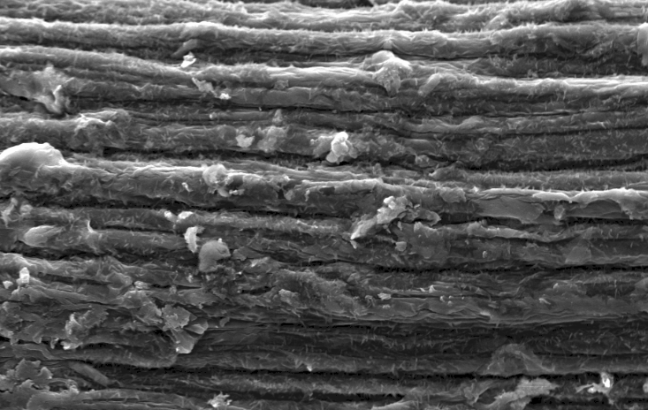  (a) | 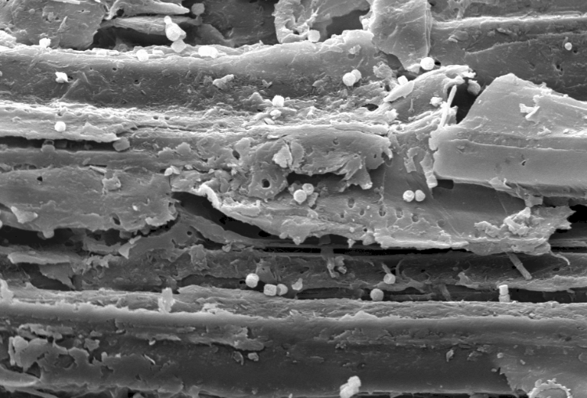  (b)
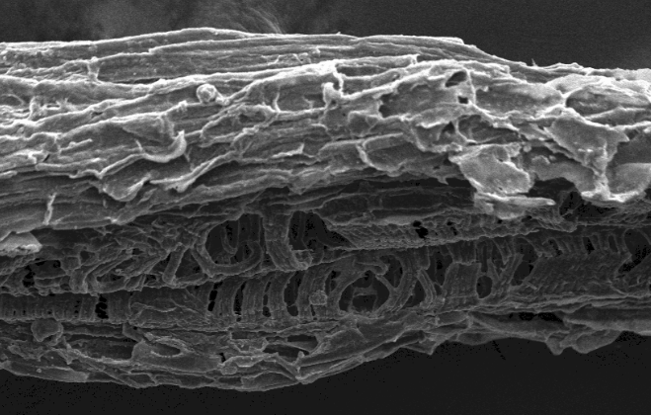  (c) | 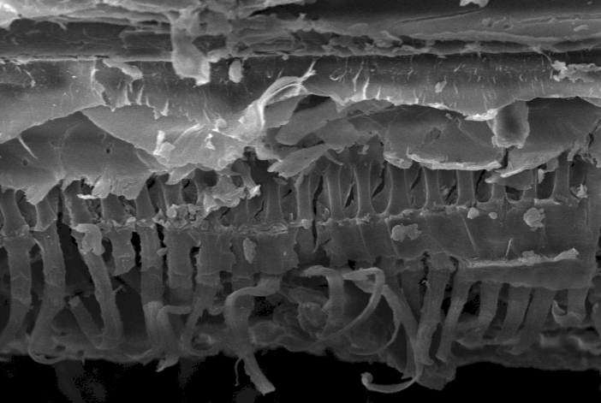  (d)

Figure 2. SEM analysis (1000x magnification) on physical changes of (a) RNPOPF, (b) PNPOPF, (c) RPOPF and (d) PPOPF

Mass balance comparison for RNPOPF & RPOPF around sample preparation
A mass balance which also called a material balance is an application of conservation of mass to the analysis of physical systems. By accounting the material entering and leaving the system, mass flows can be identified which might have been unknown or difficult to measure without this technique. In this study, in order to choose the best method in processing OPF as OPF is bulky in size, a scheme of different routes of processing the OPF was draw through the mass balance method as in Figure 3. The mass balance scheme shows the total mass balance around sample preparation on dry weight basis for both RNPOPF (Route 1) and for RPOPF (Route 2) according to its corresponding process. This method was applied based on tracking the losses of fibre and/or water as these are the key system components and the losses was compiled for all streams when possible [12]. If the process yield is calculated based on the initially harvested OPF without taking into account any water and/or fibre losses at each process, the results will be erroneous.

For the total mass balance of RNPOPF (Route 1), the process started with harvesting the OPF at 1 meter basal part of the petiole. The total mass of freshly harvested OPF was weighed and the moisture content also was recorded. The mass and moisture content of the freshly harvested OPF at the beginning is vital to be recorded as it will serve as the basis/reference along the sample preparation process pathway. As the OPF mostly the basal part is bulky and the moisture content is high with 70.13%, chopping the OPF is the effective way prior to drying process. The chopping process caused slight water losses which is less than 1% due to surrounding. Meanwhile, 0.02 kg (DWD) OPFF losses due to the chopping process. The chopped OPF was then dried under the sun for a whole day where the moisture content found decreased until 31.89%. From the sun-drying process alone, the water losses recorded were as high as 54. 03%. However, the moisture content/water content is still high with 31.89% and it is not appropriate to keep the sun-dried sample in the plastic bag at ambient temperature due to growth of fungus which later could deteriorate the sun-dried OPF. On the other hand, storing the sample at cold room will only increase the moisture content due to high humidity environment. Thus, second day of drying was done towards the RNPOPF fibre and the process seems effective with the moisture content later found to be 12.83%. Losses of fibre along the process cannot be avoided, and dried OPF by sun-drying have caused fibre losses due to the windy weather which blown the fibre easily as the drying process was carried out at open space. The dried OPF with 2.94kg was further processed by ground it into 2mm particle size.

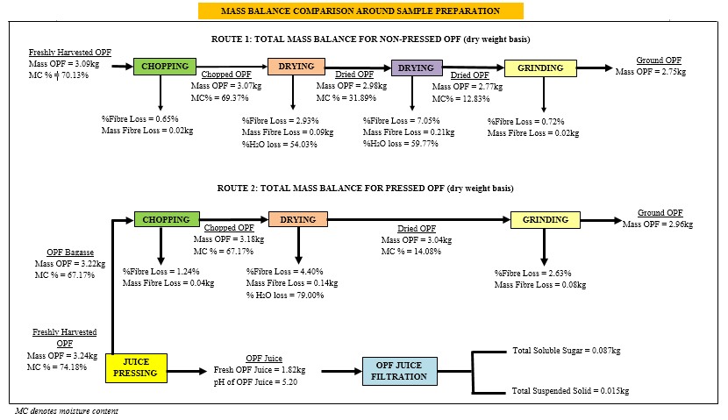

Figure 3. Mass balance comparison around sample preparation of non-pressed and pressed OPF

For RPOPF (Route 2), the first step also begins with harvesting the 1 meter basal part of OPF petiole and the total mass and its moisture content were recorded. The total mass of freshly harvested OPF is 3.24 kg of dry weight basis and the moisture content is 74.18%. The freshly harvested OPF later was pressed with sugarcane machine to extract the OPF juice. From the juice pressing process, this step produced 1.82 kg OPF juice with pH of 5.20. The freshly obtained OPF juice was filtered to remove foams/filtrate and the total OPF juice obtained is 0.087 kg. The filtered OPF juice contains high amount of readily soluble sugars such as glucose (38.88g/L), sucrose (8.11 g/L) and fructose (1.75 g/L). Apart from juice, the juice pressing step also produced OPF bagasse which this bagasse later follows the same processing step as in Route 1. Prior to chopping the OPF bagasse, the moisture content drop to 67.17% due to high amount of OPF juice have been squeezed out that results in decreasing of the water content in the bagasse. The OPF bagasse later was dried under the sun for a day and the moisture content drop to 14.08%. RPOPF bagasse as it is in shredded feature after pressing process took only shorter drying period compare to the RNPOPF fibre. Grinding process follows with dried OPF bagasse. Ground OPF bagasse also is easier compared to RNPOPF fibre. The sieving process to 2 mm particle size took place after ground and the final mass total mass is 2.90 kg.

Physically observed, RNPOPF and RPOPF have different moisture content value which was 70.13% and 74.18%. Both freshly harvested OPF were taken from the same location but from a different oil palm tree and at different period. This could describe why the mass and moisture content of OPF were different. However, the initial moisture content was comparable with Zahari et al. [9] which were 70% and 77% moisture, respectively. Further, RNPOPF took longer processing time due to its bulky feature which is drying step was carried out twice as shown in Route 1. Meanwhile, RPOPF bagasse as it is in shredded feature after pressed took shorter drying period and easier to process. In addition, pressed OPF did not cause much trouble when ground to 2mm particle size. The major problem arise during the grinding process for RNPOPF is that the outer layer of the OPF petiole is hard which causes the ground process delayed a few times frequently due to the fibre stuck inside the grinding machine. This problem does not occur with pressed OPF bagasse as the outer layer of the OPF petiole is crushed and shredded completely during pressing. Thus, based on observation made, RPOPF is easier and faster to handle compared to RNPOPF.

Conclusion
The characterization of raw OPFF and pre-treated OPFF for both the non-pressed and pressed sample were presented in this study. Even though the OPF were processed in a different way, the chemical composition in the raw sample showed only marginal difference where the chemical composition in the RNPOPF was 90.37% meanwhile 88.76% for RPOPF. The reduction in RPOPF composition suffers from the total structural carbohydrate component where a small portion of juice in the RPOPF was pressed out in the form of readily soluble sugars. The raw sample later when pre-treated by using NaOH shows increment and decrement percentage in their composition. The NaOH pre-treatment process was proven successful as it increases the percentage of glucan in both pre-treated sample. Through SEM analysis, the physical structure of the raw and pre-treated samples shows some noticeable alterations on the sample internal surface which support the chemical composition data in this study. Initially, there was a doubtful theory in whether the chemical composition of the POPF would left a significant difference compared to NPOPF chemical composition that lead to the schematic mass balance process be developed in this study. Thus, the two different processing routes around sample preparation were studied. Through the characterization data, the RPOPF total chemical composition shows less than 10% difference than RNPOPF and it is appropriate to conclude that RPOPF is chosen to be carried out in next desired process as its shredded bagasse properties is easier to process and the losses of sugar were little with the pressed OPF juice can be utilized straightly into fermentation process.

Acknowledgements
This research is funded by the Ministry of Higher Education, Malaysia under LRGS/2013/UKM-UKM/PT/01 on project entitled “Biochemical Platform for Conversion of Diversified Lignocellulosic Biomass to Priceless Precursor and Biobased Fine Chemicals” and the author gratefully acknowledge the chemical and process engineering department for the great opportunity and financial support of this work.

References

- Musatto, S. I. and Teixera, J. A. (2010). Lignocellulose as raw material in fermentable processes. Current Research, Technology and Education Topics in Applied Microbiology and Microbial Biotechnology, 2: 897 – 907.
- Malherbe, S. and Cloete, T. E. (2003). Lignocellulose biodegradation: Fundamentals and applications. Reviews in Environmental Science and Biotechnology, 1: 105 – 114.
- Abdullah, S. S. S., Shirai, Y., Bahrin, E. K. and Hassan, M. A. (2015). Fresh oil palm frond juice as a renewable, non-food, non-cellulosic and complete medium for direct bioethanol production. Industrial Crops and Products, 63: 357 – 361.
- Goh, C. S., Tan, K. T., Lee, K. T. and Bhatia, S. (2010). Bio-ethanol from lignocellulose: Status, perspectives and challenges in Malaysia. Bioresource Technology, 101(13): 4834 – 4841.
- Malaysian Palm Oil Board (2009). Monthly fresh fruit bunches received by mills: 2008 (Tonnes). Acess online from http://econ.mpob.gov.my/economy/annual/stat2008/pdf. Accessed date August 2015.
- Howard, R. L., Abotsi, E., Van Rensburg, E. J. and Howard, S. (2003). Lignocellulose biotechnology: Issues of bioconversion and enzyme production. African Journal of Biotechnology, 2(12): 602 – 619.
- Malaysian Palm Oil Council (2010). Palm oil: A success story in green technology innovations, Acess online from: http://www.akademisains.gov.my/download/asmic/asmic2010/Plenary12.pdf. Accessed date 27 August 2015.
- Fazilah, A., Mohd Azemi, M. N., Karim, A. A. and Norakma, M. N. (2009). Physicochemical properties of hydrothermally treated hemicellulose from oil palm frond. Journal of Agricultural and Food Chemistry, 57(4): 1527 – 1531.
- Zahari, M. A. K. M., Zakaria, M. R., Ariffin, H., Mokhtar, M. N., Salihon, J., Shirai, Y. and Hassan, M. A. (2012). Renewable sugars from oil palm frond juice as an alternative novel fermentation feedstock for value-added products. Bioresource Technology, 110: 566 – 571.
- Sluiter, A., Hames, B., Ruiz, R., Scarlata, C., Sluiter, J. and Templeton, D. (2006). Determination of sugars, byproducts, and degradation products in liquid fraction process samples. Golden: National Renewable Energy Laboratory.
- Tan, H. T., Lee, K. T. Lee and Rahman, M. (2011). Pretreatment of lignocellulosic palm biomass using a solvent-ionic liquid [BMIM]CI for glucose recovery: An optimization study using response surface methodology. Carbohydrate Polymers, 83: 1862 – 1868.
- Garlock, R. J., Balan, V., Dale, B. E., Pallapolu, V. R., Lee, Y. Y., Kim, Y., Mosier, N. S., Ladisch, M. R., Holtzapple, M. T., Falls, M. and Sierra-Ramirez, R. (2011). Comparative material balances around pretreatment technologies for the conversion of switchgrass to soluble sugars. Bioresource Technology, 102(24): 11063 – 11071.
- Yang, Q. B and Wyman, C. E. (2010). Xylooligomers are strong inhibitors of cellulose hydrolysis by enzymes. Bioresource Technology, 101(24): 9624 – 9630.
- Mohd Sukri, S. S., Rahman, A., Md Illias, R. and Yaakob, H. (2014). Optimization of alkaline pretreatment conditions of oil palm fronds in improving the lignocelluloses contents for reducing sugar production. Romanian Biotechnological Letters, 19 (1): 9007 – 9018.
- Saifuddin, N. M., Palanisamy, K. and Hussain, R. (2013). Microwave-assisted alkaline pretreatment and microwave assisted enzymatic saccharification of oil palm empty fruit bunch fiber for enhanced fermentable sugar yield. Journal of Sustainable Bioenergy Systems, 3(1): 7 – 17.
- Abdul, P. M., Harun, S., Md Jahim, J., Markom, M. and Hassan, O. (2011). Effect of column's temperature and evaluation of RID and ELSD as suitable ion exchange HPLC detection method of simple sugars. Journal of Science and Technology, 2011: 599 – 604.
- Sun, S., Sun, S., Cao, X. and Sun, R. (2016). The role of pretreatment in improving the enzymatic hydrolysis of lignocellulosic biomass. Bioresource Technology, 199: 49 – 58.
- Aisyah, M. S, Uemura, Y. and Yusup, S. (2014). The effect of alkaline addition in hydrothermal pretreatment of empty fruit bunhes on enyzmatic hydrolysis efficiencies. Procedia Chemistry, 9: 151 –157.
- Agbor, V. B., Cicek, N., Sparling, R., Berlin, A. and Levin, D. B. (2011). Biomass pretreatment: Fundamentals toward application. Biotechnology Advances, 29(6): 675 – 685.
- Chang, V. S., Burr, B. and Holtzapple, M. T. (1997). Lime pretreatment of switch grass. Applied Biochemistry and Biotechnology, 63: 3 – 19.
- Ilgook, K. and Han, J. I. (2012). Optimization of alkaline pretreatment conditions for enhancing glucose yield of rice straw by response surface methodology. Biomass and Bioenergy, 46: 210 – 217.
- Lai, L. W. and Idris, A. (2013). Disruption of oil palm trunks and fronds by microwave-alkali pretreatment. Bioresources, 8(2): 2792 – 2804.

