THE MORPHOLOGICAL PROPERTIES STUDY OF PHOTOCATALYTIC TIO₂/PVDF DUAL LAYER HOLLOW FIBER MEMBRANE FOR ENDOCRINE DISRUPTING COMPOUNDS DEGRADATION

(Kajian Sifat Morfologi Membran Fotopemangkin Gentian Berongga Dwi Lapisan TiO₂/PVDF untuk Penguraian Sebatian Pengganggu Endokrin)

Roziana Kamaludin¹, Mohd Hafiz Dzarfan Othman¹*,Siti Hamimah Sheikh Abdul Kadir²,
Mukhlis A Rahman¹, Juhana Jaafar¹

¹Advanced Membrane Technology Research Centre (AMTEC),
Universiti Teknologi Malaysia, 81310 Skudai, Johor.
²Institute of Medical Molecular Biotechnology, Faculty of Medicine, Sungai Buloh Campus, Universiti Teknologi MARA (UiTM), Jalan Hospital, 47000, Sungai Buloh, Selangor, Malaysia

*Corresponding author: hafiz@petroleum.utm.my

Abstract
Various Endocrine Disrupting Compounds (EDCs) either natural or synthetics have been identified including bisphenol A (BPA), dioxin, polychlorinated biphenyls, and dichlorodiphenyltrichloroethane (DDT). These compounds which present widely in the product of solvent industry, agricultural, pharmaceuticals and household convenience may directly or indirectly interrupt the normal function of endocrine system. Recently, the EDCs threats to human health have led to the increasing demand of clean water sources which excites a challenge for the contaminants removal processes. Conventional treatment methods may not completely remove the contaminants, meanwhile advanced oxidation process (AOPs) especially photocatalysis have been proven efficient in removing the contaminants. Even though photocatalysis is efficient in suspension of either nano- or microscale, the immobilizing TiO₂ in the membrane matrix for catalyst separation purposes have decreased the adsorption of organic substances on the TiO₂ surface with potential loss of TiO₂ during long-time usage. This lead to the emerging in the exploration and fabrication of dual layer hollow fiber (DLHF) membrane for better performance of immobilized TiO₂. Therefore, we exploit this fact to investigate the incorporation of photocatalysis into dual-layer hollow fiber membrane which are believed may improve the photocatalytic degradation and separation efficiency. The FESEM results showed that both layers are compatible with each other and there are no delamination found between layers. The presence of outer layer does not influence the surface roughness; however improve the hydrophilicity and membrane strength. Altogether, photocatalytic dual layer hollow fiber (DLHF) membrane was successfully fabricated using co-extrusion technique.
Keywords: dual layer, hollow fiber, TiO₂, photocatalytic

Abstrak
Pelbagai sebatian pengganggu endokrin sama ada semula jadi atau buatan telah dikenalpasti termasuk bisphenol A (BPA), dioxin, polychlorinated biphenyls, dan dichlorodiphenyltrichloroethane (DDT). Sebatian ini yang wujud secara meluas di dalam produk industri pelarut, pertanian, farmaseutikal, dan keperluan rumah mampu menggangu secara lansung atau tidak langsung fungsi normal sistem endokrin. Baru-baru ini, ancaman sebatian pengganggu endokrin kepada kesihatan manusia telah membawa kepada peningkatan permintaan sumber air bersih yang merangsang satu cabaran bagi proses penyingkiran bahan pencemaran.. Kaedah rawatan konvensional mungkin tidak membuang bahan pencemaran dengan sepenuhnya, tetapi proses pengoksidaan maju (AOP) terutama fotopemangkinan telah terbukti berkesan dalam menyingkirkan bahan pencemaran. Walaupun fotopemangkinan cekap dalam skala nano atau skala hablur pemangkin, immobilisasi TiO₂ ke dalam matriks membran untuk tujuan pemisahan pemangkin telah mengurangkan penyerapan bahan pencemar di permukaan TiO₂ dengan potensi kerugian TiO₂ untuk penggunaan yang lama. Ini membawa kepada penerokaan dan fabrikasi dwi lapisan gentian berongga (DLHF) membran untuk prestasi immobilisasi TiO₂ yang lebih baik. Oleh itu, kami mengeksploitasi fakta ini untuk menyiasat penubuhan fotopemangkinan ke dalam dwi-lapisan membran gentian berongga yang dipercayai boleh meningkatkan kecekapan fotopemangkin dalam proses degradasi dan pemisahan bahan pencemar. Keputusan FESEM menunjukkan bahawa kedua-dua lapisan serasi dengan satu sama lain dan tidak ada delaminasi di antara dua lapisan. Kehadiran lapisan luar tidak mempengaruhi kekasaran permukaan; bagaimanapun meningkatkan sifat hidrofilik dan membran kekuatan. Secara keseluruhan, dwi lapisan membran gentian berongga telah berjaya direka menggunakan teknik penyemperitan bersama.

Kata kunci: dwi lapisan, gentian berongga, TiO₂, fotopemangkin

Introduction
Endocrine system plays a vital role in the in the regulation of hormone and body homeostasis, hence slight interruption in their normal behavior by exogenous chemicals may ruin the entire system [1]. Therefore, endocrine disrupting compounds (EDCs) can be defined as exogenous chemicals that may directly or indirectly interrupt the normal function of endocrine system functions [2]. These contaminants either natural or synthetics [3] are detectable in the product of industry, agricultural, pharmaceuticals and household convenience [4]. Various EDCs have been identified including bisphenol A (BPA) [5], dioxin, polychlorinated biphenyls, dichlorodiphenyltrichloroethane (DDT) [6] and many more. Since decades ago, the presence of EDCs in household water has become major concerns among public. In addition, some EDCs including BPA have long half-lives as they are designed to improve the product usage however, they are not easily biodegradables, thus turn out to pose a threat to wildlife and humans [7]. These threats have led to the increasing demand of clean water sources which excites a challenge for the contaminants removal processes. Conventional treatment methods such as membrane filtration, adsorption and bioreactor based membrane and bioreactors may not completely remove the contaminants, meanwhile advance treatment options, including ultraviolet (UV) irradiation, hybrid system and advanced oxidation process (AOPs) have been proven efficient in removing the contaminants. Advanced oxidation processes, photocatalysis can be widely defined as photochemical reaction accelerated by the presence of a catalyst [8]. In particular, photocatalysis have been used for such significant applications such as production of renewable fuels, disinfection of water and air, mineralization of organic contaminants, and synthesis of organic compounds [2]. Heterogeneous photocatalysis accelerated by semi-conductor metal oxides is a fast-growing field and identified as a promising tool for water treatment [9] where organic contaminants are shown to be degraded up to 90% under suspension of semi-conductor photocatalytic operation [10].

Several semiconductors such as Titanium Oxide (TiO₂), Zinc Oxide (ZnO), Ferric Oxide (Fe₂O₃), Cadmium Sulfide (CdS), and Zinc Sulfide (ZnS) can act as photocatalysts [11], however among many candidates; TiO₂ is the most suitable material use at present due to its impressive photoactivity [12]. More significantly, TiO₂ exhibit strong oxidizing ability and high stability properties in addition to the lowest cost of operation [13]. Even though photocatalysis is efficient in suspension of either nano- or microscale TiO₂ catalyst particles in a photocatalytic reaction, the separation of the TiO₂ particles is a major problem that always limits the application of these photocatalytic processes for treating the contaminants. Immobilizing TiO₂ in the membrane matrix is thought to solve the separation problem; however this method decreased the adsorption of organic substances on the TiO₂ surface with potential loss of TiO₂ during long-time usage [14]. This lead to the emerging in the exploration and fabrication of dual layer hollow fiber (DLHF) membrane for better performance of immobilized TiO₂.

A series of studies have revealed the use of polymeric dual-layer hollow fiber membranes for various applications, such as gas separation [15], forward osmosis (FO) [16], protein and liquid separation [17] as well as nanofiltration (NF) [18]. Compared to the single layer hollow fiber (SLHF) membrane, dual layer hollow fiber membrane are much more attractive because it significantly saves materials cost, less complex post treatment process and better membrane performance. Recently, polyvinylidene fluoride (PVDF) has been widely used as both outer and inner layer membrane material as they are recognized to have excellent resistance to corrosive chemicals, powerful mechanical strength, good thermal stability and ease of processing ability with common organic solvents [19]. Meanwhile the incorporation of an additive into polymer membrane is shown to increase the membrane pore size and porosity [20]. In this regard, the outer layer of dual layer hollow fiber membrane immobilized with TiO₂ will provide reaction site for the photocatalytic degradation in the presence of UV light, while the inner membrane layer will act as separation layer. Therefore, the photocatalytic degradation process may be performed in a system in which reaction and separation processes occur simultaneous. In addition, high TiO₂ is expected to speed up the processes.

To date, no studies have been reported on the degradation of EDCs by photocatalytic dual-layer hollow fibre membrane reactions. Hence, the present study is conducted to investigate the incorporation of TiO₂ photocatalysis into dual-layer hollow fiber membrane to improve the photocatalytic degradation efficiency.

Materials and Method
The fabrications of dual layer hollow fiber membranes consist of polymer dope preparation and dry-wet spinning method, followed by qualitative and quantitative examination of the membrane morphology and properties.
Materials
Polyvinylidene fluoride (PVDF, Kynar 760 Series-powder, Solvay Specialty Polymers France) was used as polymer based without purification. A titanium dioxide (TiO₂ P25) nanoparticle was supply by Evonik GmbH, Germany. Polyethelene Glycole (PEG) 6000 was purchased from FLUKA. Dimethylacetamide (DMAC, QReC) was used as solvent to dissolve polymer without further purification.

Preparation of dope solution
PVDF, PEG and TiO₂ were dried in a 50 °C vacuum oven for 24 hours to remove moisture prior to dope preparation. The, PEG/TiO₂ and DMAc at desired amount were added in Scott bottle with an overhead stirrer. After the PEG/TiO₂ mixture became a homogeneous solution, the desired amounts of PVDF were added to the solution. The detailed compositions of the polymer dope solutions and spinning condition are shown in Table 1. The viscosity of the polymer dope solutions were measured using viscometer.

Table 1. Dope composition and spinning conditions of the hollow fiber membranes.
 | Dual layer (DL) | Single Layer (SL)
Outer dope composition (wt.%) | PVDF/TiO₂/DMAc (15/3/82) | -
Outer dope flow rate (ml/min) | 2 | -
Inner dope composition (wt.%) | PVDF/PEG/DMAc (18/5/77) | PVDF/TiO₂/DMAc (15/3/82)
Inner dope flow rate (ml/min) | 8 | 8
Bore fluid | Distilled water | Distilled water
Bore fluid flow rate (ml/min) | 8 | 8
Air gap (cm) | 10 | 10
Take up speed (Hertz) | 1.3 | 1.3
Spinneret dimension (mm) | 0.8/1.2/2.6/3.0/3.5 | 0.8/1.2/2.6

Then, the dope solutions were cooled down to room temperature, followed by degassed using ultrasonic bath system at ambient temperature overnight prior to spinning. Both SLHF and DLHF membranes were fabricated using dry/wet phase inversion spinning technique (Figure 1).

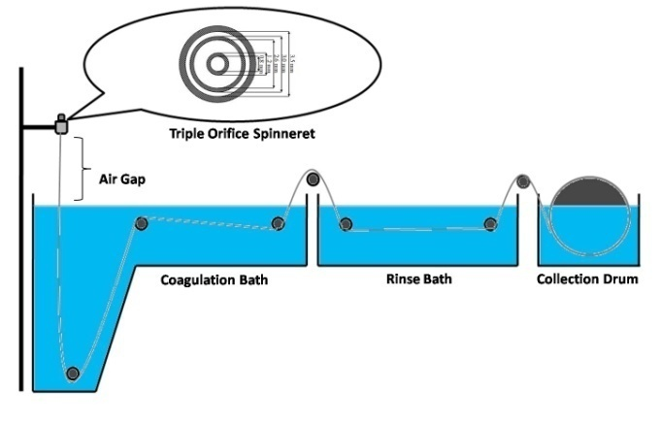

Figure 1. Dual layer hollow fiber spinning method

The dope solution was transferred into dope reservoir syringe pump followed by the dope extrusion using a triple orifice spinneret. Prior to drying, the as-spun membrane fibers were immersed into water bath for 1 day to remove residual solvent. Then, 50 pieces of 30 cm length of as-spun fiber segments were put together to form a bundle. Four to six bundles were sent to post treatment in one batch using ethanol: water, 50:50 wt.% for 1 hour followed by 100% of ethanol for another 1 hour in order to improve the membrane wet ability and pore collapse. Finally, the fibers bundles were dried at room temperature for 3 days.

Characterization of the dual layer hollow fiber membrane
The morphological nature of both DLHF and SLHF were explored qualitatively with the help of Field Emission Scanning Electron Microscopy (FESEM; Model: SU2080, Hitachi). The TiO₂ nanoparticle distribution on top surface of the tested composite membrane was investigated using the line scan of spectrum of Energy Dispersion of X-ray (EDX; Model: X-MaxN 51-XMX1011, Oxford Instrument). Prior to positioned on a metal holder, both DLHF and SLHF were immersed in liquid nitrogen for 1 min and then fractured into short samples to expose their cross sectional characteristics. The samples then were sputter coated with gold under vacuum approximately for 3 min. The cross section and surface DLHF and SLHF were examined at various magnifications. The distribution of TiO₂ nanoparticles on both DLHF and SLHF membrane surface were scan randomly by EDX.

The membrane surface roughness was determined using Atomic Force Microscopy (AFM; Model: SE-100, Park System). DLHF and SLHF samples were cut into pieces of 3 cm by 5 cm and areas of 20 μm x 20 μm of sample were scanned by tapping mode.

Contact angle measurements were conducted using the contact angle goniometer (Model: OCA 15EC, Dataphysic). 2µL of deionized water as contact liquid was dropped on the fiber surface and the measurements were obtained at different points of each sample.

The measurement of tensile strength of the hollow fibers was established by LRX, LLYOD test machine. At least six fibres with 50 mm length were tested with a load cell of 2.5 kN, at a constant elongation velocity of 10 mm/m at room temperature and the average data were taken for each sample. Tensile strength were determined by using the following equation (1) (IPC-TM-650):
$Tensile strength (Pa)=\frac{Load at break(N)}{Cross sectional area (m^{2})}$$Tensile strength (Pa)=\frac{Load (N)}{Cross sectional area (m^{2})}$
$Tensile strength (Pa)=\frac{Load at break(N)}{Cross sectional area (m^{2})}$ (1)

$$ε=\frac{w1-w2}{Vρw}×100\%$$
The membrane porosity, ε was measured using dry-wet weight method. The membrane was soaked in pure water for 3 hours, and then was weighed after absorption of the pure water. The membrane then was dried by filter paper before weighed again to obtain their dry weight. The porosity of membrane was calculated by using the following equation (2):
(2)

where ε is the porosity of the membrane (%), w1 is the mass of the wet membrane, w2 is the mass of the dry membrane, V is the volume of the membrane and ρw is the density of water (1.0 g/cm³).

Results and Discussion
Figure 2 shows representative FESEM images of the dual layer and single layer TiO₂/PVDF hollow fiber membrane. As shown in the Figure 2 (a2), the finger like structure developed at the outer and inner layer, whereas the sponge like structure developed at the intermediate layer. Porous structure was achieved with the addition of the pore former, PEG 6000 into the DLHF inner layer dope solution. As shown in the Figure 2 (a2), the resultant DLHF have large macrovoids and porous inner layer membrane. This finding is in an agreement with previously reported study where they reported the formation of a macrovoids and a large area of sponge-like structure in their membrane [21]. Both layers are compatible with each other and there are no delamination and interfacial resistance when PVDF was used for both inner and outer layer dopes.

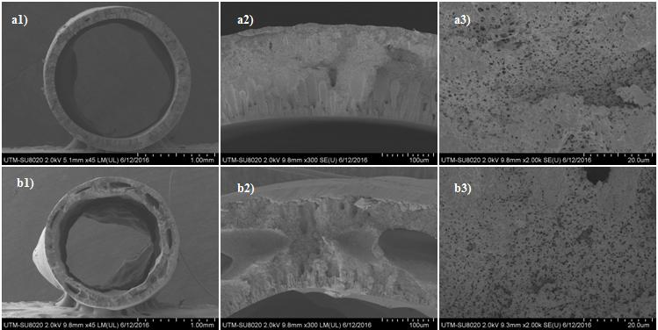
Figure 2. Cross-sectional and partial cross section FE-SEM images of the dual layer and single layer TiO₂/PVDF hollow fiber membrane for (a) DLHF and (b) SLHF
It is expected that the mutual diffusion of polymers was established between the inner and outer layers, thus two distinct layers cannot be observed. Hence, the estimation of outer layer thickness of DLHF membranes was performed by the distribution of TiO₂ nanoparticles in the outer layer as shown in the Figure 3 (a4). EDX analysis show that there is less diffusion of TiO₂ particles into the inner layer of DLHF membrane as compared to SLHF membrane. It is believed that the particles might have distributed evenly over the DLHF outer membrane surface. Even though SLHF showed higher TiO₂ loading, the TiO₂ nanoparticles are entrapped in the membrane matrix. Therefore, they might not be fully utilized for their photocatalytic properties due to the limit penetration of the light source through thick membrane layer. Hence, higher TiO₂ loading in SLHF are wasted as compared to the lower TiO₂ loading on the membrane surface of DLHF.
Figure 3. The EDX mapping of TiO2 distribution in DLHF (a4) and SLHF (b5) membrane layer
Figure 4 present the FESEM images of the outer surface of the DLHF and SLHF membranes. As can be seen, the TiO₂ nanoparticles were uniformly distributed on both configurations of the membrane surfaces. The surface of both membranes is composed of a microporous structure with relatively large pores as determined by AFM analysis.
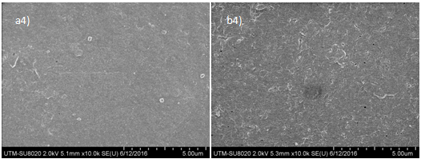
Figure 4. Surface FE-SEM images of the dual layer and single layer TiO2/PVDF hollow fiber membrane for (a) DLHF and (b) SLHF
Figure 5 shows the three dimensional AFM images and surface roughness (Ra) of the DLHF and SLHF TiO₂/PVDF membranes. The AFM images clearly show that the membrane surface roughness of both configurations has no significant difference because the TiO₂ particles loading in the dope solutions are equal. The surface roughness was strongly dependent on the TiO₂ loading and distribution of TiO₂ on the membrane surface. The Ra value of DLHF and SLHF membranes were 41.550 and 40.934 nm, respectively.
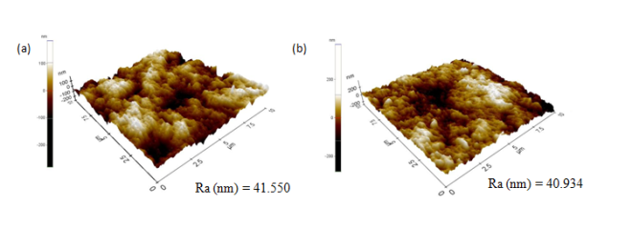
Figure 5. Surface roughness image of outer surface of (a) DLHF and (b) SHLF TiO2 /PVDF hollow fiber membranes
Table 2 summarizes the results of the tensile strength, elongation at break, contact angle, pure water flux, rejection, porosity and pore size of the membranes of both configurations. The tensile strength and elongation at break of the DLHF membranes was higher than SLHF membranes. This is because the presence of the outer layer of DLHF membranes has strengthened its structure. DLHF is more hydrophilic than SLHF. It could be observed from contact angle analysis as listed in Table 2. This finding is accordingly with the findings reported by Dzinun et al. [22]. The presence of hydrophilic nature of TiO₂ particle at the outer layer of the DLHF membranes has successfully improved the hydrophilicity of the membrane, which higher affinity towards water is better for water-related separation process. In addition, uniform distribution of TiO₂ particles at the outer layer surface will improved photocatalytic reaction site too. Therefore, the degradation and separation of EDCs are promisingly efficient.
Table 2. Performance of hollow fiber membranes with different configuration

Configuration | Tensile Strength  (Mpa) | Elongation at Break  (%) | Contact Angle  (°) | Porosity
Dual Layer Hallow Fiber (DLHF) | 15.87 ± 0.52 | 90.33 ± 13.81 | 64.60 | 2.081 ± 1.009
Single Layer Hallow Fiber (SLHF) | 11.14 ± 0.35 | 59.95 ± 2.21 | 79.32 | 1.509 ± 0.262

Conclusion
Dual layer hollow fiber membranes have successfully fabricated by single step co-extrusion techniques. The obtained dual layer hollow fiber membranes consists of sandwich-like structure where finger-like voids formed from the inner and the outer surface of membrane and separated by sponge-like structure at the middle of the membranes cross-section. The incorporation of TiO₂ nanoparticles into the outer membrane layers has increased their hydrophilicity, thus suggesting that the photocatalytic DLHF membranes also have a good separation potential in water-related processes. It is interesting to note that the co-extrusion technique is capable to produce a DLHF membrane with uniformly distributed high loading of TiO₂ particles at the outer layer surface which might highly efficient for photocatalytic degradation of EDCs. However, the investigation of photocatalytic reactions are needed in the future works to justify their degradation capability.

Acknowledgement
The authors gratefully acknowledge financial support from the Ministry of Education Malaysia under the Higher Institution Centre of Excellence Scheme (Project Number: R.J090301.7846.4J193). The authors would also like to thanks Research Management Centre, Universiti Teknologi Malaysia for the technical support.

References

- Schmidler, C. (2015). Endocrine System Glands and Hormones. Access online http://www.healthpages.org/anatomyfunction/endocrine system-gland/
- Chang, H-S., Choo, K-H., Lee B-W. and Choi, S-J. (2009). The methods of identification, analysis, and removal of endocrine disrupting compounds (EDCs) in water. Journal of Hazardous Materials 172: 1 –12.
- Filali-Meknassi, Y., Tyagi, R. D., Surampalli, R. Y., Barata, C. and Riva, M. C. (2004). Endocrine disrupting compounds in wastewater, sludge treatment processes and receiving waters: Overview. Practical Periodical Hazard, Toxic, and Radioactive Waste Management, 8: 1 – 18.
- Kralchevska, R. P., Milanova, M. M., Hristova, I. L. and Todorovsky, D. S. (2013). Some endocrine disrupting compounds in the environment and possibilities for their removal / degradation. Bulgarian Chemical Communications, 45, 2: 131 – 143.
- Pan, B., Lin, D., Mashayekhi, H. and Xing, B. (2008). Adsorption and hysteresis of bisphenol A and 17α-ethinyl estradiol on carbon nanomaterials. Environmental Science & Technology, 42(15): 5480 –5485.
- Grasselli, F., Baratta, L., Baioni, L., Bussolati, S., Ramonib, R., Grolli, S. and Basini, G. (2010). Bisphenol A disrupts granulosa cell function. Domestic Animal Endocrinology, 39: 34 – 39.
- Rubin, B. S. (2011). Bisphenol A: An endocrine disruptor with widespread exposure and multiple effects. Journal of Steroid Biochemistry and Molecular Biology, 127(1-2): 27 – 34.
- Stahlhut, R. W., Welshons, W. V. and Swan, S. H. (2009). Bisphenol A data in NHANES suggest longer than expected half-life, substantial non-food exposure, or both. Environmental Health Perspective, 117: 784 – 789.
- Kondarides, D. I. (2010). Photocatalysis. Catalysis. Encyclopedia of life support systems (EOLSS), developed under the auspices of the UNESCO. EOLSS Publishers, Paris.
- Dalrymple, O. K., Yeh, D. H. and Trotz, M. A. (2007). Removing pharmaceuticals and endocrine-disrupting compounds from wastewater by photocatalysis. Journal of Chemical Technology and Biotechnology, 82: 121 – 134.
- Xin, Y., Gao, M. Wang, Y. and Ma, D. (2014). Photoelectrocatalytic degradation of 4-nonylphenol in water with WO₃/TiO₂ nanotube array photoelectrodes. Chemical Engineering Journal, 242: 162 – 169.
- Umar, M. and Aziz, H. A. (2013). Photocatalytic degradation of organic pollutants in water. INTECH Open Access Publisher: pp. 195 – 208.
- Hashimoto, K., Irie, H. and Fujishima, A. (2005). TiO₂ photocatalysis: A historical overview and future prospects. Japanese Journal of Applied Physics, 44(12): 8269 – 8285.
- Rao, K. V. S., Subrahmanyam, M. and Boule, P. (2004). Immobilized TiO₂ photocatalyst during long-term use: decrease of its activity. Applied Catalysis B: Environmental, 49(4): 239 – 249.
- Peng, N., Chung, T.-S., Chng, M. L. and Aw, W. (2010). Evolution of ultra-thin dense-selective layer from single-layer to dual-layer hollow fibers using novel Extem® polyetherimide for gas separation. Journal of Membrane Science, 360: 48 – 57.
- Yang, Q., Wang, K. Y. and Chung, T.-S. (2009). Dual-layer hollow fibers with enhanced flux as novel forward osmosis membranes for water production. Environmental Science and Technology,, 43: 2800 – 2805.
- Ong, Y. K. and Chung, T. (2012). High performance dual-layer hollow fiber fabricated via novel immiscibility induced phase separation (I2PS) process for dehydration of ethanol. Journal of Membrane Science, 421–422: 271 – 282.
- Sun, S. P. Wang, K.Y. Peng, N. Hatton, T. A. and Chung, T.-S. (2010). Novel polyamideimide/ cellulose acetate dual-layer hollow fiber membranes for nanofiltration. Journal of Membrane Science, 363: 232 –242.
- Lee, J., Park, B., Kim, J. and Park, B. S. (2015). Effect of PVP, lithium chloride, and glycerol additives on PVDF dual-layer hollow fiber membranes fabricated using simultaneous spinning of TIPS and NIPS. Macromolecular Research, 23(3): 291 – 299.
- Khayet, M., Mengual, J., I. and Matsuura, T. (2005). Porous hydrophobic/hydrophilic composite membranes application in desalination using direct contact membrane distillation. Journal of Membrane Science, 252(1): 101 – 113.
- Setiawan, L., Wang, R., Shi, L., Li, K. and Fane, A. G. (2012). Novel dual-layer hollow fiber membranes applied for forward osmosis process. Journal of Membrane Science, 421 – 422: 238 – 246.
- Dzinun, H., Othman, M. H. D., Ismail, A. F., Puteh, M. H., Rahman, M. A. and Jaafar, J. (2015). Fabrication of dual layer hollow fibre membranes for photocatalytic degradation of organic pollutants. International Journal of Chemical Engineering and Applications, 6(4): 289 – 292.

