REMOVAL AND RECOVERY OF CHROMIUM (IV) ION VIA TRI-N-OCTYL METHYLAMMONIUMCHLORIDE-KEROSENE POLYPROPYLENE SUPPORTED LIQUID MEMBRANE

(Penyingkiran dan Pemulihan Semula Kromium (IV) melalui Membran Cecair Berpenyokong Tri-n-oktil metilammoniumklorida-kerosin-polipropilena)

Raja Norimie Raja Sulaiman¹ and Norasikin Othman^{1, 2}*

¹Faculty of Chemical and Energy Engineering,

Universiti Teknologi Malaysia, 81310 UTM Johor Bahru, Johor, Malaysia

²Centre of Lipids Engineering and Applied Research (CLEAR),

Ibnu sina Institute of Scientific and Industrial Research (IBNU SINA-ISIR),

Universiti Teknologi Malaysia, 81310 UTM Johor Bahru, Johor, Malaysia

*Corresponding author: norasikin@cheme.utm.my

Abstract

The presence of chromium in the natural water can be toxic to aquatic organism and is one of the major environmental problems. Therefore, the removal and recovery of chromium from industrial wastewater is very crucial to accomplish the standard discharge concentration limit. Supported liquid membrane is one of the processes which combines the extraction and recovery process in one single stage. This paper presents an experimental study on the removal and recovery of chromium ions from acidic aqueous solutions through a flat-sheet supported liquid membrane (FSSLM) system. Through this system, chromium ions were transported from feed phase into stripping phase via Tri-n-octyl-methylammoniumchloride (TOMAC)-kerosene-polypropylene supported liquid membrane (SLM). The liquid membrane phase was prepared by dissolving the corresponding volume of the carrier, TOMAC in organic diluent of kerosene. The stripping agent used was sodium hydroxide (NaOH) solution whereas the membrane support used was commercial Accurel polypropylene membrane with good features of 100 µm thickness, porosity of 72% and effective pore size of 0.10 µm. The chromium ion concentration in the feed and stripping phases as a function of time was analysed using an atomic absorption spectrometry (AAS). The effects of different operational variables such as TOMAC concentration in the membrane phase, NaOH concentration in the stripping phase and pH of the aqueous feed phase were investigated. The result demonstrated that about 90 and 98% of 150 ppm of chromium was removed and recovered, respectively at favorable condition of 1.0 M TOMAC, 0.5 M NaOH and pH 2 of the feed phase.

Keywords: supported liquid membrane, chromium, removal, recovery, acidic aqueous solution

Abstrak

Kehadiran kromium di dalam sumber air semula jadi adalah toksik kepada organisma akuatik dan salah satu masalah utama alam sekitar. Oleh itu, penyingkiran dan penghasilan semula kromium daripada air sisa industri adalah sangat perlu untuk memenuhi had kepekatan piawaian pelepasan. Membran cecair bersokong adalah salah satu proses yang menggabungkan penyingkiran dan penghasilan semula dalam satu peringkat proses. Kertas kerja ini membentangkan satu kajian eksperimen tentang penyingkiran dan penghasilan semula ion kromium dari larutan berasid melalui sistem helaian rata membran cecair bersokong (FSSLM). Melalui sistem ini, ion kromium dibawa dari fasa suapan ke fasa pelucutan melalui Tri-n-oktil-metilammoniumklorida (TOMAC)–kerosin-polipropilena membran cecair bersokong (SLM). Fasa cecair membran telah disediakan dengan melarutkan sejumlah pembawa, TOMAC dalam pelarut organik kerosin. Ejen pelucutan yang digunakan adalah larutan sodium hidroksida (NaOH) manakala membran sokongan yang digunakan ialah Accurel poliproprilena membran komersial yang mempunyai ciri-ciri yang baik dengan ketebalan 100µm, keliangan 72% dan saiz liang 0.10 µm. Kepekatan ion kromium dalam fasa suapan dan fasa pelucutan terhadap fungsi masa dianalisis menggunakan spektrometri penyerapan atom (AAS). Kesan pembolehubah operasi yang berbeza seperti kepekatan TOMAC dalam fasa membran, kepekatan NaOH dalam fasa pelucutan dan pH fasa suapan telah dikaji. Keputusan menunjukkan bahawa sekitar 90 dan 98% daripada 150 ppm kromium telah disingkirkan dan dihasilkan semula pada 1.0 M TOMAC, 0.5 M NaOH dan pH 2 fasa luaran.

Kata kunci: membran cecair bersokong, kromium, penyingkiran, penghasilan semula, larutan berasid

Introduction

Electroplating waste containing hazardous heavy metal of chromium is an environmental concern especially to the natural water system. Normally industrial electroplating waste contain both hexavalent and trivalent forms of chromium. According to Malaysia's environmental law, the standard discharge regulation of industrial effluent containing hexavalent and trivalent chromium is 0.05 and 1.0 ppm respectively [1]. Chromium (VI) is one of the most dangerous carcinogenic and mutagenic heavy metals as it is toxic for humans, animals, plants and microorganisms [2]. If these wastes are directly discharged into the natural water system, they will undoubtedly cause a lot of environmental problems. Thus, the removal and recovery of chromium is very crucial to bring down the concentration of such hazardous metal ions below the discharge standards. Hexavalent chromium is not precipitated as an insoluble hydroxide. Therefore hexavalent chromium need to be reduced to the trivalent state. The common reducing agent used include sulfur dioxide or bisulphite addition at low pH of 2 to 3. However this process suffers from high cost of sodium bisulphite. The use of inexpensive reducing agents such as ferrous sulphate significantly increase the volume of hydroxide sludge [3]. Besides, the solvent extraction method involves large amount of chemical consumption whereas electrodialysis provides high cost of operation [4, 5].

In order to overcome this problem, many researchers found that liquid membrane extraction technology has a great potential and has been reported as an advanced technique for separating solutes. Liquid membrane technology has attracted much interest for its potential impact in the fields of separation processes because the main advantage of liquid membrane configuration treatment is a single step process, in which removal and recovery processes occur simultaneously [6, 7]. This technique also provides high efficiency in separation and selectivity toward the desired solute as reported by Harrudin et al. [8]. Liquid membrane technologies have been commonly used to separate and recover many types of metals from diluted solutions. There are three types of liquid membrane technology namely bulk liquid membrane, emulsion liquid membrane and supported liquid membrane. Liquid membrane systems in which solvents containing carriers are placed in a porous support material are called supported liquid membrane (SLM). Supported liquid membrane has been extensively used for the recovery of organic matter, heavy metals and precious metals. The main advantages of SLM are the small amounts of organic phase and extractant used, one-step mass transfer, the possibility of achieving high separation factors, concentration of extracted compound during separation, and low separation costs [9, 10].

Carrier is one of the important components in the liquid membrane formulation. Carriers can be categorized as acidic, basic and solvating. For acidic type carrier, the metal extraction based on the cationic exchange reaction. The acidic carriers which are normally used for the extraction of various metal cations including chelating ( 5,8-diethyl-7-hydroxy- dodecan-6-oxime (LIX63), 2-hydroxy-5-nonylacetophenone oxime (LIX841) and etc) and phosphorus derivative (di-2-ethylhexyl phosphoric acid (D2EHPA), di-2,4,4-trimethylpentylmonothio phosphinic acid (Cyanex 302), di-2,4,4-trimethylpentyl phosphinic acid (Cyanex 272) and etc). On the other hand the basic type carrier tend to perform the extraction of anionic metal complexes through an anionic exchange reaction. Several basic carriers used for metal extraction are Trioctylamine (TOA), Tridodecylamine (TDA), Tri-octylmethylammonium chloride (TOMAC) and so forth. In order to achieve this exchange, the amine must be first converted to the amine salt to provide the anion to exchange with the metal species [11]. Besides, the solvating carrier are weakly basic in nature and thus they extract either neutral metal complexes or acids and suitable to extract the alkaline earth metals [12].

In this present work, Tri-n-octyl- methylammoniumchloride (TOMAC) is employed for the removal and recovery of chromium ion using supported liquid membrane process. To the best of our knowledge, the chromium compounds will release the anion complexes into the water. Hence, the best carrier for these anion complexes is the basic type carrier. Furthermore, TOMAC no need to be protonated because this compound in ionic complexes. Previously, TOMAC also have been reported as a good basic carrier for various anion complexes extraction with higher efficiency [13]. The important parameters influencing the removal and recovery efficiency such as carrier and stripping agent concentration, and pH of the feed phase were investigated.

Materials and Methods

Materials

Potassium dichromate, K₂Cr₂O₇ as a feed solution was purchased from Sigma Aldrich. Tri-n-octyl methyl ammonium chloride (TOMAC) as a carrier and kerosene as diluent was procured from Fluka and Merck, respectively. The structure of TOMAC is illustrated in Figure 1. Sodium hydroxide, NaOH as a stripping agent was supplied from Qrec. All chemicals are analytical grade and were used without further purification as received. Stock Cr (VI) solutions were prepared by dissolving K₂Cr₂O₇ in distilled water. Polypropylene membrane of 100 μm thickness, 72% porosity and an effective pore size of 0.1 μm was obtained from Accurel Membrana was used as membrane support for the liquid membrane in supported liquid membrane process.

Preparation of liquid membranes and rig set-up

The organic liquid membrane was prepared by dissolving a specified volume of TOMAC in the kerosene. Then, the polymeric hydrophobic microporous polypropylene membrane was impregnated with the liquid membrane for 24 h. After impregnation, the membrane support was let to drip for a few seconds and the excess liquid membrane was wiped from the membrane surface using the filter paper. The cleaning procedure was done gently in order to ensure that there is no liquid membrane was removed from the membrane pores. Then, the membrane was applied between the feed and strip cells as demonstrated in Figure 2. About 400 ml of feed and strip solutions were added into cell 1 and cell 2, respectively. The initial concentration of chromium in the feed phase was 150 ppm. NaOH solution was used as a stripping phase. The samples were taken from the feed and strip phase for each 30 minute and were analysed using Atomic Absorption Spectrometry (AAS) in order to observe the changes in the chromium concentration. The pH of feed phase and stripping phase was measured using a Metler Toledo pH meter. The new membrane support was used for each experiment. All experiment was carried out at ambient temperature (25±1 ºC).

Figure 1. Structure of tri-n-octyl methyl ammonium chloride (TOMAC); R= C₈H₁₇

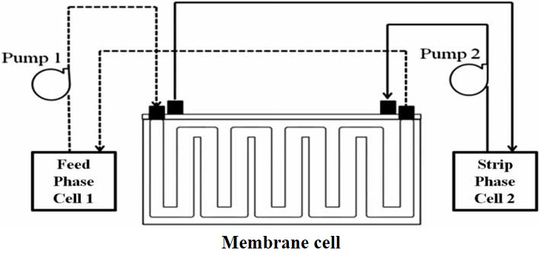

Figure 2. Schematic diagram of supported liquid membrane process [8]

Determination of removal and recovery performance

The determination of the removal and recovery percentages of chromium ion through SLM process were calculated using the following equations as below:

Removal (%) | = $\frac{{[Cr]}_{f_{o}}-{[Cr]}_{f_{t}}}{{[Cr]}_{f_{o}}}$ x 100% | (1)
Recovery (%) | = $\frac{{[Cr]}_{s}}{{[Cr]}_{f_{o}}}$ x 100% | (2)

where ${[Cr]}_{f_{o}}$ represents initial concentration of chromium in the feed phase; ${[Cr]}_{f_{t}}$ represents final concentration of chromium in the feed phase and ${[Cr]}_{s}$ represents a concentration of chromium in the strip phase.

Determination of permeability value

Membrane permeability is the ability of a membrane to allow the desired solute to pass through it. Permeability, p (cms⁻¹) of the chromium ions transferred from the feed phase to the strip phase can be determined by Equation (3) and (4) below:

Permeability, $p$ = $\frac{dC}{C}$ . $\frac{1}{dt}$ .$\frac{V}{A}$ (3)

By integration Equation (3), Equation (4) was obtained,

ln $\frac{C}{C_{fi}}$ = -$p$ $\left(\frac{A}{V}\right)$ . t (4)

where $C_{fi}$ is the initial concentration of metal ion in the feed phase, c is the concentration of metal ion at given time,$p$ is permeability value (cms⁻¹), A is the effective area of membrane (cm²), v is the volume of aqueous feed phase (cm³) and t is the time (s).

Results and Discussion

Mechanism of chromium ions transport across supported liquid membrane

All stable complexes of hexavalent chromium are anionic species which exist in different forms in the aqueous phase depending on the pH. Under alkaline or neutral condition, chromium predominantly exist as chromate ions (CrO₄²⁻) whereas at slightly acidic condition, hydrochromate ions (HCrO₄⁻) take place as the dominant species. At very low pH and high total chromium (VI) concentration, the dichromate ion (Cr₂O₇²⁻) predominates [14]. In that case, in this study, chromium ions exist as hydrochromate ions (HCrO₄⁻) in the feed phase at low initial concentration of Cr (VI) solutions. The mechanism of removal and recovery on the chromium ion is shown in Figure 3. In SLM transport process, the diffusion of chromium ions takes place via the following steps:

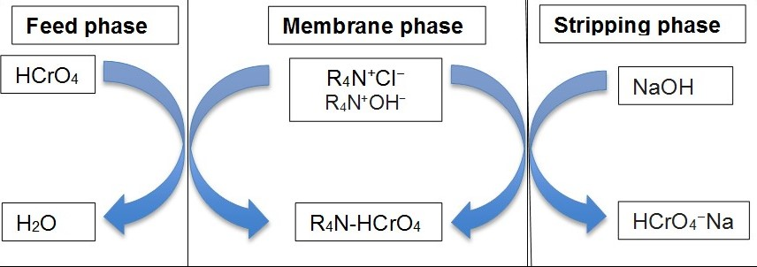

Figure 3. Removal and recovery mechanism of chromium ion by TOMAC

- The carrier, TOMAC in the membrane phase react with the stripping agent, NaOH at the membrane-internal interface as represented in Equation (5) below:

[R₄N⁺Cl⁻] _{org} + [NaOH] _{aq} [R₄N-OH] _{org} + [Cl⁻] _{aq} + [Na⁺] _{aq} (5)

- There are two types of carrier exists in the membrane phase which are [R₄N⁺Cl⁻] and [R₄N⁺OH⁻]. Therefore, at the feed-membrane interface, hydrochromate ions chemically react with both types of carrier as shown in Equation (6) and (7) below:

[HCrO₄⁻] _{aq} + [R₄N⁺Cl⁻] _{org} [R₄N-HCrO₄] _{org} + [Cl⁻] _{aq} (6)
[HCrO₄⁻] _{aq} + [R₄N⁺OH⁻] _{org} [R₄N-HCrO₄] _{org} + [OH⁻] _{aq} (7)

- The formation of R₄N-HCrO₄ complex diffuse across the membrane phase from feed-membrane interface to the membrane-internal interface reversibly, where the stripping reaction take place with stripping agent, NaOH as shown in Equation (8). The created complex HCrO₄Na is insoluble in the membrane phase and will not diffuse back to the feed phase.

[R₄N-HCrO₄] _{org +} [NaOH] _{aq} [HCrO₄Na] _{org} + [R₄N-OH] _{aq} (8)

Effect pH of feed phase

One of the important variables for the removal and recovery performance of Cr (IV) in the supported liquid membrane process is pH of the feed solution. Basically, the stable anion complexes of chromium exist in different form depending on the pH. Figure 4(a) illustrates the effect of various pH on the removal of Cr (VI). The pH was adjusted using sulphuric acid and sodium hydroxide solution for acidic and basic range, respectively. On the other hand, the calculated permeability value at different pH is tabulated in Table 1. Based on the result obtained, the highest removal percentage was observed at pH 2 (89%) with the highest permeability value of 5.91 x 10⁻² cms⁻¹. Further increase pH value up to 3, the removal percentage was slightly reduced to 80% with the permeability value of 4.32 x 10⁻² cms⁻¹. In fact, at pH 2 and 3 which are acidic medium, hydrochromate ions (HCrO₄⁻) are more predominant, thus showing the efficiency of TOMAC to chemically react with this type of anions. However, pH 2 which is more acidic, can induce higher ions dissociation from the chromium complexes. This condition will produce more hydrochromate ions in the feed phase and increases the rate formation of the solute-carrier complexes. In that case more chromium ions can be transported through the membrane, thus enhancing the permeation rate. Furthermore, the higher proton concentration also can act as a driving force to encourage the permeation of the chromium ions through the membrane. This is strongly supported by Raut et al. [15] who reported that the acidic feed solution give the high permeability values for strontium transport due to the tendency of ionic complexes formation. Under neutral condition (pH 7), the removal percentage was also high which is 87% with permeability value of 5.83 x 10⁻² cms⁻¹. At this stage, chromium predominantly exist as chromate ions (CrO₄²⁻). This anion species requires two carrier for the complexation [16]. So this condition greatly enhances the permeation of chromium ions through the membrane.

At the recovery stage as shown in Figure 4 (b), the percentage of chromium recovery gradually decreased from 98 to 56% upon increasing the pH value from 2 to 7. At acidic range, the difference in the proton concentration gradient between the feed and receiving phases is the driving force for the transportation of chromium ion into the stripping phase. In contrast, at the neutral condition, the presence of (CrO₄²⁻) ions react slowly with TOMAC in the membrane phase with 1:2 mole ratio of Cr: TOMAC as shown through equation (9) below, thus causing the recovery rate to be reduced. Hence, the optimum pH for removal and recovery of chromium achieved at pH 2.

CrO₄²⁻ + [R₄N⁺Cl⁻] _{org} [R₄N-CrO₄- NR₄] _{org} + [Cl⁻] _{aq} (9)

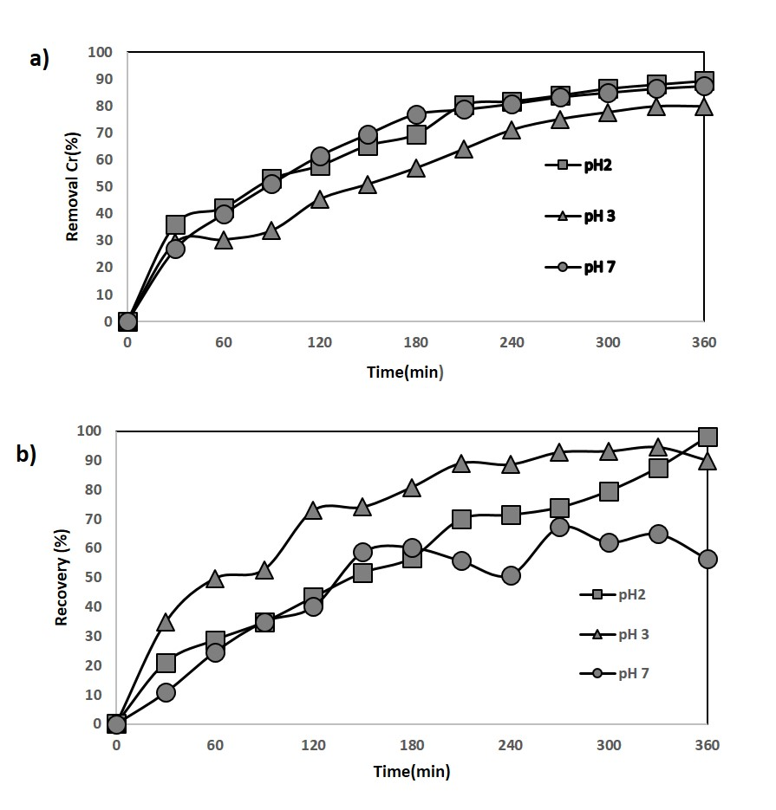

Figure 4. (a) Effect pH of feed phase on the removal of chromium ion (Experimental condition: Feed phase= 150 ppm, TOMAC = 1.0M; NaOH =1.0M, flow rate = 100 ml/min) and (b) Effect pH of feed phase on the recovery of chromium ion (Experimental condition: Feed phase = 150 ppm, TOMAC =1.0M, NaOH = 1.0M, flow rate = 100 ml/min)
Table 1. Permeability coefficient value as a function of pH of feed phase

Effect pH of Feed Phase | Permeability Value  (P x10⁻² , cms⁻¹)
2 | 5.91
3 | 4.32
7 | 5.83

Effect of carrier concentration

Figure 5(a) presents the effect of carrier concentration on the removal of chromium ion by varying the TOMAC concentration from 0.5 to 1.5 M. The permeability value as a function of carrier concentration is also shown in Table 2. Basically, the carrier in the liquid membrane phase plays a significant role through complexation with the chromium ions in the feed-membrane interface which reversibly transport them to the internal phase. The results show that the removal percentage of chromium ions increased from 13 to 89% and reached a plateau within 360 min of extraction upon increasing TOMAC concentration from 0.5 to 1.5 M, respectively. Besides, the permeability value also increased from 0.53 x 10⁻² cms⁻¹ to 5.91 x 10⁻² cms⁻¹ with increasing carrier concentration from 0.5 to 1.0 M, respectively. At 0.5 M, the carrier concentration is inadequate to aid the mass transfer of chromium ion through SLM process. Therefore more chromium anion accumulate in the feed-membrane interface without being transported. So this condition increased the mass transport resistance and leads to the low permeation of chromium ions through the membrane phase. In contrast, at higher carrier concentration, there are more available carriers for the formation of solute-carrier complexes, hence enhancing the removal efficiency.

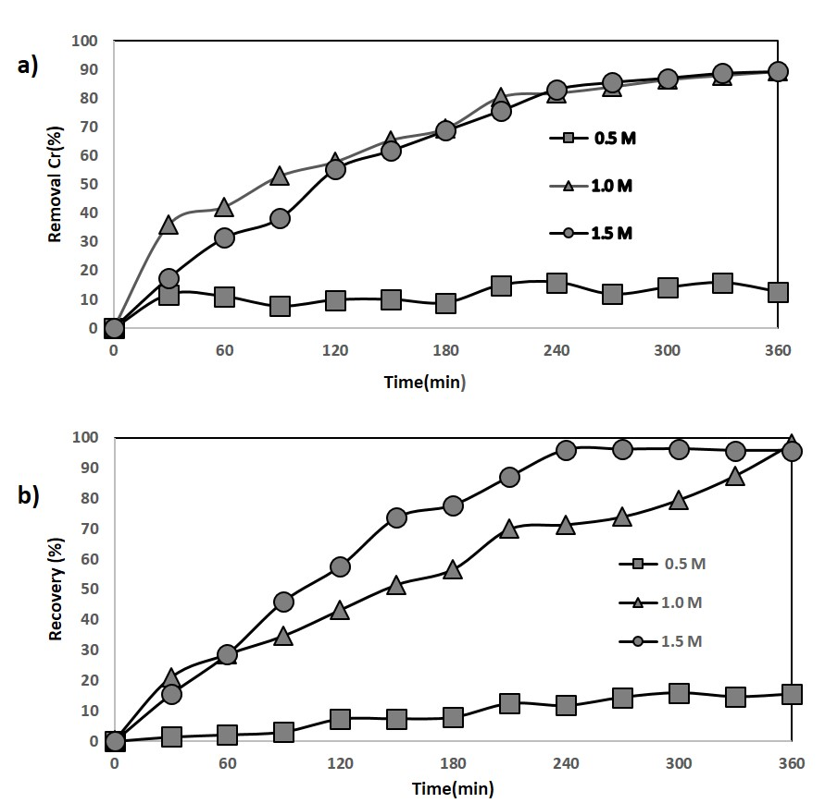

Figure 5. (a) Effect of TOMAC concentration on the removal of chromium ion (Experimental condition: Feed phase = 150 ppm (pH: 2), NaOH = 1.0M, flow rate = 100ml/min) and (b) Effect of TOMAC concentration on the recovery of chromium (Experimental condition: Feed phase = 150 ppm (pH: 2), NaOH = 1.0M, flow rate = 100 ml/min)

Based on the result obtained, 1.0 M TOMAC is adequate for the chromium ion transportation in SLM process with the highest permeability value of 5.91 x 10⁻² cms⁻¹. This is strongly supported by Nayl and Aly [17] who reported that 1.0 mol TOMAC required 1.0 mol Cr during the reaction of extraction occur in the membrane phase. Further increase of carrier concentration only cause the excess carrier in the membrane phase which thereby affecting the removal efficiency. This is also in agreement with Kumar et al. [18] who claimed that above the optimal value, the solute transportation decreased because of the extra resistance offered by the excess carrier molecules in the membrane phase. As can be seen, beyond 1.0 M, the permeability value also decreased to 5.74 x 10⁻² cms⁻¹. This is due to the viscosity effect caused by the excess carrier concentration which resists the transportation of the chromium ions through the membrane phase. This result is in line with Bey et al. [19] who reported that at certain values of carrier concentrations, the viscosity of the organic phase increases, thus slowing the organic complex diffusion through the pores.

On the other hand, Figure 5(b) displays the recovery result of the Cr (IV) extraction for various carrier concentration from 0.5 to 1.5 M. The maximum recovery was achieved at 1.0 M TOMAC (98%) followed by 1.5 M (96%) and 0.5 M (16%). It indicates that simultaneous extraction and stripping occurred completely during the process. This means the carrier concentration increased proportionally with the recovery percentage of chromium ion in the stripping phase. The higher carrier concentration means higher opportunity of chromium-carrier complexes to be stripped by stripping agent at the membrane-internal interface, hence leading to the higher recovery percentage. According to Equation (6) and (7), 1 mol of Cr ion needs 1 mol of TOMAC for the complexation, thus 1.0 M TOMAC was enough for the next experiment.

Table 2. Permeability coefficient value as a function of carrier concentration

Effect of TOMAC Concentration  (M) | Permeability Value  (P x10⁻² , cms⁻¹)
0.5 | 0.53
1.0 | 5.91
1.5 | 5.74

Effect of stripping agent concentration
A stripping agent in the receiving phase plays an important role in order to completely strip the solute ion at the membrane-internal interface. Therefore an appropriate stripping agent which can chemically complex with the desired solute ion is necessary to successfully recover the targeted solute. Figure 6(a) depicts the relationship between NaOH concentration and the removal percentage of chromium ions. The permeability result is also presented in Table 3. Based on the result obtained, as increasing NaOH concentration from 0.5 to 1.5 M, the removal efficiency of chromium linearly increased from 80 to 89% and reached plateau. The permeability value also increased proportionally with stripping agent concentration from 4.06 x 10⁻² cms⁻¹ to 5.91 x 10⁻² cms⁻¹ at 0.5 M and 1.0 M, respectively. This can be attributed to the insufficient stripping agent at 0.5 M to strip the chromium ions into the stripping phase. Therefore, more available of chromium-TOMAC complexes are trapped and accumulated in the membrane-strip interface without being stripped which tends to block the transportation of the other complexes through the membrane.

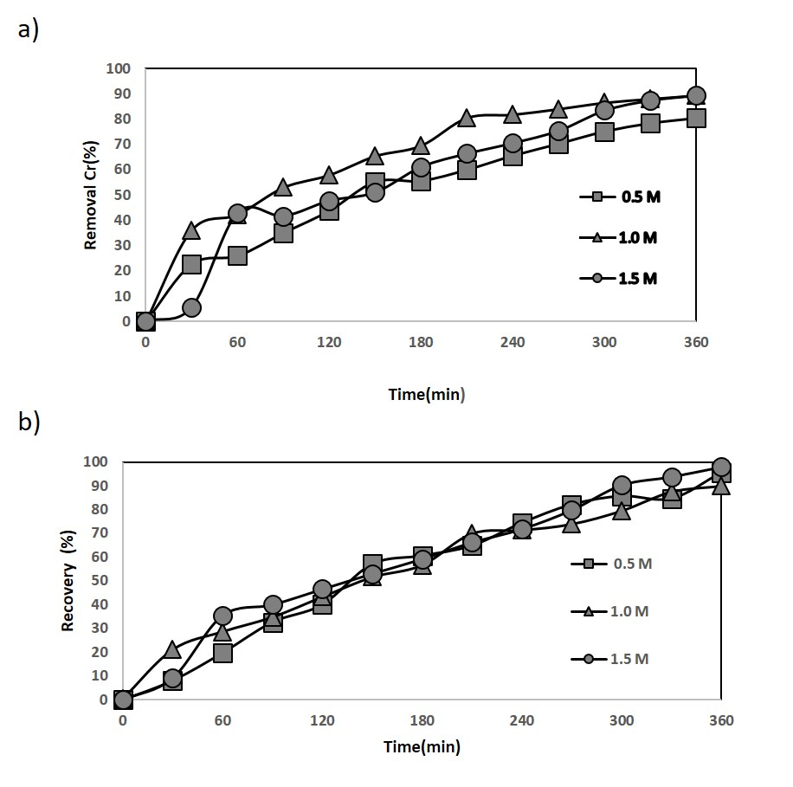

Figure 6. (a) Effect of NaOH concentration on the removal of chromium ion (Experimental condition: Feed phase = 150 ppm (pH: 2), TOMAC = 1.0M, flow rate = 100 ml/min) and (b) Effect of NaOH concentration on the recovery of chromium ion (Experimental condition: Feed phase = 150 ppm (pH: 2), TOMAC = 1.0M, flow rate = 100)

As can be observed, the permeability value at this time is the lowest, which indicates that very low permeation occurred because the membrane phase is clogged with these complexes. Further increase up to 1.0 M NaOH, the highest permeability reached up to 5.91 x 10⁻² cms⁻¹. At this state, more available NaOH appeared in the membrane-strip interface, thereby enhancing the transportation of more chromium ions through the membrane phase. This is in line with Alguacil et al. [20] who reported that the overall permeation coefficient of Cr (VI) increases with the concentration of stripping agent. However, beyond 1.0 M, the permeability value slightly decreased to 5.11 x 10⁻² cms⁻¹. Based on the transport mechanism shown in Figure 3, the counter transport also occurred where the OH⁻ ion from stripping phase also acts as a driving force by complexation with the carrier in the membrane- strip interface to aid the permeation of chromium ions through SLM process. Therefore at excess NaOH concentration, the driving force from the stripping phase only become saturated. At this condition, the number of chromium ion which permeate through the membrane phase seems to reduce as about 100% of chromium ions were already transported to the stripping phase at 1.0 M NaOH. Besides, a higher concentration of NaOH will lead to the higher ionic strength which thereby causing the inefficiency of the recovery process.

Venkatesan and Palanivelu [21] also reported that the degree of extraction remains constant afterwards as the stripping agent concentration achieved the maximum rate. This is due to the saturation of the driving force for diffusion through the SLM owing to an increase of metal complexes concentration at the membrane-internal interface. So, 0.5 M NaOH concentration is adequate for the chromium extraction. Besides, Figure 6(b) shows the recovery result at 0.5 M NaOH concentration is higher than 1.0 M. This means that the stripping reaction occurs very fast at the membrane-internal interface. Thus 0.5 M of NaOH concentration is adequate in achieve a high recovery rate of chromium.

Table 3. Permeability coefficient value as a function of stripping agent concentration

Effect of NaOH Concentration  (M) | Permeability Value  (P x10⁻² , cms⁻¹)
0.5 | 4.06
1.0 | 5.91
1.5 | 5.11

Conclusion

In conclusion, the extraction of Cr (IV) was successfully performed in SLM process using TOMAC as a carrier and NaOH as a stripping agent. TOMAC and NaOH can act as an excellent carrier and stripping agent for the removal and recovery of chromium ion. At pH 2 of feed phase with 1.0 M TOMAC and 0.5 M NaOH, about 90 and 98% of chromium can be successfully removed and recovered, respectively using a supported liquid membrane process.

Acknowledgement
The authors would like to acknowledge the Ministry of Higher Education (MOHE) and Universiti Teknologi Malaysia (Research Grant GUP: Q.J130000.2546.14H21) for financial support in making this research possible.

References

- Malaysia Environmental Quality Report (Industrial Effluent) Regulations (2009). Malaysian Department of Environment, P.U. (A) 434.
- Cavaco, S. A., Fernandes, S., Margarida, M. and Ferreira, M. (2007). Removal of chromium from electroplating industry effluents by ion exchange resins. Journal of Hazardous Materials, 144: 634 – 638.
- Unnithan, M. R. and Anirudhan, T. S. (2001). The kinetics and thermodynamics of sorption of chromium (VI) onto the iron(III) complex of a carboxylated polyacrylamide-grafted sawdust. Industrial & Engineering Chemistry Research, 40(12): 2693 – 2701.
- Kul, M. and Oskay, K. O. (2015). Separation and recovery of valuable metals from real mix electroplating wastewater by solvent extraction. Hydrometallurgy, 155: 153 – 160.
- Sadyrbaeva, T. Z. (2016). Removal of chromium (VI) from aqueous solutions using a novel hybrid liquid membrane-electrodialysis process. Chemical Engineering and Processing, 99: 183 – 191.
- Othman, N., Harrudin, N., Idris, A., Ooi, Z. Y., Fatiha, N. and Sulaiman, R. N. R. (2016). Fabrication of polypropylene membrane via thermally induced phase separation as a support matrix of tridodecylamine supported liquid membrane for Red 3BS dye removal. Desalination and Water Treatment, 57: 12287 – 12301.
- Noah, N. F. M., Othman, N. and Jusoh, N. (2016). Highly selective transport of palladium from electroplating wastewater using emulsion liquid membrane process. Journal of the Taiwan Institute of Chemical Engineers, 64: 134 – 141.
- Harrudin, N., Othman, N., Sin, A. L. E. and Sulaiman, R. N. R. (2015). Selective removal and recovery of Black B reactive dye from simulated textile wastewater using the supported liquid membrane process. Environmental Technology, 36(3): 271 – 280.
- Harruddin, N., Othman, N., Idris, A., Ooi, Z. Y. and Goto, M. (2014). Supported liquid membrane extraction of reactive dye using fabricated polypropylene membrane. Journal of Chemical Engineering of Japan, 47(10): 761 – 769.
- Ruhela, R., Panja, S., Sharma, J. N., Tomar, B. S., Tripathi, S. C., Hubli, R. C. and Suri, A. K. (2012). Facilitated transport of Pd(II) through a supported liquid membrane (SLM) containing N, N, N, N-tetra-(2 ethylhexyl) thiodiglycolamide T (2EH) TDGA: A novel carrier. Journal of Hazardous Materials, 229 – 230: 66 – 71.
- Agreda, D. D., Garcia-Diaz, I., Lopez, F. A. and Alguacil, F. J. (2011). Supported liquid membranes technologies in metals removal from liquid effluents. Revision Metal, 47 (2):146 – 168.
- Parhi, P. K. (2013). Supported liquid membrane principle and its practices: A short review. Journal of Chemistry: 1 – 11.
- Goyal, R. K., Jayakumar, N. S. and Hashim, M. A. (2011). Chromium removal by emulsion liquid membrane using [BMIM]⁺[NTf2]⁻ as stabilizer and TOMAC as extractant. Desalination, 278: 50 – 56.
- Eyupoglu, V., Surucu, A. and Kunduracioglu, A. (2015). Synergistic extraction of Cr(VI) from Ni(II) and Co(II) by flat sheet supported liquid membranes using TIOA and TBP as carriers. Polish Journal of Chemical Technology, 17(2): 34 – 42.
- Raut, D. R., Mohapatra, P. K. and Manchanda, V. K. (2012). A highly efficient supported liquid membrane system for selective strontium separation leading to radioactive waste remediation. Journal of Membrane Science, 390 – 391: 76 – 83.
- Björkegren, S. (2012). A study of the heavy metal extraction process using emulsion liquid membranes. Master Thesis. Chalmers University of Technology, Sweden.
- Nayl, A. A. and Aly, H. F. (2015). Solvent extraction of V(V) and Cr(III) from acidic leach liquors of ilmenite using Aliquat 336. Transactions of Nonferrous Metals Society of China, 25: 4183 − 4191.
- Kumar, A., Manna, M. S., Ghoshal, A. K. and Saha, P. (2016). Study of the supported liquid membrane for the estimation of the synergistic effects of influential parameters on its stability Journal of Environmental Chemical Engineering, 4: 943 – 949.
- Bey, S., Criscuoli, A., Simone, S., Figoli, A., Benamor, M. and Drioli, E. (2011). Hydrophilic PEEK-WC hollow fibre membrane contactors for chromium (VI) removal. Desalination, 283: 16 – 24.
- Alguacil, F. G., Diaz, I. G. and Lopez, F. (2013). Transport of Cr (VI) using an advanced membrane technology and (PJMTH⁺NO³⁻) ionic liquid derived from amine Primene JMT as green chemicals. Desalination and Water Treatment, 51: 7201 – 7207.
- Venkateswaran, P. and Palanivelu, K. (2005). Studies on recovery of hexavalent chromium from plating wastewater by supported liquid membrane using tri-n-butyl phosphate as carrier. Hydrometallurgy, 78:107 – 115.

