

MALAYSIAN JOURNAL OF ANALYTICAL SCIENCES
ISSN 1394 - 2506

Published by The Malaysian Analytical Sciences Society

Surface modification of PSF/TiO₂ membranes using silane coupling agents and DC plasma technique

(Modifikasi Permukaan Membran PSF/TiO₂ Menggunakan Ejen Gandingan Silana dan Teknik Plasma DC)

Soraya Ruangdit¹, Thawat Chittrakarn¹*, Sudkhet Anuchit¹, Yutthana Tirawanichakul¹, Chalad Yuenyao²

¹Membrane Science and Technology Research Center, Department of Physics, Faculty of Science,
Prince of Songkla University, Hat Yai, Songkhla 90112, Thailand
²Department of Physics, Faculty of Science and Technology,
Phetchabun Rajabhat University, 83 M.11 St.Saraburi-Lom Sak, Muang, Phetchabun 67000, Thailand

*Corresponding author: tawat.c@psu.ac.th

Received: 26 August 2016; Accepted: 8 January 2017

Abstract
Preparation and surface modification of PSF/TiO₂ membranes by DC Ar-plasma were conducted to improve membrane hydrophilicity and gas permeation efficiency. Using TiO₂ as a photocatalyst, photocatalysis could be induced upon the plasma exposure. Radicals from this process led to an increase in the membrane hydrophilicity. In order to improve the dispersion quality of TiO₂ in an organic membrane, methyltrimethoxysilane (TMMS) or ethyltrimethoxysilane (TEMS) was utilized as coupling agents to modify the TiO₂ surface prior to blending. The coupling agents caused organic silane bonds on the TiO₂ surface leading to a better dispersion of nanoparticle on the membrane matrix. The incorporation of modified-TiO₂ tended to decrease membrane water contact angles (WCA) to the lowest value when compared with PSF membranes with unmodified TiO₂ and neat PSF membranes. Results also showed that TMMS could produce better outcomes compared to TEMS. It was found that the modified-TiO₂ could decrease the WCA. More importantly, pressure normalized flux of CO₂ and CH₄ gases of PSF/modified-TiO₂ membrane was found to increase with slightly decrease in the selectivity of CO₂/CH₄.

Keywords: silane coupling agent, surface modification, gas separation membrane, low pressure DC-plasma, polysulfone

Abstrak
Penyediaan dan modifikasi permukaan membran PSF/TiO₂ oleh DC Ar-plasma telah dijalankan untuk meningkatkan kehidrofilikan membran dan kecekapan penyerapan gas. Menggunakan TiO₂ sebagai foto-pemangkin, fotopemangkinan dapat didorong apabila terdedah kepada plasma. Radikal daripada proses ini membawa kepada peningkatan dalam kehidrofilikan membran. Untuk meningkatkan kualiti penyebaran TiO₂ dalam membran organik, metiltrimetoksisilana (TMMS) atau etiltrimetoksisilana (TEMS) telah digunakan sebagai agen gandingan untuk mengubah suai permukaan TiO₂ sebelum campuran. Ejen-ejen gandingan menyebabkan ikatan silana organik di permukaan TiO₂ yang membawa kepada penyebaran nanopartikel yang lebih baik pada matriks membran. Penggabungan TiO₂ yang diubahsuai cenderung untuk mengurangkan sudut sentuhan air membran (WCA) kepada nilai yang paling rendah berbanding membran PSF dengan TiO₂ yang tidak diubahsuai dan membran PSF kawalan. Keputusan juga menunjukkan bahawa TMMS boleh menghasilkan hasil yang lebih baik berbanding PPSMI. Ia telah mendapati bahawa TiO₂ yang diubahsuai boleh mengurangkan WCA. Lebih penting lagi, tekanan fluks normal gas CO₂ dan CH₄ daripada membran PSF/TiO₂ yang diubahsuai didapati meningkat dengan sedikit penurunan kepilihan CO₂/CH₄.

Kata kunci: ejen gandingan silana, modifikasi permukaan, membran pemisahan gas, tekanan rendah dc-plasma, polisulfon

Introduction
Membrane technology is currently widely used in many industrial sectors and one of its important applications is for gas separation process. As CO₂ gas is the main causes of greenhouse effect that leads to global warming, many attempts were made to develop an ideal membrane for CO₂ adsorption and separation [1]. Polysulfone (PSF) is one of the high potential and widely used polymers because it has many advantages such as excellent stability and resistivity to high temperature and acid-base environments and easy to be used for membrane making [2, 3]. However, PSF is hydrophobic in nature [4]. For the PSF membranes to be used in the CO₂/CH₄ gas separation, the hydrophilicity of the membrane surface needs to be improved. This improvement is quite important due to the differences of the quadrupole moments of these two gases [5].

Konruang et al. [5] discussed differences of several gases that have small molecules and very little differences in size. Besides, electronic properties, polarizability and quadrupole moment, which we can be used for the extract gas, were also discussed. Table 1 shows the structure, polarizability and quadrupole moment of CO₂ and CH₄ gases [6]. Considering electronic properties of CO₂ and CH₄ gases, we can see that membrane surfaces, which have a higher polarity can absorb a higher polarizability and quadrupole moment gas more than of lower polarizability and quadrupole moment gas. Therefore, hydrophilic properties represent the polarity of membrane surfaces, which is the cause for CO₂ to permeate more through such a membrane than CH₄. The quadrupole moment affects the gas permeation through the membranes. For hydrophilic polymeric membranes, the permeability of CO₂, which has a quadrupole moment and polarizability of about 13.4 ×10⁻⁴⁰ Cm² and 2.93× 10⁻⁴⁰ J⁻¹C²m², respectively, is higher than of CH₄, which has a quadrupole moment and polarizability of about zero and 2.89 10⁻⁴⁰ J⁻¹C²m², respectively [6]. Therefore, research and development are required to improve the hydrophilicity of membranes. [5].

Table 1. Structure, physical and electronic properties of gas molecules [6]
Molecule | Structure | Polarizability  (10⁻⁴⁰J⁻¹ C² m²) | Quadrupole moment  (10⁻⁴⁰ C m²)
CO₂ | Linear | 2.93 | 13.4
CH₄ | Tetrahedral | 2.89 | 0

Titanium dioxide (TiO₂) can improve the hydrophilicity of membranes because of its photocatalytic property [7, 8]. Typically, electrons in the valence band of a photocatalytic material will jump to the conduction band when they are stimulated by a photon. The holes are created in the valence band and the electron from the donor molecule can move to this hole. At the same time, an electron from the valence band can be transferred to the acceptor [9, 10]. For this reason, the photo catalyst can take the interaction with the molecules at the material surface. Additionally, the stimulation of TiO₂ at the membrane surface can decrease the surface roughness and eventually, lead to the decrease in membrane contact angle [11].

However, the minimum energy for the stimulation of TiO₂ has to be equal with the band energy gap that is about 3.2 eV [12, 13]. Unlike PSF, TiO₂ is an inorganic material and the dispersion of TiO₂ particles in the PSF matrix is quite low. Madaeni et al. [14] studied the increase of TiO₂ loading in polyethersulfone (PES) support. Here, an increase in the TiO₂ content of the polydimethylsiloxane (PDMS) matrix lead to an increase in the self-condensation, polarity, and polar groups. Nevertheless, the CO₂ permeability in that work is reported to decrease. Chen and Yakovlev [15] studied the modification of TiO₂ nanoparticles by the interaction with organic silane. They found the creation of Si-O-Ti bonds and organic groups after TiO₂ was modified by 3-aminopropyltrimethoxysilane (APTES) and phenyltrimethoxysilane (PTMS).

This current work studied the modification of PSF membranes using dry/wet phase inversion method. TiO₂ nanoparticles were modified by silane-coupling agents, including trimethoxymethylsilane (TMMS) and triethoxymethylsilane (TEMS). The modified TiO₂ was then incorporated into the PSF membrane matrix to increase its hydrophilic properties and the permeance of CO₂. In order to further enhance the gas separation properties, the obtained membranes were treated by DC Ar-plasma and then the permeance of the hydrophilicity of plasma treated membranes was studied.

Materials and Methods
Pellets of PSF (UDEL P-1700) were supplied by Solvay (China). Polymer solvents included N,N-dimethylacetamide (DMAc) and tetrahydrofuran (THF) was purchased from Sigma-Aldrich (Singapore) and ACI Lab-scan (Australia), respectively. Titanium dioxide (TiO₂; 32 nm APS powder MW. 79.90) nanoparticles, methyltrimethoxysilane (TMMS) and ethyltrimethoxysilane (TEMS) were supplied by Alfa Aesar (China). The TMMS and TEMS were used as silane coupling agent while TiO₂ was used as an inorganic additive. Ethanol (EtOH) and methanol (MeOH) were supplied by J.T. Baker. All chemicals and materials were used as received.

In order to modify the surface of TiO₂ nanoparticles by a silane coupling agent, 1 g of TiO₂ was dispersed in 100 ml of RO water under vigorous stirring. The obtained solution was sonicated for 10 min before the addition of the silane coupling agent with a concentration of 12.5 wt.%. The reflux process was taking place for 5 hours at a temperature of 80 ºC. The as-modified TiO₂ was alternately cleaned by RO water and EtOH and collected by centrifugation at 10,000 rpm twice. The collected TiO₂ was then dried at 100 ºC for 24 hours before use.

In the first step of membrane preparation, PSF pellets were dried at 80 ºC for 24 hours to remove moisture. The dry/wet phase inversion method was used for membrane preparation in this research. Four types of membranes were prepared. They are pure PSF, PSF/TiO₂, PSF/(TiO₂-TMMS) and PSF/(TiO₂-TEMS) membranes. The PSF/(TiO₂-TMMS) and PSF/(TiO₂-TEMS) ones were PSF membranes incorporated with TiO₂ and further modified by TMMS and TEMS agent. The membrane designations before and after plasma treatment are shown in Table 2.

Table 2. Designation of the samples
Sample | Plasma Treated | Untreated
PSF | A1 | B1
PSF/TiO₂ | A2 | B2
PSF/(TiO₂-TEMS) | A3 | B3
PSF/(TiO₂-TMMS) | A4 | B4

During membrane preparations, PSF, DMAc, THF and TiO₂ (or TiO₂-TMMS or TiO₂-TEMS) were blended at a weight ratio of 22.5:38.25:38.25:1.0, respectively, at 50 – 60 ºC for 24 hours. The completely dissolved solution was then cast on a smooth and clear glass plate with a wetting thickness of about 150 µm. The cast membrane was freely placed in ambient air (evaporation time, ET) for 90 and 120 s before immersed in RO-water for 15 min followed by in MeOH solution for another 2.5 hours. Subsequently, the membrane was dried under ambient conditions for 24 hours. Finally, the membrane was dried in an electric oven at 70 ºC for 12 hours before usage.

The optimized membrane surface was further modified by DC glow discharge plasma generated from Ar gas. The membrane sample was placed on the anode electrode as shown in Figure 1. The inter-electrode gap was controlled at about 3 cm. Before Ar gas was fed into the plasma chamber, gas pressure in the chamber was controlled at 5.90×10⁻² mbar. Afterwards, Ar gas was fed into the chamber through a needle valve until the pressure reached 2.00×10⁻¹ mbar. The pressure was constant throughout the plasma treatment. Discharge power and treatment time were 20 W and 4 min, respectively.

After plasma treatment, membrane hydrophilicity was determined by measurements of water contact angle (WCA) at different ageing times. The spread tendency of a liquid that drops on a smooth surface of a solid. To measure the WCA, the contact angle measuring instrument (Model OCA 15 EC, Data Physics Instruments GmbH, Germany) was used. Membrane samples for WCA measurements were cut into rectangular shape with a dimension of 3 mm in width and 10 mm in length. The membrane was fixed on a clear and smooth glass slide. Liquid was dropped on the membrane surface and the measured WCA was analyzed by using SCA software. The WCA was measured for at least three times per sample and the average was presented in Table 3. Fourier transform infra-red (FTIR) spectroscope was used to analyze the functional groups on the modified membrane surface. The distribution of TiO₂ particles in the membrane matrix was analyzed through the micrograph of the scanning electron microscope (SEM) while the skin layer thickness was measured by SEM micrograph combined with the computer software, Carnoy versions 2.0®. Atomic force microscope (AFM) was utilized to analyze the roughness of membrane surfaces. The separation properties of all resultant membranes were evaluated through gas permeation measurement.

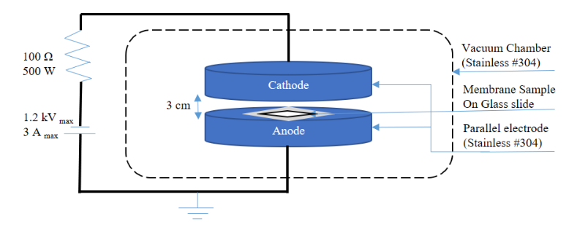
Figure 1. Schematic diagram of the membrane sample placed on the anode electrode in the DC plasma system used in this work.

Table 3. Water contact angle of membrane samples prepared at different conditions
Samples | Water contact angle (θ)
Samples | Evaporation Time (ET) 90 s | Evaporation Time (ET) 120 s
B1 | 83.30 ± 5.19 | 83.80 ± 6.22
B2 | 92.36 ± 2.09 | 81.89 ± 0.43
B3 | 81.84 ± 2.30 | 89.86 ± 1.82
B4 | 72.95 ± 1.83 | 70.07 ± 5.90

Results and Discussion
Water contact angle
As shown in Table 3, contact angles of membranes prepared at ET of 90 s, it was found that WCA of B2 increased to 92.36° whereas the WCA of B4 and B3 decreased to 72.95° and 81.84°, respectively. For membranes prepared at ET of 120 s, the highest WCA value was measured on the surface of B3 whereas the lowest WCA appeared on the surface of B4. WCA of B4 was 13° lower than of the pure B1 membrane. This indicated that modified TiO₂ by TMMS gave membranes with higher hydrophilic than by TEMS.

Table 4 shows the WCA of Ar-plasma treated membrane surfaces. It can be seen that WCA of PSF membranes that were plasma treated with a discharge power and exposure time of 20 W and 4 min, respectively, decreased clearly. From Table 4, WCA of A4 membrane prepared at ET of 90 and 120 s decreased about 60°. The lowest WCA (9.96 ± 5.32°) appeared on the surface of A4 membrane prepared at ET of 120 s. This phenomenon showed that TMMS affected the dispersion of TiO₂ in the matrix of PSF membranes. Furthermore, the photocatalytic property of TiO₂ in PSF membranes was stimulated by plasma radiation leading to an increase in hydrophilicity. TMMS showed an increase silane bonds on TiO₂ surface which enable it to improve functional groups of organic compounds capture, as explained by Zhao et al. [16].

Table 4. Water contact angle of Ar-plasma treated (20 W, 4 min) membranes
Sample | Contact angle (θ)
Sample | Evaporation Time (ET) 90 s | Evaporation Time (ET) 120 s
A1 | 17.06 ± 2.35 | 15.34 ± 1.35
A2 | 17.36 ± 2.51 | 11.11 ± 2.45
A4 | 12.58 ± 3.57 | 9.96 ± 2.32

When the surface of TiO₂ was improved with TMMS, TiO₂ exhibited properties of organic material and was well dispersed in an organic membrane. Typically, TiO₂ showed the photocatalytic properties after it was activated by plasma. These phenomena represent the increase of hydrophilic properties. Similar to Hashimato et al. [11] suggestion, TiO₂ excited by ultraviolet (UV) light revealed hydrophilic properties. Besides, TiO₂ can induce the dissociation of water without the use of external voltage. Therefore, TiO₂ induced the surface of a membrane to be more hydrophilic. The glow discharge plasma consisted of several elements and a frequency range of UV. UV light encourages its photocatalytic properties. In this work, the permanency of hydrophilicity of plasma treated membrane was evaluated. We found that in the ageing time of 30 days, WCA of plasma treated membrane surface gradually retrieved to the WCA of pure and untreated PSF membrane. The WCA of pure and plasma treated membrane recovered faster when compared with A2 and A4 membranes. Importantly, the lowest recovery of WCA appeared on the surface of A4.

Figure 2 shows that the WCA of plasma treated PSF membranes was increased with ageing time. Using B1 as a reference, the WCA of A1 increased faster when compared with that of A2 and A4 membranes. However, WCA of A1 and became close to B1 membrane in the storage time of 25 days. The recovery rate of WCA in A2 was similar to the result obtained from A4 membrane. For A2 membranes prepared with ET of 120 s, WCA increased to 56.25 ± 1.96° after being stored at room temperature for 25 days, while the A4 at the same ageing time showed about 51.24 ± 1.47°. It was clear that WCA at ageing time of 30 days of A4 recovered slower than that of A2 membranes. Additionally, for the membrane prepared with ET 90 s, WCA of A2 and A4 membrane were about 70.33 ± 1.24° and 58.35 ± 1.64°, respectively. It was confirmed that modified TiO₂ can prolong the hydrophilicity of the plasma treated PSF membranes. Due to the fact that hydrophilicity of the membrane surface easily causes contamination by airborne smirch in ambient condition. This explained the temporary water-like property [6].

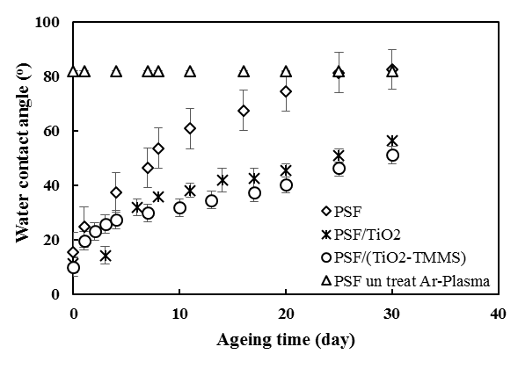
(a)

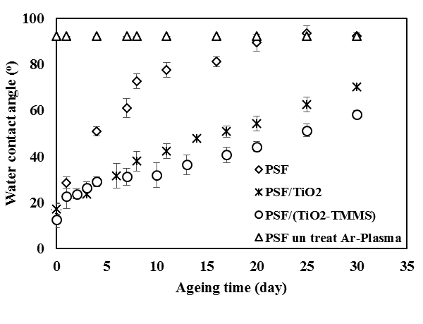
(b)

Figure 2. Variation of WCA with a storage time of 30 days of untreated and Ar-plasma treated membranes prepared at ET 120 s (a) and 90 s (b). PSF: A1, PSF/TiO2: A2, PSF/(TiO2-TMMS): A4 and PSF untreated Ar-Plasma: B1.

Fourier transform infra-red spectroscopy
Since PSF membranes are organic materials whereas TiO₂ is an inorganic material, the agglomeration of TiO₂ generally take place when it is blended in PSF membranes. To improve this problem, the modification of TiO₂ surfaces by a silane coupling agent was conducted. The objective of this modification was to introduce the organic functional group on the surface of TiO₂ nanoparticles. Introduction of organic groups on the surface of TiO₂ affected the dispersion of them in the polymer matrix. Figure 3 shows the FTIR spectrum of B2 and B4 membranes. It is shown that the Ti-O-Si bonds [17] appeared in a wavenumber range of 910 – 960 cm⁻¹. In the B4 system more Ti-O-Si bonds were created than in the B2 system. The number of Ti-O-Si bonds creations lead to an increase of the compatibility of the modified TiO₂ with the matrix of PSF membranes.

Scanning electron microscope results
Figure 4 shows an SEM micrograph at a magnification of 5,000x of a membrane cross section and Figure 4(a) shows the thick and dense selective layer and a large number of pores in the sub-structure of B1. The agglomeration and dispersion of TiO₂ particles in the membrane structure can be observed through the SEM micrograph. From Figure 4(a) and 4(b), the thicknesses of the skin layer membranes are 0.9 and 0.1 µm, respectively. TiO₂ was dispersed less in the PSF matrix compared to the modified ones with TMMS. This shows the enhancement of Ti-O-Si bonds in B4 membranes within 0.3 µm membrane thickness. The selective or skin layer of both B2 and B4 was thinner than of the B1 membrane. Additionally, the wall of pore of B2 and B4 membranes were thicker than of the B1 membrane. The variation of skin layer thickness affected the gas permeation rate of prepared membranes. According to these reasons, the plasma treated membrane showed greater gas permeation rate in A4 membrane compared to that of A1 and A2 membranes.

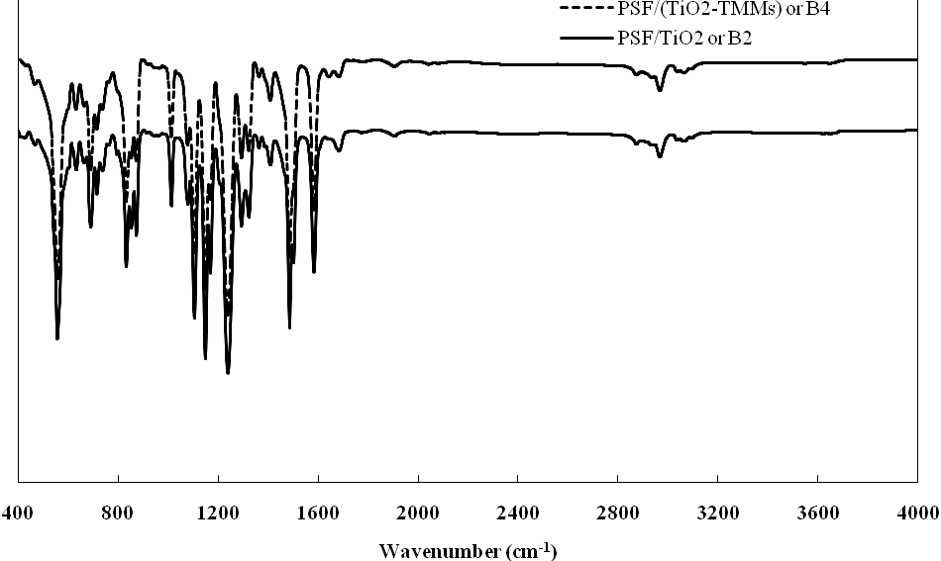

Figure 3. FTIR spectrum of B2 and B4 membranes.

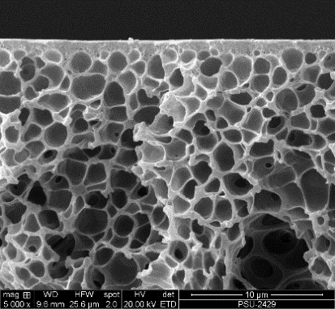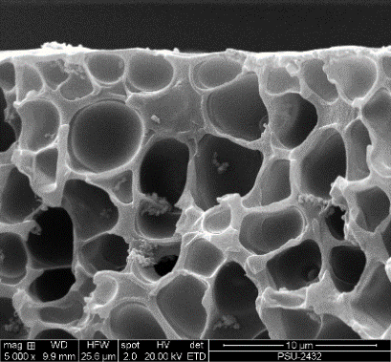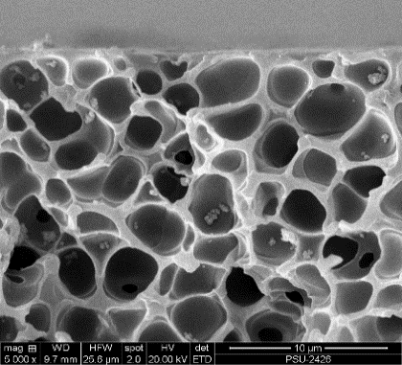
c
b
a

Figure 4. SEM micrographs (5,000x) of B1 (a), B2 (b) and B4 (c) membranes prepared with ET of 120 s

Atomic force microscope
Figure 5(a) to (c) show the surface morphology of B1, B2, and A4 membranes. An area of 50×50 µm² was scanned. It was shown that the highest roughness appeared on the surface of the B2 membrane prepared with ET of 120 s, whereas for plasma treated PSF/(TiO₂-TMMS), A4 membranes, the lowest roughness appeared when compared with B2 membranes. AFM results, when PSF was adulterated by TiO₂ it creates more roughness on the membrane surface as shown in Figure 5b (roughness at nanometer scale). After plasma treatment, the membrane surface was reduced in its roughness, as shown in Figure 5c. It should be emphasized that the smoother surface does not reflect more hydrophilicity upon the decrease nanoscale roughness, which then reduces the probability of the lotus effect occurrence. This finding is useful and can be explored further.

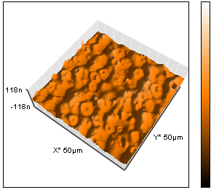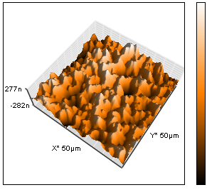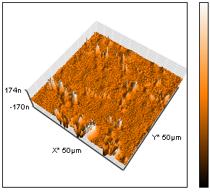
c
b
a
Rms 11.359 nm Rms 92.013 nm Rms 29.875 nm

Figure 5. AFM micrographs of B1 (a), B2 (b), and A4(c) membranes after plasma treatment

Gas permeation testing
The maximum permeance of CO₂ was about 80.81±0.09 GPU measured with the A4 membrane, which was prepared with ET of 120 s. This result corresponded to the aim of this study. The CO₂ permeance of A4 membranes is higher than of A1 and A2 membranes prepared with the same ET. From Table 5, it can be seen that the CO₂ permeance of A1 and A2 membranes were about 18.36 ± 0.07 and 17.46 ± 0.05 GPU, respectively. Similarly, the permeance of CH₄ increased from 3.29 ± 0.05 to 18.59 ± 0.07 GPU for A1 and A4 membranes, respectively. In addition to the gas permeance, the maximum CO₂/CH₄ selectivity was about 6.84 ± 0.01 for A2 membranes prepared with ET of 120 s. It was shown that the selectivity of gas inversely varied with the gas permeance. Consequently, the minimum ideal CO₂/CH₄ selectivity of about 4.34 ± 0.01 determined for the A4 membranes because these membranes showed the maximum gas permeation. To enhance both the permeance and the selectivity of gases, further studies should be conducted with new aspects such as facilitated transport and refined mixed matrix membranes to be considered.

Table 5. Permeance (P/L) and ideal CO₂/CH₄ selectivity of plasma treated membranes (ET 120 s)
Sample, ET 120 s | P/L (GPU) |  | Selectivity of CO₂/CH₄
Sample, ET 120 s | CO₂ | CH₄ | Selectivity of CO₂/CH₄
A1 | 18.36(±0.07) | 3.29(±0.05) | 5.58(±0.02)
A2 | 17.46(±0.05) | 2.55(±0.02) | 6.84(±0.01)
A4 | 80.81(±0.09) | 18.59(±0.07) | 4.35(±0.01)

Conclusion
In summary, preparation of flat sheet asymmetric PSF membranes by incorporation with the modified TiO₂ at evaporation time (ET) of 90 and 120 s was conducted. PSF/(TiO₂-TMMS) membrane prepared with ET at 120 s showed better results for CO₂ permeation by 340% and 363% compared with the PSF and PSF/TiO₂ membranes, respectively. Surface modification by DC Ar-plasma at indicated conditions showed improvement of membrane surface hydrophilicity. The maximum increase of the hydrophilic properties belonged to the plasma treated PSF/(TiO₂-TMMS) membrane preparing with ET at 120 s. The plasma treatment decreased WCA by 85.78% in PSF/(TiO₂-TMMS) membrane. Additionally, the permeance of the hydrophilic property created from Ar-plasma treatment for PSF/(TiO₂-TMMS) membranes was reported to improve. The hydrophilic property could sustain for over 30 days. The study of chemical change through the FTIR spectrum found an increase of Ti-O-Si bonds in the wavenumber range of 910-960 cm⁻¹. This confirmed the bonding of TiO₂ with TMMS coupling agent and lead to the enhancement of dispersion of modified TiO₂ in the PSF membranes. The dispersion of TiO₂ was also confirmed by SEM micrographs. This study also found that TiO₂ modified with TMMS leading to the enhancement of their hydrophilicity, although a slight decrease in CO₂/CH₄ selectivity was evidenced.

Acknowledgement
Special thanks to Wanichapichart, P. and Durrast, H., Prince of Songkla University (PSU) for their kind editing. Financial support from the National Talented Scholarship in Science Project is also acknowledged. The authors would like to thank to the Membrane Science and Technology Research Center (MSTRC) and Physics Department, PSU for providing the infrastructure needed.

References
- Yuenyao, C., Tirawanichakul, Y. and Chittrakarn, T. (2015). Asymmetric polysulfone gas separation membranes treated by low pressure DC glow discharge plasmas. Journal of Applied Polymer Science, 132(24): 42116 – 42126.
- Zhang, Y. and Liu, P. (2015). Polysulfone (PSF) composite membrane with micro-reaction locations (MRLs) made by doping sulfated TiO₂ deposited on SiO₂ nanotubes (STSNs) for cleaning waste water. Journal of Membrane Science, 493: 275 – 284.
- Xueli, G., Haizeng, W., Jian, W., Xing, H. and Congjie, G. (2013). Surface-modified PSF UF membrane by UV-assisted graft polymerization of capsaicin derivative moiety for fouling and bacterial resistance. Journal of Membrane Science, 445: 146 – 155.
- Yang, Y., Zhang, H., Wang, P., Zheng, Q. and Li, J. (2007). The influence of nano-sized TiO₂ fillers on the morphologies and properties of PSF UF membrane. Journal of Membrane Science, 288: 231 – 238.
- Konruang, S., Sirijarukul, S., Wanichapichart, P., Yu, L. and Chittrakarn, T. (2015). Ultraviolet-ray treatment of polysulfone membranes on the O₂/N₂ and CO₂/CH₄ separation performance. Journal of Applied Polymer Science, 132(25): 42074 – 42082.
- Bae, Y.-S. and Lee, C.-H. (2005). Sorption kinetics of eight gases on a carbon molecular sieve at elevated pressure. Journal of Carbon, 43: 95 – 107.
- Huang, S.-Y., Ganesan, P. and Popov, B. N. (2010). Electrocatalytic activity and stability of niobium-doped titanium oxide supported platinum catalyst for polymer electrolyte membrane fuel cells. Journal of Applied Catalysis B: Environmental, 96: 224 – 231.
- Albiter, E., Valenzuela, M. A., Alfaro, S., Valverde-Aguilar, G. and Martínez-Pallares, F. M. (2015). Photocatalytic deposition of Ag nanoparticles on TiO₂: Metal precursor effect on the structural and photoactivity properties. Journal of Saudi Chemical Society, 19: 563 – 573.
- Djurišic, A. B., Leung, Y. H. and Ching Ng, A. M. (2014). Strategies for improving the efficiency of semiconductor metal oxide photocatalysis. Journal of Royal Society of Chemistry, 1: 400 – 410.
- Monllor-Satoca, D., Gómez, R., González-Hidalgo, M. and Salvador, P. (2007). The ‘‘Direct–Indirect’’ model: An alternative kinetic approach in heterogeneous photocatalysis based on the degree of interaction of dissolved pollutant species with the semiconductor surface. Journal of Catalysis Today, 129: 247 – 255.
- Hashimoto, K., Irie, H. and Fujishima, A. (2005). TiO₂ photocatalysis: A historical overview and future prospects. Japanese Journal of Applied Physics, 44(12): 8269 – 8285.
- Khatun, N., Rini, E. G., Shirage, P., Rajput, P., Jha, S. N. and Sen, S. (2016). Effect of lattice distortion on band gap decrement due to vanadium substitution in TiO₂ nanoparticles. Journal of Materials Science in Semiconductor Processing, 50: 7 – 13.
- Liu, H., Lv, T. and Zhu, Z. (2016). Direct band gap narrowing of TiO₂/MoO₃ heterostructure composites for enhanced solar-driven photocatalytic activity. Journal of Solar Energy Materials & Solar Cells, 153: 1 – 8.
- Madaeni, S. S., Badieh, M., Vatanpour, V. and Ghaemi, N. (2012). Effect of titanium dioxide nanoparticles on polydimethylsiloxane/polyethersulfone composite membranes for gas separation. Journal of Polymer Engineering and Science, 56: 2664 – 2674.
- Chen, Q. and Yakovlev, N. L. (2010). Adsorption and interaction of organic silanes on TiO₂ nanoparticles. Journal of Applied Surface Science, 257: 1395 – 1400.
- Zhao, J., Milanova, M., Marijn, M.C.G. and Dutschk, V. (2012). Surface modification of TiO₂ nanoparticles with silane coupling agents. Journal of Colloids and Surfaces A, 413: 273 – 279.
- Li, Z., Hou, B., Xu, D., Sun, Y., Hu, W. and Deng, F. (2005). Comparative study of sol–gel-hydrothermal and sol–gel synthesis of titania–silica composite nanoparticles. Journal of Solid State Chemistry, 178: 1395 – 1405.

