

MALAYSIAN JOURNAL OF ANALYTICAL SCIENCES
ISSN 1394 - 2506

Published by The Malaysian Analytical Sciences Society

RESPONSE SURFACE METHODOLOGY ON WAX DEPOSIT OPTIMIZATION

(Pengoptimuman Lilin Mendap Menggunakan Kaedah Gerak Balas Permukaan)

Norida Ridzuan*, Zulkefli Yaacob, Fatmawati Adam

Faculty of Chemical Engineering & Natural Resources,

Universiti Malaysia Pahang, 26300 Gambang, Pahang, Malaysia

*Corresponding author: norida@ump.edu.my

Received: 21 October 2015; Accepted: 14 June 2016

Abstract

In this study, the application of response surface method design based on rotatable central composite design (CCD) was used to optimize wax deposit using Design Expert 7.1.6 software. The process consisted of 13 experiments involving eight factorial points and five replications at the center point. The influence of operating parameters on the weight of wax deposit was investigated using cold finger apparatus. The experimental result indicated that the amount of wax deposit was significant due to factors of cold finger temperature and experimental duration. The wax deposit amount decreased significantly with the decrease of experimental duration when the cold finger temperature increased to 25 °C. The minimum value of 0.0042 g of wax deposit was obtained at the optimized conditions of 1.5 hours and 25 °C, respectively.

Keywords: cold finger method, crude oil, optimization

Abstrak

Dalam kajian ini, penggunaan kaedah gerak balas permukaan berdasarkan reka bentuk komposit berpusat berputar (CCD) digunakan bagi mengoptimumkan lilin mendap menggunakan perisian Design Expert 7.1.6. Proses ini terdiri daripada 13 eksperimen yang melibatkan lapan titik faktorial dan lima ulangan di titik pusat. Pengaruh parameter operasi terhadap berat lilin mendap telah dikaji dengan menggunakan radas jejari sejuk. Hasil eksperimen menunjukkan bahawa jumlah lilin mendap dipengaruhi oleh faktor suhu jejari sejuk serta tempoh eksperimen. Jumlah lilin mendap akan berkurang sekiranya tempoh eksperimen dikurangkan berserta peningkatan suhu jejari sejuk kepada 25 °C. Nilai minimum 0.0042g lilin mendap telah diperolehi pada keadaan yang optimum iaitu pada 1.5 jam dan 25 °C .

Kata kunci: kaedah jejari sejuk, minyak mentah, pengoptimuman

Introduction

The major problem faced by the petroleum industry especially in flow assurance is the deposition of wax from crude oil at the tubing, pipeline, and surface flow line [1–3]. The formation of solid wax may lead to increased pumping power, decreased flow rate or even total blockage of line, with loss of production and capital investment [4]. Waxes are solids essentially made of mixtures of long chains, either normal or branched alkane compound formed when the temperature of crude oil falls below the wax appearance temperature (WAT) [5].

Normal conditions for reservoir temperature and pressures are within the range of 70 to 150 °C and 8,000 –15,000 psi, respectively [3, 6], while ocean floor temperature is around 4 °C [3]. When crude oil is transported from reservoir to pipeline, the crude oil temperature decreases below its wax appearance temperature (WAT) due to heat lost to surroundings [3, 7]. At ambient condition, for carbon atom chains less than four atoms (C1 to C4), it will show a gaseous state. Meanwhile, in the range of carbon atoms from C5 to C16, it turns to liquid and for carbon atoms more that C17, it forms solid [8]. Flow assurance is expected to lead to losses of billions of dollars yearly worldwide [9]. Many remediation techniques to encounter deposition problem have been employed, including removal and prevention approaches such as chemical, mechanical and thermal methods [5, 10 – 12]. To avoid wax deposition problems, the understanding of physicochemical characteristics of wax phase is needed [13].

The deposition of wax from crude oil is influenced by several factors, such as wax content and composition, flow rate, temperature difference between oil and pipe surface, and cooling rate along the pipeline [9]. Kelechukwu et al. [14, 15] claimed that the most common factor for wax deposition is the decrease of crude oil temperature. Many researchers have investigated the factor that gives the best influence on wax deposition. Shear and temperature effects have been observed by Jennings and Weispfennig toward wax deposition [16, 17]. They found an increase in shear increased wax inhibition; however, for the temperature effect, the inhibition result contradicted with the shear effect.

Previously, the optimum combination of operating conditions for minimum wax deposition has been studied by implementing one-factor-at-a-time technique (OFAT). However, this technique cannot examine the interactions of the factors considered. Therefore, to determine the impact of two or more factors on a response, Design Expert (DO) software was introduced. DO is a statistical software package that is specifically designed to perform the design of experiment (DOE). An experiment is a series of tests, called runs, in which changes are made in the input variables in order to identify the reasons for changes in the output response [18 – 20]. This software is able to offer comparative tests, screening, characterization, optimization, robust parameter design, mixture designs and combined designs. It also manages to come up with a systematic plan for the minimum number experiments to avoid time consumption [18, 19].

To optimize a response (output variable) that is influenced by several independent variables (input variables), response surface methodology (RSM) was introduced. RSM is a collection of mathematical and statistical techniques for building an empirical model. A group of researcher has investigated the factor that gives the best influence on wax deposition. For example, Valenijad et al. [21] have studied the experimental factors that affect crude oil wax deposition problem using Taguchi method. These factors include inlet crude oil temperature, temperature difference between the oil and pipe wall, flow rate of crude oil, wax content and time. However, there are limited studies on optimization that have been performed to optimize the process parameters for wax deposition by using response surface methodology and central composite design.

The present study focused on the development of a mathematical model for wax deposit prediction to describe the effects and the relationships between the process variables to obtain minimum yield of wax deposit formation using CCD.

Materials and Methods

Materials

Poly(ethylene-co-vinyl acetate) (EVA), n-heptane (purity 99.5%), and petroleum ether were obtained from Sigma-Aldrich. The raw crude oil sample was kindly supplied by PETRONAS Refinery from Kerteh, Terengganu, Malaysia. The characteristics of the crude oil sample are listed in Table 1.

Cold finger experimental set up

The rate of wax deposition of crude oil was evaluated using cold finger apparatus as shown in Figure 1. This apparatus is suitable for understanding the temperature correlation between bulk crude oil and the wall that is exposed to the temperature below WAT [17, 22, 23]. To run the experiment, a stainless steel jar was filled with 300 mL of crude oil sample. The crude oil needs to be conditioned above WAT for the purpose of thermal treatment for 1 hour in order to solubilize any precipitated wax. The experiments were carried out for 2 hours and the temperature of the crude oil sample needed to be maintained at 50 °C. The total amount of inhibitor used for each experiment was about 10 mL. The experiments were repeated three times to obtain precise data. The deposit was then scrapped off from the finger, weighed, and saved for potential analysis. Visual observation of the wax was made for determining the physical characteristics.

Table 1. Summary of the list of equipment used for physical analysis
Equipment | Usage
Differential scanning calorimeter (DSC) | To determine the wax appearance temperature (WAT) of the crude oil sample.
Cloud point and pour point apparatus, model Koehler | To determine the pour point of the crude sample.
Brookfield rotational digital, model DV-III (spindle No. 31) | To determine the rheology behavior of the crude oil sample.
Gas pycnometer, model Micromeritics AccuPyc II 1340 | To measure the density of the crude oil sample.
Acetone precipitation technique (Modified UOP method 46-64) | Extraction of wax crystal from the crude oil sample.

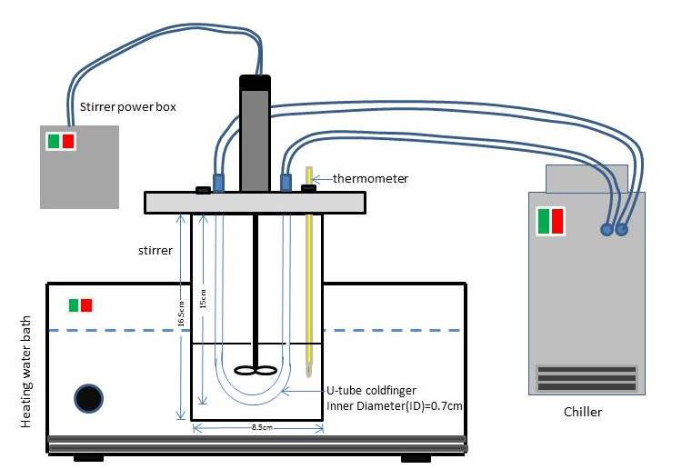

Figure 1. Cold finger apparatus set up

Experimental design
A standard RSM design called central composite design (CCD) was applied to study the wax deposit variables. The two independent variables studied were the cold finger temperature (A) and experimental duration (B) that were coded at five levels. Details of the lower limit and upper limit are shown in Table 2. The CCD includes eight factorial points and five replications at the center point, in which a total of 13 experimental runs were employed to fit a second-order polynomial model using Design Expert (State-Ease, USA) version 7.1.6. The inhibitor concentration and speed of rotation were set for 5000ppm and 0 rpm respectively for each run.

Table 2. Five-level two-factor central composite design condition variables
Independent Variables | Code  Symbol | Coded Level
Independent Variables | Code  Symbol | -α | -1 | 0 | 1 | + α
Cold finger temperature (°C) | A | 5 | 10 | 15 | 20 | 25
Experimental duration (h) | B | 1 | 1.5 | 2 | 2.5 | 3

Results and Discussion

CCD was employed in this study to optimize wax formation. The experimental work was done using cold finger test. The influence of cold finger temperature (A) and experimental duration (B) on the amount of wax deposit was investigated. An actual experimental model as shown in Table 3 was developed to predict the optimum condition for wax formation in order to minimize the expression of wax deposit. Figure 2 displays the experimental and predicted data from the polynomial relationship for each response. This model indicates a good model and shows a satisfactory correlation between the experimental and predicted values because the clusters of experimental and predicted values for the amount of wax deposit amount are close to the diagonal line in the parity plot (Figure 2). ANOVA test was carried out to prove the significance of each variable in the model. Table 4 shows ANOVA results. The final equation in terms of coded factors for the second-order polynomial is presented by Equation (1).

Ln (wax deposit+0.02), g = − 0.19 + 0.15 B − 1.03 A – (7.338E – 03) AB + 0.033 B² – 0.35 A² (1)

Table 3. Central composite design matrix for the experimental design and corresponding results
Std | Factor * |  |  | Wax Deposit (g)
Std | A B |  | Experimental | Experimental | Predicted | Predicted
Std | Uncoded  (Coded) | Uncoded  (Coded) | Valueª  (X),g | Value^{b}  (X’) | Value^{b}  (Y’) | Value ^{b}  (Y),g
1 | 1.5(−1) | 10(−1) | 1.5 | 0.42 | 0.366 | 1.33
2 | 2.5(1) | 10(−1) | 2.25 | 0.82 | 0.666 | 1.95
3 | 1.5(−1) | 20(1) | 0.2 | -1.51 | -1.694 | 0.15
4 | 2.5(1) | 20(1) | 0.3 | -1.14 | -1.394 | 0.23
5 | 1(−2) | 15(0) | 0.65 | -0.40 | -0.814 | 0.55
6 | 3(2) | 15(0) | 1.1 | 0.11 | -0.214 | 1.17
7 | 2(0) | 5(−2) | 1.5 | 0.42 | 1.546 | 1.58
8 | 2(0) | 25(2) | 0 | -3.91 | -2.574 | 0.01
9 | 2(0) | 15(0) | 0.75 | -0.26 | -0.514 | 0.81
10 | 2(0) | 15(0) | 0.75 | -0.26 | -0.514 | 0.81
11 | 2(0) | 15(0) | 0.75 | -0.26 | -0.514 | 0.81
12 | 2(0) | 15(0) | 0.75 | -0.26 | -0.514 | 0.81
13 | 2(0) | 15(0) | 0.75 | -0.26 | -0.514 | 0.81
A: Experimental duration, h, B: Cold Finger temperature, °C
ªExperiment values of wax deposit
^{b}Wax deposit that has been transformed according to the requirement of the statistical analysis.
*Constant variables: 5000 ppm and 0 rpm
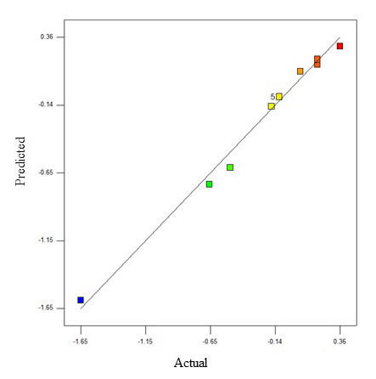

Figure 2. The comparison of predicted and experimental values for wax deposit amount using CCD

The fitness of the model is expressed by the R² value, which is 0.9886, indicating that 98.86% of the variability in the response can be explained by the model. Meanwhile, the coefficient of determination (adjusted R²) was calculated and determined as 0.9805, indicating that only 1.95% of the total variation were not included in the model. This value indicates a good agreement between the observed and the predicted values of wax deposit formation. Therefore, the regression model was applied to calculate the predicted values and the usefulness of the model as shown in Table 3, where the predicted values are closely matched with the experimental values after the transformation. In other words, the model obtained is applicable to predict the optimum conditions that will minimize the expression of wax deposit.

Table 4 shows the results for ANOVA. The significant terms are corresponded to A, B and B². This result reveals that cold finger temperature (B) gave the most significant effect to the expression of wax deposit (P < 0.0001) compare to experimental duration (A) factor. However, this significant effect could also be easily observed from Figure 3, where the highest cold finger temperature reduced the expression of wax deposit amount, and in contrast, lower temperature enhanced the formation of wax deposit.

Table 4. Analysis of variance (ANOVA) for the response of wax deposit using CCD
 | Sum of |  | Mean | F | p-value
Source | Squares | DF | Square | Value | Prob > F
Model | 16.19 | 5 | 3.24 | 121.77 | < 0.0001
A - Experimental duration | 0.27 | 1 | 0.27 | 10.11 | 0.0155
B - Cold finger temperature | 12.62 | 1 | 12.62 | 474.51 | < 0.0001
AB | 2.15 x 10⁻⁴ | 1 | 2.15 x 10⁻⁴ | 8.10 x 10⁻³ | 0.9308
A² | 2.60 x 10⁻² | 1 | 2.60 x 10⁻² | 0.97 | 0.3585
B² | 2.86 | 1 | 2.86 | 107.44 | < 0.0001
Residual | 0.19 | 7 | 2.70 x 10⁻²
Lack of Fit | 0.19 | 3 | 0.062
Pure Error | 0 | 4 | 0
Cor Total | 16.38 | 12

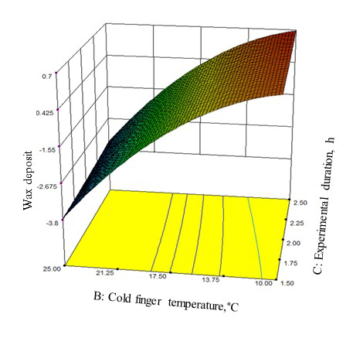

Figure 3. The comparison of predicted and experimental values of wax deposit amount using CCD

For model validation, 10 additional experiments were conducted by varying the experimental duration and cold finger temperature within the factor limit. The model validation of experimental and predicted data is shown in Table 5. The percentage between experimental and predicted values based on the model was found less than 10%. It can be seen that the validation correlation between the experimental and predicted values of wax deposit is in the form of a satisfactory correlation. For example, the actual experimental validation of 0.73 g of wax deposit was obtained at 1.5 hours and 15 °C. Meanwhile, the predicted values of wax deposit at the same condition was 0.72 g. Hence, the model for wax study can be considered to be valid.

Optimization studies
The optimization was performed to minimize the amount of wax deposited on the cold finger by using the selected range of variables after investigating the effect of experimental duration (A) and cold finger temperature (B), in which contour plots and response surface plot were produced according to the model (Equation (1)) as shown in Figure 3.

The response surface plot shows the optimum predicted wax amount for minimum wax formation. By applying the desirability function method in RSM, 9 solutions were obtained for the optimum covering criteria with the desirability value close to 1. In this case, the first solution was selected as a good desirability for a minimum amount of wax deposit with the desirability equal to 0.992. At this point, weight deposit is 0.0042 g at 1.5 hours experimental duration and 25 °C cold finger temperature, respectively. Table 6 shows the summary of the optimized wax deposit condition compared to the original value. It was found that after the optimization, the minimum value of 0.0042 g was achieved. It shows that 150-fold decrement of wax formation expression was achieved compared to prior the optimization.

Table 5. Model validation experiments and predicted data
 | Factors* |  | Experimental  Valueª  (X), g | Experimental  Value^{b}  (X’) | Predicted  Value^{b}  (Y') | Predicted  Value^{b}  (Y), g
No of  Experiments | A | B
1 | 1.7 | 10 | 1.4 | 0.35 | 0.41 | 1.48
2 | 2 | 17 | 0.58 | -0.51 | -0.64 | 0.51
3 | 1.5 | 15 | 0.73 | -0.29 | -0.30 | 0.72*
4 | 2.3 | 12 | 1.45 | 0.39 | 0.42 | 1.50
5 | 3 | 20 | 0.4 | -0.87 | -1.12 | 0.31
6 | 1.5 | 18 | 0.43 | -0.80 | -1.03 | 0.34
7 | 2.4 | 14 | 1.16 | 0.17 | 0.16 | 1.15
8 | 2.8 | 20 | 0.31 | -1.11 | -1.22 | 0.27
9 | 2 | 14 | 0.99 | 0.01 | 0.01 | 0.99
10 | 2 | 7 | 1.61 | 0.49 | 0.55 | 1.72

A: Experimental duration, h and B: Cold Finger Temperature, °C
ªExperimental values of wax deposit
^{b}Wax deposit that has been transformed according to the requirement of the statistical analysis
*An example of satisfactory correlation between the experimental and predicted

Table 6. Summary of the optimized wax deposit condition
Factor | Optimum  Condition | Original Condition | Experimental  Optimum  Valueª, G | Experimental  Original Value^{b}, G [24]
A - Experimental duration (h) | 0 | 0 | 0.0042 | 0.7500
B - Cold finger temperature (°C) | 25 | 15 | 0.0042 | 0.7500
C - Speed of rotation (rpm) | 1.5 | 2 | 0.0042 | 0.7500
D - Inhibitor concentration (ppm) | 5000 | 5000 | 0.0042 | 0.7500

ªOptimum condition and optimum values obtained from RSM result
^{b}Original condition and the best experimental values obtained from FFD result [24]

Conclusion

The optimization for the condition of wax deposit formation was achieved using response surface methodology. The optimized conditions were obtained at 1.5 hours and 25 °C. The minimum value achieved after the optimization was 0.0042 g, which is 150-fold decrement of wax formation expression compared to prior the optimization.

Acknowledgement
The authors would like to express high appreciation to Universiti Malaysia Pahang and the Ministry of Education (MOE), Malaysia, through the Research Acculturation Grant Scheme (RAGS-RDU 121414) for having this research project to be successfully conducted.

References
- Adewusi, V. (1997). Prediction of wax deposition potential of hydrocarbon systems from viscosity-pressure correlations. Fuel, 76: 1079 – 1083.
- Alben, K. (2002). Design, analyze, and optimize with Design-Expert. Analytical Chemistry, 74: 222 –223.
- Alghanduri, L. M., Elgarni, M. M., Daridon, J.L., and Coutinho, J. A. P. (2010). Characterization of Libyan waxy crude oils. Energy & Fuels, 24: 3101 – 3107.
- Azevedo, L.F.A., and Teixeira, A. M. (2003). A critical review of the modeling of wax deposition mechanisms. Petroleum Science and Technology, 21: 393 – 408.
- Benallal, A., Maurel, P., Agassant, J. F., Darbouret, M., Avril, G. and Pueriere, E. (2008). Wax deposition in pipelines: Flow-loop experiments and investigations on a novel ppproach. In Proceeding of SPE Annual Technical Conference and Exhibition: pp. 1 – 17.
- Huang, Z. (2011). Application of the fundamentals of heat and mass transfer to the investigation of wax deposition in subsea pipelines.Ph.D Thesis. University of Michingan,USA.
- Huang, Z., Lu, Y., Hoffmann, R. and Fogler, H. S. (2011). The effect of operating temperatures on wax deposition. Energy & Fuels, 25: 5180 – 5188.
- Jennings, D. W., and Breitigam, J. (2010). Paraffin inhibitor formulations for different application environments: From heated injection in the desert to extreme cold arctic temperatures. Energy & Fuels, 24: 2337 – 2349.
- Jennings, D. W. and Weispfennig, K. (2005). Effects of shear and temperature on wax deposition: Coldfinger investigation with a Gulf of Mexico crude oil. Energy & Fuels, 19:1376 – 1386.
- Jennings, D. W., and Weispfennig, K. (2006). Effect of shear on the performance of paraffin inhibitors: Cold finger investigation with Gulf of Mexico crude oils. Energy & Fuels, 20: 2457 – 2464.
- Kelechukwu, E., Said Al-Salim, H. S., and Yassin, A. A. M. (2010). Influencing factors governing paraffin wax deposition during crude production. International Journal of the Physical Sciences, 5: 2351 – 2362.
- Kelland, M. A. (2014). Production Chemicals for the oil and gas industry. Second Edition. CRC Press.
- Lashkarbolooki, M., Esmaeilzadeh, F. and Mowla, D. (2011). Mitigation of wax deposition by wax-crystal modifier for Kermanshah crude oil. Journal of Dispersion Science and Technology, 32: 975 –985.
- Lashkarbolooki, M., Seyfaee, A., Esmaeilzadeh, F. and Mowla, D. (2010). Experimental investigation of wax deposition in Kermanshah crude oil through a monitored flow loop apparatus. Energy & Fuels, 24: 1234 – 1241.
- Lazić, Ž. R. (2004). Design of experiments in chemical engineering: A practical guide. John Wiley & Sons.
- Lee, H.V. and Taufiq-yap, Y. H. (2015). Optimization study of binary metal oxides catalyzed transesterification system for biodiesel production. Process Safety and Environmental Protection, 94: 430 – 440.
- Mahto, V., Verma, D., Kumar, A. and Sharma, V. P. (2014). Wax deposition in flow lines under dynamic conditions. Petroleum Science and Technology, 32: 1996 – 2003.
- Misra, S., Baruah, S. and Singh, K. (1995). Paraffin problems in crude oil production and transportation: A review. SPE Production & Facilities, 10: 50 – 54.
- Kelechukwu, E. M., Said Al-Salim, H., and Saadi, A. 2013. Prediction of wax deposition problems of hydro-carbon production system. Journal Petroleum Science and Engineering, 108: 128 – 136.
- Dos Santos, J. D. S. T., Fernandes, A. C. and Giulietti, M. (2004). Study of the paraffin deposit formation using the cold finger methodology for Brazilian crude oils. Journal Petroleum Science and Engineering, 45: 47 – 60.
- Towler, B. F., Jaripatke, O., and Mokhatab, S. 2011. Experimental investigations of the mitigation of paraffin wax deposition in crude oil using chemical additives. Petroleum Science and Technology, 29: 468 – 483.
- Valinejad, R. and Nazar, A. R. S. (2013). An experimental design approach for investigating the effects of operating factors on the wax deposition in pipelines. Fuel, 106: 843 – 850.
- Wei, B. (2015). Recent advances on mitigating wax problem using polymeric wax crystal modifier. Journal of Petroleum Exploration and Production Technology, 5: 391 – 401.
- Ridzuan, N., Yaacob, Z. and Adam, F. (2016). Screening of factor influencing wax deposition using full factorial experimental design. Petroleum Science and Technology, 34: 84 – 90.

