

MALAYSIAN JOURNAL OF ANALYTICAL SCIENCES
ISSN 1394 - 2506

Published by The Malaysian Analytical Sciences Society

MORPHOLOGICAL PROPERTIES OF POLY(VINYLIDENE FLUORIDE-CO-TETRAFLUOROETHYLENE MEMBRANE): EFFECT OF SOLVENTS AND POLYMER CONCENTRATIONS

(Sifat–Sifat Morfologi Membran Kepingan Rata Poli(Vinilidena Fluorida-Ko Tetrafluoridaetilena): Kesan Pelarut dan Kepekatan Polimer)

Amira Mohd Nasib*, Irfan Hatim, Nora Jullok, Hameed R. Alamery

School of Bioprocess Engineering,

Universiti Malaysia Perlis, 02600 Arau, Perlis, Malaysia

*Corresponding author: amira.m.nasib@gmail.com

Received: 26 August 2016; Accepted: 8 January 2017

Abstract

Poly(vinylidene fluoride-co-tetrafluoroethylene) (PVDF-co-PTFE) flat sheet membranes were prepared via phase inversion process by means of immersion precipitation. The effects on the microstructure of prepared membranes by using different solvents and the effect of polymer solution composition (polymer concentration) on the membrane morphologies and the membrane porosity were studied. Three different solvents were employed, which were, N,N-dimethylacetamide (DMAc), N-methyl-2-pyrrolidone (NMP) and N,N-dimethylformamide (DMF). Different polymer concentrations were used; 20 wt.%, 25 wt.% and 30 wt.%. Brookfield viscometer was used to measure the viscosity for each polymer solution before the membrane was casting. The morphological study for the cross-sectional area of PVDF-co-PTFE membrane was carried out by using scanning electron microscope (SEM). The membrane porosity was determined by using the weight difference and density resulted from the immersing of dry membrane into octanol for 15 seconds. The results showed that the polymer concentration was a particularly important parameter. At different polymer concentration, the precipitant plays an important role and finally influence the prepared membrane microstructure. At higher concentration of PVDF-co-PTFE polymer, the prepared membrane possessed a sponge-like membrane structures, whereas at lower concentration, a finger-like structure was obtained. It was also found that, the membrane porosity decreases with the increasing of polymer concentration. The effect of different solvent reflected to different morphologies of the prepared flat sheet membranes. Prepared membrane with more sponge-like structure indicated a weak dissolution solvent was used. Hence, a small amount of water needed to induce precipitation and reduced the precipitation rate.

Keywords: PVDF-co-PTFE polymer, phase inversion, polymer concentration, membrane morphology

Abstrak

Membran kepingan rata poli (vinilidena fluorida-ko-tetrafluoridaetilena) (PVDF-ko-PTFE) telah disediakan dengan kaedah fasa penyongsangan menggunakan fasa pemisah bukan pelarut teraruh (FPBT). Kesan ke atas mikrostruktur membran tersedia dengan menggunakan pelarut yang berbeza dan kesan komposisi larutan penuangan (kepekatan polimer) ke atas morfologi membran dan keliangan membran telah dikaji. Tiga pelarut yang berbeza digunakan ialah N,N-dimetilasetamida (DMAs), N-metil-2-pirolidon (NMP) dan N,N-dimetilformamida (DMF). Kepekatan polimer yang berbeza akan digunakan, iaitu pada 20 wt.%, 25 wt.% dan 30 wt.%. Brookfield viskometer digunakan untuk mengukur kelikatan lasrutan polimer sebelum membran diacukan. Kajian morfologi bagi kawasan keratan rentas membran PVDF-co-PTFE telah dijalankan dengan menggunakan mikroskop elektron pengimbas (SEM). Analisis keputusan keliangan ditentukan dengan perendaman membran kering di dalam oktanol selama 15 saat. Keputusan menunjukkan bahawa kepekatan polimer adalah parameter penting. Pada kepekatan polimer yang berbeza, bahan pemendak memainkan peranan yang penting dan akhirnya mempengaruhi mikrostruktur membran tersedia. Pada kepekatan polimer PVDF-ko-PTFE yang lebih tinggi, membran tersedia memiliki struktur membran seperti span, sedangkan pada kepekatan yang lebih rendah, struktur seperti-jejari telah diperolehi. Ia juga mendapati bahawa, keliangan membran menurun dengan peningkatan kepekatan polimer. Penggunaan pelarut yang berbeza terkesan kepada berlainan morfologi membran kepingan rata yang tersedia. Membran tersedia dengan struktur seperti span menunjukkan pelarut pelarutan lemah telah digunakan. Oleh itu, jumlah air yang sedikit diperlukan untuk mendorong mendakan dan mengurangkan kadar mendakan.

Kata kunci: PVDF-ko-PTFE polimer, fasa pemisah, kepekatan polimer, morfologi membran

Introduction

The first commercial membrane was invented via phase inversion method by Loeb and Sourirajan in early 1960’s [1]. Phase inversion is a demixing process whereby the initially homogenous polymer solution changed from a liquid to a solid state in a controlled manner. The process can be achieve in different ways, which are (a) non-solvent induced phase separation (NIPS) or known as immersion precipitation; (b) thermally induced phase separation (TIPS); and (c) vapour induced phase separation (VIPS). It is reported that among these techniques, NIPS is the most popular method for the membrane fabrication because it allows the preparation of many membrane morphologies [2, 3]. However, different variable of phase inversion parameters applied will give different morphological properties of the prepared membranes, and consequently on their properties [4]. These include the composition of polymer solution (polymer concentration, solvent, co-solvent, additives and their respective concentration) [5], the types of support materials (polymer, glass, metal, nonwovens, etc.) [6], the thickness of the casted polymer films [7], the temperature and evaporation time before immersion [8], as well as the temperature and composition of the coagulation bath [9]. Therefore, the preparation of membrane will exhibit different properties of the membranes and it is necessary to understand the factors contribute to the changes of membrane properties [10].

The membranes can be made from inorganic material and/or organic material. Fluoropolymers such as poly(vinylidene fluoride) (PVDF) is among attractive organic material that been used for commercial membrane fabrication. Usually, fluoropolymers possess a high thermal stability, chemical resistance and lower surface tension due to low polarizability and strong electronegativity of the fluorine atom, its small van Der Waals radius and the strong C-F bond [11-13]. The application fields of PVDF membrane had been reported by many researchers which include the application in pharmaceutical industry for removal of endotoxins from pharmaceutical grade-water system; application in membrane distillation for reverse osmosis pre-treatment for brackish water and seawater [14], application in waste water treatment for textile dye removal [15, 16], recovery of ethanol [17], application as a separator in lithium-ion rechargeable batteries [7], and absorption of CO₂ [18]. Despite the advantages of PVDF membrane mentioned in the previous work, there still a room for improvement to enhanced the hydrophobicity and mechanical properties of the prepared membrane [19, 20]. Poly(vinylidene fluoride-co-tetrafluoroethylene) (PVDF-co-PTFE) is a PVDF copolymer. The increase in the fluorine content results to more hydrophobic material than PVDF due to the incorporation of an amorphous phase of tetrafluoroethylene (TFE) into the main vinylidenefluoride (VDF) constituent blocks. The contact angle of PVDF membrane is around 70 to 80° can be increased up to 100° by using PVDF-co-PTFE polymer. In addition, Feng et al. (2004) in their study of preparation and properties of microporous membrane from PVDF-co-PTFE for membrane distillation reported that the addition of TFE in PVDF gave a superior mechanical strength compared to PVDF [21].

In this work, three different solvents (N,N-dimethylacetamide, N-methyl-2-pyrrolidone and N,N-dimethyl-foemamide) at different PVDF-co-PTFE polymer concentration (20 wt.%, 25 wt.% and 30 wt.%) was used to explore the effect on the prepared membrane properties. The polymer solution viscosity was measured by using Brookfield viscometer. Meanwhile, the morphologies of prepared membranes were characterized by using scanning electron microscope (SEM), whereas the membrane volume porosity was determined by gravimetric method.

Materials and Methods

Materials

Poly (vinylidene fluoride-co-tetrafluoroethylene) (PVDF-co-PTFE) was obtained from Arkema Pte Ltd, Singapore. Three solvents were used namely N,N-dimethylacetamide (DMAc), N-methyl-2-pyrrolidone (NMP) and N,N-dimethylfoemamide (DMF). DMAc (≥ 99.0% purity) was purchased from Merck Millipore Corporation, NMP (≥ 99.5% purity) from Sigma Aldrichand DMF (≥ 95.0% purity) from Fisher Scientific. All solvents were used as a solvent without any purification.

Polymer solution preparation

PVDF-co-PTFE powder and its solvent (DMAc, NMP and DMF) were dissolved in a sealed conical flask under continuous rotation for 2 hours using an overhead stirrer. The rotation speed was constant at 200 rpm. Throughout the stirring process, the temperature of the mixture was maintained at 50 °C. A homogenous polymer solution was then degassed in an oven with a temperature of 45 to 50 °C for 24 hours [22].

Phase inversion method

The non-solvent induced phase separation (NIPS) was choosen to cast a flat sheet membrane. A PVDF-co-PTFE solution was casted onto a glass plate using a hand-casting knife with a knife gap set at 400±10 μm and followed by exposed to the surrounding air for 30 seconds. The cast film together with the glass plate was immersed into a coagulation bath immediately for 24 hours after the evaporation period come to an end. The coagulation bath medium consists of purely distilled water. Finally, the solidified membrane was taken out from the coagulation bath and dried at room temperature for 24 hours [22].

Characterization of prepared membrane

The polymer solution viscosity was measured by a Brookfield Dial Reading Viscometer (RVT Model) using a cylindrical sample container. The result of all measurement was taken from the mean of at least three single measurement at room temperature. Meanwhile, the prepared membrane surface and the cross section morphological studies was carried out by using a scanning electron microscope (SEM) model JSM 6260 LE JEOL. The pore sizes was observed through the SEM images and measured by using SEMAFORE software. Whereas, the porosity of the prepared membrane was analysed by using an octanol test. The membrane porosity, ω was defined as the volume of the membrane pores divided by the total volume of the porous membrane [21]. The sample was immersed into octanol for 15 seconds to improve the hydrophilicity. The sample was immersed into distilled water for 2 min before being dried using a filter paper. Mass of samples before and after soaked in both octanol and distilled water were recorded. Equation (1) was used to calculate the membrane porosity.

$ω = \frac{m_{n}/ρ_{n}}{{m_{n}}/{p_{n}}+ {m_{p}}/{ρ_{p}}}$ (1)

where ω is the porosity of the membrane, m_{p} is the mass of dry membrane (g), m_{n} is the mass of absorbed octanol (g), ρ_{p} is the density of the membrane (g/cm³), and ρ_{n} is the density of octanol (g/cm³). This method is used to estimate the porosity by determined the weight of liquid contained in the membrane pores.

Results and Discussion

Effect of different solvent in polymer solution

Three different solvents, DMAc, NMP and DMF were used to study the effect on the prepared membrane properties. The preparation of polymer solution was by adding 20 wt.% of PVDF-co-PTFE into 80 wt.% of solvent. Table 1 lists the formulation used to prepare the polymer membranes and the polymer solution viscosity reading.

Table 1. Fabrication conditions of flat sheet PVDF-co-PTFE membrane
Membrane Code | Polymer Solution Composition |  | Viscosity (cp)
Membrane Code | PVDF-co-PTFE  (wt.%) | Solvent | Viscosity (cp)
C-20-0 | 20 | 80 wt.% DMAc | 750
P-20-0 | 20 | 80 wt.% NMP | 1000
F-20-0 | 20 | 80 wt.% DMF | 2100

The viscosity of the polymer solution was an important parameter, which used to determine the inter-diffusion rate of solvent and non-solvent during the immersion precipitation process. Therefore, it affected the kinetics of the phase inversion throughout the membrane formation. As shown in Table 1, the viscosity of 20 wt.% PVDF-co-PTFE prepared with different solvents were found to be highest by using DMF and followed by NMP and DMAc respectively. According to Gracia-Fernandez, increasing of polymer solution viscosity reduced the coagulation rate of the polymer solution [23]. Hence, lower in coagulation rate hindered the formation of finger-like structure or even macro-voids.

Figure 1 shows the micrographs of the surface and cross sections of the flat sheet membranes. As can be seen from the figure, the cross sectional area of C-20-0, P-20-0 and F-20-0 membranes exhibited inhomogeneous structures due to the presence of large voids and cavities with different size and shape beneath the skin. It is observed that the number and size of interconnected macrovoids for the membrane casting with DMAc solvent was larger than the membrane casting with NMP and DMF solvents. This structure indicated a fast precipitation rate during the immersion process. Meanwhile, the least macrovoids formation can be seen from F-20-0 micrograph. The membrane microstructure exhibited a mixture of finger-like and a sponge-like structure throughout the membrane cross section. The elimination of macro-voids from the cross section structure along with the highest reading of polymer solution viscosity agree with each other. Similar result was obtained by Peng et al. where increasing the polymer solution viscosity was the main approach to suppress the macro-voids from the prepared membrane cross section [24].

a
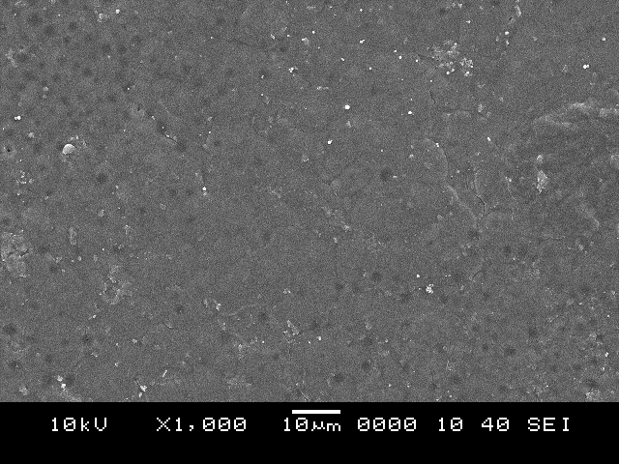  Pores  C-20-0  a | 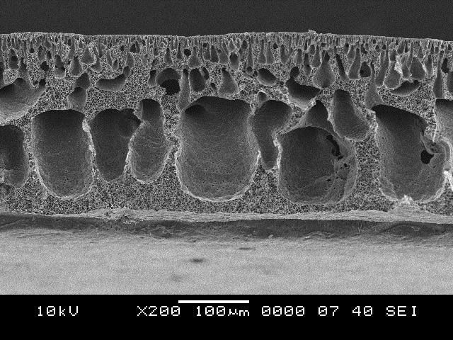  C-20-0  b
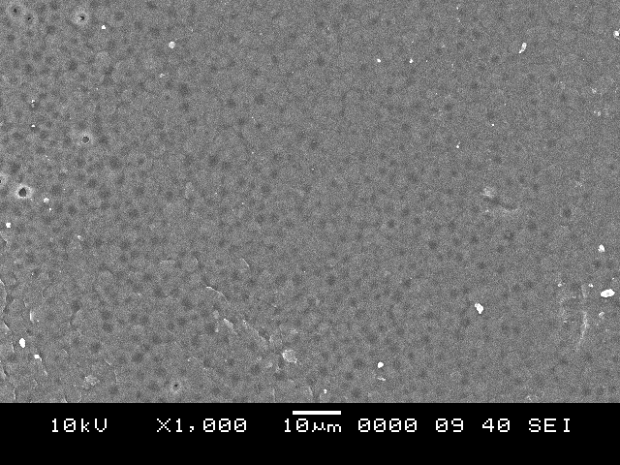  P-20-0  b  Pores | 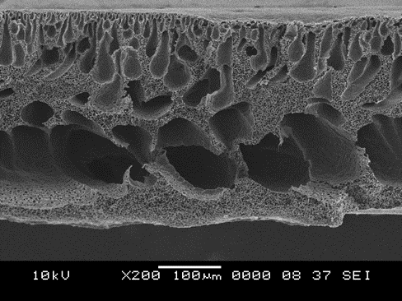  P-20-0
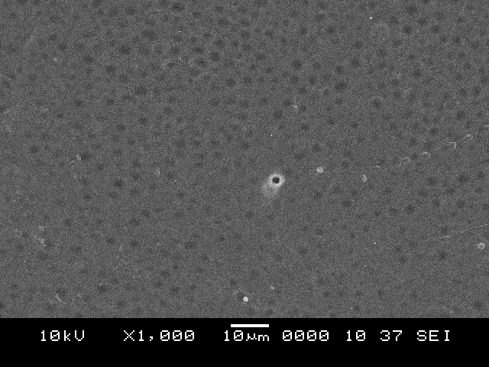  c  F-20-0  Pores | 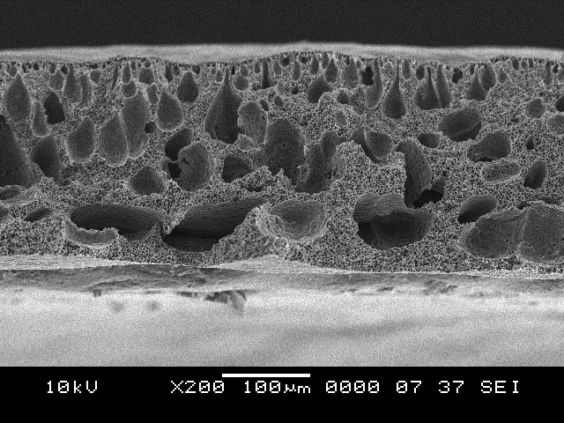  c  F-20-0

Figure 1. SEM micrographs of flat sheet membranes surface and cross sectional area prepared by using 20 wt.% PVDF-co-PTFE with different solvent; (a) DMAc, (b) NMP and (c) DMF

Table 2. Membrane pore size and porosity with different solvents
Membrane Code | Solvent | Pore Size (μm) |  | Porosity, ε (%)
Membrane Code | Solvent | Minimum | Maximum | Porosity, ε (%)
C-20-0 | DMAc | 4.3 ± 1.7 | 115.0 ± 35.1 | 47.6
P-20-0 | NMP | 4.0 ± 1.6 | 153.8 ± 34.7 | 53.7
F-20-0 | DMF | 4.3 ± 1.9 | 76.9 ± 20.6 | 35.8

It has been generally accepted that the morphology of prepared membrane affected by the precipitation rate which will then influences the membrane properties [19]. Table 2 represents the membrane properties of PVDF-co-PTFE membranes casted with different solvents in terms of pore sizes and porosity measured by using SEMAFORE software. It can be seen that the smallest pore size was contributed by F-20-0, followed by C-20-0 and P-20-0 respectively. The membrane used NMP as solvent obtained the maximum pore size of 153.8 μm, larger than those other membranes. The membrane prepared by NMP showed the highest porosity value which was 53.7%, which can be related to the pore sizes. This findings agreed with the research conducted by Li et al. in investigation of mixed solvents effect on the membrane performance [25]. Therefore, the growing of membrane macrovoids leads to higher porosity.

Effect of polymer concentration

Three different polymer concentrations were used (20 wt.%, 25 wt.% and 30 wt.%) to study their effects on the prepared flat sheet membrane. Table 3 summarizes the fabrication conditions of flat sheet PVDF-co-PTFE membrane along with their polymer solution viscosities. NMP was chosen to be a constant solvent for all three different polymer concentrations. Increasing the polymer concentration from 20 wt.% to 30 wt.% caused a greatly increasing of polymer solution viscosity from 1000 cp to 16500 cp.

Polymer concentration in polymer solution plays an important part in determining the membrane properties. Figure 2 represents the SEM micrographs of PVDF-co-PTFE flat sheet membrane using different polymer concentrations. It can be obviously seen that the increasing of polymer concentration in the casting solution changed the pore morphologies from large macrovoids to thin finger-like voids with combination of sponge-like elements. The number and size of maximum cavities were reduced with increasing of polymer concentration from 20 to 30 wt. %. The maximum cavities size was reduced from 153.8 μm at 20 wt.% to 46.2 μm at 30 wt. % of polymer concentration.

Table 3. Fabrication conditions of flat sheet PVDF-co-PTFE membrane
Membrane Code | Polymer Solution Composition |  | Viscosity (cp)
Membrane Code | PVDF-co-PTFE  (wt.%) | Solvent | Viscosity (cp)
P-20-0 | 20 | 80 wt.% NMP | 1000
P-25-0 | 25 | 75 wt.% NMP | 3800
P-30-0 | 30 | 70 wt.% NMP | 16500

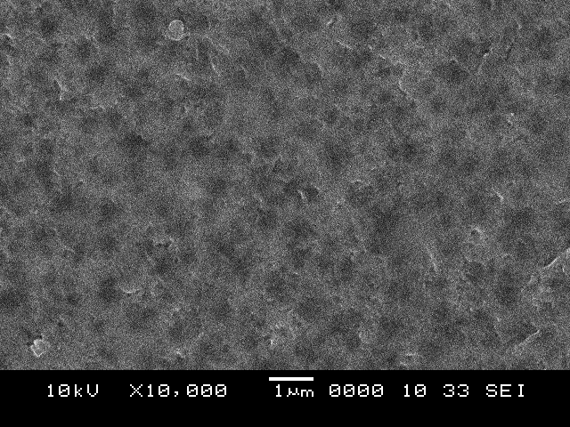  P-20-0  a | P-20-0  a
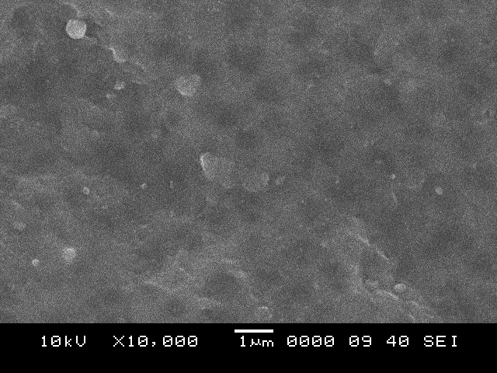  P-25-0  b | 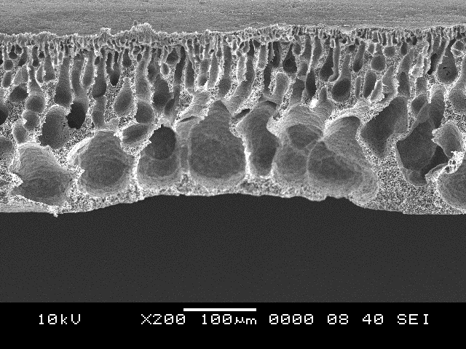  P-25-0  b
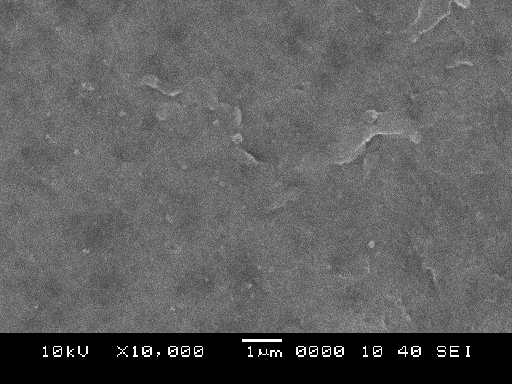  P-30-0  cC | 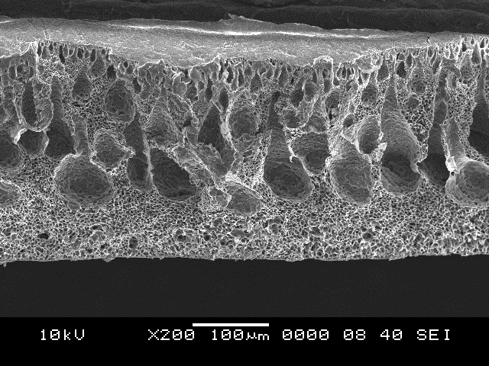  P-30-0  c

Figure 2. SEM micrographs of flat sheet membranes surface and cross sectional area using different polymer concentrations by using NMP as a solvent. (a) 20 wt.%, (b) 25 wt.% and (c) 30 wt.%

Increasing the polymer concentration resulted in higher polymer concentrations at the polymer/non-solvent interface prior the immersion in the non-solvent coagulation bath. This implied the volume fraction of polymer increases. Therefore, diffusion rate of solvent and non-solvent was slowed down, thus resulted in delay demixing. Consequently, the membrane morphology changes from macrovoids to a more spongy structure [3]. A similar result also found by Hoϯda et al. in the study of polysulfone concentration effects on the nanofiltration membranes. As the polysulfone concentration increased, the number of macrovoids decreases and their shape changes from a finger-like to pear-like structure [26]. The findings were also agreed in another research conducted by Marbelia et al. [8]. Formation of smaller pores as increasing of polymer concentration was due to the delayed liquid-liquid demixing between the solvent and non-solvent [8].

Figure 3 shows the effect of polymer concentration on porosity. The average porosity of membrane decreases with the increased of the polymer concentration. The increasing of polymer concentration in the polymer solution resulted in higher polymer concentration at the non-solvent interface. This implied that the volume fraction of polymer increased and consequently lower porosity was obtained [3].

Figure 3. Effect of polymer concentration on PVDF-co-PTFE membrane porosity

Conclusion

The PVDF-co-PTFE membranes were prepared by using phase inversion by means NIPS method. The membrane morphology, porosity and pore size obtained was greatly depends on the experimental parameters such as the selection of solvent and the concentration of polymer used. The results reveals that the types of solvents used in the casting solution considerably affected the membrane properties. From SEM micrographs, higher number of finger-like macrovoids formed when DMAC was used instead of DMF due to the rate of precipitation of polymer solution using DMAc is faster due to lower viscosity. On the other hand, sponge-like structure with lower porosity can be observed by using DMF as a solvent. With increasing polymer concentration lead to increasing in polymer solution viscosity, hence the precipitation rate becomes slower. The structure of the prepared membranes changes remarkably from finger-like macrovoids to sponge-like as the polymer concentration increased. In addition, the number of macrovoids also decreased. The alteration of the pore structure resulted in decreasing of pore sizes and consequently, the membrane porosity was reduced.

Acknowledgement

This work was financially supported by research grant from Malaysia government.

References
- Liu, F., Hashim, N. A., Liu, Y., Abed, M. M. and Li, K. (2011). Progress in the production and modification of PVDF membranes. Journal of Membrane Science, 375(1): 1 - 27.
- Mulder, J. (2012). Basic principles of membrane technology. Springer Science & Business Media.
- Guillen, G. R., Pan, Y., Li, M. and Hoek, E. M. (2011). Preparation and characterization of membranes formed by nonsolvent induced phase separation: A review. Industrial & Engineering Chemistry Research, 50(7): 3798 - 3817.
- Khayet, M. and Matsuura, T. (2011). Membrane distillation: Principles and applications. Elsevier, Amsterdam.
- See-Toh, Y. H., Ferreira, F. C. and Livingston, A. G. (2007). The influence of membrane formation parameters on the functional performance of organic solvent nanofiltration membranes. Journal of Membrane Science, 299(1): 236 - 250.
- Gevers, L. E., Aldea, S., Vankelecom, I. F. and Jacobs, P. A. (2006). Optimisation of a lab-scale method for preparation of composite membranes with a filled dense top-layer. Journal of Membrane Science, 281(1): 741 - 746.
- Ji, G.-L., Zhu, B.-K., Cui, Z.-Y., Zhang, C.-F. and Xu, Y.-Y. (2007). PVDF porous matrix with controlled microstructure prepared by TIPS process as polymer electrolyte for lithium ion battery. Polymer, 48(21): 6415 - 6425.
- Marbelia, L., M. R. Bilad, A. Piassecka, P.S. Jishna, P.V. Naik & I.F. Vankelecom, (2016). Study of PVDF asymmetric membranes in a high-throughput membrane bioreactor (HT-MBR): Influence of phase inversion parameters and filtration performance. Separation and Purification Technology, 162: 6 - 13.
- Ahmad, A., Ramli, W., Fernando, W. and Daud, W. R. W. (2012). Effect of ethanol concentration in water coagulation bath on pore geometry of PVDF membrane for membrane gas absorption application in CO₂ removal. Separation and Purification Technology, 88: 11 - 18.
- Buonomenna, M., Macchi, P., Davoli, M. and Drioli, E. (2007). Poly (vinylidene fluoride) membranes by phase inversion: the role the casting and coagulation conditions play in their morphology, crystalline structure and properties. European Polymer Journal, 43(4): 1557 - 1572.
- Souzy, R. and Ameduri, B. (2005). Functional fluoropolymers for fuel cell membranes. Progress in Polymer Science, 30(6): 644 - 687.
- Drobny, J. G. (2008). Technology of fluoropolymers. CRC Press, Florida.
- Cui, Z., Drioli E. and Lee, Y. M. (2014). Recent progress in fluoropolymers for membranes. Progress in Polymer Science, 39(1): 164 - 198.
- Alkhudhiri, A., Darwish, N. and Hilal, N. (2012). Membrane distillation: A comprehensive review. Desalination, 287: 2 - 18.
- Kang, G.-D. and Cao, Y.-M. (2014). Application and modification of poly (vinylidene fluoride)(PVDF) membranes – A review. Journal of Membrane Science, 463: 145 - 165.
- Deowan, S. A., Galiano, F., Hoinkis, J., Johnson, D., Altinkaya, S. A., Gabriele, B., Hilal, N., Drioli, E. and Figoli, A. (2016). Novel low-fouling membrane bioreactor (MBR) for industrial wastewater treatment. Journal of Membrane Science, 510: 524 - 532.
- Zhan, X., Li, J., Huang, J.and Chen, C. (2010). Enhanced pervaporation performance of multi-layer PDMS/PVDF composite membrane for ethanol recovery from aqueous solution. Applied Biochemistry and Biotechnology, 160(2): 632 - 642.
- Mansourizadeh, A., Ismail, A. F., Abdullah, M. S. and Ng, B. C. (2010). Preparation of polyvinylidene fluoride hollow fiber membranes for CO₂ absorption using phase-inversion promoter additives. Journal of Membrane Science, 355(1): 200 - 207.
- Wang, J., Zheng, L., Wu, Z., Zhang, Y. and Zhang, X. (2016). Fabrication of hydrophobic flat sheet and hollow fiber membranes from PVDF and PVDF-CTFE for membrane distillation. Journal of Membrane Science, 497: 183 - 193.
- Ameduri, B. (2009). From vinylidene fluoride (VDF) to the applications of VDF-containing polymers and copolymers: Recent developments and future trends. Chemical Reviews, 109(12): 6632 - 6686.
- Feng, C., Shi, B., Li, G. and Wu, Y. (2004). Preparation and properties of microporous membrane from poly (vinylidene fluoride-co-tetrafluoroethylene)(F2.4) for membrane distillation. Journal of Membrane Science, 237(1): 15 - 24.
- Ooi, B., Yatim, N., Ahmad, A. and Lai, S. (2012). Preparation of polyvinylidene fluoride membrane via dual coagulation bath system and its wettability study. Journal of Applied Polymer Science, 124(S1): 225 - 232

- García-Fernández, L., García-Payo, M. and Khayet, M. (2014). Effects of mixed solvents on the structural morphology and membrane distillation performance of PVDF-HFP hollow fiber membranes. Journal of Membrane Science, 468: 324 - 338.
- Peng, N., Chung, T.-S. and Wang, K. Y. (2008). Macrovoid evolution and critical factors to form macrovoid-free hollow fiber membranes. Journal of Membrane Science, 318(1): 363 - 372.
- Li, Q., Xu, Z. L. and Yu, L.Y. (2010). Effects of mixed solvents and PVDF types on performances of PVDF microporous membranes. Journal of Applied Polymer Science, 115(4): 2277 - 2287.
- Hołda, A. K., Aernouts, B., Saeys W. and Vankelecom, I. F. (2013). Study of polymer concentration and evaporation time as phase inversion parameters for polysulfone-based SRNF membranes. Journal of Membrane Science, 442: 196 - 205.

