EFFECT OF CALCINATION TEMPERATURE ON ZnO/TIO₂
COMPOSITE IN PHOTOCATALYTIC TREATMENT OF PHENOL
UNDER VISIBLE LIGHT

(Kesan Pengkalsinan Suhu ke atas Komposit ZnO/TiO₂ untuk Menyingkirkan Fenol

Melalui Fotopemangkin di bawah Cahaya Nampak)

Nur Syazrin Amalina Abdullah*, Sufian So’aib, Jaganatthan Krishnan

Faculty of Chemical Engineering

Universiti Teknologi Mara, 40450 Shah Alam, Selangor, Malaysia

*Corresponding author: syaz_pingu@yahoo.com

Abstract

Composite catalyst ZnO/TiO₂ of molar ratio 0.75% was synthesized via sol gel method. The effect of preparation method on the crystal morphology was investigated. The catalyst particles were calcinated at 500 ºC,550 ºC and 600 °C for 3 hours. The XRD results revealed that calcination temperature controls the crystalline phase in terms of homogeneity and surface area of catalyst produced. The particle size was found to increase with calcination temperature suggesting the effect of different calcination temperatures on catalytic activity for complete degradation of phenol. The result found that ZnO/TiO₂ catalyst calcinated at 600 ºC resulted in 70% phenol degradation within five hours of irradiation time under visible light. The kinetic behavior of phenol degradation was found to fit with pseudo first order Langmuir-Hinshelwood kinetic model.

Keywords: sol gel, ZnO/TiO₂ catalyst, photocatalytic degradation, visible light, kinetic

Abstrak
Pemangkin komposit ZnO/TiO₂ dengan 0.75% nisbah molar telah di sintesis melalui kaedah sol gel. Kesan kaedah penyediaan pada morfologi kristal itu telah di selidiki. Zarah-zarah pemangkin telah dikalsinkan pada suhu 500 ºC, 550 ºC dan 600 ºC selama 3 jam. Keputusan XRD menunjukkan suhu pengkalsinan mengawal fasa kristal dari segi kesamaan dan kawasan permukaan pemangkin dihasilkan. Saiz zarah didapati meningkat sejajar dengan peningkatan suhu pengkalsinan mencadangkan kesan suhu pengkalsinan yang berbeza pada aktiviti pemangkin untuk penyingkiran penuh fenol. Keputusan mendapati pemangkin ZnO/TiO₂ yang dikalsinkan pada 600 ºC boleh menyebabkan 70% fenol terdegradasi bagi tempoh lima jam masa penyinaran di bawah cahaya nampak. Kelakuan kinetik degradasi fenol didapati sesuai dengan pseudo peringkat pertama model kinetik Langmuir - Hinshelwood.

Kata kunci: sol gel, mangkin ZnO/TiO₂, degradasi fotomangkin, cahaya nampak, kinetik

Introduction
Phenol if present even in lower concentrations causes water pollution in terms of reduction in taste and strong odor. The toxicity imparted by phenol is mainly sourced from industrial wastewater especially petrochemical industries. To date, promising treatment using Advanced Oxidation Process (AOPs) which relies on highly reactive chemical compound such as hydroxyl radical (OH) are gaining favorable in water remediation [1]. The main reason for this immense attraction is because the process is capable to bring complete removal of pollutant by converting broad of them to water and carbon dioxide. Among various AOPs process, the photocatalytic oxidation methods appear to be most effective for the treatment of wastewater contaminated with phenolic compound as this process offer lower cost compared to other AOPs treatments. In addition, other major advantages of photocatalytic treatment include ambient operating conditions and complete destruction of water pollutants without generation of secondary pollutants. Titanium dioxide (TiO₂) has been subject of the most work in photocatalytic treatment applications due to its high activity, relative chemical stability, inertia to corrosion, reducing cost and environment friendly. Nonetheless, photooxidation by TiO₂ photocatalytic alone relies on ultraviolet light which only makes up to 5% of solar light.

To address this, coupling two or more semiconductors that able to undergo photo-excitation under much broader visible light spectrum seem to provide a novel approach to achieve a higher efficient charge separation and enhances interfacial charge [2]. Specifically, absorption of TiO₂ can be extended to visible range [3] when coupling with other semiconductor or doping with non-metal or metal ion such as B, C, N, Fe³⁺ and Zn²⁺ [4] or metal oxides such as ZnO and MgO. Previous works reported that ZnO appeared as promising photocatalyst and alternative to TiO₂ since its photo degradation mechanism was identical to TiO₂. Furthermore, ZnO is known to have wider direct gap as well as higher solar reception and utilization efficiency for organic pollutant degradation [5]. In short, the doping energy level that is forming between ZnO-TiO₂ can generate more photon utilization and consequently, a higher photocatalytic activity will be attained. Therefore, it is highly advantageous to develop TiO₂-ZnO based photocatalyst to enhanced activities under visible light. At present, a number of synthetic methods have been used to synthesize the nanostructures of catalyst. Sol gel technique is common and convenient approach to obtain products of controlled shape and size at high purity and low cost [6]. Others advantages are low processing temperature, which resulting uniform nanostructures for easier control of the kinetics of the chemical reaction.

In this work, the photocatalytic degradation of phenol was carried using doped TiO₂ with ZnO operating under visible light. The photocatalytic activity of ZnO/TiO₂ was optimized by applying optimum calcination temperature during catalyst synthesis. This was followed by characterization using Scanning Electron Microscopy (SEM) and X-ray Diffraction (XRD) technique.

Materials and Methods
Synthesizing TiO₂/ZnO composite catalysts via sol gel method
The zinc and titanium precursor solutions were prepared separately. TiO₂ precursor sol was prepared by mixing 30 mL of tetraisopropyl titanate with 100 mL ethanol absolute forming solution A. The solution was stirred for half an hour. In order to obtain ZnO precursor sol, 0.04g of zinc acetate and 90 mL deionized water were mixed with 10 mL acetic acid to form solution B. The solution was then stir until zinc acetate completely dissolved. The starting materials ratio was equal to ZnO/TiO₂ (molar ratio) of 0.75% dopant concentration. Then, solution B was added drop by drop into solution A under vigorous stirring for 2 hours in order to increase the solubility. The mixed sol was aged for 24 hours at room temperature until forming gel. The product dried in an oven at 100 °C for about 24 hours in order to evaporate the solvent and to remove the organic residuals. The crystal form of sample was then ground using mortar and pestle before calcinate for 3 hours with the heating rate of 3Cº/minutes at three different calcination temperatures of 500, 550 and 600 ºC.

Photocatalytic activity
The photocatalytic activity of the synthesized composite catalyst was tested with phenol as a model pollutant at atmospheric pressure and room temperature. A 100 ml of phenol solution with initial concentration of 10 ppm was mixed with 0.1 g of the ZnO/TiO₂ catalyst in the photoreactor. The catalysts were suspended in an aqueous solution of phenol in 100 ml beaker. The suspension was illuminated by a 25 Watt Fluorescent lamp in a closed box. Prior to irradiation, the suspension was magnetically stirred in dark for 30 minutes to attain the adsorption-desorption equilibrium between the catalyst and the solution and 2 ml of sample was taken out and analyzed. In order to maximize the energy exchange between the source of irradiation and reaction mixture, the lamp has been placed in the centre of the reactor with distance of 6 cm from phenol solution [7]. After 30 minutes’ irradiation, 2 ml sample was taken out and centrifuge for 10 minute at 10000 rpm to separate catalyst and phenol solution. Next, 1 ml of supernatant was mixed with Folin reagent and finally analyst by UV-visible spectrophotometers at 750 nm. Consequently, the procedure was repeated after every 30 minutes until complete 5 hours reaction of lamp illumination. The experiments were repeated for different calcination temperature. Then, the photodegradation efficiency can be calculated from the equation 1:

$η=\frac{\left[{(c}_{0}-c_{t})\right]}{c_{o }} x 100\%$ (1)$η=\frac{\left[{(c}_{0}-c_{t})\right]}{c_{o }} x 100\%$

where ɳ is define as phenol degradation rate efficiency, C_{o} is define as concentration of phenol at initial time (before illuminate) and C_{t} is concentration of phenol at specific time.

Kinetic studies of photocatalytic degradation of phenol on ZnO/TiO₂
Langmuir-Hinshelwood (L-H) model was used to describe kinetics of photocatalytic degradation of ZnO/TiO₂. It has been widely used for phenol catalytic reaction rate equations in liquid-phase photocatalysis for a surface-catalyzed reaction. When the concentrations of water and oxygen remain constant, the equation model can be presented as follows to determine the reaction rate:

$r=-\frac{dC}{dt}=\frac{kK_{LH}C}{1+K_{LH}C}$ (2)

where r is the reaction rate (mg m^{–3} min^{–1}), C is the initial concentration (mg m^{–3}), K is the reaction rate constant (mg m^{–3} min^{–1}) and K_{LH} is the Langmuir adsorption constant (m³ min^{–1}) related to the limiting rate of reaction at maximum coverage for the experimental conditions.

The reaction rate is dependent on the experimental conditions (experimental setup design, irradiation conditions, and inlet concentration) and also on the competitive mechanisms of photochemical reactions, and adsorption. At low concentrations of phenols, K_{LH}C (K_{LH}Ceq<< 1) is negligible and equation (2) becomes a pseudo-first-order rate expression (3), as denoted below:

$r=-\frac{dC}{dt}=k_{LH}K_{L}C_{eq}=k_{app}C_{eq}$ (3)

Integrating equation (3)

$ln\frac{C_{eq}}{C}=k_{app}t+constant$ (4)

Equations (2) – (3) account for the adsorption of the reactant (phenols) only but do not consider the adsorption on catalyst of any intermediates or products formed during the course of the degradation reaction. When the adsorption is relatively low or when initial concentration of pollutants is very low, the reaction can be simplified to pseudo-first-order kinetics. A plot of − ln(C/Co) versus reaction time t yields a straight line, and the slope is the apparent rate constant (k).

$ln\frac{C}{C_{o}}=-kt$ (5)
Characterization

The synthesized catalysts are characterized by XRD and SEM studies for their structural and morphological characteristics respectively. Structure and phase composition are determined by X-ray diffraction (XRD) and Cu Ka radiation (l = 1.5418 A˚) at 20 kV and the diffraction angle being in the range of 10º–80º.The crystallite size of the samples were then calculate using Scherrer’s equation (6).

$D=\frac{kλ}{βcosθ}$ (6)
where θ is the diffraction angle, λ is the X-ray wavelength (0.154059 nm), β is the full width at half maximum (FWHM) of the diffraction, D is the crystallite size and k is a constant (shape factor, about 0.9).

While, the morphology was characterized by a high-resolution scanning electron microscopy, SEM at an accelerating voltage of 50 kV.

Results and Discussion
Effect of calcination temperature
A comparative study was conducted to describe the effect of calcination temperature on the efficiency of synthesized ZnO/TiO_{2.} The rates of phenol degradation with respect to different calcination temperature are shown on Figure 1. The result shows the phenol was degraded up to 70% at calcination temperature of 600 ºC, (Figure 1 (a)) compared to 36% at 550 ºC (Figure 1(b)) and 40% at 500 ºC (Figure 1(c)). Complete removal only took 120 minutes’ reaction at optimum 600 ºC calcination temperature. The degradation rate of phenol turned drastically low after 120 minutes. This phenomenon may explain the presence of inhibition occurred on the surface of Zn-TiO₂ catalyst. Other than that, it is believed photo-corrosion effect adsorption on the surface of catalyst during photocatalytic reaction contributed to low degradation rate [8]. Furthermore, the lower photocatalytic activity of phenol possibly can be explained by the less photo-generated electron and holes participated in reaction [9]. Consequently, reducing the availability of surface actives site for reaction to take place. On other words, more recombination occurred at the interface due to less electrons and hole scavengers present in lower heat treatment of synthesized composite catalyst. In addition, higher aggregation shown Figure 4(a) lead to lower reaction rates since it possessed smaller surface area.

(a)

Figure 1. Phenol degradation profile by composite catalyst calcinated at different temperature: (a)500 ºC, (b) 550 ºC and (c) 600 ºC

These experimental results indicate that ZnO/TiO₂ synthesized at 600 ºC works more effectively corresponding to the maximum formation of hydroxyl radical on the ZnO/TiO₂ surface resulting in the destruction of the target pollutant [10]. Morever, maximum phenol degradation achieved at this temperature was contributed by the formation of higher anatase phase which consequently enhances the crytallization of the phase [11]. Another reason, this can be due to the enhancement of the reaction rate took place between the organic molecules and the hydroxyl radicals and due to the increasing collision frequency of molecules to make ZnO and TiO₂ highly reactive under light excitation.

Apparently, effective degradation rate in all samples suggested TiO₂ doping with ZnO resulted narrow band gap. Therefore, it can be deduced doping TiO₂ with some metal oxide such ZnO appears to be the most promising to enhance photocatalytic activity under visible light. It is therefore reasonable to conclude photocatalytic activity of ZnO/TiO₂ was remarkably improved by applying higher calcination temperature. Carina et al. [12] demonstrated doping TiO₂ with ZnO optimized photocatalytic activity of Rhodamine under visible light. The presence of ZnO precursor boosts the vacant hydroxyl radicals for oxidation of dye. In addition, to wider light adsorption spectrum to visible light, ZnO also provides large surface to volume ratio to maximize surface contact with the pollutant. Another study by Janitabar et al. [13] made point that longer wavelength than catalyst band gap was needed in order to excite the surface thus increasing rate of degradation against pollution. These studies highlighted the influence of ZnO application as doping material and light on efficiency of reaction rate.

Kinetic studies of photocatalytic degradation of phenol on ZnO/TiO₂
Kinetic of photocatalytic obeyed first order reaction since apparent constant increased with temperature. This illustration can be explained by considering Langmuir-Hinshelwood model. The relationship between ln C/Co versus time, t was shown in Figure 2. The values of k_{app} represented by slope of graph can be obtained directly from linear curve in the plot. Value of rate constant shown in Figure 2 of photocatalytic degradation is influenced by calcination temperature. The lower reaction rate is probably due to impenetrability of the suspension and dissipation of light by catalyst particles [14]. However, the values obtained are still within the range of the previous studies (0.001-0.5).

(a)

(b)

(c)

Figure 2. Pseudo first order kinetic plot by composite catalyst calcinate at different temperature: (a) 500 ºC, (b) 550 ºC and (c) 600 ºC

X-ray diffractometer analysis
X-ray diffractometer (XRD) pattern was used in the determination of phase structure of photocatalyst calcinated at various temperatures. Based on the standard card of #JCPDS 84-1286 [15], for the sharp diffraction peaks located at 2𝜃 = 25.0°, 37.2○,38.4○, 39.1○, 48.2○, 54.0○, 55.3○ and 63.4○, can be attributed to the (101), (004), (112), (200), (105), (211), (118), and (220) planes, respectively. All samples posses’ almost similar diffraction peaks (Figure 3) which suggested only anatase phase present in the structure without any detectable ZnO related peaks. Rajesh et al proposed that photocatalytic activity of TiO₂ can be enhanced with the presence of anatase phase for degradation of dyes and organic contaminant in water as compared to rutile phase [16]. Dorian et al found that influencing factor such as higher number of surface hydroxyl group adsorbed on the anatase phase and slower charge carrier recombination contributed to higher rate of photocatalytic degradation of many pollutant [17].

Furthermore, no trace of wurtzite could be detected in the XRD pattern. This probably due to small dopant concentration of ZnO used in this study which is only 0.75%. This finding is in agreement with the reported studies where disappearances of ZnO peaks is attributed to the very small of crystallite size [3]. Figure 3(a) illustrates the highest intensity at 600ºC and sharpen peaks indicate at higher calcination temperature up to 600 ºC promotes higher crystallinity of catalyst forming. The average of crystallize size of the powder were then calculated using Scherrer equation and tabulated in Table 1.

Table 1. Different crystallize size with respect to various calcination temperature

Sample | Crystalline size, D (nm)
ZnO/TiO₂-500ºC | 8.76
ZnO/TiO₂-550ºC | 17.59
ZnO/TiO₂-600ºC | 29.24

An increase in the width of diffraction indicates a decrease in size of crystallite. As seen from Figure 3 where the line width of diffraction peak at different temperature changes considerably. The variation could be due to formation of anatase phase as crystallize size also increasing.

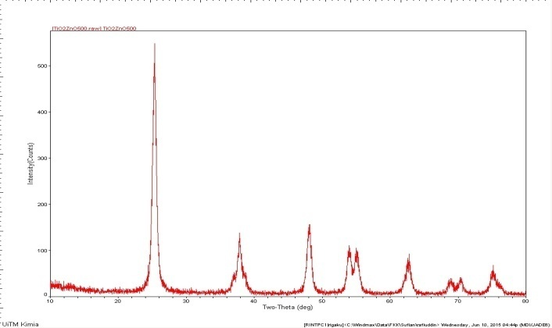
(a)

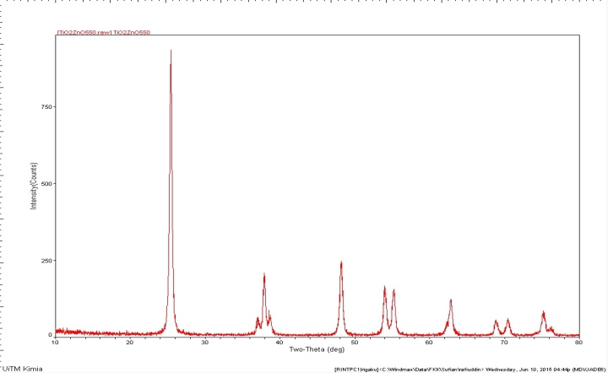
(b)

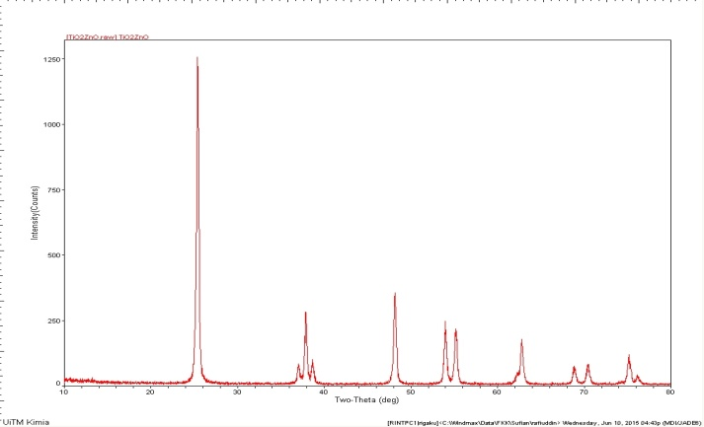
(c)

Figure 3. XRD analysis for ZnO-TiO₂ calcinated at different temperature: (a) ZnO/TiO₂-500 ºC, (b) ZnO/TiO₂-550 ºC, (c) ZnO/TiO₂-600 ºC

Scanning electron microscopy analysis
The morphology of ZnO/TiO₂ at different calcination temperature was characterized using Scanning Electron Microscopy (SEM). Based on observation, all prepared samples were found agglomerated and the particles were an irregular in size and shape. According to measurement, all sample as shown in Figure 4 having size of particles not more than 30 µm. Besides, the presence of small particles estimated to be less than 10 µm in diameter widely distributed within the samples were also observed.

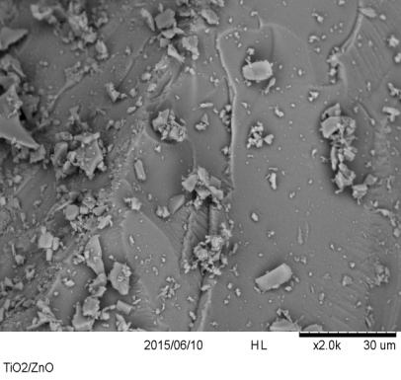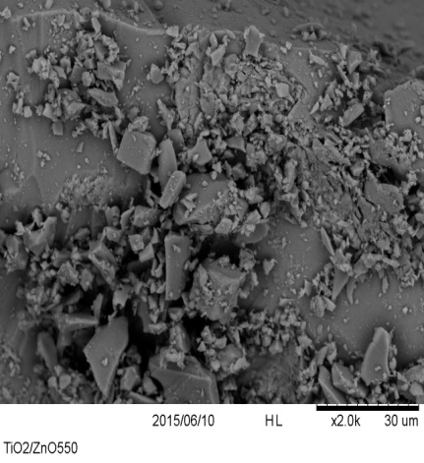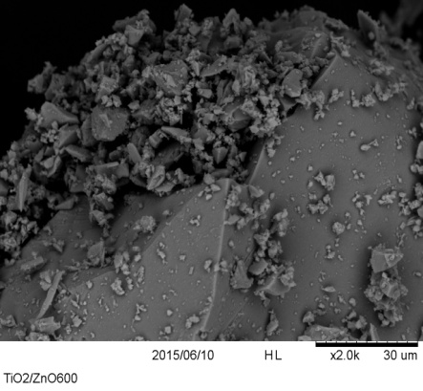
(c)
(b)
(a)

Figure 4. SEM analysis for ZnO-TiO₂ calcinated at different temperature:(a) ZnO/TiO₂ 500 ºC, (b) ZnO/TiO₂-550 ºC and (c) ZnO/TiO₂ 600 ºC

In agreement with the result obtained from XRD, it seems that TiO₂ is major component whereby ZnO were widely dispersed. It can be noticed that there was coagulation of particles in Figure 4(a) compared to the result in figure 4(b) where flocculation reduced specific surface area of synthesized catalyst. While, less aggregation on the surface ZnO/TiO₂ observed from figure 4(c) suggests more prolonged lifetime of excited state which leads to more effective reaction rate. Therefore, it can be deduced that the smaller particles would give higher surface area which is favorable for higher photocatalytic activity. This is likely due to many factors such as time taken for complete stirring of catalyst suspension, rate of stirring as well as temperature used during calcination [18] step potentially induced the formation of particle size.

Conclusion
The photocatalytic efficiency was evaluated using phenol solution as a model pollutant. The maximum efficiency of photodegradation rate of phenol was achieved at calcination temperature of 600 ºC. The crystalline size showed an increasing trend with respect to higher calcination temperature. The rate constant also increased with increasing calcination temperature. The adsorption kinetics was found to follow pseudo-first-order kinetics.

Acknowledgement
Authors would like to thank Research Management Centre (RMC), Universiti Teknologi MARA (UiTM) and Ministry of Higher Education Malaysia for funding through RAGS GRANT: 600-RMI/RAGS 5/3 (73 /2013).

References

- Pera-Titus, M., Garcıa-Molina, V., Baños, M. A., Giménez, J. and Esplugas, S. (2004). Degradation of chlorophenols by means of advanced oxidation processes: a general review. Applied Catalysis B: Environmental, 47(4): 219 – 256.
- Annadurai, G., Ling, L. Y. and Lee, J. (2007). Biodegradation of phenol by Pseudomonas pictorum on immobilized with chitin. African Journal of Biotechnology, 6(3): 296 – 303.
- Zou, X., Dong, X., Wang, L., Ma, H., Zhang, X. and Zhang, X. (2014). Preparation of Ni doped ZnO-TiO₂ composites and their enhanced photocatalytic activity. International Journal of Photoenergy, 2014: 1 – 8.
- Dey, S. and Mukherjee, S. (2010). Performance and kinetic evaluation of phenol biodegradation by mixed microbial culture in a batch reactor. International Journal of Water Resources and Environmental Engineering, 3(2): 40 – 49.
- Busca, G., Berardinelli, S., Resini, C. and Arrighi, L. (2008). Technologies for the removal of phenol from fluid streams: A short review of recent developments. Journal of Hazardous Materials, 160(2), 265 – 288.
- Udom, I., Myers, P. D., Ram, M. K., Hepp, A. F., Archibong, E., Stefanakos, E. K. and Goswami, D. Y. (2014). Optimization of photocatalytic degradation of phenol using simple photocatalytic reactor. American Journal of Analytical Chemistry, 5(11): 743 – 750.
- Sikirman, A., Krishnan, J., Jai, J. and Faraziehan, S. (2014). Preparation, characterization and effectivity of N, Fe-TiO₂ as a visible light active photocatalyst. Advanced Materials Research, 894: 245 – 249.
- Feng, C., Li, G., Ren, P., Wang, Y., Huang, X. and Li, D. (2014). Effect of photo-corrosion of Ag₂CO₃ on visible light photocatalytic activity of two kinds of Ag₂CO₃/TiO₂ prepared from different precursors. Applied Catalysis B: Environmental, 158: 224 – 232.
- Wang, Z-P., Xu, J., Cai, W-M., Zhou, B-X., He, Z-G., Cai, C-G. and Hong, X-T. (2005). Visible light induced photodegradation of organic pollutants on nitrogen and fluorine co-doped TiO₂ photocatalyst. Journal of Environmental Sciences, 17(1): 76 – 80.
- Yu, J., Yu, H., Cheng, B., Zhou, M. and Zhao, X. (2006). Enhanced photocatalytic activity of TiO₂ powder (P25) by hydrothermal treatment. Journal of Molecular Catalysis A: Chemical, 253(1): 112 –118.
- Yu, J. G., Yu, H. G., Cheng, B., Zhao, X. J., Yu, J. C.and Ho, W. K. (2003). The effect of calcination temperature on the surface microstructure and photocatalytic activity of TiO₂ thin films prepared by liquid phase deposition. The Journal of Physical Chemistry B, 107(50): 13871 – 13879.
- Pei, C. C. and Leung, W. W. F. (2013). Photocatalytic degradation of Rhodamine B by TiO₂/ZnO nanofibers under visible-light irradiation. Separation and Purification Technology, 114: 108 – 116.
- Janitabar Darzi, S. and Movahedi, M. (2014). Visible light photodegradation of phenol using nanoscale TiO₂ and ZnO impregnated with merbromin dye: A mechanistic investigation. Iranian Journal of Chemistry and Chemical Engineering, 33(2): 55 – 64.
- Abramović, B. F., Anderluh, V. B., Topalov, A. S. and Gaál, F. F. (2004). Kinetics of photocatalytic removal of 2-amino-5-chloropyridine from water. Acta Periodica Technologica, 35: 79 – 86.
- Joint Committee on Powder Diffraction Standards. Powder Diffraction File, Card No.21-1272. Swarthmore, PA.
- Tayade, R. J., Surolia, P. K., Kulkarni, R. G. and Jasra, R. V. (2007). Photocatalytic degradation of dyes and organic contaminants in water using nanocrystalline anatase and rutile TiO₂. Science and Technology of Advanced Materials, 8(6): 455 – 462.
- Hanaor, D. A. and Sorrell, C. C. (2011). Review of the anatase to rutile phase transformation. Journal of Materials Science, 46(4): 855 – 874.
- Amrollahi, R., Hamdy, M. S. and Mul, G. (2014). Understanding promotion of photocatalytic activity of TiO₂ by Au nanoparticles. Journal of Catalysis, 319: 194 – 199.

