IRON AND MANGANESE REMOVAL BY NANOFILTRATION AND ULTRAFILTRATION MEMBRANES: INFLUENCE OF PH ADJUSTMENT

(Penyingkiran Besi dan Mangan oleh Membran Penurasan-Nano dan Penurasan-Ultra: Pengaruh Pelarasan pH)

Norherdawati Kasim ^{1,3}*, Abdul Wahab Mohammad ^{1,2}, Siti Rozaimah Sheikh Abdullah¹

¹Department of Chemical and Process Engineering

Faculty of Engineering and Built Environment,

Universiti Kebangsaan Malaysia, 43600 UKM Bangi, Selangor, Malaysia

²Research Centre for Sustainable Process Technology (CESPRO)

Faculty of Engineering and Built Environment,

Universiti Kebangsaan Malaysia, 43600 UKM Bangi, Selangor, Malaysia

³Department of Chemistry, Centre for Defence Foundation Studies,

National Defence University of Malaysia, Kem Sg. Besi, 57000 Kuala Lumpur, Malaysia

*Corresponding author: herdawati@upnm.edu.my

Abstract

Iron and manganese present naturally in groundwater. Both metallic ions at excessive amounts normally contribute to rusty taste and reddish color to the water. Membrane technology may improve the conventional groundwater treatment method which commonly requires a large area and a lot of manpower. The present experimental work focused on membrane filtration of iron and manganese in order to study the influence of pH adjustment to the prepared artificial groundwater based on the permeate quality and membrane performances. In this study, two commercially available polyamide nanofiltration and ultrafiltration membranes (PA-NF, PA-UF) were tested to examine their capabilities in treating groundwater for drinking water resources. In order to achieve WHO drinking water standard, permeate quality of the artificial groundwater is considered satisfy if concentration of iron and manganese has reached 0.3 and 0.1 mg/L, respectively. Experimental results showed that pH at a range of 3-11 have significantly improved membrane performance in terms of their rejection. Rejection of iron at a feed concentration of 100 mg/L increased as pH of the feed solution increased for all tested membranes. However, the manganese rejection with a feed concentration at 50 mg/L showed various pattern of performance for each membrane. The pH of feed solution played an important role in changing the membrane surface properties and also, the characteristic of solute. This concludes that solute-membrane interaction mechanism has improved the performance of the tested membranes.

Keyword: iron rejection, manganese rejection, artificial groundwater, pH adjustment, drinking water

Abstrak

Besi dan mangan wujud semulajadi di dalam air bawah tanah. Kedua-dua ion logam ini pada jumlah yang berlebihan menyumbang kepada rasa berkarat dan warna yang kemerahan pada air. Kajian ini memberi tumpuan kepada penurasan logam besi dan mangan oleh membran dengan tujuan untuk mengkaji kesan pelarasan pH terhadap air bawah tanah buatan berdasarkan kepada kualiti telapan dan prestasi membran. Dalam ujikaji ini, dua membran poliamida penurasan-nano dan penurasan-ultra (PA-NF, PA-UF) yang boleh didapati secara komersial telah diuji untuk mengkaji keupayaan dalam merawat air bawah tanah sebagai sumber air minuman. Untuk mencapai piawaian WHO bagi air minuman, kualiti telapan air bawah tanah buatan dianggap memuaskan jika kepekatan besi dan mangan masing-masing mencapai 0.3 dan 0.1 mg/L. Keputusan ujikaji menunjukkan bahawa pH di antara julat 3-11 dengan ketaranya telah menambahbaik prestasi membran dari segi penyingkiran. Penyingkiran besi pada kepekatan suapan 100 mg/L telah meningkat apabila pH suapan meningkat untuk semua membran yang diuji. Walau bagaimanapun, penyingkaran mangan dengan kepekatan suapan pada 50 mg/L menunjukkan kepelbagaian corak prestasi bagi setiap membran. pH larutan suapan memainkan peranan penting dalam mengubah sifat-sifat permukaan membran dan juga sifat bahan terlarut. Kesimpulannya, mekanisme interaksi bahan terlarut-membran telah meningkatkan prestasi membran yang diuji.

Kata kunci: penyingkiran besi, penyingkiran mangan, air bawah tanah, pelarasan pH, air minuman

Introduction

Most of countries around the world rely on surface water for their daily needs including for drinking water sources. This is because surface water can be easily found over the land surface either in rivers, ponds, lakes, swamps or other fresh (not salty) sources. However, this natural water resource is more easily contaminated and contains most bacteria and other microorganism. Along with surface water, groundwater resources play a vital role in the production of clean and adequate drinking water supply all around the world. In countries such as Germany, Canada and the United States of America, nearly 70% of drinking water originates from groundwater [1]. The quality of groundwater is much better than surface water as soils, sands or rocks underneath the ground have become the filtration layers. It has been reported that most of groundwater consists some metal such as iron and manganese which naturally leach from many types of rocks and soils [2]. Iron (Fe) and manganese (Mn) are common metallic elements that exist together naturally especially in deeper wells [3]. Both are commonly found in water and are essential elements required in small amounts by all living organisms. Presence of excess amount of Fe and Mn resulted in metallic taste of water, slightly reddish colored water and rusty-brown stains of products like paper, cloths, and plastics [4]. World Health Organization (WHO) suggested that Fe and Mn concentrations in drinking water should be less than 0.3 mg/L and 0.1 mg/L, respectively [5].

The natural occurrence of Fe and Mn in groundwater usually with very little or without existence of oxygen, typically in deeper wells, in areas where groundwater flow is slow, and also in areas where groundwater flows through soils rich in organic matter. Fe and Mn usually present in natural groundwater in their most soluble form as divalent ions, Fe²⁺ and Mn²⁺. In soluble form they are colorless in groundwater but when exposed to air, they get oxidized then turn to insoluble form of Fe³⁺ and Mn⁴⁺, respectively and leave the water with brown-red color. Several techniques have been applied to remove these metals from groundwater including ion-exchange and water softening, adsorption by activated carbon, aeration and filtration, biosorption, ionic liquid extraction, and so forth [6–10]. Recently, the application of membrane technology including nanofiltration (NF) in water treatment for producing drinking water resources has been increased rapidly. NF technology is able to overcome operational problems that used to associate with conventional technique. In addition, other advantages of NF membranes are high retention of divalent ions at lower operating pressure and higher flux with lower energy consumption.

Numerous studies have been reported in investigating the ability of membrane filtration in water treatment [11–13]. However, only a limited number of studies have examined the removal of Fe and Mn in groundwater by using NF membranes [14]. Therefore, this study was conducted with the aim to investigate the influence of operating variables on the retention of Fe and Mn in groundwater using NF membranes. Along with this membrane, the treatment was also conducted by UF membrane in order to compare their performances. In this work, Fe and Mn removal were investigated using polyamide NF and UF membrane assigned as PA-NF and PA-UF, respectively. The main objective of this study is to investigate the influence of feed solution pH on the prepared synthetic groundwater, quality of permeate samples and performance of the membranes. Further analysis according to surface morphology images was measured by field emission scanning electron microscopy (FESEM) to further understand the rejection mechanisms involved.

Materials and Methods

Chemicals and membranes

All of purchased chemicals were analytical grade with high purity and no further purification required before used. Ferrous chloride tetrahydrate (FeCl₂.4H₂O) was procured from HmbG® Chemicals and manganese chloride tetrahydrate (MnCl₂.4H₂O) was obtained from Bendosen Laboratory Chemicals. In the preparation of synthetic groundwater, both chemicals were used by dissolving them in ultra-pure water with conductivity less than 1µS/cm as a single component for filtration experiment. The feed solution with individual metal of Fe and Mn were provided at initial concentration of 100 mg Fe/L and 50 mg Mn/L, respectively. The synthetic groundwater was freshly prepared a day before filtration experiment and kept in a cold room. This procedure was conducted to avoid the divalent ions from being oxidized. Ferrous iron reagent powder (HACH Permachem®, USA) was used for determination of the remaining Fe²⁺ ion in permeate from each filtration. Manganese reagent set (HACH Permachem®, USA) consisting of buffer powder citrate type for Mn and sodium periodate were used for detection of Mn²⁺ in permeate samples. Individual salt solutions of sodium chloride, sodium sulphate and calcium chloride (NaCl, Na₂SO₄ and CaCl₂) were freshly prepared using NaCl (Merck, Germany), Na₂SO₄ and CaCl₂ (Sigma, USA). Low concentration of hydrochloric acid (HCl) and sodium hydroxide (NaOH) were used for pH adjustment on the feed solution.

Two different type of membranes were employed in order to investigate their performances for groundwater treatment, specifically for Fe and Mn removal. Both NF and UF membranes were supplied by Sterlitech Corp., USA. The polyamide (PA) flat sheet NF and UF membranes denoted as PA-NF and PA-UF, respectively were soaked overnight prior to use. The specification of the selected membranes is provided in Table 1.

Table 1. Specification of membranes

Parameter | PA-NF | PA-UF
Manufacturer | Koch | Osmonics
ªMWCO (Da) | 200 | 1000
ªpH range at 25°C | 4-10 | 2-11
^{b}Contact angle (°) | 44 ± 2.5 | 66 ± 2.5

ª – data provided by manufacturer, ^{b} – data obtained from contact angle measurement at ambient temperature, MWCO – molecular weight cut off

Experimental set-up

A bench-scale dead-end stirred cell procured from Sterlitech Corporation, WA (Model HP4750) that houses a 49 mm diameter flat sheet membrane with effective area of 14.6 cm² was used for filtration experiment. The filtration set-up comprises of a nitrogen gas tank, 2000 mL reservoir tank, 300 mL stainless steel stirred cell and a precision balance (Sartorious AG, Germany, Model AX6202) connected to a data acquisition personal computer. Filtration experiments by the sellected membranes were conducted for 1 to 3 hour and permeate sample was collected for further water quality analysis of Fe²⁺ and Mn²⁺ ions using spectrophotometer (HACH, Model DR3900).

Filtration experiments were performed to investigate the ability of applied membranes based on permeability, flux and rejection using ultra pure water and synthetic samples of groundwater. All membranes were soaked in ultra-pure water for overnight prior to use. This step was purposely to remove preservatives, and the soaking step also considered as a wetting process for the membrane. Then, compaction of membrane was conducted for 30 to 45 minutes by pressurizing the stirred cell with nitrogen gas at 5 bar without stirring. After compaction, the pure water permeability test was conducted. For determination of flux and rejection, a volume of 200 mL of feed solution was placed into the stirred cell and filtered for permeate sample collection.

Pure water flux was calculated by the following Eq. 1 where, J_{w} is pure water flux (L⋅h⁻¹·m⁻²), Q is amount of water collected (L) for $t$ (h) which is time duration using a membrane coupon with area A (m²).

$$J_{w}=\frac{Q}{At}$$ | (1)

The flux of sample of feed solution was measured by the following Eq. 2 where J is the sample flux (L⋅h⁻¹·m⁻²·bar⁻¹), as a function of permeability, L_{p} (L⋅h⁻¹·m⁻²·bar⁻¹) and applied transmembrane pressure, ΔP (bar) taking the osmotic pressure difference between feed and permeate, Δπ (bar) into account.

$$J=L_{p }\left(P-\right)$$ | (2)

The rejection of sample of feed solution and the removal efficiency of NF and UF membranes during the filtration was measured by Eq. 3, where R_{o} is the observed rejection and C_{p} and C_{f} are the concentration of permeate and feed, respectively.

$${ R}_{o}=\left(1-\frac{C_{p}}{C_{f}}\right)×100\%$$ | (3)

Characterization of membrane

The detail protocol for determination of characteristics of the selected commercial membranes was described in earlier publication [15]. In that publication TFC-SR3 and GHSP were referred to the PA-NF and PA-UF membrane, respectively. The hydrophilicity of membrane surface was analyzed by contact angle measurements using a static sessile drop method by Goniometer contact angle (Ramé-Hart, Model 290, Netcong, USA). The analysis was conducted by using ultra-pure water dropped on top of a clean membrane surface with three series of measurement at three different spots. Images of the top surface and cross-sectional morphologies of membranes were provided by field emission scanning electron microscopy (FESEM) (Zeiss SUPRA 55VP Oberkochen, Germany). The instrument was equipped with an energy dispersive X-ray (EDX) analysis system to identify foulants that have been filtered by the membranes. The membrane pure water permeability, L_{p} was determined by measurement of water flux at operating pressure ranged of 1 to 5 bar using ultra-pure water at conductivity less than 1 µS/cm and conducted at room temperature. Membranes were immersed in ultra-pure water and kept for overnight before compaction at 5 bar for 30 to 45 min prior to use.

Iron and manganese ion analysis

Permeate samples of Fe and Mn were analyzed using spectrophotometer (HACH, Model DR3900). The collected permeate after filtration process was checked for water quality analysis in identifying the best operating variables to meet the drinking water standards. Physico-chemical parameters were measured to investigate the efficiency of membranes. Conductivity, pH and TDS were measured using Hanna Instrument HI2550, whereas turbidity were analyzed by using Turbidimeter (HA 2100AN). Color, Fe and Mn in permeate were detected by using spectrophotometer (HACH, Model DR3900). All parameters were analyzed according to the APHA standard methods.

Results and Discussion

Surface characteristic of NF and UF membranes: Water flux

Three different coupons of PA-NF and PA-UF were used for measurement of water fluxes. The average volumetric water flux at applied pressure of 5.0 bar for PA-NF membrane was found 10.75 ± 0.5 L·m⁻²·h⁻¹. The result obtained was lesser than the PA-UF membrane flux at 15.85 ± 0.5 L·m⁻²·h⁻¹. From the observed results, these indicated that all coupons of PA-NF and PA-UF membranes conducted for this objective have permeability of 2.15 ± 0.5 L.m⁻².h⁻¹.bar⁻¹ and 3.17 ± 0.5 L·m⁻²·h⁻¹·bar⁻¹, respectively. These results showed that the separation layer of PA-UF membrane was more permeable to water in comparison to PA-NF. Data obtained from manufacturer had reported that the molecular weight cut off for PA-NF and PA-UF were 200 and 1000 Da, respectively. Therefore, results of water flux were congruent with specification of the NF and UF membranes. Data of water fluxes is presented in Table 2 for comparison.

Table 2. Water permeability test of NF and UF membranes

Parameter | PA-NF | PA-UF
Average volumetric water flux  (L·m⁻²·h⁻¹) | 10.75 ± 0.5 | 15.85 ± 0.5
Membrane permeability  (L·m⁻²·h⁻¹·bar⁻¹) | 2.15 ± 0.5 | - ± 0.5

Hydrophobicity

The hydrophobicity of membranes was measured by static sessile drop method. The contact angle between pure water droplet and the clean surface of membrane is a measurement of wettability of membranes. The higher value of contact angle indicates that the membrane is more hydrophobic. Three series of measurement at three different spot of clean membranes were conducted a day after the samples were kept overnight in a desiccator. The average contact angles of three clean membrane coupons for each PA-NF and PA-UF was found at 44° ± 2.5 and 66° ± 2.5, respectively. Results showed that PA-NF is more hydrophilic than PA-UF membrane. The findings of contact angle of the selected NF and UF membranes in this study revealed that both membranes were suitable for further application in treating groundwater. However, the potential of both membranes in rejecting contaminants and meeting the drinking water standard should be the main priority.

Effect of pH on solute and membrane units: Feed solution

The prepared synthetic groundwater containing Fe and Mn was added with low concentration (0.1 M) of hydrochloric acid (HCl) or sodium hydroxide (NaOH) in order to adjust the pH of feed solution in the range of 3 to 11. Fig. 1 represents the physical observation on the feed solution of synthetic groundwater at pH 9 prepared for filtration experiment. This result is used to further show that there was color changed in the feed solution as the solute has transformed from lower to higher oxidation state.

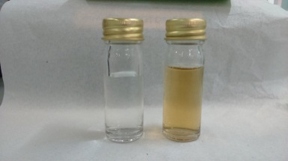
(a)
B
A

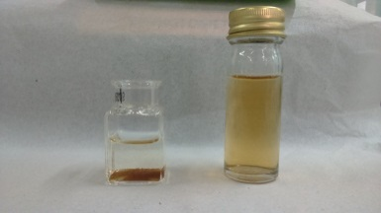
(b)
A
Fe(OH)₃

Figure 1. Physical properties of 100 mg Fe/L (a) at feed pH 9.3 (sample A), pH 6.5 (sample B) and (b) when Fe(OH)3 formed as flocs

Insoluble trivalent ferric ions, Fe³⁺ or known as iron solid commonly occur as colourful bright reddish-yellow to yellowish-brown stains as in sample A in Fig. 1(a). When sample A was exposed to air at ambient temperature for about 10 to 20 minutes, precipitate of iron hydroxide (Fe(OH)₃) was settled down at the bottom of sample cell as sediment as shown in Fig. 1(b). The natural pH of FeCl₂ and MnCl₂ feed solution right after preparation of the synthetic groundwater was found at 6.0 ± 0.5. At this condition, both divalent metal ions were soluble in water, with the prepared synthetic groundwater samples consist of either Fe or Mn were colourless as sample B in Figure 1(a). By increasing the pH, the soluble divalent ions were slowly oxidized to become insoluble and stable ions as the following Eq. 4 and Eq. 5;

$${ Fe}^{2+}+3H_{2}O\overset{→}{}Fe{\left(OH\right)}_{3}+3H^{+}+e^{-}$$ | (4)
$${ Mn}^{2+}+2H_{2}O\overset{→}{}MnO_{2}+4H^{+}+{2e}^{-}$$ | (5)

The stability of Fe ions depend not only on pH but also on the activity of electrons. The occurrence and behaviour of Mn is not similar to Fe. It was found that Fe²⁺ is more easily and rapidly oxidized than Mn²⁺. Precipitation of Fe(OH)₃ and MnO₂ was due to the feed solution having bigger size of particles formed once the feed solution pH has increased. Therefore, size exclusion was expected to be the domain rejection mechanism for feed solution at higher pH and membrane performance has been significantly influenced by the feed pH adjustment.

Permeate quality

Fig. 2(a) presents the permeate concentrations measured after filtration experiments using feed solution with 100 mg Fe/L at adjustment of pH in the range of 3 to 11. Results show that at these pH range, the concentration of metallic ions detected in permeate decreased with increasing pH. For Fe removal by PA-NF membrane at pH 9 and 11, permeate concentration measured were well below than the acceptable limit for drinking water standard set by WHO which were 0.08 and 0.12 mg Fe/L, respectively. Whereas by using PA-UF membrane, results showed that the permeate quality (0.12, 0.07 and 0.13 mg Fe/L) was satisfied when feed solution used were at pH 7, 9 and 11. These results indicated that Fe rejection was succesful at pH 9 and above. It was found that poor rejection of Fe by both NF and UF membranes when feed solution pH was adjusted below 7. Thus, results proved that pH has importantly impacted Fe removal as also reported by other scholars [16]. The feed pH may change the nature of the membrane surface charge and pore size, as well as the dissolved metal species and therefore can affect the membrane separation efficiency [17]. Between pH 3 and 7, almost all Fe present as soluble Fe²⁺. Higher than pH 8, Fe is predominantly present as insoluble Fe³⁺ and easily precipitate as Fe(OH)₃ on the surface of membrane. Therefore, Fe removal at this point were mainly by size exclusion (seiving effect).

For Mn removal with feed concentration at 50 mg Mn/L, it was found that the best quality of permeate achieved when using feed solution at pH 9 with detected permeate concentration at 0.4 mg Mn/L as shown in Fig. 2(b). This value was achieved by filtration using PA-NF membrane. However, it was considered as unsatisfied as for drinking water since the acceptable value should be at least 0.1 mg Mn/L. Poor quality of permeate at below than pH 9 especially by PA-UF membrane probably attributed by the effect of concentration polarization. The occurence and behavior of Mn is not similar to Fe, as Fe²⁺ ions were easily and rapidly oxidized than Mn²⁺ ions. At higher than pH 9, Mn is slowly exist as stable Mn⁴⁺ and insoluble as MnO₂ which then precipitate on the surface of membrane or blocked in the pores. At this point, Mn removal could be attributed solely by size exclusion. Between pH 3 and 7, Mn exist as soluble Mn²⁺ and thus, easily permeate and pass through membrane pores. As a result, poor rejection occured especially at pH 3 with high value of permeate concentration at 42.2 mg Mn/L was detected. In acidic feed solution, membrane pores could be expanded. At this point, PA-NF was reported to be positively charged. Low retention at pH 3 explained that solute-membrane interaction is the main mechanism and dominated by the nature of membrane pores.

(a)
(b)
Figure 2. Effect of pH on permeate concentration for filtration of (a) Fe and (b) Mn from synthetic groundwater

Rejection

Fig. 3 presented the effect of feed pH on Fe and Mn rejection by using PA-NF and PA-UF membrane. In general, as the pH increased from 3 to 11, the rejection of these metallic ions inreased. This can be mainly caused by the solute-membrane charges interaction. It is obviously showed that rejection of Fe at various feed pH were higher than Mn. Lower rejection of Mn could be attributed solely to the electrostactic effect interaction between membrane material and Mn²⁺ ions [18]. The isoelectric point (IEP) of PA-NF is in the range of 6 to 8 as reported by De Munari et al. [19]. This membrane is characterized as an amphoteric membrane whereby it is positively charged in solution less than pH 6 and negatively charged in solution more than pH 8. Between pH 3 and 5, the membrane is positively charged and lower Fe rejection could be due to dissolved Fe²⁺ were easily permeate the membrane pores. Thus, charge repulsion and size exclusion are less important at this feed pH range. At pH 7, high Fe rejection mainly because of electrostatic interaction between the membrane and the ions was zero. Therefore, the ions did not easily permeate through the membrane and contribute to higher rejection of Fe at IEP of membrane.

The pH of feed solution may change the nature of the membrane surface charge and pore size, as well as that of dissolved metal species and therefore can affect the membrane separation efficiency. PA-NF membrane has reached higher rejection rate for both metals in comparison with PA-UF as depicted in Fig. 3(a) and 3(b), respectively. Similar findings for Fe removal has previously been reported by Jusoh et al. [7] and De Munari et al. [19]. Regarding to Mn²⁺ ions, De Munari and Schafer [14] reported that PA-NF membrane has achieved more than 95% of rejection at pH 7. In Fig. 3(b), Mn rejection at pH 7 has inreased very well to >70% from 26% rejection at pH 5. At pH 9, higher Mn rejection was achieved to more than 95% and mainly because of changes of solute charges to a stable form which easily removed by membrane as further explained in the earlier section. The good rejection at this condition was mainly contributed by solute-membrane charge interactions. The charge of solute influenced the extent of rejection by NF membranes though the precise mechanism of rejection will depend upon the particular membrane in use [20].

(a)

(b)

Figure 3. Rejection of (a) Fe and (b) at various feed pH by using 100 mg Fe/L and 50 mg Mn/L, 5 bar, 25 °C with 500 rpm stirring rate

Surface morphology analysis

An image of fouled PA-NF membranes for filtration of single metal component in synthetic groundwater at pH 9 is presented in Fig. 4. From visual observation, brownish cake layer become visible on top surface of membrane (PA-NF)_{A}, resulted from Fe removal. Whereas, blackish cake layer formed on the surface of membrane (PA-NF)_{B} after filtration with synthetic groundwater solution with Mn ions. The cake layer formed mainly because of precipitation of Fe(OH)₃ and MnO₂ as explained in the earlier section. Bordoloi et al. [21] reported that the SEM image with EDS analysis of arsenic and iron removal from groundwater by oxidation-coagulation at optimized pH revealed that the sorption of As onto the poorly crystalline precipitate of Fe(OH)₃ and existence of a small amount of MnO₂. The FESEM images of the precipitate obtained in the presence of Fe and Mn for filtration by both NF and UF membranes at adjusted pH of feed solutions are depicted in Figure 5. The precipitates of Fe(OH)₃ on PA-NF and PA-UF membranes are presented by Fig. 5(a) and 5(c), respectively. Whereas, Fig. 5(b) and 5(d) indicate the precipitate of MnO₂ on the NF and UF membranes with aggregated large regularly shaped particles suggestive of stable crystallinity of precipitate. In comparison to Fe(OH)₃, MnO₂ was found more stable especially at pH higher than 8.

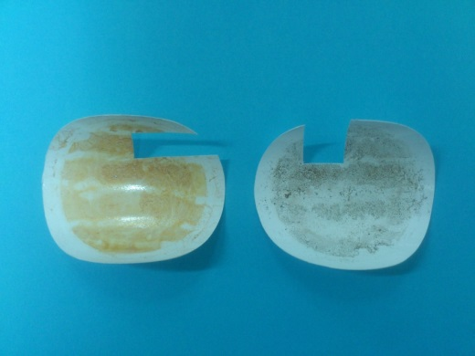
Fe removal
Mn removal
(PA-NF)_{A}
(PA-NF)_{B}
Figure 4. Visualization on physical quality of fouled PA-NF membranes for filtration at 5 bar and pH 9

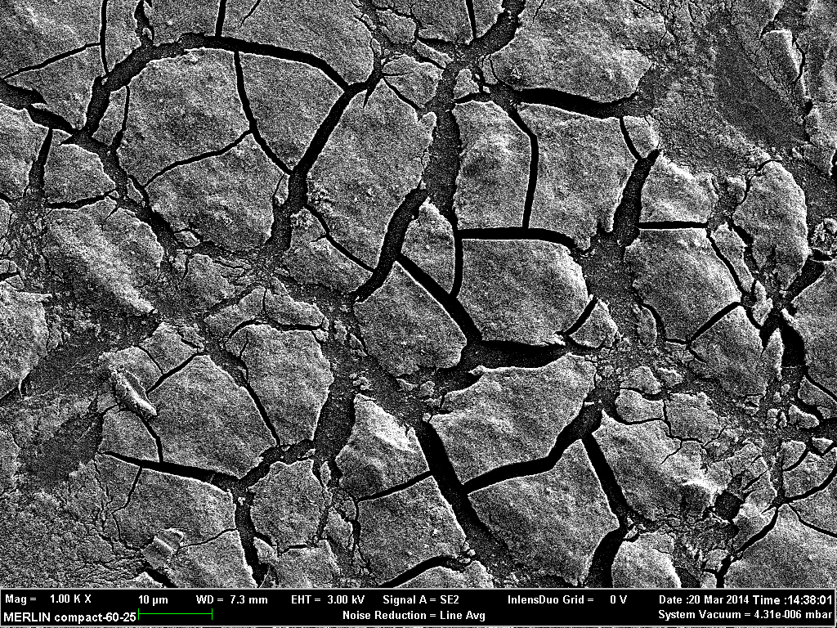  (a)  10 µm Mag = 1.00 K X EHT = 3.00 kV MERLIN compact-60-25  WD = 7.3 mm Signal A = SE2 20 Mar 2014 | 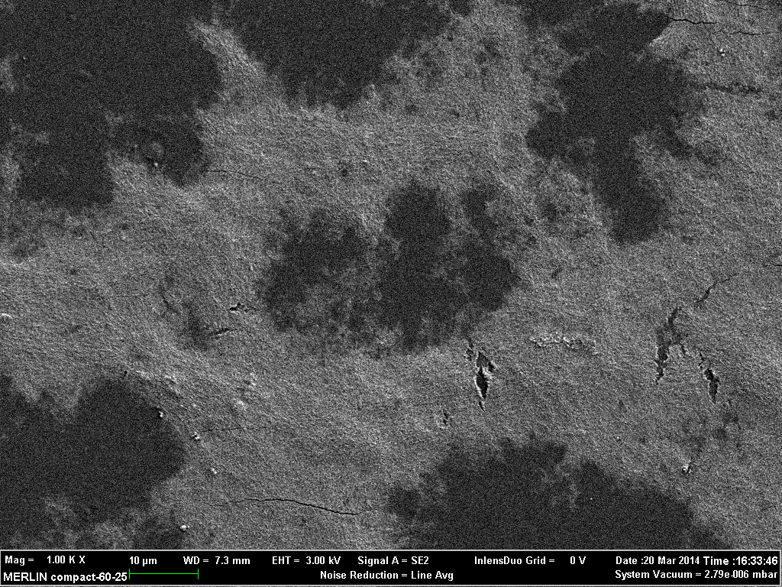  (b)  10 µm Mag = 1.00 K X EHT = 3.00 kV MERLIN compact-60-25  WD = 7.3 mm Signal A = SE2 20 Mar 2014
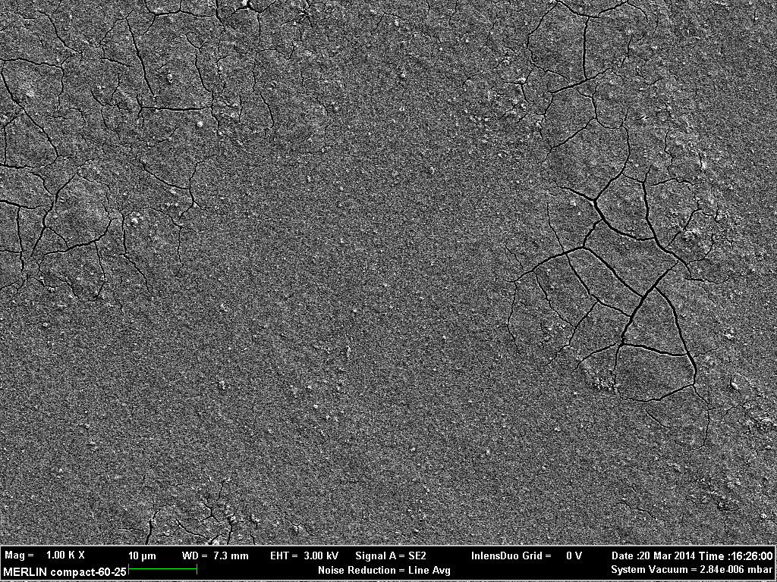  (c)  10 µm Mag = 1.00 K X EHT = 3.00 kV MERLIN compact-60-25  WD = 7.3 mm Signal A = SE2 20 Mar 2014 | 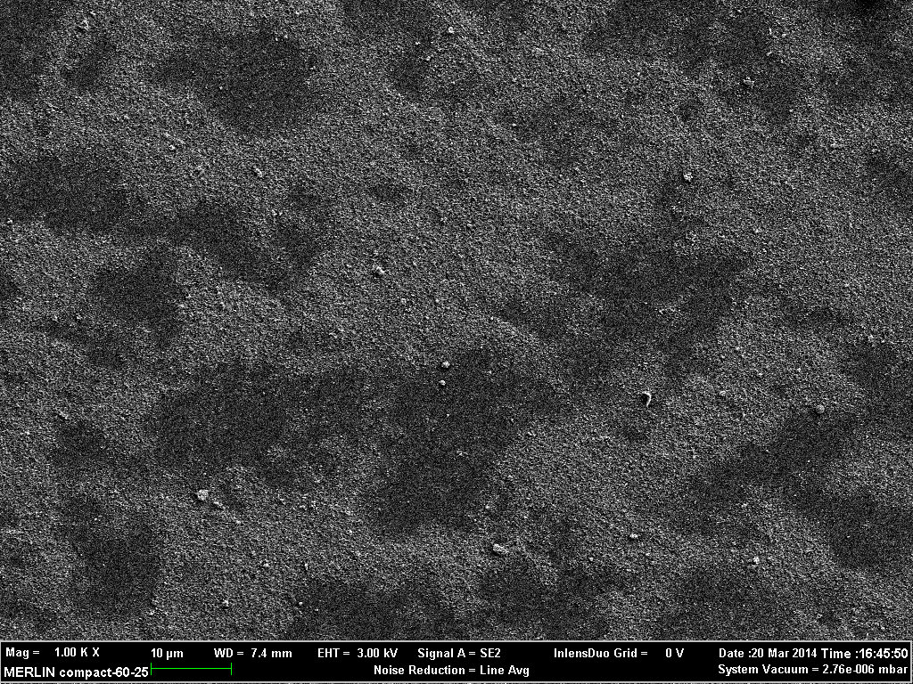  10 µm Mag = 1.00 K X EHT = 3.00 kV MERLIN compact-60-25  WD = 7.4 mm Signal A = SE2 20 Mar 2014  (d)

Figure 5. FESEM image of (a) Fe(OH)₃ (b) MnO₂ on PA-NF, and (c) Fe(OH)₃ (d) MnO₂ on PA-UF membranes

Conclusion

The solute-membrane interaction during removal of iron and manganese from synthetic groundwater were investigated in this study. The rejection mechanism of both metallic ions by using PA-NF and PA-UF membranes were also identified and evaluated in this work. The main focus for this paper was to inspect the effect of adjustment on the initial pH of feed solution mainly on the rejection behaviour, permeate quality towards meeting the drinking water standard and also changes on solubility of solute in feed solution. The efficiencies of these membranes were assessed based on permeability, water flux and rejection capabilities at 5 bar and feed solution pH ranged of 3 to 11. The rejection rates for metal component (Fe and Mn) in artificial groundwater using these membranes were significantly influenced by the adjustment of pH. Particularly, rejections of both metals by PA-NF were found higher than PA-UF for all cases. In addition, results proved that PA-NF membrane had efficiently rejected Fe²⁺ and Mn²⁺ ions to the allowable value for drinking water based on WHO standards. Excellent separation performance of PA-NF membrane was mainly due to its effective separation layer of membrane structure.

The significant contribution of solute-membrane charge interactions was determined and influenced by the initial pH of feed solution. It was observed that an increase of pH determined a higher efficiency of Fe and Mn rejections by PA-NF membrane. Higher pH of the feed solution contributed to transformation of soluble divalent Fe²⁺ and Mn²⁺ ions to insoluble Fe³⁺ and Mn⁴⁺ ions which were more stable and easily precipitated on membrane surfaces. The increase of feed solution pH has decreased the solubility of the divalent metallic ions (Fe²⁺ and Mn²⁺). Therefore, flocculation of metallic ions in the feed solution as the pH increased has resulted to higher rejection of the metal components from the synthetic groundwater. In conclusion, all findings in this study contributed to possibility of developing the membrane technology for Malaysia’s groundwater treatment specifically in the removal of iron and manganese for clean and safe drinking water resources.

Acknowledgement

The authors would like to thank Universiti Kebangsaan Malaysia by the grant ICONIC-2013-002 for financial supports. Additionally, the first author is gratefully wished special thanks to the Ministry of Higher Education Malaysia and also the National Defence University of Malaysia for funding the scholarship.

References
- Filip, Z. and Demnerova, K. (2009). Survival in groundwater and FT-IR characterization of some pathogenic and indicator bacteria. Threats to Global Water Security: 117 – 122.
- Stewardship, W., Series, I. (2007). Iron & manganese in groundwater, Br. Columbia Groundwater Association.
- Ahmad, M. (2012). Iron and manganese removal from groundwater, Thesis University of Oslo.
- Marchovecchio, R. H., Botte, J. E. and Freiji, S. E (2011). Heavy metals, major metals, trace elements, in: Handbook Water Analysis, CRC Press.
- World Health Organization, WHO. (2008). Guidelines for drinking-water quality, in: Recomendations, Volume1, 3rd edition, World Health Organization, Geneva: pp. 390 – 399.
- Chaturvedi, S. and Dave, P. N. (2012). Removal of iron for safe drinking water. Desalination, 303: 1–11.
- Jusoh, A., Cheng, W. H., Low, W. M., Nora’aini, A. and Megat Mohd Noor, M. J. (2005). Study on the removal of iron and manganese in groundwater by granular activated carbon. Desalination, 182: 347 –353.
- Ellis, D., Bouchard, C. and Lantagne, G. (2000) Removal of iron and manganese from groundwater by oxidation and microfiltration. Desalination, 130: 255 – 264.
- Abdul Kadir, A., Othman, N. B. and Azmi, N. M (2012). Potential of using Rosa Centifolia to remove iron and manganese in groundwater treatment. International Journal of Sustainable Construction Engineering Technology, 3: 70 – 82.
- Hussin, N. H., Yusoff, I., Alias, Y., Mohamad S., Rahim, N.Y. and Ashraf, M. A. (2013). Ionic liquid as a medium to remove iron and other metal ions: A case study of the North Kelantan Aquifer, Malaysia. Environmental Earth Science, 71: 2105 – 2113.
- Choo, K.-H., Lee, H and Choi., S.-J. (2005). Iron and manganese removal and membrane fouling during UF in conjunction with prechlorination for drinking water treatment. Journal of Membrane Science, 267: 18 – 26.
- Potgieter, J. H., Mccrindle R. I., Sihlali, Z., Schwarzer R. and Basson, N. (2005). Removal of iron and manganese from water a high organic carbon loading part I : The effect of various coagulants. Water, Air Soil Pollution, 162: 49 – 59.
- Lin, J. L., Huang, C., Pan, J. R. and Wang, Y. S. (2013). Fouling mitigation of a dead-end microfiltration by mixing-enhanced preoxidation for Fe and Mn removal from groundwater. Colloids Surfaces A Physicochemical and Engineering Aspects, 419: 87 – 93.
- De Munari, A. and Schäfer, A. I. (2010). Impact of speciation on removal of manganese and organic matter by nanofiltration. Journal of Water Supply Research and Technology Aqua, 59 : 152 – 163.
- Kasim, N., Mohammad, A.W. and Abdullah, S. R. S. (2015). Characterization of hydrophilic nanofiltration and ultrafiltration membranes for groundwater treatment as potable water resources. Desalination and Water Treatment, 57(17): 7711 – 7720.
- Bordoloi, S., Nath, M. and Dutta, R. K. (2013). pH-conditioning for simultaneous removal of arsenic and iron ions from groundwater. Process Safety and Environmental Protection, 91: 405 – 414.
- Al-Rashdi, B. A. M., Johnson, D. J. and Hilal, N. (2013). Removal of heavy metal ions by nanofiltration. Desalination, 315: 2 – 17.
- Kabsch-Korbutowicz, M. and Winnicki, T. (1996). Application of modified polysulfone membranes to the treatment of water solutions containing humic substances and metal ions. Desalination, 105: 41 – 49.
- De Munari, A., Semiao, A. J. C. and Antizar-Ladislao, B. (2013). Retention of pesticide endosulfan by nanofiltration: Influence of organic matter-pesticide complexation and solute-membrane interactions. Water Research, 47: 3484 – 3496.
- Waite, T. D. (2005). Chemical speciation effects in nanofiltration separation, in: T.D. Schäfer, Andrea I., Fane, A.G., Waite (Ed.), Nanofiltration-principles Application. Elsevier B.V.: pp. 148 – 168.
- Bordoloi, S., Nath, S. K., Gogoi, S. and Dutta, R. K. (2013). Arsenic and iron removal from groundwater by oxidation-coagulation at optimized pH: Laboratory and field studies. Journal of Hazardous Materials, 260: 618 – 626.

