CYCLIC VOLTAMMETRY STUDIES OF THE CORROSION PROCESS

ON THE STAINLESS STEEL ELECTRODES IN THE

ACIDIC THIOUREA SOLUTION

(Kajian Voltammetri Berkitar Terhadap Proses Pengkakisan di atas Permukaan Elektrod Keluli Tahan Karat di dalam Larutan Tiourea Bersasid)

Amirul Islah Nazri, Nor Irwin Basir, Muhamad Nazri Murat*

School of Chemical Engineering, Engineering Campus

Universiti Sains Malaysia, 14300 Nibong Tebal, Pulau Pinang, Malaysia

*Corresponding author: chnazri@usm.my

Abstract

A cyclic voltammetry study has been carried out in order to determine the voltage range that contributes to the initiation of the corrosion on the surface of stainless steel in the acidic thiourea solution. In this study, the knowledge of corrosion on stainless steel is useful in the optimisation process for gold recovery from electronic waste based on electrodeposition technique. Since stainless steel material has been used as both anode and cathode in the experimental setup, under certain applied voltage, corrosion might occur and hinder the gold recovery process by damaging the electrodes. With the aid of cyclic voltammetry study, the suitable applied voltage for electrodeposition process has been investigated and found to be approximately 1.4 V for two-electrode setup for a system with sulfuric acid concentration of 0.1 M in the presence of 0.1 M thiourea. The data obtained can be used as a basis to determine a suitable pre-set applied voltage in the electrodeposition process such that corrosion on the electrodes can be avoided.

Keywords: cyclic voltammetry, stainless steel, corrosion, acidic thiourea solution

Abstrak

Suatu kajian menggunakan kaedah voltammetri berkitar (CV) telah dijalankan bertujuan untuk menentukan julat voltan yang menyumbang kepada permulaan proses pengkakisan di atas permukaan keluli tahan karat di dalam larutan tiourea berasid. Dalam kajian ini, pengetahuan mengenai proses pengkakisan terhadap keluli tahan karat berguna dalam proses pengoptimuman terhadap perolehan emas daripada sisa buangan elektronik berasaskan kepada teknik elektropeendapan. Memandangkan bahan keluli tahan karat digunakan sebagai anod dan katod di dalam persediaan eksperimen, di bawah voltan gunaan tertentu, proses pengkakisan berkemungkinan berlaku dan boleh menghalang proses perolehan emas dengan merosakkan elektrod. Dengan bantuan dari kajian voltammetri berkitar, voltan gunaan yang sesuai untuk proses elektropeendapan telah dikaji dan hasil dari kajian mendapati bahawa nilai voltan gunaan tersebut adalah sebanyak lebih kurang 1.4 V untuk konfigurasi dua-elektrod untuk satu sistem dengan kepekatan asid sulfurik sebanyak 0.1 M dalam kehadiran tiourea 0.1 M. Data yang diperolehi dapat digunakan sebagai asas bagi menentukan voltan gunaan yang sesuai dalam proses elektropeendapan, dalam masa yang sama proses pengkakisan terhadap elektrod dapat dielakkan.

Kata kunci: voltammetri berkitar, keluli tahan karat, pengkakisan, larutan tiourea bersifat asid

Introduction

Corrosion is a process involving the destructive attack of a metal by chemical or electrochemical reaction with its environment. In electrochemical cell, corrosion most likely to occur at the anode via metal oxidation processes. Additionally, introducing electricity flow through the cell might also increase the rate of corrosion of metal electrode in the presence of corroding agent. The usage of coatings, inhibitors, passivators and suitable alloyed materials could reduce the amount of metal being corroded [1].

Stainless steel is one of the long listed alloyed materials available in the market. Generally, stainless steels are widely used in industrial applications due to their strength, corrosion resistance, mechanical workability and excellent electrical and thermal conductivities [2]. Also, it is affordable compared to other nobler metals such as platinum and tantalum. High corrosion resistance of stainless steels is primarily attributed to the passive oxide film formed on its surface and the resistance of this passive film is determined by the environmental conditions in which it being exposed to [3].

Even though stainless steel has high corrosion resistance under normal application, however, corrosion of stainless steel can still occur under certain conditions, such as in the presence of acid, or when certain voltage being applied. Thus, in this paper, CV experiments has been done in order to study the corrosion process on the stainless steel electrode in the acidic thiourea solution as well as determining the limiting voltage in order to minimize the effect of corrosion on the electrodes. For the application in electrodeposition process, knowledge of suitable applied voltage is very useful so that the corrosion of the electrodes can be avoided. This in turn can increase the deposition yield of the overall process.

Cyclic Voltammetry (CV) technique has widely being used in electrochemical studies especially in gold electroleaching and electrodeposition processes using acidic thiourea solution [4 – 8]. Gold recovery via thiourea solution has received many attentions from a number of researchers since it was first recognized by Moir in 1906 and then pioneered by Plaskin and Kozukhova in 1941 [9]. By implementing CV in this study, further understanding on the reaction mechanisms involved in the process could be grasped. Also, a voltage region which separately represents electroleaching process and electrodeposition process could also be determined.

This paper discusses the CV studies for further understanding of corrosion behaviour on stainless steel electrodes. The understanding of corrosion behaviour is useful to optimise the electrodeposition process of gold recovery from electronic waste (e-waste), specifically when using a stainless reactor [10]. On the point of optimising the electrodeposition process, CV study on the redox process of gold in the acidic thiourea solution as well as determining the appropriate applied voltage range to enhance the gold leaching and deposition was also conducted earlier [11].

The area of study related to this research is electrochemical study, for enhancing the electrodeposition process and avoiding corrosion of the electrodes.

Materials and Methods

Chemicals and solutions

Thiourea (99%, Acros) and sulfuric acid (95% - 98%, Sigma-Aldrich) were used without further purification. All solutions were prepared by mixing desired amount of reagent together with deionized water purified in a Millipore Milli-Q system (18 MΩ cm) and were used immediately after preparation [7].

Apparatus

Cyclic Voltammetry (CV) experiments were carried out using a potentiostat (CH Instrument, model: 600E) by measuring electrochemical reading of the system. CV experiments were carried out in a simple three-electrode cell using a glass beaker. Two stainless steel plates (about 15cm² each) were used as working and counter electrodes and all the potentials measured in the three-electrode cell were reported relative to a saturated calomel electrode (SCE) purchased from CH Instrument. The saturated calomel electrode acted as the reference electrode to the system. For CV experiments with two-electrode cells, the reference electrode is omitted.

Initial preparation of electrodes

Prior to each experiment, both the working and counter electrodes were carefully ground and polished with ultra-fine P2000 grit abrasive paper. After polishing, the electrodes were rinsed with deionized water and left to dry in oven (about 50 °C).

Experimental setup

Figure 1 shows the experimental setup for the CV experiments to study the corrosion of stainless steel electrode in acidic thiourea solution. The prepared stainless electrodes were connected to both positive and negative terminals of the potentiostat whilst the SCE was connected to another terminal for reference electrode (RE). The electrode connected to the positive terminal are then referred to as working electrode (WE) and the electrode connected to the negative terminal are referred to as counter electrode (CE).

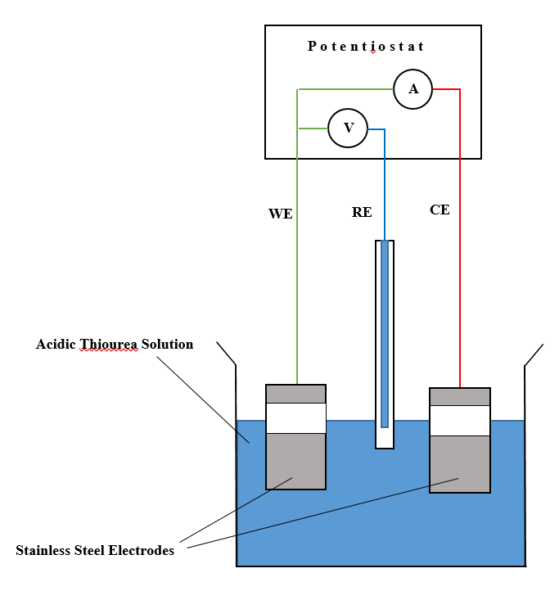

Figure 1. Experimental setup for 3-electrode system of CV study on corrosion of stainless steel electrode in acidic thiourea solution

All the electrodes including the reference SCE were immersed into the freshly prepared acidic thiourea solution and positioned as shown in Figure 1 by which the RE was positioned in between the WE and the CE. Once ready, the experiment was started and data collected by potentiostat were recorded and logged to the computer connected to the potentiostat. The data were then interpreted by using the appropriate software included by the manufacturer.

As for the experimental work using the 2-electrode system, the configuration in Figure 1 was slightly altered in which the SCE was disconnected from the RE output terminal. The output terminal for RE was then connected directly with the CE, thus forming the 2-electrode system with both stainless steel as the anode (WE) and cathode (CE). This configuration was provided by the manufacturer, CH Instrument through the manuals.

Experimental method

The CV experiments were carried out in predetermined voltage range with variation concentration of thiourea and sulfuric acid. All experiments were carried out under room temperature (25 °C) with CV scan rate of 100 mV/s.

Result and Discussion

In this section, results regarding system behaviour on stainless steel electrode in acidic thiourea solution are discussed based on cyclic voltammogram. Results on the limiting voltage that could be applied based on the comparison between the three-electrode system and a two-electrode system are also presented.

System behaviour on stainless steel electrode in acidic thiourea solution

Figure 2 (a) and Figure 2 (b) shows cyclic voltammograms of stainless steel electrodes in acidic thiourea solution from applied voltage region of -0.8 V to 1.8 V using different amount of concentration for both sulfuric acid (H₂SO₄) and thiourea (TU) reagents in the presence of each other. Note that Fig. 2 (a) represents condition in which sulfuric acid concentration were varied between 0.1 M, 0.3 M and 0.5 M while thiourea concentration were fixed at 0.1 M. Meanwhile, Fig. 2 (b) represents condition in which TU concentration were varied between 0.1 M, 0.3 M and 0.5 M while H₂SO₄ concentration were fixed at 0.1 M.

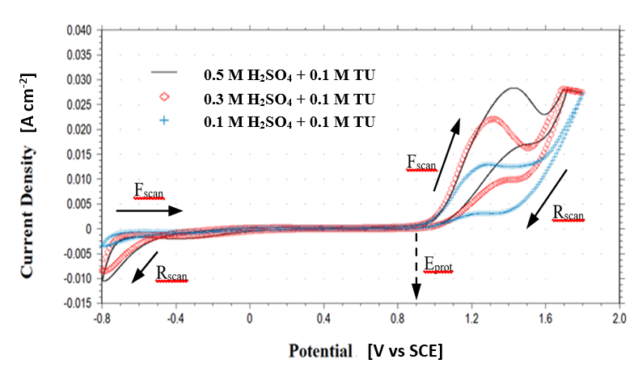
(a)

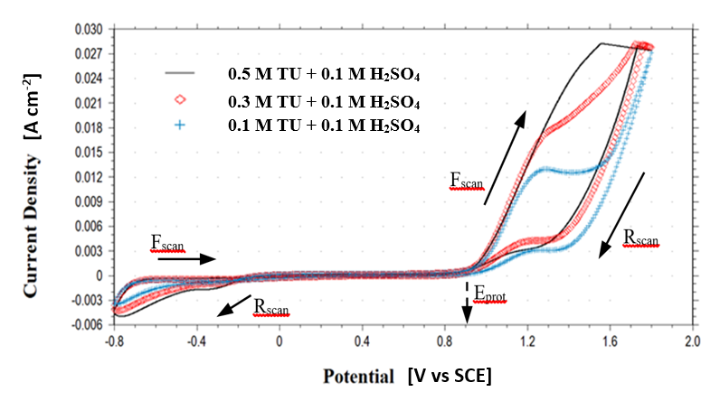
(b)

Figure 2. Cyclic voltammogram of stainless steel electrodes in the acidic thiourea solution for fixed (a) concentration of thiourea and (b) concentration of sulfuric acid

It can be seen in either voltammogram in Fig. 2 (a) or Fig. 2 (b) that there are basically two anodic peaks and one cathodic peak exist during both forward (F_{scan}) and reverse (R_{scan}) scan. Both anodic peaks are related to corrosion process in which the one during the F_{scan} represents the breakdown of the passive film and the initiation of pitting corrosion. The one during the R_{scan} represents the activation of the electrode. Note that the voltage in which the current density reached zero during the activation process in R_{scan} indicates the protection potential (E_{prot}). It can be concluded that there are no pitting corrosion occurs at the potential below E_{prot} and pit nucleation tends to start at the potential above E_{prot}. On the other hand, the cathodic peak represent the onset of hydrogen evolution reaction. The origins of all three peaks are agreed with what has been reported by Albrimi and his colleagues in their publication [2].

Generally, there are no significant differences between both voltammogram in Fig. 2 (a) and Fig. 2(b). It can be seen in both figures that as the concentration increased, the anodic peak also increased in current density as well as shifted towards more anodic voltage. In the presence of both TU and H₂SO₄ in the solution, it was found that the results from both figures show the same peak behaviours no matter which reagent was being manipulated, thus making it impossible to directly determine which reagent was responsible for catalysing the corrosion process. Due to that reason, further experiments need to be carried out in order to determine which reagent catalysed the corrosion of the stainless steel electrode.

Influence of sulfuric acid on the system

The experimental results involved the CV studies on stainless steel electrodes at different concentration of sulfuric acid in the absence of thiourea is shown in Figure 3.

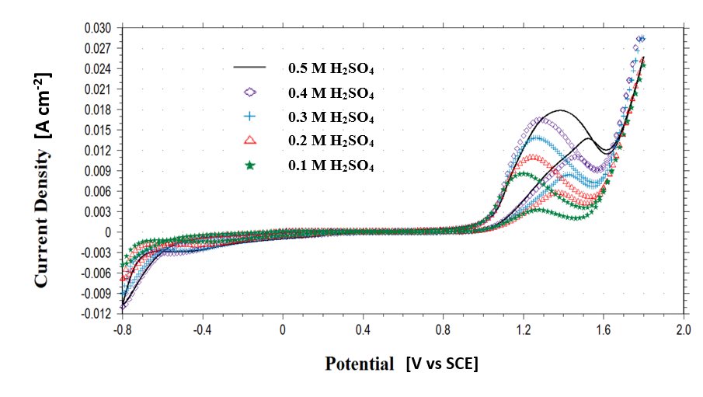

Figure 3. Cyclic voltammogram of stainless steel electrodes using different concentration of sulfuric acid in the absence of thiourea

As shown in Figure 3, the increasing of sulfuric acid concentration from 0.1 M up to 0.5 M tends to increase the current density for both anodic peaks during F_{scan} and R_{scan}. Note that the behaviour of this voltammogram is quite the same with what being reported in Figure 2. This phenomenon indicates that sulfuric acid in the solution catalysed the corrosion of stainless steel electrodes. Note that, the voltage in which the nucleation of pit corrosion tends to occur, E_{prot} for all concentration of sulfuric acid maintained the same i.e. approximately 0.9 V_{SCE.}

In order to further prove the facts that sulfuric acid acts as the catalyst for the corrosion process of stainless steel electrodes, another set of experiment involving manipulation of thiourea in the absence of sulfuric acid has been done and discussed in the next section.

Influence of thiourea on the system

The influence of various concentration of thiourea on stainless steel electrodes in the absence of sulfuric acid in shown in Figure 4.

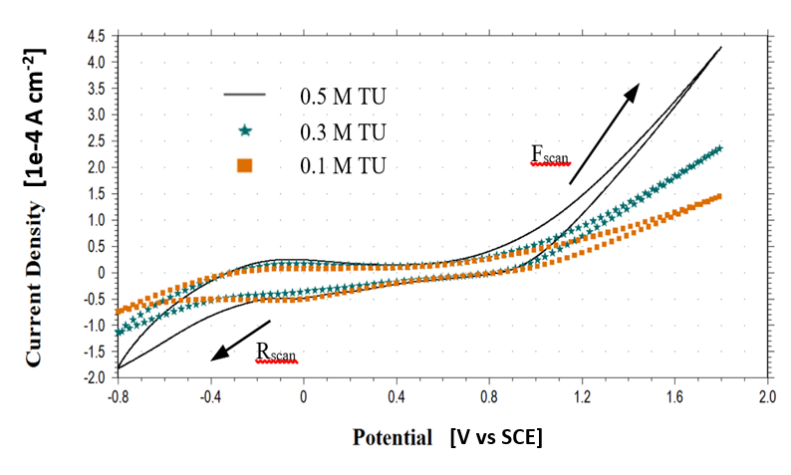

Figure 4. Cyclic voltammogram of stainless steel electrodes using different concentration of TU in the absence of sulfuric acid

In the absence of sulfuric acid, the behaviour recorded in voltammogram shown in Figure 4 is different to what has been reported in the previous sections. The increment of thiourea concentration up to 0.5 M does increase the current density but in a very small values compared to what being recorded when using sulfuric acid. Also, there are no visible current plateau during the whole scans. This indicates that thiourea did not significantly affects the corrosion of stainless steel electrodes as much as sulfuric acid.

Limiting applied voltage

As the actual application of gold recovery is based on two-electrode system connected with a direct currect (DC) power supply, it is more beneficial to have the data gained from the three-electrode system CV studies being modified and readily used for two-electrode system arrangement. Thus, CV experiment by using 2-electrode system setup described in section II (D) has been done by implementing the best parameters used in the CV experiment using the 3-electrode system which provided the lowest possible corrosion toward the stainless steel electrode. Repetition of experiments was carried out in order to make sure the uniformity of the result and the average results data has been used to develop the trends for CV study of both 3- and 2-electrode system.

A series of experiment comparing the applied voltage of corrosion process for two different system i.e. three-electrode system and two-electrode system with the same parameters i.e. 0.1 M H₂SO₄ + 0.1 M TU has been done and the result is shown in Figure 5.

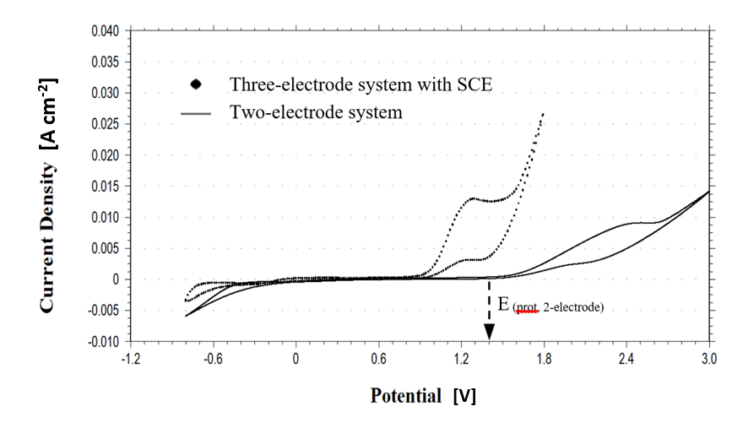

Figure 5. Cyclic voltammogram of stainless steel electrodes using (●) three-electrode system with saturated calomel electrode (SCE) as reference electrode, and (▬) two-electrode system

From the figure, the anodic current plateau from three-electrode system shifted toward more positive voltage as the system changed to a two-electrode system whilst maintaining the general peaks behaviour. It is acceptable as the calculation from (1) which represent electrochemical reaction for SCE requires the data gained from SCE-based reference electrode needs to be added with 0.241 V (CH Instrument SCE model: CHI150) in order to change the values to normal hydrogen electro (NHE) instead of SCE [12]. The values gained from CV (E _{(prot, 2-electrode)} = approx. 1.4 V) however differs to the values from (1) i.e. 1.141 V due to differences in experimental setup etc.

Hg₂Cl₂ + 2e = 2Hg + 2Cl⁻ , E° = 0.241 V_{NHE, 25 °C} (1)

Besides that, the current density recorded from two-electrode system for the corrosion plateau is generally lower than the corrosion plateau by the three-electrode setup. This indicates that corrosion effects on the stainless steel electrode could be further reduced if direct use of two-electrode system is implemented.

Conclusion

Series of experiments were conducted to investigate the unwanted process of corrosion of stainless steel electrodes in acidic thiourea solution. The investigation was performed based on Cyclic Voltammetry (CV) technique, with the aid of an electrochemical device, namely potentiostat, to measure the electrochemical reading of the system. From the experiments, it was found that thiourea ligand has no significant contribution towards the corrosion process of stainless steel electrodes. In fact, it was found that sulfuric acid was the one plays major role in the corrosion process. In addition to that, the chances of the stainless steel electrodes to corrode increase proportionally with the concentration of sulfuric acid being used. On the other hand, it was found that the two-electrode system in actual process is less prone to corrosion compared to the three-electrode system, which is used specifically in CV studies. Last but not least, the limiting applied voltage was found to be approximately 0.9 V_{SCE} for three-electrode system or approximately 1.4 V for two-electrode system.

Acknowledgement

Authors are grateful to CREST-USM grant 304/PJKIMIA/6050265/C121, the company in collaboration i.e. Scrap Computer Trading (SCT) Sdn. Bhd., the MYBRAIN15 scholarship for their financial assistance and to all technicians for their technical supports.

References

- Revie, R. W. and Uhlig, H. H. (2008). Corrosion and corrosion control. 4th ed. United States of America: John Wiley & Sons.
- Albrimi, Y. A., Eddib, A., Douch, J., Berghoute, Y., Hamdani, M. and Souto, R. M. (2011). Electrochemical behaviour of AISI 316 austenitic stainless steel in acidic media containing chloride ions. International Journal of Electrochemical Science, 6: 4614 – 4627.
- Iliyasu, I., Yawas, D. S. and Aku, S. Y. (2012). Corrosion behavior of austenitic stainless steel in sulfuric acid at various concentration. Advances in Applied Science Research, 3 (6): 3909 – 3915.
- Bolzan, A. E., Piatti, R. C. V. and Arvia, A. J. (2003). Electrochemical processes at gold∣thiourea-containing aqueous acid solution interfaces. Journal of Electroanalytical Chemistry, 552: 19 – 34.
- Gomez, H., Lizama, H., Suarez, C. and Valenzuela, A. (2009). Effect of thiourea concentration on the electrochemical behavior of gold and copper electrodes in presence and absence of Cu (II) ions. Journal of the Chilean Chemical Society, 54 (4): 439 – 444.
- Shetsova, O. N., Bek, R. Y., Zelinskii, A. G. and Vais, A. A. (2006). Anodic behavior of gold in acid thiourea solutions: A cyclic voltammetry and quartz microgravimetry study. Russian Journal of Electrochemistry, 42 (3): 239 – 244.
- Yang, X. Y., Moats, M. S. and Miller, J. D. (2010). The interaction of thiourea and formamidine disulfide in the dissolution of gold in sulfuric acid solutions. Minerals Engineering, 23 (9): 698 – 704.
- Zhang, H., Ritchie, I. M. and La Brooy, S. R. (2001). Electrochemical oxidation of gold and thiourea in acidic thiourea solutions. Journal of the Electrochemical Society, 148 (10): 146 – 153.
- Hilson, G. and Monhemius, A. J. (2006). Alternatives to cyanide in the gold mining industry: What prospects for the future?. Journal of Cleaner Production, 14 (12–13): 1158 – 1167.
- Nazri, A. I., Basir, N. I. and Murat, M. N. (2015). A conceptual reactor design based on combination of pressure leaching - electrochemical deposition techniques for study of gold recovery from e-waste. Advanced Materials Research, 1113: 187 – 192.
- Nazri, A. I., Basir, N. I. and Murat, M. N. (2015). Cyclic voltammetry application in determining oxidation and reduction of gold in acidic thiourea solution using gold-stainless steel paired electrode. 5th International Conference on Environment 2015 (ICENV 2015), Eastin Hotel, Penang, Malaysia.
- Pavlishchuk, V. V. and Addison, A. W. (2000). Conversion constants for redox potentials measured versus different reference electrodes in acetonitrile solutions at 25 °C. Inorganica Chimica Acta, 298 (1): 97 – 102.

