A SINGLE HPLC METHOD FOR SEPARATION OF OLIGOSTILBENES FROM DIFFERENT DIPTEROCARPACEAE EXTRACTS

(Kaedah KCPT untuk Pemisahan Oligostilbene dari Ekstrak Dipterocarpaceae yang Berbeza)

Erni Muis¹, Rohaity Ramli^{1,2}, Nurhuda Manshoor^{1,2*}

¹Faculty of Pharmacy, Universiti Teknologi MARA Selangor, Puncak Alam Campus,
43200 Puncak Alam, Selangor, Malaysia

²Atta-ur-Rahman Institute for Natural Products Discovery, Universiti Teknologi MARA Selangor,

Puncak Alam Campus, 43200 Puncak Alam, Selangor, Malaysia

*Corresponding author: nurhuda15@salam.uitm.edu.my

Abstract

One standard method of chromatographic conditions of HPLC was developed for different Dipterocarpaceae plant extracts. The purpose of this study is to achieve an optimized chromatographic method that is able to produce a reasonably good separation and resolution of oligostilbenes in plant crude extracts. For this purpose, five model samples of Dipterocarpaceae extracts, Shorea parvifolia, Shorea ovalis, Dipterocarpus crinitus, Dipterocarpus gracilis and Hopea spp. were used. The parameters, which include types of chromatographic solvents, types of mobile phase elution, solvent composition and the injection volumes, were modified. The results showed that the optimum chromatographic conditions were achieved when a gradient elution was adopted, with the solvent composition of H₂O: ACN from 95:5 to 25:75 in 20 minutes. The injection volume of 5 μL is best for a 1 mg/ml sample concentration. The temperature was maintained at 35 °C and the flow rate was at 1.0 ml/min. Some compromises were taken into account such as having less accurate method if compared with a single method developed for single extract or sample. The method showed positive results when tested on 10 extracts of the same family from different plant parts and localities.

Keywords: Dipterocarpaceae, Shorea spp., Dipterocarpus spp., chromatography, high performance liquid chromatography

Abstrak

Satu kaedah piawai untuk keadaan kromatografi KCPT telah dibina untuk ekstrak dari tumbuhan Dipterocarpaceae yang berlainan. Tujuan kajian ini ialah untuk mencapai satu kaedah kromatografi optimum yang dapat menghasilkan pemisahan komponen oligostilbene dari ekstrak tumbuhan dengan resolusi yang baik. Untuk tujuan ini, lima sampel ekstrak tumbuhan Dipterocarpaceae, Shorea parvifolia, Shorea ovalis, Dipterocarpus crinitus, Dipterocarpus gracilis dan Hopea spp. telah digunakan sebagai model. Parameter yang merangkumi jenis pelarut, jenis aliran fasa bergerak, komposisi pelarut dan isipadu suntikan sampel telah diubahsuai. Keputusan menunjukkan kaedah kromatografi yang sesuai berjaya dicapai apabila aliran bercerun digunakan dengan komposisi pelarut H₂O: ACN dari 95:5 kepada 25:75 di dalam masa 20 minit. Isipadu suntikan 5 μL adalah sesuai untuk larutan sampel berkepekatan 1 mg/ml. Suhu turus ditetapkan pada 35 °C dan kadar aliran fasa bergerak adalah pada 1.0 ml/min. Walaubagaimanapun, resolusi setiap kromatogram tidak sebaik dan sejitu apabila kaedah berlainan dibangunkan untuk setiap sampel secara individu. Kaedah ini telah telah menunjukkan keputusan yang positif apabila diuji ke atas sepuluh ekstrak lain dari famili tumbuhan yang sama. Sampel ujian tersebut adalah dari bahagian tumbuhan yang berlainan dan dari kawasan pensampelan yang berbeza.

Kata kunci: Dipterocarpaceae, Shorea spp., Dipterocarpus spp., kromatografi, kromatografi cecair prestasi tinggi

Introduction
Dipterocarpaceae family produces a high diversity of oligostilbene structures, ranging from dimeric to octameric stilbenes. Oligostilbenes are the most phytochemical components that were studies on this family due to their abundance in the plants which can be isolated from their leaves, bark, wood, heartwood and seeds. Oligostilbenes have attracted a major attention due to the bioactivities of crude extracts, fractions, as well as the isolated pure compounds including anti-inflammatory, cytotoxicity, antimicrobial and antioxidant activities [1-3]. As the isolation and characterization techniques for plant compounds developed, investigations of oligostilbenes became more abundant and more new compounds from various families were characterized. In our previous report, we have isolated 5 new oligostilbenes from Neobalanocarpus heimii [4].

Chromatographic technique is now being used beyond its original purpose, which is to separate and purify a mixture of compounds. It is also used to identify and quantify the individual components of mixtures in the phytochemical and analytical chemistry [5]. High performance liquid chromatography (HPLC) analysis plays a major role in phytochemical analysis including identification of crude plant extracts [6]. Method development for HPLC requires decisions regarding the choice of column, mobile phase, detectors, and method quantitation [7]. Optimization of HPLC conditions and other important perspectives during method development are conducted to provide a simple, precise, rapid and accurate analysis of plants.

The obvious challenge in chromatographic profiling of plant extracts is repetitive method development works whenever working with new samples. Usually, the chromatographic method differs for every sample. Thus, chromatographic method is developed for one particular sample only at one time. This leads to the increase consumption of money and time. We were suggesting a dereplication strategy to identify compounds as early as in a crude mixture in order to work faster [8,9].

The aim of analysis of each HPLC method may vary for each developmental area. In phytochemical studies, HPLC are frequently applied for quantitative and qualitative analysis of organic compounds in natural plant extracts, such as and alkaloids from Nicotiana spp.[10]. In a different field, a number of HPLC methods have been developed for the quantification of samples such as sildenafil in human plasma [11], acetazolamide, furosemide and phenytoin in suspensions [12].

Phytochemical studies of Dipterocarpaceae by using HPLC are conducted to determine the composition of the plant such as resveratrol dimer O-glucosides with enantiomeric aglycones [13], bergenin phenylpropanoates [14], oligostilbenoids and 3-ethyl-4-phenyl-3,4-dihydroisocoumarins [15].

In this study, one standard method of chromatographic conditions of HPLC is developed to analyze different samples of Dipterocarpaceae extracts. Optimization of developing method involves the changing of solvent conditions and injection volume only. Conditions, such as column temperature and types of solvents were selected based on the previous study [4], flow rate was calculated based on Van Deemter equation for mobile phase velocity, and the wavelengths were measured prior to the experiments.

Materials and Methods
Materials and reagents
The model samples, Shorea parvifolia, Shorea ovalis, Dipterocarpus crinitus, Dipterocarpus gracilis and Hopea spp. are available at Atta-ur-Rahman Institute for Natural Product Discovery repository. The test samples were collected from Malaysian National Parks, mainly in the area of Selai and Kuala Kerian. Organic solvents used for extraction were of analytical grade. Acetonitrile used for HPLC analyses were of chromatographic grade from RCI Labscan. Ultrapure water (18 MΩ cm⁻¹) was obtained from PURELAB® Option water purification system (ELGA).

Instrumentation
The HPLC system is a Dionex Ultimate 3000 from Thermoscientific. The system is equipped with an ultra-pressure pump, a degasser, an auto sampler and a diode array detector (DAD). The chromatographic profiles and the integrated data were recorded using Chromeleon Chromatography software. The separations were achieved through a Phenomenex® Luna 5 μm C18 column (150 X 4.6 mm) equipped with a guard column of similar chemistry.

Extraction of samples
An amount 1 g of each sample was extracted in 10 ml of acetone. Extraction was carried out by maceration under sonication. For each sample, the extraction process was repeated 3 times. The extracts were filtered and reduced under vacuum. The samples were transferred into vials and dried over nitrogen gas.

Sample preparation for HPLC analysis
The samples were prepared by dissolving the extracts in acetonitrile to the concentration of 1000 ppm according to the weight. Then, the samples were filtered through 0.45 μm membrane filter into HPLC vials.

HPLC analysis
The HPLC analyses for Dipterocarpaceae crude extracts were established at the wavelengths of 215 nm, 254 nm and 283 nm. The column temperature was maintained at 35 °C, and the flow-rate was set at 1 ml/min. The injection volumes were 5 and 10 µl for each analysis. The mobile phase were acetonitrile: water (ACN:H₂O) at different compositions, for both isocratic and gradient elution mode.

The system was purged prior to initiation of analysis to ensure the line tubes are free from air bubbles. The column was conditioned for 30 minutes and the baseline was monitored for irregularities. The sample injections were performed automatically by an auto sampler. The column was flushed with 95% acetonitrile for 5 minute after each chromatographic run, followed by a 5-minute post-run at solvent composition of the next injection.

Method development and validation
A method development was initiated by a full-range gradient of ACN:H₂O (5:90 to 95:5), enables the elution of all compounds in sample ranging from polar to non-polar compounds. By keeping the initial solvent composition of ACN:H₂O at 5:90, the water component was gradually reduced at the end of chromatographic run, until the retention time of the last peak achieve maximum chromatographic run, and/or an isocratic gradient is achieved. The run-time was adjusted to accommodate the retention time of all compounds in the samples. Each chromatogram was analyzed and the best solvent composition was decided. The analyses were continued by keeping the end solvent composition of selected condition, while gradually increasing acetonitrile percentage in the initial composition. Using this strategy, the solvent compositions were adjusted until an isocratic gradient was achieved. An optimum condition was selected for the best separation of all model samples. The system is also enable to create a curve gradient (Figure 1), which were also tested for all samples. The injection volumes were also tested.

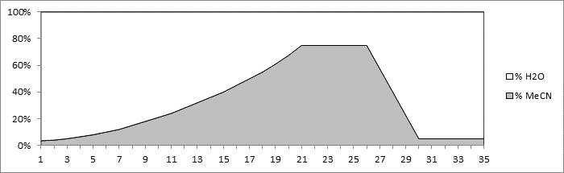
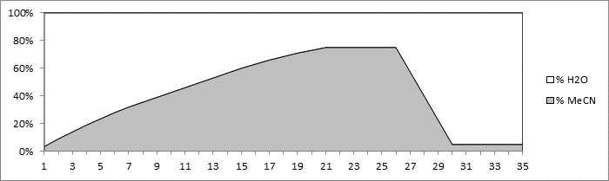

Figure 1.Curve gradient elution; concave (top) and convex (bottom) gradient elution, The graph represent the percentage of water and acetonitrile

Result and Discussion
Chromatographic conditions for model sample

All model samples had undergone a full-range gradient method to obtain the overall performance of their chromatographic profiles. The full-range gradient method is also a standard gradient elution scouting run to determine the best elution mode to be chosen in this study. Dolan [16] had suggested that the scouting run can be a guide tool to determine the best elution mode for a specific sample, column and eluent system. The chromatographic profiles samples using the full-range gradient method show that the samples occupied more than 40% of the separation space (Figure 2). This indicates that the separation should be done by the gradient elution.

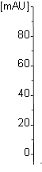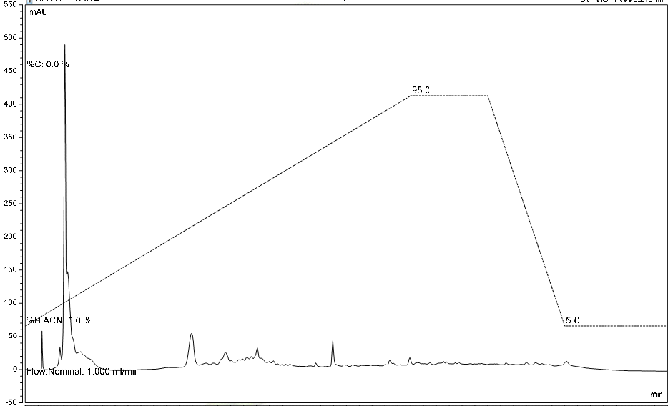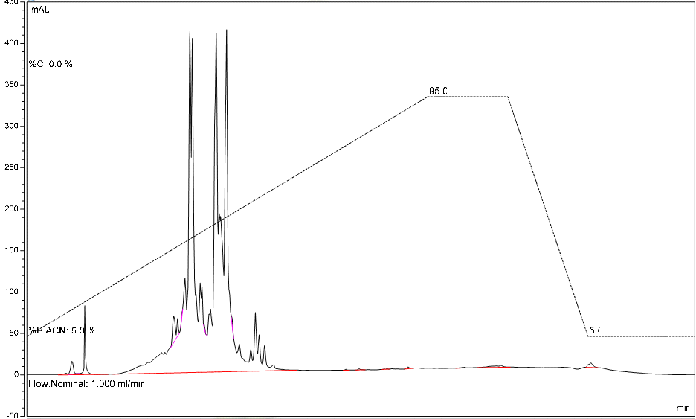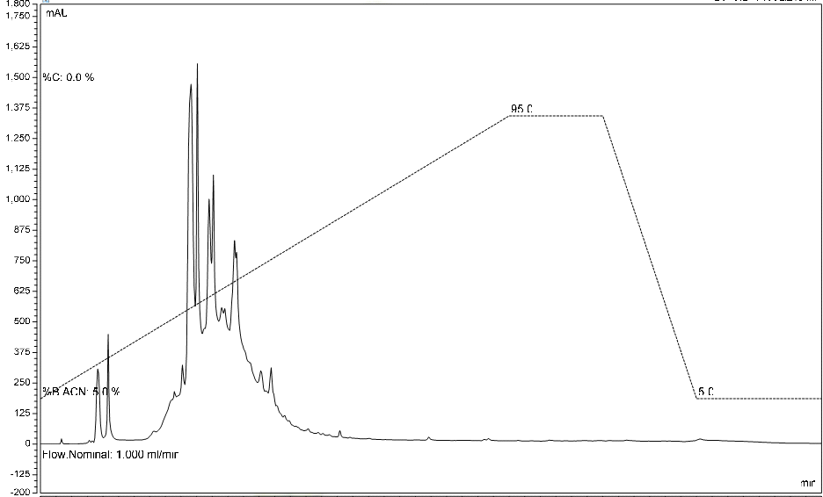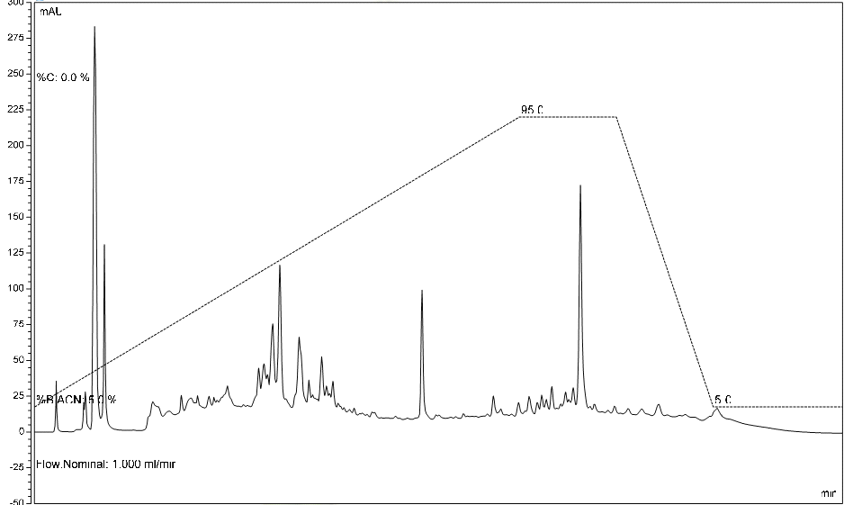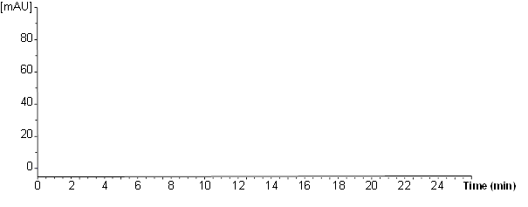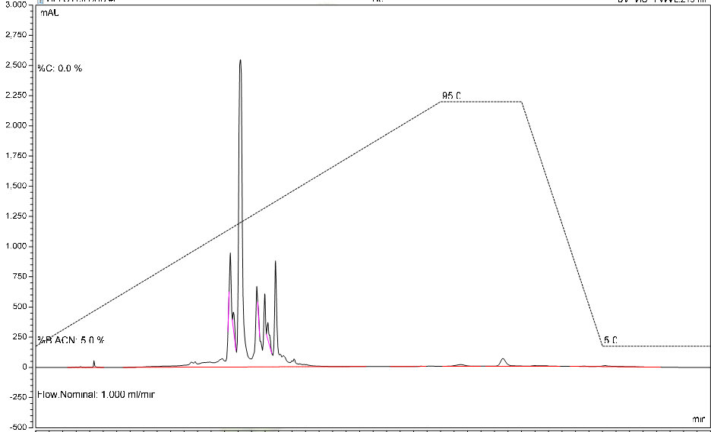
(a)
(b)
(c)
(d)
(e)

Figure 2. Chromatogram profiles of model samples using full-range gradient method of ACN:H₂O (5:95 to 95:5 in 15 minutes); (a) Shorea parvifolia, (b) Shorea ovalis, (c) Dipterocarpus crinitus, (d) Dipterocarpus gracilis, and (e) Hopea spp

From the initial analysis of the chromatographic profile, we have decided to increase the chromatographic run from 15 to 20 minutes to accommodate the wide range of retention time for compounds in Dipterocarpus gracilis. The analyses were continued by changing the solvent composition of the initial and the end of a chromatographic run. All chromatographic profiles were analyzed and after some adjustment and modification, an isocratic mode of ACN:H₂O (5:95 to 75:25 in 20 minutes) was considered performing a reasonably good separation for all samples. Figure 3 shows the chromatographic profiles of all model samples using the selected chromatographic conditions.

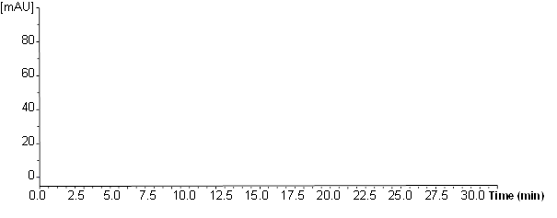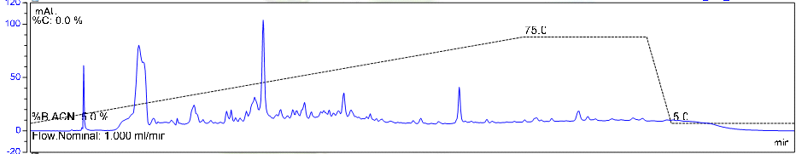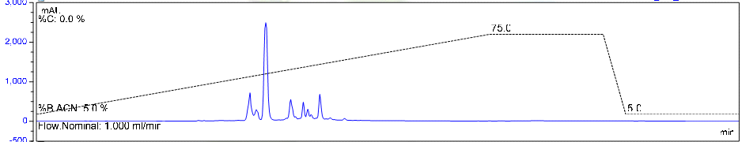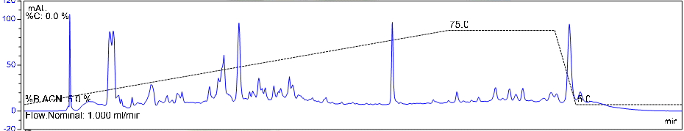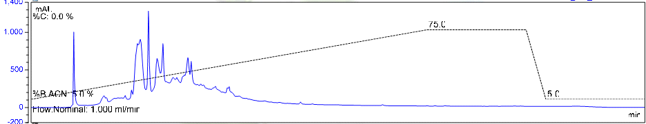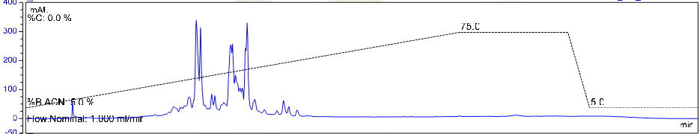
(a)
(b)
(c)
(d)
(e)

Figure 3. Chromatographic profiles of model samples using an isocratic mode of ACN:H₂O (5:95 to 75:25 in 20 minutes); (a) Shorea parvifolia, (b) Shorea ovalis, (c) Dipterocarpus crinitus, (d) Dipterocarpus gracilis, and (e) Hopea spp

Curved gradient method
Basically, there are two types of curved gradient method; concave and convex gradients. These methods were tested to discover any improvements on the separation of samples. In a reverse phase chromatography, concave and convex gradients were used for analyzing multi-component samples which require the extra resolution either at the beginning or at the end of the gradient. The elution rate was maintained at H₂O:ACN (95:5 to 25:75 in 20 minutes) for both gradient method. The results, however, did not show any improvement in the resolution and failed to achieve optimal separation of model samples. Thus, it was not considered for further optimization of the chromatographic conditions for the model samples.

Injection volume
Injection volume is considered as one of the parameter that can be modified to achieve optimized method development for better separation of all samples. In this study, the gradient elution was fixed to be H₂O:ACN (95:5 to 25:75) and the run time was set up to be 20 minutes. The chromatograms showed that the injection volume had the significant effect on the chromatographic resolution. The shapes of peaks were improved, thus producing a better resolution. Previous studies [17,18] also showed that with the increase of injection volume, the resolution of separated compounds would be decreased. In this study, the injection volume of 5 μl per injection of samples is considered to be the best compromise.
Method validation on test samples

Ten plant samples were chosen to be tested with the optimized chromatographic conditions to ensure the reproducibility of the developed method. The tested samples are from the same family as the model samples but different parts of the plant that were studied. The tested samples were taken from the wood of the buttress and each species were from two places in Malaysia (Selai and Kuala Kerian). Shorea parvifolia, Shorea leprosula, Shorea ovalis, Dipterocarpus crinitus and Hopea spp. were chosen to test the method. Figure 4(a-e) shows the chromatographic profiles of all tested samples.

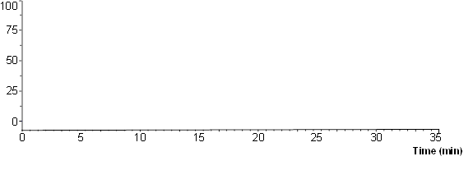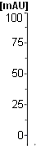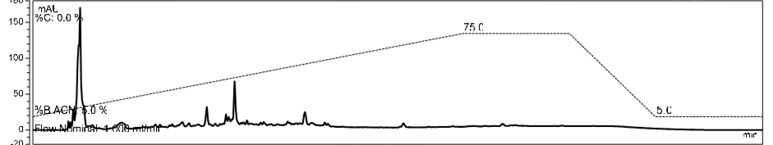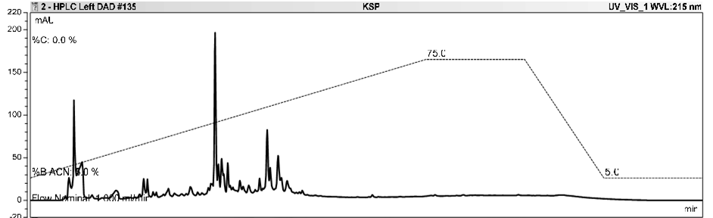
(a)
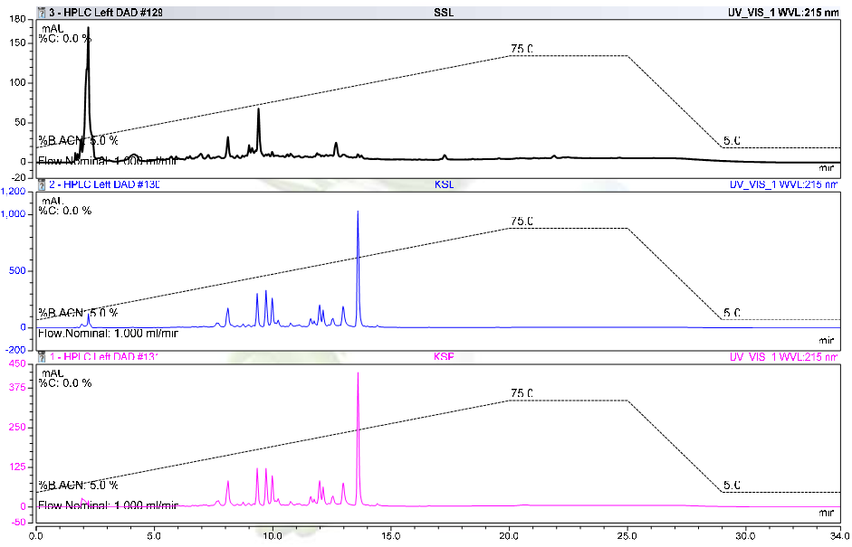
(b)
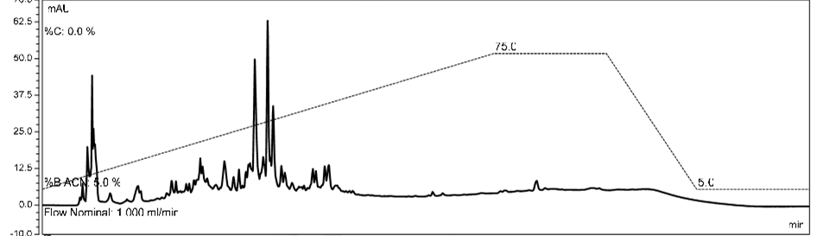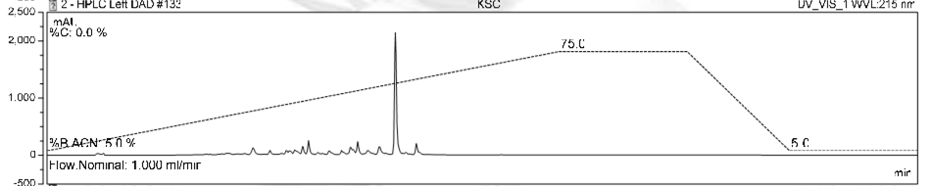
(c)

Figure 4. Chromatographic profiles of test samples using an isocratic mode of ACN:H₂O (5:90 to 75:25 in 20 minutes); (a) Shorea parvifolia, (b) Shorea leprosula and (c) Shorea ovalis. The top chromatograms are for samples from Selai and the bottom are samples from Kuala Kerian
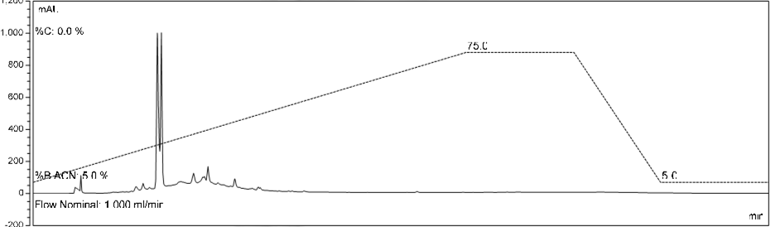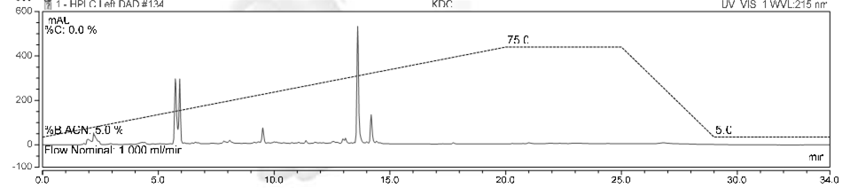
(d)
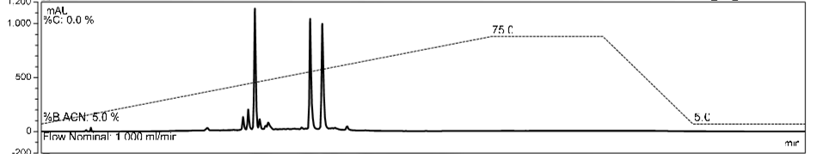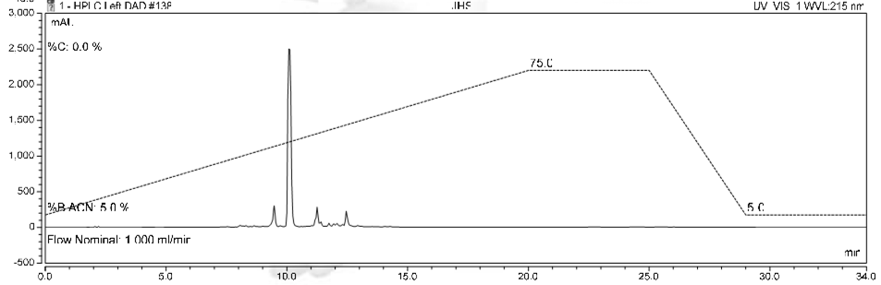
(e)
Figure 4 (cont.): Chromatographic profiles of test samples using an isocratic mode of ACN:H₂O (5:90 to 75:25 in 20 minutes); (d) Dipterocarpus crinitus and (e) Hopea spp. The top chromatograms are for samples from Selai and the bottom are samples from Kuala Kerian

The optimum chromatographic profiles for Dipterocarpaceae plant extracts were achieved by a gradient elution of water-acetonitrile from 95:5 to 25:75 in 20 minutes. A smaller injection volume is more favourable for a better resolution, in this case is 5 μL per injection. This standard method can reduce the overall assay development time for analysis of similar samples and provide essential information regarding the effects of chromatographic parameters on the separation. A longer gradient time will increase the retention of compounds in the column. Thus, the elution is slower and overlapping peaks for early-eluting compounds can be avoided. Nonetheless, longer gradient time up to a limit will cause overlapping peaks to the late-eluting compounds. Since the compounds were retained longer in the column, there is a chance that peaks will not eluted during the fixed run time and may be missing from the analyzed samples.

Though the tested samples can be separated by using the optimized method, it is best to individually alter the chromatographic conditions. This is to ensure better separation and resolution of samples and as well as a more accurate method can be achieved.

Conclusion
The results show that a single chromatographic method for analyses of different plant samples is possible. A gradient elution method using water-acetonitrile (from 95:5 to 25:75) and injection volume of 5 μL was the chosen and optimized method. The run time was extended to 20 minutes to give sufficient time for the compounds to be eluted from the column and to avoid peak overlapping. Other parameters, the column temperature (35 °C) and the flow rate (1.0 ml/min) were kept constant.

As far as phytochemical studies are concerned, the ability of such a method to separate a set of plants samples using only one chromatographic condition provides a useful tool for more efficient natural compounds isolation. This eliminates the dependence on reproducing precise chromatographic data for every single plant sample, which has significantly influenced the energy and time consumptions. The strategy of having a single method for chromatographic condition can increase the productivity of phytochemical analysis of plant extracts, and avoid the replication of developing chromatographic conditions unnecessarily.

Acknowledgement

The members of this project would like to thank Atta-ur-Rahman Institute for Natural Products Discovery, Research Management Institute (RMI), UiTM for supporting this project by providing laboratory space and administrative assistance. We are also grateful to The Ministry of Education (MOE) for the research funding under the Fundamental Research Grant Scheme (FRGS). We also want to thank Puan Marina Ismail, Akademi Pengajian Bahasa, UiTM for proofreading the manuscript.

References

- Ito, T. (2011). Structures of oligostilbenoids in dipterocarpaceaeous plants and their biological activities. Yakugaku Zasshi, 131(1): 93 – 100.
- Ito, T., Akao, Y., Tanaka, T., Iinuma, M. and Nozawa, Y. (2002). Vaticanol C, a novel resveratrol tetramer, inhibits cell growth through induction of apoptosis in colon cancer cell lines. Biological and Pharmaceutical Bulletin, 25(1): 147 – 148.
- Zuraida, W., Ahmat, N., Hazana, N. and Ainaa, N. (2011). The evaluation of antioxidant, antibacterial and structure identification activity of trimer resveratrol from Malaysia’s Dipterocarpaceae. Australian Journal of Basic and Applied Scienc,e 5(5): 926 – 929.
- Bayach, I., Manshoor, N., Sancho-Garcia, J. C., Choudhary, M. I., Trouillas, P., Weber, J. F. F. (2015). Oligostilbenoids from the heartwood of N. heimii and insights in their biogenesis. Chemistry - An Asian Journal, 10: 198 – 211.
- Boligon, A. A. and Athayde, M. L. (2014). Importance of HPLC in analysis of plants extracts. Austin Chromatography, 1(3): 2 – 3.
- Bucar, F., Wube, A. and Schmid, M. (2013). Natural product isolation–how to get from biological material to pure compounds. Natural Product Reports, 30(4): 525 – 545.
- Prathap, B., Dey, A., Srinivasarao, G. H., Johnson, P. and Arthanariswaran, P. A. (2013). Review-importance of RP-HPLC in analytical method development. International Journal of Novel Trends in Pharmaceutical Sciences, 3: 15 – 23.
- Manshoor, N. and Weber, J. F. F. (2015) Mass spectrometric analysis for discrimination of Diastereoisomers. Mass Spectrometry Letters, 6(4): 99 – 104.
- Manshoor, N. and Weber J. F. F. (2015) Mass fragmentation patterns as fingerprints for positive identification of polyphenolic compounds in a crude extract. Mass Spectrometry Letters, 6(4): 105 –111.
- Moghbel, N., Ryu, B. and Steadman, K. J. (2015). A reversed-phase PLC-UV method developed and validated for simultaneous quantification of six alkaloids from Nicotiana spp. Journal of Chromatography B, 997: 142 – 145.
- Al-Hroub, H., Alkhawaja, B., Alkhawaja, E. and Arafat, T. (2015). Sensitive and rapid HPLC-UV method with back-extraction step for the determination of sildenafil in human plasma. Journal of Chromatography B, 1009: 1 – 6.
- Sila-on, W., Na-Ranong, S., Rakrod, S., Ornlaor, S. and Joungmunkong, Z. (2015). Development and validation of RP-HPLC method for determination of acetazolamide, furosemide and phenytoin extemporaneous suspensions. Asian Journal of Pharmaceutical Sciences, 11: 138 – 139.
- Ito, T., Nishiya, K., Oyama, M., Tanaka, T., Murata, J., Darnaedi, D. and Iinuma, M. (2013). Novel isolation of resveratrol dimer O-glucosides with enantiomeric aglycones from the leaves of Shorea cordifolia. Phytochemistry Letters, 6(4): 667 – 670.
- Ito, T., Hara, Y., Oyama, M., Tanaka, T., Murata, J., Darnaedi, D. and Iinuma, M. (2012). Occurrence of bergenin phenylpropanoates in Vatica bantamensis. Phytochemistry Letters, 5(4): 743 – 746.
- Morikawa, T., Chaipech, S., Matsuda, H., Hamao, M., Umeda, Y., Sato, H. and Pongpiriyadacha, Y. (2012). Antidiabetogenic oligostilbenoids and 3-ethyl-4-phenyl-3, 4-dihydroisocoumarins from the bark of Shorea roxburghii. Bioorganic & Medicinal Chemistry, 20(2): 832 – 840.
- Dolan, J. W. (2000). Starting out right, Part VI-the scouting gradient alternative. LC GC Europe, 13(6): 388 – 395.
- Eisenbeiss, F., Ehlerding, S., Wehrli, A. and Huber, J. F. K. (1985). Optimization of throughput in preparative column liquid chromatography by column overloading and partial fractionation of the effluent. Chromatographia, 20(11): 145 – 145.
- Ren, D. B., Yang, Z. H., Liang, Y. Z., Fan, W. and Ding, Q. (2013). Effects of injection volume on chromatographic features and resolution in the process of counter-current chromatography. Journal of Chromatography A, 1277: 7 – 14.

