

MALAYSIAN JOURNAL OF ANALYTICAL SCIENCES
ISSN 1394 - 2506

Published by The Malaysian Analytical Sciences Society

NON-PLATINUM CATALYST FOR SINGLE CELL OF DIRECT METHANOL FUEL CELL

(Mangkin Bukan Platinum Untuk Sel Tunggal Sel Bahan Api Metanol Langsung)

Nabila A. Karim¹, Siti Kartom Kamarudin^{1,2}*, Loh Kee Shyuan¹, Zahira Yaakob¹, Wan Ramli Wan Daud¹,

Abdul Amir Hassan Khadum²

¹Fuel Cell Institute

²Department of Chemical and Process Engineering, Faculty of Engineering and Built Environment

Universiti Kebangsaan Malaysia, 43600 UKM Bangi, Selangor, Malaysia

*Corresponding author: ctie@ukm.edu.my

Received: 21 October 2015; Accepted: 14 June 2016

Abstract

This paper presented short communication of non-platinum catalyst for single cell DMFC. CoPc/C supported on Tungsten Oxide Nanowire (W₁₈O₄₉) is synthesis using solvothermal and pyrolysis process so that can be used as non-platinum cathode catalyst for DMFC. Transmission Electron Microscopy (TEM) image revealed that the synthesis Tungsten Oxide Nanowire has single diameter from 2 nm to 5 nm while Field Emission Scanning Electron Microscopy (FESEM) image had shown that the nanowires are surrounded with CoPc/C. The activity of catalyst towards oxygen reduction reaction had been tested using cyclic voltammetry and Rotating Ring-Disk Electrode (RRDE) giving reduction peak potential at 0.6 V vs. RHE and electron transfer in oxygen reduction reaction almost to 4-electron transfer comparable to other catalysts. Pyrolysis process had changed value of x in composition CoN_{x} referring to incomplete breaking bonding from CoN₄ to form CoN_{x}. The single performance test DMFC using this non-platinum catalyst had shown that the power has increase to 8.7 mW/cm² compared to other non-platinum catalyst.

Keywords: direct methanol fuel cell, non-platinum catalyst, oxygen reduction reaction, cobalt phthalocyanine/carbon, nanowires

Abstrak

Kertas kajian ini membentangkan secara ringkas mengenai kajian mangkin bukan platinum untuk sel tunggal sel bahan api metanol langsung (DMFC). CoPc/C disokong oleh penyokong mangkin Tungsten Oksida Wayar-Nano (W₁₈O₄₉) yang disintesis melalui proses pelarut-terma dan pirolisis supaya dapat diaplikasikan sebagai mangkin bukan platinum katod DMFC. Imej Mikroskop Transmisi Elektron (TEM) telah menunjukkan diameter wayar-nano tunggal adalah daripada 2 nm hingga 5 nm manakala imej Mikroskop Elektron Sinaran Pancaran Medan (FESEM) pula menunjukkan wayar-nano dikelilingi oleh CoPc/C. Aktiviti mangkin terhadap tindak balas penurunan oksigen telah diuji menggunakan voltameter berkitar dan elektrod cakera-gelang berputar (RRDE) memberi keputusan keupayaan puncak penurunan pada 0.6 V vs. RHE dan pemindahan elektron dalam tindak balas penurunan oksigen menghampiri pemindahan 4-elektron setanding dengan mangkin lain. Proses pirolisis telah mengubah nilai x dalam komposisi CoN_{x} merujuk kepada ketidak-sempurnaan pemutusan ikatan daripada CoN₄ menjadi CoN_{x}. Ujian prestasi sel tunggal menggunakan mangkin bukan platinum ini telah menunjukkan peningkatan kuasa menjadi 8.7 mW/cm² berbanding menggunakan mangkin bukan platinum lain.

Kata kunci: sel bahan api metanol langsung, mangkin bukan platinum, tindak balas penurunan oksigen, wayar-nano, kobalt ftalosianina/karbon

Introduction
Fuel cell is one of the alternative energy that convert chemical energy to electrical energy without any combustion process. There are several types of fuel cell and one of it is Direct Methanol Fuel Cell (DMFC). DMFC use methanol as fuel to produce electricity. Advantages of DMFC over the other fuel cell such as low emission carbon dioxide, high power density and high energy density [1]. There are also some disadvantages of DMFC that need to overcome such as methanol crossover, low chemical rates, catalyst poisoning and others [2].

There are two main reactions in DMFC that produce electricity; methanol oxidation reaction at anode side and oxygen reduction reaction at cathode side [3]. The uses of combination platinum-ruthenium metal (PtRu) as catalyst for methanol oxidation reaction at anode side has solved the poisoning of catalyst due to high adsorption CO molecule at surface of Pt metal catalyst [4]. Meanwhile platinum metal catalyst has high selectivity toward oxygen reduction reaction. Some of methanol permeate through membrane to cathode side and giving bad effect reaction at cathode side when using Pt for oxygen reduction reaction. This methanol crossover giving competitive reaction at cathode side. Furthermore, oxidation of methanol on Pt surface at cathode side worsen for the reduction reaction as the site of reaction decrease due to poisoning effect on the catalyst surface.

Due to the problem, finding non-platinum catalyst is important to increase activity of oxygen reduction reaction at cathode side [4]. Using Pt metal as catalyst also increase cost of DMFC as Pt metal is costly and hinder the commercialization of DMFC. There is a problem arise when using non-platinum catalyst as the side product from oxygen reduction reaction, hydrogen peroxide produce using this catalyst. The production of hydrogen peroxide need to be as low as possible because hydrogen peroxide give poison environment to membrane in DMFC [5].

There are number of study non-platinum catalyst for oxygen reduction reaction with the promising catalyst come from macrocycle that has low cost compared to Pt and other noble metal [6]. CoPc/C (Cobalt Phthalocyanine/Carbon) supported on Tungsten Oxide Nanowire, W₁₈O₄₉ (CoPc/C-NW) has been synthesis and shown promising as non-platinum cathode catalyst for oxygen reduction reaction. This paper present analysis of CoPc/C-NW for oxygen reduction reaction and applied it as cathode catalyst on single cell performance test DMFC.

Materials and Methods
The synthesis of nanowires was taken from Sun et al. [7] but briefly Cobalt Phthalocyanine (CoPc) (Sigma-Aldrich) was mixed with carbon black (HiSpec®) and ultrasonic bath for four hours. The preparation of the catalyst doped with Tungsten Oxide Nanowires (NW) has done by mixing CoPc/C with WCl₆ (Sigma-Aldrich) with concentration 0.007 M and transferred to PTFE-lined 100 mL autoclave. The autoclave was heated in 200 °C for 12 hours. The product was washing with water, acetone and ethanol and then centrifuge and dried for further pyrolysis at 700 °C under flow of nitrogen gas for two hours. The tube furnace was adjusted to increase the temperature at a ramping rate of 5 °C/min until the desired heat-treatment temperature was reached. The furnace was then held at this temperature for 2 hours, followed by cooling at a rate of 5 °C/min until a room temperature was reached.

The surface morphologies of the catalyst were recorded on Field Emission Scanning Electron Microscopy (FESEM) on Carl Zeiss Supra 55VP and Transmission Electron Microscopy (TEM) in which the images were recorded on Philips CM12 microscope operated at 120 kV. The sample catalyst was placed in ethanol and ultrasonic bath for 30 minutes. The bonding of the catalyst has been analysis using X-ray photoelectron spectroscopy (XPS) in Krato Axis Ultra DLD instrument operated at 14 kV. A dual-anode x-ray source with Mg K irradiation with energy of 1253.6 eV was used. All the spectra were charge-referenced to the carbon at 284.5 eV.

Cyclic voltammetry (CV) and rotating ring-disk electrode (RRDE) has been done to determine the electrochemical characterization of the catalyst. The deposited ink catalyst on the glassy carbon, platinum gauze and Ag/AgCl electrode were used as the working electrode, counter electrode and reference electrode respectively. All the potential in this paper has been transferred to the Reversible Hydrogen Electrode (RHE). A solution of 0.5 M H₂SO₄ was saturated with oxygen gas by bubbling O₂ for 30 minutes.

PtRu/C and CoPc/C-NW was used as anode and cathode catalyst, respectively, for single cell performance test. The loading of catalyst for both anode and cathode was 5 mg/cm² and 2 mg/cm², respectively. Nafion 117 was used as electrolyte membrane. MEA was fabricated by sandwiching the anode and cathode electrodes with Nafion 117 by hot-pressing at 5 MPa for three minutes.

Results and Discussion
Figure 1 showed TEM image of synthesis Tungsten oxide nanowires W₁₈O₄₉. The nanowires appeared in bundle shape with diameter of the bundle around 50 nm to 100 nm and diameter of single nanowire is around 2.15 nm to 5 nm. The length of nanowire has dimension about 150 nm to 200 nm.

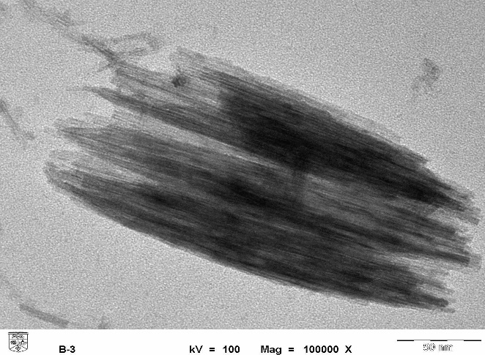

Figure 1. TEM image of synthesis Tungsten oxide nanowire W₁₈O₄₉

Figure 2 showed FESEM image of synthesis catalyst CoPc/C-Tungsten oxide nanowire, W₁₈O₄₉ (CoPc/C-NW). The bundle nanowires appeared surrounded by CoPc/C with diameter of bundle nanowires around 50 nm and up to 100 nm. Some of bundle nanowires after pyrolysis are merged together to increase the diameter size of bundle nanowires.

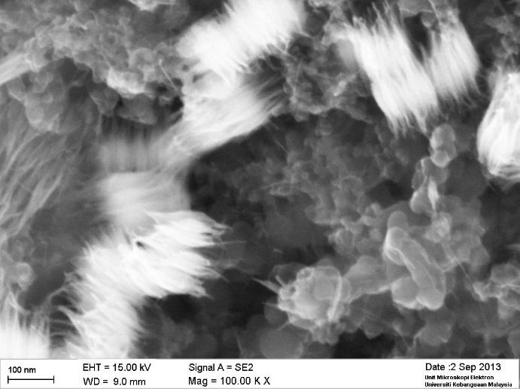

Figure 2. FESEM image of catalyst synthesis CoPc/C- Tungsten oxide nanowire (W₁₈O₄₉)

The electrochemical analysis of catalyst CoPc/C-NW has been tested by cyclic voltammetry and rotating ring-dick electrode (RRDE). Figure 3 showed the cyclic voltammetry (CV) of catalyst CoPc/C-W₁₈O₄₉ in 0.5 M H₂SO₄ saturated with nitrogen and oxygen. There is catalytic activity towards oxygen reduction reaction with reduction peak at 0.6 V vs. RHE and current density at reduction peak is 0.8 mA/cm². The reduction peak is more positive compared with other study of CoPc.

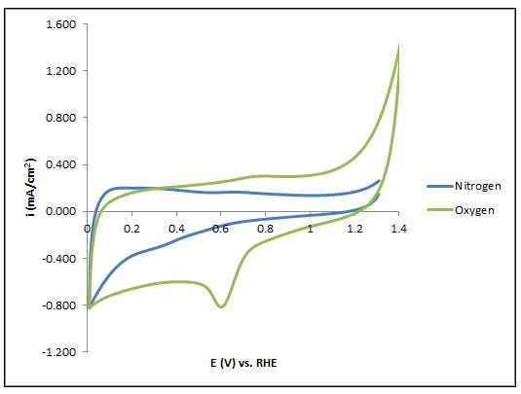

Figure 3. Cyclic voltammetry of catalyst CoPc/C-NW in 0.5 M H₂SO₄ solution saturated with nitrogen and oxygen with scan rate of 5 mV/s

Figure 4 showed the number of electron transfer using CoPc/C-NW catalyst. This graph is extracted from RRDE analysis (not shown here). There are two pathway in oxygen reduction reaction. The first pathway according to equation (1) in which 4 total number of electron transfer to produce water while in equation (2) produce hydrogen peroxide for 2 electron transfer. Pathway of chemical equation (1) is favourable in oxygen reduction reaction to produce water. Production of hydrogen peroxide should be minimized as low as possible because hydrogen peroxide brings toxic environment toward membrane in Direct Methanol Fuel Cell (DMFC) as it will breaking chemical bonding of membrane.

O₂ + 4H⁺ + 4e⁻ → H₂O (1)
O₂ + 2H⁺ + 2e⁻ → H₂O₂ (2)

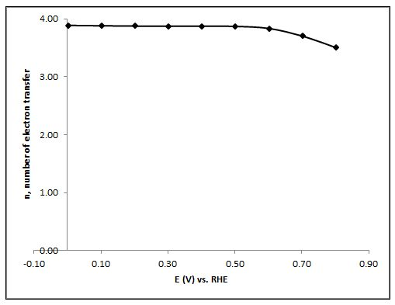

Figure 4. Calculated number of electron transfer for oxygen reduction reaction in 0.5 M H₂SO₄ using CoPc/C-NW
In Figure 4 showed that the number of electron transfer using CoPc/C-NW. The number of electron transfer in oxygen reduction reaction using CoPc/C-NW is near to 4. The number electron transfer also almost constant at 0 V vs. RHE to 0.6 V vs. RHE but has a little dropping in value above 0.6 V vs. RHE. This dropping in value could be instability of catalyst at higher potential. Even though, the average electron transfer using catalyst CoPc/C-NW is 3.81.

Table 1 showed comparison number of electron transfer in oxygen reduction reaction using other catalyst. Iron phthalocyanine (FePc) is another macrocyclic catalyst from phthalocyanine family structure where iron atom at centre of chemical structure phthalocyanine. FePc is well known superior catalyst in oxygen reduction compared to CoPc. Most study using CoPc catalyst has lower number electron transfer and produce hydrogen peroxide as presented in Table 1 while FePc has higher electron transfer to produce water as main product. CoPc/C-NW catalyst has shown high catalytic activity comparable to FePc and Pt catalyst in term of number of electron transfer. CoPc/C-NW activity also increase after supported with Tungsten oxide nanowire (W₁₈O₄₉) compared without support of CoPc/C.

Table 1. Comparison number of electron transfer using different catalyst for oxygen reduction reaction
Catalyst | No of Electron Transfer | Reference
CoPc/C-NW | 3.81 | This study
FePc/MWCNT | Close to 3 | [8]
Fe-N-C | 3.8 | [9]
CoPc/MWCNT | Less than 3 | [8]
CoPc/MWCNT | 1.7-1.8 | [10]
Pt | 4.0 | [11]

Table 2 showed atomic % in sample catalyst CoPc/C-NW. The atomic % in sample catalyst CoPc/C-NW is 77.39, 7.84, 10.46, 2.55 and 1.75 referring to element C, N, O, Co and W, respectively. Catalyst CoPc/C-NW has high atomic percentage of element nitrogen. The ratio element nitrogen to cobalt in CoPc/C-NW is 3.07. This ratio represented value of x in bonding CoN_{x}. Chemical structure of CoPc has four nitrogen bonded to cobalt atom at the centre of chemical structure as showed in Figure 5. The value of x in CoN_{x} without pyrolysis is four. As the catalyst is treated in pyrolysis, the process of pyrolysis has breaking bonding of CoN_{x} become x from value of four. In this sample catalyst, the value of x has become incomplete 3.07 from 4.

Table 2. XPS, atomic % of sample catalyst CoPc/C-NW
Catalyst/ Element | C | N | O | Co | W | N/Co
CoPc/C-NW | 77.39 | 7.84 | 10.46 | 2.55 | 1.75 | 3.07

Catalyst CoPc/C-NW also has been applied in single cell DMFC as cathode catalyst to test it performance. Figure 6 showed the polarization curve and power density of single cell DMFC using CoPc/C-NW as cathode catalyst. Power density for the single cell is 8.7 mW/cm². The power density is higher compared to catalyst Pani-FeTsPc as shown in Table 3. It is well-known that in Pc catalyst family, FePc has higher oxygen reduction reaction activity compared to CoPc catalyst. Number of electron transfer produce by using CoPc/C-NW catalyst is comparable as shown in Table 2 and higher in power density as shown in Table 3.

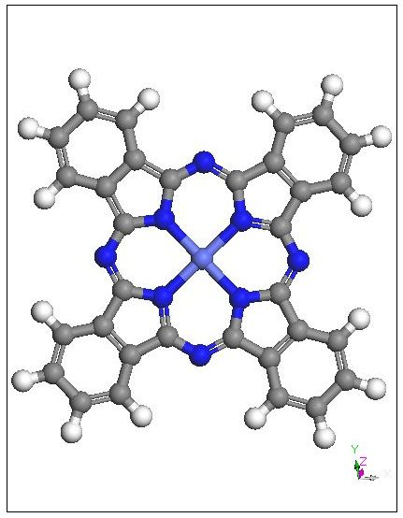

Figure 5. Chemical structure of CoPc

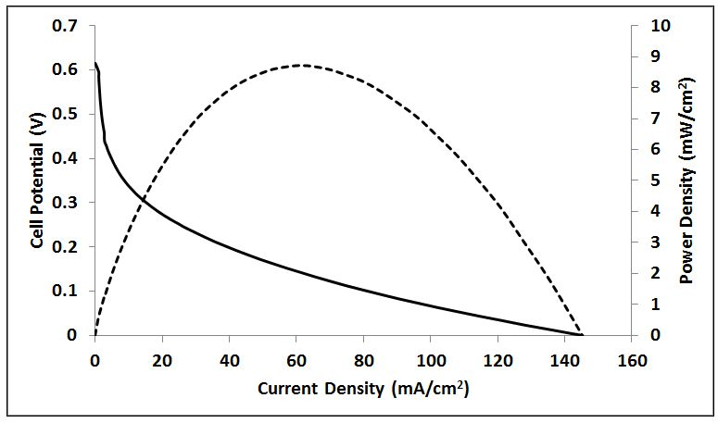

Figure 6. Polarization curves and power density of DMFC with cathode catalyst CoPc/C-NW at 70 °C

Table 3. Comparison Power density of single cell DMFC
Catalyst | Power Density  (mW/cm²) | Reference
CoPc/C-NW | 8.7 | This study
Pani-FeTsPc | 6.0 | [12]

Conclusion
Result has shown that catalyst CoPc/C-NW can be used for oxygen reduction reaction as it is better than CoPc/C and comparable with other macrocyclic catalyst and Pc family catalyst. Single performance test also has shown that CoPc/C-NW has increase in power density than FePc catalyst. FESEM structure has revealed that the support NW are not well distributed to CoPc/C could be disadvantages such as lower stability catalyst and other problem. Further research can be studied to improve morphology of CoPc/C supported on NW thus can also increase catalyst stability and performance of single cell DMFC.

Acknowledgement
The authors gratefully acknowledge financial support for this work by Universiti Kebangsaan Malaysia under Grant No.: DIP-2012-04 and DPP-2013-133.

References
- Kamarudin, S. K., Achmad, F. and Daud, W. R. W. (2009). Overview on the application of direct methanol fuel cell (DMFC) for portable electronic devices. International Journal of Hydrogen Energy, 34(16): 6902 - 6916.
- Kamarudin, S. K., Daud, W. R. W., Ho, S. L. and Hasran, U. A. (2007). Overview on the challenges and developments of micro-direct methanol fuel cells (DMFC). Journal of Power Sources, 163(2): 743 - 754.
- Zainoodin, A. M., Kamarudin, S. K. and Daud, W. R. W. (2010). Electrode in direct methanol fuel cells. International Journal of Hydrogen Energy, 35(10): 4606 - 4621.
- Karim, N. A. and Kamarudin, S. K. (2013). An overview on non-platinum cathode catalysts for direct methanol fuel cell. Applied Energy, 103(0): 212 - 220.
- Song, C. and Zhang, J. (2008). Electrocatalytic oxygen reduction reaction in PEM fuel cell electrocatalysts and catalyst layers, J. Zhang, Editor. Springer London: pp. 89 - 134.
- Karim, N. A., Kamarudin, S. K., Shyuan, L. K., Yaakob, Z., Daud, W. R. W. and Khadum, A. A. H. (2014). Novel cathode catalyst for DMFC: Study of the density of states of oxygen adsorption using density functional theory. International Journal of Hydrogen Energy, 39(30): 17295 - 17305.
- Sun, S., Zou, Z, and Min, G. (2009). Synthesis of bundled tungsten oxide nanowires with controllable morphology. Materials Characterization, 60(5): 437 - 440.
- Kruusenberg, I., Matisen, L. and Tammeveski. K. (2013). Oxygen electroreduction on multi-walled carbon nanotube supported metal phthalocyanines and porphyrins in acid media. International Journal of Electrochemical Science, 8(1): 1057 - 1066.
- Bezerra, C. W., Zhang, L., Lee, K., Liu, H., Zhang, J., Shi, Z., Marques, A. L., Marques, E. P., Wu, S. and Zhang, J. (2008). Novel carbon-supported Fe-N electrocatalysts synthesized through heat treatment of iron tripyridyl triazine complexes for the PEM fuel cell oxygen reduction reaction. Electrochimica Acta, 53(26): 7703 - 7710.
- Xu, Z., Li, H., Cao, G., Zhang, Q., Li, K. and Zhao, X. (2011). Electrochemical performance of carbon nanotube-supported cobalt phthalocyanine and its nitrogen-rich derivatives for oxygen reduction. Journal of Molecular Catalysis A: Chemical, 335(1): 89 - 96.
- Nørskov, J. K., Rossmeisl, J., Logadottir, A., Lindqvist, L. R. K. J., Kitchin, J. R., Bligaard, T. and Jonsson, H. (2004). Origin of the overpotential for oxygen reduction at a fuel-cell cathode. The Journal of Physical Chemistry B, 108(46): 17886 - 17892.
- Baranton, S., Coutanceau, C., Léger, J. M., Roux, C. and Capron, P. (2005). Alternative cathodes based on iron phthalocyanine catalysts for mini-or micro-DMFC working at room temperature. Electrochimica Acta, 51(3): 517 - 525.

