POLYIMIDE MEMBRANES FOR ORGANIC SALTS RECOVERY FROM MODEL BIOMASS FERMENTATION

(Membran Poliimida untuk Pengumpulan Garam Organik daripada

Model Sup Penapaian Biojisim)

Nadiah Khairul Zaman, Rosiah Rohani*, Abdul Wahab Mohammad

Department of Chemical and Process Engineering, Faculty of Engineering and Built Environment

Universiti Kebangsaan Malaysia, 43600 Bangi, Selangor, Malaysia

*Corresponding author: rosiah@ukm.edu.my

Abstract

Succinic acid displays promising properties as a precursor for synthesizing valuable chemicals. However, its recovery experiences difficulty due to the formation of by-products with similar physicochemical properties, namely acetate and formate. The succinate separation process via pressure filtration membrane technology demonstrates polyimide (PI) membrane as a potential candidate due to its high resistance and selectivity to many organic solvents from its imide groups, an important feature in separation of biomass fermentation broth. This study aims to investigate the performance of newly synthesized PI (P84) membrane prepared by phase inversion for succinate recovery from fermentation broth (simulated model solution is used). PI polymer composition 14 – 17 wt% were cast to investigate the effect of varying polymer compositions on the performance of NF membrane determined from the recovery of succinate, and removal of formate and acetate from ternary organic salt solutions at concentration range between 10 – 50 g/L. PI membrane (15 wt%) shows the highest selective succinate retention of 73%. Succinate selective retention was observed to increase whereas rejection of by-products decreased at increasing mixed salt solution concentration from 20 – 50 g/L. Field Emission Scanning Electron Microscope (FESEM) results showed a PI membrane with dense and thick top layer, with porous middle substructure to support membrane performance.

Keywords: Polyimide, nanofiltration membrane, succinate, biomass fermentation, mixed salt solution

Abstrak
Asid suksinik mempunyai kepentingan sebagai pelopor dalam mensintesis bahan kimia yang bernilai. Namun, pengumpulannya menghadapi kesukaran kerana pembentukan satu lagi produk sampingan yang mempunyai sifat fizikokimia yang sama seperti asetat dan format. Dalam proses pemisahan/pengumpulan suksinat menerusi tekanan teknologi membran penapisan, membran poliimida (PI) didapati berpotensi sebagai calon membran kerana ia bersifat perintang yang tinggi kepada banyak pelarut organik dan juga mempunyai pemilihan yang tinggi ke atas air melalui kumpulan imida yang penting dalam pengasingan sup penapaian biojisim. Oleh itu, kajian ini bertujuan untuk menyiasat prestasi membran PI (P84) yang baru disintesis dan disediakan dengan teknik fasa songsangan dalam bidang pengumpulan suksinat dari sup penapaian (model simulasi digunakan). Kepekatan PI polimer sebanyak 14 – 17 wt% telah disediakan dan kesan kepekatan polimer dalam penyediaan membran PI telah disiasat untuk mencapai membran PI berprestasi tinggi yang ditentukan dari pengumpulan suksinat dan penyingkiran asetat dan format pada julat kepekatan antara 10 – 50 g/L. Melalui kajian ini, membran PI (15 wt%) menunjukkan pengumpulan suksinat tertinggi sebanyak 73%. Pengumpulan suksinat diperhatikan meningkat manakala penyingkiran produk sampingan berkurangan dengan peningkatan kepekatan garam campuran dari 20 – 50 g/L. FESEM yang menunjukkan lapisan atas membran PI yang padat dan tebal serta lapisan substruktur tengah yang berliang untuk menyokong prestasi membran PI.

Kata kunci: Poliimida, nanopenurasan, suksinat, penapaian biojisim, garam campuran

Introduction
Succinic acid is a dicarboxylic acid (consists of two carboxyl) and is of high interest as a precursor for synthesizing a variety of valuable chemicals in the production of food [1], pharmaceutical products [2], and in the chemicals industry [3,4]. The versatility of succinic acid has attracted many attentions to find an alternative production route over the traditional process of using petroleum feedstock due to long-term environmental concern. This thus gives rise to the production of succinic acid from fermentation process using abundant biomass for a cleaner technology approach. Presently, studies have reported high production of succinate at various amounts via fermentation process when using different producing bacteria; 50 g/L by Mannheimia succiniciproducens [5], 83 g/L by Anaerobiospirillum succiniciproducens [6], 99.2 g/L by E. coli [7] and 100 g/L by Actinobacillus succinogenes [8]. However, along with the succinic acid production, other by-products such as acetic acid, formic acid, lactic, and pyruvic acids (depending on the producing bacteria) with similar physicochemical properties were also produced [9]. In addition to that, the requirement of pre-treating the fermentation broth prior to succinic acid separation has made the downstream processing of succinic acid difficult and costly which could mount up to about 50 – 70% of the production cost [10].

Many separation processes have been intensively studied for the separation/recovery of succinic acid including precipitation and crystallization [11], reactive extraction [12] and chromatography [13]. However these processes are subjected to limitations of either low recovery rate or purity, contamination of process by impurities, high energy consumptions or the need of frequent regeneration [14]. Among the separation technologies, intensive study using membrane filtration including microfiltration, ultrafiltration and nanofiltration (NF) have been carried out using commercial membranes [15-19]. Initial study was carried out by Glassner in 1992 on succinic acid purification process using integrated desalination electrodialysis and bipolar membrane electrodialysis. The former stage is applied to separate the ionic species such as acids from the fermentation broth containing the uncharged compounds such as sugars, saccharides or proteins. The charged molecules then passed through a membrane, and sodium succinate was collected. Meanwhile at the latter stage, bipolar membrane electrodialysis is used to convert sodium succinate into succinic acid while recycling back the NaOH to maintain the pH of the fermentation broth. However, this type of membrane filtration was found to be prone to low product yield due to loss of succinic acid and membrane pollution [20]. Later, succinic acid separation from fermentation broth was investigated using ultrafiltration. Wang et al. carried out a study on succinic acid separation which focused more on the membrane fouling mechanism in treating succinate acid from fermentation broth using dead-end ultrafiltration. Their study investigated the type of fouling experienced by different membranes including RC 10 kDa, PES 30 kDa, PES 100 kDa, and PES 10 kDa during succinate separation using Hermia’s model. It was found that most of the membranes tended to foul by cake layer or concentration polarization [21].

Among membrane filtration separation technologies, NF membranes for acid mixtures separation was highly reported due to the NF membrane characteristic that has high selectivity towards divalent anions compared to monovalent anions especially for separation of divalent anion from multivalent anions solution [15, 19]. Choi et al. [16] reported the retention of succinic acid using NF membrane, NF270 of Filmtec. The retention of organic salts was found to be dependent on the molecular weight cut off (MWCO) of membrane. Furthermore, the retention of succinic acid was over 90% irrespective of operating pressure and concentration due to close molecular weight (MW) of succinic acid to the MWCO of the NF270 membrane used. However for organic acid with lower MW (i.e. formic acid, acetic acid and propionic acid) than the MWCO of membrane, the retention is found to be dependent on the operating pressure and concentration. They also reported that the retention of succinic acid increases with increasing pH, depending on the degree of dissociation [16].

Therefore, the successful recovery of succinate/succinic acid using the commercial polymeric NF membrane has become the main motivation of this study. In this work an investigation on the succinate recovery from biomass fermentation broth was carried out using newly synthesized PI NF membrane fabricated via phase inversion, which to our knowledge has not yet been investigated in this field of succinate recovery from fermentation broth. The introduction of PI in the field of recovering succinate from fermentation broth is due to its excellent chemical resistance, good thermal and mechanical properties, easy processing, and good solubility in a variety of common solvents. It also possesses high negative surface charge that could effectively impede bio-fouling unlike the commercial membranes [22]. This material is also chosen due to its recent introduction in organic solvent separation [23,24], which is found to be also suitable for the targeted application in purifying the biomass fermentation broth that is composed of a complex mixture of alcohol, organic acid/salts, sugars, and biomass. A robust membrane such as PI polymer is required to withstand the extreme environment during separation and recovery of the desired product.

In this study, succinate retention was investigated based on the manipulation of polymer compositions during the doped solution preparation. This varying composition is expected to give different morphologies of the membrane thus influencing the retention of desired product. Phase inversion was used as it created an asymmetric membrane suitable for the application targeted. In the phase inversion, the cast polymer is immersed in a coagulation-bath containing poor solvent (non-solvent) such as water to create polymer rich and polymer lean phases from the diffusion of non-solvent into the cast film and of solvent out of it, inducing liquid-liquid demixing due to thermodynamic instability [22]. The former and latter polymer phases are then subsequently transformed into membrane matrix and membrane pores respectively [25]. The fabricated membranes were characterized using FESEM and salt retention to determine the membrane morphologies and retention properties. The performance of the fabricated membranes was also tested with a modelled ternary solution consisting succinate, formate, and acetate at different concentrations to investigate the selective recovery of succinate from the ternary solution.

Materials and Methods
Materials
For membrane preparation, polyimide (P84) fibers was purchased from Good Fellow and dried overnight at 120 °C prior to use. N–methyl–2–pyrrolidinone (NMP, Merck) was used as solvent. De-ionized H₂O was used as coagulation media while 2–propanol (2–PrOH, Merck) was used for membrane post-treatment. For model solution preparation, succinic acid (with molecular weight [MW] 118.09 g/mol, R&M Chemicals), formic acid (MW 46.03 g/mol, R&M Chemicals) and acetic acid (MW 90.09 g/mol, R&M Chemicals) were used to prepare the model fermentation broth solution at different concentration for retention analysis. Sodium hydroxide (NaOH, R&M Chemicals) was used to adjust pH to 7.0. All chemicals were used without further purification.

Membrane preparation
Homogeneous PI solutions were prepared by adding NMP solvent to the PI chopped fibers, which was subsequently heated at 60 °C for 4 hours until completely dissolved. The solution was stirred overnight until homogeneous for casting at room temperature using an automated film applicator (Elcometer 4340, UK). The cast speed, membrane thickness and evaporation time were set at 10 cm/s, 250 μm and 30 s, respectively. After casting, membrane films were exposed to ambient air to allow evaporation of the solvents and subsequently immersed in a coagulation bath of de-ionized water at room temperature for 10 min, after which the de-ionized water was replaced to remove all solvents. For post treatment by a solvent exchange procedure to avoid pore collapse upon drying, all cast membranes were immersed in 2–PrOH for 3 hours [26] and finally air dried naturally [27].

Salt rejection
To determine the level of membrane separation towards divalent and monovalent anions, salt rejections were carried out using dead end filtration cell (HP4750 Stirred Cell, Sterlitech) with a filtration area of 0.00146 m². A fixed pressure of 20 bar was used with feed consisting of NaCl and Na₂SO₄ at 20 mM concentration each. The salt rejection of membrane was determined by analysing the salt permeate using conductivity meter (METTLER TOLEDO). The flux was calculated based on the following Equation (1) while retention was calculated based on the following Equation (2):

$$J=\frac{ΔV}{A. t} (1)$$

where J is the flux (L/m².h), V is the volume of permeate (L), A is the effective area of membrane (m²) and t is time (h).

$$R \left(\%\right)=\left[1-\left(\frac{C_{P}}{C_{R}}\right)\right] (2)$$

where R is the percentage retention, C_{P} is the concentration of permeate and C_{R} is the concentration of retentate.

Membrane morphology
For membrane morphology, membrane cross-sections were observed with field emission scanning electron microscopy (FESEM) (SUPRA 55VP, ZEISS). Dried membrane samples were fractured in liquid nitrogen and mounted on aluminum stubs for platinum sputter-coated using sputter-coater (QUORUM Q150RS, UK) to make samples appear to have electrical conductivity. The samples were observed in standard high-vacuum conditions of 5 kV.

Succinate recovery
The recovery of succinate from multi-salt solutions using PI membranes were carried out using dead end filtration cells similar as in salt retention analysis. After every run, membranes used were rinsed with ultra-pure water until the initial water flux was recovered. Please note that the flux and rejection calculation are based on the salt rejection also. The flux and rejection were measured at various mixed-salt solution concentrations between 10 – 50 g/L at 15 bar. All mixed-salt solution concentrations were carried out at 1:1:1 ratio of succinate, formate, and acetate respectively (for simplification, 33.33:33.33:33.33 ratio in percentage).

The organic acid salts were measured using a high performance liquid chromatography (HPLC) (G1313A series, Agilent) with a separating column (REZEX ROA ORGANIC ACID H+ [8%], 300 x 7.8 mm, PHENOMENEX). The analysis was run with a refractive index (RI) detector at column temperature of 60 °C. An amount 0.005 M H₂SO₄ was used as the mobile phase at 0.6 ml/min of flow rate [19].

Result and Discussion
Salt retention
A desired NF membrane is a membrane that possesses high rejection of divalent anions while low rejection of monovalent anions. This means the succinate is to be retained in the retentate while other organic salts (formate and acetate) are to be removed in the permeate in this study. In order to investigate the retention of monovalent and divalent anions of the synthesized membranes, four different compositions of PI in the range of 14 – 17 wt% were prepared and tested using 20 mM of NaCl (monovalent anion) and Na₂SO₄ (divalent anion).

Table 1. NaCl and Na₂SO₄ retention and solution flux of PI membrane at different composition
PI membranes composition (wt%) | Flux for NaCl (L/m².h) | Rej. for NaCl (%) | Flux for Na₂SO₄ (L/m².h) | Rej. for Na₂SO₄ (%)
14 | 35.34 | 9.94 | 34.52 | 18.90
15 | 15.41 | 6.57 | 15.31 | 39.10
16 | 6.26 | 60.16 | 5.94 | 52.19
17 | 1.51 | 66.89 | 1.92 | 53.84

Table 1 shows the retention of each salt and the solution flux. From the results, it was observed that the fabricated PI membrane started to show NF characteristics at composition above 14 wt% based on the retention of NaCl and/or Na₂SO₄ of above 20%. Based on The DOW Chemical Company membrane specification, a typical NF membrane shows retention of dissolved salts between 20–80% [28]. Figure 1 shows the comparison between the retention of monovalent and divalent anions at different membrane compositions. Among the tested membranes, PI at 15 wt% composition shows the largest retention difference between monovalent anion, Cl⁻ and divalent anion, SO₄²⁻ with approximately 83% retention difference. It was also observed that below 15 wt% PI, the divalent anions shows higher retention compared to monovalent anions but above 15 wt% PI, monovalent anion has slightly higher retention than the divalent anion. It seemed that below 15 wt% PI composition, Donnan exclusion and sieve effect play important roles in ion separation while above 15 wt%, only Donnan exclusion acted as the major factor in the ion separation [19,29]. From the salt retention test, 15 wt% PI shows the highest potential for selective retention of succinate from mixture solution containing both mono- and divalent anions (Cl⁻ and SO₄²⁻ respectively) as it shows the highest retention difference between these two anions.

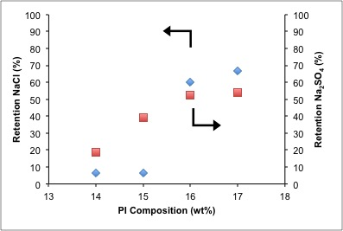

Figure 1. Comparison between retention of NaCl and Na₂SO₄ using PI membrane at different doped solution compositions (14, 15, 16 and 17 wt%). (Membrane synthesis conditions: membrane thickness of 250 μm, evaporation time of 30s. Filtration conditions: 20 bar, room temperature)
Membrane morphology
In order to further investigate the influence of polymer composition on the retention performance, the morphology of the membranes were examined using FESEM. Figure 2 shows the magnified cross-sections of PI membranes at different composition between 14 – 17 wt% of PI. Overall cross-section of the PI membrane images shows three layers of i) thin top skin layer, ii) intermediate nodular structure and iii) finger like porous sub-structure with macro voids. This top skin layer and nodular structure indicated an NF membrane properties as reported by [22,24]. The images observed as in Figure 2(c), within 10 μm of the top skin layer of the membranes exhibit dense sponge like morphologies leaving small channels reaching the surface of the membrane. At increasing PI composition, the membrane skin layer was observed to become denser while the middle sub-structure became less porous especially above 15 wt% PI composition. This observation explained the overall increase in retention of the tested solutes and the reduction in fluxes at composition higher than 15 wt%. The phenomenon is due to the slow down and delay on the non-solvent in diffusion and demixing of the polymer/non-solvent interface upon immersion when a higher composition of PI is used and thus resulting in a denser skin layer [22]. A dense skin layer may strongly affect the transport process of solute during rejection process thus making the rejection of the ions to be more effective. This result will be further discussed in the succinate recovery in the following section.

Meanwhile for the surface morphology of the fabricated membrane at different PI compositions, the FESEM images as in Figure 2(d) show an overall rough surface area at magnification of 100000x. It is also observed that as the composition of PI increases, the surface morphology becomes more wrinkled, which increases the surface roughness of the membrane. Lin et al. reported that the increase in surface roughness indicates that the membrane would have higher retention [30], which is in agreement with the results of salt retention test presented in Table 1. The results show that the retention of monovalent and divalent salt increases from 6.64 to 66.89% and from 18.9 to 53.84% respectively with increasing PI composition from 14 to 17 wt%.

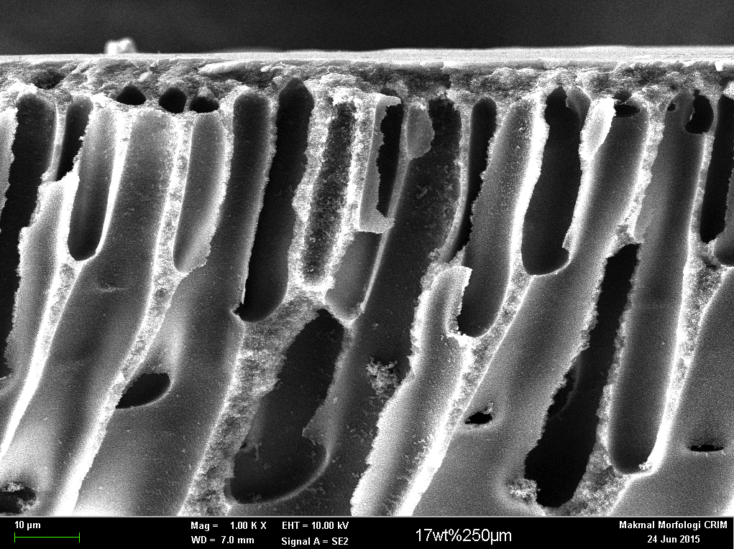  14 wt% (a) | 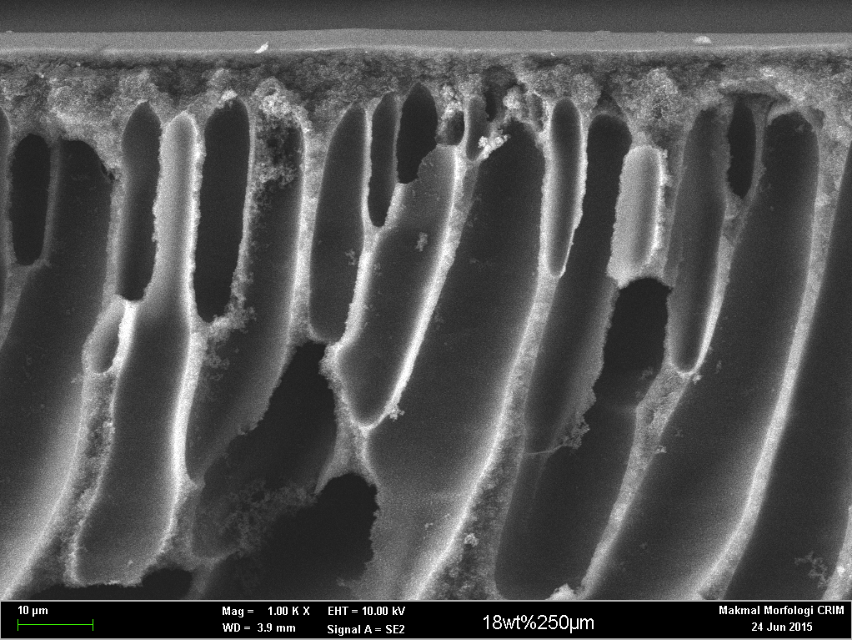  15 wt% (a) | 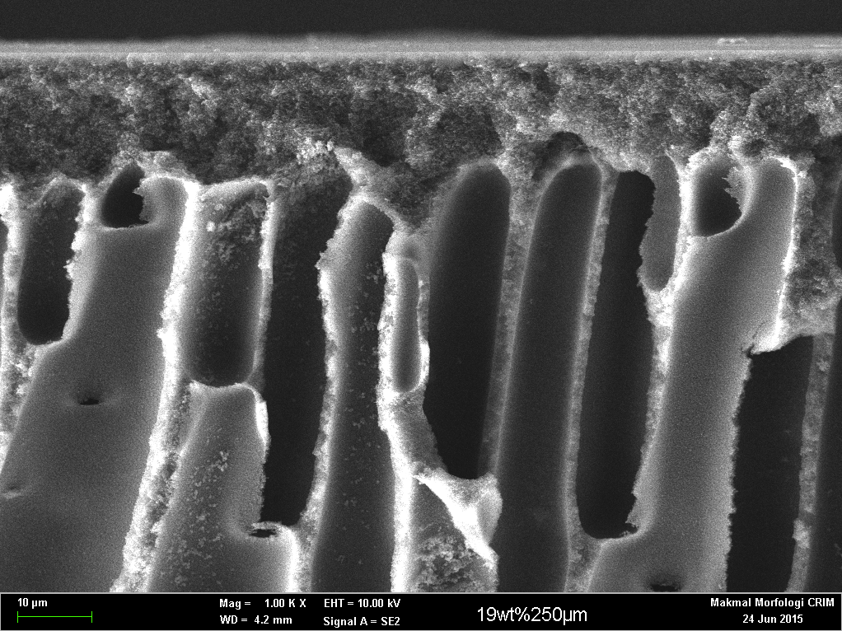  16 wt% (a) | 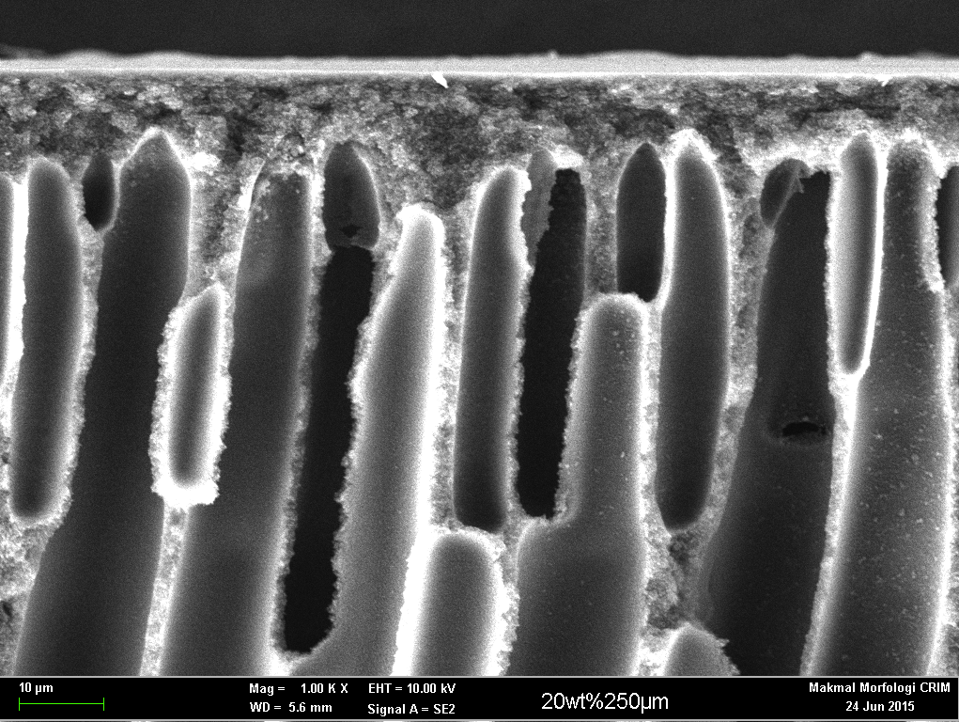  17 wt% (a)
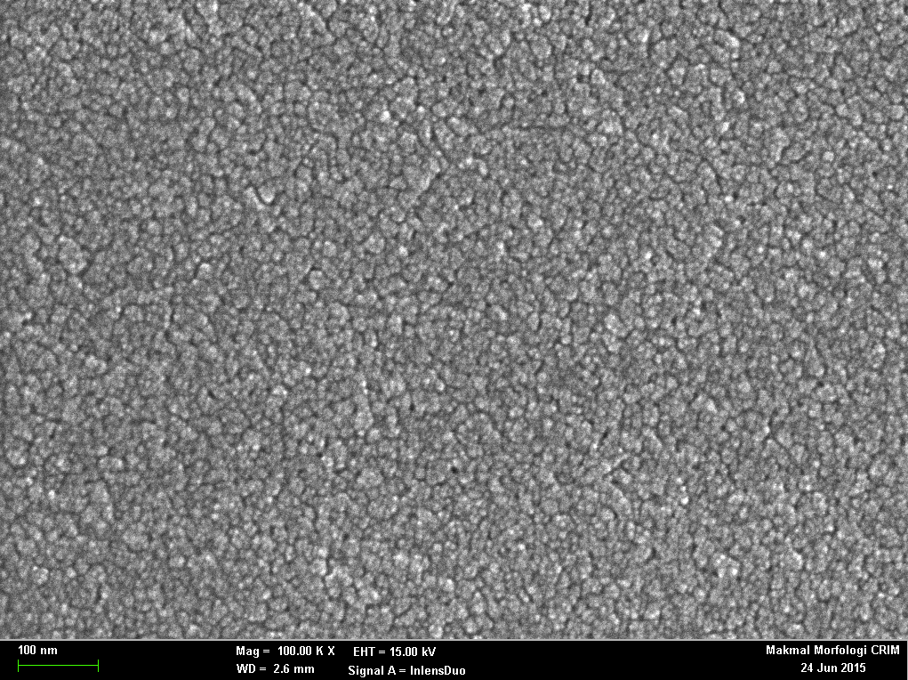  14wt% (b) | 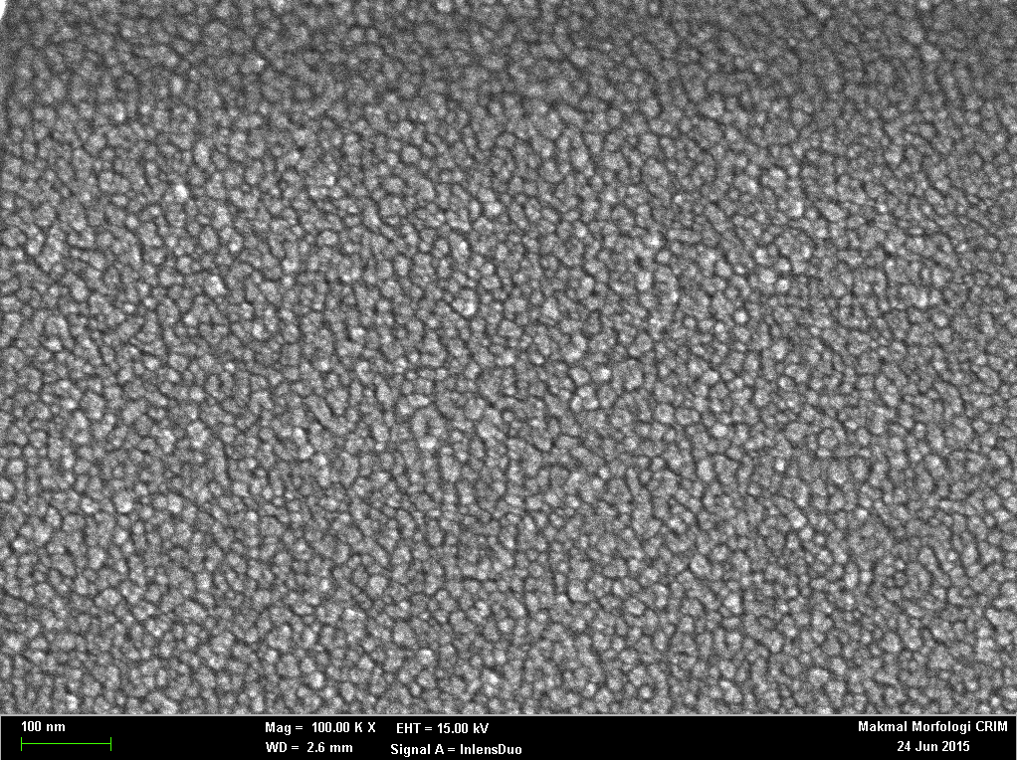  15 wt% (b) | 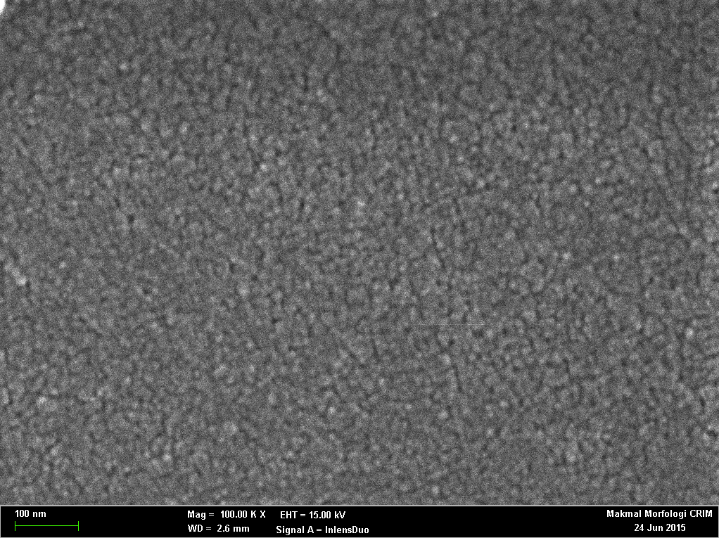  16 wt% (b) | 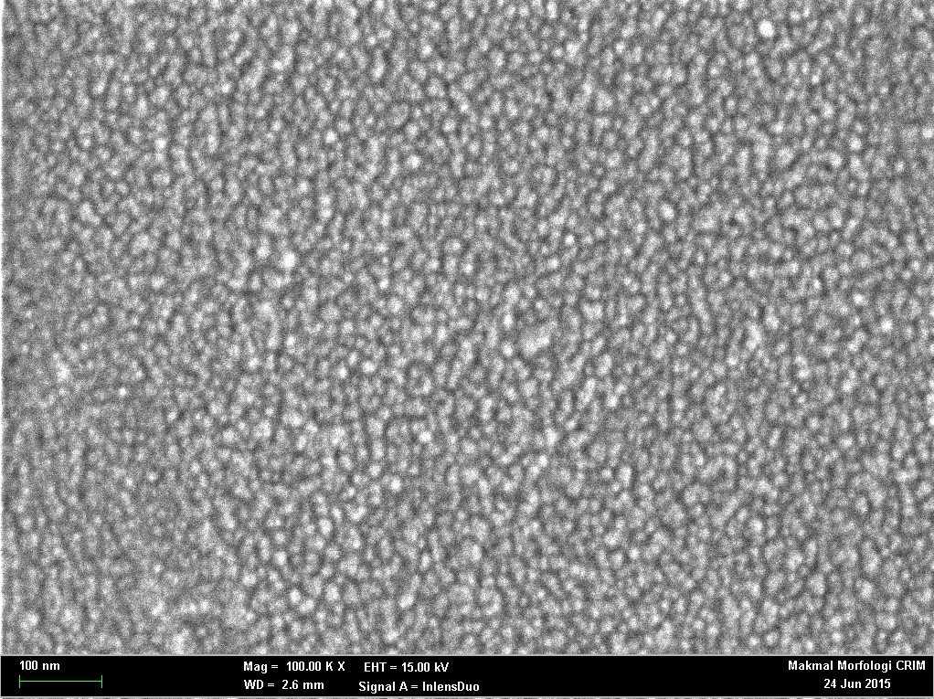  17 wt% (b)
Figure 2. Effect of PI compositions (14, 15, 16 and 17 wt%) on morphology of membranes: A) cross-section 500x and B) surface 100,000x (Membrane synthesis conditions: membrane thickness: 250 μm, evaporation time of 30s).
Succinate recovery
The performance of the membrane was also tested for the retention of succinate from ternary solution containing succinate, formate, and acetate at different concentration between 10 – 50 g/L. Figure 3 represents the flux of the ternary solutions and Figure 4 shows the succinate retention at different polymer compositions. From Figure 3, overall it was observed that the fluxes of ternary solution decreases with increasing concentrations, and polymer composition with 14 wt% PI membrane showed the highest fluxes. Meanwhile Figure 4 shows that the retention of succinate overall increased as the polymer composition increased irrespective of the ternary solution concentration. This observation is in agreement with the morphology of the membrane obtained in Figure 2(b) where the membrane skin layer becomes denser as the polymer composition increases thus resulting in the reduction of fluxes and increase of succinate retention. Similar results were also reported in previous studies using PI for rejection of isopropanol [22] and toluene [24].

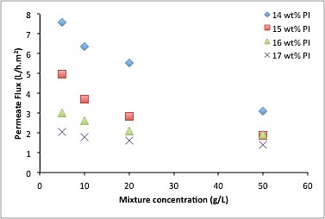

Figure 3. Permeate flux of mixed salt solution as a function of mixture concentrations for 4 different PI compositions (14, 15, 16 and 17 wt% PI). (Membrane synthesis conditions: membrane thickness of 250 μm, evaporation time of 30s. Filtration conditions: 15 bar, room temperature).

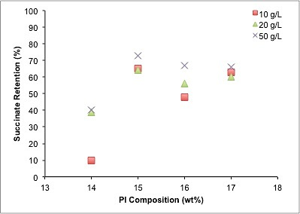

Figure 4. Succinate retention from 10, 20 and 50 g/L mixed salt solution concentrations as a function of PI composition (14 – 17 wt%) PI. (Membrane synthesis conditions: membrane thickness of 250 μm, evaporation time of 30s. Filtration conditions: 15 bar, room temperature).

However, for the selective separation of succinate in the mixed salt solution, in which succinate is recovered (retained in the retentate) while acetate and formate are removed in the permeate, 14 wt% PI membrane shows poor performance compared to the 15 wt% PI. Figure 5(a) shows that the retention of succinate by PI membrane at 14 wt% is approximately 40% for all concentration tested except at 10 g/L mixed salt solution concentration, in which a lower retention of 10% was obtained. The retention of formate and acetate were also found to be equivalent or higher than succinate retention indicating that 14 wt% PI membrane is not suitable for the selective separation of succinate. Such phenomenon can be explained by the large MWCO of membrane determined from the low retention of NaCl (MW = 58.44 g/mol) and Na₂SO₄ (MW = 142.04 g/mol) obtained in Table 1.

As the polymer composition increases to 15 wt% as shown in Figure 5(b), it was observed that succinate was able to be selectively retained while removing acetate and formate at high concentration of above 10 g/L. The succinate retention increased from 64 to 73%, while the retention of formate reduced from 42 to 39%, and acetate retention did not change much with the increasing of ternary solution concentration from 20 – 50 g/L. This increase in difference between succinate, formate, and acetate retentions indicates that the selectivity of succinate increases at high mixture concentration. It is expected that, if multiple filtrate tests are carried out, higher succinate retention and selectivity could be achieved. In a normal practice, multi-run/multi-celled, and integrated system of membrane coupled with other separation technologies are usually applied to get higher selectivity.

The increase in selectivity observed at increasing concentration could be explained by the pumping effect of monovalent anion (formate and acetate) by the divalent anion (succinate) [19]. Having a higher valency, divalent anions tend to stay further away from the membrane surface due to strong repulsion while pushing monovalent anions towards the membrane surface to meet electroneutrality in the membrane phase. Consequently this increases the concentration of monovalent anions in the membrane phase, thus the monovalent ions permeate preferentially at higher fraction compared to the divalent ions resulting in the observed lower retention of acetate and formate, compared to succinate [19]. This phenomenon was also found to be more significant at higher mixed salt solution concentration of above 10 g/L as observed in Figure 5(b) because at higher concentration, succinate, a divalent anion could effectively balance the charge of counter ion, Na⁺ thus acetate/formate is no longer required for electroneutrality, causing its retention to decrease [31]. Moreover it was also observed that the retention of formate decreases more compared to acetate at increasing mixed salt solution concentration from 20 to 50 g/L. This can be explained by the smaller degree of dissociation of formic acid (pK_{a} 3.8) compared to acetic acid (pK_{a} 4.7), thus formic acid was more completely dissociated than acetic acid at the pH tested [15,32].

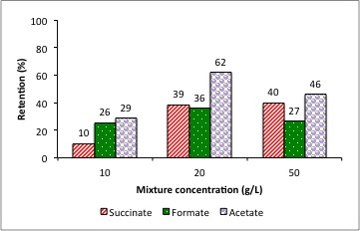  (a) | 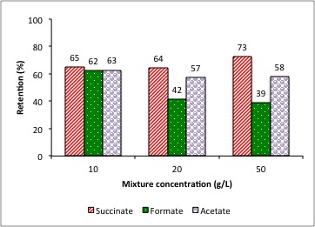  (b)
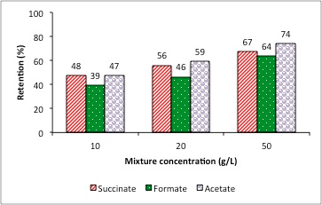  (c) | 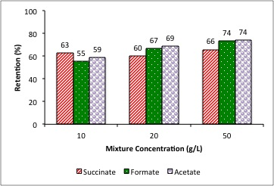  (d)

Figure 5. Retention of succinate, formate and acetate from mixed salt solution at 10, 20 and 50 g/L concentrations for (a) 14, (b) 15 (c) 16 and (d) 17 wt% PI membranes. (Membrane synthesis conditions: membrane thickness of 250 μm, evaporation time of 30s. Filtration conditions: 15 bar, room temperature)
However, when the polymer composition increased above 15 wt%, it was observed that succinate was not able to be selectively separated from the mixed salt solutions irrespective of the concentration of salt solutions tested, as shown in Figures 5 (c) and (d). All compounds (succinate, formate, and acetate) show similar retention percentage and only slight increase in succinate selectivity was observed as the mixture concentration increases from 10 to 50 g/L. This result is found to be consistent with the salt retention test that was carried out as discussed in section 3.1. Membranes with higher PI composition of above 15 wt% show a reduction in the retention difference between monovalent and divalent anions. Thus it is not suitable for selective separation of divalent anions from solution containing both monovalent and divalent anions.

Conclusion

Overall, PI shows high potential to be fabricated into NF membrane via phase inversion by manipulating the polymer composition. The NF characteristic was observed when PI composition is above 14 wt% based on the salt retention obtained. Based on the salt retention of NaCl and Na₂SO₄, 15 wt% PI membrane was found to have relatively low retention to monovalent ions and high retention to divalent ions. It also shows the best performance in selectively separated and retained succinate while rejecting formate and acetate from the model fermentation broth solution. The highest succinate retention of 73% was obtained at 50 g/L mixture solutions. Succinate selectivity was also observed with increasing mixture solution concentration from 20 to 50 g/L which was determined from the reduction in formate retention from 42 to 39%. As the test was only carried out in a single test with single cell filtration, it is expected that a higher purity can be achieved with a multi-run/multi-celled or/and integrated system of membrane coupled with other separation technologies processes, which are usually used in a normal practice. FESEM images showing dense and thick skin layer with porous substructure resembling common NF membrane morphology also supported the result of the succinate retention.

Acknowledgement

The authors gratefully acknowledge the LRGS Project Future Biorefineries (LRGS/2013/UKM_UKM/PT/03) and Fundamental Research Grant Scheme (FRGS/2/2013/TK05/UKM/02/4) by Ministry of Science, Technology and Innovation (MOSTI), and Geran Galakan Penyelidikan Muda (GGPM-074-2013) by Universiti Kebangsaan Malaysia for providing financial support for this research project.

References

- Chimirri, F., Bosco, F., Ceccarelli, R., Venturello, A. and Geobaldo, F. (2010). Succinic acid and its derivatives: fermentative production using sustainable industrial agro food by-products and its applications in the food industry. Italian Journal of Food Science, 22: 119 - 125.
- Sener, A., Kadiata, M. M., Ladrie`re, L. and Malaisse, W. J. (1997). Synergistic insulinotropic action of succinate, acetate, and glucose esters in islets from normal and diabetic rats. Endocrine, 7: 151 - 155.
- Kurzrock, T. and Weuster-Botz, D. (2010). Recovery of succinic acid from fermentation broth. Biotechnolology Letter, 32: 331 - 339.
- Delhomme, C., Weuster-Botz, D. and Khun, F. E. (2009). Succinic acid from renewable resources as a C4 buildig-block chemical-a review of the catalytic possibilities in aqueous media. Green Chemistry, 11: 13 - 26.
- Song, H., Lee, J. W., Choi, S., You, J. K., Hong, W. H. and Lee, S. Y. (2007). Effects of dissolved CO₂ levels on the growth of Mannheimia succiniciproducens and succinic acid production. Biotechnology and Bioengineering, 98: 1296 - 1304.
- Meynial-Salles, I., Dorotyn, S. and Soucaille, P. (2008). A new process for the continous production of succinic acid from glucose at high yield, titer, and productivity. Biotechnology and Bioengineering, 99: 129 - 135.
- Vemuri, G. N., Eiteman, M. A. and Altman, E. (2002). Succinate production in dual-phase Escherichia coli fermentations depends on the time of transition from aerobic to anaerobic conditions. Journal of Industrial Microbiology and Biotechnology, 28: 325 - 332.
- Guettler, M. V., Rumler, D. and Jain, M. K. (1999). Actinobacillus succinogenes sp.nov., a novel succinic-acid-producing strain from the bovine rumen. International Journal of Systematic Bacteriology, 49: 207 - 216.
- Li, Q., Wang, D., Wu, Y., Li, W. L., Zhang, Y. J., Xing, J. M. and Su, Z. G. (2010). One step recovery of succinic acid from fermentation broths by crystallization. Separation and Purification Technololgy, 72: 294 - 300.
- Arora, M. B., Hestekin, J. A., Snyder, S. W., Martin, E. J. S., Lin, Y. J., Donnelly, M. I. and Sanville M. C. (2007). The separation biorector: a continuous separation process for the simultaneous production and direct capture of organic acids. Journal of Separation Science and Technology, 42: 2519 - 2538.
- Bechthold, I., Brezt, K., Kabasci, S., Kopitzky, R. and Springer, A. (2008) Succinic acid: A new platform chemical for biobased polymers from renewable resources. Chemical Engineering and Technology, 31: 647 - 654.
- McKinlay, J. B., Vieille, C. and Zeikus, J. G. (2007). Prospects for a biobased succinate industry. Applied Microbiology & Biotechnology. 76: 727 - 740.
- Huh, Y. S., Jun, Y.-S., Hong, Y. K., Song, H., Lee, S. Y. and Hong, W. H. (2006). Effective purification of succinic acid from fermentation broth produced by Mannheimia succinicproducens. Process Biochemistry, 41: 1461 - 1465.
- Nam, H.-G., Park, K.-M., Lim, S. S. and Mun, S. (2011). Adsorption equilibria of succinic acid and lactic acid on amberchrom CG300C resin. Journal of Chemical and Engineering Data, 56: 464 - 471.
- Cao, Y., Zhang, R., Sun, C., Cheng, T., Liu, Y. and Xian, M. (2013). Fermentative succinate production: an emerging technology to replace the traditional petrochemical processes. BioMed Research International, 2013: 1 - 12.
- Choi, J.-H., Fukushi, K. and Yamamoto, K. (2008). A study on the removal of organic acids from wastewaters using nanofiltration membranes. Separation and Purification Technology, 59: 17 - 25.
- Staszak, K., Wozniak, M. J., Karas, Z., Staniewski, J. and Prochaska, K. (2013). Application of nanofiltration in the process of the separation of model fermentation broth components. Polish Journal Chemical Technology, 15(4): 1 - 4.
- Yao, Z., Wu, H., Liu, H., Li, S. and Jiang, M. (2008). Method for separation succinic acid from anaerobic fermentation broth. Chinese Patent CN 200610086003.7
- Wu, H., Jiang, M., Wie, P., Lei, D., Yao, Z. and Zuo, P. (2011). Nanofiltration method for separation of succinic acid from its fermented broth. Chinese Patent CN 200910025531.5.
- Kang, S. H. and Chang, Y. K. (2005). Removal of organic acid salts from simulated fermentation broth containing succinate by nanofiltration. Journal of Membrane Science, 246: 49 - 57.
- Datta, R., Glassner, D. A., Jain, M. K. and Vick Roy, J. R. (1992). Fermentation and purification process for succinic acid. U.S. Patent 5,168,055.
- Wang, C., Li, Q., Tang, H., Yan, D., Zhou, W., Xing, J. and Wan, Y. (2012). Membrane fouling mechanism in ultrafiltration of succinic acid fermentation broth. Bioresource Technology, 116: 366 -371.
- Vandezande, P., Li, X., Gevers, L. E. M. and Vankelecom, I. F. J. (2009). High throughput study of phase inversion parameters for polyimide-based SRNF membranes. Journal of Membrane Science, 330: 307 - 318.
- Valadez-Blanco, R. and Livingston, A. G. (2009). Solute molecular transport through polyimide asymmetric organic solvent nanofiltration (OSN) membranes and the effect of membrane-formation parameters on mass transfer. Journal of Membrane Scienc, 326: 332 - 342.
- See-Toh, Y. H., Ferreira, F. C. and Livingston, A. G. (2007). The influence of membrane formation parameters on the functional performance of organic solvent nanofiltration membranes. Journal of Membrane Science 299: 236 - 250.
- Vankelecom, I. F. J., De Smet, K., Gevers, L. E. M., and Jacobs, P. A., (2005). Nanofiltration. principles and applications. Ed. de A.I. Schäfer, A.G. Fane, T.D. Waite ; pról. de Robert J. Petersen, Elsevier.
- Lee, J., Chae, H.-R., Won, Y. J., Lee, K., Lee, C.-H., Lee, H. H., Kim, I.-C. and Lee, J.-M. (2013). Graphene oxide nanoplatelets composite membrane with hydrophilic and antifouling properties for wastewater treatment. Journal of Membrane Science, 448: 223 - 230.
- Qiao, X., Chung, T.-S. and Pramoda, K. P. (2005). Fabrication and characterization of BTDA-TDI/MDI (P84) co-polyimide membranes for the pervaporation dehydration of isopropanol. Journal of Membrane Science, 264: 176 - 189.
- DOW. Dow Water and Process Solutions - Levels of Separation of IX, RO, NF, UF and CFT (2015). DOW answer center. The DOW company.
- Peeters, J. M. M., Boom, J. P., Mulder, M. H. V. and Strathmann, H. (1998). Retention measurements of nanofiltration membranes with electrolyte solutions. Journal of Membrane Science, 145: 199 - 209.
- Lin, S. W., Sicairos, S. P. and Navarro, R. M. F. (2007). Preparation, characterization and salt rejection of negatively charged polyamide nanofiltration membranes. Journal of Mexican Chemical Society, 51: 129 - 135.
- Krieg, H. M., Modise, S. J., Keizer, K., and Neomagus, H. W. J. P. (2004) Salt rejection in nanofiltration for single and binary salt mixtures in view of sulphate removal. Desalination, 171: 205 -215.
- Van der Burggen, B., Schaep, J., Wilms, D. and Vandecasteele, C. (1999). Influence of molecular size, polarity and change on the retention of organis molecules by nanofiltration. Journal of Membrane Science, 156: 29 - 41.

