THE EFFECT OF VARIOUS PRETREATMENT METHODS ON EMPTY FRUIT BUNCH FOR GLUCOSE PRODUCTION

(Kesan Kaedah Prarawatan Berbeza Terhadap Tandan Kosong Kelapa Sawit Bagi Penghasilan Glukosa Ringkas)

Nurul Hazirah Che Hamzah¹, Masturah Markom^{1*}, Shuhaida Harun¹, Osman Hassan²

¹Department of Chemical & Process Engineering, Faculty of Engineering and Built Environment

Universiti Kebangsaan Malaysia, 43600 Bangi, Malaysia

²School of Chemical Science and Food Technology, Faculty of Science and Technology

Universiti Kebangsaan Malaysia, 43600 Bangi, Malaysia

*Corresponding author: masturahmarkom@ukm.edu.my

Abstract

In this study, a pretreatment of empty fruit bunch (EFB) using supercritical carbon dioxide (SC-CO₂), acid and alkaline were investigated for glucose yield from enzymatic hydrolysis. The chemical composition, X-ray diffraction (XRD) and Scanning Electron Microscopy (SEM) analysis of EFB before and after pretreatment were determined. From this study, the chemical composition of EFB (% g/g dry biomass) before pretreatment for cellulose, hemicellulose and Klason lignin were recorded as 36.7%, 22.8%, and 24.2%, respectively. After pretreatment, the highest cellulose composition was obtained from EFB treated with alkaline followed by acid and SC-CO₂ which gave the results of 48.5%, 47.7% and 38% respectively. The glucose yield after enzymatic hydrolysis for untreated EFB was 17% (w/w). After pretreatment, the glucose yield increased to 84.4%, 34% and 24% for alkaline, acid and SC-CO₂ of the treated EFB, respectively. Other than that, XRD analysis showed increase in the crystallinity index after each pretreatment. Morphology analysis showed the surface of the treated EFB looked swollen and ruptured as compared with the surface of the untreated EFB. Between the three pretreatments, alkaline pretreatment gives the highest cellulose composition and glucose yield. Thus, it shows that alkaline pretreatment was the best pretreatment method on EFB compared to acid and SC-CO₂ pretreatments.

Keywords: empty fruit bunches, enzymatic hydrolysis, pretreatment, glucose

Abstrak

Melalui kajian ini prarawatan tandan buah kosong (TKKS) menggunakan kaedah supergenting karbon dioksida (SC-CO₂), asid dan alkali telah dilakukan untuk mendapatkan hasil glukosa daripada hidrolisis enzim. Analisis komposisi kimia, pembelauan sinar-X (XRD) dan mikroskopi pemgimbasan elektron (SEM) terhadap TKKS sebelum dan selepas prarawatan telah ditentukan. Dari kajian ini komposisi kimia TKKS (% g/g biomas kering) sebelum prarawatan bagi selulosa, hemiselulosa dan lignin ialah 36.7%, 22.8%, and 24.2%. Selepas prarawatan, komposisi selulosa yang paling tinggi diperolehi daripada TKKS terawat dengan prarawatan alkali diikuti dengan prarawatan asid dan SC-CO₂ iaitu 48.5%, 47.7% dan 38%. Hasil glukosa selepas hidrolisis enzim bagi TKKS yang tidak terawat ialah 17% (w/w). Selepas prarawatan, hasil glukosa telah meningkat kepada 84.4%, 34% dan 24% bagi prarawatan alkali, asid dan SC-CO₂. Selain daripada itu, analisis XRD menunjukkan peningkatan indeks penghabluran terhadap TKKS terawat. Analisis morfologi menunjukkan perubahan pada permukaan TKKS terawat dimana ia kelihatan bengkak dan pecah berbanding dengan permukaan TKKS yang tidak terawat. Antara ketiga-tiga kaedah prarawatan, prarawatan alkali memberikan komposisi selulosa dan hasil glukosa yang paling tinggi. Oleh itu, kajian ini menunjukkan bahawa prarawatan alkali adalah kaedah prarawatan terbaik terhadap TKKS berbanding prarawatan asid dan SC-CO₂.

Kata kunci: Tandan kosong kelapa sawit, hidrolisis enzim, prarawatan, glukosa

Introduction

Malaysia produces approximately 43% of the world’s palm oil supply and is the second largest exporters in the world after Indonesia, which produces 44% of palm oil [1]. Crude palm oil production has increased every year due to high demand in the market which also leading to massive production of biomass in the form of trunks, fronds, fibers, shells and empty fruit bunch (EFB) [2]. The potentials of this biomass are yet to be fully exploited that currently leads to waste disposal problems [3].

EFB is a lignocellulosic material consists of carbohydrate sugars, lignin, extractives and ash with inorganic minerals. Carbohydrate sugars such as cellulose and hemicellulose, which can be used as a source of biomass energy when hydrogen is produced via bioconversion process. However it is difficult to yield high amount of reducing sugars from bioconversion of lignocellulosic materials as its end product due to their complex structure and component [4]. Thus, EFB has to undergo pretreatment in order to break the complex structure of lignocellulosic and thus improves enzymatic hydrolysis process for the production of high sugar yields [5].

Many studies have been done on pretreatment of lignocellulosic biomass material either physical, chemical or biological [6]. Chemical pretreatments using acid and alkaline have been claimed as a potential technique for lignocellulose degradation [7]. Acid pretreatment is one of the most extensively studied pretreatment methods that results in hydrolyzes hemicellulose from lignocellulose [8]. Alkaline pretreatment disrupts the cell wall by breaking down the -ether linkages between lignin and/or hemicelluloses and solubilized thus increasing the enzymatic digestibility of cellulose [9].

Besides the most widely used of chemical methods, physico-chemical pretreatment such as supercritical carbon dioxide (SC-CO₂) has also been of interest in recent years because it uses a low-cost of CO₂, non-toxic and environmentally friendly [10]. During pretreatment, CO₂ molecules penetrate into the micropores of lignocellulose and destroy the structure of the biomass by rapidly release CO₂ [11].

The objectives of this research are to characterize the chemical composition of EFB and to study the effects of alkaline, acid and supercritical carbon dioxide (SC-CO₂) pretreatments on EFB for sugar production during enzymatic hydrolysis.

Materials and Methods

Materials

Empty fruit bunch fibers (EFB) were collected from Sime Darby Sdn. Bhd. palm oil milling, Pulau Carey, Selangor, Malaysia. The EFB was dried using oven (less than 10 wt. % moisture content) and then was milled into particles (0.25 – 0.42 mm). The samples were stored at room temperature until they were used for the pretreatment process. The CO₂ gas was purchased from Gas Pantai Timur, Malaysia and had the purity of 99.9%. The commercial enzymes used in this study were cellulase enzyme and β-glucosidase purchased from Sigma Aldrich.

Pretreatment procedure

Three pretreatment methods were employed in this study. The SC-CO₂ pretreatment was carried out in static type at 75% moisture content, 250 bars and 130 °C. An amount 5g of samples was introduced into a high pressure stainless steel reactor vessel. The supercritical CO₂ was fed into the reactor until desired pressure after the system reached the set temperature. Then, the system was maintained at constant pressure and temperature for 60 min. After the reaction process finished, the supercritical CO₂ was immediately released to atmospheric pressure [12]. NaOH and H₂SO₄ solution at concentration level 4% were used to pretreat EFB. The samples were treated in a 250 mL Erlenmeyer flask at temperature of 121 °C for 1 hour and with ratio of biomass to liquid was 1:10. Later, the treated fibers were washed until all chemicals used were removed [13]. Then, the treated fibers were dried in an oven at 50 ºC overnight.

Enzymatic saccharification

Enzymatic hydrolysis of untreated and treated EFB were carried out in 250 mL Erlenmeyer flasks containing 1% (w/v) glucan loading in 0.05 M citrate buffer, pH 4.8 and together with desired cellulase and cellobiase enzymes. Cellulose and cellobiase enzymes were added at 60 FPU per g glucan loading and 64 ρNPGU per g glucan loading, respectively. An amount of 10% sodium azide was added at concentration of 20 mg/mL act as an antibiotic. The saccharification was done in a shaker incubator at 200 rpm at 37 ºC for 48 hours. Samples were taken periodically, filtered and stored at -8 °C for sugar determination using High Performance Liquid Chromatography (HPLC) [14].

Analytical method

The chemical composition of EFB was determined according to NREL standard method [15]. In this method, the structural carbohydrates and insoluble lignin (Klason lignin) in biomass were analyzed. The sugar monomers in untreated and treated EFB fiber samples after enzymatic hydrolysis were determined by high performance liquid chromatography. HPLC system (Model G1311A, Agilent Technologies) equipped with reflective index detector and Rezex ROA column was used for the analysis. The mobile phase used was 0.005 N sulfuric acid with a flow rate of 0.6 mL/min at 60 °C. The samples were centrifuged for 5 minutes and filtered with 0.2 µm syringe filter for HPLC analysis. The glucose yield from EFB was measured based on the glucose released after both pretreatment and enzymatic hydrolysis as proposed by Srinivasan and Ju [16].

Scanning electron microscope

SEM analysis was conducted using SEM model Philips XL30 to determine the surface changes before and after pretreatment. For sample preparation, the samples were coated with a thin layer of gold using sputter coater system Model Q150 RS.

X-ray diffraction

The crystallinities of untreated and pretreated Tamarix solids were measured using a Bruker D8 Advance instrument. The data analysis was calculated from XRD data and determined based on the formula by Segal follows [17].

CrI = 100 × [(I002-Iam)/I002] (1)

where I002 is the maximum intensity of 002 reflections from the crystalline and amorphous portions at about 2θ = 22.5˚, and Iam is the minimum intensity of diffraction from the amorphous portion at a 2θ ≈ 18.7˚ of the EFB fibers in most literatures [18]. During the calculation, the height of (002) peaks were used at a 2θ ≈ 22˚, while the intensity of Iam was taken at a 2θ ≈ 16˚.

Result and Discussion

Effect of various pretreatments on chemical composition of EFB

The chemical compositions of untreated and treated EFB fibers were shown in Figure 1. Chemical composition of untreated EFB fiber for cellulose, hemicellulose and Klason lignin were 36.7%, 22.8%, and 24.2%, respectively. The cellulose, hemicellulose and lignin content in untreated EFB fiber were similar to that reported by Chong et al. who studied the chemical composition of EFB [8]. These results proved that more than 30% -50% of EFB component is cellulose, followed by hemicellulose 20% - 30% and lignin 15% - 20% of the overall components in biomass [4,19]. After pretreatment, it was observed that the composition of cellulose increased in the treated EFB as the results after SC-CO₂, acid and alkaline pretreatment were 38%, 47.7% and 48.5%, respectively. While the composition of hemicellulose was increased after SC-CO₂ and alkaline pretreatment but decreased after acid pretreatment as the results obtained were 25.5%, 29.1% and 0.012% respectively.

The composition of Klason lignin showed that the percentages reduced after SC-CO₂ and alkaline pretreatment but increased after acid pretreatment which were calculated at 23.8%, 20.4% and 31.2%, respectively. The result showed differences in the composition of EFB after pretreatments because of different effects of pretreatment on EFB fiber. SC-CO₂ is a physicochemical pretreatment in which at supercritical conditions and high temperatures, carbonic acid possibly formed by the interaction of SC-CO₂ with water and may have hydrolyzed hemicellulose [20]. Whereas acid and alkaline are chemical pretreatment which chemically changing the structure of lignocellulose EFB and destroying its crystalline structure [6]. The acid pretreatment enhances the hydrolysis of hemicelluloses and portion of amorphous cellulose while alkaline pretreatment disrupts the cell wall by dissolving hemicelluloses and lignin from lignocellulose [21,22].

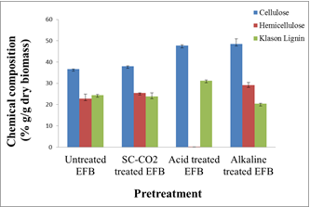

Figure 1. Chemical compositions of untreated, supercritical carbon dioxide, acid and alkaline treated EFB.

Effect of various pretreatments on glucose yield

The trends of glucose yield after 48 hours’ enzymatic hydrolysis over different pretreatments were shown in Figure 2. After enzymatic hydrolysis, the glucose yield for untreated compared with supercritical carbon dioxide, acid and alkaline treated EFB were calculated at 17%, 24%, 34% and 84.4%, respectively. The results showed that all the three pretreatments caused an increase of the glucose yield after enzymatic hydrolysis compared to untreated EFB. The highest glucose yield was obtained in EFB treated with 4% NaOH showing that alkaline pretreatment gave significant effect on glucose yield. Alkaline pretreatment enhancing enzymatic hydrolysis by removing lignin that linked to both hemicellulose and cellulose from lignocellulose [2]. Acid and SC-CO₂ pretreatment also help in enzymatic hydrolysis however the glucose yield is lower than alkaline pretreatment. During acid and SC-CO₂ pretreatment, most of the hemicellulose was hydrolyzed leaving lignin as a barrier that preventing penetration of enzymes and difficult for the enzyme to access the cellulose [4].

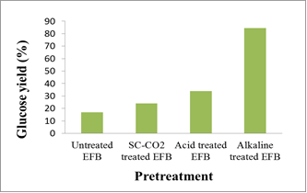

Figure 2. Glucose yield of the enzymatic hydrolysis for untreated, supercritical carbon dioxide, acid and alkaline treated EFB after 48 hours enzymatic hydrolysis.

X-ray diffraction analysis

Table 1 showed the crystallinity index of untreated EFB, SC-CO₂ treated EFB, acid treated EFB and alkaline treated EFB. Crystallinity index for each sample was calculated using the formula by Segal et al. [17]. It was determined that crystallinity index of cellulose in untreated EFB was 44%. The crystallinity increased after each pretreatment as for SC-CO₂ treated EFB (45.3%), acid treated EFB (47%) and alkaline treated EFB (50%), respectively. Crystallinity index had been used in various studies to interpret the changes in the structure of cellulose after pretreatment [23]. Cellulose crystallinity index was the main factor affecting the hydrolysis since degradation of cellulose crystallinity will increase the rate of enzymatic hydrolysis [24]. This concept was used because cellulose structure can be divided into two parts which amorphous part that was easy to hydrolyze and crystalline part that was more difficult to hydrolyze [23]. However, in this study, it showed that the crystallinity index was increased for each pretreatment similarly in previous studies conducted by Singh et al. [21] on rice straw using alkaline pretreatment which increased the crystallization index of 2.35%. Therefore, it can be concluded that the crystallization is not the only factor affecting the enzymatic hydrolysis of biomass but other parameters such as hemicellulose and lignin also involve in enhancing the enzymatic hydrolysis.

Table 1. Chemical compositions of untreated, supercritical carbon dioxide, acid and alkaline treated EFB

Samples | Crystallinity Index (%)
Untreated EFB | 44
SC-CO₂ treated EFB | 45.3
Acid treated EFB | 47
Alkaline treated EFB | 50

Scanning electron microscopy

Scanning electron microscopy (SEM) analysis was used to observe the structure changes in EFB before and after pretreatment. Figure 3 shows SEM images of EFB samples for (a) untreated EFB (b) SC-CO₂ treated EFB (c) acid treated EFB and (d) alkaline treated EFB. From the SEM images, it showed that untreated EFB had a rough surface with the silica bodies on the surface strand. The structure looked very rigid and solid because the surface of the fiber was covered by a layer of matrix material like lignin or waxes. On the other hand, after pretreatment the SEM showed the structural damage EFB. After SC-CO₂ pretreatment process, the structure of EFB became porous and visible cracks formed were seen due to quick release of CO₂ [25]. A significant effect can be observed after alkaline and acid pretreatment where these pretreatments caused greater disruptions on the fiber structure by destroying the cell wall, hydrolyzing lignin or hemicellulose of lignocellulose and creating number of large pores [14]. Thus after pretreatment more cellulose was exposed to the enzymes, resulting in increment of glucose yield.

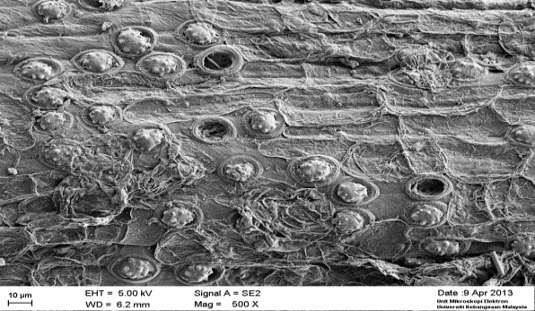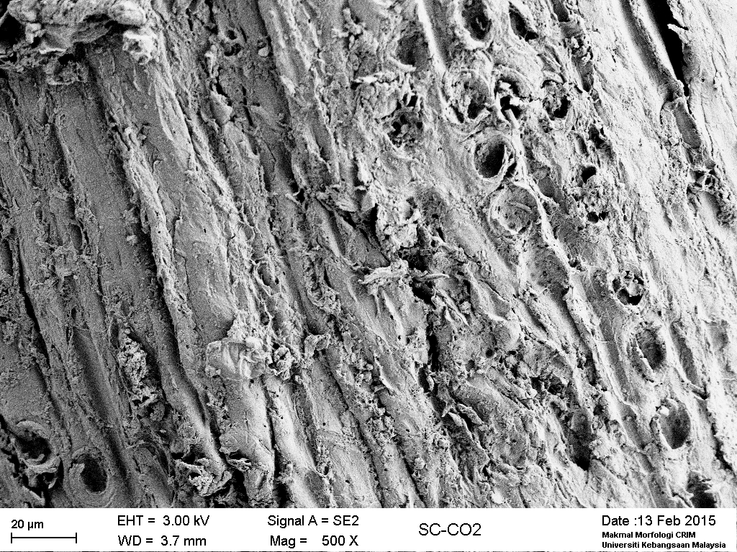

(b)
(a)

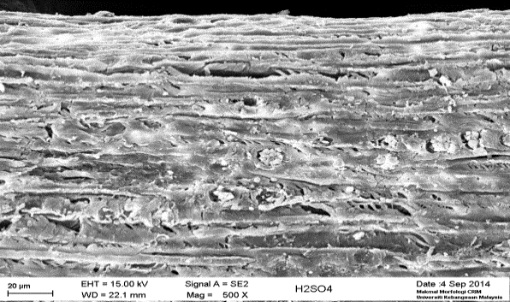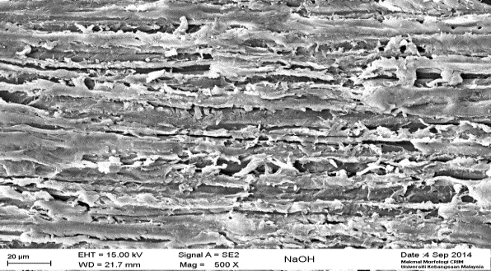
(d)
(c)

Figure 3. SEM images of EFB samples (a) untreated EFB (b)SC-CO₂ treated EFB (c) acid treated EFB and (d) alkaline treated EFB; Arrow indicates silica bodies on the EFB strand

Conclusion

In summary, SC-CO₂, acid and alkaline pretreatment on EFB enhances the glucose yields of enzymatic hydrolysis. The highest glucan composition and glucose yield were obtained from EFB treated with alkaline followed by acid and SC-CO₂. After pretreatment, SEM images demonstrated that the structure of treated EFB was swollen and ruptured as compared with the untreated EFB. A significant effect can be observed after alkaline and acid pretreatment which were the chemical pretreatment. XRD analysis showed increase in the crystallinity index for EFB treated using SC-CO₂, acid and alkaline pretreatment by 1.3%, 3% and 6% compared to untreated EFB. Therefore based on these findings, it could be concluded that alkaline pretreatment using NaOH was the best pretreatment method on EFB which gives the highest glucose yield through enzymatic hydrolysis.

Acknowledgement

The authors would like to thank Universiti Kebangsaan Malaysia and KURSI UKM-Yayasan Sime Darby (UKM-YSD) for sponsoring this work.

References

- Shuit, S. H., Tan, K. T., Lee, K. T. and Kamaruddin, A. H. (2009). Oil palm biomass as a sustainable energy source: A Malaysian case study. Energy, 34(9): 1225 – 1235.
- Shamsudin, S., Md Shah, U. K., Zainudin, H., Abd-Aziz, S., Mustapa Kamal, S. M., Shirai, Y. and Hassan, M. A. (2012). Effect of steam pretreatment on oil palm empty fruit bunch for the production of sugars. Biomass and Bioenergy, 36: 280 – 288.
- Yaakob, M. Y., Hasoloan, H. I. P., Yahaya, S. H. and Said, M. R. (2012). Solid fuel from empty fruit bunch fiber and waste papers part 3: ash content from combustion test. Global Engineers & Technologists Review, 2(3): 26 – 32.
- Ariffin, H., Hassan, M. A., Kalsom, M. S. U., Abdullah, N. and Shirai, Y. (2008). Effect of physical, chemical and thermal pretreatments on the enzymatic hydrolysis of oil palm empty fruit bunch (OPEFB). Journal of Tropical Agriculture and Food Sciences, 36(2): 259 – 268.
- Zheng, Y., Pan, Z. and Zhang, R. (2009). Overview of biomass pretreatment for cellulosic ethanol production. International Journal of Agricultural and Biological Engineering, 2: 51 – 69.
- Taherzadeh, M. J. and Karimi, K. (2008). Pretreatment of lignocellulosic wastes to improve ethanol and biogas production: A review. International Journal of Molecular Sciences, 9: 1621 – 1651.
- Misson, M., Haron, R., Ahmad, M. F., Aishah, N. O. R. and Amin, S. (2009). Pretreatment of empty palm fruit bunch for lignin degradation. Jurnal Teknologi, 50: 89 – 98.
- Chong, P. S., Jahim, J. M., Harun, S., Lim, S. S., Mutalib, S. A., Hassan, O. and Nor, M. T. M. (2013). Enhancement of batch biohydrogen production from prehydrolysate of acid treated oil palm empty fruit bunch. International Journal of Hydrogen Energy, 38: 9592 – 9599.
- Varga, E., Schmidt, A. S., Réczey, K. and Thomsen, A. B. (2003). Pretreatment of corn stover using wet oxidation to enhance enzymatic digestibility. Applied Biochemistry and Biotechnology, 104: 37 – 50.
- Lü, H., Ren, M., Zhang, M. and Chen, Y. (2013). Pretreatment of corn stover using supercritical CO₂ with water-ethanol as co-solvent. Chinese Journal of Chemical Engineering, 21(5): 551 – 557.
- Yin, J., Hao, L., Yu, W., Wang, E., Zhao, M., Xu, Q. and Liu, Y. (2014). Enzymatic hydrolysis enhancement of corn lignocellulose by supercritical CO₂ combined with ultrasound pretreatment. Chinese Journal of Catalysis, 35(5): 108 – 119.
- Narayanaswamy, N., Faik, A., Goetz, D. J. and Gu, T. (2011). Supercritical carbon dioxide pretreatment of corn stover and switchgrass for lignocellulosic ethanol production. Bioresource Technology, 102(13): 6995 – 7000.
- Ying, T. Y., Teong, L. K., Abdullah, W. N. W. and Peng, L. C. (2014). The effect of various pretreatment methods on oil palm empty fruit bunch (EFB) and kenaf core fibers for sugar production. Procedia Environmental Sciences, 20: 328 – 335.
- Iberahim, N. I., Jahim, J. M., Harun, S., Nor, M. T. M. and Hassan, O. (2013). Sodium hydroxide pretreatment and enzymatic hydrolysis of oil palm mesocarp fiber. International Journal of Chemical Engineering and Applications, 4(3): 101 – 105.
- Sluiter, A., Hames, B., Ruiz, R., Scarlata, C., Sluiter, J., Templeton, D. and Crocker, D. (2008). Determination of structural carbohydrates and lignin in biomass. Biomass analysis technology team laboratory analytical procedure.
- Srinivasan, N. and Ju, L.-K. (2012). Statistical optimization of operating conditions for supercritical carbon dioxide-based pretreatment of Guayule Bagasse. Biomass and Bioenergy, 47: 451 – 458.
- Segal, L. G. J. M. A., Creely, J. J., Martin, A. E. and Conrad, C. M. (1959). An empirical method for estimating the degree of crystallinity of native cellulose using the X-ray diffractometer. Textile Research Journal, 29(10): 786 – 794.
- Xiao, L., Sun, Z., Shi, Z. and Xu, F. (2011). Impact of hot compressed water pretreatment on the structural changes of woody biomass for bioethanol production. Bioresources, 6: 1576 – 1598.
- Kelly-Yong, T. L., Lee, K. T., Mohamed, A. R. and Bhatia, S. (2007). Potential of hydrogen from oil palm biomass as a source of renewable energy worldwide. Energy Policy, 35: 5692 – 5701.
- Kim, K. H. and Hong, J. (2001). Supercritical CO₂ pretreatment of lignocellulose enhances enzymatic cellulose hydrolysis. Bioresource Technology, 77(2): 139 – 144.
- Singh, R., Shukla, A., Tiwari, S. and Srivastava, M. (2014). A review on delignification of lignocellulosic biomass for enhancement of ethanol production potential. Renewable and Sustainable Energy Reviews, 32: 713 – 728.
- Xiao, B., Sun, X. and Sun, R. (2001). Chemical, structural, and thermal characterizations of alkali-soluble lignins and hemicelluloses, and cellulose from maize stems, rye straw, and rice straw. Polymer Degradation and Stability, 74(2): 307 – 319.
- Park, S., Baker, J. O., Himmel, M. E., Parilla, P. A. and Johnson, D. K. (2010). Cellulose crystallinity index: Measurement techniques and their impact on interpreting cellulase performance. Biotechnology for Biofuels, 3: 1 – 10.
- Hassan, O., Ling, T. P., Maskat, M. Y., Illias, R. M., Badri, K., Jahim, J. and Mahadi, N. M. (2013). Optimization of pretreatments for the hydrolysis of oil palm empty fruit bunch fiber (EFBF) using enzyme mixtures. Biomass and Bioenergy, 56: 137 – 146.
- Gao, M., Xu, F., Li, S., Ji, X., Chen, S. and Zhang, D. (2010). Effect of SC-CO₂ pretreatment in increasing rice straw biomass conversion. Biosystems Engineering, 106(4): 470 – 475.

